Online Supplementary Materials

Table of Contents
Table S1. 2
Descriptives of compassionate responses and mediators (Studies 1, 2, 3) 2
Additional Measures of Religiosity in Study 2 3
Importance of Spirituality 3
Frequency of Religious Practices 4
Daily Spiritual Experiences 6
Four Dimensions of Religiousness 7
Table S2. 7
Correlations between additional indices of religiosity and compassionate responding in Study 2 7
Valuation of Compassion 9
Figure S1. 10
Valuation of compassion mediates the relationship between religiosity and compassionate responses in Study 2 (top) and Study 3 (bottom). 10
Table S3 11
Correlations between psychological closeness and compassionate responding (Studies 2, 3) 11

Table S1.

Descriptives of compassionate responses and mediators (Studies 1, 2, 3)

Variable | Scale | N | M | SD
Study 1
Control:
Compassionate experience | 1-9 | 138 | 5.82 | 1.65
Compassionate choice (%) | 0-100 | 138 | 34.54 | 21.38
Easter:
Compassionate experience | 1-9 | 138 | 5.90 | 1.66
Compassionate choice (%) | 0-100 | 138 | 37.84 | 22.53
Study 2
Compassionate experience | 1-9 | 442 | 5.95 | 1.75
Compassionate choice (%) | 0-100 | 442 | 26.04 | 23.36
Valuation of compassion | 1-7 | 442 | 5.34 | 1.66
Psychological closeness | 1-7 | 442 | 3.40 | 1.32
Study 3
Whole sample:
Compassionate experience | 1-9 | 369 | 6.53 | 1.57
Compassionate choice (%) | 0-100 | 369 | 38.96 | 23.21
Valuation of compassion | 1-7 | 369 | 5.95 | 1.08
Psychological closeness | 1-7 | 369 | 4.09 | 1.50
Christians:
Compassionate experience | 1-9 | 195 | 6.57 | 1.52
Compassionate choice (%) | 0-100 | 195 | 36.35 | 23.81
Valuation of compassion | 1-7 | 195 | 6.02 | 1.04
Psychological closeness | 1-7 | 195 | 4.09 | 1.52
Buddhists:
Compassionate experience | 1-9 | 174 | 6.49 | 1.41
Compassionate choice (%) | 0-100 | 174 | 41.89 | 22.24
Valuation of compassion | 1-7 | 174 | 5.87 | 1.12
Psychological closeness | 1-7 | 174 | 4.09 | 1.47

Additional Measures of Religiosity in Study 2

Importance of Spirituality
Reference: Modified from Saroglou, V., & Munoz-Garcia, A. (2008). Individual differences in religion and spirituality: An issue of personality traits and/or values. Journal for the Scientific Study of Religion, 47(1), 83-101. https://doi.org/https://doi.org/10.1111/j.1468-
5906.2008.00393.x
Directions: To what extent do you agree with the following statements:
Code Extensions: IR

Scale seen by participants:

1  (not at all) | 2 | 3 | 4 | 5 | 6 | 7 | 8 | 9  (yes, extremely)

Item
How much is spirituality important in your life?

Frequency of Religious Practices
Measure Title: Frequency of Religious Practice (FRP) Scale
Reference: General Social Survey. 1998. Chicago: National Opinion Research Center, University of Chicago.

Idler, E. L., Musick, M. A., Ellison, C. G., George, L. K., Krause, N., Ory, M. G., Pargament, K. I., Powell, L. H., Underwood, L. G., & Williams, D. R. (2003). Measuring multiple dimensions of religion and spirituality for health research: Conceptual background and findings from the 1998 General Social Survey. Research on Aging, 25(4), 327-365.
Directions: Please choose the best answer for each question.
Code Extensions: FRP

Items | Code
How often do you attend religious services? | 1 = Never  2 = Less than once a year  3 = About once or twice a year  4 = Several times a year  5 = About once a month  6 = 2-3 times monthly  7 = Nearly every week  8 = Every week  9 = Several times a week
How often do you take part in the activities of a place of worship other than attending services? | 1 = Never  2 = Less than once a year  3 = About once or twice a year  4 = Several times a year  5 = About once a month  6 = 2-3 times monthly  7 = Nearly every week  8 = Every week  9 = Several times a week  10 = Once a day  11 = Several times a day
How often have you read the Bible or other religious text in last year? | 1 = I have not read the Bible or other religious texts in the last year  2 = Less than once a week  3 = Once a week  4 = Several times a week  5 = Once a day  6 = Several times a day

Reference: Generated for this research
Directions: Please choose the best answer for each question.

Variable Name | Items | Code
FRP_gp | How often do you pray with other people in places other than specific religiously oriented buildingw? | 1 = Never  2 = Less than once a month  3 = Once a month  4 = A few times a month  5 = Once a week  6 = A few times a week  7 = Once a day  8 = More than once a day
FRP_ps | How often do you intentionally pray for those who suffer in the world?
FRP_test | At church or in any other setting, how often do you hear others testify and/or testify yourself?
FRP_vol | How often do you engage in church-based volunteering activities? | 1 = Never  2 = Less than once a year  3 = About once or twice a year  4 = Several times a year  5 = About once a month  6 = 2-3 times monthly  7 = Nearly every week  8 = Every week  9 = Several times a week

Daily Spiritual Experiences
Measure Title: Daily Spiritual Experiences Scale (short form)
Reference: Underwood, L. G., & Teresi, J. A. (2002). The daily spiritual experience scale: Development, theoretical description, reliability, exploratory factor analysis, and preliminary construct validity using health-related data. Annals of Behavioral Medicine, 24(1), 22-33.
Directions: You may experience the following in your daily life. If so, how often?

Note: In the items below, you may take the word “God” to represent any experiences with the transcendent, whether you consider that to be God, the divine, or a Higher Power.
Code Extensions: DSE

Scale seen by participants:

1  (Never or almost never) | 2  (Once a while) | 3  (Some days) | 4  (Most days) | 5  (Everyday) | 6  (Many times a day)

Items
I feel God’s presence.
I find strength and comfort in my religion.
I feel deep inner peace or harmony.
I desire to be closer to or in union with God.
I feel God's love for me, directly or through others.
I am spiritually touched by the beauty of creation.

Four Dimensions of Religiousness
Measure Title: The Four Basic Dimensions of Religiousness Scale
Reference: Saroglou, V., Clobert, M., Cohen, A. B., Johnson, K. A., Ladd, K. L., Van Pachterbeke, M., Adamovova, L., Blogowska, J., Brandt, P.-Y., Çukur, C. S., Hwang, K.-K., Miglietta, A., Motti-Stefanidi, F., Muñoz-García, A., Murken, S., Roussiau, N., & Tapia Valladares, J. (2020). Believing, bonding, behaving, and belonging: The cognitive, emotional, moral, and social dimensions of religiousness across cultures. Journal of Cross-Cultural Psychology, 51(7-8), 551-575. https://doi.org/10.1177/0022022120946488
Directions: Please indicate how much you agree with each of the following statements.
Code Extensions: DR

Scale seen by participants:
1  (Totally disagree) | 2 | 3 | 4 | 5 | 6 | 7  (Totally agree)

Items
In religion, I enjoy belonging to a group/community.
Belonging to a religious tradition and identifying with it is important for me.
Referring to a religious tradition is important for my cultural/ethnic identity.
I am attached to the religion for the values and ethics it endorses.
Religion helps me to try to live in a moral way.
When I've got a moral dilemma, religion helps me to make a decision.
I like religious ceremonies.
Religious rituals, activities or practices make me feel positive emotion.
Religion has many artistic, expressions, and symbols that I enjoy.
I feel attached to religion because it helps me to have a purpose in my life.
It is important to believe in a Transcendence that provides meaning to human existence.
Religious beliefs have important implications for our understanding of human existence.

Table S2.

Correlations between additional indices of religiosity and compassionate responding in Study 2

Variable | Choice to be Compassionate | Compassionate experience
Frequency of Religious Practices
Freq of religious service | .14** | .13**
Freq of religious activities | .17*** | .11*
Freq of bible reading | .24*** | .18***
Freq of group prayer | .27*** | .18***
Freq of praying for sufferers | .26*** | .24***
Freq of testifying | .19*** | .18***
Freq of volunteering | .17*** | .22***
4 Dimensions of Religiosity (DR) | .21*** | .18***
Belonging (DR) | .21*** | .15**
Behaving (DR) | .21*** | .15**
Bonding (DR) | .19*** | .20***
Believing (DR) | .19*** | .18***
Spirituality
Importance of spirituality | .22*** | .20***
Daily Spiritual Experiences | .22*** | .20***
Religious Orientation (Liberal-Conservative) | .03 | -.01
Note: * p < .05, ** p < .01, *** p < .001

Valuation of Compassion

Alongside psychological closeness, we measured another possible mechanism that could mediate the influence of religiosity on compassionate responding: valuation of compassion.
Valuation of compassion was assessed in Studies 2 and 3 using three items adapted from Hasson and colleagues’ (2018) motivation for empathy scale. Participants were asked, “As you were looking at the pictures, how much did you want to experience these emotions?”, and provided ratings for empathy, sympathy, and compassion on a scale from 1 (not at all) to 7 (very much). A composite score was taken by averaging the three items (Study 2 α = .98, Study 3 α = .84). Religiosity was positive related to valuation of compassion in both Study 2 (r = .19 [.10, .28], p < .001) and Study 3 (r = .29 [.19, .38], p < .001).
Next, we examined whether valuation of compassion mediated the associations between religiosity and each of the compassion response outcomes using Process (Hayes, 2022) model 4. All models were statistically significant, consistent with evidence for mediation by valuation of compassion for both compassionate experience and compassionate choice; Figure S1.

Figure S1.

Valuation of compassion mediates the relationship between religiosity and compassionate responses in Study 2 (top) and Study 3 (bottom).

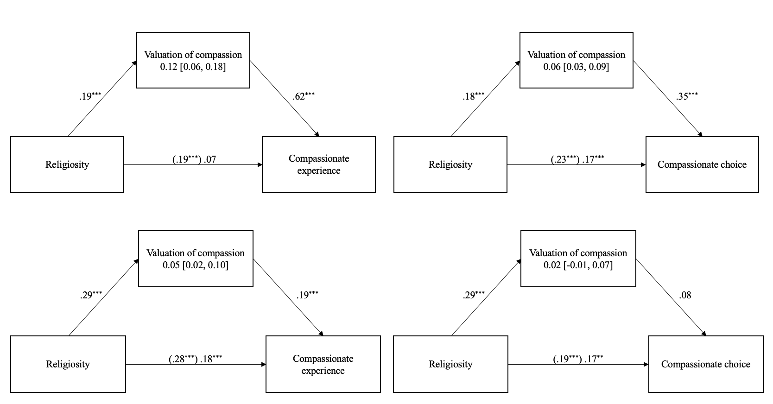
Note. Left panel refers to compassionate experience, right panel denotes compassionate choice. All coefficients are standardized. Confidence intervals not including zero indicate evidence for mediation.

Table S3

Correlations between psychological closeness and compassionate responding (Studies 2, 3)
Variable |  | Choice to be Compassionate | Compassionate experience
Psychological closeness | Study 2 | .31*** | .50***
 | Study 3 | .17** | .35***
Note: * p < .05, ** p < .01, *** p < .001

