Supplementary Results

Supplementary Table 1. Multiple Linear Regression Model for Valence Bias for Words
Variable | Supplementary Model 1
 | b | SE | t
Constant | 0.61*** | 0.09 | 7.17
Distance Within Positive Cluster | -0.01 | 0.01 | -1.40
Distance Within Ambiguous Cluster | -0.01 | 0.01 | -1.39
Distance Between Positive and Ambiguous Cluster | 0.01 | 0.01 | 0.08
F | 1.41
Adjusted R² | 0.01
Note. *** p < 0.001, ** p < 0.01, * p < 0.05

Supplementary Table 2. Multiple Linear Regression Model for Valence Bias for Faces
Variable | Supplementary Model 2
 | b | SE | t
Constant | 0.55*** | 0.15 | 3.77
Distance Within Positive Cluster | 0.01 | 0.01 | 0.74
Distance Within Ambiguous Cluster | -0.01 | 0.01 | -0.60
Distance Between Positive and Ambiguous Cluster | 0.00 | 0.01 | 0.00
F | 0.30
Adjusted R² | -0.01
Note. *** p < 0.001, ** p < 0.01, * p < 0.05
Supplementary Table 3. Task Stimuli
Name | Condition | Image Type | Database | Task
hap_M26_u | Happy | Face | Umea | Valence Bias
07F_HA_O | Happy | Face | NimStim | Valence Bias
sur_M46_u | Surprise | Face | Umea | Valence Bias
sur_M41_u | Surprise | Face | Umea | Valence Bias
AM10ANS | Angry | Face | KDEF | Valence Bias
09F_SP_O | Surprise | Face | NimStim | Valence Bias
28M_SP_O | Surprise | Face | NimStim | Valence Bias
01F_HA_O | Happy | Face | NimStim | Valence Bias
AM35SUS | Surprise | Face | KDEF | Valence Bias
37M_HA_O | Happy | Face | NimStim | Valence Bias
01F_AN_C | Angry | Face | NimStim | Valence Bias
AF14ANS | Angry | Face | KDEF | Valence Bias
sur_F35_u | Surprise | Face | Umea | Valence Bias
02F_SP_O | Surprise | Face | NimStim | Valence Bias
08F_HA_O | Happy | Face | NimStim | Valence Bias
AF01SUS | Surprise | Face | KDEF | Valence Bias
AF02SUS | Surprise | Face | KDEF | Valence Bias
37M_AN_C | Angry | Face | NimStim | Valence Bias
sur_F14_u | Surprise | Face | Umea | Valence Bias
36M_SP_O | Surprise | Face | NimStim | Valence Bias
AM18SUS | Surprise | Face | KDEF | Valence Bias
24M_HA_O | Happy | Face | NimStim | Valence Bias
ang_F48_u | Angry | Face | Umea | Valence Bias
ang_M55_u | Angry | Face | Umea | Valence Bias
08F_AN_C | Angry | Face | NimStim | Valence Bias
AM34SUS | Surprise | Face | KDEF | Valence Bias
sur_M20_u | Surprise | Face | Umea | Valence Bias
20M_AN_C | Angry | Face | NimStim | Valence Bias
AF30SUS | Surprise | Face | KDEF | Valence Bias
ang_M13_u | Angry | Face | Umea | Valence Bias
AF06HAS | Happy | Face | KDEF | Valence Bias
AF08HAS | Happy | Face | KDEF | Valence Bias
27M_SP_O | Surprise | Face | NimStim | Valence Bias
36M_HA_O | Happy | Face | NimStim | Valence Bias
sur_F51_u | Surprise | Face | Umea | Valence Bias
hap_M49_u | Happy | Face | Umea | Valence Bias
AM28ANS | Angry | Face | KDEF | Valence Bias
sur_F6_u | Surprise | Face | Umea | Valence Bias
07F_SP_O | Surprise | Face | NimStim | Valence Bias
hap_F40_u | Happy | Face | Umea | Valence Bias
sur_M55_u | Surprise | Face | Umea | Valence Bias
AM01HAS | Happy | Face | KDEF | Valence Bias
AM06SUS | Surprise | Face | KDEF | Valence Bias
AM12SUS | Surprise | Face | KDEF | Valence Bias
09F_AN_C | Angry | Face | NimStim | Valence Bias
AF13SUS | Surprise | Face | KDEF | Valence Bias
AF34SUS | Surprise | Face | KDEF | Valence Bias
ang_F35_u | Angry | Face | Umea | Valence Bias
2717 | negative | Scene | IAPS | Valence Bias
1440 | positive | Scene | IAPS | Valence Bias
1030 | ambiguous | Scene | IAPS | Valence Bias
1303 | ambiguous | Scene | IAPS | Valence Bias
9220 | negative | Scene | IAPS | Valence Bias
1441 | positive | Scene | IAPS | Valence Bias
2339 | ambiguous | Scene | IAPS | Valence Bias
2485 | ambiguous | Scene | IAPS | Valence Bias
2688 | ambiguous | Scene | IAPS | Valence Bias
9421 | negative | Scene | IAPS | Valence Bias
6410 | ambiguous | Scene | IAPS | Valence Bias
9432 | negative | Scene | IAPS | Valence Bias
8501 | ambiguous | Scene | IAPS | Valence Bias
1710 | positive | Scene | IAPS | Valence Bias
7430 | ambiguous | Scene | IAPS | Valence Bias
7620 | ambiguous | Scene | IAPS | Valence Bias
2091 | positive | Scene | IAPS | Valence Bias
7502 | positive | Scene | IAPS | Valence Bias
4233 | ambiguous | Scene | IAPS | Valence Bias
9295 | negative | Scene | IAPS | Valence Bias
1560 | ambiguous | Scene | IAPS | Valence Bias
2347 | positive | Scene | IAPS | Valence Bias
8010 | ambiguous | Scene | IAPS | Valence Bias
9050 | negative | Scene | IAPS | Valence Bias
7380 | negative | Scene | IAPS | Valence Bias
7570 | ambiguous | Scene | IAPS | Valence Bias
2340 | positive | Scene | IAPS | Valence Bias
2480 | ambiguous | Scene | IAPS | Valence Bias
3360 | ambiguous | Scene | IAPS | Valence Bias
9910 | negative | Scene | IAPS | Valence Bias
6837 | ambiguous | Scene | IAPS | Valence Bias
2057 | positive | Scene | IAPS | Valence Bias
9561 | negative | Scene | IAPS | Valence Bias
2550 | positive | Scene | IAPS | Valence Bias
5825 | positive | Scene | IAPS | Valence Bias
8060 | ambiguous | Scene | IAPS | Valence Bias
8466 | ambiguous | Scene | IAPS | Valence Bias
8380 | positive | Scene | IAPS | Valence Bias
2704 | ambiguous | Scene | IAPS | Valence Bias
3211 | ambiguous | Scene | IAPS | Valence Bias
3310 | ambiguous | Scene | IAPS | Valence Bias
1460 | positive | Scene | IAPS | Valence Bias
4598 | ambiguous | Scene | IAPS | Valence Bias
9830 | negative | Scene | IAPS | Valence Bias
7460 | ambiguous | Scene | IAPS | Valence Bias
9424 | negative | Scene | IAPS | Valence Bias
7590 | ambiguous | Scene | IAPS | Valence Bias
9185 | negative | Scene | IAPS | Valence Bias
RETREAT | ambiguous | Word | NA | Valence Bias
DISCIPLINE | ambiguous | Word | NA | Valence Bias
CRUSH | ambiguous | Word | NA | Valence Bias
BATTER | ambiguous | Word | NA | Valence Bias
PICK | ambiguous | Word | NA | Valence Bias
SURVIVAL | ambiguous | Word | NA | Valence Bias
TRICK | ambiguous | Word | NA | Valence Bias
RUSH | ambiguous | Word | NA | Valence Bias
COURT | ambiguous | Word | NA | Valence Bias
EVIL | negative | Word | NA | Valence Bias
SLAVE | negative | Word | NA | Valence Bias
ROTTEN | negative | Word | NA | Valence Bias
CRAPPY | negative | Word | NA | Valence Bias
DECAY | negative | Word | NA | Valence Bias
DEADLY | negative | Word | NA | Valence Bias
VANDAL | negative | Word | NA | Valence Bias
LOVEABLE | positive | Word | NA | Valence Bias
MUSIC | positive | Word | NA | Valence Bias
MOTHER | positive | Word | NA | Valence Bias
FOOD | positive | Word | NA | Valence Bias
TREASURED | positive | Word | NA | Valence Bias
FRUITFUL | positive | Word | NA | Valence Bias
LEMONADE | positive | Word | NA | Valence Bias
CLOSE | ambiguous | Word | NA | Valence Bias
REVOLUTION | ambiguous | Word | NA | Valence Bias
FIGHTER | ambiguous | Word | NA | Valence Bias
HAIL | ambiguous | Word | NA | Valence Bias
HANG | ambiguous | Word | NA | Valence Bias
OPERATION | ambiguous | Word | NA | Valence Bias
SHAKE | ambiguous | Word | NA | Valence Bias
BEAT | ambiguous | Word | NA | Valence Bias
RADICAL | ambiguous | Word | NA | Valence Bias
THICK | ambiguous | Word | NA | Valence Bias
TRAFFIC | ambiguous | Word | NA | Valence Bias
BREAK | ambiguous | Word | NA | Valence Bias
PISS | negative | Word | NA | Valence Bias
WRECK | negative | Word | NA | Valence Bias
MISFIRE | negative | Word | NA | Valence Bias
SNAPPY | ambiguous | Word | NA | Valence Bias
SPINELESS | negative | Word | NA | Valence Bias
COMEDIAN | positive | Word | NA | Valence Bias
SUNSET | positive | Word | NA | Valence Bias
AMUSE | positive | Word | NA | Valence Bias
THINKER | positive | Word | NA | Valence Bias
Faces_156_h | ambiguous | Scene | NAPS | EmoMap
Faces_347_h | ambiguous | Scene | NAPS | EmoMap
2795 | ambiguous | Scene | IAPS | EmoMap
8475 | ambiguous | Scene | IAPS | EmoMap
8206 | ambiguous | Scene | IAPS | EmoMap
2681 | ambiguous | Scene | IAPS | EmoMap
Faces_267_v_resized.png | ambiguous | Scene | NAPS | EmoMap
9150 | ambiguous | Scene | IAPS | EmoMap
2095 | negative | Scene | IAPS | EmoMap
1151_injuries_infections | negative | Scene | DIRTI | EmoMap
2120 | negative | Scene | IAPS | EmoMap
Sp045 | negative | Scene | GAPED | EmoMap
A067 | negative | Scene | GAPED | EmoMap
1152_injuries_infections | negative | Scene | DIRTI | EmoMap
1254_hygiene | negative | Scene | DIRTI | EmoMap
9322 | negative | Scene | IAPS | EmoMap
5829 | positive | Scene | IAPS | EmoMap
Excited face 5 | positive | Scene | OASIS | EmoMap
P011 | positive | Scene | GAPED | EmoMap
4574 | positive | Scene | IAPS | EmoMap
5833 | positive | Scene | IAPS | EmoMap
Nude couple 7 | positive | Scene | OASIS | EmoMap
8467 | positive | Scene | IAPS | EmoMap
Couple 2 | positive | Scene | OASIS | EmoMap
Note. This table includes all stimuli used across both tasks. UMEA refers to the Umea University Database of Facial Expressions, KDEF refers to the Karolinska Directed Emotional Faces, NimStim refers to the NimStim Set of Facial Expressions. IAPS refers to the International Affective Picture System. Naps refers to the Nencki Affective Picture System. GAPED refers to the Geneva Affective Picture Database. OASIS refers to the Open Affective Standardized Image Set.

Supplementary Table 4. Variance Inflation Factors for Model 1
Variable | VIF
Distance Within Positive Cluster | 2.02
Distance Within Ambiguous Cluster | 3.61
Distance Between Positive and Ambiguous Clusters | 4.30
Note. The variance inflation factors for each variable from the full hierarchical multiple linear regression model predicting valence bias from valence differentiation.
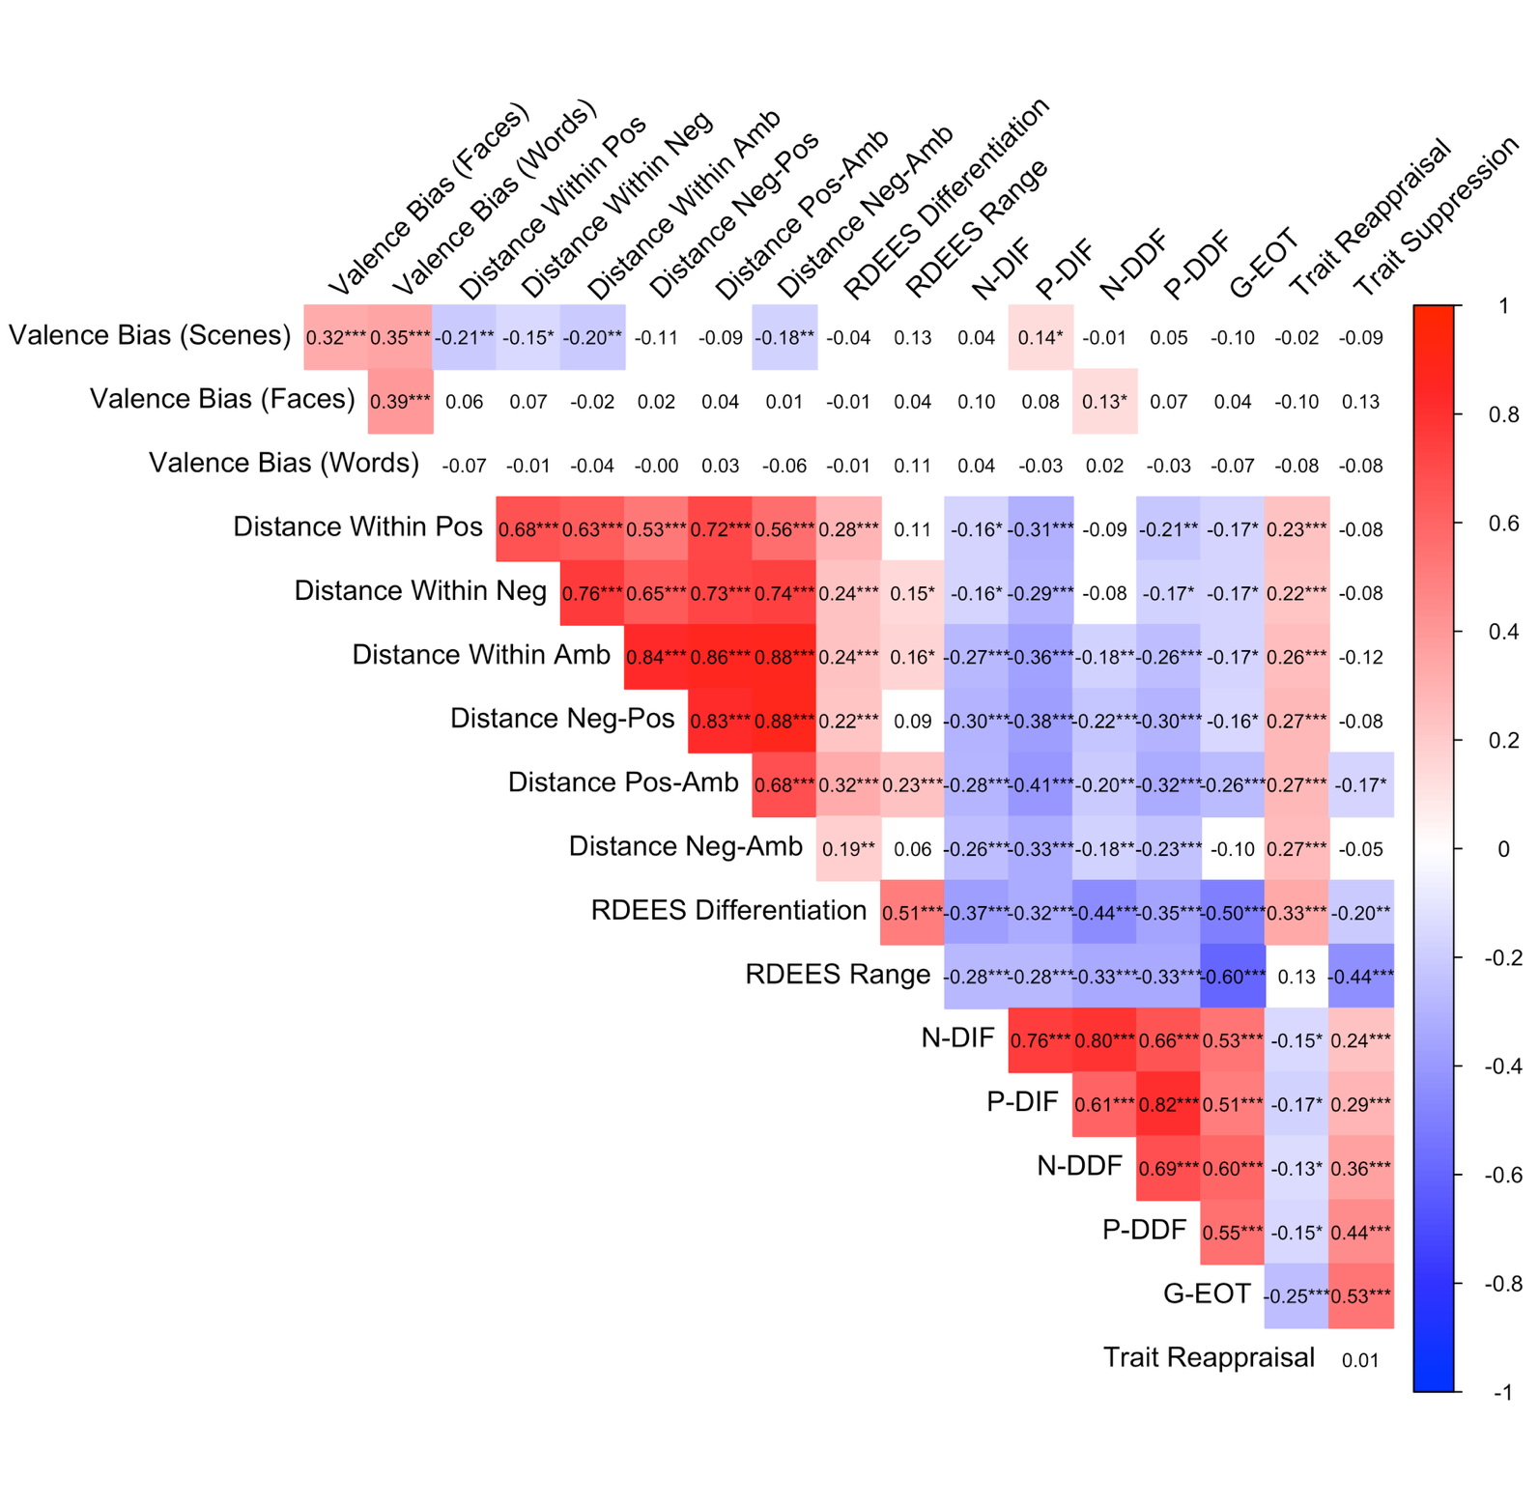
Supplementary Figure 1.
A Heatmap of All Study Variables
Note. Valence Bias (Scenes), Valence Bias (Faces), and Valence Bias (Words) represent participant’s valence bias for scenes only, faces only, and words only, respectively. Distance Within Pos, Distance Within Neg, Distance Within Amb represent the within cluster scores for the valence differentiation task while Distance Neg-Pos, Distance Pos-Amb, and Distance Neg-Amb represent the between cluster scores. RDEES Differentiation and RDEES Range represent the two subscales for the Range and Differentiation of Emotional Experiences Scale. N-DIF, P-DIF, N-DDF, P-DDF, and G-EOT are the subscales for the Perth Alexithymia Scale where the N represents negative emotions and the P represents positive emotions and where DIF represents difficulty identifying feelings, DDF represents difficulty describing feelings, and G-EOT represents general externally oriented thinking. Trait Reappraisal and Trait Suppression represent the two subscales of the Emotion Regulation Questionnaire.

Supplementary Figure 2
Boruta plot for EmoMap Task Variables
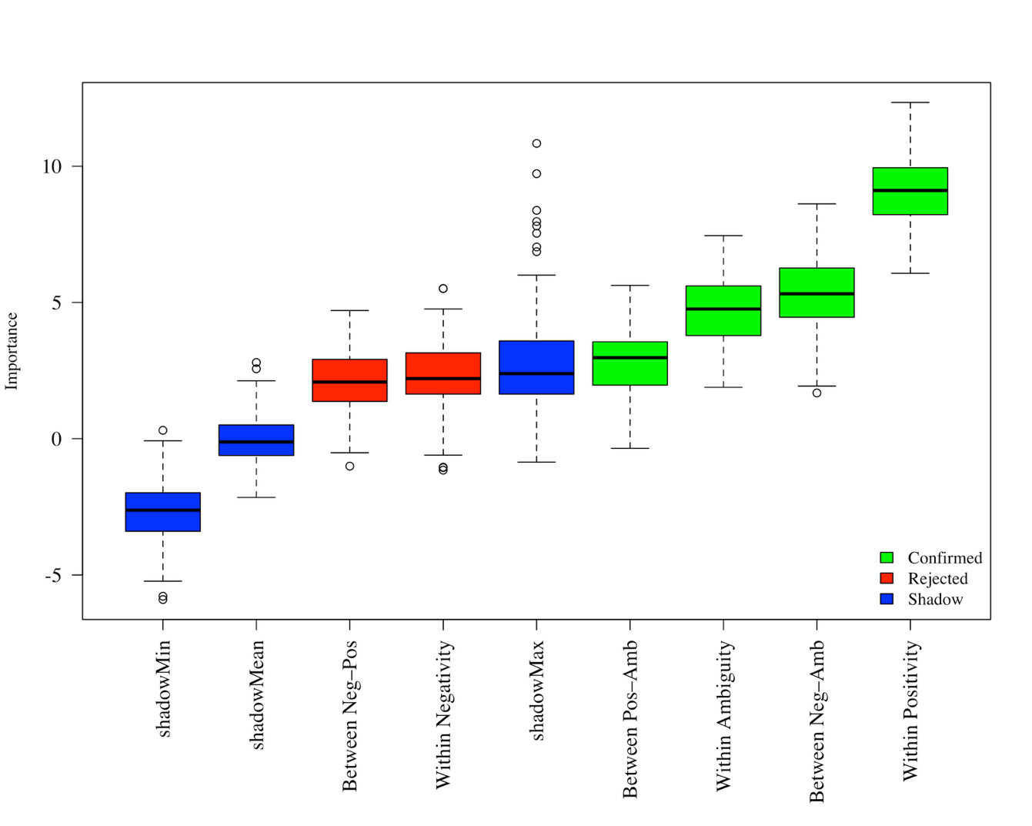
Note. A Boruta plot showing confirmed variables associated with valence bias. Box plots represent importance scores (Z-scores) based on 500 decision trees. shadowMin represents the minimum Z-score calculated from shadow copies created using the Boruta wrapper algorithm, shadowMean is the mean Z-score, and shadowMax represents the maximum Z-score calculated from shadow copies.

Supplementary Figure 3.
Boruta plot for Trait Measures
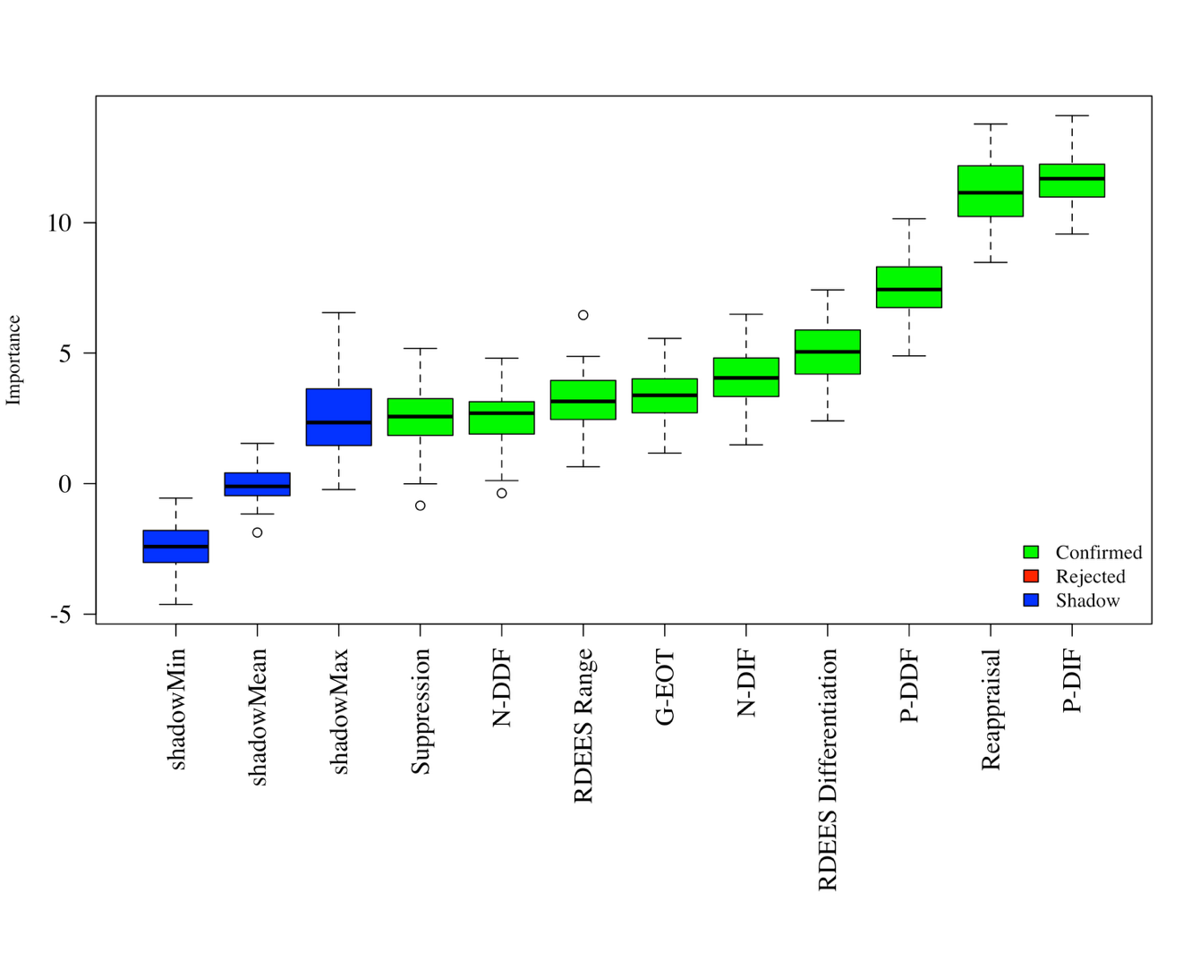
Note. A Boruta plot showing confirmed variables associated with Total Valence Distance. Box plots represent importance scores (Z-scores) based on 500 decision trees. shadowMin representes the minimum Z-score calculated from shadow copies created using the Boruta wrapper algorithm, shadowMean is the mean Z-score, and shadowMax represents the maximum Z-score calculated from shadow copies.

