Supplementary information for: “Structured variation in daily life experience within and across individuals”

Philip Deming¹*, Zulqarnain Khan²*, Katie Hoemann³, Lily Marino¹, Şerife Leman Runyun¹, Zoe Kross¹, Yiyang Gao¹, Liz Cory¹, Catie Nielson¹, Mallory J. Feldman⁴, Madeleine Devlin¹, Jennifer Dy^{2,5}, Lisa Feldman Barrett^{1,6}, Jolie B. Wormwood⁷**, Karen S. Quigley¹**

¹Department of Psychology, Northeastern University, Boston, MA, United States
²Roux Institute, Northeastern University, Portland, ME, United States
³Department of Psychology, University of Kansas, Lawrence, KS, United States
⁴Department of Psychology and Neuroscience, University of North Carolina at Chapel Hill, Chapel Hill, NC, United States
⁵Department of Electrical and Computer Engineering, Northeastern University, Boston, MA, United States
⁶Department of Psychiatry and the Martinos Center for Biomedical Imaging, Massachusetts General Hospital, Charlestown, MA, United States
⁷Department of Psychology, University of New Hampshire, Durham, NH, United States
*These authors contributed equally: Philip Deming and Zulqarnain Khan
**These authors jointly supervised this work: Jolie B. Wormwood and Karen S. Quigley

Supplementary Methods

Payment
Participants received $30 (Cohort 1) or $35 (Cohort 2) for their first in-lab session, $20 per day for the first five days of experience sampling, $30 per day for the second five days of experience sampling, and $40 per day for the final four days of experience sampling. Participants were incentivized to respond to an average of eight prompts per day during experience sampling, and received a $10 bonus for every pay period in which they made this target (i.e., up to 3 times total). Lastly, participants received $50 for their second and final in-lab session. Participants also received a $25 bonus for completion of an in-lab temporal discounting task.

Similar Patterns Across Participants: Sensitivity Analyses of an Original Approach
We selected the final approach for identifying similar patterns across participants after analyses revealed that an originally planned approach was insufficiently sensitive. Following Hoemann et al. (2020), in the original approach each pattern was categorized according to within-pattern effect sizes for each feature. For example, given the effect sizes of each feature, a given pattern would have been labeled as pleasant with high arousal, recorded in a seated position while doing leisure activities in a mixture of social settings, with negligible changes in the cardiovascular features. Similar patterns were those with matching categorical labels.
Using the two simulated datasets described in the main text, in sensitivity analyses we examined the degree to which this original analytic approach would recover similar patterns across participants if they exist. If the original approach were perfectly sensitive, it would have identified (within each dataset) ten patterns each shared by ten participants. Instead, the 0% Additional Noise Simulation identified three patterns each shared by 10-13 participants, four patterns each shared by 4-7 participants, four each shared by 3 participants, and 16 each shared by 1-2 participants. Similarly, the 50% Additional Noise Simulation identified five patterns each shared by 4-7 participants, two patterns each shared by 3 participants, and 35 each shared by 1-2 participants. In sum, although the simulated data were known to consist of patterns that were similar across participants, our original analytic approach gave the appearance that the multimodal patterns were highly variable across people. Since the iMDL-based approach was more sensitive to similarity across participants, this approach replaced the original, effect-size based approach.

Additional Analyses
The Relationship Between Pattern and Sampling Day. We examined the extent to which each participant’s multimodal patterns occurred more frequently on any one experience sampling day. For each participant, a cumulative link model assessed how pattern assignment predicted the sampling day (i.e., an ordinal outcome variable). We further examined all participants whose model achieved significance for any one pattern, that is, who recorded more events within any one pattern on a small subset of days.
The Relationship Between Pattern and Randomly Sampled Events. We also examined the extent to which each participant’s multimodal patterns consisted of a greater proportion of randomly sampled events, relative to biologically-triggered events. For each participant, a binomial logistic regression assessed how pattern assignment predicted whether an event was randomly sampled vs. biologically-triggered. We further examined all participants whose model achieved significance for any one pattern, that is, whose randomly sampled events were overrepresented within a single pattern.

Supplementary Results

The Relationship Between Pattern and Sampling Day
Among 97 participants, 31 demonstrated a significant relationship between events’ pattern assignments and the day on which the events were sampled (see Fig. S12). For example, the first participant displayed in Fig. S12 exhibited a greater percentage of events in one pattern (Pattern C) on days one and seven. Similarly, the fifth participant in Fig. S12 exhibited a greater percentage of events in Pattern B on days nine and fourteen. However, no participants exhibited all events within any one pattern in one day. In other words, every multimodal pattern was observed on more than one experience sampling day. One participant exhibited 70.0% of events within one pattern in one day, the highest percentage observed.
For all other participants, events associated with specific multimodal patterns were relatively evenly distributed across sampling days.

The Relationship Between Pattern and Randomly Sampled Events
Nine of 97 participants demonstrated a significant relationship between events’ pattern assignments and the events’ sampling method (i.e., random vs. biologically-triggered; see Fig. S13). For example, the first participant displayed in Fig. S13 had a higher percentage (62.5%) of randomly sampled events that clustered within one pattern (Pattern C), and this was the highest such percentage observed across participants. No participants displayed a multimodal pattern that was comprised entirely of randomly sampled events.
In all other participants, randomly sampled events were evenly distributed among the observed multimodal patterns.

Supplementary Tables

Table S1. Coding of activity labels from dropdown menu provided to participants
Activity Label from Dropdown Menu | Final Activity Code
Commuting | Non-work task
Preparing food | Non-work task
Housework | Non-work task
Shopping | Non-work task
Personal grooming | Non-work task
Taking care of children | Non-work task
Working | Work
Socializing | Leisure
Relaxing | Leisure
Watching TV | Leisure
On the phone | Leisure
Napping | Leisure
Exercising | Leisure
Intimate relations | Leisure
Praying/meditating/worship | Leisure
Eating | Eating
Using computer/email/internet | Using computer
Other (free label) | Coded by two independent raters

Table S2. Hyperparameters for physiological signal processing
Signal | Hyperparameter | Value | Reference Value | Reference Publication
Electrocardiogram (ECG) | Length of signal for flatness check | 1.2*sampling frequency | 0.8*sampling frequency | (Nabian et al., 2018)
Electrocardiogram (ECG) | Minimum standard deviation for flatness check | 1.00E-05 | 1.00E-05
 | Length for minimum-maximum check | 1.2*sampling frequency | 1.2*sampling frequency
 | Minimum/maximum for max/min check | -.005/.005 | -.005/.005
 | Length of signal for skewness check | 1.2*sampling frequency | 1.2*sampling frequency
 | Length of sub-chunks for skewness check | .064*sampling frequency | .032*sampling frequency
 | Minimum skewness | .45 | .45
Impedance cardiogram (ICG) | Window for point detection around R-peak | -250 ms to +500 ms | -250 ms to +500 ms | (Nabian et al., 2018)
Impedance cardiogram (ICG) | Number of cycles for ensemble averaging | 8 | 8
Impedance cardiogram (ICG) | Maximum dZ/dt slope (d²Z/dt²) for d³Z/dt³ zero-crossings over first third of detected most prominent monotonically-increasing segment | Start threshold at 2*H/fs, increase in steps of 2 until > 1 zero-crossing; max 10*H/fs | 10*H/fs | (Forouzanfar et al., 2018)
 | Minimum d³Z/dt³ value for local maxima over first third of most prominent monotonically-increasing segment | 7*H/fs | 4*H/fs

Supplementary Figures

Fig. S1. The distribution of within-subject means for the cardiovascular features. Box plots display the first and third quartiles as upper and lower hinges and the median as a horizontal bar. Whiskers extend to 1.5 times the interquartile range. Dots represent individual means. Abbreviations: RSA = respiratory sinus arrhythmia; IBI = interbeat interval; PEP = pre-ejection period; LVET = left ventricular ejection time, SV = stroke volume, CO = cardiac output

Fig. S2. The distribution of within-subject percent of events recorded in each posture category (i.e., sitting, standing, lying). Box plots display the first and third quartiles as upper and lower hinges and the median as a horizontal bar. Whiskers extend to 1.5 times the interquartile range. Dots represent individual percentages.

Fig. S3. The distribution of within-subject means for the affective features (i.e., self-reported valence and arousal). Box plots display the first and third quartiles as upper and lower hinges and the median as a horizontal bar. Whiskers extend to 1.5 times the interquartile range. Dots represent individual means.

Fig. S4. The distribution of within-subject percent of events reported for each activity category (i.e., leisure, work, non-work task, eating, using computer). Box plots display the first and third quartiles as upper and lower hinges and the median as a horizontal bar. Whiskers extend to 1.5 times the interquartile range. Dots represent individual percentages.

Fig. S5. The distribution of within-subject percent of events reported for each social context category (i.e., alone and not alone). Box plots display the first and third quartiles as upper and lower hinges and the median as a horizontal bar. Whiskers extend to 1.5 times the interquartile range. Dots represent individual percentages.

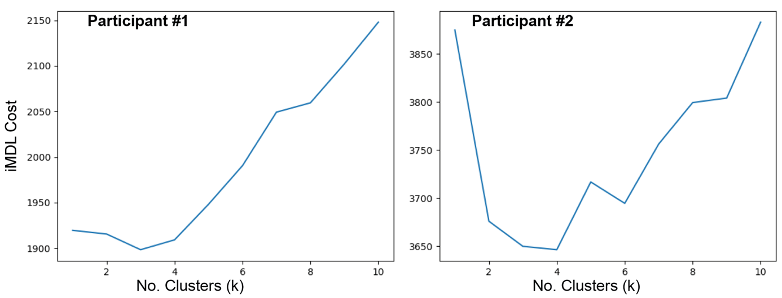
Fig. S6. Cost of segregating events into k clusters for two example participants. INTEGRATE (Böhm et al., 2010) allows for automatic selection of the appropriate number of clusters. This is achieved by running the method for a range of k clusters (1 to 10 in this case) and calculating the optimum information-theoretic minimum description length (iMDL) cost for each choice. When the number of clusters is too small, iMDL cost is high as the data is not sufficiently compressed. Similarly, when the number of clusters is too high, iMDL cost goes up again as the model complexity increases too much and offsets the gains made from data compression. The number of clusters that corresponds to the smallest iMDL cost (3 for Participant #1, 4 for Participant #2) is the choice recommended by INTEGRATE, and used in all further analysis and results.

Fig. S7. Summaries of multimodal patterns for four additional example subjects. Cardiovascular and mental features (i.e., valence and arousal), which are continuous, are displayed on radar plots, in which dark red lines represent the within-pattern mean, and light red lines represent the within-pattern standard deviation. The middle (i.e., second largest) ring represents zero. Values toward the center are negative, values toward the outside are positive. The social context, posture, and primary activity, which are categorical, are summarized in donut plots. Section size represents the proportions of within-cluster events.

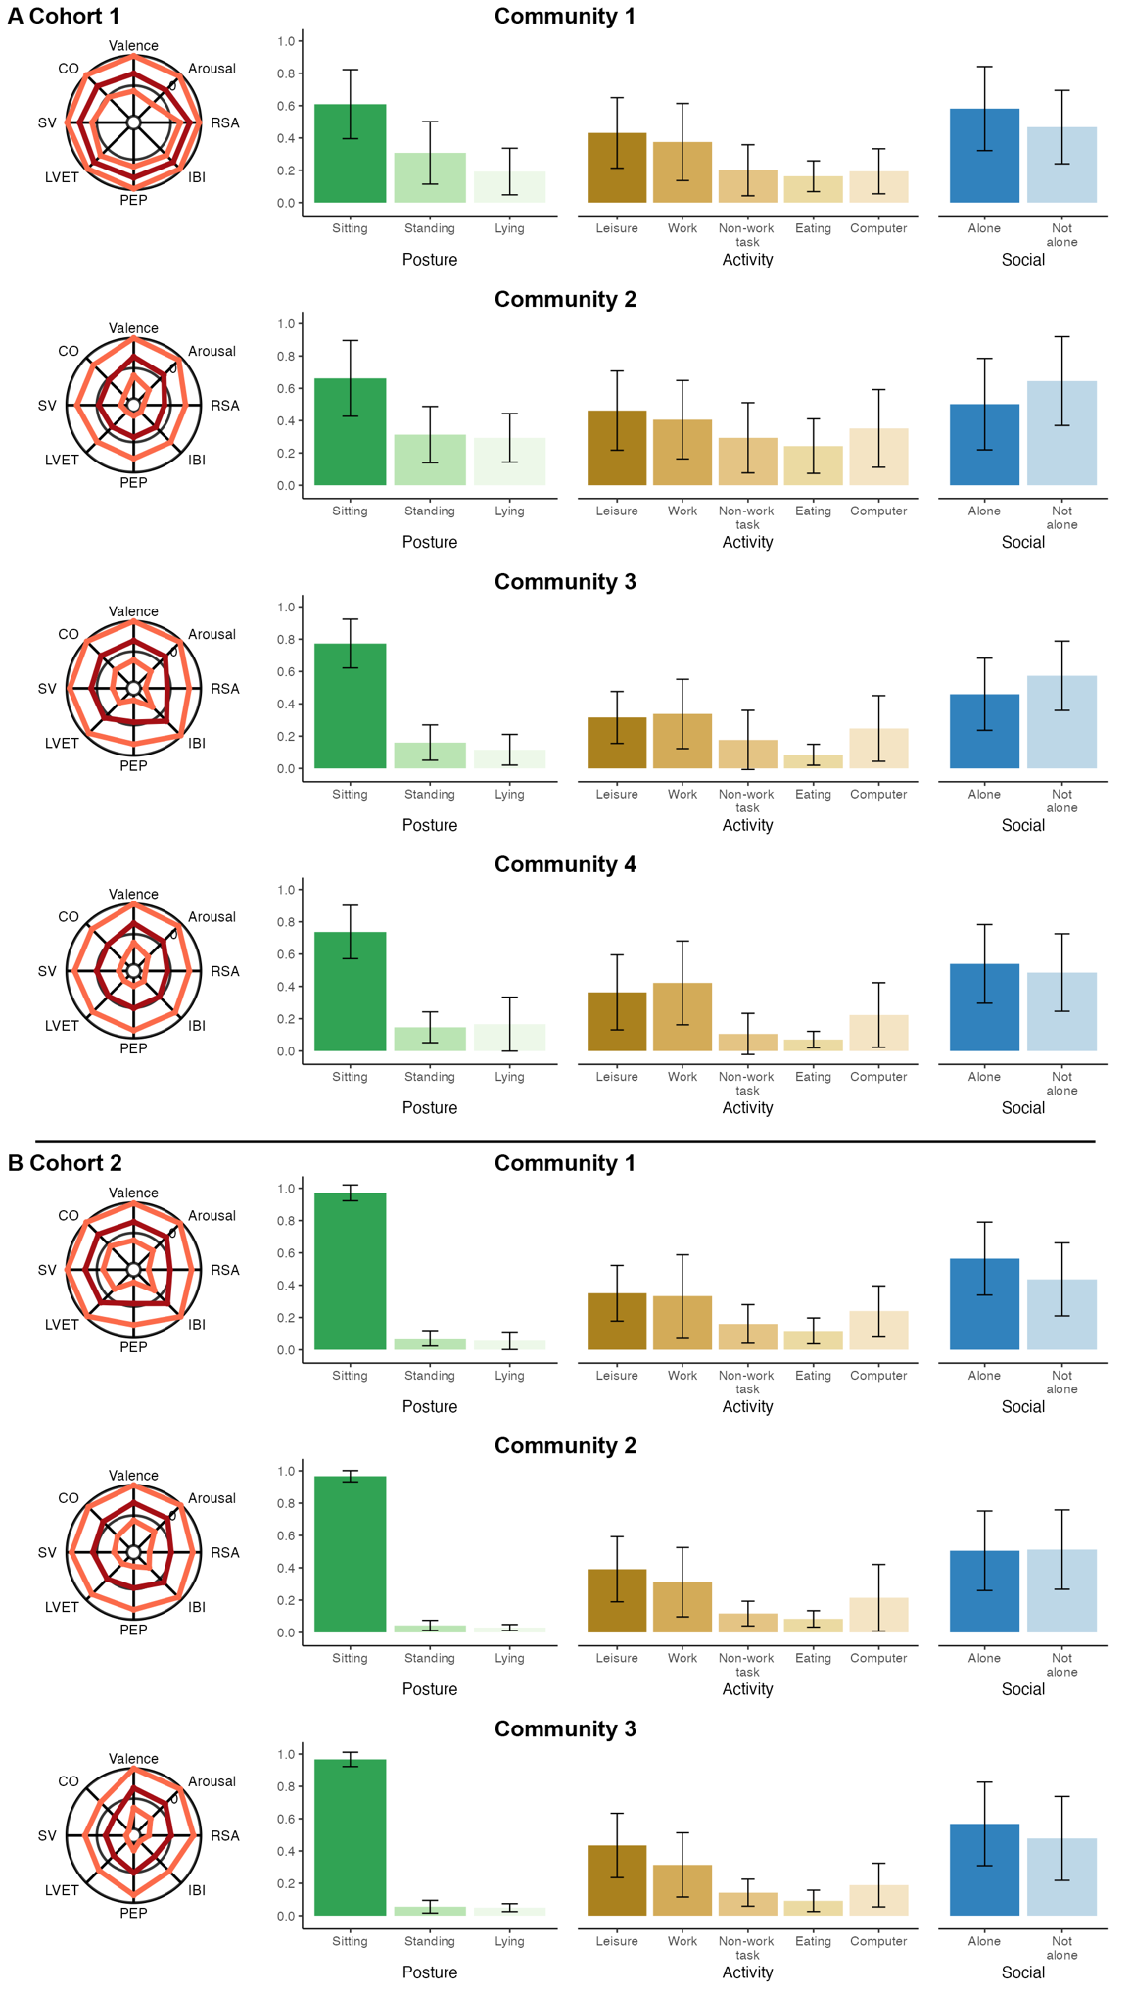
Fig. S8. Summaries of communities of common patterns (across participants) identified by Louvain community detection. Cardiovascular and mental features (i.e., valence and arousal), which are continuous, are displayed on radar plots, in which dark red lines represent the within-community mean, and light red lines represent the within-community standard deviation. The middle (i.e., second largest) ring represent zero. Values toward the center are negative, values toward the outside are positive. The social context, posture, and primary activity, which are categorical, are summarized in bar plots with error bars showing one standard deviation above and below the within-community mean.

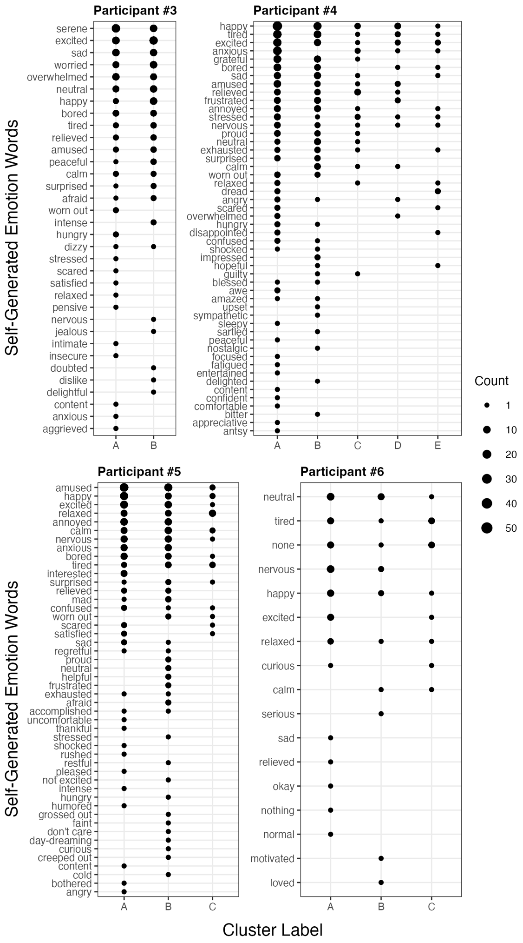
Fig. S9. Within- and between-person variability in the emotion words used to describe each multimodal pattern, presented for four additional example participants (the same as presented in Fig. S1) with differing numbers of patterns and emotion words.

Fig. S10. Summaries of prescribed patterns for an example participant from Group 2 of the 0% Additional Noise Simulation Dataset. Cardiovascular and mental features (i.e., valence and arousal), which are continuous, are displayed on radar plots, in which dark red lines represent the within-pattern mean, and light red lines represent the within-pattern standard deviation. The middle (i.e., second largest) ring represents zero. Values toward the center are negative, values toward the outside are positive. The social context, posture, and primary activity, which are categorical, are summarized in donut plots. Section size represents the proportions of within-cluster events.

Fig. S11. Summaries of prescribed patterns for an example participant from Group 2 of the 50% Additional Noise Simulation Dataset. Cardiovascular and mental features (i.e., valence and arousal), which are continuous, are displayed on radar plots, in which dark red lines represent the within-pattern mean, and light red lines represent the within-pattern standard deviation. The middle (i.e., second largest) ring represents zero. Values toward the center are negative, values toward the outside are positive. The social context, posture, and primary activity, which are categorical, are summarized in donut plots. Section size represents the proportions of within-cluster events.

Fig. S12. The proportion of events within each pattern that were recorded on each experience sampling day. Thirty-one participants are displayed (each in a separate panel), each of whom recorded more events within a pattern on a small subset of days, as revealed by cumulative link models.

Fig. S13. The proportion of events within each pattern that were randomly sampled vs. biologically triggered. Nine participants are displayed (each in a separate panel), each of whom recorded a significant proportion of randomly sampled events within a single pattern, as revealed by binomial logistic regression models.

References

Böhm, C., Goebl, S., Oswald, A., Plant, C., Plavinski, M., & Wackersreuther, B. (2010). Integrative parameter-free clustering of data with mixed type attributes. In M. J. Zaki, J. X. Yu, B. Ravindran, & V. Pudi (Eds.), Advances in Knowledge Discovery and Data Mining (Vol. 6118, pp. 38–47). Springer Berlin Heidelberg. https://doi.org/10.1007/978-3-642-13657-3_7
Forouzanfar, M., Baker, F. C., De Zambotti, M., McCall, C., Giovangrandi, L., & Kovacs, G. T. A. (2018). Toward a better noninvasive assessment of preejection period: A novel automatic algorithm for B‐point detection and correction on thoracic impedance cardiogram. Psychophysiology, 55(8), e13072. https://doi.org/10.1111/psyp.13072
Hoemann, K., Khan, Z., Feldman, M. J., Nielson, C., Devlin, M., Dy, J., Barrett, L. F., Wormwood, J. B., & Quigley, K. S. (2020). Context-aware experience sampling reveals the scale of variation in affective experience. Scientific Reports, 10(1), 1–17. https://doi.org/10.1038/s41598-020-69180-y
Nabian, M., Yin, Y., Wormwood, J., Quigley, K. S., Barrett, L. F., & Ostadabbas, S. (2018). An open-source feature extraction tool for the analysis of peripheral physiological data. IEEE Journal of Translational Engineering in Health and Medicine, 6, 1–11.

