Supplementary Materials
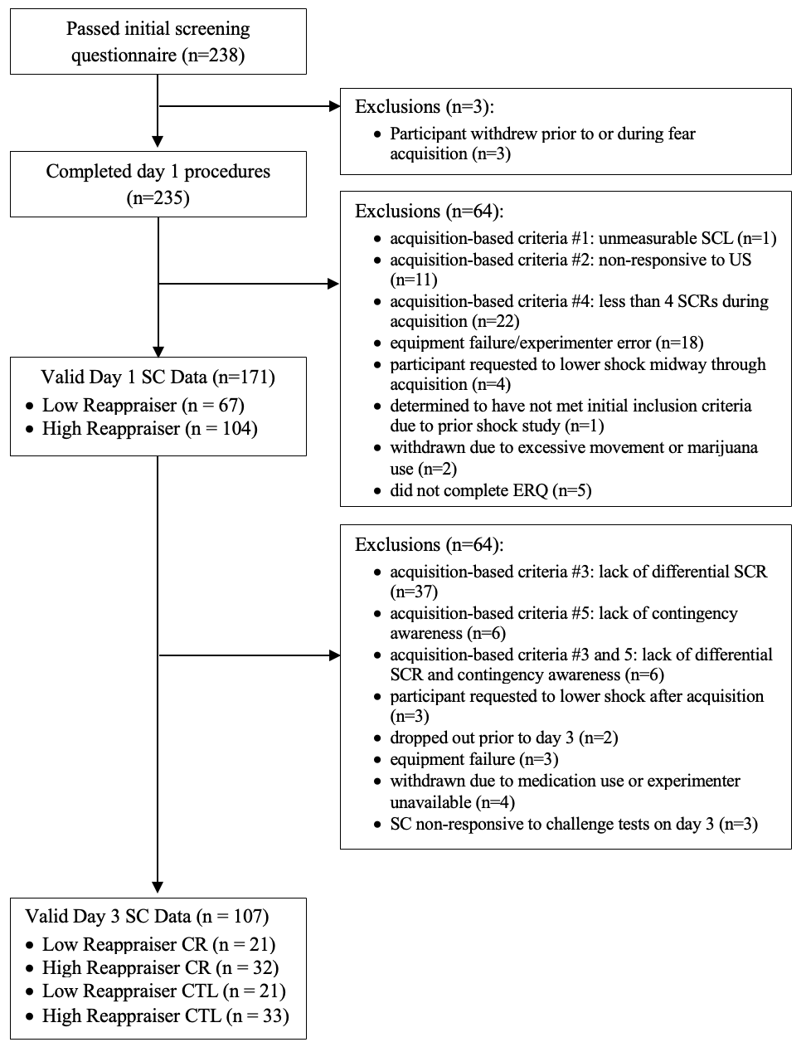
Figure S1. Flow diagram of participants through the study and reasons for exclusion

Table S1. Demographics of excluded participants
 | All excluded (n=119ª) | Excluded for SC-related reasons (n=80^{b})
Age M(SD) | 25.1(7.7)* | 25.3(7.8)*
Sex %(n) | - 70% (83) Female  - 29% (35) Male  - 1% (1) Other | - 71% (56) Female  - 28% (22) Male  - 1% (1) Other
Education %(n) some college or less | 55% (66) | 49% (39)
Ethnicity %(n) Non-Hispanic or Latino | 91% (108)* | 90% (71)
Race %(n) | - 1% (1) American Indian or Alaska Native  - 39% (46) Asian  - 24% (28) Black or African American  - 8% (9) More than one race  - 4% (5) Other  - 25% (30) White or Caucasian | - 1% (1) American Indian or Alaska Native  - 38% (30) Asian  - 20% (16) Black or African American  - 9% (7) More than one race  - 4% (3) Other  - 28% (22) White or Caucasian
English Native Language %(n) | 70% (83) | 68% (54)

Note. ªMissing demographics on 12 excluded participants out of 238 total who passed initial screening questionnaire. ^{b}Missing demographics on 1 participant. SC = skin conductance. *Significant difference from analyzed participants (n=107; p<.05).

Table S2. Participant study design related characteristics by dispositional reappraisal/manipulation group and overall
 | Low Reappraiser CR (n=21) | High Reappraiser CR (n=32) | Low Reappraiser CTL (n=21) | High Reappraiser CTL (n=33) | All groups (n=107)
Day 1 shock voltage level Mean(SD) | 37.4(10.0)V | 36.3(11.8))V | 37.9(10.2)V | 36.8(9.7)V | 37.0(10.4)V
Day 1 perceived shock intensity level (0-9) Mean(SD) | 5.67(0.98) | 5.66(1.58) | 5.67(1.20) | 5.49(1.23) | 5.61(1.28)
Day 1 average raw UCR Mean(SD) | 2.66(2.13) | 2.59(1.90) | 3.26(2.46) | 3.33(2.49) | 2.96(2.24)
Day 1 CS+ category %(n) birds | 52%(11) | 44%(14) | 57%(12) | 42%(14) | 48%(51)
Day 2 manipulation duration Mean(SD) minutes | 23.5(4.2) | 23.4(3.4) | 23.0(4.5) | 22.1(3.0) | 22.9(3.7)
Day 2 proportion received memory reactivation %(n) | 62%(13) | 44%(14) | 57%(12) | 43%(14) | 50%(53)
Day 3 perceived CR success rating (0-10) Mean(SD) | 6.19(2.14) | 7.23(1.54)ª | n/a | n/a | 6.8(1.9)

Note. ªValue missing for one participant. CR = cognitive restructuring; CTL = control; UCR = unconditioned response

Table S3. Example Cognitive Restructuring Worksheet
Objects/Events | Automatic Emotion(s)  Rate intensity of each (0-6) | Automatic Thought(s)  Rate belief in each (0-6) | Alternative Thought(s)  Rate belief in each (0-6) | Outcome  Re-rate belief in automatic thoughts and intensity of automatic emotion
Images that were followed by the shock  fish / birds  (circle one) | - Nervous (6)  - Uncomfortable (6) | - “I am definitely going to be shocked.” (5)  - “I really don’t like these fish.” (5) | - “I may or may not be shocked.” (6)  - “The fish are pretty colors.” (5) | Post-ratings Automatic Emotions:  - (3)  - (1)  Post-ratings Automatic Thoughts:  - (0)  - (2)
The shock | - Anxious (5)  - Scared (6) | - “I am not going to be able to handle it.” (5)  - “The sensation of the shock is so unpleasant.” (5) | - “It’s not that bad.” (6)  - “I have tolerated much worse sensations and been okay.” (5) | Post-ratings Automatic Emotions:  - (2)  - (1)  Post-ratings Automatic Thoughts:  - (1)  - (2)
Note. Cognitive restructuring worksheet used during the manipulation with example responses.

