Title: The memory palace architect: effect of valence on loci-dependent recall performance

Authors: Nicholas Chiang, Akram Bakkour*

Affiliations: Department of Psychology, Institute for Mind and Biology, Neuroscience Institute, University of Chicago; Chicago, IL 60637, USA.
*Corresponding author. Email: bakkour@uchicago.edu

Permissions Alert:

Figure S1. All Minecraft images used in this study were created in accordance with the official Minecraft Usage Guidelines, which permit users to create and share screenshots and videos of their own gameplay for both personal and commercial purposes, including academic publications, provided the Minecraft logo or brand is not used. The white house used in the memory palace still was adapted from a publicly available YouTube tutorial (HALNY, 2023), but NC built the structure independently within his own game world and captured all screenshots himself. Accordingly, the images shown here are original gameplay content and do not require additional permissions.

Figure S2. The icon representing the “Self-Assessment Manikin (SAM)” in Figure 1A, and the full SAM displayed in Figure S2, were adapted from the original Self-Assessment Manikin developed by Bradley and Lang (1994). For Figure S2, the SAM was modified to include numerical labels and “Arousal” and “Valence” descriptors. Permission to reproduce the SAM was granted by Elsevier, the copyright holder of Bradley and Lang (1994).

Figure S3. The first-row images in Figure S3 were adapted from the LaMem dataset (Khosla et al., 2015), which is freely available through MIT CSAIL for academic research and educational use. The second-row images were adapted from the MemCat database (Goetschalckx & Wagemans, 2019), whose usage guidelines permit image use for academic research purposes. All images in Figure S3 were used solely for research and illustrative purposes and comply with the LaMem and MemCat licensing terms.

Supplemental Material

Pilot Study

Methods

Participants

Forty-six participants were recruited from online crowdsourcing platform Amazon Mechanical Turk (AMT) and tested using Cognition.run. AMT participants were pre-screened using CloudResearch to ensure robust data quality (Hauser et al., 2022). Data was collected following the standards of the University of Chicago’s Institutional Review Board (IRB) and participants provided informed consent prior to participation in the study. We only considered participants in our analysis who were between the ages of 18 and 65 years old, had a level of education of high school diploma or higher, and reported no mental or learning disabilities. No participants were excluded based on selection criteria. All participants were compensated at a rate of $7.50 per hour ($1.25 for a 10-minute task).

Task Setup

Prior to collecting data for the main task, we conducted a pilot study to calibrate the arousal and valence of the memory palaces such that they had approximately equal, moderately low arousal but opposite valences. This is based on the circumplex model for affect (Russell, 1980) that categorizes emotion along the dimensions of valence and arousal, where valence describes the extent to which an emotion is positive or negative and arousal captures the magnitude of the emotional state (Barrett & Russell, 1999; Lang, Bradley, & Cuthbert, 1997; Russell, 2003; Posner, Russell, & Peterson, 2005). The PAD emotional state model, of which the PA part of PAD represents the dimensions of pleasure (valence) and arousal on the circumplex model for affect, states that physical environments influence behavioral responses through pleasure, arousal, and dominance (Mehrabian & Russell, 1974). This model has been widely applied in environmental psychology to examine how modifications to physical environments can influence human emotion and has informed approaches to interior and architectural design (McCormack et al., 2004; Banaei et al., 2020). For this study, our memory palace featured a two-story house blueprint designed using sandbox application Minecraft that was maintained across treatment groups, but specific design elements within the house were altered to evoke positive or negative emotion (Figure S1). Minecraft was used due to its flexibility in the construction of specialized 3D, virtual environments through its wide offering of colors and material types (Brashears, 2024).

The positively valenced house utilized warmer and brighter colors (Rong, 2023; Dou & Xue, 2025; Jonauskaite & Mohr, 2025; Song et al., 2025), ample natural lighting (Morales-Bravo et al., 2022; Goldberg, 2025), and upbeat and pleasant décor (Evans & McCoy 1998; Hong et al., 2025), while the negatively valenced house utilized cooler and darker colors (Jonauskaite et al., 2020; Jonauskaite & Mohr, 2025), dim and sober lighting (Yan et al., 2019), and melancholic and serious décor (Cho et al., 2022). For example, exposure to and mental imagery of natural environments and green spaces have been shown to elicit positive emotions (Koivisto & Grassini, 2023; Vitale & Bonaiuto, 2024). Thus, the positive house contains a well-kept garden with vibrant flora while the negative house contains a poorly kept garden with dead flora. Visual exposure to smooth, metallic, and wooden materials, such as the quartz blocks and oak planks used in the positive house, is associated with greater pleasure when compared to rugged, stone-like materials, such as the stone bricks used in the negative house (Rice et al., 2006; Bertheaux et al., 2024). Window design is a key element in interior design, and window view quality is associated with psychological comfort (Aries et al., 2010). The positive house has transparent glass panes that allow for an unobstructed window view outside, while the negative house has translucent, brown-stained glass panes that obstruct the view outside and reduce transmitted natural light. Collectively, the manipulation of these design characteristics is rooted in the biophilia hypothesis, which suggests that humans possess an inherent biological and genetic affinity for nature – a connection often diminished by built environments that disrupt natural systems and separate occupants from the natural world (Kellert & Wilson, 1993; Gaekwad et al., 2022). We hypothesize that a built environment that utilizes a biophilic design, such as the positive house, would increase positive affect while one that does not utilize biophilic design would increase negative affect.

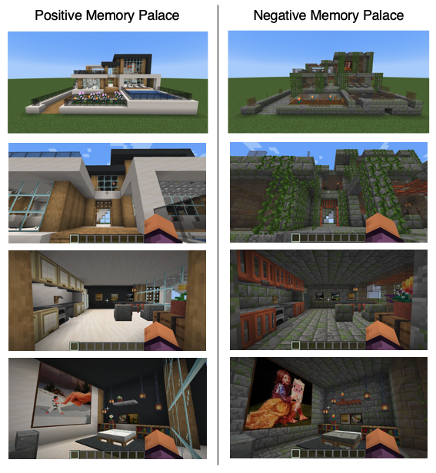
Figure S1. Example imaged locations in positive and negative memory palaces. Both positive and negative houses have the same overall layout but different interior design to evoke positive and negative valence respectively. These imaged locations were inputted into ResMem to estimate the memorability of the positive and negative houses. The images were created and included in accordance with Minecraft usage guidelines.

Participants were randomly assigned to either the positive (N = 23) or negative (N = 23) memory palace treatment groups. For each group, participants viewed 18 imaged locations that captured different areas around their correspondingly assigned house and were asked to complete a Self-Assessment Manikin (SAM; Bradley & Lang, 1994; Figure S2). Participants rated their arousal on a Likert-like scale of 1 to 9, with 1 being the least aroused and 9 being the most aroused. Participants rated valence on a scale of -4 to 4, with -4 being the most negatively valenced and 4 being the most positively valenced. Numbers for valence and arousal were hidden, and only pictorial representations were visible.

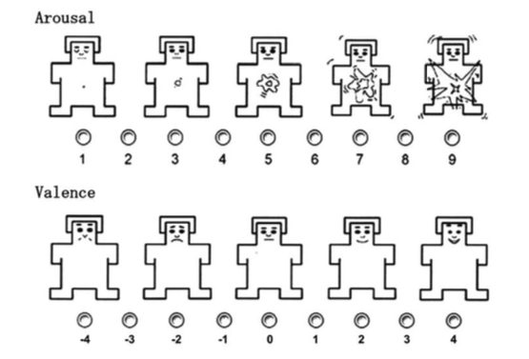
Figure S2. Self-assessment Manikin (SAM). Participants rate their level of arousal (1 to 9) and valence (-4 to 4) after viewing the video traversing the house that will later be used as a memory palace. The figure was modified with permission from Bradley and Lang (1994).

Memorability has also been found to be an intrinsic property of images that can influence how likely a novel stimulus is eventually remembered or forgotten (Bainbridge, 2020). Because the memorability of memory palaces may influence recall performance, we tested whether the positive and negative stimuli had approximately similar memorability using ResMem, a machine learning model for predicting the intrinsic memorability of an image (Needell & Bainbridge, 2022). ResMem was trained on a mixture of two datasets: the Large Scale Memorability Dataset (LaMem) containing 60,000 images (Khosla et al., 2015) and a smaller 10,000 category-based image set quantified on memorability (MemCat; Goetschalckx & Wagemans, 2019). While MemCat contains object-focused images that are of higher quality and more naturalistic, LaMem is a compilation of several other datasets and contains a diverse array of images such as scenes, people, objects, iconography, and text that are more unconventional and enable ResMem to be more generalizable (Needell & Bainbridge, 2022; Figure S3). Because a vast majority of LaMem’s images are scenes, ResMem may also potentially be a well-suited model for testing the memorability of Minecraft stills. We inputted 18 image stills from each video traversing the positive or negative house (Figure S1) into ResMem. ResMem assigned an estimated memorability score between 0 and 1 to each image, with 0 being least memorable and 1 being most memorable.

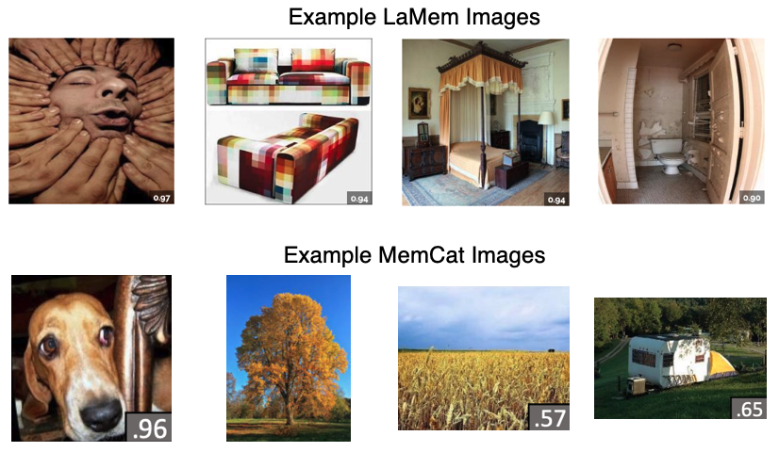
Figure S3. LaMem and MemCat example images used to train ResMem model. While MemCat images are more naturalistic, LaMem images are more unconventional. The use of LaMem and MemCat enables ResMem to be a more generalizable model for predicting memorability. LaMem images included according to terms of use by Khosla et al. (2015). MemCat images included according to terms of use by Goetschalckx, L., & Wagemans, J. (2019).

Data Analysis

We tested the normality of data distribution obtained from the pilot study to determine whether to conduct parametric or non-parametric statistical tests. Based on the results of the Shapiro-Wilk normality test, the distributions of positive arousal and positive valence scores were non-normal, so we used a non-parametric Mann-Whitney U-test to compare arousal and valence between groups (Positive group arousal: p = .012, Positive group valence: p < .001). The distribution of ResMem scores were approximately normal (Positive group: p = .13, Negative group: p = .21), so we used a Student’s t-test to compare memorability scores between groups.

Results

Successful calibration of house stimuli with same arousal and memorability but opposite valence

Using the data collected from the pilot study, we examined whether the positively valenced and negatively valenced houses evoked similar arousal but opposite valence to ensure that only valence was manipulated since the goal of the overall study is to deduce the effect of memory palace valence on method of loci (MOL) mediated recall performance. The positive stimuli (M = 4.26, SD = 2.00) and negative stimuli (M = 4.17, SD = 1.95) evoked approximately equal arousal in participants (Mdn_{pos} = Mdn_{neg} = 5, Mann-Whitney U = 273.5, p = .85, |δ| = 0.03). However, the positive (M = 2.87, SD = 0.87) and negative (M = -1.13, SD = 1.79) stimuli evoked a significantly different valence (Mdn_{pos} = 3, Mdn_{neg} = -1, Mann-Whitney U = 510, p < .001, |δ| = 0.93). A negligible effect size (|δ| ≤ 0.147) for arousal and large effect size for valence measured by Cliff’s δ, a non-parametric analog of Cohen’s d, support the findings from the U-test. Thus, arousal was held approximately constant, but valence was isolated and manipulated between houses, as seen by the overlapping arousal density distributions (Figure S4A) but bimodal valence density distributions for positive and negative treatment groups (Figure S4B). The arousal scores corresponded to dull to neutral intensity (Geethanjali et al., 2016) while the stimuli were oppositely valenced.

We also tested whether the two houses had similar memorability since memorability can influence memory recall by comparing ResMem memorability scores. The positive (M = 0.70, SD = 0.069) and negative (M = 0.69, SD = 0.066) houses were found to be similar in memorability with small effect size (t(33.95) = 0.47, p = .64, d = 0.16, Figure S4C). Thus, intrinsic memorability did not differ between the two stimuli. Overall, using SAM and ResMem, the results of the pilot study indicate that we were able to successfully calibrate the positive and negative memory palaces to have approximately equal arousal and memorability and opposite valence.

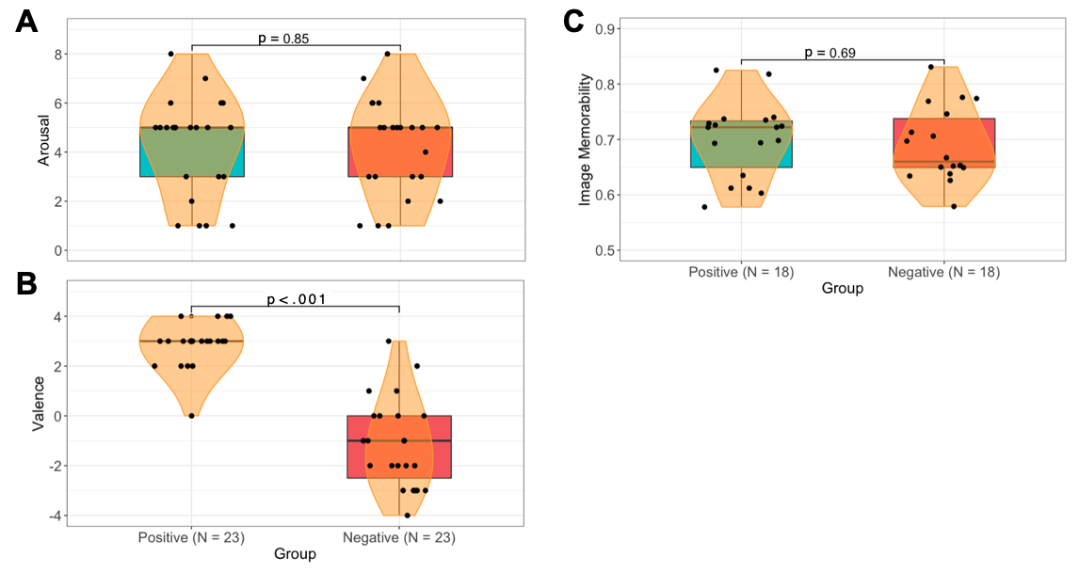
Figure S4. Calibration of positively and negatively valenced memory palaces. The positive and negative houses were rated with approximately equal arousal (A), but opposite valences (B). The two houses were also found to have approximately equal memorability scores (C). For (A) and (B), each point represents an individual participant’s arousal and valence rating for the series of images. For (C), each point represents a ResMem score from each image. Pirate plot consists of boxplot with median score, upper and lower quartile whiskers, and smoothed density curve.

Main Study

Methods

Study Phase

MOL Instructions
In the word recall and process recall experiments, participants were first given the following instructions on how to apply MOL technique:

You will now begin a new task involving the method of loci. The method of loci, or memory palace technique, is a mnemonic device that leverages spatial memory to enhance recall. For example, if you are memorizing a shopping list, you could associate each item on the shopping list with a room in your house. When you mentally walk through the house from room to room, you can recall the items you associated with each room. You will be performing a similar exercise using method of loci and using the house from the video you just watched.

After participants understand the instructions for how to apply MOL, they click to continue to the study phase of the experiment.

Word Recall Experiment
In the study phase for the word recall experiment, we filtered the ANEW corpus to include words with a neutral valence and arousal (5 on a 9-point rating scale for both valence and arousal). We also ensured that the words were commonly used in a wide range of English-written texts (Kucera-Francis written frequency between 1 and 20 per million words; Kucera & Francis, 1964). Finally, we selected words with relatively high familiarity (degree of prior exposure) and imageability (ease of generating a mental image; 5 to 7 on a 7-point scale) according to the Glasgow Norms ratings (Scott et al., 2018). The 31 words used in the word recall experiment are listed in Table S1.

From the grand mean and grand standard deviation, the valence and arousal of the word list are approximately neutral (Valence: M_{grand} = 5.14, SD_{grand} = 1.76; Arousal: M_{grand} = 4.47, SD_{grand} = 2.34). Valence is not skewed towards either positive or negative affect, while arousal is minimally skewed towards dull intensity (SAM rating ≲ 5; Geethanjali et al., 2016). The mean Kucera-Francis written frequency is 6.42 per million words (SD = 5.72). The mean familiarity and imageability ratings were roughly similar, though words tended to have greater imageability than familiarity (Familiarity: M_{grand} = 5.67, SD_{grand} = 1.54; Imageability: M_{grand} = 6.41, SD_{grand} = 1.07; Figure S5).

Word | Valence |  | Arousal |  | K-F Written Frequency (per million words) | Familiarity |  | Imageability
 | Mean | SD | Mean | SD | Number | Mean | SD | Mean | SD
Alien | 5.60 | 1.82 | 5.45 | 2.15 | 16 | 5.03 | 1.8 | 5.824 | 1.855
Alley | 4.48 | 1.97 | 4.91 | 2.42 | 8 | 5 | 1.503 | 6.182 | 0.999
Ankle | 5.27 | 1.54 | 4.16 | 2.03 | 8 | 6.346 | 1.107 | 6.724 | 0.69
Beast | 4.23 | 2.41 | 5.57 | 2.61 | 7 | 5.047 | 1.653 | 5.563 | 1.345
Boxer | 5.51 | 1.80 | 5.12 | 2.26 | 1 | 5.531 | 1.732 | 6.618 | 0.642
Clock | 5.14 | 1.54 | 4.02 | 2.54 | 20 | 6.407 | 1.028 | 6.448 | 1.003
Dentist | 4.02 | 2.23 | 5.73 | 2.13 | 12 | 5.909 | 1.422 | 6.424 | 1.156
Fabric | 5.30 | 1.20 | 4.14 | 1.98 | 15 | 5.771 | 1.436 | 5.706 | 1.273
Fork | 5.29 | 0.97 | 3.96 | 1.94 | 14 | 6.415 | 1.201 | 6.667 | 0.876
Frog | 5.71 | 1.74 | 4.54 | 2.03 | 1 | 5.429 | 1.72 | 6.889 | 0.314
Fur | 4.51 | 1.88 | 4.18 | 4.32 | 13 | 5.813 | 1.55 | 6.303 | 1.193
Hammer | 4.88 | 1.16 | 4.58 | 2.02 | 9 | 5.471 | 1.557 | 6.629 | 0.759
Hawk | 5.88 | 1.62 | 4.39 | 2.29 | 14 | 5.7 | 1.636 | 6.303 | 0.969
Hay | 5.24 | 1.24 | 3.95 | 2.58 | 19 | 5.375 | 1.728 | 6.594 | 0.701
Insect | 4.07 | 2.16 | 4.07 | 2.46 | 14 | 6.063 | 1.345 | 6.294 | 1.404
Ketchup | 5.60 | 1.35 | 4.09 | 2.08 | 1 | 6.375 | 1.111 | 6.118 | 1.51
Knot | 4.64 | 1.36 | 4.07 | 2.15 | 8 | 5.324 | 1.71 | 6.265 | 1.171
Lantern | 5.57 | 1.19 | 4.05 | 2.28 | 13 | 5.094 | 1.721 | 6.571 | 0.728
Mushroom | 5.78 | 2.22 | 4.72 | 2.33 | 2 | 6.063 | 1.029 | 6.849 | 0.359
Nursery | 5.73 | 2.30 | 4.04 | 2.74 | 13 | 5.546 | 1.519 | 5.765 | 1.19
Owl | 5.80 | 1.31 | 3.98 | 1.87 | 2 | 6.156 | 1.228 | 6.719 | 0.672
Pig | 5.07 | 1.97 | 4.20 | 2.42 | 8 | 5.5 | 1.658 | 6.7 | 0.526
Poster | 5.34 | 1.75 | 3.93 | 2.56 | 4 | 6.061 | 1.347 | 6.229 | 1.267
Razor | 4.81 | 2.16 | 5.36 | 2.44 | 15 | 5.677 | 1.446 | 6.484 | 0.713
Scissors | 5.05 | 0.96 | 4.47 | 1.76 | 1 | 5.909 | 1.401 | 6.543 | 1.179
Skull | 4.27 | 1.83 | 4.75 | 1.85 | 3 | 5.667 | 1.333 | 6.724 | 0.518
Stove | 4.98 | 1.69 | 4.51 | 2.14 | 15 | 5.367 | 1.816 | 6.618 | 0.971
Tank | 5.16 | 1.87 | 4.88 | 1.86 | 12 | 5.406 | 1.73 | 6.471 | 0.737
Tower | 5.46 | 1.75 | 3.95 | 2.28 | 13 | 5.206 | 1.549 | 6.371 | 1.173
Trumpet | 5.75 | 1.38 | 4.97 | 2.13 | 7 | 5.563 | 1.58 | 6.844 | 0.363
Vest | 5.25 | 1.33 | 3.95 | 2.09 | 4 | 5.515 | 1.69 | 6.177 | 1.465

Table S1. List of 31 possible words in the word recall experiment. The mean and standard deviation of valence, arousal, familiarity, and imageability rating are listed for each word. The Kucera-Francis written frequency (per million words) is also listed.

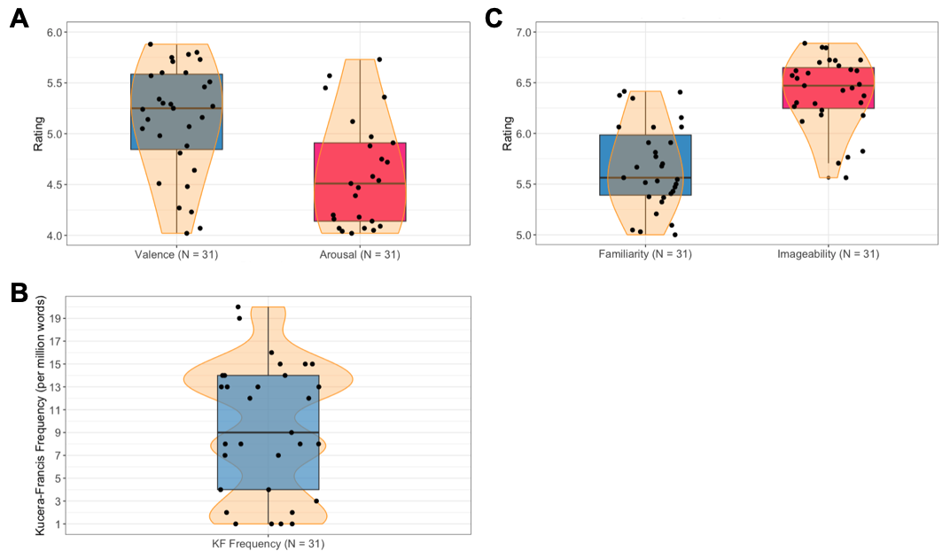
Figure S5. Characteristics of word list used in word recall experiment. The word list had roughly neutral valence and dull to neutral arousal (A). Words were also recognizable and commonly used in the English-written text (B). Finally, the word list had high familiarity and imageability, though words tended to have greater imageability than familiarity (C). Pirate plot consists of boxplot with median score, upper and lower quartile whiskers, and smoothed density curve.

Process Recall Experiment
In the study phase of the word recall experiment, participants are given 3 minutes to memorize the following list of nine steps for how to create floral paperweights:

- Press fresh or dried flowers, leaves, and botanicals.
- Prepare a clear epoxy resin.
- Prepare a silicone mold in the desired shape and size.
- Arrange the botanicals in the mold into the desired pattern.
- Pour the mixed resin into the mold over the botanicals.
- Use a heat gun to eliminate any air bubbles.
- Allow the resin to cure and harden.
- Remove the paperweight from the mold.
- Use sandpaper to smooth rough edges and clear gloss for a shiny look.

To ensure that the floral paperweight procedure was neutrally valenced (SAM rating ≈ 0) and arousal scores corresponded to dull or neutral intensity (SAM rating ≲ 5; Geethanjali et al., 2016), we recruited 80 participants from AMT who did not participate in the main experiment and were pre-screened through CloudResearch. We asked these participants to rate the floral paperweight procedure on the valence and arousal dimensions using the SAM task. Data was collected following the standards of the University of Chicago’s IRB, and all participants were compensated at a rate of $7.50 per hour ($0.40 for a 3-minute task).
The participants rated the floral paperweight procedure as neutrally valenced (Mdn = 0, MAD = 2.97) with dull or neutral intensity (Mdn = 3, MAD = 2.97; Figure S6). Thus, we show that the floral paperweight procedure is neutral memorial content for the process recall experiment.

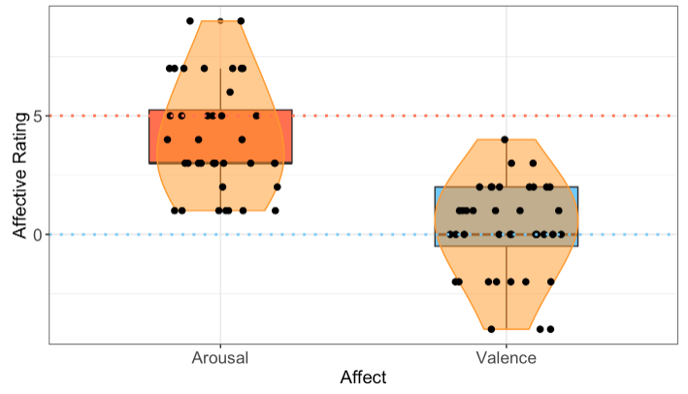
Figure S6. Arousal and valence ratings for floral paperweight procedure. The floral paperweight procedure was rated as dull to low arousal and neutral valence using the SAM. Boxes mark the first and third quartile of the data. Thick horizontal lines mark the median. Violins represent the smoothed density distributions of the data. Black dots represent individual participant performance. Orange dotted line indicates the rating corresponding to dull to low arousal (SAM rating ≲ 5) while blue dotted line indicates neutral valence (SAM rating ≈ 0).

Data Analysis

We tested the normality of the valence ratings, arousal ratings, recognition memory task scores, and recall performance distributions obtained in the main word recall and process recall experiments using the Shapiro-Wilk’s test to determine whether to conduct parametric or non-parametric statistical tests for our analysis. Table S2 contains p-values for the different datasets. The non-normal sample distributions for valence and arousal ratings, recognition memory scores, and memory recall scores indicate that a non-parametric analysis is appropriate for our study.

 | Word Recall Experiment |  |  |  | Process Recall Experiment
 | Positive | Negative | Control |  | Positive | Negative | Control
Valence | < 0.01*** | < 0.01*** | - |  | < 0.01*** | < 0.01*** | -
Arousal | < 0.01*** | 0.23 | - |  | 0.23 | < 0.01*** | -
Recognition Memory | < 0.01*** | < 0.01*** | - |  | < 0.01*** | < 0.01*** | -
Memory Recall | 0.225 | 0.018** | 0.01 |  | 0.059* | 0.039** | 0.012**
Note: |  |  |  |  |  | *p<0.1; **p<0.05; ***p<0.01
Table S2. Testing normality using Shapiro-Wilk's test to determine whether to conduct parametric or non-parametric analyses. A p-value less than 0.05 indicates a non-normal sample distribution. Because the sample data for valence and arousal ratings and recognition memory and memory recall scores consist of non-normal sample distributions, we used non-parametric analyses.
To control for multiple comparisons between the control, positive, and negative groups when assessing efficacy of MOL, we used the Holm-Bonferroni method, which controls the family-wise error rate (FWER), the probability of making at least one Type I error. A standard Bonferroni method uniformly adjusts the threshold p-value across all tests using the formula $p=\frac{α}{m}$ , where α is the original significance level (0.05) and m is the number of tests. This means that the Bonferroni method is highly conservative, which reduces the likelihood of Type I errors but increases the risk of Type II errors. As a result, it may lead to more false negatives due to its stringent criteria.

We used the Holm-Bonferroni method because it utilizes a sequentially adjusted alpha level where the i-th smallest p-value is compared to a progressively less strict significance level. This is given by the formula for the threshold p-value $p_{i}=\frac{α}{m-i+1}$, where i is the rank of the current p-value (from smallest to largest), α is the original significance level (0.05), and m is the number of tests. As such, the smallest p-value would be compared to the strictest threshold, and we continue comparisons with subsequent ranks until we encounter a p-value that is greater than the corresponding adjusted alpha level. If $p_{i}>\frac{α}{m-i+1}$ for any i, all remaining hypotheses are not rejected, even if their p-values are smaller than their respective thresholds. This enables the Holm-Bonferroni method to adaptively control the FWER while being less stringent than the Bonferroni method. By adjusting the significance threshold for each test based on its rank, it ensures that fewer false positives are made without overly penalizing the discovery of true effects.

Results

Different emotional valence, but same arousal and memory following navigation of memory palace

For both word recall and process recall experiments, participants in the training task completed a SAM for valence and arousal following completion of the house video stimuli. Results from participants that viewed either the positive or negative stimuli in video format reported similar arousal and valence scores to those who viewed stimuli in image format in the pilot study (Word recall: Figures S7A & S7B; process recall: Figures S7C & S7D). Furthermore, participants in the word recall experiment reported similar arousal and valence scores as those reported by participants in the process recall experiment.

For the word recall experiment, the positive stimuli (M = 5.13, SD = 2.00) and negative stimuli (M = 5.15, SD = 1.60) evoked approximately equal arousal in participants (Mann-Whitney U = 723.5, p = .99, |δ| = 0.02). In addition, the positive (M = 2.00, SD = 1.74) and negative (M = -1.87, SD = 1.73) stimuli evoked a significantly different valence (Mann-Whitney U = 1334.5, p < .001, |δ| = 0.90).

For the process recall experiment, the positive stimuli (M = 4.09, SD = 1.70) and negative stimuli (M = 4.45, SD = 1.64) evoked approximately equal arousal in participants (Mann-Whitney U = 488.5, p = .47, |δ| = 2.24). In addition, the positive (M = 2.36, SD = 1.27) and negative (M = -1.13, SD = 1.79) stimuli evoked a significantly different valence (Mann-Whitney U = 1032, p < .001, |δ| = 0.90).
Similar effect sizes to those in the pilot study were also reported for arousal and valence. Replicated results from the SAM task in the pilot and main task as well as similar arousal and valence results between the word recall and process recall experiments provide strong support for different valence but similar arousal between the positive and negative memory palace stimuli.

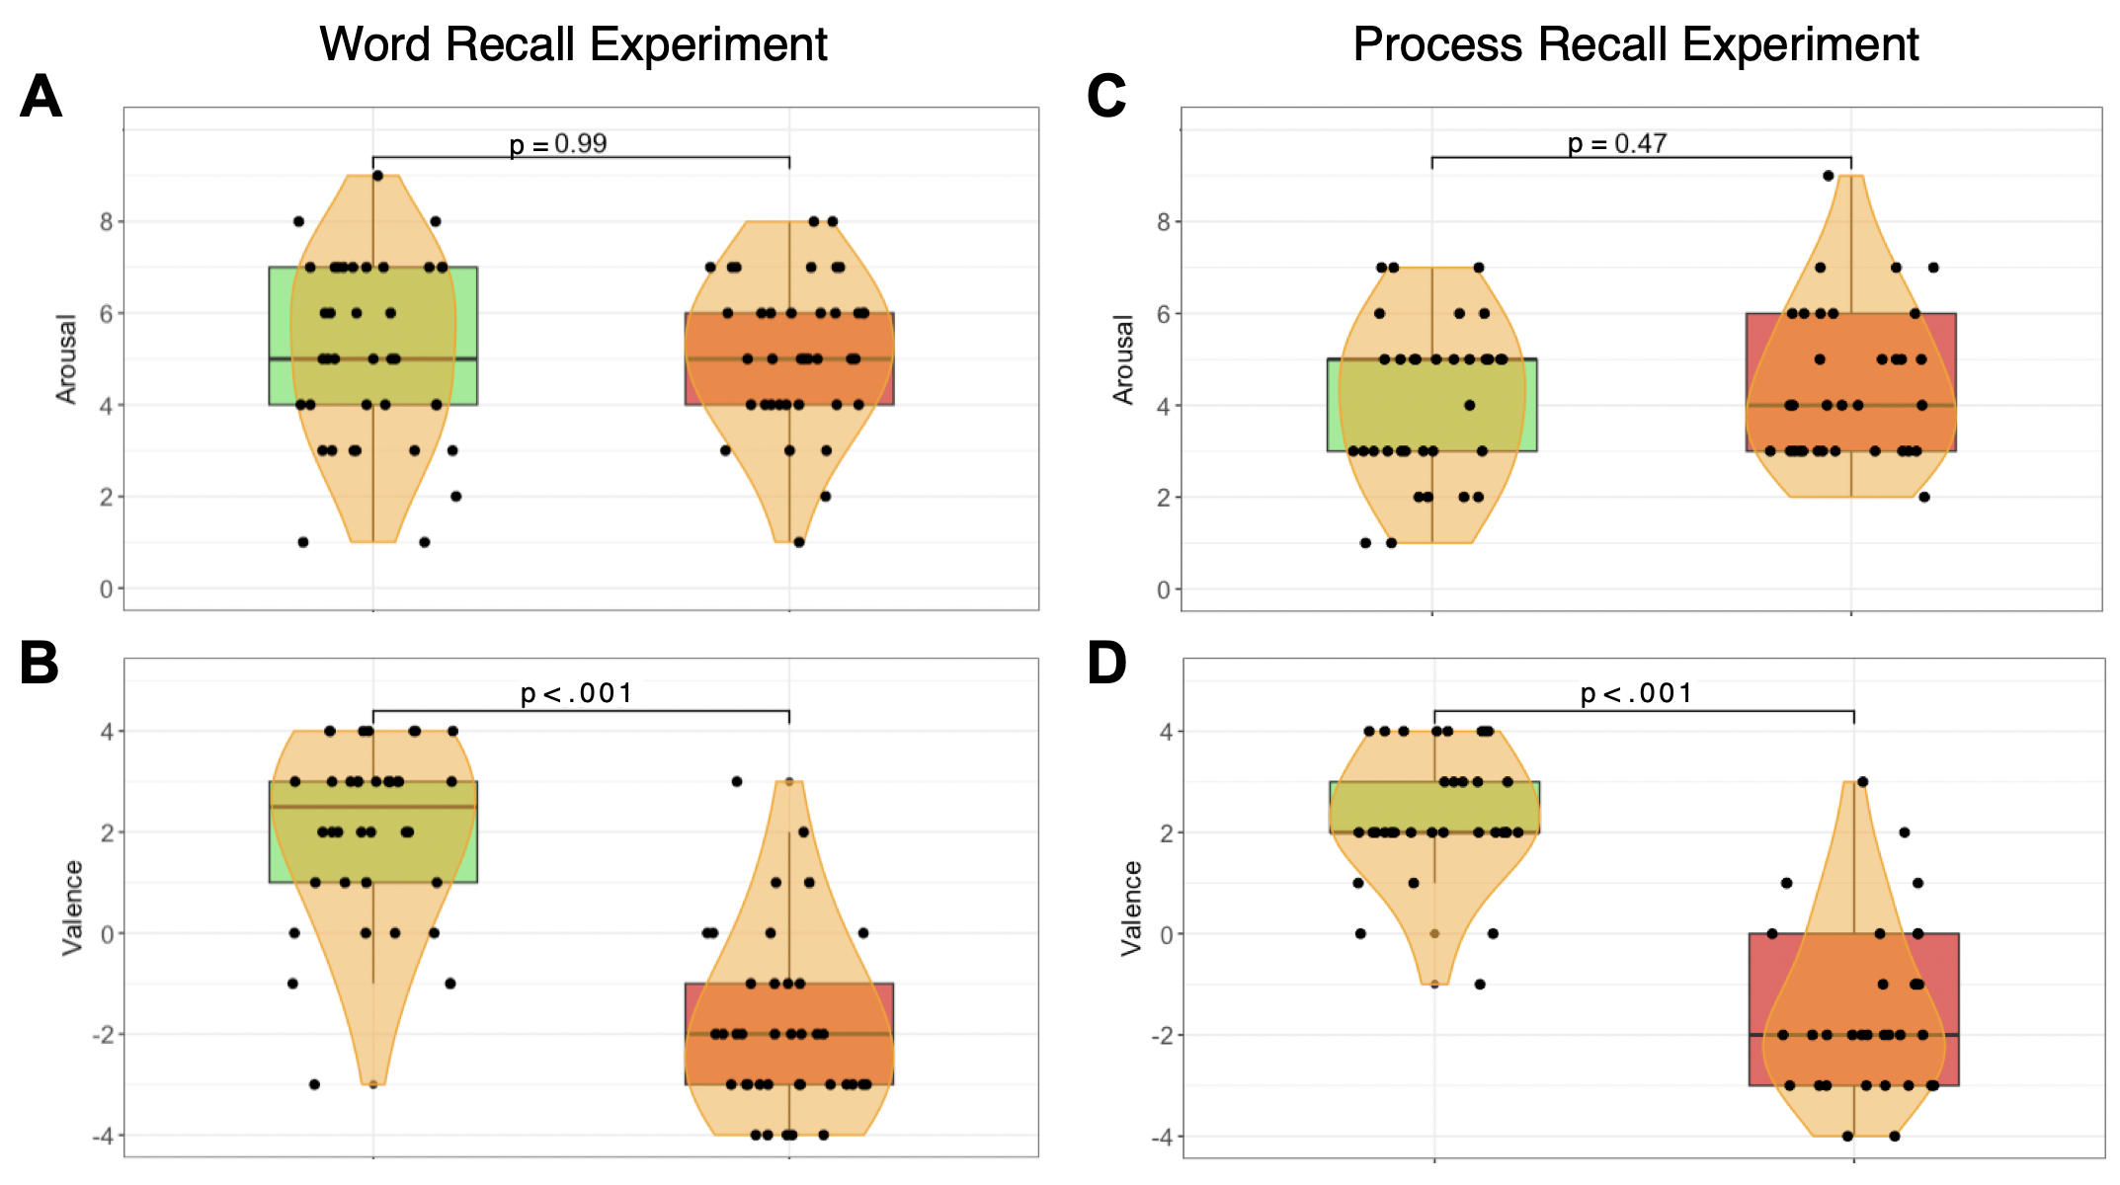
Figure S7. Self-Assessment manikin (SAM) and old-new recognition memory test. Self-Assessment Manikin (SAM) conducted following video stimulus in main study produces similar valence and arousal scores for both positive and negative groups when compared to SAM conducted in the pilot study. Participants in the two groups rated arousal approximately equally for word (A) and process (C) recall experiments, but valence in opposite directions (B, D). Each point represents an individual participant’s arousal and valence rating for the video they watched. Pirate plot consists of boxplot with median score, upper and lower quartile whiskers, and smoothed density curve.

The positive and negative memory palaces are remembered equally well

Corrected hit rate
Following the SAM, participants in the main task were given the old-new recognition memory test. We calculated the corrected hit rate by subtracting the false alarm rate from the hit rate. For the word recall experiment (Figure S8A), the positive (M = 0.51, SD = 0.41) and negative group (M = 0.58, SD = 0.44) encoded the memory palace stimuli that they would use later for recall equally well across conditions (Mann-Whitney U = 639, p = .21, |δ| = 0.17). For the process recall experiment (Figure S8D), the positive (M = 0.52, SD = 0.47) and negative group (M = 0.64, SD = 0.32) encoded the memory palace stimuli that they would use later for recall equally well across conditions (Mann-Whitney U = 476.5, p = .28, |δ| = 0.37).

Signal sensitivity
To determine the sensitivity between the noise and positive and negative signal distributions of the old-new experiment, we apply signal detection theory. Although the distribution of d’ values was non-normal across participants for both word recall (Positive p = .003; Negative p < .001) and process recall (Positive p < .001; Negative p < .001), standard d’ was used as a sensitivity index following signal detection theory conventions, which assume underlying, reasonably Gaussian signal and noise distributions rather than normality of d’ scores themselves (Pastore et al., 2003). d' was calculated using the following formula: $d^{'}=z\left(Hit Rate\right)-z(False Alarm Rate)$, and we assume the noise distribution to be a Gaussian distribution with a mean of 0 and standard deviation of 1. We found moderately good discrimination between the noise and positive and negative signal distributions for both word recall (Positive d’ = 1.14; Negative d’ = 1.32; Figure S8B) and process recall (Positive d’ = 1.16; Negative d’ = 1.42; Figure S8E). There was no difference in sensitivity between the positive and negative signal distributions for the word and process recall experiments (Word recall: Δ d’ = 0.18, Process recall: Δ d’ = 0.26).

Since the distribution of d’ values is non-normal, we also evaluated the sensitivity of the signal distributions using nonparametric A’. A’ values closer to 1 indicate greater sensitivity while A’ values closer to 0.5 indicate no discrimination (chance performance). Similar to the results using d’, we found moderate sensitivity for positive and negative signal distributions for both word recall (Positive A’ = 0.80; Negative A’ = 0.83) and process recall (Positive A’ = 0.80; Negative A’ = 0.88). Using Grier’s B, a nonparametric measure of response bias, we observed minimal to low bias (B ≈ 0) in either the conservative (B > 0, more likely to say “new”) or liberal (B < 0, more likely to say “old”) direction for both word (Positive B = 0.10, Negative B = -0.15) and process (Positive B = 0.19, Negative B = -0.26) recall experiments.

Although we observed moderately good discrimination between the noise and positive and negative signal distributions, the recognition assessment only contained 6 relatively easy trials (3 old, 3 new), so performance tended to be closer to ceiling for both conditions, which might explain the equal encoding of the memory palace that we observed. The main purpose of the old/new recognition memory task was to briefly check whether encoding was relatively similar and sufficient between groups and was not primarily designed to test for differences in valence-based recall performance. In future experiments, a greater number of old/new trials will allow for better sensitivity measurements and better Gaussian approximation of the signal distributions.

Correlation between corrected hit rate and recall performance
Although both positive and negative groups exhibited approximately equal corrected hit rate, we observed a moderate association between corrected hit rate and recall performance only for the negative group for both word (Positive ρ = 0.02; Negative ρ = 0.48; Figure S8C) and process (Positive ρ = -0.11; Negative ρ = 0.48; Figure S8F) recall experiments. This finding suggests that the relationship between recognition memory sensitivity and recall performance depends on emotional valence. Negative information typically engages more attentional control or vigilance than positive information (Pratto & John, 1991; Öhman et al., 2001), so participants who can better remember the negative memory palace may perform better with MOL-driven memory recall.

Correlation between corrected hit rate and valence/arousal
For both positive and negative groups, we observed weak correlation between corrected hit rate and valence for both word (Positive ρ = -0.08; Negative ρ = -0.35) and process (Positive ρ = -0.14; Negative ρ = -0.28) recall experiments. In addition, we observed weak to moderate correlation between hit rate and arousal for both word (Positive ρ = 0.03; Negative ρ = 0.01) and process (Positive ρ = 0.42; Negative ρ = -0.08) recall experiments.
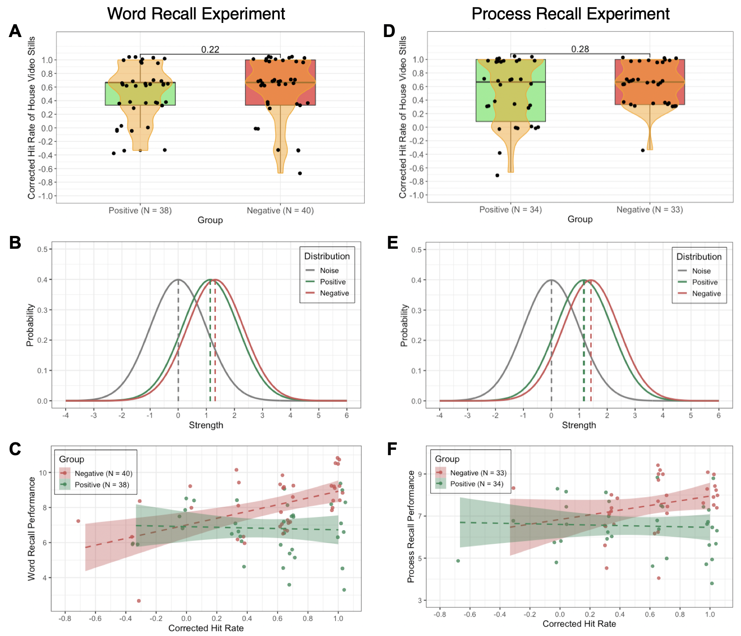
Figure S8. Old-new recognition memory test. No significant difference in corrected hit rate of house video stills between positive and negative group for both word recall (A) and process recall (D) experiments. Assuming a Gaussian noise distribution with mean of 0 and standard deviation of 1 and positive and negative signal distribution with mean d’ and standard deviation of 1, we observe moderately good discrimination between the noise and signal distributions (B, E). Finally, we observe no association between corrected hit rate and recall performance for the positive group but a positive association between corrected hit rate and recall performance for the negative group (C, F). Positive group is indicated by the green color, while the negative group is indicated by the red color. Each point represents an individual participant’s corrected hit rate from the old-new recognition memory test. Pirate plot consists of boxplot with median corrected hit rate, upper and lower quartile whiskers, and smoothed density curve.

Post hoc power analysis for Kruskal-Wallis multi-group comparison

Because our sample size is relatively small, a post hoc power analysis can potentially add to the reliability of statistical findings. Following the Kruskal-Wallis test comparing memory recall performance among the positive, negative, and control groups, we conducted a post hoc power analysis using a Monte Carlo simulation with 1000 simulations, which yielded a power of 1 for both word and process recall experiments (Figure S9). This confirms that our study had sufficient sample sizes and effect sizes to detect the observed differences in memory recall performance between the positive, negative, and control groups.
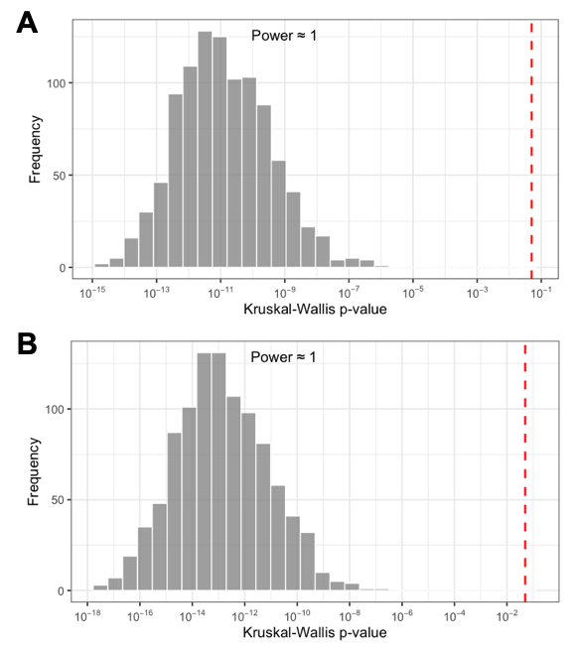
Figure S9. Post hoc power analysis for Kruskal-Wallis test comparing multi-group memory recall performance. We conducted a post hoc power analysis using a Monte Carlo simulation with 1000 simulations comparing memory recall performance among positive, negative, and control groups, which yielded a power of 1 for both word recall (A) and process recall (B) experiments. The vertical red dashed line represents p = .05 or 10^{-1.3}.

No observed effect of valence-mediated mood induction on word recall performance

Because the emotional valence of the memory palace was manipulated, a mood induction effect may have accounted for the observed MOL-based effect on recall performance. The influence of mood on memory is complex and can also impact executive control (Mitchell & Phillips, 2007) and attention (Sedikides, 1992; Grol & Raedt, 2014). Visual stimuli such as video clips are commonly used in psychological experiments to induce an emotional state (Devilly & O’Donohue, 2021), and induced mood has been shown to influence memory recall and distortion (Van Damme & Smets, 2014). Congruency between mood and previously encoded mood-congruent content can also lead to enhanced recall accuracy in both healthy and depressed individuals (Matt et al., 1992; Faul & LaBar, 2022). Therefore, to confirm that the observed difference in recall performance in our Main Study was not driven by mood induction alone, we compared word recall performance for a non-MOL control group (same participants as the non-MOL, word recall control group in the Main Study) and non-MOL groups from a separate study that watched the positive or negative house video prior to the Study Phase.

Participants
Ninety two participants who did not participate in the main study were recruited from AMT, pre-screened through CloudResearch, and tested using Cognition.run. Participants were
randomly assigned to watch either a positive (N = 45) or negative (N = 47) video prior to a non-MOL Study Phase. Data was collected following the standards of the University of Chicago’s Institutional Review Board, and all participants provided informed consent prior to participating in the study. Participants were compensated at a rate of $7.50 per hour ($3.75 for a 30-minute task). Using the same exclusion criteria as the word recall and process recall experiments, the final sample size comprised N = 39 for the positive non-MOL group and N = 42 for the negative non-MOL group.

Task Setup
Participants from both groups followed the same procedure as the non-MOL control group in the word recall experiment. The only difference was the addition of the Training Task and subsequent SAM prior to the Study Phase, where one group watched the positive house video (positive non-MOL group) and the other group watched the negative house video (negative non-MOL group).

Data Analysis
We tested the normality of the valence ratings, arousal ratings, recognition memory task scores, and recall performance distributions for both positive and negative non-MOL groups. Table S3 contains p-values for different datasets. The non-normal sample distributions for valence and arousal ratings, recognition memory scores, and memory recall scores indicate that a non-parametric analysis is appropriate for this study. The normality of memory recall for the control group of the word recall experiment (non-MOL, no video group) is also included in Table S3 as the control group for our mood induction study.

 | Video Stimulus |  | No Video Stimulus
 | Positive |  | Negative | Control
Valence | < 0.01*** |  | < 0.01*** | -
Arousal | 0.04** |  | 0.01** | -
Recognition Memory | < 0.01*** |  | < 0.01*** | -
Memory Recall | 0.11 |  | 0.04** | 0.01**
Note: |  |  |  | *p<0.1; **p<0.05; ***p<0.01
Table S3. Testing normality using Shapiro-Wilk's test to determine whether to conduct parametric or non-parametric analyses. A p-value less than 0.05 indicates a non-normal sample distribution. Because the sample data for valence and arousal ratings and recognition memory and memory recall scores consist of non-normal sample distributions, we used non-parametric analyses.

Different valence but same arousal following navigation of memory palace
Both non-MOL groups that watched the positive or negative video reported similar arousal and valence scores as those reported in the Main Study. The positive stimuli (M = 5.15, SD = 1.65) and negative stimuli (M = 5.29, SD = 1.50) evoked approximately equal arousal in participants (Mann-Whitney U = 790, p = .78, |δ| = 0.09). In addition, the positive (M = 2.13, SD = 1.54) and negative (M = -2.12, SD = 1.42) stimuli evoked a significantly different valence (Mann-Whitney U = 1581.5, p < .001, |δ| = 3.00).

The positive and negative memory palaces are remembered equally well
Following the SAM, participants in the separate study were given the old-new recognition memory test. Based on the corrected hit rate of participants in the word recall experiment, the positive (M = 0.56, SD = 0.38) and negative group (M = 0.51, SD = 0.48) encoded the memory palace stimuli that they would use later for recall equally well across conditions (Mann-Whitney U = 838, p = .85, |δ| = 0.10).

Assuming Gaussian underlying signal and noise distributions, we found moderately good discrimination between the noise and positive and negative signal distributions (Positive d’ = 1.23; Negative d’ = 1.14). There was no difference in sensitivity between the positive and negative signal distributions (Δ d’ = 0.09). Using nonparametric A’, we similarly found moderate sensitivity for positive and negative signal distributions (Positive A’ = 0.82; Negative A’ = 0.79). Using Grier’s B, we observed minimal bias in either the conservative or liberal direction (Positive B = -0.07, Negative B = 0.03).

Similar word recall performance in non-MOL conditions with or without watching house video stimulus
To determine whether potential mood induction from watching the house video stimulus influenced recall performance in the Memory Recall Assessment, we compared the word recall performance of the non-MOL, no-video control group to that of the non-MOL, positive video and non-MOL negative video groups. The Kruskal-Wallis test comparing the control (M = 4.76, SD = 1.49), positive (M = 4.51, SD = 1.57), and negative (M = 4.45, SD = 1.58) groups yielded no significant difference in recall performance across groups (Mdn_{con} = 4, Mdn_{pos} = 5, Mdn_{neg} = 4, H = 0.77, p < .001, η² = .01). A Dunn’s multiple comparison test using the Holm-Bonferroni method resulted in no significant difference between all groups (Control-Negative p = .60, |δ| = 0.07; Control-Positive p = .80, |δ| = 0.10; Negative-Positive p = 1.00; |δ| = 0.02; Figure S10). Overall, these results suggest no significant effect of mood induction on word recall performance. They also provide evidence that the greater recall performance observed in the positive and negative MOL groups in the main task are driven by MOL rather than by mood induction from the house videos alone.

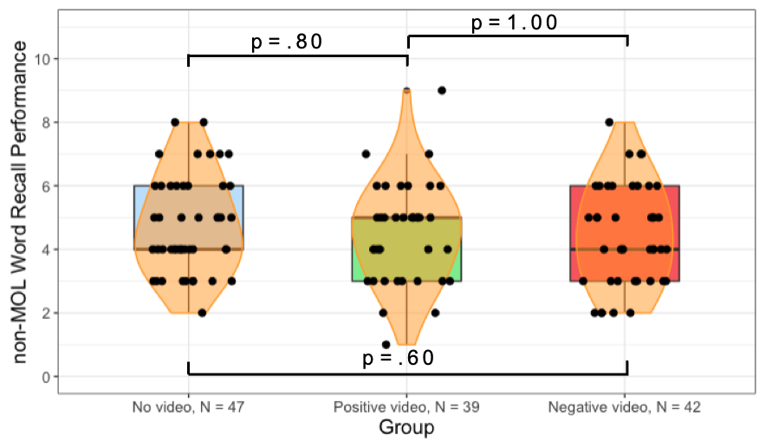
Figure S10. Similar word recall performance when not using MOL. Non-MOL participants who watched either a positive or negative house video before the Training Task and Memory Recall Assessment performed similarly well compared to participants who did not watch any video. Boxes mark the first and third quartile of the data. Thick horizontal lines mark the median. Violins represent the smoothed density distributions of the data. Black dots represent individual participant performance.

No observed effect of memory palace novelty on word recall performance

Studies have shown that exposure to novel information can promote memory for information following the exposure (Quent et al., 2021; Lorents et al., 2023). Because participants who use MOL in our main study closely observe a new, virtual house stimulus prior to completing the Training Task and Memory Assessment and mentally traverse the house during these memory tasks, the perception of novelty from unexpected elements within the negative video may have accounted for the greater recall performance observed.

In the same study described in the previous section that tested word recall performance for non-MOL groups that were exposed to either the positive or negative house stimuli, participants were asked to rate the extent to which the house felt familiar on a 5-point scale (0 for not at all familiar, 1 for slightly familiar, 2 for moderately familiar, 3 for very familiar, and 4 for extremely familiar) in the Exit Questionnaire. This scale serves as an inverse measurement of perceived novelty of the house stimuli to the participant. There was no significant difference in novelty between the non-MOL positive (M = 2.56, SD = 1.29) and non-MOL negative (M = 2.83, SD = 1.08) groups (Mann-Whitney U = 739.5, p = .43, |δ| = 0.10). In addition, based on Spearman’s rank correlation coefficient, there was no observable relationship between novelty of the positive or negative house stimulus on recall performance (Positive ρ = 0.04; Negative ρ = 0.14). Therefore, perceived novelty of the house stimuli likely did not influence recall performance in our main task.

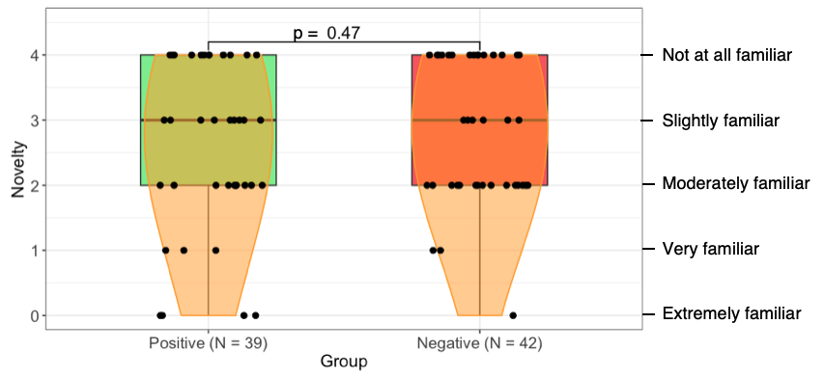
Figure S11. Similar levels of perceived novelty between non-MOL participants who watched either the positive or negative video. There was no significant difference in novelty between the positive and negative groups in a non-MOL context. Participants were asked to rate the extent to which the house felt familiar on a scale from 0 to 5. Perceived novelty ratings are the inverse of familiarity ratings. Boxes mark the first and third quartile of the data. Thick horizontal lines mark the median. Violins represent the smoothed density distributions of the data. Black dots represent individual participant novelty rating.

Less Stringent Regression Analysis

For word recall and process recall experiments, we regressed recall performance on valence, arousal, and control variables to examine whether valence was a significant regressor of recall performance. As part of the exclusion criteria, we excluded participants with moderate to extensive prior knowledge and familiarity with MOL and/or Minecraft from the word recall sample and participants with prior knowledge of MOL and how to create floral paperweights from the process recall sample.

In the less stringent regression analysis, we incorporated indicator variables for familiarity with MOL, familiarity with Minecraft, and prior knowledge for how to create floral paperweights. We observed a non-significant slope coefficient for arousal but a significant slope coefficient for valence and environment (Table S4). The results from the less stringent regression model reflect the results we observed when the exclusion criteria were upheld.

 | Recall Performance
 | Word Recall |  | Process Recall
Arousal | 0.187  (0.312) |  | 0.204  (0.261)
Valence | 1.679***  (0.390) |  | 1.235***  (0.346)
Age | -0.042***  (0.015) |  | -0.024*  (0.012)
VVIQ_Total | 0.034***  (0.012) |  | 0.011  (0.010)
BDI | 0.012  (0.057) |  | -0.010  (0.027)
Gender | 0.051  (0.318) |  | -0.288  (0.297)
Education | 0.019  (0.066) |  | 0.070  (0.076)
Race | 0.059  (0.130) |  | -0.145  (0.161)
MOL | 0.067  (0.250) |  | 0.912  (0.663)
Procedure |  |  | -0.397  (0.645)
Minecraft | 0.005  (0.250)
Group | 3.319***  (1.250) |  | 1.559*  (0.814)
Arousal:Group | -0.147  (0.199) |  | -0.086  (0.169)
Valence:Group | -1.038***  (0.259) |  | -0.809***  (0.199)
Intercept | -0.560  (2.546) |  | 3.255*  (1.751)
Observations | 91 |  | 71
R² | 0.571 |  | 0.457
Adjusted R² | 0.499 |  | 0.333
RSE | 1.473 (df = 77) |  | 1.095 (df = 57)
F Statistic | 9.43*** (df = 13; 77) |  | 3.689*** (df = 13; 57)
Note: |  |  | *p<0.1; **p<0.05; ***p<0.01
Table S4. Less stringent regression model. For word recall and process recall experiment, when using indicator variables for participants who had prior knowledge or experience of MOL, how to create floral paperweights, and Minecraft, we report similar results as those obtained when we excluded these participants. We observe a significant slope coefficient for valence but a non-significant slope coefficient for arousal. We also observe no interaction effect between arousal and group but a significant interaction effect between valence and group.

Participant Depression and Vividness Levels on Recall Performance

For word recall and process recall experiments, we observed a similar significant interaction effect between depression level and group and vividness level and group (Table S5). As depression level increases, recall performance increases for the negative group but decreases for the positive group, even in the presence of perceived valence. As vividness levels increase, recall performance of the positive group increases towards the recall performance of the negative group.

 | Word Recall Performance |  |  | Process Recall Performance
 | Depression Model | Vividness Model |  | Depression Model | Vividness Model
Arousal | -0.121  (0.084) | -0.033  (0.113) |  | 0.069  (0.100) | 0.121  (0.099)
Valence | -0.064  (0.124) | 0.070  (0.131) |  | 0.142  (0.093) | 0.131  (0.095)
Age | -0.035**  (0.017) | -0.058  (0.022) |  | -0.011  (0.012) | -0.016  (0.012)
VVIQ_Total | 0.024*  (0.013) | 0.127***  (0.032) |  | 0.013  (0.008) | 0.089***  (0.027)
BDI | -0.590***  (0.095) | -0.031  (0.045) |  | -0.236***  (0.064) | -0.034  (0.023)
Gender | 0.583*  (0.329) | 0.295  (0.393) |  | 0.339  (0.333) | 0.296  (0.339)
Education | 0.044  (0.061) | 0.003  (0.081) |  | 0.029  (0.084) | -0.017  (0.084)
Race | -0.005  (0.135) | 0.169  (0.120) |  | -0.018  (0.192) | -0.126  (0.193)
Group | -1.605  (1.099) | 9.338***  (1.923) |  | 0.308  (0.613) | 6.729***  (1.667)
BDI:Group | 0.368***  (0.060) |  |  | 0.142***  (0.041)
VVIQ_Total:  Group |  | -0.069***  (0.020) |  |  | -0.051***  (0.016)
Intercept | 8.901***  (2.827) | -6.768*  (3.533) |  | 4.914***  (1.352) | -4.093  (2.726)
Observations | 88 | 88 |  | 81 | 81
R² | 0.567 | 0.459 |  | 0.371 | 0.354
Adjusted R² | 0.511 | 0.389 |  | 0.281 | 0.261
RSE | 1.461  (df = 77) | 1.634  (df = 77) |  | 1.349  (df = 70) | 1.367  (df = 70)
F Statistic | 19.14***  (df = 10; 77) | 9.086***  (df = 10; 77) |  | 4.126***  (df = 10; 70) | 3.832***  (df = 10; 70)
Note: |  |  |  | *p<0.1; **p<0.05; ***p<0.01
Table S5. Regression models exhibiting interaction effects between BDI and group (Depression model) and VVIQ and group (Vividness model). For both word recall and process recall experiments, we observe significant interaction effect between depression level and group and vividness level and group.

Addressing Differences in Depression and Vividness Level Among Control, Positive, and Negative Groups

Differences in depression and vividness level between groups may potentially confound our regression analyses and impact the validity of the depression and vividness models. For both word recall and process recall experiments, we conducted a Kruskal-Wallis test and post hoc Dunn test comparing depression and vividness level between control, positive, and negative groups with and without excluding participants that reported moderate to severe depression, inability to generate mental imagery (aphantasia), and condition of extreme mental imagery (hyperphantasia). When generating our valence and arousal interaction models for predicting recall performance, we excluded these participants, but when generating our depression and vividness models, we included these participants.

Observed difference in group depression and vividness level for word recall experiment
For the word recall experiment with exclusions, the Kruskal-Wallis test comparing the control (M = 5.04, SD = 3.93), positive (M = 7.16, SD = 3.89), and negative (M = 9.9, SD = 4.19) groups yielded a significant difference in depression level (Mdn_{con} = 4, Mdn_{pos} = 7, Mdn_{neg} = 9, H = 26.87, p < .001, η² = .20). A Dunn’s multiple comparisons test using a Holm-Bonferroni method to control for the family-wise error rate resulted in a significant difference between all groups (Control-Negative p < .001, |δ| = 0.62; Control-Positive p = .02, |δ| = 0.33; Negative-Positive p = .01; |δ| = 0.37; Figure S12A).

For the word recall experiment without exclusions, the Kruskal-Wallis test comparing the control (M = 5.63, SD = 5.39), positive (M = 8.11, SD = 5.68), and negative (M = 10.64, SD = 5.31) groups yielded a significant difference in depression level (Mdn_{con} = 4, Mdn_{pos} = 7, Mdn_{neg} = 9, H = 25.91, p < .001, η² = .17). A Dunn’s multiple comparisons test using a Holm-Bonferroni method to control for the family-wise error rate resulted in a significant difference between all groups (Control-Negative p < .001, |δ| = 0.59; Control-Positive p = .02, |δ| = 0.31; Negative-Positive p = .02; |δ| = 0.32; Figure S12B).

For the word recall experiment with exclusions, the Kruskal-Wallis test comparing the control (M = 105.19, SD = 7.54), positive (M = 108.68, SD = 16.20), and negative (M = 97.15, SD = 13.76) groups yielded a significant difference in vividness level (Mdn_{con} = 106, Mdn_{pos} = 108, Mdn_{neg} = 97.15, H = 17.70, p < .001, η² = .13). A Dunn’s multiple comparisons test using a Holm-Bonferroni method to control for the family-wise error rate resulted in a significant difference between the control-negative groups and positive-negative groups (Control-Negative p < .001, |δ| = 0.26; Control-Positive p = .18, |δ| = 0.41; Negative-Positive p = .01; |δ| = 0.47; Figure S12C).

For the word recall experiment without exclusions, the Kruskal-Wallis test comparing the control (M = 104.80, SD = 11.70), positive (M = 105.48, SD = 22.40), and negative (M = 95.98, SD = 18.26) groups yielded a significant difference in vividness level with (Mdn_{con} = 106, Mdn_{pos} = 112, Mdn_{neg} = 96, H = 14.65, p < .001, η² = .09). A Dunn’s multiple comparisons test using a Holm-Bonferroni method to control for the family-wise error rate resulted in a significant difference between the control-negative groups and positive-negative groups (Control-Negative p = .01, |δ| = 0.38; Control-Positive p = .35, |δ| = 0.21; Negative-Positive p < .001; |δ| = 0.38; Figure S12D).

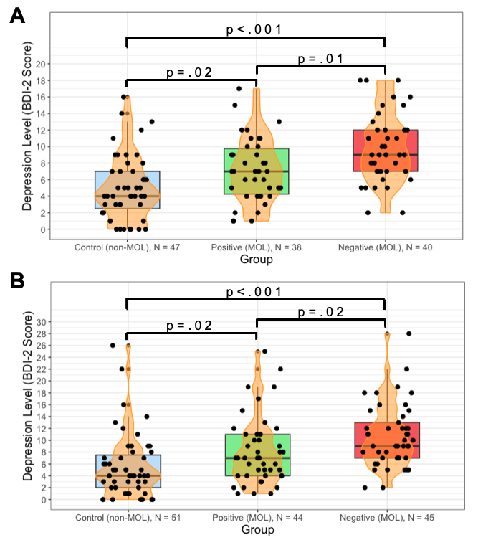

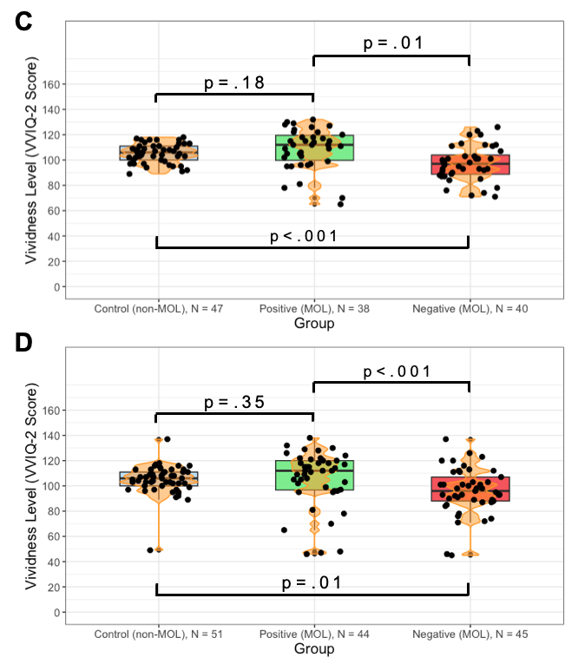
Figure S12. Depression and vividness level between control, positive, and negative groups for word recall experiment. With (A) or without (B) excluding participants with moderate to severe depression, aphantasia, or hyperphantasia, there was a significant difference in depression level between the control, positive, and negative group. With (C) or without (D) excluding participants, there was a significant difference in vividness level between the control-negative groups and negative-positive groups. Boxes mark the first and third quartile of the data. Thick horizontal lines mark the median. Violins represent the smoothed density distributions of the data. Black dots represent individual participant depression or vividness level.

No observed difference in group depression and vividness level for process recall experiment
For the word recall experiment with exclusions, the Kruskal-Wallis test comparing the control (M = 4.77, SD = 4.40), positive (M = 5.56, SD = 5.81), and negative (M = 6.00, SD = 5.11) groups yielded no significant difference in depression level (Mdn_{con} = 3, Mdn_{pos} = 4, Mdn_{neg} = 6, H = 0.74, p = .69, η² = .01). A Dunn’s multiple comparisons test using a Holm-Bonferroni method to control for the family-wise error rate resulted in a significant difference between all groups (Control-Negative p = .61, |δ| = 0.11; Control-Positive p = 1.00, |δ| = 0.05; Negative-Positive p = .83; |δ| = 0.09; Figure S13A).

For the word recall experiment without exclusions, the Kruskal-Wallis test comparing the control (M = 5.47, SD = 5.91), positive (M = 7.95, SD = 8.26), and negative (M = 7.85, SD = 7.44) groups yielded a significant difference in depression level (Mdn_{con} = 4, Mdn_{pos} = 5, Mdn_{neg} = 7, H = 1.84, p = .40, η² = .001). A Dunn’s multiple comparisons test using a Holm-Bonferroni method to control for the family-wise error rate resulted in a significant difference between all groups (Control-Negative p = .31, |δ| = 0.17; Control-Positive p = .40, |δ| = 0.15; Negative-Positive p = 1.00; |δ| = 0.03; Figure S13B).

For the word recall experiment with exclusions, the Kruskal-Wallis test comparing the control (M = 106.68, SD = 10.92), positive (M = 100.06, SD = 11.50), and negative (M = 102.55, SD = 17.10) groups yielded a significant difference in vividness level (Mdn_{con} = 106, Mdn_{pos} = 100.5, Mdn_{neg} = 102, H = 4.24, p = .12, η² = .02). A Dunn’s multiple comparisons test using a Holm-Bonferroni method to control for the family-wise error rate resulted in a significant difference between the control-negative groups and positive-negative groups (Control-Negative p = .35, |δ| = 0.16; Control-Positive p = .06, |δ| = 0.31; Negative-Positive p = .58; |δ| = 0.11; Figure S13C).

For the word recall experiment without exclusions, the Kruskal-Wallis test comparing the control (M = 105.82, SD = 16.28), positive (M = 102.07, SD = 18.14), and negative (M = 99.89, SD = 21.02) groups yielded a significant difference in vividness level (Mdn_{con} = 106, Mdn_{pos} = 101.5, Mdn_{neg} = 99, H = 2.69, p = .26, η² = .006). A Dunn’s multiple comparisons test using a Holm-Bonferroni method to control for the family-wise error rate resulted in a significant difference between the control-negative groups and positive-negative groups (Control-Negative p = .19, |δ| = 0.20; Control-Positive p = .27, |δ| = 0.19; Negative-Positive p = 1.00; |δ| = 0.03; Figure S13D).

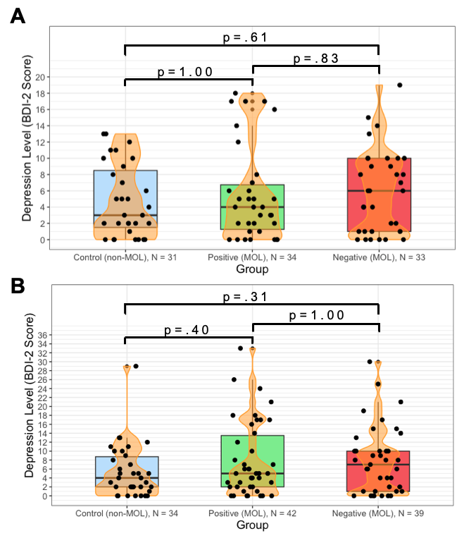
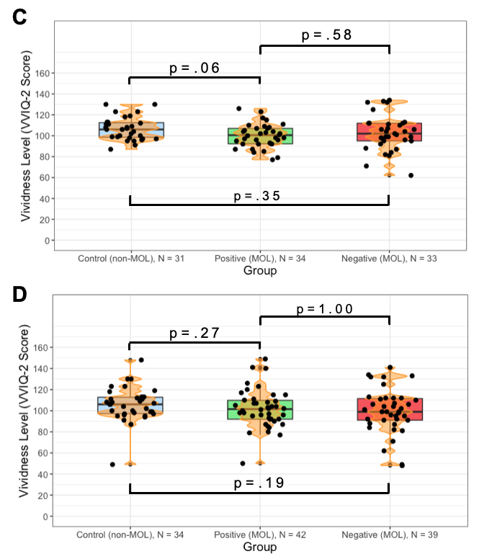
Figure S13. Depression and vividness level between control, positive, and negative groups for process recall experiment. With (A) or without (B) excluding participants with moderate to severe depression, aphantasia, or hyperphantasia, there was a significant difference in depression level between the control, positive, and negative group. With (C) or without (D) excluding participants, there was a significant difference in vividness level between the control-negative groups and negative-positive groups. Boxes mark the first and third quartile of the data. Thick horizontal lines mark the median. Violins represent the smoothed density distributions of the data. Black dots represent individual participant depression or vividness level.

Comparing Regression Models using Depression and Vividness Level as Regressors of No Interest
To determine whether the difference in depression and vividness level between the positive and negative groups impacts our regression models for word recall and process recall performance, we compared two models that use and do not use depression and vividness level as regressors of no interest. We found that in all models, the main effect of group is preserved, which suggests that differences in depression and vividness level between group minimally impacts our regression models (Table S6). Furthermore, for all groups, the first and third quartile of lie within the normal clinical range of depression and vividness levels.

Factors that may have influenced the observed differences in depression and vividness levels between groups include variation in individual participant characteristics, a relatively small sample size, and the BDI-2 task assigned after the memory recall assessment. Affective and cognitive self-report measures can vary considerably across individuals, reflecting not only unique personal circumstances that can influence overall depression and vividness levels but also differences in distinct underlying phenomena captured by each measure (Fried & Nesse, 2015; Dijkstra et al., 2017).

 | Word Recall Performance |  |  | Process Recall Performance
 | Without BDI & VVIQ Regressors | With BDI & VVIQ Regressors |  | Without BDI & VVIQ Regressors | With BDI & VVIQ Regressors
Valence | 1.741***  (0.286) | 1.837***  (1.574) |  | 1.413***  (0.301) | 1.427***  (0.329)
BDI |  | 0.038  (0.048) |  |  | -0.004  (0.026)
VVIQ_Total |  | 0.028**  (0.011) |  |  | 0.006  (0.011)
Group | 1.510**  (0.582) | 1.833***  (0.553) |  | 1.765***  (0.438) | 1.756***  (0.479)
Valence:Group | -1.134***  (0.211) | -1.180***  (0.208) |  | -0.886***  (0.168) | -0.896***  (0.178)
Intercept | 4.092***  (0.783) | 0.327*  (1.574) |  | 3.493***  (0.801) | 2.881*  (1.487)
Observations | 78 | 78 |  | 67 | 67
R² | 0.470 | 0.528 |  | 0.340 | 0.402
Adjusted R² | 0.448 | 0.495 |  | 0.369 | 0.353
RSE | 1.271  (df = 74) | 1.216  (df = 72) |  | 1.035  (df = 63) | 1.047  (df = 61)
F Statistic | 25.13  (df = 3; 74) | 19.49  (df = 5; 72) |  | 14.76  (df = 3; 63) | 8.78  (df = 5; 61)
Note: |  |  |  | *p<0.1; **p<0.05; ***p<0.01
Table S6. Regression tables for regression models with and without BDI and VVIQ regressors. The regression formula without regressors for depression and vividness level is Memory Recall ~ Valence x Group. The regression formula with regressors for depression and vividness level is Memory Recall ~ Valence x Group + BDI + VVIQ. Group in all regressions is a factor that includes two levels: Positive and Negative.

Addressing Regression Model Multicollinearity

In our regression analyses, we did not mean-center our continuous predictors because the interpretation of the model intercepts is not relevant to our study and mean-centering does not affect the statistical interpretation and validity of partial slope coefficients or their associated predictor p-values, even when models contain interactions between continuous variables (Wurm & Reitan, 2025). Furthermore, while mean-centering may be helpful in reducing collinearity between a main effect and its interaction term, it does not reduce collinearity between predictors themselves and offers no interpretive advantage to our study. Instead, the relationship between an interaction term and response variable is best explained by the partial slope coefficient, not the bivariate correlation coefficient (Echambadi & Hess, 2007; Dalal & Zickar, 2011). However, to account for potential multicollinearity in our regression models, we have calculated the variance inflation factor (VIF) of their predictors. We use the rule of thumb criteria VIF < 5 to determine acceptable predictor multicollinearity, 5 < VIF < 10 to determine potentially problematic predictor multicollinearity, and VIF > 10 to determine severe multicollinearity (Marcoulides & Raykov, 2018), though VIFs greater than 10 do not, by themselves, minimize the results of regression analyses nor require the use of regularization techniques such as ridge regression or Lasso (O’Brien, 2007). Because interaction terms are often highly correlated with the predictors that comprise them, elevated VIF values are an artifact of non-essential collinearity, expected for both the main effects and the corresponding interaction term, and are generally not of major concern.

We calculated VIF and adjusted generalized VIF (aGVIF) values, which accounts for varying predictor degrees of freedom due to the presence of multilevel predictors (Fox & Monette, 1992), for the interaction, depression, and vividness models in our word recall and process recall experiments. We found inflated VIF values only for interaction terms and their associated predictors, but when applying the same VIF rule of thumb criteria for aGVIF values, all predictors exhibit acceptable levels of multicollinearity (Table S7). This provides evidence that our regression models exhibit nonessential multicollinearity arising from the inclusion of interaction terms, rather than problematic essential collinearity that would bias or destabilize parameter estimates.

 | Word Recall Performance |  |  |  |  |  |  | Process Recall Performance
 | Interaction Model (3) |  | Depression Model |  | Vividness Model |  |  | Interaction Model (6) |  | Depression Model | Vividness Model
Arousal | 1.208  (10.166)** |  | 1.036  (1.073) |  | 1.067  (1.139) |  |  | 1.308  (12.767)** |  | 1.063  (1.130) | 1.062  (1.129)
Valence | 1.531  (25.257)** |  | 1.438  (2.067) |  | 1.388  (1.926) |  |  | 1.507  (44.616)** |  | 1.680  (2.821) | 1.637  (2.681)
Age | 1.073  (1.152) |  | 1.059  (1.122) |  | 1.043  (1.088) |  |  | 1.149  (1.320) |  | 1.111  (1.233) | 1.120  (1.254)
VVIQ_Total | 1.135  (1.288) |  | 1.086  (1.180) |  | 1.161  (11.437)** |  |  | 1.058  (1.120) |  | 1.022  (1.044) | 1.169  (11.642)**
BDI | 1.197  (1.433) |  | 1.152  (11.797)** |  | 1.058  (1.120) |  |  | 1.109  (1.231) |  | 1.211  (11.158)** | 1.154  (1.331)
Gender | 1.038  (1.078) |  | 1.025  (1.050) |  | 1.026  (1.053) |  |  | 1.062  (1.127) |  | 1.072  (1.149) | 1.079  (1.164)
Education | 1.051  (1.105) |  | 1.025  (1.051) |  | 1.030  (1.061) |  |  | 1.185  (1.403) |  | 1.125  (1.266) | 1.114  (1.241)
Race | 1.106  (1.223) |  | 1.123  (1.262) |  | 1.135  (1.289) |  |  | 1.085  (1.178) |  | 1.063  (1.131) | 1.056  (1.116)
Group | 1.059  (11.995)** |  | 1.151  (6.444)* |  | 1.161  (30.863)** |  |  | 1.055  (9.258)* |  | 1.211  (4.179) | 1.169  (30.091)**
Arousal:Group | (19.941)** |  |  |  |  |  |  | (21.251)**
Valence:Group | (23.827)** |  |  |  |  |  |  | (32.610)**
BDI:Group |  |  | (17.705)** |  |  |  |  |  |  | (11.597)**
VVIQ_Total;  Group |  |  |  |  | (32.146)** |  |  |  |  |  | (39.400)**
Note: |  |  |  |  |  |  |  |  | *VIF or aGVIF>5; **VIF or aGVIF>10
Table S7. Predictor VIF and aGVIF values. VIF and aGVIF values were calculated for all predictors in the interaction (model 3), depression, and vividness regression models for word and process recall experiments. We found elevated VIF values only for interaction terms and their associated predictors, but all predictors exhibited acceptable levels of multicollinearity based on aGVIF values. For each model predictor, aGVIF values are written above VIF values, which are in parentheses.

In addition, to determine the correlation between predictors for potential multicollinearity, we calculated the polyserial correlation between predictors (Figure S14). Polyserial correlation is used because our dataset is mixed-type and contains continuous and categorical/ordinal variables while standard Pearson correlations assume continuous variables. As such, polyserial correlations can provide scale-invariant estimates of association between continuous and ordinal variables while being robust to modest violations of normality (Flora & Curran, 2011). For both word and process recall experiments, we found a strong association between Group and Valence, which reflects an observed lower perceived valence for the negative group and higher perceived valence for the positive group. For the process recall experiment, we also found a moderate negative association between depression level and valence, where individuals with greater levels of depression tended to have lower perceived valence. However, the moderate BDI-valence association is not of major concern as the predictor for BDI-2 score had low VIF and aGVIF values (VIF = 1.231, aGVIF = 1.109; Table S7), indicating that this correlation does not significantly impact our process recall regression estimates.

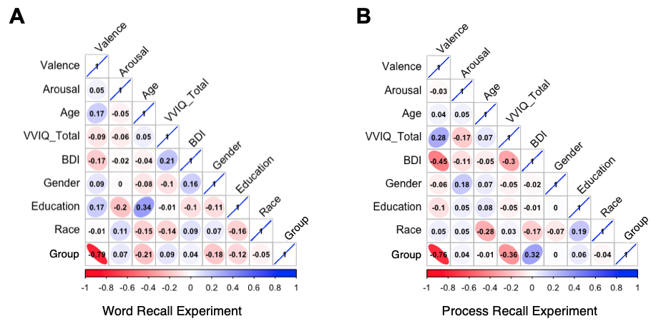
Figure S14. Polyserial correlation heat map for word recall and process recall experiments. The scale-invariant polyserial correlation was computed between regression predictors to identify potential multicollinearity. We observed a strong association between group and valence in both word recall and process recall experiments, as well as a moderate negative association between depression level and perceived valence. Negative correlations are red, while positive correlations are blue. The red color of the Group-Valence association is an artifact of how positive and negative groups were numerically encoded as 1 and 2, respectively.

Participant Comments and Feedback

Participants were given the option to provide open feedback at the conclusion of the study. Overall, participants found the study relatively straightforward, easy to understand, interesting, and engaging.

In the word recall experiment, one participant who was assigned to the positive MOL treatment group noted that they were “surprised [by] how well using the method of loci with the Minecraft house seemed to help [them] remember words.” Participants from both groups found the experiment interesting.

In the process recall experiment, one participant who was assigned to the positive MOL treatment group noted that they utilize MOL technique in their daily lives to help remember lists of items but was not aware of MOL prior to the experiment. Another participant who was assigned to the positive MOL treatment group noted that they performed “remotely well with the memory tasks.”

Application of Automated Scoring of Process Recall Performance Using BERT

Performance of BERT Model for Semantic Similarity

Of interest is the application of machine learning models in the field of neuropsychology as they serve as powerful tools for pattern detection (Rosenbusch et al., 2021). In the case of this study, we conducted a re-scoring of free responses for the memory recall assessment using a language representation model called BERT (Bidirectional Encoder Representations from Transformers). BERT is a deeply bidirectional, unsupervised machine learning framework developed by research scientists at Google AI Language that is used for natural language processing (NLP; Devlin et al., 2018). It measures the degree of semantic textual similarity using a cosine similarity approach and leverages the transformer architecture (Uszkoreit, 2017) to process text from both left-to-right and right-to-left for enhanced contextual understanding. These bidirectional NLPs can capture deeper contextual relationships and dependencies between words in a sentence compared to their counterparts like Generative Pre-trained Transformer (GPT) that use a unidirectional transformer architecture. We explored the potential for applying BERT as a more unbiased, novel method of automated scoring for grading free responses on semantic similarity for the process recall experiment and its implications for use in future psychology experiments.

We adapted Google’s open-source BERT model built on TensorFlow and deep-learning Keras Application Programming Interface (API) written in Python. The model was trained on 100,000 samples from the Stanford Natural Language Inference (SNLI) corpus to convergence to perform an NLI task to determine the logical relationship between two provided texts. The relationship can be categorized as entailment (logical inference from premise to hypothesis), contradiction (direct opposition between premise and hypothesis), or neutral (no logical relationship between premise and hypothesis; MacCartney & Manning, 2008). In addition to outputting the logical relationship between texts, it also estimated a probability for the logical relationship, or BERTScore, from 0 to 1. However, in practice, BERTScores usually fall within a relatively narrow range (Zhang et al., 2020), as we observed in our application of BERT when doing a re-analysis of our results.

To evaluate the performance of our BERT model, we looked at the accuracy over 4 epochs. After the model was trained on 2 epochs with batch size of 32, it was incrementally fine-tuned by unfreezing the top layer and retrained on 20,000 samples with low learning rate. After fine-tuning, the entire model is trained from end-to-end on 2 epochs. In addition, after each of the four epochs, we tested the model on a training (old) and prediction (new) set of 500 samples, and by the fourth epoch, the training accuracy was at 85.4% while the validation accuracy was at 81.6% (Figure S15A). We also observed decreasing training and validation loss functions using the mean squared error (MSE), which shows that the model is improving after each epoch by better fitting the training data without overfitting while generalizing to unseen data (Figure S15B).

Because the BERT model is a three-class model (entailment, neutral, or contradiction), we employ a one-vs-the-rest (OvR) multiclass strategy to generate an ROC curve for each class. Varying the threshold for classification, we obtain high-performance ROC curves denoted by AUC scores of 0.86, 0.79, and 0.86 for entailment, neutral, and contradiction classes respectively. The macro-average ROC curve and AUC score of 0.83 reflect similar results and overall indicates that our BERT model accurately classifies statements based on semantic similarity (Figure S15C).

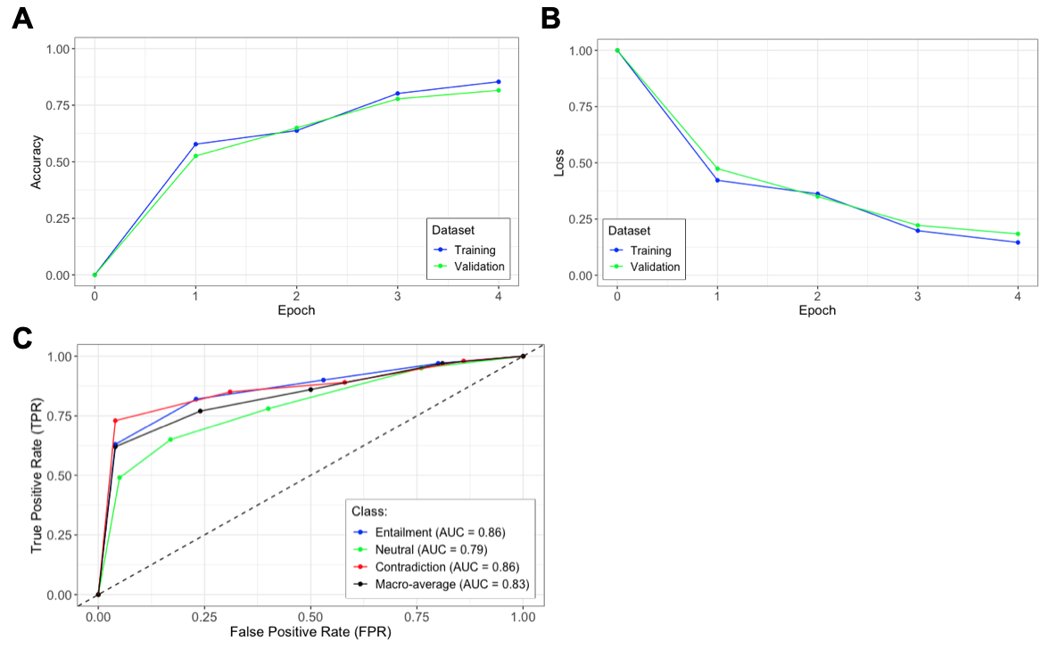
Figure S15. Validating BERT model for semantic similarity. (A) As the number of epoch increases, the accuracy of the BERT model increases. (B) We observed a decreasing mean squared error (MSE) loss function as the number of epochs increases. (C) We obtained ROC curves for each of the three classes (entailment, neutral, and contradiction) with a macro-average AUC score of 0.83.

Automated Scoring of Free Responses Yields Similar Results

We obtained BERTScores for all participants in the process recall experiment and linearly scaled them to a range between 0 and 1 using the formula ${BERTScore}_{Adj}=\frac{1}{4}BERTScore+min$, where min is 0 or $\frac{1}{4}$ if the participant’s free response was categorized by BERT as a contradiction or neutral statement compared to the premise respectively. This adjustment sets an upper bound for the adjusted BERTScore of contradictions and neutral statements at 0.25 and 0.5 respectively. Because the lower bound for BERTScores for statements categorized as entailment is 0.5, these scores were not adjusted. To examine metric quality and inter-judge reliability between manual and automated scoring, we computed the Kendall rank correlation τ and Spearman’s rank correlation ρ to be τ = 0.76 and ρ = 0.88. Since the effect size for τ and ρ were large (|τ| ≥ 0.50, |ρ| ≥ 0.50), there was high inter-judge reliability between the manual and automated scoring. From the linear fit in Figure S16, we see that the adjusted BERTScore predicted the manual score sufficiently well. High BERTScores were matched with high manual scores, and the linear scaling allowed for low adjusted BERTScores to be matched with low manual scores.

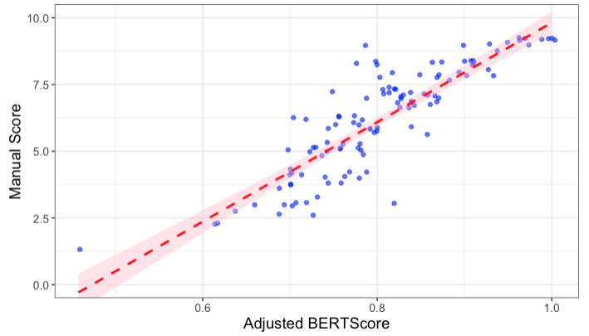
Figure S16. Manual score plotted against automated score for the process recall experiment using BERT. The manual score is predicted reasonably well with BERT with adjustment with τ = 0.76 and ρ = 0.88. Points are individual participants’ scores, dashed line is the regression model prediction, and the shaded area is the 95% confidence interval.

Using the automated scores, we reran our analyses and obtained similar statistically significant results for the process recall experiment. The negative group had the highest recall accuracy, followed by the positive group, and finally the control group. The same interaction effects between valence, depression level, and vividness level with environment were observed, and the automated scoring supports our conclusion that a negative memory palace is optimal for MOL (Table S8-S10, Figures S17-19). Thus, the automated scoring validated our manual scoring and offers a way to score recall accuracy for free responses in a less time-consuming and more unbiased manner.

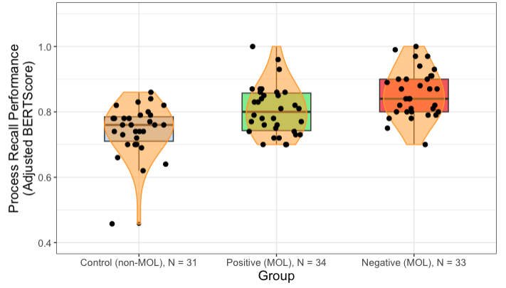
Figure S17. Free response memory recall performance using automated scoring. We report similar results to those obtained using manual scoring in the process recall experiment. MOL participants had greater recall accuracy than non-MOL participants. Furthermore, MOL participants that utilized a negatively valenced memory palace had the greatest recall accuracy, followed by MOL participants that utilized a positively valenced memory palace, and finally non-MOL participants. Boxplots with smoothed density distributions correspond to respective treatment (positive and negative MOL) and control (non-MOL) groups. Points represent individual participant’s BERTScore on the memory recall assessment.

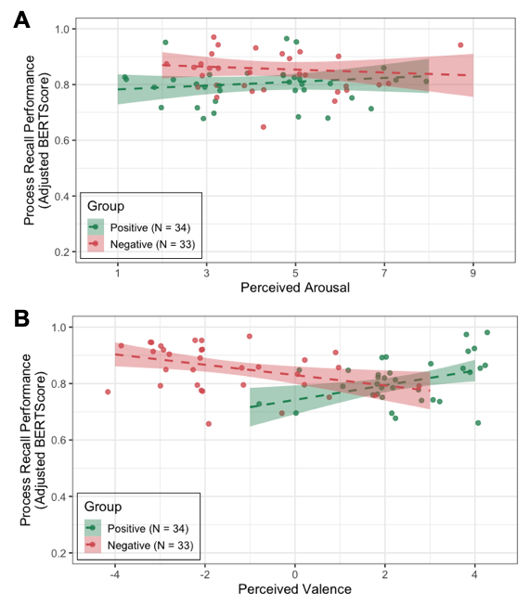
Figure S18. Regression model of process recall performance vs. perceived affect with negative environment (red) and positive environment (green) using automated scoring. We report similar results to those obtained using manual scoring in the process recall experiment. (A) No observed interaction between perceived arousal and environment type. (B) Observed interaction between perceived valence and environment type. As perceived valence increases, process recall performance decreases for the negative group but increases for the positive group. Dashed lines represent the line of best fit with 95% confidence intervals.

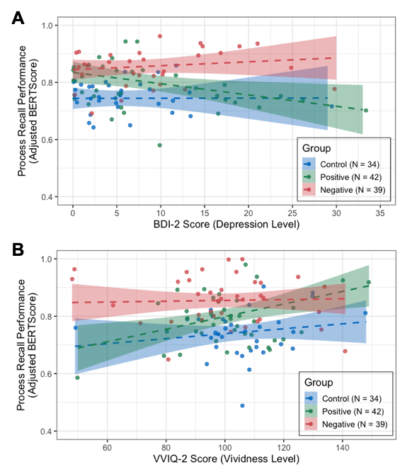
Figure S19. Effect of depression and vividness level on recall accuracy using automated scoring. We report similar results to those obtained using manual scoring in the process recall experiment. (A) Regression model of accuracy vs. depression level (BDI-2 score) with negative environment in red, positive environment in green, and control in blue. There is an observed interaction effect between depression level and environment, where environment results in a differential effect of BDI-2 score on recall accuracy. For the positive group, as BDI-2 score increases, recall accuracy decreases. Conversely, for the negative group, as BDI-2 score increases, recall accuracy increases. (B) Regression model of accuracy vs. vividness level (VVIQ-2 score). There is an observed interaction effect between vividness level and environment, where environment results in a differential effect of VVIQ-2 score on recall accuracy. For the positive group, as VVIQ-2 score increases, recall accuracy increases. Conversely, for the negative group, recall accuracy remains high across a wide range of VVIQ-2 scores. Datapoints represent individual participant BDI-2 or VVIQ-2 score. Dashed lines represent the line of best fit with 95% confidence intervals.

 | Process Recall Performance (BERTScore)
 | (1) | (2) | (3)
Arousal | 0.020  (0.016) |  | 0.020  (0.018)
Valence |  | 0.065***  (0.020) | 0.057**  (0.023)
Age |  |  | -0.001  (0.001)
VVIQ_Total |  |  | 0.001  (0.001)
BDI |  |  | -0.002  (0.002)
Gender |  |  | -0.010  (0.019)
Education |  |  | 0.001  (0.005)
Race |  |  | -0.005  (0.011)
Group | 0.104**  (0.050) | 0.079***  (0.030) | 0.115**  (0.051)
Arousal:Group | -0.013  (0.011) |  | -0.013  (0.011)
Valence:Group |  | -0.042***  (0.012) | -0.038***  (0.013)
Intercept | 0.672***  (0.076) | 0.671***  (0.053) | 0.512***  (0.110)
Observations | 67 | 67 | 67
R² | 0.126 | 0.258 | 0.334
Adjusted R² | 0.084 | 0.223 | 0.213
RSE | 0.075  (df = 63) | 0.069  (df = 63) | 0.069  (df = 55)
F Statistic | 3.016**  (df = 3; 63) | 7.296***  (df = 3; 63) | 2.627***  (df = 11; 55)
Note: |  | *p<0.1; **p<0.05; ***p<0.01
Table S8. Interaction models for arousal and valence with environment using automated scoring. We report similar results to those obtained using manual scoring in the process recall experiment. Arousal is a poor predictor of recall accuracy, but valence is a significant predictor of recall accuracy. Furthermore, there is a significant interaction effect between valence and environment.

 | Process Recall Performance (BERTScore)
 | Positive  (4) | Negative  (5) | Positive  (6) | Negative  (7)
Arousal | 0.010  (0.008) | -0.005  (0.008)
Valence |  |  | 0.021*  (0.012) | -0.020***  (0.007)
Age | -0.001  (0.001) | 0.001  (0.001) | -0.001  (0.001) | 0.0002  (0.001)
VVIQ_Total | -0.0002  (0.001) | 0.002*  (0.001) | 0.0001  (0.001) | 0.002*  (0.001)
BDI | -0.005*  (0.002) | -0.0004  (0.003) | -0.003  (0.002) | -0.001  (0.003)
Gender | 0.001  (0.027) | 0.004  (0.035) | -0.006  (0.027) | -0.007  (0.031)
Education | 0.002  (0.007) | -0.001  (0.008) | -0.002  (0.006) | 0.002  (0.007)
Race | -0.014  (0.015) | -0.005  (0.019) | -0.004  (0.015) | -0.001  (0.016)
Intercept | 0.831***  (0.137) | 0.698***  (0.105) | 0.795***  (0.135) | 0.632***  (0.085)
Observations | 34 | 33 | 34 | 33
R² | 0.224 | 0.177 | 0.267 | 0.372
Adjusted R² | 0.015 | -0.053 | 0.070 | 0.197
RSE | 0.074  (df = 26) | 0.074  (df = 25) | 0.072  (df = 26) | 0.065  (df = 25)
F Statistic | 1.070**  (df = 7; 26) | 0.770  (df = 7; 25) | 1.353**  (df = 7; 26) | 2.119***  (df = 7; 25)
Note: |  |  | *p<0.1; **p<0.05; ***p<0.01

Table S9. Main effect models for arousal and valence using automated scoring. We report similar results to those obtained using manual scoring in the process recall experiment. There is no significant main effect between arousal and recall accuracy for positive (4) and negative (5) groups. There is a significant main effect between valence and recall accuracy for positive (6) and negative (7) groups.

 | Process Recall Performance (BERTScore)
 | Depression Model | Vividness Model
Arousal | 0.008  (0.005) | 0.007  (0.006)
Valence | 0.0003  (0.006) | 0.002  (0.006)
Age | 0.0003  (0.001) | 0.0001  (0.001)
VVIQ_Total | 0.001  (0.0005) | 0.004***  (0.002)
BDI | -0.010**  (0.004) | -0.002  (0.001)
Gender | 0.014  (0.020) | 0.013  (0.020)
Education | 0.001  (0.005) | -0.001  (0.005)
Race | 0.003  (0.011) | -0.002  (0.011)
Group | 0.013  (0.036) | 0.268***  (0.097)
BDI:Group | 0.006**  (0.002)
VVIQ_Total:Group |  | -0.002**  (0.001)
Intercept | 0.649***  (0.079) | 0.292*  (0.159)
Observations | 81 | 81
R² | 0.268 | 0.262
Adjusted R² | 0.164 | 0.156
RSE | 0.079  (df = 70) | 0.079  (df = 70)
F Statistic | 2.565**  (df = 10; 70) | 2.483**  (df = 10; 70)
Note: |  | *p<0.1; **p<0.05; ***p<0.01

Table S10. Regression models exhibiting interaction effects between BDI and group (Depression model) and VVIQ and group (Vividness model). We report similar results as those obtained from manual scoring in the process recall experiment. We observe significant interaction effect between depression level and group and vividness level and group.

Vividness of Visual Imagery Questionaire-2 (VVIQ-2)

We used the following VVIQ-2 scale developed by Marks (1973) to assess individual participant vividness level:

Instructions

Visual imagery refers to the ability to visualize, that is, the ability to form mental pictures, or to ‘see in the mind’s eye’. Marked individual differences are found in the strength and clarity of reported visual imagery and these differences are of considerable psychological interest.

The aim of this test is to determine the vividness of your visual imagery. The items of the test will possibly bring certain images to your mind. You are asked to rate the vividness of each image by reference to the five-point scale given below. For example, if your image is ‘vague and dim’, then give it a rating of 4. After each item, write the appropriate number in the box provided.

Before you turn to the items, familiarize yourself with the different categories on the rating scale. Throughout the test, refer to the rating scale when judging the vividness of each image. Try to do each item separately, independent of how you may have done other items.

This test consists of 32 items to be imaged with your eyes closed. When we say “eyes closed”, we mean the question is read, you close your eyes, an image is formed with them closed, and then open them to write the score. Please refer to the scale scores throughout the test when you judge the vividness of each image. Please do not go to the next page until you have completed the items on the page you are doing, and do not look at the items you’ve already covered. Try to score each item separately and independently of how you scored the other items.

Rating Scale

Perfectly clear and as vivid as normal vision (5)

Clear and reasonably vivid (4)

Moderately clear and vivid (3)

Vague and dim (2)

No image at all, you only “know” that you are thinking of the object (1)

Items

Think of some relative or friend whom you frequently see (but who is not with you at present) and consider carefully the picture that comes before your mind’s eye.

1 The exact contour of face, head, shoulders and body. [ ]

2 Characteristic poses of head, attitudes of body etc. [ ]

3 The precise carriage, length of step, etc. in walking. [ ]

4 The different colours worn in some familiar clothes. [ ]

Think of the rising sun. Consider carefully the picture that comes before your mind’s eye.

5 The sun is rising above the horizon into a hazy sky. [ ]

6 The sky clears and surrounds the sun with blueness. [ ]

7 Clouds. A storm blows up, with flashes of lightening. [ ]

8 A rainbow appears. [ ]

Think of the front of a shop which you often go to. Consider the picture that comes before your mind’s eye.

9 The overall appearance of the shop from the opposite side of the road. [ ]

10 A window display including colours, shape and details of individual items for sale. [ ]

11 You are near the entrance. The colour, shape and details of the door. [ ]

12 You enter the shop and go to the counter. The counter assistant serves you. Money changes hands. [ ]

Think of a country scene which involves trees, mountains and a lake. Consider the picture that comes before your mind’s eye.

13 The contours of the landscape. [ ]

14 The colour and shape of the trees. [ ]

15 The colour and shape of the lake. [ ]

16 A strong wind blows on the tree and on the lake causing waves. [ ]

Think of being driven in a fast-moving car by a relative or friend along a major highway. Consider the picture that comes into your mind’s eye.

17 You observe the heavy traffic travelling at maximum speed around your car. The overall appearance of vehicles, their colours, sizes and shapes. [ ]

18 Your car accelerates to overtake the traffic directly in front of you. You see and urgent expression on the face of the driver and the people in the other vehicles as you pass. [ ]

19 A large truck is flashing its headlight directly behind. Your car quickly moves over to let the truck pass. The driver signals with a friendly wave. [ ]

20 You see a broken-down vehicle beside the road. Its lights are flashing. The driver is looking concerned and she is using a mobile phone. [ ]

Think of the beach by the ocean on a warm summer’s day. Consider the picture that comes before your mind’s eye.

21 The overall appearance and colour of the water, surf, and sky. [ ]

22 Bathers are swimming and splashing about in the water. Some are playing with a brightly coloured beach ball. [ ]

23 An ocean liner crosses the horizon. It leaves a trail of smoke in the blue sky. [ ]

24 A beautiful air balloon appears with four people aboard. The balloon drifts past you, almost directly overhead. The passengers wave and smile. You wave and smile back at them. [ ]

Think of a railway station. Consider the picture that comes before your mind’s eye.

25 The overall appearance of the station viewed from in front of the main entrance. [ ]

26 You walk into the station. The colour, shape and details of the entrance hall. [ ]

27 You approach the ticket office, go to a vacant counter and purchase your ticket. [ ]

28 You walk to the platform and observe other passengers and the railway lines. A train arrives. You climb aboard. [ ]

Finally, think of a garden with lawns, bushes, flowers and shrubs. Consider the picture that comes before your mind’s eye.

29 The overall appearance and design of the garden. [ ]

30 The colour and shape of the bushes and shrubs. [ ]

31 The colour and appearance of the flowers. [ ]

32 Some birds fly down onto the lawn and start pecking for food. [ ]

Scoring

Sum of all ratings for each item.
≤ 50: Aphantasia
51 < VVIQ-2 Score < 134: Normal
≥ 135: Hyperphantasia

Beck’s Depression Inventory-2 (BDI-2)

We used the following BDI-2 scale developed by Beck et al. (1996) to assess individual participant depression level:

Instructions

This questionnaire consists of 21 groups of statements. Please read each group of statements carefully. And then pick out the one statement in each group that best describes the way you have been feeling during the past two weeks, including today. Circle the number beside the statement you have picked. If several statements in the group seem to apply equally well, circle the highest number for that group. Be sure that you do not choose more than one statement for any group, including Item 16 (Changes in Sleeping Pattern) or Item 18 (Changes in Appetite).

Items

1. Sadness
0. I do not feel sad.
1. I feel sad much of the time.
2. I am sad all the time
3. I am so sad or unhappy that I can’t stand it.

2. Pessimism
0. I am not discouraged about my future.
1. I feel more discouraged about my future than I used to.
2. I do not expect things to work out for me.
3. I feel my future is hopeless and will only get worse.

3. Past Failure
0. I do not feel like a failure.
1. I have failed more than I should have.
2. As I look back, I see a lot of failures.
3. I feel I am a total failure as a person.

4. Loss of Pleasure
0. I get as much pleasure as I ever did from the things I enjoy.
1. I don’t enjoy things as much as I used to.
2. I get very little pleasure from the things I used to enjoy.
3. I can’t get any pleasure from the things I used to enjoy.

5. Guilty Feelings
0. I don’t feel particularly guilty.
1. I feel guilty over many things I have done or should have done.
2. I feel quite guilty most of the time.
3. I feel guilty all of the time.

6. Punishment Feelings
0. I don’t feel I am being punished.
1. I feel I may be punished.
2. I expect to be punished.
3. I feel I am being punished.

7. Self-Dislike
0. I feel the same about myself as ever.
1. I have lost confidence in myself.
2. I am disappointed in myself.
3. I dislike myself.

8. Self-Criticalness
0. I don't criticize or blame myself more than usual.
1. I am more critical of myself than I used to be.
2. I criticize myself for all of my faults.
3. I blame myself for everything bad that happens.

9. Suicidal Thoughts or Wishes
0. I don't have any thoughts of killing myself.
1. I have thoughts of killing myself, but I would not
carry them out.
2. I would like to kill myself.
3. I would kill myself if I had the chance.

10. Crying
0. I don't cry anymore than I used to.
1. I cry more than I used to.
2. I cry over every little thing.
3. I feel like crying, but I can't.

11. Agitation
0. I am no more restless or wound up than usual.
1. I feel more restless or wound up than usual.
2. I am so restless or agitated, it's hard to stay still.
3. I am so restless or agitated that I have to keep moving or doing something.

12. Loss of Interest
0. I have not lost interest in other people or activities.
1. I am less interested in other people or things than before.
2. I have lost most of my interest in other people or things.
3. It's hard to get interested in anything.

13. Indecisiveness
0. I make decisions about as well as ever.
1. I find it more difficult to make decisions than usual.
2. I have much greater difficulty in making decisions than I used to.
3. I have trouble making any decisions.

14. Worthlessness
0. I do not feel I am worthless.
1. I don't consider myself as worthwhile and useful as I used to.
2. I feel more worthless as compared to others.
3. I feel utterly worthless.

15. Loss of Energy
0. I have as much energy as ever.
1. I have less energy than I used to have.
2. I don't have enough energy to do very much.
3. I don't have enough energy to do anything.

16. Changes in Sleeping Pattern
0. I have not experienced any change in my sleeping.
1a I sleep somewhat more than usual.
1b I sleep somewhat less than usual.
2a I sleep a lot more than usual.
2b I sleep a lot less than usual.
3a I sleep most of the day.
3b I wake up 1-2 hours early and can't get back to sleep.

17. Irritability
0. I am not more irritable than usual.
1. I am more irritable than usual.
2. I am much more irritable than usual.
3. I am irritable all the time.

18. Changes in Appetite
0. I have not experienced any change in my appetite.
1a My appetite is somewhat less than usual.
1b My appetite is somewhat greater than usual.
2a My appetite is much less than before.
2b My appetite is much greater than usual.
3a I have no appetite at all.
3b I crave food all the time.

19. Concentration Difficulty
0. I can concentrate as well as ever.
1. I can't concentrate as well as usual.
2. It's hard to keep my mind on anything for very long.
3. I find I can't concentrate on anything.

20. Tiredness or Fatigue
0. I am no more tired or fatigued than usual.
1. I get more tired or fatigued more easily than usual.
2. I am too tired or fatigued to do a lot of the things I used to do.
3. I am too tired or fatigued to do most of the things I used to do.

21. Loss of Interest in Sex
0. I have not noticed any recent change in my interest in sex.
1. I am less interested in sex than I used to be.
2. I am much less interested in sex now.
3. I have lost interest in sex completely.

Scoring

Sum of all ratings for each item.
0 to 13: none or minimal depression
14 to 19: mild depression
20 to 28: moderate depression
29 to 63: severe depression

References

Aries, M., Veitch, J., & Newsham, G. Windows, view, and office characteristics predict physical and psychological discomfort. Journal of Environmental Psychology, 30(4), 533-541. https://doi.org/10.1016/j.jenvp.2009.12.004

Bainbridge W. A. (2020). The resiliency of image memorability: A predictor of memory separate from attention and priming. Neuropsychologia, 141, 107408. https://doi.org/10.1016/j.neuropsychologia.2020.107408

Banaei, M., Ahmadi, A., Gramann, K., Hatami, J. (2020). Emotional evaluation of architectural interior forms based on personality differences using virtual reality. Frontiers of Architectural Research, 9(1), 138-147. https://doi.org/10.1016/j.foar.2019.07.005

Beck, A. T., Steer, R. A., & Brown, G. (1996). Beck Depression Inventory–II (BDI-II) [Database record]. APA PsycTests. https://doi.org/10.1037/t00742-000

Bertheaux, C., Zimmermann, E., Gazel, M., Delanoy, J., Raimbaud, P., & Lavoué, G. (2024). Effect of material properties on emotion: a virtual reality study. Frontiers in human neuroscience, 17, 1301891. https://doi.org/10.3389/fnhum.2023.1301891

Bowman, S.R., Angeli, G., Potts, C., & Manning, C.D. (2015). A large annotated corpus for learning natural language inference. Proceedings of the 2015 Conference on Empirical Methods in Natural Language Processing. https://aclanthology.org/D15-1075

Bradley, M. M., & Lang, P. J. (1994). Measuring emotion: the Self-Assessment Manikin and the Semantic Differential. Journal of behavior therapy and experimental psychiatry, 25(1), 49–59. https://doi.org/10.1016/0005-7916(94)90063-9

Brashears, B. (2024). Learning in Minecraft: A New Paradigm for Psychological Research. (Publication No. 10567) [Doctoral Dissertation, The University of Western Ontario]. Western University Electronic Thesis and Dissertation Repository. https://ir.lib.uwo.ca/etd/10567/

Cho, H. R., Kim, S., & Lee, J. S. (2022). Spaces Eliciting Negative and Positive Emotions in Shrinking Neighbourhoods: a Study in Seoul, South Korea, Using EEG (Electroencephalography). Journal of urban health : bulletin of the New York Academy of Medicine, 99(2), 245–259. https://doi.org/10.1007/s11524-022-00608-8

CyberZHG, bojone, nikitos9000, tim5go, HughChi, & thethiny (2024). Keras BERT [GitHub]. https://github.com/CyberZHG/keras-bert

Dalal, D., & Zickar, M. (2011). Some Common Myths About Centering Predictor Variables in Moderated Multiple Regression and Polynomial Regression. Organizational Research Methods, 15(3). https://doi.org/10.1177/1094428111430

Devilly, G., & O’Donohue, R. (2021). A video is worth a thousand thoughts: comparing a video mood induction procedure to an autobiographical recall technique. Australian Journal of Psychology, 4, 438-451. https://doi.org/10.1080/00049530.2021.1997553

Devlin, J., Chang, M., Lee, K., & Toutanova, K. (2019). BERT: Pre-training of Deep Bidirec- tional Transformers for Language Understanding. Arxiv. https://doi.org/10.48550/arXiv.1810. 04805

Dijkstra, N., Bosch, S. E., & van Gerven, M. A. (2017). Vividness of Visual Imagery Depends on the Neural Overlap with Perception in Visual Areas. The Journal of neuroscience : the official journal of the Society for Neuroscience, 37(5), 1367–1373. https://doi.org/10.1523/JNEUROSCI.3022-16.2016

Dou, J., & Xue, W. (2025). Perceptual (dis)similarities between colors and emotions: An empirical investigation with the image-based visual corpus analysis approach. Acta psychologica, 259, 105447. https://doi.org/10.1016/j.actpsy.2025.105447

Echambadi, R., & Hess, J. (2007). Mean-Centering Does Not Alleviate Collinearity Problems in Moderated Multiple Regression Models. Marketing Science, 26(3), 438-445. https://doi.org/10.1287/mksc.1060.0263

Evans, G. & McCoy, J. (1998) When Buildings Don’t Work: The Role of Architecture in Human Health. Journal of Environmental Psychology, 18(1), 85-94. https://doi.org/10.1006/jevp.1998.0089

Faul, L., & LaBar, K. S. (2023). Mood-congruent memory revisited. Psychological review, 130(6), 1421–1456. https://doi.org/10.1037/rev0000394

Flora, D. B., & Curran, P. J. (2004). An empirical evaluation of alternative methods of estimation for confirmatory factor analysis with ordinal data. Psychological methods, 9(4), 466–491. https://doi.org/10.1037/1082-989X.9.4.466

Fox, J., & Monette, G. (1992). Generalized Collinearity Diagnostics. Journal of the American Statistical Association, 87(417), 178–183. https://doi.org/10.2307/2290467

Francis, W.N. and Kucera, H. (1964) A Standard Corpus of Present-Day Edited American English, for Use with Digital Computers. Department of Linguistics, Brown University, Providence.

Fried, E.I., Nesse, R.M. (2015) Depression sum-scores don’t add up: why analyzing specific depression symptoms is essential. BMC Med 13, 72. https://doi.org/10.1186/s12916-015-0325-4

Gaekwad, J. S., Sal Moslehian, A., Roös, P. B., & Walker, A. (2022). A Meta-Analysis of Emotional Evidence for the Biophilia Hypothesis and Implications for Biophilic Design. Frontiers in psychology, 13, 750245. https://doi.org/10.3389/fpsyg.2022.750245

Geethanjali, B., Adalarasu, K., Hemapraba, A., Kumar, S.P., & Rajasekeran, R. (2017). Emotion analysis using SAM (Self Assessment Manikin) scale. Biomedical Research: Complex World of Neuroscience, 1-7. https://www.abacademies.org/articles/emotion-analysis-using-sam-selfassess ment-manikin-scale.pdf

Goetschalckx, L., & Wagemans, J. (2019). MemCat: a new category-based image set quantified on memorability. PeerJ, 7, e8169. https://doi.org/10.7717/peerj.8169

Goldberg, X. (2025). Natural daylight exposure improves mood. Nat Revs Psychol, 4, 437. https://doi.org/10.1038/s44159-025-00470-w

Grol, M., & Raedt, R. D. (2014). Effects of positive mood on attentional breadth for emotional stimuli. Frontiers in psychology, 5, 1277. https://doi.org/10.3389/fpsyg.2014.01277

HALNY (2023). Minecraft modern house 1.20.1 tutorial [Video]. YouTube. https://www.youtube.com/watch?v=nMwif4MNS5I&t=3s

Hauser, D. J., Moss, A. J., Rosenzweig, C., Jaffe, S. N., Robinson, J., & Litman, L. (2022). Evaluating CloudResearch’s Approved Group as a solution for problematic data quality on MTurk. Behavior Research Methods, 55, 3953-3964. https://doi.org/10.3758/s13428-022-01999-x

Hong, Y., Cho, J., & Wang, Z. (2025). A study of interior design elements promoting the perception of healing considering genderand age: A multi-domain approach. Building and Environment, 271, 112649. https://doi.org/10.1016/j.buildenv.2025.112649

Jonauskaite, D., & Mohr, C. (2025). Do we feel colours? A systematic review of 128 years of psychological research linking colours and emotions. Psychonomic bulletin & review, 32(4), 1457–1486. https://doi.org/10.3758/s13423-024-02615-z

Jonauskaite, D., Parraga, C. A., Quiblier, M., & Mohr, C. (2020). Feeling Blue or Seeing Red? Similar Patterns of Emotion Associations With Colour Patches and Colour Terms. i-Perception, 11(1), 2041669520902484. https://doi.org/10.1177/2041669520902484

Kellert, S. R., & Wilson, E. O. (1993). The biophilia hypothesis. Island Press.

Khosla, A., Raju, A., Torralba, A., & Oliva, A. (2015) Understanding and Predicting Image Memorability at a Large Scale, 2015 IEEE International Conference on Computer Vision (ICCV), 2390-2398. https://doi.org/10.1109/ICCV.2015.275

Koivisto, M., & Grassini, S. (2022). Mental imagery of nature induces positive psychological effects. Current Psychology: A Journal for Diverse Perspectives on Diverse Psychological Issues. Advance online publication. https://doi.org/10.1007/s12144-022-04088-6

Lang, P.J., Bradley, M.M., & Cuthbert, B.N. (1997). International Affective Picture System (IAPS): Technical Manual and Affective Ratings. Encyclopedia of Personality and Individual Differences. NIMH Center for the Study of Emotion and Attention.

Lorents, A., Ruitenberg, M. F. L., & Schomaker, J. (2023). Novelty-induced memory boosts in humans: The when and how. Heliyon, 9(3), e14410. https://doi.org/10.1016/j.heliyon.2023.e14410

MacCartney, B., & Manning, C.D. (2008). Modeling Semantic Containment and Exclusion in Natural Language Inference. Proceedings of the 22nd international Conference on Computational Linguistics (Coling 2008), 521-528. https://aclanthology.org/C08-1066/

Marcoulides, K. M., & Raykov, T. (2019). Evaluation of Variance Inflation Factors in Regression Models Using Latent Variable Modeling Methods. Educational and psychological measurement, 79(5), 874–882. https://doi.org/10.1177/0013164418817803

Marks, D.F. (1973). Visual imagery differences and eye movements in the recall of pictures. Perception & Psychophysics, 14, 407-412. https://doi.org/10.3758/BF03211175

Matt, G. E., Vázquez, C., & Campbell, W. K. (1992). Mood-congruent recall of affectively toned stimuli: A meta-analytic review. Clinical Psychology Review, 12(2), 227–255. https://doi.org/10.1016/0272-7358(92)90116-P

McCormack, G., Giles-Corti, B., Lange, A., Smith, T., Martin, K., & Pikora, T. J. (2004). An update of recent evidence of the relationship between objective and self-report measures of the physical environment and physical activity behaviours. Journal of science and medicine in sport, 7(1 Suppl), 81–92. https://doi.org/10.1016/s1440-2440(04)80282-2

Mehrabian, A., & Russell, J. A. (1974). An approach to environmental psychology. The MIT Press.

Mitchell, R. L., & Phillips, L. H. (2007). The psychological, neurochemical and functional neuroanatomical mediators of the effects of positive and negative mood on executive functions. Neuropsychologia, 45(4), 617–629. https://doi.org/10.1016/j.neuropsychologia.2006.06.030

Morales-Bravo, J., Navarrete-Hernandez, P. (2022). Enlightening wellbeing in the home: The impact of natural light design on perceived happiness and sadness in residential spaces. Building and Environment, 223. https://doi.org/10.1016/j.buildenv.2022.109317

Needell, C.D., Bainbridge, W.A. (2022). Embracing New Techniques in Deep Learning for Estimating Image Memorability. Computational Brain and Behavior 5, 168–184. https://doi.org/10.1007/s42113-022-00126-5

O'Brien, R. M. (2007). A caution regarding rules of thumb for variance inflation factors. Quality & Quantity: International Journal of Methodology, 41(5), 673–690. https://doi.org/10.1007/s11135-006-9018-6

Öhman, A., Flykt, A., & Esteves, F. (2001). Emotion drives attention: detecting the snake in the grass. Journal of experimental psychology. General, 130(3), 466–478. https://doi.org/10.1037/0096-3445.130.3.466
Pastore, R. E., Crawley, E. J., Berens, M. S., & Skelly, M. A. (2003). "Nonparametric" A' and other modern misconceptions about signal detection theory. Psychonomic bulletin & review, 10(3), 556–569. https://doi.org/10.3758/bf03196517

Posner, J., Russell, J. A., & Peterson, B. S. (2005). The circumplex model of affect: an integrative approach to affective neuroscience, cognitive development, and psychopathology. Development and psychopathology, 17 (3), 715–734. https://doi.org/10.1017/S0954579405050340

Pratto, F., & John, O. P. (1991). Automatic vigilance: the attention-grabbing power of negative social information. Journal of personality and social psychology, 61(3), 380–391. https://doi.org/10.1037//0022-3514.61.3.380

Quent, J. A., Henson, R. N., & Greve, A. (2021). A predictive account of how novelty influences declarative memory. Neurobiology of learning and memory, 179, 107382. https://doi.org/10.1016/j.nlm.2021.107382

Rice, J., Kozak, R., Meitner, M., & Cohen, D. (2006). Appearance Wood Products and Psychological Well-Being. Wood and Fiber Science, 4. https://wfs.swst.org/index.php/wfs/article/view/180/180

Rong, Z. (2023). Research on the Application of Emotional Psychology and Aesthetic Psychology in the Color of Art Design. Archives of Clinical Psychiatry, 49(5). https://archivespsy.com/menu-script/index.php/ACF/article/view/1031

Rosenbusch, H., Soldner, F., Evans, A.M., & Zeelenberg, M. (2021). Supervised machine learning methods in psychology: A practical introduction with annotated R code. Social and Personality Psychology Compass, 15(2). https://doi.org/10.1111/spc3.12579

Russell J. A. (2003). Core affect and the psychological construction of emotion. Psychological review, 110(1), 145–172. https://doi.org/10.1037/0033-295x.110.1.145

Russell, J. A. (1980). A circumplex model of affect. Journal of Personality and Social Psychology, 39(6), 1161–1178. https://doi.org/10.1037/h0077714

Russell, J. A., & Barrett, L. F. (1999). Core affect, prototypical emotional episodes, and other things called emotion: Dissecting the elephant. Journal of Personality and Social Psychology, 76(5), 805–819. https://doi.org/10.1037/0022-3514.76.5.805

Scott, G.G., Keitel, A., Becirspahic, M. et al. The Glasgow Norms: Ratings of 5,500 words on nine scales. Behav Res 51, 1258–1270 (2019). https://doi.org/10.3758/s13428-018-1099-3

Sedikides, C. (2008). Mood as a determinant of attentional focus. Cognition and Emotion, 2, 129-148. https://doi.org/10.1080/02699939208411063

Song, L., Zhang, G., Ma, L., Silvennoinen, J., & Cong, F. (2025). Comparative analysis of color emotional perception in art and non-art university students: hue, saturation, and brightness effects in the Munsell color system. BMC psychology, 13(1), 650. https://doi.org/10.1186/s40359-025-03034-y

Uszkoreit, J. (2017). Transformer: A Novel Neural Network Architecture for Language Under- standing. Google Research. https://blog.research.google/2017/08/transformer-novel-neural-net work.html

Van Damme, I., & Smets, K. (2014). The power of emotion versus the power of suggestion: Memory for emotional events in the misinformation paradigm. Emotion, 14(2), 310–320. https://doi.org/10.1037/a0034629

Vitale, V., & Bonaiuto, M. (2024). The role of nature in emotion regulation processes: An evidence-based rapid review. Journal of Environmental Psychology, 96, 102325. https://doi.org/10.1016/j.jenvp.2024.102325

Wurm, L. H., & Reitan, M. (2025). Mean centering is not necessary in regression analyses, and probably increases the risk of incorrectly interpreting coefficients. Frontiers in psychology, 16, 1634152. https://doi.org/10.3389/fpsyg.2025.1634152

Yan, L., Lonstein, J. S., & Nunez, A. A. (2019). Light as a modulator of emotion and cognition: Lessons learned from studying a diurnal rodent. Hormones and behavior, 111, 78–86. https://doi.org/10.1016/j.yhbeh.2018.09.003

Zhang, T., Kishore, V., Wu, F., Weinberger, K.Q., & Artzi, Y. (2020). BERTScore: Evaluating Text Generation with BERT. The Eighth International Conference on Learning Representations. https://iclr.cc/virtual 2020/poster SkeHuCVFDr.html

The Minecraft build designed by HALNY used for this study can be found here. The original design is used for the positive valence condition, while the texture, color scheme, lighting, and interior design was altered for the negative valence condition.
ResMem model developed by Needell & Bainbridge (2022) used for this study can be found here.
Code for pre-trained Keras-BERT model developed by Cyber ZHG et al. can be found on GitHub.
The SNLI consists of 570,000 human-written English sentence pairs that are manually labeled with either “entailment,” “contradiction,” or “neutral” (Bowman et al., 2015). In our application of BERT, the premise is the nine steps for how to create a floral paperweight. The hypothesis is the free response given by participants during the memory recall assessment.

