Paired samples analysis
The results of the paired samples t-test analysis revealed significant differences in both groups for all the variables except for the amusement emotion in the AD group. Specifically, the AD group obtained the following results on the positive stimuli: amusement clip t (33) = -1.49, p = .147, d = -.26 and tenderness clip t (40) = -8.00 , p = .009, d = -1.25; while on the negative stimuli, they obtained: anger clip t (40) = -9.12, p = .009, d = -1.42; fear clip t (41) = -6.70 , p = .009 , d = -1.04 and sadness clip t (40) = -7.13, p = .009, d = -1.11. The control group’s results for the positive stimuli were as follows: amusement clip t (42) = -4.02, p = .009, d = -.61 and tenderness clip t (55) = -14.11, p = .009, d = -1.89; while for the negative stimuli, the results were the following: anger clip t (55) = -22.35, p = .009, d = -2.99; fear clip t (55) = -8.94, p = .009, d = -1.20 and sadness clip t (55) = -16.82, p = .009, d = -2.25. It was shown that the targets elicited a higher intensity of emotion in all the discrete emotions compared to the participants’ baseline. Figure 1 shows the results of the means for each variable.

Figure 1
Intra-Individual Emotional Reactivity of the Target Emotions between the Baseline Neutral Stimulus and the Target
HC GROUP
AD GROUP
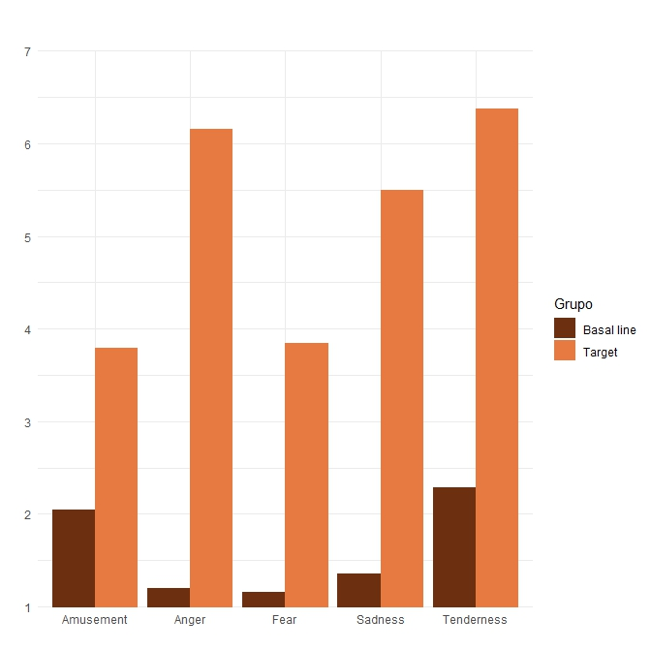
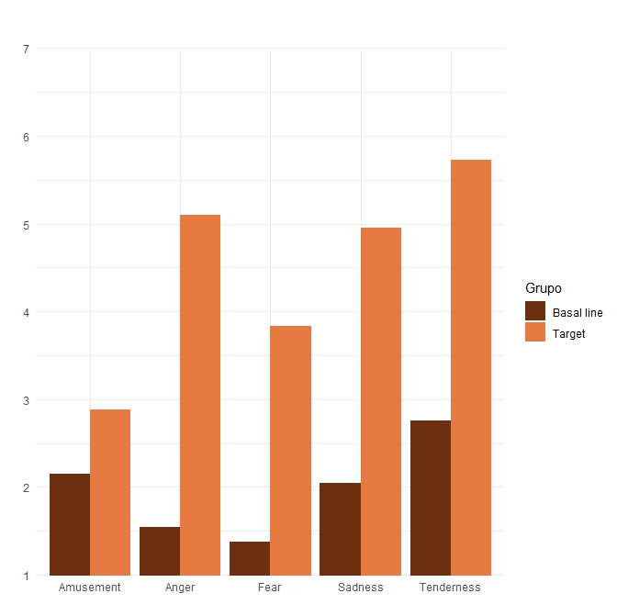
7

7

Sadness
Fear
Anger
Amusement
Tenderness
Baseline
Target
Target
Baseline
6
5
4
3
2
1
1
2
5
6
4
3
Amusement
Anger
Fear
Sadness
Tenderness

Note. Baseline: level of the discrete target emotion experienced in response to baseline neutral stimulus. Target: level of the same discrete target emotion experienced in response to the target stimulus. The results are expressed as means representing the differences p < .05 (e.g., comparison between the level of amusement experienced for the baseline clip and the amusement-inducing target).

