Supplementary Material for:
Behavioral Consequences of Blunting Fear with Acetaminophen

S.1 Supplementary Methods: Elaborations from Main Text 2
S.1.1 Drug Conditions Were Comparable 2
S.1.2 Participants Could Not Identify Their Drug Condition 3
S.1.3 Outliers and Missing Data 3
S.1.4 Exclusion Criteria 3
S.2 Supplementary Methods: Spider Plank 5
S.3 Supplementary Results: Plank Walk 6
S.3.1 Heart rate partially mediates the effect of acetaminophen on speed 6
S.3.2 Robustness Check 7
S.4 Supplementary Results: Spider Plank 13
S.4.1 Main Effects 13
S.4.2 Robustness Check 15
S.5 Supplementary Results: Hypotheses Not Supported 17
S.5.1 Non-Significant Hypothesized Main Effects 17
S.5.2 Hypothesized Interactions Not Tested 19
S.6 Supplementary Results: Exploratory 20
S.6.1 Correlations with Fear 20
S.6.2 Sex Differences (Exploratory) 21
S.6.3 Non-Significant Interactions with Trait Fear (Exploratory) 23
S.6.4 Drug Condition × Heart Rate Increase on Fear 24

Supplementary Methods: Elaborations from Main Text

Drug Conditions Were Comparable
 | Age | Sex | Ethnicity | Nationality
Acetaminophen | M = 20.59  SD = 3.62 | 95 F  34 M | White: 64  Asian: 27  Black: 8  Mixed: 16  Other: 14 | Canadian: 104 (incl. 7 dual)  Asia: 15  Africa: 4  Europe: 0  N. America: 2  S. America: 2
Placebo | M = 20.74  SD = 3.87 | 93 F  38 M | White: 87  Asian: 19  Black: 2  Mixed: 14  Other: 9 | Canadian: 108 (incl. 4 dual)  Asia: 13  Africa: 1  Europe: 4  N. America: 2  S. America: 1
Table S1. Age, sex, ethnicity, and number of Canadian and non-Canadian citizens by continent, per drug condition.

 | Trait fear of heights | Trait fear of spiders | VR experience
Acetaminophen | M = 2.31, SD = 1.45 | M = 2.82, SD = 2.26 | Current regular use: 2  Previous regular use: 5  Tried once or a few times: 79  Never tried: 43
Placebo | M = 2.17, SD = 1.42 | M = 2.72, SD = 2.42 | Current regular use: 1  Previous regular use: 9  Tried once or a few times: 75  Never tried: 46
Table S2. Trait fear of heights and spiders, and experience with virtual reality, by drug condition.

Participants Could Not Identify Their Drug Condition
To ensure participants were not able to accurately identify what drug condition they were in (above chance), the post-experiment survey asked, “Please take your best guess as to what capsules you were given at the start of the study,” to which they chose “1000 mg acetaminophen (equivalent to two Extra-Strength Tylenol)” or “Placebo (no active ingredients).” Participants were not any more or less likely to believe they were given acetaminophen capsules depending on their drug condition (acetaminophen vs. placebo: 36.7% (47/128) vs. 35.9% (47/131), χ²(1) = .00, p = .991, V = .00).

Outliers and Missing Data
Note on sample size: Due to a brief malfunction in the random assignment feature on Qualtrics, four more participants were assigned to the placebo group than to the acetaminophen group. Additionally, our total sample size is six less than we believed when stopping (at our stopping rule of 266). Five participated before a preregistration update, so were excluded. One accidentally participated twice; we excluded their second time. Data were also missing for some participants on some variables due to experimenter error or technological malfunctions (e.g., video did not record properly, sensor malfunctions).
Analysis | Non-missing  sample size | Outliers  removed | Final  sample size
Time to take first step | 254 (125, 129) | 6 (2, 4) | 248 (123, 125)
Walking speed  Heart rate increase on plank  Heart rate increase on spider plank | 254 (125, 129)  253 (126, 127)  207 (100, 107) | 5 (3, 2)  7 (4, 3)  4 (3, 1) | 249 (122, 127)  246 (122, 124)  203 (97, 106)
Table S3. Number of non-missing observations, number of outliers removed, and final sample size, from all hypothesized analyses with significant results. The first number in parentheses is the acetaminophen group, the second is the placebo group. Each analysis includes only complete cases for all variables involved, and excludes outliers based on that complete dataset’s sample size. According to our preregistration, we consulted the lookup table by Van Selst and Jolicoeur (1994) which indexes the standard deviation criteria to use as a cut-off, given the cell size in each condition.

Exclusion Criteria
Before coming to the lab, we screened participants to ensure they did not meet any of the following risk factors associated with acetaminophen: currently taking blood-thinning medications or a medication that contains acetaminophen; having had an allergic reaction to acetaminophen before; having consumed acetaminophen or alcohol within the past 48 hours; having a history of alcohol abuse; drinking more than 12 alcoholic drinks per week for females or more than 15 alcoholic drinks per week for males; or having a history of liver or kidney disease. We also ensured that participants had used acetaminophen at some point in their life without any adverse reactions, were not pregnant or concussed, and had never had adverse reactions to virtual reality. We asked participants not to eat any food for three hours before the study to allow for maximum absorption of acetaminophen. We told them they could bring a small snack to the lab in case they became uncomfortably hungry and ensured that they were not diabetic or prone to hypoglycemia.

Supplementary Methods: Spider Plank
Willingness to participate in spider plank walk. This binary measure assessed whether participants chose to try a second optional plank walk with a new frightening element. Participants saw the following Qualtrics message: “Please now let the experimenter know whether you would like to go back into the virtual environment and try the plank walk with virtual spiders. If so, you will be tasked with retrieving a piece of cake on the end of the plank, and you will encounter virtual spiders of varying sizes.” Most participants across conditions (218/265; 82%) ended up trying the spider plank walk, which means that any comparisons across conditions were subject to ceiling effects.
Fear manipulation: spider plank walk. Participants who opted to do so were tasked with walking the plank surrounded by virtual spiders. They also had to remove a virtual cake that blocks their path on the plank, either by throwing or virtually eating it. When they bent down to grab onto the first slice of cake, a cluster of small virtual spiders emerged from inside the cake. Virtual giant spiders would then race towards them from multiple directions as they walked to the end of the plank and back.
Measures for the spider plank walk. We used the same measures for the spider plank walk as we did for the regular one: a composite of three fear ratings (α = .89; measured when small spiders first appear, when a giant spider first appears, and written afterwards), valence (written afterwards), time to take first step, speed to the end (including the time spent moving virtual cake), speed returning, distance, and heart rate increase. We did not measure the proportion of time looking down for the spider plank walk, as most participants were looking at the spiders or cake.
Spider Phobia Questionnaire (SPQ-15). We assessed participants’ baseline fear of spiders using the SPQ-15 (Olatunji et al., 2009). This scale consists of 15 items (α = .96; e.g., “I avoid going to parks or on camping trips because there may be spiders about”, “I would feel some anxiety holding a toy spider in my hand”) which participants respond to on an 11-point scale from 0 (does not describe me at all) to 10 (describes me perfectly). The SPQ-15 was completed during the survey period immediately following acetaminophen or placebo administration.

Supplementary Results: Plank Walk

Heart rate partially mediates the effect of acetaminophen on speed
Note: While the findings reported below are consistent with our preregistered hypothesis, they should be interpreted cautiously as suggestive (rather than evidence) of the underlying mechanism. Mediation analyses rely on directional causality assumptions that cannot be empirically established with cross-sectional data.
First, zero-order correlations indicated a significant negative association between acetaminophen (dummy coded as 1, placebo as 0) and heart rate increase on the plank, r(234) = -.18 [-.32, -.04], p = .010, a significant negative association between heart rate increase and walking speed, r(234) = -.28 [-.42, -.13], p < .001, as well as a positive association between acetaminophen and speed, r(234) = .18 [.05, .30], p = .010.
Regression analyses revealed drug condition predicted 3.3% of the variance in participants’ heart rate increase on the plank (relative to resting), t(234) = -2.82, p = .005, R² = .033 [.00, .09], b = -4.74 [-8.06, -1.43], supporting the a-path of the proposed mediation model. Further, participants’ heart rate increase on the plank uniquely predicted 6% of the variance in walking speed beyond the variance already accounted for by drug condition, t(233) = -4.06, p < .001, sr² = .06 [.00, .12], b = -0.05 [-0.07, -0.03], supporting the b-path of the proposed mediation model. Lastly, without controlling for heart rate, drug condition predicted 3.3% of the variance in walking speed, supporting the c-path of the proposed mediation model, t(234) = 2.81, p = .005, R² = .033 [.00, .09], b = 0.92 [0.28, 1.57].
Because both the a- and b-paths of the model were supported, we tested for mediation using bootstrapping with bias-corrected confidence intervals. The result supported the indirect path between acetaminophen and walking speed via heart rate increase, b = 0.24 [0.09, 0.48], p < .001. However, the direct path between acetaminophen and walking speed remained significant after accounting for heart rate increase, b = 0.68 [0.13, 1.36], p = .020. Because the direct path between acetaminophen and walking speed remained at a non-zero relationship, these results suggest that heart rate increase may partially, but not fully, mediate the relation between acetaminophen and walking speed (26% mediation, 95% CI [8%, 76%]).

Robustness Check
Here we report all main text findings when analyzed without removing outliers. When including outliers led to deviations from approximate normality, we used Mann-Whitney U tests. Apart from the non-significant effect on fear composite scores becoming marginally significant, all other results are consistent with those reported in the main text with outliers removed.
Time to Step on Plank. Participants on acetaminophen took significantly less time to get both feet onto the plank than participants on placebo (acetaminophen vs. placebo: N = 125 vs. 129, Mdn = 11 s vs. 13 s, M = 15.31 s vs. 19.19 s, SD = 19.33 s vs. 21.47 s, respectively, U = 6681.5, p = .009, r = -.15, HL = -2.00 s [95% upper bound: -1.00 s]; see Figure S1). At the median (i.e., HL), this is two seconds (15.4%) faster.

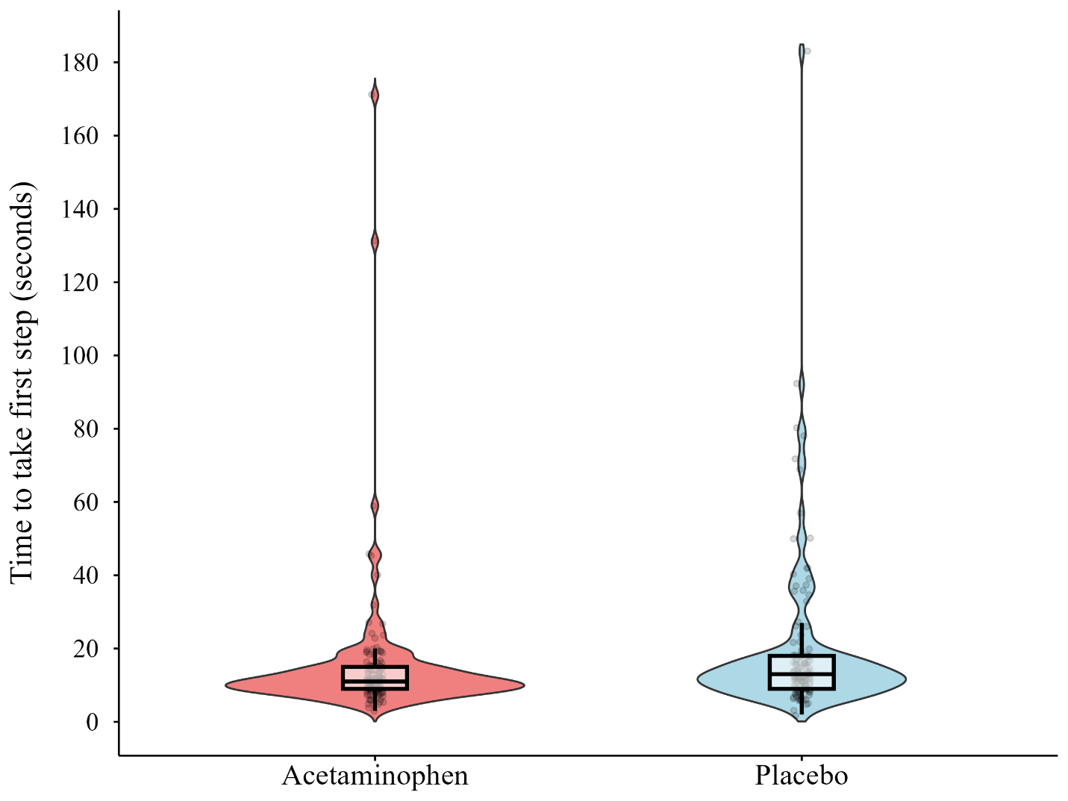
Figure S1. Violin plot depicting the distribution, and box plot depicting the median and IQR of participants’ time to get both feet onto the first plank, by condition (including all outliers).

Speed. Participants on acetaminophen walked significantly faster towards the plank’s end than participants on placebo (acetaminophen vs. placebo: N = 125 vs. 129, Mdn = 5.26 cm/s vs. 4.35 cm/s, M = 5.83 cm/s vs. 4.63 cm/s, SD = 3.55 cm/s vs. 2.65 cm/s, respectively, U = 9922, p < .001, r = .20, HL = 1.04 cm/s [95% lower bound: 0.51 cm/s]; see Figure S2). At the median (i.e., HL), this is 1.04 cm/s (23.9%) faster.

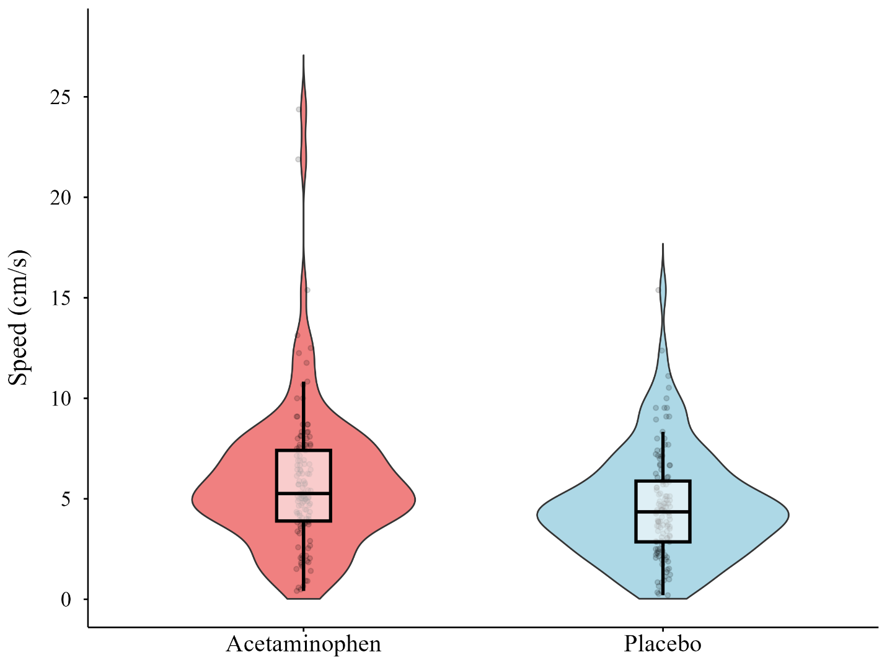
Figure S2. Violin plot depicting the distribution, and box plot depicting the median and IQR of participants’ walking speed on the first plank, by condition (including all outliers).

Heart Rate Increase. There were no baseline differences in resting heart rates before the plank walk (acetaminophen vs. placebo: N = 128 vs. 130, M = 72.84 bpm vs. 72.64 bpm, SD = 11.37 bpm vs. 9.84 bpm, respectively, t(256) = 0.15, p = .882). During the plank walk, participants’ heart rate increased significantly less in the acetaminophen group than the placebo group (acetaminophen vs. placebo: N = 126 vs. 127, Mdn increase = 30 bpm vs. 35 bpm, M increase = 33.6 bpm vs. 37.43 bpm, SD = 15.45 bpm vs. 14.75 bpm, respectively, U = 6523.5, p = .006, r = -.16, HL = -4.00 bpm [95% upper bound: -2.00 bpm]; see Figure S3). At the median (i.e., HL), this is four beats per minute (11.4%) less.

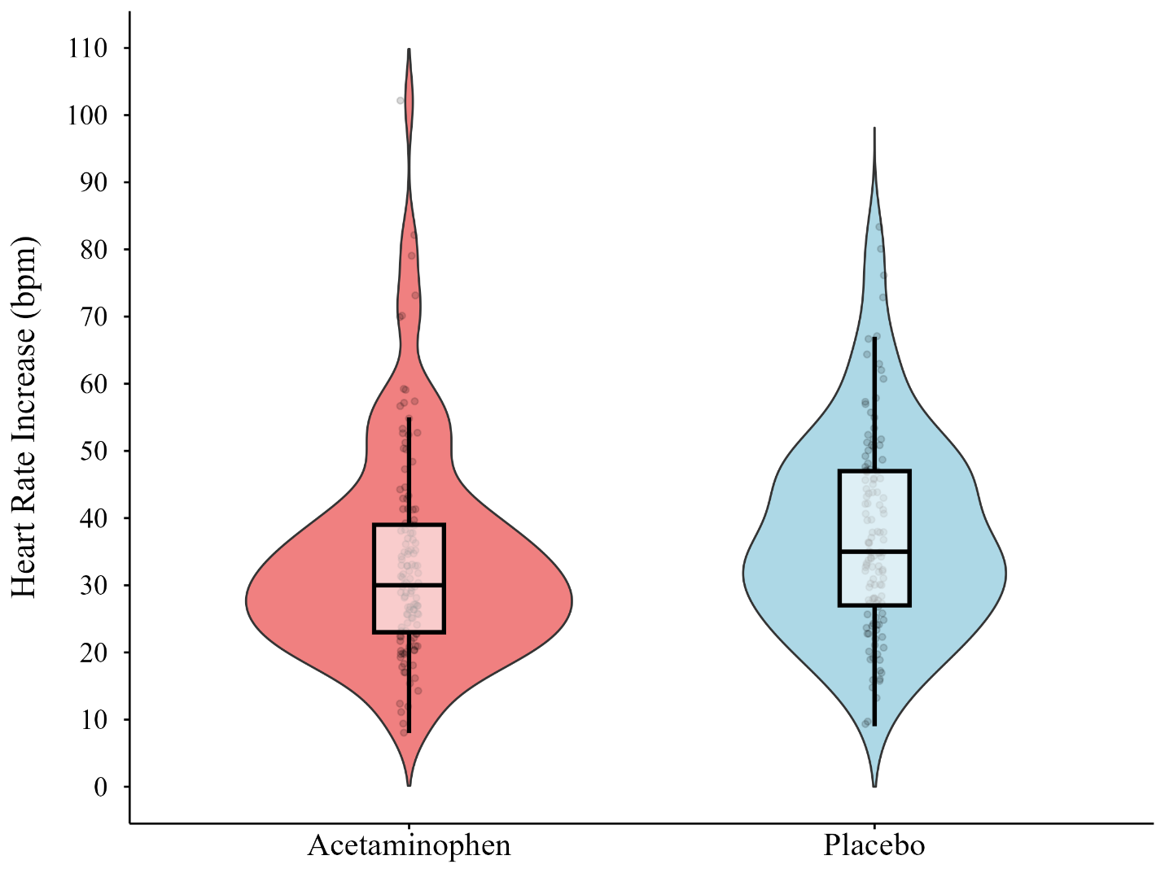
Figure S3. Violin plot depicting the distribution and box plot depicting the median and IQR of participants’ heart rate increase (change in beats per minute from average resting HR to first plank walk maximum HR), by condition (including all outliers).

Drug Condition × Timepoint on Heart Rate. As another robustness check of this result, we also ran a linear mixed effects model with heart rate as the dependent variable, predicted by an interaction between drug condition and timepoint (resting vs. plank walk), with a random intercept for individual participants.
Consistent with the heart rate increase group difference reported above and in the main text, this LMM showed a significant interaction between drug condition and timepoint on heart rate, χ²(1) = 3.99, p = .046. Pairwise contrasts on model-derived estimated marginal means suggested that the effect of timepoint (i.e., the effect of the plank walk) on heart rate was significantly weaker in the acetaminophen condition than in the placebo condition, t(254) = -2.00, p = .047, b = -3.79 bpm (acetaminophen: t(253) = 25.01, p < .001, b = 33.6 bpm; placebo: t(254) = 28.03, p < .001, b = 37.4 bpm).
Also as expected, there was a main effect of timepoint on heart rate, χ²(1) = 1407.96, p < .001. Pairwise contrasts on model-derived estimated marginal means indicated that participants’ heart rates were significantly higher on the plank walk (M = 108.2 bpm [106.4, 110.1]) than at rest (M = 72.7 bpm [70.9, 74.5]), t(254) = -37.42, p < .001, M_{diff} = 35.5 bpm [33.7, 37.4]. Also as expected, there was no main effect of drug condition (given that the two groups did not differ at rest), χ²(1) = 1.00, p = .318.

Fear. Participants on acetaminophen reported marginally significantly lower fear (composite scores) than those given placebo (acetaminophen vs. placebo: N = 117 vs. 121, M = 5.87 vs. 6.23, SD = 2.02 vs. 2.10, respectively, t(236) = -1.36, p = .088, d = -0.18 [-0.43, 0.08]; see Figure S4).
The acetaminophen group gave marginally significantly lower verbal fear ratings than the placebo group immediately after turning around at the farthest, least stable point on the plank (acetaminophen vs. placebo: N = 118 vs. 122, M = 6.45 vs. 6.84, SD = 2.31 vs. 2.22, respectively, t(238) = -1.31, p = .096, d = -0.17 [-0.42, 0.08]; see Figure S5).
The two groups did not differ in their written fear ratings (N = 128 vs. 131, M = 6.27 vs. 6.60, SD = 2.31 vs. 2.31, respectively, t(257) = -1.12, p = .131, d = -0.14 [-0.38, 0.10]).
There were no outliers for verbal fear ratings taken immediately after participants stepped onto the plank (non-significant; see main text).

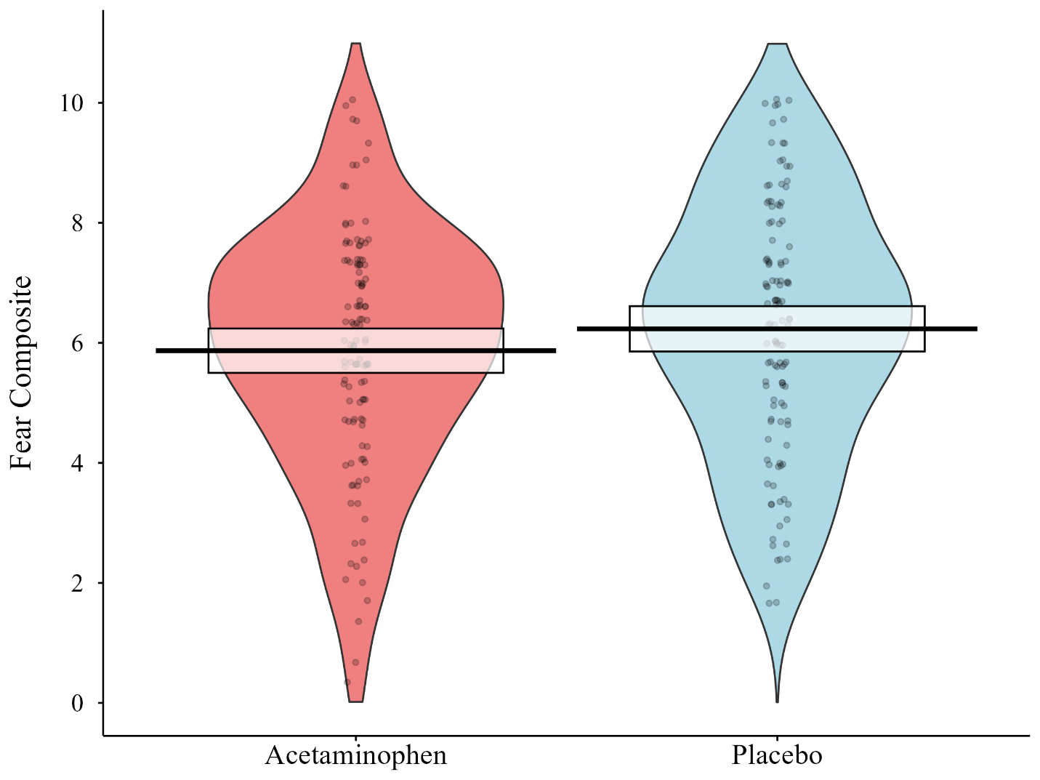
Figure S4. Violin plot depicting the distribution, with means and 95% confidence intervals, of fear composite scores by condition (including all outliers).
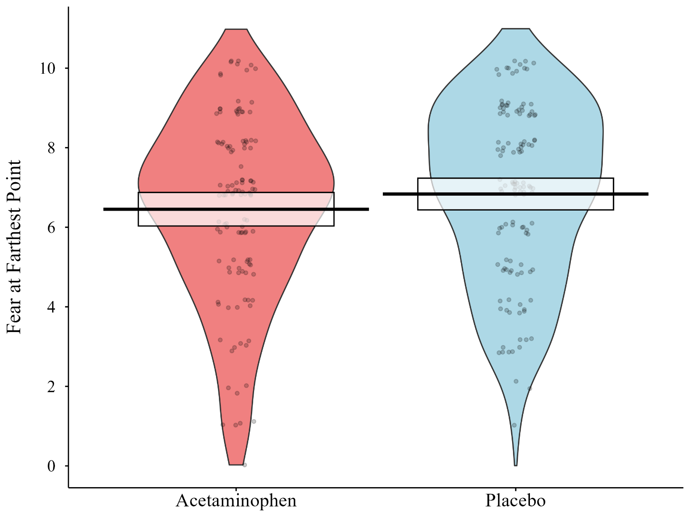
Figure S5. Violin plot depicting the distribution, with means and 95% confidence intervals, of verbal fear ratings at the farthest point on the plank, by condition (including all outliers).

Supplementary Results: Spider Plank

Main Effects
Heart Rate Increase (spider plank). Participants’ heart rate increased significantly less during the spider plank walk in the acetaminophen group than the placebo group (acetaminophen vs. placebo: N = 97 vs. 106, M increase = 31.35 bpm vs. 35.01 bpm, SD = 10.82 bpm vs. 12.6 bpm, respectively, t(201) = -2.21, p = .014, d = -0.31, [-0.59, -0.03]; see Figure S6). This corresponds to a mean difference of 3.66 bpm (10.5%) with a small-to-medium effect size.

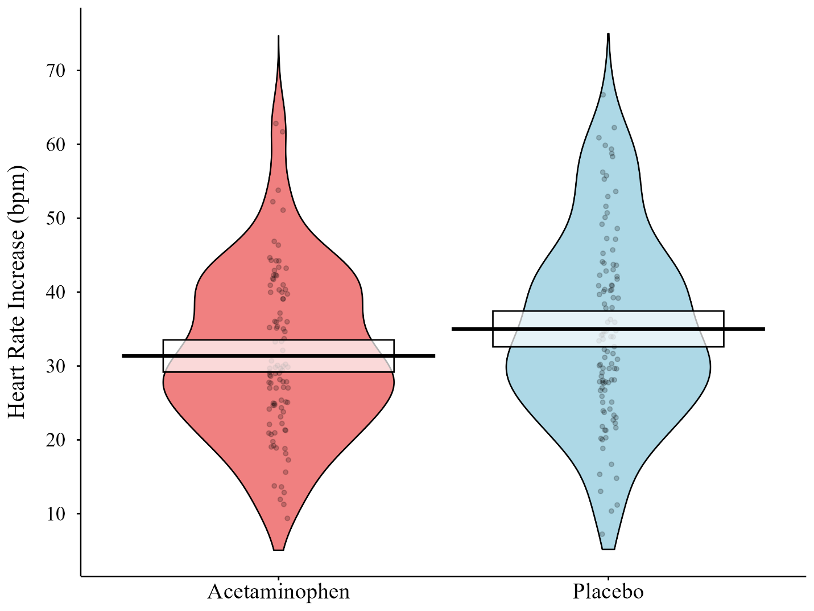
Figure S6. Violin plot depicting the distribution, with means and 95% CIs, of participants’ heart rate increase on the spider plank walk, by condition (change in beats per minute from average resting HR to spider plank maximum HR).

Speed (spider plank). Participants on acetaminophen moved marginally significantly faster to reach their end points on the spider plank walk than participants on placebo (acetaminophen vs. placebo: N = 92 vs. 105, Mdn = 4.21 cm/s vs. 3.64 cm/s, M = 4.93 cm/s vs. 4.60 cm/s, SD = 3.09 cm/s vs. 3.22 cm/s, respectively, U = 5364, p = .091, r = .10, HL = 0.39 cm/s [95% lower bound: -0.11 cm/s]). At the median (i.e., HL), this is .39 cm/s (10.7%) faster.
The acetaminophen group also walked marginally significantly faster than those on placebo when returning to the virtual elevator from the spider plank walk (acetaminophen vs. placebo: N = 87 vs. 95, Mdn = 13.33 cm/s vs. 12.44 cm/s, M = 17.73 cm/s vs. 13.5 cm/s, SD = 14.99 cm/s vs. 8.44 cm/s, respectively, U = 4260.5, p = .085, r = .10, HL = 1.50 cm/s [95% lower bound: -0.22 cm/s]). At the median (i.e., HL), this is 1.5 cm/s (12%) faster.

Robustness Check
Here we report all spider plank findings (reported above in S.4.1), when analyzed without removing outliers. The results are similar to the analysis above with outliers removed, except that the marginally significant effect on speed becomes fully significant (p = .091 vs. p = .047), and the marginally significant effect on returning speed becomes non-significant (p = .085 vs. p = .127).
Heart rate increase (spider plank). Participants’ heart rate increased less during the spider plank walk in the acetaminophen group than the placebo group (acetaminophen vs. placebo: N = 100 vs. 107, Mdn increase = 30 bpm vs. 34 bpm, M increase = 32.94 bpm vs. 35.38 bpm, SD = 14.38 bpm vs. 13.12 bpm, respectively, U = 4619, p = .045, r = -.11, HL = -3.00 bpm [95% upper bound: -0.00 bpm], see Figure S7). At the median (i.e., HL), this is three beats per minute (8.8%) less.

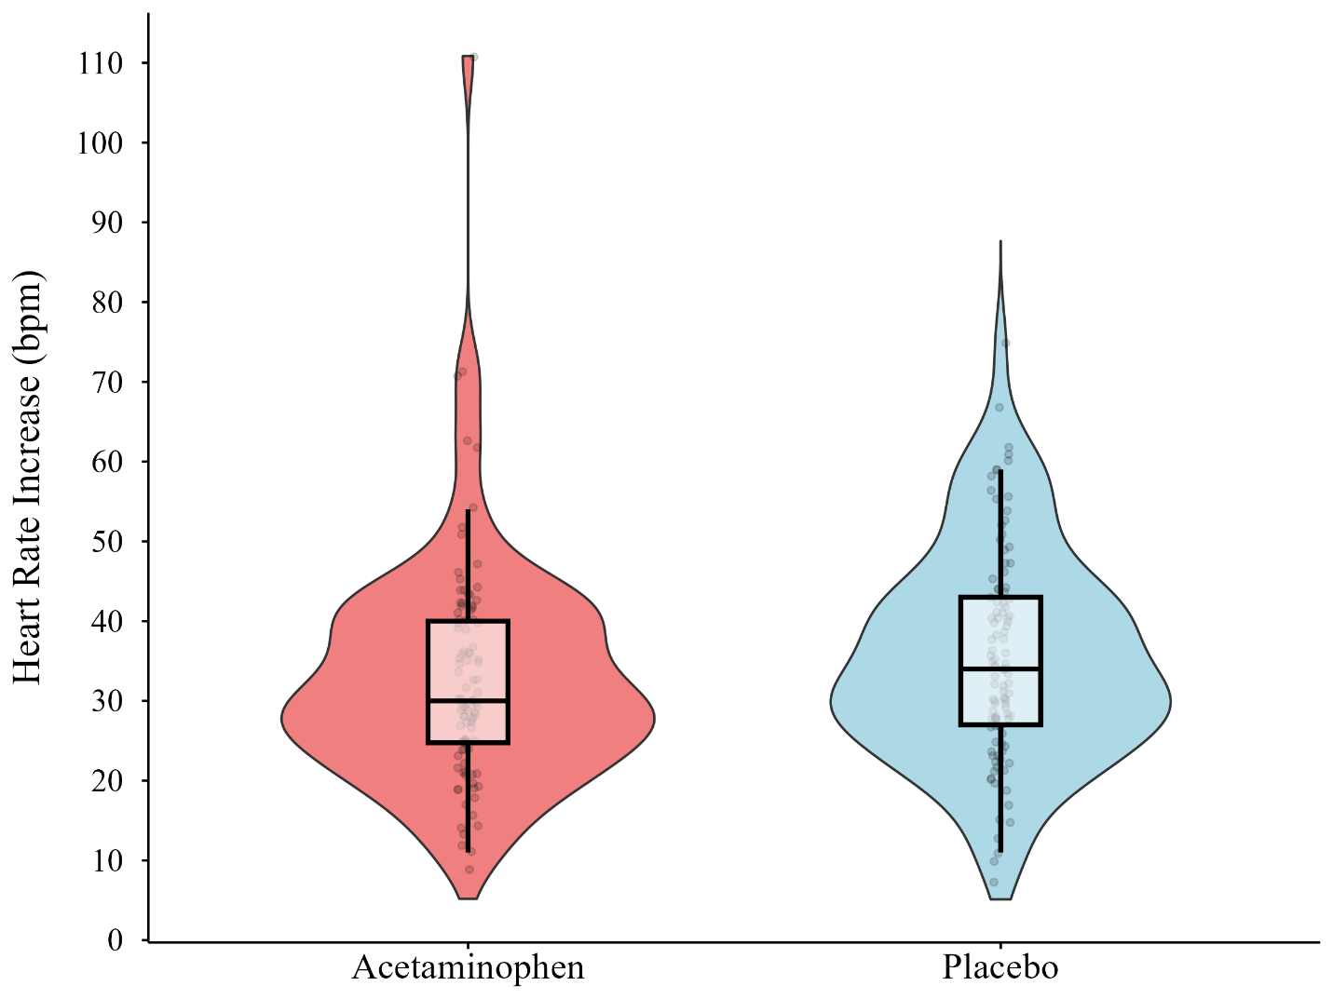
Figure S7. Violin plot depicting the distribution, and box plot depicting the median and IQR of participants’ heart rate increase on the spider plank walk, by condition (including outliers).

Speed (spider plank). Participants on acetaminophen moved significantly faster to reach their end points on the spider plank walk than participants on placebo (acetaminophen vs. placebo: N = 96 vs. 106, Mdn = 4.34 cm/s vs. 3.67 cm/s, M = 5.75 cm/s vs. 5.12 cm/s, SD = 5.1 cm/s vs. 6.24 cm/s, respectively, U = 5783, p = .047, r = .10, HL = 0.51 cm/s [95% lower bound: 0.00 cm/s]). At the median (i.e., HL), this is .51 cm/s (13.9%) faster.
However, the acetaminophen group did not walk significantly faster than placebo when returning to the virtual elevator from the spider plank walk (acetaminophen vs. placebo: N = 88 vs. 98, Mdn = 13.33 cm/s vs. 12.5 cm/s, M = 19.63 cm/s vs. 14.99 cm/s, SD = 23.24 cm/s vs. 12.33 cm/s; respectively, U = 4730.5, p = .127, r = .07, HL = 1.30 cm/s [95% lower bound: -0.44 cm/s]).
Thus, while both speed and returning speed were marginally significant with outliers removed as preregistered, speed towards the end of the plank was fully significant with outliers included, and speed returning was not significant with outliers included. We therefore have lower confidence in the presence (or lack of) these effects.

Supplementary Results: Hypotheses Not Supported

Non-Significant Hypothesized Main Effects
The following analyses did not show any significant effects of acetaminophen but are presented here for posterity as they were preregistered. Later in the Supplementary, we present exploratory analyses showing that acetaminophen did not interact with any trait variables (e.g., fear of heights or spiders) on any dependent measures.
First Plank Walk
Proportion of time looking down. Those on acetaminophen did not spend a significantly lower proportion of time looking down at the plank than those on placebo (acetaminophen vs. placebo: N = 116 vs. 115, Mdn = .57 vs. .63, M = .55 vs. .57, SD = .39 vs. .38, respectively, U = 6391, p = .291, r = -.04, HL = -0.00 [95% upper bound: 0.03]). Table S4 shows that looking down was only weakly correlated with fear, and if anything was negatively correlated with fear, such that it would not have provided a good test of our hypotheses.
Return Speed. The acetaminophen group did not walk significantly faster than the placebo group when returning to the virtual elevator from the farthest point reached on the plank (acetaminophen vs. placebo: N = 115 vs. 120, Mdn = 7.38 cm/s vs. 7.02 cm/s, M = 8.38 cm/s vs. 7.86 cm/s, SD = 4.12 cm/s vs. 3.64 cm/s, respectively, U = 7335, p = .202, r = .05, HL = 0.39 cm/s [95% lower bound: -0.38 cm/s]). In retrospect, this is perhaps unsurprising: fearful participants might be slower to reach the end of the plank, because their fear inhibits them from moving further, but won’t necessarily be slower to return from the plank, because being fast gets them out of the fearful situation sooner. In fact, the prediction could have gone the other way – more fearful participants might be faster to return, not slower. As such, if acetaminophen was blunting their fear, it should make them faster to walk out on the plank (as described in the main text), but in retrospect there is no clear prediction on whether they should be faster or slower to return.
Distance. There was a ceiling effect in our analysis of the distance that participants walked on the plank. Of those who did not fall off the virtual plank prematurely, around half of all participants walked the maximum 200 cm to the end of the plank (63/121 on acetaminophen, 62/121 on placebo). As a result, participants on acetaminophen did not walk significantly farther on the plank than those on placebo (acetaminophen vs. placebo: N = 121 vs. 121, Mdn = 200 cm vs. 200 cm, M = 189.21 cm vs. 186.99 cm, SD = 20.23 cm vs. 23.6 cm, respectively, U = 7456.5, p = .394, r = .02, HL = 0.00 cm [95% lower bound: -0.00 cm]).
Valence. Participants on acetaminophen did not rate the plank walk significantly less “objectively” scary (i.e., valence) than participants on placebo (acetaminophen vs. placebo: N = 125 vs. 131, Mdn = 7 vs. 7, M = 6.98 vs. 6.86, SD = 1.68 vs. 1.6, respectively, U = 8590.5, p = .756, r = .04, HL = 0.00 [95% upper bound: 0.00]).

Spider Plank Walk
One methodological limitation for this second spider plank walk is that it lacked standardization across participants. Individuals were free to look in any direction while in the simulation, which means that some people saw more spiders, or more “jump scares” than others. This inconsistency in scary content may account for why we did not find acetaminophen to significantly reduce any behavioral measures of fear on the spider plank walk. Further, the simulated heights and plank walk itself, not accounting for the spiders, was likely less frightening this time around simply because participants had already experienced it once before.
Fear. Participants on acetaminophen did not report significantly lower fear towards the spider plank walk than participants on placebo (acetaminophen vs. placebo: N = 89 vs. 100, M = 5.33 vs. 5.39, Mdn = 5.67 vs. 5.67, SD = 2.58 vs. 2.38, respectively, t(187) = -0.18, p = .430, d = -0.03 [-0.31, 0.26]).
Time to take first step. Participants on acetaminophen did not take less time to take their first step when beginning the spider plank walk than those on placebo (acetaminophen vs. placebo: N = 93 vs. 102, Mdn = 10 s vs 9 s, M = 10.49 s vs. 10.11 s, SD = 5.12 s vs. 4.02 s, respectively, U = 4816, p = .574, r = .01, HL = 0.00 s [95% upper bound: 1.00 s]), probably because they had all already completed the first plank walk and no spiders were visible yet.
Speed. While the effect of acetaminophen on speed towards the end of the spider plank was marginally significant with outliers removed as preregistered, it was fully significant with outliers included (see S.4). Conversely, while speed returning from the spider plank was marginally significant with outliers removed, it was not significant with outliers included. Therefore, while the results are generally in line with our predictions, we have lower confidence in these effects. Some of this ambiguity may be due to problems with the speed variable, as it included time spent stationary removing the virtual cake from the plank. Some participants pushed the entire cake off the plank right away, while others spent more time throwing (or virtually eating) the cake piece by piece. Further, some participants continued towards the end of the plank after removing the cake, while others started heading back immediately after. This would have led to inconsistency in this speed variable, as it was calculated as maximum distance/ time to get there.
Speed towards virtual cake. Excluding time spent standing still to throw the virtual cake off the plank, participants on acetaminophen did not walk any faster on their way to the virtual cake, when spiders were anticipated but had not yet appeared, than those on placebo (acetaminophen vs. placebo: N = 94 vs. 98, M = 8.72 cm/s vs. 8.26 cm/s, Mdn = 8.03 cm/s vs. 8.12 cm/s, SD = 3.7 cm/s vs. 3.41 cm/s, respectively, t(190) = 0.90, p = .185, d = 0.13 [-0.15, 0.41]).
Distance. Participants on acetaminophen did not make it significantly farther on the plank walk when accompanied by spiders than participants on placebo, possibly because so many participants made it nearly all 200 cm (acetaminophen vs. placebo: N = 88 vs. 99, Mdn = 192 cm vs. 190 cm, M = 181.64 cm vs. 179.18 cm, SD = 20.1 cm vs. 22.9 cm, respectively, U = 4518.5, p = .327, r = .03, HL = 0.00 cm [95% lower bound: -0.00 cm]).
Valence. Those on acetaminophen did not rate the spider plank walk as less “objectively” scary (valence) than those on placebo (acetaminophen vs. placebo: N = 100 vs. 109, Mdn = 7 vs. 7, M = 6.77 vs. 6.61, SD = 1.8 vs. 1.9, respectively, U = 5730.5, p = .743, r = .05, HL = 0.00 [95% upper bound: 1.00]).
Willingness to add spiders. Participants neither more nor less willing to add virtual spiders to the plank walk depending on drug condition, possibly because most participants in both conditions were willing to do so (acetaminophen vs. placebo: 79.8% (103/129) vs. 84.7% (111/131), χ²(1) = .76, p = .384, V = .01).
These non-significant findings likely reflect the previously described methodological problems with the spider plank walk. Consistent with this, neither trait fear of spiders nor state fear was as strongly correlated with behavioral fear measures from the spider plank walk as trait fear of heights and state fear were with behavioral fear measures from the first plank walk (see Table S4).

Hypothesized Interactions Not Tested
Acetaminophen and Fear. We hypothesized that fear would mediate the relationship between acetaminophen and several behavioral outcome variables (speed, speed returning, and distance on both plank walks, and proportion of time spent looking down on the first plank walk). However, there was no significant relationship between drug condition and fear on either plank walk (fear on first plank reported in main text, fear on spider plank reported in S.5.1), so we did not test for these mediations.
Acetaminophen and heart rate. We hypothesized that heart rate would also mediate the relationship between acetaminophen and several behavioral outcome variables (proportion of time spent looking down on the first plank, time to take first step, distance and speed returning on both planks, and speed on the spider plank). However, acetaminophen did not predict proportion of time looking down or speed returning on the first plank, nor distance on either plank (see S.5.1). We also did not test whether heart rate increase mediated the effect of acetaminophen on time to take first step, because the mediator (change from resting to maximum heart rate on the plank) might chronologically occur after the outcome variable (time to take first step). Further, even though acetaminophen predicted speed and speed returning on the spider plank with marginal significance when analyzed with the preregistered non-parametric Mann Whitney tests (see S.4.1), acetaminophen did not predict speed on the spider plank when analyzed with linear regressions required for mediation analyses, t(195) = .72, p = .470, R² = .003 [.00, .04], b = 0.33 [-0.56, 1.22], and the relationship between acetaminophen and heart rate on the spider plank walk was no longer significant after excluding observations that were missing spider plank return speed data, t(172) = -1.51, p = .134, R² = .013 [.00, .06], b = -2.57 [-5.94, 0.80]. Thus, we did not test whether heart rate mediated the relationship between acetaminophen and these variables.

Supplementary Results: Exploratory

Correlations with Fear
Variable | Corr. with  state fear  (1st plank) | Corr. with  trait fear  (1st plank) | State vs. trait corr. difference  (1st plank) | Corr. with  state fear  (spider) | Corr. with  trait fear  (spider) | State vs. trait  corr. difference (spider) | Corr. difference between the two planks (state fear) | Corr. difference between the two planks (trait fear)
First step | r₂₃₅ = .40  p < .001 | r₂₅₁ = .25  p < .001 | Δr = .15  p = .025
Looking down | r₂₁₃ = -.11  p = .114 | r₂₂₈ = -.15  p = .021 | Δr = .04  p = .570
Speed | r₂₃₅ = -.49  p < .001 | r₂₅₁ = -.22  p < .001 | Δr = -.27  p < .001 | r₁₈₅ = -.19  p = .008 | r₁₉₉ = -.12  p = .090 | Δr = -.07  p = .285 | Δr = -.30  p < .001 | Δr = -.10  p = .304
Return speed | r₂₃₁ = -.07  p = .270 | r₂₃₈ = .02  p = .703 | Δr = -.10  p = .198 | r₁₇₇ = .12  p = .120 | r₁₈₄ = .11  p = .127 | Δr = .00  p = .951 | Δr = -.19  p = .075 | Δr = -.09  p = .400
Distance | r₂₃₆ = -.41  p < .001 | r₂₅₆ = -.28  p < .001 | Δr = -.14  p = .046 | r₁₇₂ = -.23  p = .002 | r₁₈₆ = -.06  p = .412 | Δr = -.17  p = .016 | Δr = -.18  p = .053 | Δr = -.22  p = .025
Heart rate | r₂₃₀ = .22  p < .001 | r₂₅₀ = .05  p = .391 | Δr = .17  p = .022 | r₁₈₃ = .23  p = .001 | r₂₀₄ = .12  p = .086 | Δr = .11  p = .109 | Δr = -.01  p = .923 | Δr = -.07  p = .458
Valence | r₂₃₆ = .61  p < .001 | r₂₅₆ = .22  p < .001 | Δr = .39  p < .001 | r₁₈₈ = .65  p < .001 | r₂₁₀ = .32  p < .001 | Δr = .34  p < .001 | Δr = -.04  p = .470 | Δr = -.10  p = .245
Trait fear | r₂₃₅ = .35  p < .001 |  |  | r₁₈₈ = .53  p < .001 |  |  | Δr = -.18  p = .016
Table S4. Correlations, and differences in correlations (using Steiger’s (1980) method of comparing dependent correlations with Fisher’s r to z transformations), between each dependent variable and 1.) state fear on each plank walk (first plank and spider plank) and 2.) trait fear (of heights on the first plank, or of spiders on the spider plank).

Sex Differences (Exploratory)
Fear. Male participants indicated they were significantly less afraid on the plank walk than female participants (male vs. female: N = 70 vs. 166, M = 5.36 vs. 6.41, SD = 1.96 vs. 1.95, respectively, t(234) = -3.76, p < .001, d = -0.54 [-0.82, -0.25]). Male participants also reported they were marginally significantly less afraid on the spider plank walk than female participants (males vs. females: N = 56 vs. 133, M = 4.83 vs. 5.58, SD = 2.6 vs. 2.39, respectively, t(187) = -1.94, p = .054, d = -0.31 [-0.62, 0.01]).
Time to take first step. Male participants took significantly less time to take their first step onto the plank walk than female participants (male vs. female: N = 70 vs. 177, Mdn = 11 s vs. 12 s, M = 12.2 s vs. 15.41 s, SD = 7.55 s vs. 10.59 s, respectively, U = 4868, p = .009, r = -.17, HL = -2.00 s [-3.00 s, -1.00 s]).
Speed. Male participants walked significantly faster towards the plank’s end than female participants (male vs. female: N = 71 vs. 179, M = 5.83 cm/s vs. 4.67 cm/s, SD = 2.97 cm/s vs. 2.38 cm/s, respectively, t(107.43) = 2.95, p = .004, d = 0.43, [0.14, 0.73]). Males also moved significantly faster than females on the spider plank walk (males vs. females: N = 62 vs. 134, Mdn = 4.64 cm/s vs. 3.59 cm/s, M = 5.81 cm/s vs. 4.17 cm/s, SD = 3.52 cm/s vs. 2.61 cm/s, respectively, U = 5530, p < .001, r = .27, HL = 1.25 cm/s [0.61 cm/s, 1.93 cm/s]). However, there were no significant sex differences in speed returning from either the first plank (males vs. females: N = 68 vs. 166, Mdn = 7.15 cm/s vs. 7.3 cm/s, M = 8.35 cm/s vs. 7.96 cm/s, SD = 3.4 cm/s vs. 4 cm/s, respectively, t(232) = 0.71, p = .479, d = 0.10 [-0.18, 0.38]) or the spider plank (males vs. females: N = 52 vs. 129, Mdn = 9.09 cm/s vs. 12.5 cm/s, M = 16.21 cm/s vs. 14.59 cm/s, SD = 14.11 cm/s vs. 9.3 cm/s, respectively, U = 3137.5, p = .498, r = -.05, HL = -0.83 cm/s [-3.33 cm/s, 1.67 cm/s]).
Distance. Male participants made it significantly farther on the plank walk than female participants (males vs. females: N = 67 vs. 177, Mdn = 200 cm vs. 197 cm, M = 195.94 cm vs. 186.19 cm, SD = 9.02 cm vs. 22.05 cm, respectively, U = 7591, p < .001, r = .23, HL = 0.00 cm [0.00 cm, 5.00 cm]). However, there was no significant sex difference in the distance reached on the spider plank (males vs. females: N = 52 vs. 134, Mdn = 193.5 cm vs. 190 cm, M = 182.75 cm vs. 179.83 cm, SD = 20.01 cm vs. 21.73 cm, respectively, U = 3913.5, p = .182, r = .10, HL = 0.00 cm/s [-0.00 cm, 5.00 cm]).
Heart rate increase. Male participants’ heart rates increased significantly less from resting to the plank walk than female participants’ (male vs. female: N = 68 vs. 179, M = 30.82 bpm vs. 35.7 bpm, SD = 11.01 bpm vs. 13.87 bpm, respectively, t(151.41) = -2.88, p = .005, d = -0.39 [-0.66, -0.12]). The same was true on the spider plank walk; male participants’ heart rate increased less than females’ (males vs. females: N = 65 vs. 139, M = 29.26 bpm vs. 35.4 bpm, SD = 10.78 bpm vs. 12.3 bpm, respectively, t(141.43) = -3.62, p < .001, d = -0.53 [-0.82, -0.24]).
Valence. Male participants indicated they believed most people would find the plank walk “objectively” less scary than female participants did (males vs. females: N = 70 vs. 186, M = 6.57 vs. 7.05, SD = 1.6 vs. 1.63, respectively, t(254) = -2.12, p = .035, d = -0.30 [-0.57, -0.02]). However, there was no significant sex difference in valence ratings for the spider plank walk (males vs. females: N = 65 vs. 144, Mdn = 7 vs. 7, M = 6.49 vs. 6.78, SD = 1.95 vs. 1.80, respectively, t(207) = -1.03, p = .303, d = -0.15 [-0.45, 0.14]).
Trait fear. Male participants reported lower trait fear of heights than female participants did (males vs. females: N = 69 vs. 186, M = 1.46 vs. 2.45, SD = 0.97 vs. 1.41, respectively, t(176.48) = -6.34, p < .001, d = -0.82 [-1.08, -0.55]). Male participants also reported lower trait fear of spiders than female participants did (males vs. females: N = 69 vs. 186, M = 1.57 vs. 3.11, SD = 1.43 vs. 2.38, respectively, t(201.21) = -6.25, p < .001, d = -0.78 [-1.04, -0.52]).
Proportion of time looking down. Male participants spent a significantly greater proportion of time looking down than female participants (males vs. females: N = 67 vs. 164, Mdn = .93 vs. .42, M = .75 vs. .48, SD = .32 vs. .38, respectively, U = 7858.5, p < .001, r = .34, HL = .27 [.13, .40]).

Non-Significant Interactions with Trait Fear (Exploratory)
In the main text, we present the effect of acetaminophen on various dependent variables, and in Supplementary S.6.1 (Table S4), we present the correlations between trait fear and those same dependent variables. We conducted exploratory analyses to see if the effects of acetaminophen were greater in participants with higher trait fear. None of these interactions were significant (see Table S5 below). In other words, there were main effects of both acetaminophen and trait fear on our virtual reality plank walk measures, but there were no interactions between acetaminophen and trait fear.
Dependent  Variable | Non-significant interaction term:  Drug & trait fear of heights  (1st plank) | Non-significant interaction term:  Drug & trait fear of spiders  (spider plank)
First Step | t(243) = -1.52, p = .129,  sr² = .01, β = -0.13
Looking Down | t(226) = 1.14, p = .256,  sr² = .01, β = 0.11
Speed | t(244) = 0.84, p = .403,  sr² = .00, β = 0.08 | t(192) = 1.54, p = .125,  sr² = .01, β = 0.15
Return Speed | t(230) = -1.35, p = .179,  sr² = .01, β = -0.12 | t(178) = 0.43, p = .671,  sr² = .00, β = 0.04
Distance | t(242) = 0.44, p = .661,  sr² = .00, β = 0.04 | t(182) = 0.82, p = .415,  sr² = .00, β = 0.08
Heart Rate | t(241) = -0.35, p = .726,  sr² = .00, β = -0.03 | t(198) = -1.38, p = .168,  sr² = .01, β = -0.13
State Fear | t(231) = -0.64, p = .523,  sr² = .00, β = -0.04 | t(185) = -0.50, p = .617,  sr² = .00, β = -0.04
Valence | t(251) = -0.35, p = .725,  sr² = .00, β = -0.03 | t(204) = -1.64, p = .103,  sr² = .01, β = -0.15
Table S5. Non-significant interaction terms for drug condition and trait fear (mean-centered) predicting each dependent variable on 1. the first plank walk and 2. the spider plank walk.

Drug Condition × Heart Rate Increase on Fear
To explore whether the link between physiological arousal and subjective emotion may be weakened by acetaminophen, we tested for an interaction between drug condition and heart rate increase on self-reported fear (composite scores) using an exploratory moderated regression analysis.
While heart rate increase predicted 4% of the variance in fear, t(228) = 2.93, p = .004, sr² = .04 [-.01, .08], β = 0.28 [0.09, 0.46], b = .04 [0.01, 0.06], there was no main effect of drug condition on fear, t(228) = -1.20, p = .232, sr² = .01 [-.01, .03], β = -0.08 [-0.20, 0.05], b = -0.32 [-0.85, 0.21].
There was also no significant interaction between drug condition and heart rate increase on fear, t(228) = -0.89, p = .374, sr² = .00 [-.01, .02], β = -0.08 [-0.27, 0.10], b = -0.02 [-0.05, 0.02]. In other words, the relationship between heart rate increase and fear did not significantly differ by group. That being said, the model-derived slope of heart rate increase on fear was (non-significantly) weaker in the acetaminophen group, t(228) = 1.84, p = .067, b = 0.02 [-0.00, 0.05], than in the placebo group, t(228) = 2.93, p = .004, b = 0.04 [0.01, 0.06].

References
Olatunji, B. O., Woods, C. M., de Jong, P. J., Teachman, B. A., Sawchuk, C. N., & David, B.
(2009). Development and initial validation of an abbreviated Spider Phobia Questionnaire using item response theory. Behavior Therapy, 40(2), 114-130. https://doi.org/10.1016/j.beth.2008.04.002

Steiger, J. H. (1980). Tests for comparing elements of a correlation matrix. Psychological
Bulletin, 87(2), 245. https://doi.org/10.1037/0033-2909.87.2.245

Van Selst, M., & Jolicoeur, P. (1994). A solution to the effect of sample size on outlier
elimination. The Quarterly Journal of Experimental Psychology, 47(3), 631-650. https://doi.org/10.1080/14640749408401131

All zero-order correlations reported are corrected for multiple comparisons using the Holm correction, though we note that they are also significant with a more conservative Bonferroni correction.
When analyzed with Mann-Whitney tests, there are no longer marginal significant differences between the groups on either fear composite scores or fear at the farthest point (with or without outlier exclusion), despite only negligible normality deviations.
This is a composite score of two verbal fear ratings during the spider plank walk and one written fear rating after the task was over. Participants missing any of these were excluded from this analysis.
This excludes the first 18 participants from before we started explicitly telling participants to go as far as they were comfortable going on the spider plank walk after completing the cake portion.
These analyses exclude outliers for each sex using the previously described procedure by Van Selst & Jolicouer (1994). When distributions were not approximately normal, we used Mann-Whitney tests in place of independent samples t-tests. When distributions were approximately normal but the group variances differed significantly (indicted by Levene’s test), we used Welch’s t-tests. All tests are two-sided.
This measure of speed captures how quickly participants got to the farthest point on the spider plank walk, but participants were not moving uniformly, as this includes stopping to “eat” or throw virtual cake off the plank.
As with any analysis involving the spider distance variable, we excluded the first 18 participants from before we explicitly told participants to go as far as they were comfortable going on the spider plank walk after completing the cake portion.
Distance on the spider plank excludes the first 18 participants, as prior to this we did not explicitly tell participants to go as far as they were comfortable going on the spider plank walk after completing the cake portion.

