Supplementary Materials
In the main manuscript, to account for potential interindividual and age-group differences in fixation patterns, we used % fixation time (fixation time in an AOI expressed as a proportion of the total fixation time for the trial). Below, we present the analyses with the raw fixation time expressed in milliseconds.
For the traditional viewing task, there was a significant interaction between emotion and participant age-group, F(2, 180) = 7.09, p = .001, η_{p}² = .07. This was followed up by looking at the effect of emotion type separately for each age-group. Younger adults showed no difference in time spent gazing at positive and negative faces, t(48) = 1.68, p = .100, d = .20. However, relative to neutral faces, they looked more at negative faces, t(48) = 2.96, p = .005, d =.48, and at positive faces, t(48) = 4.68, p <.001, d =.71 (see Figure 1A). Older adults showed a significant difference in time spent gazing at positive and negative faces, t(48) = 2.62, p = .012, d =.49. This reflected the fact that older adults were looking less at negative relative to positive faces (see Figure 1A). Older adults also looked less at a negative faces relative to neutral faces, t(48) = 2.48, p = .017, d =.38, but showed no differences in gaze time to positive and neutral faces, t(48) = 1.27, p = .210, d =.16 (see Figure 1A). For the naturalistic task, there was no interaction between participant age-group and emotion, F(2, 182) = 0.22, p =.802, η_{p}² <.01 (see Figure 1B).
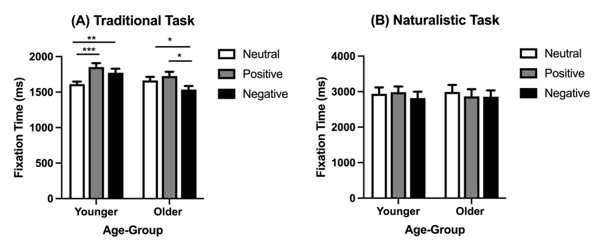
Figure 1
Fixation time (ms) to positive, negative and neutral faces for younger and older adults in the (A) traditional task, and (B) naturalistic task.
Within our primary analysis, we also included target face-age as a factor to explore own-age biases. While there was no main effect of emotion or any interactions with emotion, there was a significant three-way interaction with participant age-group, target face-age and task, F(1, 90) =5 .73, p = .019, η_{p}² = .06. This was followed up by looking at the effect of participant age-group on target face-age separately for each task. Again, raw scores were used in these follow up analyses. For the traditional viewing task, there was a main effect of target face-age, F(1, 96) = 6.66, p =.011, η_{p}² = .07, which reflected the fact that overall both groups were looking more at younger faces (M= 1723, SD =317) relative to older faces (M= 1669, SD =299). There was no main effect of participant age-group, F(1, 96) = 3.45, p =.066, η_{p}² = .04, and no interaction between target face-age and participant age-group, F(1, 96) = 1.07, p =.304, η_{p}² = .01 (see Figure 2A). For the naturalistic task, there was a main effect of target face-age, F(1, 95) = 27.80, p <.001, η_{p}² = .23, such that younger faces were looked at more (M= 3159, SD =1222) than older faces (M= 2629, SD =1030). There was also a significant interaction between target face-age and participant age-group, F(1, 95) = 5.70, p =.019, η_{p}² = .06. This was followed up by testing the effect of target face-age separately for each age-group. This revealed that both younger adults, t(47) = 4.78, p <.001. d = .69, and older adults, t(48) = 2.39, p =.021. d = .25, looked more at younger faces compared to older faces. However, this effect was much larger in the younger participants (see Figure 2B)
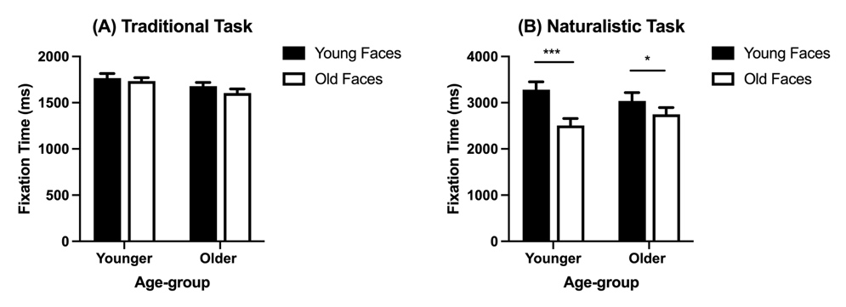
Figure 2
Fixation time (ms) to younger and older adult faces separately for younger and older adults in the (A) traditional task and (B) naturalistic task

