Supplemental Materials of “The impact of emotional prosody on self-reported well-being: The role of empathy”

Figure S1
Mediation analysis (Experiment 1b)
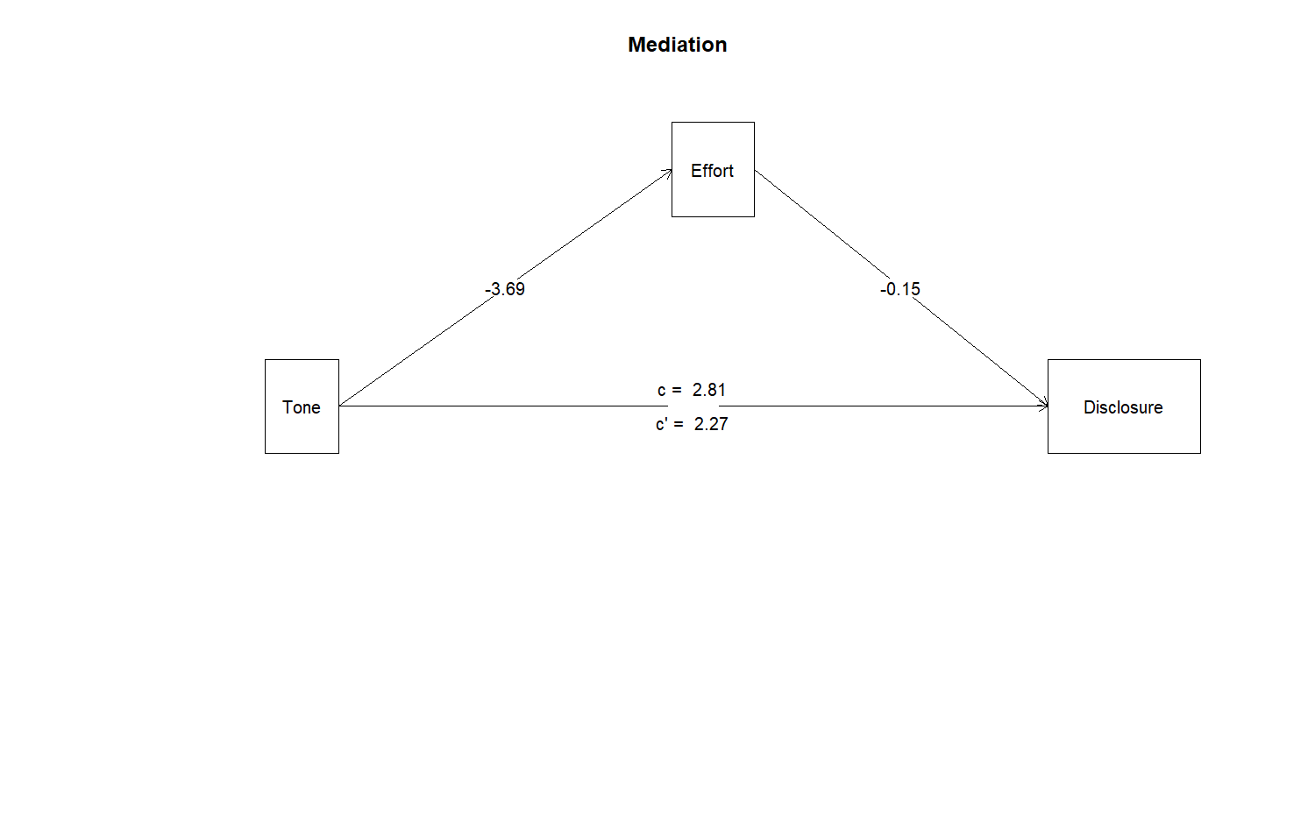
Note. Tone with 1: Happy and 0: Angry.

Figure S2a
Mediation analysis (Experiment 2): The effect of tone of voice on self-reported intention to self-disclose mediated by perceived effort, feelings of discomfort, and perceived breach of social norms
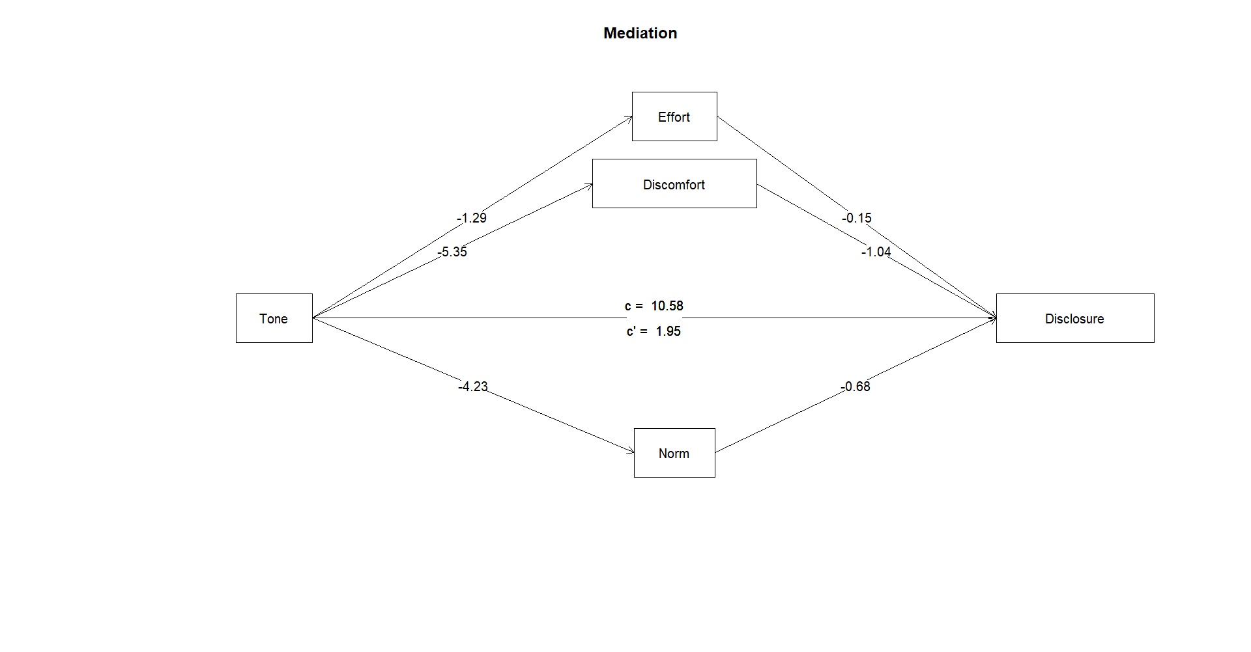
Figure S2b
Mediation analysis (Experiment 2): The effect of tone of voice on rated intention to self-disclose mediated by perceived effort, feelings of discomfort, and perceived breach of social norms
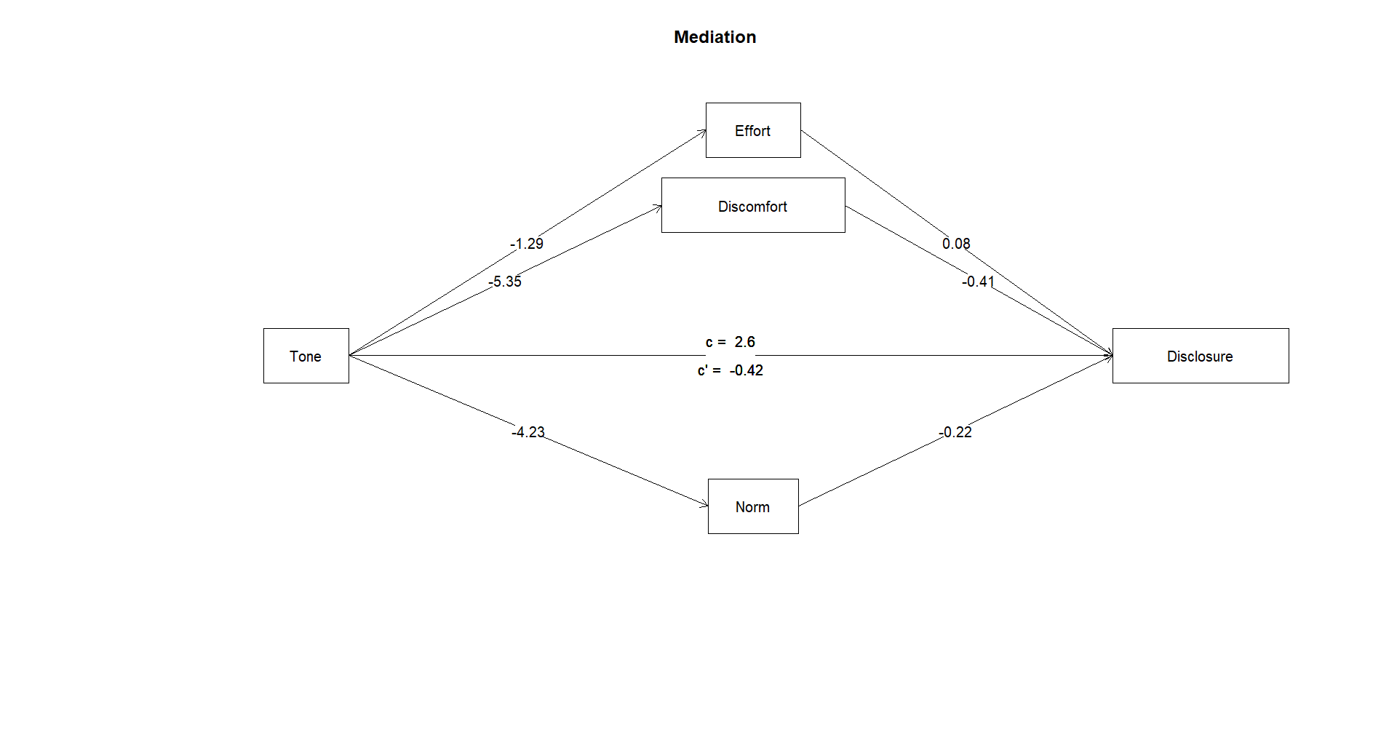
Figure S2c
Mediation analysis (Experiment 2): The effect of tone of voice on self-reported intention to self-disclose mediated by perceived effort, feelings of discomfort, and perceived breach of social norms
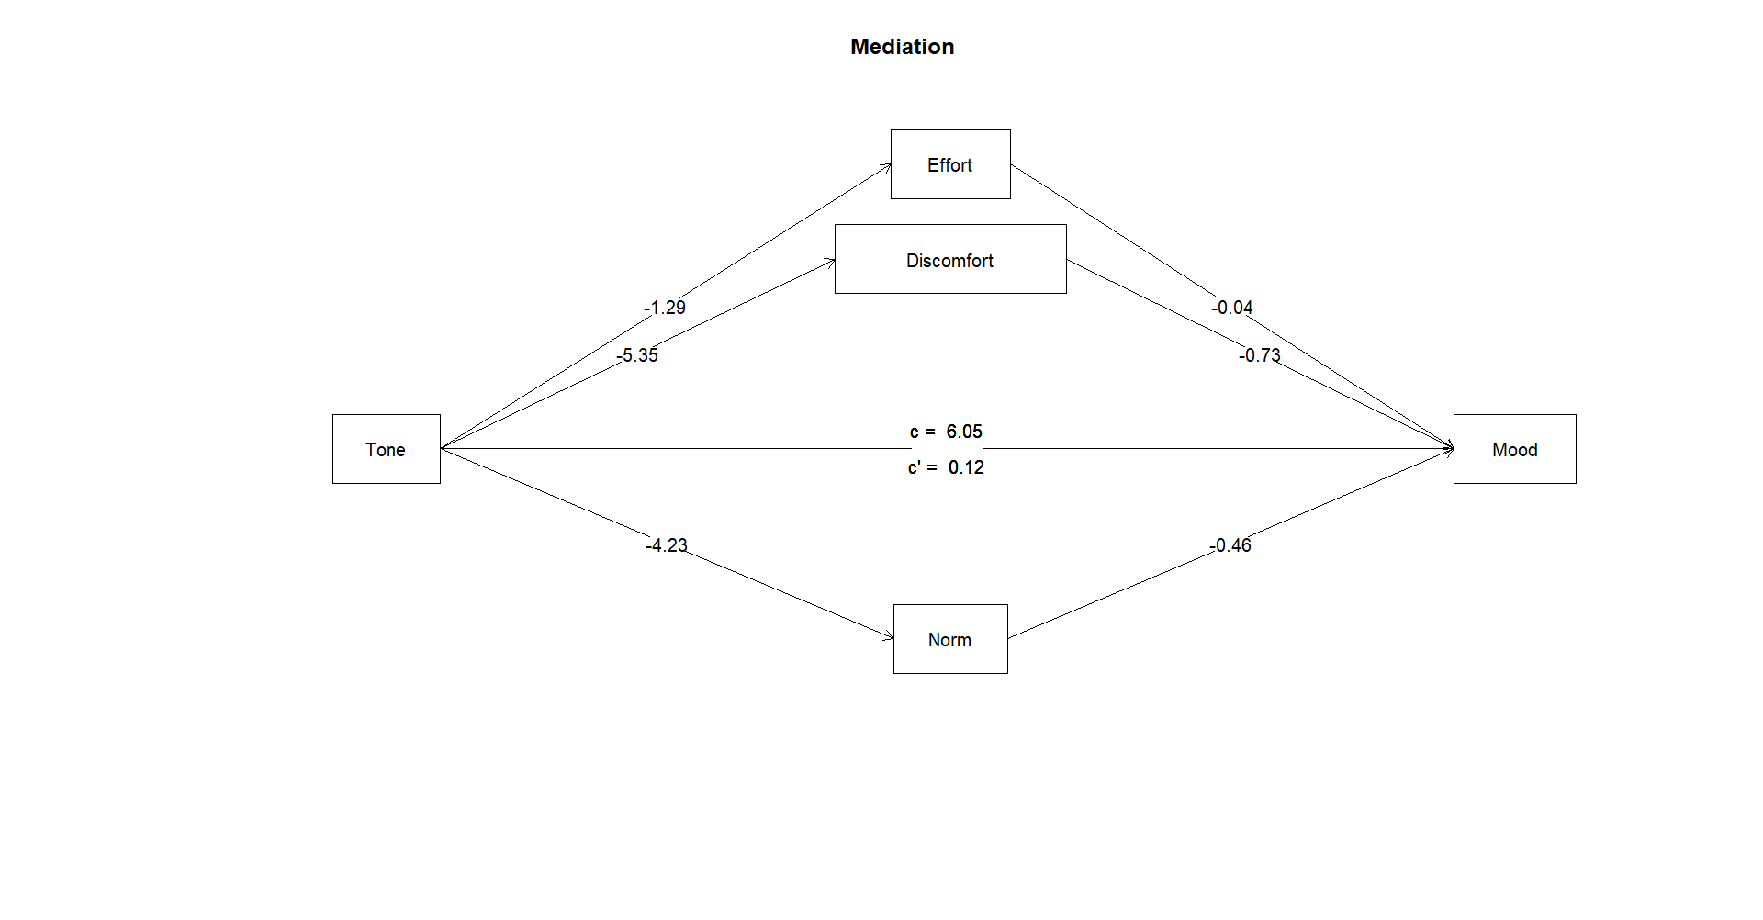

Table S1a
Correlations between all dependent variables of the happy condition, demographic variables, and moderators (Experiment 1a)
 |  | 1 | 2 | 3 | 4 | 5 | 6 | 7 | 8 | 9 | 10
1 | Positive | -
2 | Negative | -.45*** | -
3 | Autonomy | .72*** | -.59*** | -
4 | Relatedness | .79*** | -.41*** | .77*** | -
5 | Disclosure | .66*** | -.46*** | .67*** | .66*** | -
6 | Self-esteem | .6*** | -.28*** | .58*** | .65*** | .54*** | -
7 | Age | .04 | -.05 | .05 | .03 | .01 | .05 | -
8 | Gender (1: M, 2: W) | .04 | -.09 | .04 | .04 | .09 | .02 | .01 | -
9 | Political orientation | .11 | -.05 | .01 | .06 | .04 | .03 | .07 | -.11 | -
10 | Cognitive empathy | .1 | -.16* | .18** | .13* | .23*** | .13* | -.04 | .2** | -.01 | -
11 | Affective resonance | .22*** | -.19** | .21*** | .2** | .24*** | .26*** | .09 | .31*** | -.26*** | .3***
Note. *p < .05, **p < .01, ***p < .001

Table S1b
Correlations between all dependent variables of the angry condition, demographic variables, and moderators (Experiment 1a)
 |  | 1 | 2 | 3 | 4 | 5 | 6 | 7 | 8 | 9 | 10
1 | Positive | -
2 | Negative | -.13* | -
3 | Autonomy | .48*** | -.58*** | -
4 | Relatedness | .55*** | -.3*** | .64*** | -
5 | Disclosure | .43*** | -.11 | .4*** | .51*** | -
6 | Self-esteem | .36*** | -.16** | .35*** | .26*** | .36*** | -
7 | Age | .1 | -.01 | .04 | .09 | .08 | .01 | -
8 | Gender (1: M, 2: W) | -.11 | .13* | -.04 | -.02 | .02 | -.14* | .01 | -
9 | Political orientation | .13* | -.09 | .17** | .12 | .2** | .2** | .07 | -.11 | -
10 | Cognitive empathy | -.15* | 0 | -.05 | -.12 | .01 | .07 | -.04 | .2** | -.01 | -
11 | Affective resonance | -.18** | .14* | -.3*** | -.23*** | -.16* | -.12 | .09 | .31*** | -.26*** | .3***
Note. *p < .05, **p < .01, ***p < .001

Table S2a
Correlations between all dependent variables of the happy condition, demographic variables, and moderators (Experiment 1b)
 |  | 1 | 2 | 3 | 4 | 5 | 6 | 7 | 8 | 9 | 10 | 11 | 12
1 | Positive | -
2 | Negative | -.47*** | -
3 | Autonomy | .74*** | -.63*** | -
4 | Relatedness | .83*** | -.56*** | .81*** | -
5 | Disclosure | .7*** | -.38*** | .62*** | .71*** | -
6 | Self-esteem | .58*** | -.24*** | .54*** | .58*** | .47*** | -
7 | Perceived effort | -.43*** | .43*** | -.47*** | -.5*** | -.38*** | -.27*** | -
8 | Age | -.06 | -.01 | -.06 | -.06 | -.2*** | .01 | -.01 | -
9 | Gender (1: M, 2: W) | -.04 | .03 | -.04 | -.03 | .05 | .02 | -.04 | -.04 | -
10 | Political orientation | -.03 | -.1 | 0 | -.01 | -.11 | .02 | .03 | .21*** | -.1 | -
11 | Cognitive empathy | .3*** | -.24*** | .26*** | .33*** | .31*** | .27*** | -.18** | -.06 | .22*** | -.05 | -
12 | Affective resonance | .23*** | -.15* | .2*** | .23*** | .26*** | .23*** | -.16** | -.04 | .36*** | -.17** | .42*** | -
13 | Perceived stress | -.15* | .26*** | -.26*** | -.19** | -.08 | -.28*** | .09 | -.26*** | -.07 | -.16** | -.12 | -.04
Note. *p < .05, **p < .01, ***p < .001

Table S2b
Correlations between all dependent variables of the angry condition, demographic variables, and moderators (Experiment 1b)
 |  | 1 | 2 | 3 | 4 | 5 | 6 | 7 | 8 | 9 | 10 | 11 | 12
1 | Positive | -
2 | Negative | -0.28*** | -
3 | Autonomy | 0.48*** | -0.66*** | -
4 | Relatedness | 0.59*** | -0.47*** | 0.71*** | -
5 | Disclosure | 0.4*** | -0.22*** | 0.4*** | 0.5*** | -
6 | Self-esteem | 0.38*** | -0.34*** | 0.51*** | 0.37*** | 0.24*** | -
7 | Perceived effort | -0.25*** | 0.25*** | -0.34*** | -0.4*** | -0.2*** | -0.14* | -
8 | Age | 0.09 | -0.23*** | 0.09 | -0.03 | 0.02 | 0.16** | 0.07 | -
9 | Gender (1: M, 2: W) | -0.12* | 0.11 | -0.04 | -0.04 | -0.07 | -0.1 | -0.02 | -0.04 | -
10 | Political orientation | 0.04 | -0.2*** | 0.13* | 0.03 | -0.04 | 0.06 | 0.04 | 0.21*** | -0.1 | -
11 | Cognitive empathy | -0.13* | 0.07 | -0.11 | -0.08 | -0.08 | 0 | 0.09 | -0.06 | 0.22*** | -0.05 | -
12 | Affective resonance | -0.15* | 0.17** | -0.17** | -0.21*** | -0.17** | -0.08 | 0.07 | -0.04 | 0.36*** | -0.17** | 0.42*** | -
13 | Perceived stress | -0.02 | 0.18** | -0.14* | 0.02 | 0.01 | -0.16** | -0.03 | -0.26*** | -0.07 | -0.16** | -0.12 | -0.04
Note. *p < .05, **p < .01, ***p < .001

 |  | 1 | 2 | 3 | 4 | 5 | 6 | 7 | 8 | 9 | 10 | 11 | 12 | 13 | 14 | 15 | 16 | 17 | 18 | 19 | 20 | 21
1 | Positive | -
2 | Negative | -.57*** | -
3 | Autonomy | .8*** | -.73*** | -
4 | Relatedness | .83*** | -.66*** | .9*** | -
5 | Self-disclosure | .72*** | -.51*** | .74*** | .75*** | -
6 | Self-esteem | .62*** | -.36*** | .59*** | .62*** | .59*** | -
7 | Effort | -.42*** | .35*** | -.46*** | -.46*** | -.37*** | -.28*** | -
8 | Discomfort | -.66*** | .64*** | -.65*** | -.67*** | -.52*** | -.38*** | .34*** | -
9 | Norm violation | -.57*** | .58*** | -.61*** | -.61*** | -.49*** | -.41*** | .31*** | .78*** | -
10 | Disclosure (r) | .28*** | -.2*** | .26*** | .27*** | .23*** | .14* | -.17** | -.31*** | -.24*** | -
11 | Positive tone (r) | .49*** | -.33*** | .43*** | .46*** | .39*** | .34*** | -.25*** | -.48*** | -.47*** | .51*** | -
12 | Empathy (r) | .44*** | -.31*** | .39*** | .43*** | .34*** | .3*** | -.24*** | -.44*** | -.42*** | .53*** | .85*** | -
13 | Politeness (r) | .41*** | -.31*** | .37*** | .4*** | .32*** | .3*** | -.22*** | -.44*** | -.47*** | .46*** | .78*** | .82*** | -
14 | Word count (l) | .08 | -.06 | .04 | .02 | .03 | .06 | -.12* | -.11 | -.13* | .54*** | .31*** | .43*** | .35*** | -
15 | Positive tone (l) | .21*** | -.04 | .21*** | .25*** | .19** | .16** | -.06 | -.06 | -.08 | -.12* | .21*** | .09 | .12* | -.22*** | -
16 | Negative tone (l) | -.22*** | .15* | -.19** | -.19** | -.12* | -.13* | .22*** | .26*** | .19** | .06 | -.17** | -.15* | -.19** | .03 | -.07 | -
17 | Politeness (l) | .1 | -.05 | .1 | .12* | .08 | .07 | -.11 | -.07 | -.1 | -.12* | .02 | .03 | .19** | -.16** | .39*** | -.03 | -
18 | Age | -.18** | .02 | -.09 | -.12* | -.14* | -.01 | .05 | .11 | .07 | -.05 | -.05 | -.02 | -.01 | .05 | -.08 | .03 | -.1 | -
19 | Gender (1: M, 2: W) | .17** | -.09 | .13* | .12* | .12* | .13* | -.14* | -.11 | -.12* | .1 | .09 | .09 | .09 | .04 | .05 | -.06 | -.01 | -.02 | -
20 | Political orientation | .02 | .03 | -.03 | -.02 | -.05 | 0 | .1 | -.05 | -.03 | .03 | .04 | -.03 | .02 | -.08 | -.04 | 0 | .04 | .21*** | -.05 | -
21 | Cognitive empathy | .16** | -.18** | .19** | .17** | .24*** | .22*** | -.09 | -.21*** | -.18** | .15* | .17** | .14* | .12* | .07 | .08 | .04 | .02 | .02 | .2*** | .02 | -
22 | Affective resonance | .22*** | -.28*** | .3*** | .24*** | .32*** | .24*** | -.16** | -.23*** | -.28*** | .14* | .11 | .13* | .15* | .1 | .09 | -.07 | .14* | .08 | .32*** | -.16** | .37***

Table S3a
Correlations between all dependent variables of the happy condition, demographic variables, and moderators (Experiment 2)
Note. (r): As coded by four human raters, (l): as analysed by LIWC, version 22. *p < .05, **p < .01, ***p < .001

Table S3b
Correlations between all dependent variables of the angry condition, demographic variables, and moderators (Experiment 2)
 |  | 1 | 2 | 3 | 4 | 5 | 6 | 7 | 8 | 9 | 10 | 11 | 12 | 13 | 14 | 15 | 16 | 17 | 18 | 19 | 20 | 21
1 | Positive | -
2 | Negative | -.24*** | -
3 | Autonomy | .57*** | -.66*** | -
4 | Relatedness | .64*** | -.52*** | .78*** | -
5 | Self-disclosure | .58*** | -.37*** | .62*** | .67*** | -
6 | Self-esteem | .4*** | -.4*** | .64*** | .44*** | .42*** | -
7 | Effort | -.09 | .11 | -.08 | -.14* | -.12 | -.03 | -
8 | Discomfort | -.51*** | .56*** | -.61*** | -.63*** | -.49*** | -.31*** | .13* | -
9 | Norm violation | -.38*** | .38*** | -.47*** | -.47*** | -.47*** | -.31*** | .12* | .52*** | -
10 | Disclosure (r) | 0 | -.01 | .11 | .1 | .17** | .07 | -.07 | -.13* | -.15* | -
11 | Positive tone (r) | .19** | -.16** | .23*** | .25*** | .25*** | .18** | -.09 | -.32*** | -.25*** | .65*** | -
12 | Empathy (r) | .05 | 0 | .08 | .11 | .15** | .09 | -.05 | -.14* | -.17** | .65*** | .72*** | -
13 | Politeness (r) | .01 | .05 | .02 | .05 | .11 | .05 | -.07 | -.12* | -.14* | .61*** | .7*** | .85*** | -
14 | Word count (l) | -.08 | .11 | -.05 | -.07 | .04 | -.04 | -.03 | .05 | 0 | .42*** | .07 | .37*** | .29*** | -
15 | Positive tone (l) | -.02 | 0 | 0 | .05 | .01 | -.05 | -.04 | -.01 | -.05 | .24*** | .25*** | .12 | .17** | -.09 | -
16 | Negative tone (l) | -.08 | .21*** | -.21*** | -.21*** | -.08 | -.16** | .06 | .17** | .14* | -.22*** | -.39*** | -.17** | -.15** | -.02 | -.18** | -
17 | Politeness (l) | .17** | -.15* | .15* | .16** | .09 | .01 | .02 | -.13* | -.06 | .1 | .19** | .06 | .16** | -.1 | .3*** | -.12 | -
18 | Age | -.01 | -.21*** | .12 | .06 | .06 | .12* | .1 | 0 | .08 | .1 | .03 | .01 | -.02 | .07 | 0 | -.05 | -.12* | -
19 | Gender (1: M, 2: W) | -.13* | .27*** | -.22*** | -.17** | -.12 | -.19** | .01 | .2*** | .05 | -.03 | -.06 | .02 | 0 | .07 | .03 | .13* | -.11 | -.02 | -
20 | Political orientation | .1 | -.17** | .13* | .1 | .04 | .13* | -.01 | -.03 | -.04 | -.05 | .02 | -.08 | -.1 | -.09 | .11 | -.05 | -.11 | .21*** | -.05 | -
21 | Cognitive empathy | -.1 | .07 | -.1 | -.14* | -.15* | 0 | .14* | .11 | .1 | 0 | -.03 | -.05 | -.01 | .02 | .07 | .03 | 0 | .02 | .2*** | .02 | -
22 | Affective resonance | -.32*** | .25*** | -.34*** | -.35*** | -.2*** | -.25*** | .06 | .23*** | .14* | .16** | .05 | .09 | .11 | .08 | .01 | .02 | -.09 | .08 | .32*** | -.16** | .37***
Note. (r): As coded by four human raters, (l): as analysed by LIWC, version 22. *p < .05, **p < .01, ***p < .001

