Supplementary Materials
Towards Ecological Validity in Expression Discrimination: Forced-Choice Saccadic Responses to Posed and Naturalistic Faces
Natalie Peluso¹, Blake W. Saurels ¹, and Jessica Taubert¹
¹ School of Psychology, The University of Queensland

Minimum Saccadic Latency Analysis
To assess accuracy by the minimum saccadic latency, we analysed all individual saccades which exceeded 40 DVA per second for 3 ms (to avoid miscategorising noise as a saccade) from a starting point within a radius of 1° around fixation and only for durations greater than 50ms from stimulus onset (to avoid anticipatory saccades). The end of a saccade met the criteria for inclusion if eye movement speed dropped below 10 DVA/second. Only one saccade was used from each trial, and only saccades when start and end points could be identified were included. We divided the distributions of these valid trials (numbering approximately 4800 in each condition) into 10 ms bins, using a chi-squared test (p < .05) to identify the first of 5 consecutive significant bins as the minimum latency. This method is similar to that used by previous similar saccadic choice studies (Crouzet et al., 2010; Entzmann et al., 2021) and the number of valid trials for each condition in this analysis is comparable to those used by Entzmann et al. (2021). By using this minimum latency approach to define saccades, we did not find strong evidence that the direction of the initial saccades was accurate in any of the four unique conditions (i.e., target expression x stimulus set; Happy NimStim: M = 0.52, Happy Wild: M = 0.50, Neutral NimStim: M = 0.46, Neutral Wild: M = 0.48) (Figure S1).

Figure S1
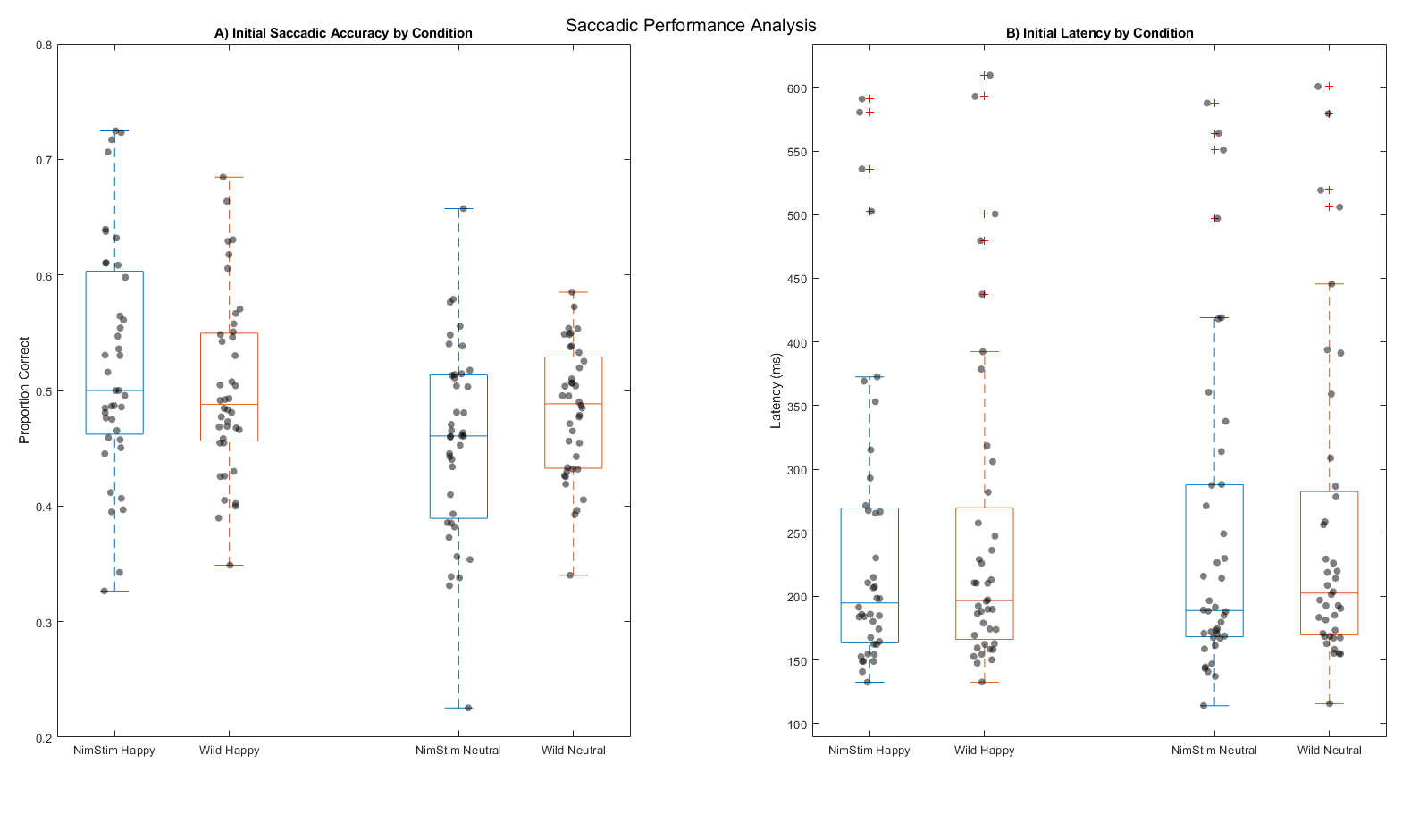
Minimum Initial Saccades
Note. (A) Individual participant data showing the mean proportion of initial correct responses (i.e., the proportion of correct saccades for which participants looked at the correct happier target) within the range specified as an initial saccade, with Happy Target Expressions (left) and Neutral Target Expressions (right). Box plots show median and interquartile ranges for the sample, for NimStim faces in blue, and Wild Faces in orange. Each dot represents a single participant’s mean performance after filtering for initial saccades. (B) Box plots showing the distribution of initial saccadic latencies for all participants with Happy Target Expressions (left) and Neutral Target Expressions (right). Box plots show median and interquartile ranges for the sample, for NimStim faces in blue, and Wild Faces in orange. Each dot represents a single participant’s mean performance after filtering for initial saccades.

Correlations Between Eye Movements and Stimulus Features

To investigate potential differences in eye movements between trials with anger and fearful expressions, we conducted a similar analysis to that of Calvo and Nummenmaa (2011) by computing Spearman correlations between time-locked horizontal eye movements (in DVA) averaged across all participants (extracted at 100, 150, 200, 250, and 300 ms) and both stimulus features (perceived gender, mouth shape, gaze direction [Wild Faces only, as Nim Stim were all direct], and threat type [angry vs. fearful]). No correlations emerged to differentiate threat type at any time point, suggesting no advantage for either angry or fearful expressions in either NimStim faces (Figure S2) or Wild Faces (Figure S3). However, we found a similar weak positive correlation between eye movements and perceived gender in Wild Faces at 150 ms (Rs = .38, p = .05) and a moderate positive correlation between eye movements and closed mouth shape at 100 ms (Rs = .40) and 150 ms (Rs = .37, p = .05). This suggested female faces, and closed mouth shape facilitated detection of neutral Wild Face targets. Further, no significant correlations emerged for gaze direction in this condition (Figure S3). Subsequent Bayesian correlation analysis did not provide strong evidence of the alternative hypothesis [BF₁₀ > 3] for any of these correlations.

Figure S2
Correlation Heatmap Between Time-Locked Eye Position and NimStim faces in Neutral v Threat
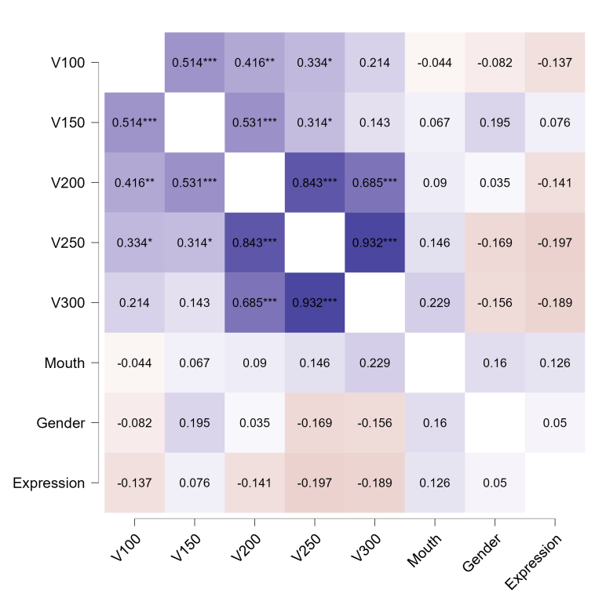

Note. Spearman’s correlations for NimStim faces in the Neutral v Threat condition, showing the association between mean time-locked eye position (in DVA) at 100, 150, 200, 250, and 300 ms post stimuli onset, and the following stimulus-based features: mouth shape (open = 1, closed = 2), perceived gender (male = 1, female = 2), and expression type (angry = 1, fearful = 2). Gaze direction for NimStim faces did not vary and thus was not included as a variable. Positive correlations indicate that items coded ‘2’ facilitated target detection. Here, only time-locked eye movements showed significant positive correlations. * p < .05, ** p < .01, *** p < .001.

Figure S3
Correlation Heatmap Between Time-Locked Eye Position and Wild Faces in Neutral v Threat
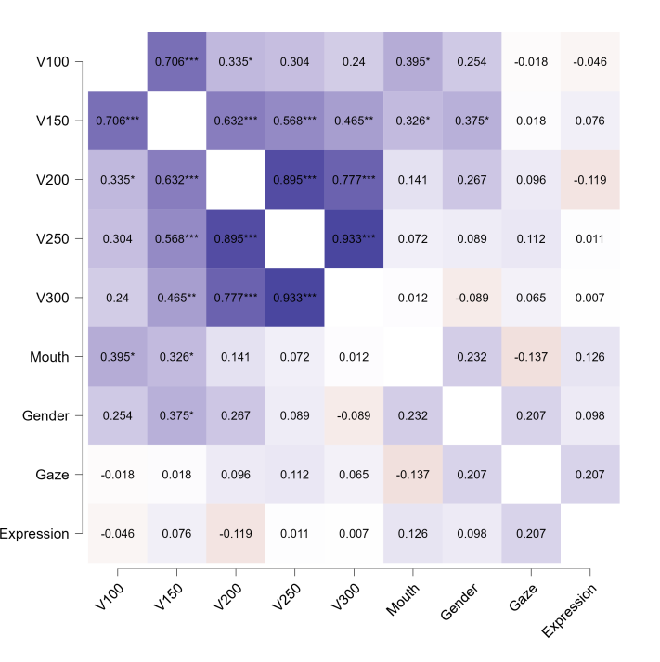

Note. Spearman’s correlations for Wild Faces in the Neutral v Threat condition, showing the association between mean time-locked eye position (in DVA) at 100, 150, 200, 250, and 300 ms post stimuli onset, and the following stimulus-based features: perceived gender (male = 1, female = 2), mouth shape (open = 1, closed = 2), gaze direction (direct = 1, averted = 2), and expression type (anger = 1, fearful = 2). Positive correlations indicate that items coded ‘2’ facilitated target detection. Perceived female gender showed a significant positive association with eye movements toward neutral targets at 150 ms. Closed mouths also showed a significant positive association with eye movements toward neutral targets at 100 and 150 ms. * p < .05, ** p < .01, *** p < .001

Horizontal Eye Movements Analysis of Gaze Direction in Wild Faces
Since both Wild Face targets and distractors contained a variety of gaze directions, it is possible these may have influenced eye movements in particular trials by capturing and/or shifting attention (Dalmaso et al., 2020). Typically, direct gaze capture and/or gaze-cueing effects are elicited when a cue stimulus is presented at fixation prior to a target (Kürten et al., 2025; McKay et al., 2021). Yet in this study, both target and distractor were presented simultaneously. Further, since Wild Face stimuli appeared equally often on either side of the screen, the presence of directive social cues would have both facilitated and interfered with target detection across trials. Nevertheless, to rule out any potential confounding effect, we conducted a post-hoc analysis of horizontal eye movements for direct and averted gaze Wild Faces to determine if viewing behaviour significantly differed between them (for a descriptive summary of directive social cues in Wild Faces see Table S3).
First, we conducted a within-database comparison using Bayesian t-tests [BF₁₀ > 3] comparing horizontal eye positions at each 1ms time point post-stimulus onset for both averted and direct gaze within each condition for Wild Faces only (i.e. not compared to NimStim faces). Two key comparisons were made: direct happy Wild Faces v averted happy Wild Faces, and direct threatening Wild Faces vs averted threatening Wild Faces. When analysing all trials, we found no evidence of an advantage for either gaze type in threatening Wild Faces, but there was evidence of a time-course advantage for direct over averted happy Wild Faces at 206.5 ms, consistent with direct gaze affording greater discriminability in both databases, but more so in posed faces.
We then used Bayesian t-tests [BF₁₀ > 3] comparing horizontal eye positions at each 1ms time point post-stimulus onset for the following between-database comparisons: NimStim happy versus direct Wild Faces happy, NimStim happy versus averted Wild Faces happy, NimStim threatening versus direct Wild Faces threatening, and NimStim threatening versus averted Wild Faces threatening. When analysing all trials, we found evidence of a greater happy face advantage for NimStim faces over Wild Faces regardless of directive cues, but the time-course of this advantage varied; in direct Wild Faces it emerged from 375.5 ms, and in averted Wild Faces from 302 ms, consistent with the earlier difference found after examining differences within Wild Faces (Figure S4a). Similarly, we again found evidence of a greater advantage for threatening Wild Faces over NimStim when looking for neutral targets regardless of directive cues across all trials, but again the time-course for this advantage for varied, with averted threatening Wild Faces from 146 - 170 ms (and again from 246 ms), and direct threatening Wild Faces from 370 ms (Figure S4b).
Finally, when analysing the same between-database comparisons in correct trials only, we again found evidence for a greater happy face advantage for Wild Faces, emerging for direct happy Wild Faces at 452 ms, and averted happy Wild Faces at 167 ms - 306 ms, persisting again at 433 ms. However, making this exploratory comparison analysed markedly fewer trials than those for all trials, and thus should be interpreted with caution (Figure S4c).
Taken together, the results from this exploratory analysis are consistent with 2-AFC saccadic choice tasks which favour the enhanced discriminability afforded by direct gaze, rather than averted gaze potentially biasing attention towards a target/distractor. Further, they indicate nuanced temporal differences in the effects of socially-directive cues in naturalistic stimuli, underscoring the importance of incorporating such stimuli in future research (Böckler et al., 2015; Dalmaso et al., 2020; Hietanen & Leppänen, 2003).
Table S1
Directive Cues in Wild Faces
Image Characteristics | Gaze |  | Head Orientation |  | Total
Image Characteristics | Direct | Averted | Direct | Averted
Happy | 20 | 20 | 17 | 23 | 40
Threat  Anger  Fear | 10  7  3 | 30  12  18 | 9  5  4 | 31  14  17 | 40  19  21
Neutral | 25 | 55 | 25 | 55 | 80
Figure S4
Horizontal Eye Movements Between Posed and Wild Faces by Gaze
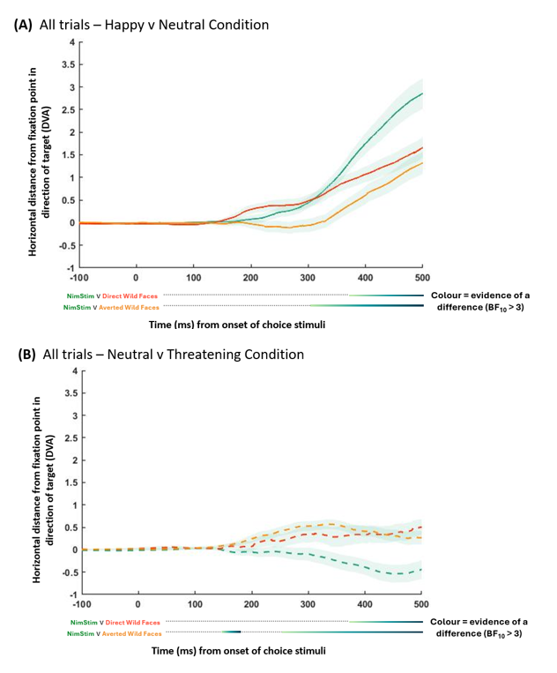
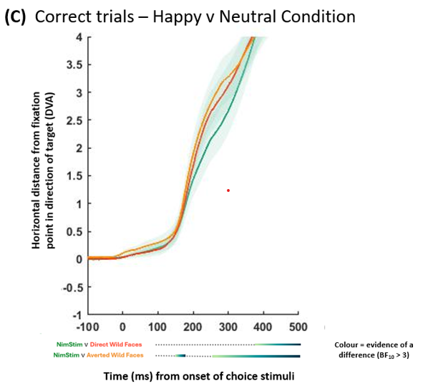
Note. Average horizonal eye position in DVA as a function of time from the onset of choice stimuli for all trials (transparent areas = + / - SE). The time course of significant pairwise differences (BF₁₀ > 3) are provided underneath the x-axis for both NimStim (green lines) vs. Direct and Averted Wild Faces (red and orange lines respectively). (A) All trials for Happy v Neutral condition (solid lines), (B) All Trials for Neutral v Threatening (hatched lines), and (C) Correct Trials for Happy v Neutral (solid lines) for which participants gazed at the happier target at the end of each trial.

Supplementary References
Kürten, J., Breil, C., Pittig, R., Huestegge, L., & Böckler, A. (2025). How eccentricity modulates attention capture by direct face/gaze and sudden onset motion. Attention, Perception & Psychophysics. https://doi.org/10.3758/s13414-025-03015-8
Dalmaso, M., Castelli, L., & Galfano, G. (2020). Social modulators of gaze-mediated orienting of attention: A review. Psychonomic Bulletin & Review, 27(5), 833–855. https://doi.org/10.3758/s13423-020-01730-x
McKay, K. T., Grainger, S. A., Coundouris, S. P., Skorich, D. P., Phillips, L. H., & Henry, J. D. (2021). Visual attentional orienting by eye gaze: A meta-analytic review of the gaze-cueing effect. Psychological Bulletin, 147(12), Article 12. https://doi.org/10.1037/bul0000353
Hietanen, J. K., & Leppänen, J. M. (2003). Does facial expression affect attention orienting by gaze direction cues? Journal of Experimental Psychology. Human Perception and Performance, 29(6), 1228–1243. https://doi.org/10.1037/0096-1523.29.6.1228

