Unlocking Emotional Well-Being: Evaluation of a Stress Mindset Intervention with a Metacognitive Approach

1. Moderating Role of Baseline Stress Mindset
Whether the intervention effects were moderated by individual baseline stress mindsets was examined using moderation analysis (Model 1) when the observed intervention effect was direct or moderated mediation analysis (Model 8) when the observed intervention effect was indirect using PROCESS Macro. All regression estimates are presented in Table S1. Using the Johnson–Neyman technique in PROCESS, we also identified regions of significance of the moderator (i.e., stress mindset) at which the intervention had a significant impact (Bauer & Curran, 2005).
The results suggested that baseline stress mindset significantly moderated the relationship between condition and negative affect at 4-month follow-up (p = .002). Specifically, the intervention was effective among those with moderate (b = −.42, SE = .09, p < .001, 95% CI [−.59, −.25]) and lower levels (b = −.71, SE = .13, p < .001, 95% CI [−.96, −.46]) of stress-is-enhancing mindset at baseline, but the effect was non-significant among those who reported higher levels of stress-is-enhancing mindset (b = −.14, SE = .12, p = .27, 95% CI [−.38, .11]) at baseline. Likewise, baseline stress mindset significantly moderated the relationship between condition and anxious affect at 4-month follow-up (p = .001): the intervention was effective among those with moderate (b = −.26, SE = .08, p = .002, 95% CI [−.42, −.09]) and lower levels (b = −.54, SE = .12, p < .001, 95% CI [−.78, −.31]) of stress-is-enhancing mindset at baseline but the intervention effect was non-significant among those who reported higher levels of stress-is-enhancing mindset at baseline (b =.03, SE = .12, p = .79, 95% CI [−.20, .26]). However, baseline stress mindset did not significantly moderate the relationship between condition and positive affect (p = .13).
Lastly, baseline stress mindset significantly moderated the association between intervention condition and GPA at T4 (p = .001). Specifically, the intervention was effective among those with moderate (b = .16, SE = .07, p = .02, 95% CI [.03, .29]) and lower levels (b = .31, SE = .08, p < .001, 95% CI [.15, .47]) of stress-is-enhancing mindset at baseline, but the effect was non-significant among those who reported higher levels of stress-is-enhancing mindset (b = -.09, SE = .09, p = .32, 95% CI [−.27, .09]) at baseline. The Johnson–Neyman values for all significant interactions suggested that the intervention was effective for most of the participants (ranging from 58.95% to 79.56%).

Table S1
Moderating Effect of Baseline Stress Mindset on Intervention Effect on Emotional Well-being and Academic Achievement
Effects | 4-Month Follow-up
Effects | b (SE) | 95% CI
Negative Affect
Constant | 4.37 (1.42)** | [1.57, 7.17]
Baseline negative affect | .18 (.05)** | [.08, .28]
Age | -.05 (.07) | [-.20, .10]
Gender | -.06 (.09) | [-.23, .11]
SES | -.27 (.02) | [-.07, .02]
Condition | -1.91 (.48)*** | [-2.87, -.96]
Baseline stress mindset | -.38 (.13)** | [-.63, -.13]
Condition × Baseline Stress Mindset | .49 (.16)** | [.18, .80]
Positive Affect
Constant | .45 (1.16)
Baseline positive affect | .31 (.05)*** | [.21, .41]
Age | .06 (.06) | [-.06, .18]
Gender | .09 (.07) | [-.54, .23]
SES | -.003 (.02) | [-.04, .04]
Condition | .84 (.40)* | [.05, 1.62]
Baseline stress mindset | .21 (.11)* | [.004, .42]
Condition × Baseline Stress Mindset | -1.96 (.13) | [-.45, .06]
Anxious Affect
Constant | 3.23 (1.37)* | [.53, 5.93]
Baseline anxious affect | .24 (.05)*** | [.13, .35]
Age | -.01 (.07) | [-.15, .13]
Gender | .08 (.08) | [-.08, .25]
SES | -.02 (.02) | [-.06, .03]
Condition | -1.77 (.46)*** | [-2.68, -.86]
Baseline stress mindset | -.37 (.12)** | [-.61, -.13]
Condition × Baseline Stress Mindset | .50 (.15)*** | [.21, .79]
GPA
Constant | .46 (1.04) | [-1.59, 2.52]
Baseline GPA | .73 (.03)*** | [.66, .79]
Age | -.06 (.06) | [-.17, .05]
Gender | .06 (.07) | [-.07, .19]
SES | -.01 (.02) | [-.05, .02]
Condition | 1.14 (.35)*** | [.67, 2.04]
Baseline stress mindset | .73 (.03) | [.66, .19]
Condition × Baseline GPA | -.40 (.11)*** | [-.62, -.18]
Notes. The models were estimated after controlling for gender, age, SES, and baseline outcomes. Unstandardized coefficients are presented.
*p < .05. **p < .01. ***p < .001.

Figure S1
The Main Intervention Effects on Stress Mindset and Emotional Well-Being at T4

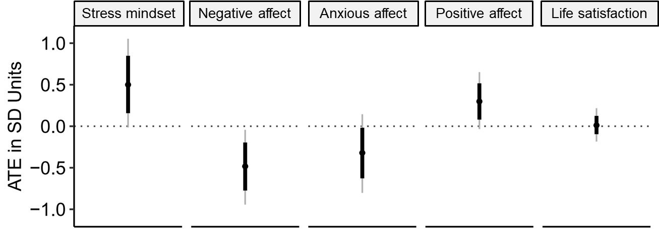
Note: ATE = average treatment effects. Thick bands indicate the 10th and 90th percentiles of the posterior distribution; the grey lines indicate the 2.5th to 97.5th percentile.
Figure S2
The Main Intervention Effects on Academic Achievement at T4
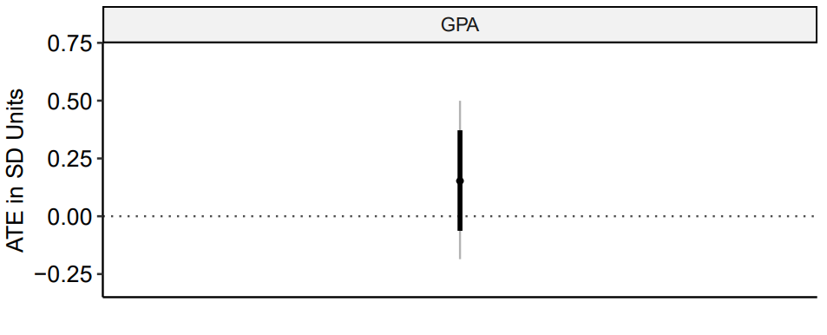
Note: ATE = average treatment effects. Thick bands indicate the 10th and 90th percentiles of the posterior distribution; the grey lines indicate the 2.5th to 97.5th percentile.

References
Bauer, D. J., & Curran, P. J. (2005). Probing Interactions in Fixed and Multilevel Regression: Inferential and Graphical Techniques. Multivariate Behavioral Research, 40(3), 373-400. https://doi.org/10.1207/s15327906mbr4003_5

