Supplemental Materials

Cachia, J. Y. A., Blevins, E., Chen, Y. C., Ko, M., Yen, N. S., Knutson, B., & Tsai, J. L. (2024). Cultural Variation in the Smiles We Trust: The Effects of Reputation and Ideal Affect on Resource Sharing. Manuscript under review.

Table of Contents

Section 1. Analyses on Full Sample (Without Exclusions) 3
Study 1: Trustworthiness Reputation 3
Study 2: Competence Reputation 4
Study 3: Past Return Behavior 4
Study 4: Emotional Stability Reputation 5
Section 2. Analyses with Covariates 6
Study 1: Trustworthiness Reputation Results, Controlling for SES 6
Study 2: Competence Reputation Results, Controlling for SES and Age 8
Study 3: Past Return Behavior Results, Controlling for SES and Age 9
Study 4: Emotional Stability Reputation Results, Controlling for SES 10
Section 3. Bonus Payment Computation 13
Section 4. Avatar Selection 15
Section 5. Trust Game Trials Without Reputation (No Reputation Trust Game) 18
Study 2: Cultural Differences in Transfers to Excited, Calm, and Neutral Targets 18
Study 4: Cultural Differences in Transfers to Excited, Calm, and Neutral Targets 19
Section 6. Ipsatized Transfer Results in Studies 1-4 22
Study 1: Trustworthiness Reputation 22
Study 2: Competence Reputation 23
Study 3: Past Behavior 24
Study 4: Emotional Stability Reputation 25
Section 7. Results for Raw Transfers for Studies 1-4 26
Study 1: Trustworthiness Reputation 26
Study 2: Competence Reputation 28
Study 3: Past Behavior Reputation 31
Study 4: Emotional Stability Reputation 33
Section 8. Testing the Moderating Effect of Target Race and Sex 37
Section 9: Alternative Explanations 39
Section 9A. Presentation Order 39
Section 9B: Visual Reputation as an Alternative Explanation 42
Section 10. Cultural Differences in Ideal Affect 46
Section 11. Additional Trait Ratings of Targets 49
Section 12. Trait Ratings for Studies 1-4 54
References 62

Section 1. Analyses on Full Sample (Without Exclusions)
In the main manuscript, our analysis excluded participants who transferred the same amount across all trials of the Trust Game, consistent with previous work (Park et al., 2017). Here we compare the results obtained for the “full” sample (i.e., without exclusions) with those reported in the manuscript for the “sample with exclusions.”

Study 1: Trustworthiness Reputation
No Reputation Trust Game:
Main Effects and Interactions. All significant main effects and interactions emerged for the full sample as did for the sample with exclusions.
Pairwise Comparisons. All but three significant pairwise comparisons emerged for the full sample. The three exceptions were:
1) The significant main effect of Participant Culture observed in the sample with exclusions was not significant in the full sample, F(1, 216) = 1.56, p = .211.
2) In the sample with exclusions, there was no significant difference in transfers to neutral and excited targets. However, this difference emerged for the full sample, such that neutral targets received more transfers than did excited targets, p = .009, 95% CI [0.03, 0.34], d = 0.16.
3) For the sample with exclusions, there was no cultural difference in how much European Americans and Taiwanese transferred to calm targets. However, this difference emerged for the full sample, such that Taiwanese transferred more to calm than European Americans, p = .007, 95% CI [0.04, 0.24], d = 0.17.
Reputation Trust Game:
Main Effects and Interactions. All significant main effects and interactions were similar for the full sample and the sample with exclusions.
Pairwise Comparisons. All but one pairwise comparison showed consistent results across the two samples. In the sample with exclusions, European Americans transferred more to high reputation excited targets than did Taiwanese (p < .001, 95% CI [0.06, 0.38], d = 0.37). In contrast, in the full sample, this pairwise comparison was marginally significant, p = .103.

Study 2: Competence Reputation
No Reputation Trust Game:

Main Effects and Interactions. All significant main effects and interactions were consistent for the full sample and the sample with exclusions.
Pairwise Comparisons. All pairwise comparisons showed consistent results for the two samples.
Reputation Trust Game:

Main Effects and Interactions. All significant main effects and interactions were consistent for the full sample and the sample with exclusions.
Pairwise Comparisons. All but two pairwise comparisons showed consistent results across the full sample and the sample with exclusions.
- For the sample with exclusions, Taiwanese transferred marginally more to high-reputation neutral targets than did European Americans (p = .071). However, in the full sample, this marginal difference was statistically significant (p = .008, 95% CI [0.04, 0.43], d = 0.35).
- For the sample with exclusions, there was no significant cultural difference in transfers. However, in the full sample, a significant cultural difference emerged, with Taiwanese transferring significantly more to high-reputation calm targets than European Americans (p = .025, 95% CI [0.02, 0.40], d = 0.32).

Study 3: Past Behavior
Main Effects and Interactions
All significant main effects and interactions were consistent for the full sample and the sample with exclusions.
Pairwise Comparisons
All pairwise comparisons revealed consistent results for the full sample and the sample with exclusions.

Study 4: Emotional Stability Reputation
No Reputation Trust Game:
Main Effects and Interactions. All significant main effects and interactions were consistent for the two samples.
Pairwise Comparisons. All but one pairwise comparison showed consistent results between the full sample and the sample with exclusions. In the sample with exclusions, European Americans transferred more to excited than neutral targets, p = .048, 95% CI [0.002, 0.40], d = 0.21. However, in the full sample, this pairwise comparison was marginally significant, p = .072.
Reputation Trust Game:
Main Effects and Interactions. All significant main effects and interactions were consistent for the two samples.
Pairwise Comparisons. All pairwise comparisons revealed consistent results for the full sample and the sample with exclusions.

Section 2. Analyses with Covariates
This section presents results of the main analyses, controlling for cultural group differences in socioeconomic status (SES) (Studies 1-4) and age (Studies 2 and 3). Importantly, the overall pattern of results remained similar when these covariates were included.

Study 1: Trustworthiness Reputation Results, Controlling for SES
We conducted a three-way repeated-measures ANOVA on ipsatized transfers to test the interaction between Participant Culture (between-subjects: European American, Taiwanese), Target Emotional Expression (within-subjects: excited, calm, neutral), and Target Reputation (within-subjects: low trustworthiness, moderate trustworthiness, high trustworthiness), controlling for SES. All post hoc pairwise comparisons were conducted using Tukey's HSD test.
There was a significant main effect of Target Emotional Expression on transfers, F(2, 374) = 13.73, p < .001, η² = 0.07, such that overall, participants transferred more to calm than neutral and excited targets (Calm: M = 0.06, SE = 0.04; Neutral: M = -0.02, SE = 0.04; Excited: M = -0.05, SE = 0.03; Calm vs. Neutral: p < .001, 95% CI [0.03, 0.13], d = 0.14; Calm vs. Excited: p < .001, 95% CI [0.06, 0.16], d = 0.19).
There was also a significant main effect of Target Reputation, F(2, 374) = 954.89, p < .001, η² = 0.84, such that the higher the reputation of the target, the more participants transferred to them (Low: M = -0.88, SE = 0.01; Moderate: M = -0.03, SE = 0.01; High: M = 0.91, SE = 0.01; Low vs. Moderate: p < .001, 95% CI [0.75, 0.94], d = 1.44; Moderate vs. High: p < .001, 95% CI [0.84, 1.03], d = 1.58).
There was a marginally significant Participant Culture X Target Emotional Expression interaction, F(2, 374) = 2.93, p = .055, η² = 0.02. Taiwanese transferred the most to calm, followed by neutral, followed by excited targets (Calm vs. Excited: p < .001, 95% CI [0.08, 0.23], d = 0.27; Calm vs. Neutral: p = .016, 95% CI [0.01, 0.16], d = 0.14; Neutral vs. Excited: p < .001, 95% CI [0.0002, 0.15], d = 0.12). In contrast, European Americans transferred marginally more to calm than neutral targets (Calm vs. Neutral: p = .058, 95% CI [0.006, 0.14], d = 0.13), with excited targets falling in the middle.
These effects were qualified by a marginally significant Participant Culture X Target Emotional Expression by Target Reputation interaction, F(4, 748) = 1.99, p = .095, η² = 0.01. We broke this interaction down by cultural group. For European Americans, when target reputation was moderate, European Americans transferred more to calm than neutral targets (Calm vs. Neutral: p = .001, 95% CI [0.04, 0.25], d = 0.24), and transfers to excited targets fell between both groups. However, when target reputation was low or high, European Americans transferred equally to all targets (Low Reputation: pairwise comparisons p ≥ .570; High Reputation: all pairwise comparisons p ≥ .376).
For Taiwanese, when targets’ reputations were moderate, Taiwanese transferred more to calm than excited and neutral targets (Calm vs. Excited: p < .001, 95% CI [0.05, 0.27], d = 0.28; Calm vs. Neutral: p < .001, 95% CI [0.06, 0.28], d = 0.29). When targets’ reputations were low, there were no significant expression preferences within low reputation (all pairwise comparisons p ≥ .160), but when targets’ reputations were high, Taiwanese transferred more to calm and neutral than excited targets (High Reputation: Calm vs. Excited: p < .001, 95% CI [0.11, 0.33], d = 0.37; Neutral vs. Excited: p < .001, 95% CI [0.08, 0.30], d = 0.32).
Other analyses
We also compared transfers between cultural groups for each reputation level. European Americans also transferred more to high-reputation excited targets than did Taiwanese (p = .027, 95% CI [0.01, 0.33], d = 0.29). All other pairwise comparisons were not significant (all p ≥ .812).
Again, these findings were very similar to those reported in the main manuscript, and therefore, we dropped SES from the analyses.

Study 2: Competence Reputation Results, Controlling for SES and Age
We conducted a three-way repeated-measures ANOVA on ipsatized transfers to test the interaction between Participant Culture (between-subjects: European American, Taiwanese), Target Emotional Expression (within-subjects: excited, calm, neutral), and Target Reputation (within-subjects: low competence, moderate competence, high competence), controlling for SES and age. All post hoc pairwise comparisons were conducted using Tukey's HSD test.
As in Study 1, there was a significant main effect of Target Emotional Expression, F(2, 394) = 7.98, p < .001, η² = 0.04, a significant main effect of Target Reputation, F(2, 394) = 304.72, p < .001, η² = 0.61, and a significant Participant Culture X Target Emotional Expression interaction, F(2, 394) = 18.53, p < .001, η2 = 0.02, such that Taiwanese transferred more to calm and neutral than excited targets (Calm vs. Excited: p < .001, 95% CI [0.14, 0.31], d = 0.33; Neutral vs. Excited: p < .001, 95% CI [0.12, 0.29], d = 0.30). European Americans, however, did not show a significant expression preference (all pairwise comparisons p ≥ .155).
As in Study 1, these effects were qualified by a significant Participant Culture X Target Emotional Expression X Target Reputation interaction, F(4, 788) = 3.96, p = .003, η² = 0.02. We broke this interaction down by cultural group. When targets’ reputations were moderate, European Americans transferred more to calm than neutral targets (Calm vs. Neutral: p = .041, 95% CI [0.003, 0.24], d = 0.17), with excited targets falling in the middle. However, when targets’ reputations were low (all pairwise comparisons p ≥ .658) or high (all pairwise comparisons p ≥ .870), European Americans transferred equally to calm, excited, and neutral targets.
As in Study 1, Taiwanese showed a different pattern. When targets’ reputations were moderate, Taiwanese transferred more to calm than excited targets (Calm vs. Excited: p = .002, 95% CI [0.04, 0.30], d = 0.25), with transfers to neutral targets falling in between transfers to calm and excited targets. However, when targets’ reputations were low or high, Taiwanese transferred equally to neutral and calm targets, but more to calm and neutral than excited targets (Low Reputation: Calm vs. Excited: p < .001, 95% CI [0.07, 0.32], d = 0.28; Neutral vs. Excited: p < .001, 95% CI [0.06, 0.31], d = 0.26; High Reputation: Calm vs. Excited: p < .001, 95% CI [0.19, 0.45], d = 0.46; Neutral vs. Excited: p < .001, 95% CI [0.20, 0.45], d = 0.47).
Other analyses
We also compared transfers between cultural groups for each reputation level. European Americans transferred significantly more to low-reputation excited targets (p = .008, 95% CI [0.04, 0.46], d = 0.36) and marginally more to high-reputation excited targets than did Taiwanese (p = .085, 95% CI [-0.01, 0.40], d = 0.28). All other pairwise comparisons were not significant (all p ≥ .125).
Again, these results were strikingly similar to those reported in the main manuscript, and therefore, we dropped these covariates from the main analyses.

Study 3: Past Behavior Results, Controlling for SES and Age
We conducted a three-way repeated-measures ANOVA on ipsatized transfers to test the interaction between Participant Culture (between-subjects: European American, Taiwanese), Target Emotional Expression (within-subjects: excited, calm, neutral), and Target Past Behavior (within-subjects: low past behavior, moderate past behavior, high past behavior), controlling for SES and age.
As in Studies 1 and 2, there was a significant main effect of Target Emotional Expression, F(2, 406) = 7.63, p < .001, η² = 0.04, and a significant main effect of Target Past Behavior, F(2, 406) = 655.01, p < .001, η² = 0.76. However, unlike Study 1, the Participant Culture X Target Emotional Expression interaction was not significant, F(2, 406) = 1.57, p = .210. Similarly, the Participant Culture X Target Emotional Expression X Target Past Behavior interaction did not reach significance, F(4, 812) = 1.44, p = .218.
However, because we were specifically interested in whether Taiwanese trust for excited targets would change when we provided explicit information about targets’ past behavior, we conducted planned pairwise comparisons despite this non-significant interaction. When targets’ past behavior was moderate, Taiwanese transferred significantly more to calm than to excited targets (p = .039, 95% CI [0.003, 0.19], d = 0.16) but did not differ significantly in transfers to excited vs. neutral targets (p = 0.662). When targets’ past behavior was low, Taiwanese did not differ in how much they transferred to targets of different expressions (all pairwise p ≥ .460). However, when targets’ past behavior was high, Taiwanese again transferred significantly more to calm than excited targets (p < .001, 95% CI [0.04, 0.22], d = 0.22), and also transferred more to neutral than excited targets (p < .001, 95% CI [0.05, 0.24], d = 0.24).
When targets’ past behavior was moderate, European Americans transferred more to calm than neutral targets (p = .010, 95% CI [0.02, 0.20], d = 0.18), with excited targets falling in the middle, but when targets’ past behavior was clearly low or high, European Americans transferred similarly to excited, calm, and neutral targets.

Study 4: Emotional Stability Reputation Results, Controlling for SES
We conducted a three-way repeated-measures ANOVA on ipsatized transfers to test the interaction between Participant Culture (between-subjects: European American, Taiwanese), Target Emotional Expression (within-subjects: excited, calm, neutral), and Target Reputation (within-subjects: low stability, moderate stability, high stability), controlling for SES. As in Studies 1-2, there was a significant main effect of Target Emotional Expression, F(2, 392) = 20.73, p < .001, η² = 0.10, a significant main effect of Target Reputation, F(2, 394) = 318.66, p < .001, η² = 0.62, and a significant Participant Culture X Target Emotional Expression interaction, F(2, 392) = 4.27, p = .015, η² = 0.02, such that Taiwanese transferred more to calm than excited and neutral targets (Calm vs. Excited: p < .001, 95% CI [0.12, 0.31], d = 0.30; Calm vs. Neutral: p < .001, 95% CI [0.10, 0.28], d = 0.26), and European Americans transferred more to calm than neutral targets (Calm vs. Neutral: p = .001, 95% CI [0.04, 0.20], d = 0.17), with excited targets falling in between these groups.
Like Study 3, the Participant Culture X Target Emotional Expression X Target Reputation interaction was not significant, F(4, 784) = 1.81, p = .125. However, because we were specifically interested in whether Taiwanese trust for excited targets would change when we provided explicit information about targets’ emotional stability information, we conducted planned pairwise comparisons despite this non-significant interaction.
Providing emotional stability reputation information did reduce the magnitude of differences in transfer to excited vs. neutral targets for high reputation targets among Taiwanese. At low and high levels of targets’ emotional stability reputation, Taiwanese transferred similarly to excited and neutral targets, whereas in every other study, they still transferred more to neutral than excited targets.
In addition, among Taiwanese, there was a clear preference for calm over excited and neutral targets across all levels of target reputation, suggesting that Taiwanese felt greater trust for calm targets above and beyond the effects of target reputation (Low Reputation: Calm vs. Excited: p = .031, 95% CI [0.01, 0.28], d = 0.20; Calm vs. Neutral: p = .003, 95% CI [0.04, 0.32], d = 0.25; Moderate Reputation: Calm vs. Excited: p = .002, 95% CI [0.04, 0.32], d = 0.25; Calm vs. Neutral: p = .005, 95% CI [0.04, 0.31], d = 0.24; High Reputation: Calm vs. Excited: p < .001, 95% CI [0.18, 0.46], d = 0.44; Calm vs. Neutral: p < .001, 95% CI [0.07, 0.35], d = 0.29). Just mentioning targets’ emotional stability, even when it was low, gave calm targets a boost compared to excited and neutral ones among Taiwanese. Thus, for Taiwanese, providing targets’ emotional stability reputation information did not reduce the magnitude of differences in transfer to excited vs. calm targets, as it did in Study 3.
For European Americans, as in Studies 1 and 2, when targets’ reputations were moderate, European Americans transferred more to calm and excited than neutral targets (Calm vs. Neutral: p = .004, 95% CI [0.03, 0.28], d = 0.21; Excited vs. Neutral: p = .037, 95% CI [0.004, 0.25], d = 0.17). When targets’ emotional stability reputations were low, there were no significant expression preferences (all pairwise comparisons p ≥ .836). When targets’ reputations were high, European Americans transferred as much to neutral as they did to excited targets. However, unlike previous studies, when targets’ reputations were high, European Americans now transferred more to calm than neutral and excited targets (Calm vs. Neutral: p = .002, 95% CI [0.04, 0.28], d = 0.22; Calm vs. Excited: p = .019, 95% CI [0.01, 0.26], d = 0.19), suggesting that calm targets received a boost from the emotional stability reputation information among European Americans as well.
Other analyses
We also compared transfers between cultural groups for each reputation level. European Americans transferred more to high-reputation excited targets than did Taiwanese (p = .033, 95% CI [0.01, 0.41], d = 0.29). All other pairwise comparisons were not significant (all p ≥ .136).
Again, these results were strikingly similar to those reported in the main manuscript, and therefore, we dropped these covariates from the main analyses.

Section 3. Bonus Payment Computation
Participants’ final compensation consisted of the base payment plus the “bonus payment,” which was the amount they earned on a randomly chosen trial of the reputation Trust Game. The bonus payment consisted of the amount participants kept from the endowment of US$10 (or NT$300), plus the amount returned by the target. Because these targets were not real, we simulated the amount of their return, based on previous research.
For Studies 1, 2, and 4, since reputation was based on what others said, we began by considering the target characteristics to model their returns as realistically as possible. Since targets varied in race and sex, we examined the previous literature to find data to model these returns based on target race and sex. Based on Croson and Buchan (1999), returns did not differ based on race but they did differ by sex: females returned more than males. Therefore, we modeled returns of female and male targets using the mean and standard deviation values reported by the authors. For female targets, the mean proportion returned was 37.4% (SD = 13.8), while for male targets, the mean proportion returned was 28.6% (SD = 17.8). In modeling these distributions, we assumed normal distributions, because the exact probability distributions were not specified in the paper.
Importantly, once we established these distributions, we used the targets’ reputation as the area under the curve to simulate the proportion of the investment that targets returned. For example, if the randomly selected trial involved a female target, the distribution of the proportion returned would be a normal distribution with a mean of 37.4% and standard deviation of 13.8. Now, if the target had a reputation value of 50%, their return would be 50% of the area under the curve, or the mean (37.4%) of the distribution. Thus, if participants invested the full US$10 to this target, the investment would be quadrupled to US$40, and the target would return 37.4% of this investment, or about US$14.96 (which was rounded up to US$15).
In Study 3, since the target information pertained to the percentage of times they had previously given back half (vs. nothing) of what they received, we simply simulated whether the target player would return half or nothing. For example, if the target’s past behavioral information was 50% (50% of times they returned half of what they received), and the participant invested the full US$10 to them, this amount would be quadrupled to US$40, and there would be a 50% chance that the target would return US$20, and 50% chance that the target would return nothing. Thus, the higher the past behavioral information of the target, the more likely they were to return half of the participant’s investment.
The exact scripts that were used to compute the bonus payments (bonus_payment.Rmd) are posted on the Open Science Framework (OSF) and may be accessed by visiting the following link: https://osf.io/9xt3k/?view_only=aeb72ec5034b4855b5e09e32b8d48717

Section 4. Avatar Selection
Before playing the Trust Game, participants chose one out of 12 avatars to represent themselves in the game. These avatars varied by sex (female, male), race (White, Asian), and emotional expressions (calm, excited, neutral) (see Figure S4). As mentioned in the manuscript, facial stimuli were generated using Facegen Modeller program (http://facegen.com) with identical parameters as those used and pre-tested in previous work (Park et al., 2017) to create faces that varied by expression, race, and sex in Facegen (see Figure 1 for examples of targets with various expressions).
Participants were more likely to choose avatars that matched their own sex and race. Moreover, cultural differences emerged in the selection of avatar expressions, and these differences were related to ideal affect. Below, we provide a detailed description of these avatar choices.
Figure S4
Avatars That Participants Chose to Represent Themselves By, Ranging in Expression, Sex, and Race
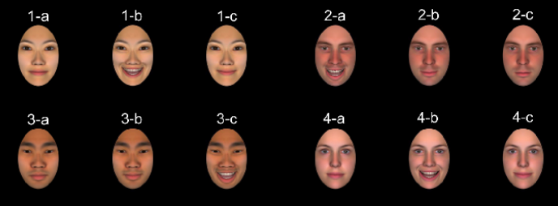
Note. 1-a, 2-c, 3-a, and 4-a are Neutral expressions; 1-c, 2-b, 3-b, and 4-c are Calm expressions; 1-b, 2-a, 3-c, and 4-b are Excited expressions.
Since participants were asked to choose their avatars in all four studies, we collapsed across all four studies to examine whether there were cultural differences in avatar choice. Participants were more likely to choose avatars that matched their race ($χ^{2}$(df = 1) = 191.78, p < .001; see Table S4a for percentages) and sex ($χ^{2}$(df = 1) = 456.89, p < .001; see Table S4b for percentages). Additionally, there were cultural differences in the selection of avatar expressions, $χ^{2}$(df = 2) = 12.66, p = .002: Both European Americans and Taiwanese chose calm avatars most frequently, but neutral avatars were the next most chosen for Taiwanese whereas excited avatars were the next most chosen for European Americans (see Table S4a for percentages). This is different from Park et al. (2017) in which European Americans chose the excited avatar 93.9% of the time, the calm 5.1% of the time, and the neutral face 1% of the time. Finally, we tested whether ideal affect (ideal HAP - ideal LAP) and actual affect (actual HAP - actual LAP) were related to the intensity of the chosen avatars’ smiles. We included both difference scores (ideal and actual affect) in a single ordinal regression model to test the independent effect of each while controlling for the other. The more participants valued HAP over LAP (ideal HAP - ideal LAP), the more they chose avatars with higher intensity smiles, B = -0.34, SE = .08, z = -4.36, p < .001. Similarly, the more participants reported actually feeling HAP over LAP (actual HAP - actual LAP), the more they chose avatars with higher intensity smiles, B = 0.17, SE = .08, z = 2.21, p = .027 (see Table S4c for all means and standard deviations).

Table S4a

Choice of Avatar Expression and Race by Participant Culture

 | Expression |  |  |  |  |  | Race
 | Excited | Calm | Neutral |  |  | White |  | Asian
European American | 33.12% | 45.65% | 21.23% |  |  | 83.44% |  | 16.56%
Taiwanese | 22.66% | 50.70% | 26.64% |  |  | 38.32% |  | 61.68%

Table S4b

Choice of Avatar Sex by Participants' Sex

 | Avatar Sex
 | Female | Male
Female participants | 93.66% | 6.34%
Male participants | 23.47% | 76.53%

Table S4c

Mean Participant Ideal and Actual Affect by Expression of Chosen Avatar

 |  |  | Expression
 | Excited |  | Calm |  | Neutral
 | M | SD | M | SD | M | SD
Ideal (HAP – LAP) | -0.41 | 0.83 | -0.75 | 0.89 | -0.88 | 0.91
Actual (HAP – LAP) | -0.22 | 0.79 | -0.45 | 0.90 | -0.58 | 0.86

Note. M and SD represent mean and standard deviation, respectively.

Section 5. Trust Game Trials Without Reputation (No Reputation Trust Game)

In Studies 1, 2, and 4, participants played 12 trials in which they saw targets without reputation information. These trials were included to ensure we replicated the findings from Blevins et al. (2024) in which participants played the Trust Game without receiving any information about targets’ reputation. The results from the trials without reputation for Study 1 are reported in the manuscript. Here, we report results of the No Reputation Trust Game for Studies 2 and 4 (participants did not play the No Reputation Trust Game in Study 3).

Study 2: Cultural Differences in Transfers to Excited, Calm, and Neutral Targets
As in our previous studies (Park et al., 2017), we excluded participants (33 European Americans, 15 Taiwanese) who did not vary their responses across trials. This resulted in a final sample size of 89 European Americans (59.6% female, 37.1% male, 3.4% NA) and 89 Taiwanese (68.5% female, 31.5% male) participants.
To test whether there were cultural differences in transfers to excited, calm, and neutral targets, we ran a two-way repeated-measures ANOVA testing the Participant Culture (between-subjects: European American, Taiwanese) X Target Emotional Expression (within-subjects: excited, calm, neutral) interaction. There was a significant main effect of Target Emotional Expression on transfers, F(2, 352) = 12.77, p < .001, η² = 0.07, such that overall, participants transferred more to calm than both neutral and excited targets (Calm: M = 0.15, SE = 0.04; Neutral: M = -0.04, SE = 0.04; Excited: M = -0.12, SE = 0.05; Calm vs. Neutral: p = .002, 95% CI [0.06, 0.32], d = 0.20; Calm vs. Excited: p < .001, 95% CI [0.14, 0.40], d = 0.28).
However, this effect was qualified by a significant Participant Culture X Target Emotional Expression interaction, F(2, 352) = 33.88, p < .001, η² = 0.16, such that Taiwanese transferred more to calm and neutral than excited targets (Calm vs. Excited: p < .001, 95% CI [0.47, 0.84], d = 0.69; Neutral vs. Excited: p < .001, 95% CI [0.30, 0.67], d = 0.50). In contrast, European Americans transferred more to both calm and excited targets than neutral targets (Calm vs. Neutral: p = .023, 95% CI [0.02, 0.39], d = 0.22; Excited vs. Neutral: p < .001, 95% CI [0.14, 0.50], d = 0.33; see Table S4 for all means and standard errors).
Additionally, European American participants transferred more to excited targets than Taiwanese participants (p < .001, 95% CI [0.40, 0.65], d = 0.55), and Taiwanese participants transferred more to calm and neutral targets than did European Americans (Calm: p < .001, 95% CI [0.12, 0.37], d = 0.26; Neutral: p < .001, 95% CI [0.15, 0.40], d = 0.29).
Overall, we replicated the main findings from Blevins et al., 2024 among European Americans: they transferred more to smiling (calm and excited) targets than neutral targets. Taiwanese transferred the most to calm, followed by neutral (but not significantly different from calm), and the least to excited targets, which is slightly different from previous findings, in which they transferred more to calm than both neutral and excited targets. In addition, consistent with cultural differences in ideal affect, European Americans transferred more to excited and less to calm targets than did Taiwanese.

Study 4: Cultural Differences in Transfers to Excited, Calm, and Neutral Targets
As in our previous studies (Park et al., 2017), we excluded participants (43 European Americans, 20 Taiwanese) who did not vary their responses across trials. This resulted in a final sample size of 81 European Americans (66.7% female, 29.6% male, 3.7% NA) and 89 Taiwanese (69.7% female, 29.2% male, 1.1% NA) participants.
To test whether there were cultural differences in transfers to excited, calm, and neutral targets, we ran a two-way repeated-measures ANOVA testing the Participant Culture (between-subjects: European American, Taiwanese) X Target Emotional Expression (within-subjects: excited, calm, neutral) interaction. There was a significant main effect of Target Emotional Expression on transfers, F(2, 336) = 22.56, p < .001, η² = 0.12, such that overall, participants transferred more to calm than both neutral and excited targets (Calm: M = 0.22, SE = 0.04; Neutral: M = -0.07, SE = 0.04; Excited: M = -0.15, SE = 0.05; Calm vs. Neutral: p < .001, 95% CI [0.16, 0.43], d = 0.31; Calm vs. Excited: p < .001, 95% CI [0.22, 0.49], d = 0.37).
However, this effect was qualified by a Participant Culture X Target Emotional Expression interaction, F(2, 336) = 12.37, p < .001, η² = 0.07, such that Taiwanese transferred the most to calm, followed by neutral, and least to excited targets (Calm vs. Excited: p < .001, 95% CI [0.40, 0.78], d = 0.62; Calm vs. Neutral: p = .002, 95% CI [0.08, 0.46], d = 0.28; Neutral vs. Excited: p < .001, 95% CI [0.13, 0.51], d = 0.34). In contrast, European Americans transferred more to both calm and excited targets than neutral targets (Calm vs. Neutral: p < .001, 95% CI [0.12, 0.51], d = 0.33; Excited vs. Neutral: p = .048, 95% CI [0.002, 0.40], d = 0.21; see Table S4 for all means and standard errors).
Additionally, European American participants transferred more to excited targets than Taiwanese participants (p < .001, 95% CI [0.20, 0.46], d = 0.35), and Taiwanese participants transferred more to calm and neutral targets than European Americans (Calm: p = .034, 95% CI [0.01, 0.27], d = 0.15; Neutral: p = .005, 95% CI [0.06, 0.32], d = 0.20).
Overall, we replicated the main findings from Blevins et al., 2024 and Studies 1 and 2: European Americans transferred more to smiling (calm and excited) targets than neutral targets, and Taiwanese transferred the most to calm, followed by neutral, and the least to excited targets.

Table S4

Means and Standard Errors of Ipsatized Transfers as a Function of Participant Culture and Target Expression

 |  | Target Expression
 |  | Excited |  | Calm |  | Neutral
 |  | M | SE | M | SE | M | SE
Study 1 | European American | 0.03 | 0.07 | 0.17 | 0.07 | -0.19 | 0.07
Study 1 | Taiwanese | -0.38 | 0.06 | 0.29 | 0.06 | 0.09 | 0.06
Study 2 | European American | 0.14 | 0.06 | 0.03 | 0.06 | -0.18 | 0.06
Study 2 | Taiwanese | -0.38 | 0.06 | 0.28 | 0.06 | 0.10 | 0.06
Study 3 | European American | 0.03 | 0.07 | 0.15 | 0.06 | -0.17 | 0.07
Study 3 | Taiwanese | -0.30 | 0.06 | 0.29 | 0.06 | 0.02 | 0.06

Section 6. Ipsatized Transfer Results in Studies 1-4
In this section, we report the means and standard errors for the ipsatized transfers by participant cultural group, target emotional expression, and target reputation level for each study. We also report the differences between cultural groups for each study.

Study 1: Trustworthiness Reputation

Table S6a

Means (M) and Standard Errors (SE) of Ipsatized Transfers as a Function of Participant Culture, Target Emotional Expression, and Target Trustworthiness Reputation

 | Target Trustworthiness Reputation
 | Low |  | Moderate |  | High
 | M | SE | M | SE | M | SE
European American
Excited Target | -0.92 | 0.05 | -0.03 | 0.04 | 0.90 | 0.05
Calm Target | -0.87 | 0.05 | 0.02 | 0.04 | 0.98 | 0.04
Neutral Target | -0.89 | 0.05 | -0.12 | 0.04 | 0.93 | 0.06
Taiwanese
Excited Target | -0.91 | 0.03 | -0.09 | 0.02 | 0.68 | 0.03
Calm Target | -0.77 | 0.03 | 0.09 | 0.02 | 0.97 | 0.03
Neutral Target | -0.83 | 0.02 | -0.07 | 0.02 | 0.93 | 0.03

Between-Culture Differences in Transfers by Expression and Reputation
Consistent with cultural differences in ideal HAP, European Americans transferred more to high reputation excited targets than did Taiwanese (p < .001, 95% CI [0.06, 0.38], d = 0.37). All other pairwise comparisons, however, were not significant (all p ≥ .475).

Study 2: Competence Reputation

Table S6b

Means (M) and Standard Errors (SE) of Ipsatized Transfers as a Function of Participant Culture, Target Emotional Expression, and Target Competence Reputation

 | Target Competence Reputation
 | Low |  | Moderate |  | High
 | M | SE | M | SE | M | SE
European American
Excited Target | -0.58 | 0.03 | -0.03 | 0.03 | 0.69 | 0.03
Calm Target | -0.64 | 0.04 | 0.01 | 0.02 | 0.66 | 0.03
Neutral Target | -0.64 | 0.03 | -0.11 | 0.03 | 0.65 | 0.03
Taiwanese
Excited Target | -0.82 | 0.03 | -0.11 | 0.02 | 0.51 | 0.04
Calm Target | -0.64 | 0.03 | 0.05 | 0.02 | 0.82 | 0.03
Neutral Target | -0.65 | 0.03 | -0.009 | 0.02 | 0.84 | 0.04

Between-Culture Differences in Transfers by Target Expression and Target Reputation
Consistent with cultural differences in ideal HAP, European Americans transferred more to low-reputation excited targets than did Taiwanese (p = .012, 95% CI [0.03, 0.44], d = 0.34). All other pairwise comparisons were not significant (all p ≥ .071). This was different from Study 1, where the cultural differences emerged for high reputation excited targets.

Study 3: Past Behavior

Table S6c

Means (M) and Standard Errors (SE) of Ipsatized Transfers as a Function of Culture, Emotional Expression, and Target Past Behavior

 | Target Past Behavior
 | Low |  | Moderate |  | High
 | M | SE | M | SE | M | SE
European American
Excited | -0.87 | 0.03 | -0.03 | 0.02 | 0.85 | 0.03
Calm | -0.86 | 0.03 | 0.06 | 0.02 | 0.87 | 0.02
Neutral | -0.88 | 0.03 | -0.05 | 0.02 | 0.91 | 0.03
Taiwanese
Excited | -0.84 | 0.03 | -0.05 | 0.02 | 0.76 | 0.03
Calm | -0.79 | 0.03 | 0.04 | 0.02 | 0.89 | 0.03
Neutral | -0.82 | 0.03 | -0.10 | 0.02 | 0.90 | 0.03

Between-Culture Differences in Transfers by Expression and Past Behavior
Contrary to Studies 1 and 2, there were no significant between culture differences in transfers to excited targets at any level of target past behavior.

Study 4: Emotional Stability Reputation

Table S6d

Means (M) and Standard Errors (SE) of Ipsatized Transfers as a Function of Culture, Emotional Expression, and Emotional Stability Reputation

 | Target Stability Reputation
 | Low |  | Moderate |  | High
 | M | SE | M | SE | M | SE
European American
Excited | -0.68 | 0.03 | 0.005 | 0.02 | 0.66 | 0.03
Calm | -0.64 | 0.03 | 0.03 | 0.02 | 0.80 | 0.03
Neutral | -0.69 | 0.03 | -0.12 | 0.02 | 0.63 | 0.03
Taiwanese
Excited | -0.66 | 0.03 | -0.11 | 0.03 | 0.47 | 0.04
Calm | -0.50 | 0.03 | 0.13 | 0.03 | 0.81 | 0.03
Neutral | -0.68 | 0.03 | -0.08 | 0.03 | 0.61 | 0.03

Between-Culture Differences in Transfers by Expression and Reputation
As in Study 1, European Americans transferred marginally more to high-reputation excited targets than Taiwanese (p = .050, 95% CI [0.0002, 0.38], d = 0.27), but all other pairwise comparisons were not significant (all p ≥ .262).

Section 7. Results for Raw Transfers for Studies 1-4
To control for cultural differences in response styles, we report ipsatized transfers in the manuscript. Here we report results from analyses of raw transfers for each study.

Study 1: Trustworthiness Reputation
We conducted a three-way repeated-measures ANOVA on raw transfers to test the interaction between Participant Culture (between-subjects: European American, Taiwanese), Target Emotional Expression (within-subjects: excited, calm, neutral), and Target Reputation (within-subjects: low trustworthiness, moderate trustworthiness, high trustworthiness). There was a significant main effect of Participant Culture, F(1, 203) = 22.04, p < .001, η² = 0.10: European Americans transferred more than Taiwanese (European Americans: M = 5.10, SE = 0.04; Taiwanese: M = 4.11, SE = 0.03).
There was also a significant main effect of Target Reputation, F(2, 406) = 517.275, p < .001, η² = 0.72: the higher the reputation of the target, the more participants transferred to them (Low: M = 2.69, SE = 0.03; Moderate: M = 4.52, SE = 0.02; High: M = 6.59, SE = 0.03; Low vs. Moderate: p < .001, 95% CI [2.11, 1.54], d = 1.48; Moderate vs. High: p < .001, 95% CI [2.36, 1.79], d = 1.68).
There was also a significant main effect of Target Emotional Expression, F(2, 406) = 14.10, p < .001, η² = 0.06: participants transferred more to calm than neutral and excited targets (Calm: M = 4.72, SE = 0.04; Neutral: M = 4.58, SE = 0.04; Excited: M = 4.50, SE = 0.04; Calm vs. Neutral: p = .002, 95% CI [0.05, 0.24], d = 0.12; Calm vs. Excited: p < .001, 95% CI [0.12, 0.32], d = 0.18).
Further, the Participant Culture X Target Reputation interaction was significant, F(2, 406) = 6.27, p = .002, η² = 0.03. This interaction revealed that while European Americans consistently transferred more than Taiwanese at all levels of reputation, the difference in transfers increased as the reputation level increased. At low reputation, European Americans transferred more than Taiwanese (p = .024, 95% CI [0.08, 1.07], d = 0.46). At moderate reputation, the difference grew larger (p < .001, 95% CI [0.46, 1.45], d = 0.78), and at high reputation, the difference was the most pronounced (p < .001, 95% CI [0.93, 1.93], d = 1.16).
Additionally, there was a significant Participant Culture X Target Emotional Expression interaction, F(2, 406) = 4.19, p = .016, η² = 0.02. Taiwanese participants transferred more to calm and neutral targets than excited targets (Calm vs. Excited: p < .001, 95% CI [0.18, 0.46], d = 0.26; Neutral vs. Excited: p = .006, 95% CI [0.04, 0.32], d = 0.15). In contrast, European Americans showed a preference for calm over neutral targets (Calm vs. Neutral: p = .028, 95% CI [0.29, 0.01], d = 0.12), with excited targets falling in between.
Although the Participant Culture X Target Emotional Expression X Target Reputation interaction was not significant, F(4, 812) = 1.68, p = 0.152, the pattern of results was the same as reported in the manuscript.

Figure S7a
Raw Transfers by Participant Cultural Group, Target Emotional Expression, and Target Trustworthiness Reputation in Study 1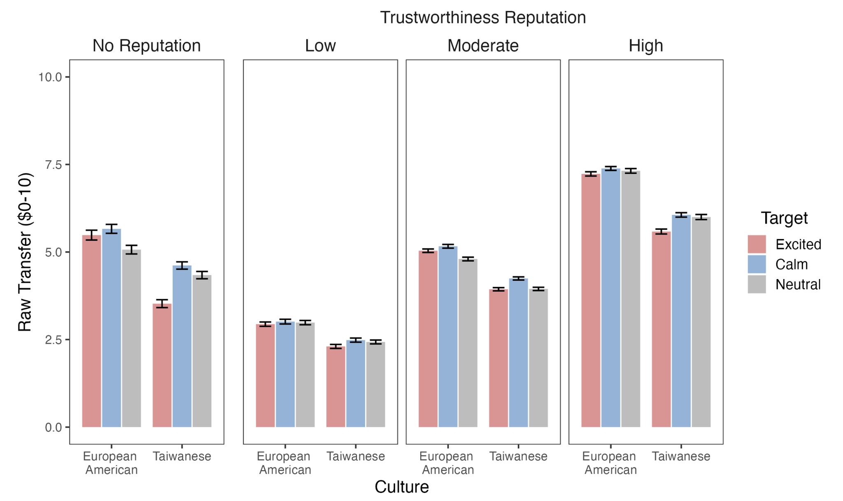
Note. Error bars represent ±1 standard error of the mean.

Table S7a

Means (M) and Standard Errors (SE) of Raw Transfers as a Function of Target Trustworthiness Reputation, Participant Culture and Target Emotional Expression

 | Target Trustworthiness Reputation
 | Low |  | Moderate |  | High
 | M | SE | M | SE | M | SE
European American
Excited Target | 2.94 | 0.06 | 5.04 | 0.05 | 7.23 | 0.06
Calm Target | 3.01 | 0.07 | 5.16 | 0.05 | 7.39 | 0.06
Neutral Target | 2.98 | 0.06 | 4.80 | 0.05 | 7.32 | 0.07
Taiwanese
Excited Target | 2.30 | 0.06 | 3.94 | 0.05 | 5.58 | 0.07
Calm Target | 2.48 | 0.06 | 4.25 | 0.04 | 6.06 | 0.06
Neutral Target | 2.43 | 0.06 | 3.95 | 0.05 | 6.00 | 0.07

Study 2: Competence Reputation
We conducted a three-way repeated-measures ANOVA on raw transfers to test the interaction between Participant Culture (between-subjects: European American, Taiwanese), Target Emotional Expression (within-subjects: excited, calm, neutral), and Target Reputation (within-subjects: low competence, moderate competence, high competence). All post hoc pairwise comparisons were conducted using Tukey's HSD test. There was a significant main effect of Participant Culture, F(1, 206) = 73.14, p < .001, η2 = 0.26: European Americans transferred more than Taiwanese did (European Americans: M = 5.91, SE = 0.03; Taiwanese: M = 3.57, SE = 0.03).
There was also a significant main effect of Target Reputation, F(2, 412) = 206.90, p < .001, η2 = 0.50: the higher the reputation of the target, the more participants transferred to them (Low: M = 3.51, SE = 0.03; Moderate: M = 4.68, SE = 0.02; High: M = 6.16, SE = 0.03; Low vs. Moderate: p < .001, 95% CI [0.86, 1.47], d = 0.94; Moderate vs. High: p < .001, 95% CI [1.17, 1.79], d = 1.20).
There was a significant main effect of Target Emotional Expression, F(2, 412) = 5.19, p = .006, η2 = 0.02: participants transferred more to calm than excited targets (Calm: M = 4.86, SE = 0.03; Excited: M = 4.70, SE = 0.03; Neutral: M = 4.79, SE = 0.03; Calm vs. Excited: p = .002, 95% CI [0.05, 0.30], d = 0.14).
Although the Participant Culture X Target Reputation interaction was not significant, F(2, 412) = 0.59, p = .555, the Participant Culture X Target Emotional Expression interaction was, F(2, 412) = 12.15, p < .001, η2 = 0.06. European Americans showed no significant expression preferences (all pairwise comparisons p ≥ .20), while Taiwanese participants transferred more to both calm and neutral targets than excited targets (Calm vs. Excited: p < .001, 95% CI [0.21, 0.57], d = 0.32; Neutral vs. Excited: p < .001, 95% CI [0.16, 0.52], d = 0.27).
All of the above effects and interactions, however, were further qualified by a significant Participant Culture X Target Emotional Expression X Target Reputation interaction, F(4, 824) = 3.54, p = .007, η2 = 0.02. We broke this three-way interaction down by participant cultural group. For European Americans, no expression preferences were found at any target reputation level (Low Reputation: all p ≥ .36; Moderate Reputation: all p ≥ .22; High Reputation: all p ≥ .95).
Taiwanese, however, showed a different pattern. Taiwanese transferred as much to neutral targets as they did to calm targets across all levels of trustworthiness reputations. Additionally, across all levels of reputation, Taiwanese transferred more to calm than excited targets (Low Reputation: Calm vs. Excited: p = .007, 95% CI [0.05, 0.55], d = 0.24; Neutral vs. Excited: p = .008, 95% CI [0.05, 0.55], d = 0.24; Moderate Reputation: Calm vs. Excited: p = .005, 95% CI [0.06, 0.56], d = 0.26; High Reputation: Calm vs. Excited: p < .001, 95% CI [0.31, 0.81], d = 0.46; Neutral vs. Excited: p < .001, 95% CI [0.29, 0.79], d = 0.44).
Although our hypotheses focused on differences within cultural groups, we also compared transfers between cultural groups. Comparisons consistently showed that European Americans transferred more than Taiwanese did across target reputation and target emotional expression, which was consistent with the significant main effect of Participant Culture on transfers (all p ≤ .001).

Figure S7b
Raw Transfers by Participant Cultural Group, Target Emotional Expression, and Target Competence Reputation in Study 2
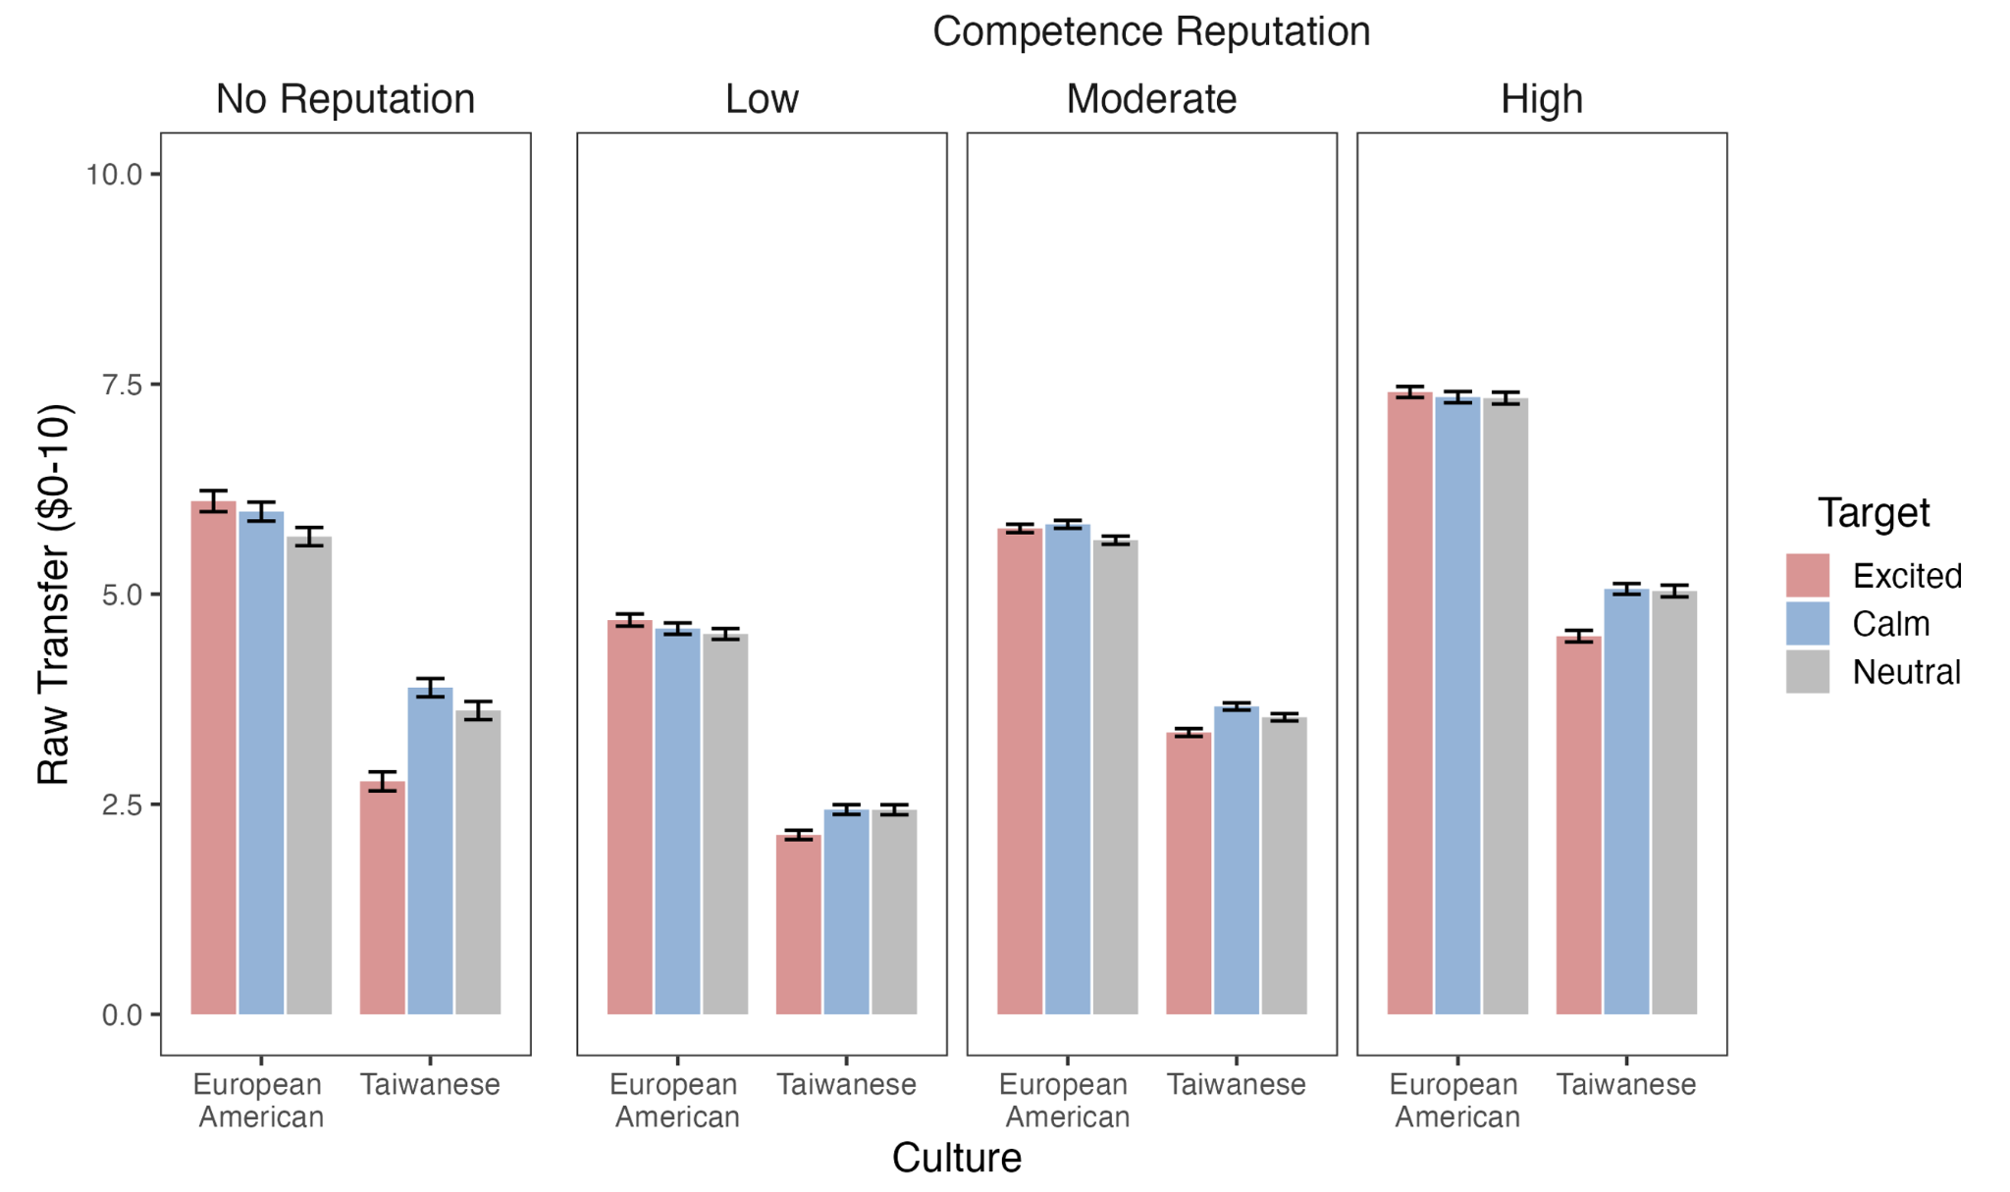

Note. Error bars represent ±1 standard error of the mean.

Table S7b

Means (M) and Standard Errors (SE) of Raw Transfers as a Function of Participant Culture, Target Emotional Expression, and Target Competence Reputation

 | Target Competence Reputation
 | Low |  | Moderate |  | High
 | M | SE | M | SE | M | SE
European American
Excited Target | 4.69 | 0.07 | 5.78 | 0.05 | 7.41 | 0.07
Calm Target | 4.59 | 0.07 | 5.83 | 0.05 | 7.34 | 0.07
Neutral Target | 4.53 | 0.06 | 5.64 | 0.05 | 7.33 | 0.07
Taiwanese
Excited Target | 2.14 | 0.06 | 3.35 | 0.05 | 4.50 | 0.07
Calm Target | 2.44 | 0.06 | 3.66 | 0.04 | 5.06 | 0.06
Neutral Target | 2.44 | 0.06 | 3.54 | 0.04 | 5.04 | 0.07

Study 3: Past Behavior
We conducted a three-way repeated-measures ANOVA on raw transfers to test the interaction between Participant Culture (between-subjects: European American, Taiwanese), Target Emotional Expression (within-subjects: excited, calm, neutral), and Target Past Behavior (within-subjects: low past behavior, moderate past behavior, high past behavior). All post hoc pairwise comparisons were conducted using Tukey's HSD test. Although the main effect of Participant Culture, F(1, 211) = 0.09, p = .762, was not significant, the main effect of Target Past Behavior was significant, F(2, 422) = 407.38, p < .001, η2 = 0.66, such that participants transferred more to targets with higher past return behavior (Low: M = 2.12, SE = 0.03; Moderate: M = 3.95, SE = 0.02; High: M = 6.03, SE = 0.03; Low vs. Moderate: p < .001, 95% CI [1.51, 2.16], d = 1.63; Moderate vs. High: p < .001, 95% CI [1.76, 2.41], d = 1.85).
The main effect of Target Emotional Expression was also significant, F(2, 422) = 8.06, p = .0004, η2 = 0.04: participants transferred more to calm targets than both excited and neutral targets (Calm: M = 4.11, SE = 0.04; Excited: M = 3.98, SE = 0.04; Neutral: M = 4.01, SE = 0.04; Calm vs. Excited: p = .0004, 95% CI [0.05, 0.21], d = 0.11; Calm vs. Neutral: p = .011, 95% CI [0.02, 0.18], d = 0.09).
Neither the Participant Culture X Target Past Behavior interaction (F(2, 422) = 1.64, p = .196) nor the Participant Culture X Target Emotional Expression interaction (F(2, 422) = 1.73, p = .178) were significant. Finally, the three-way Participant Culture X Target Past Behavior X Target Emotional Expression interaction was also not significant, F(4, 844) = 1.77, p = .133, although the means were in the same direction as for ipsatized scores reported in the manuscript.
Figure S7c
Raw Transfers by Participant Cultural Group, Target Emotional Expression, and Target Past Behavior in Study 3
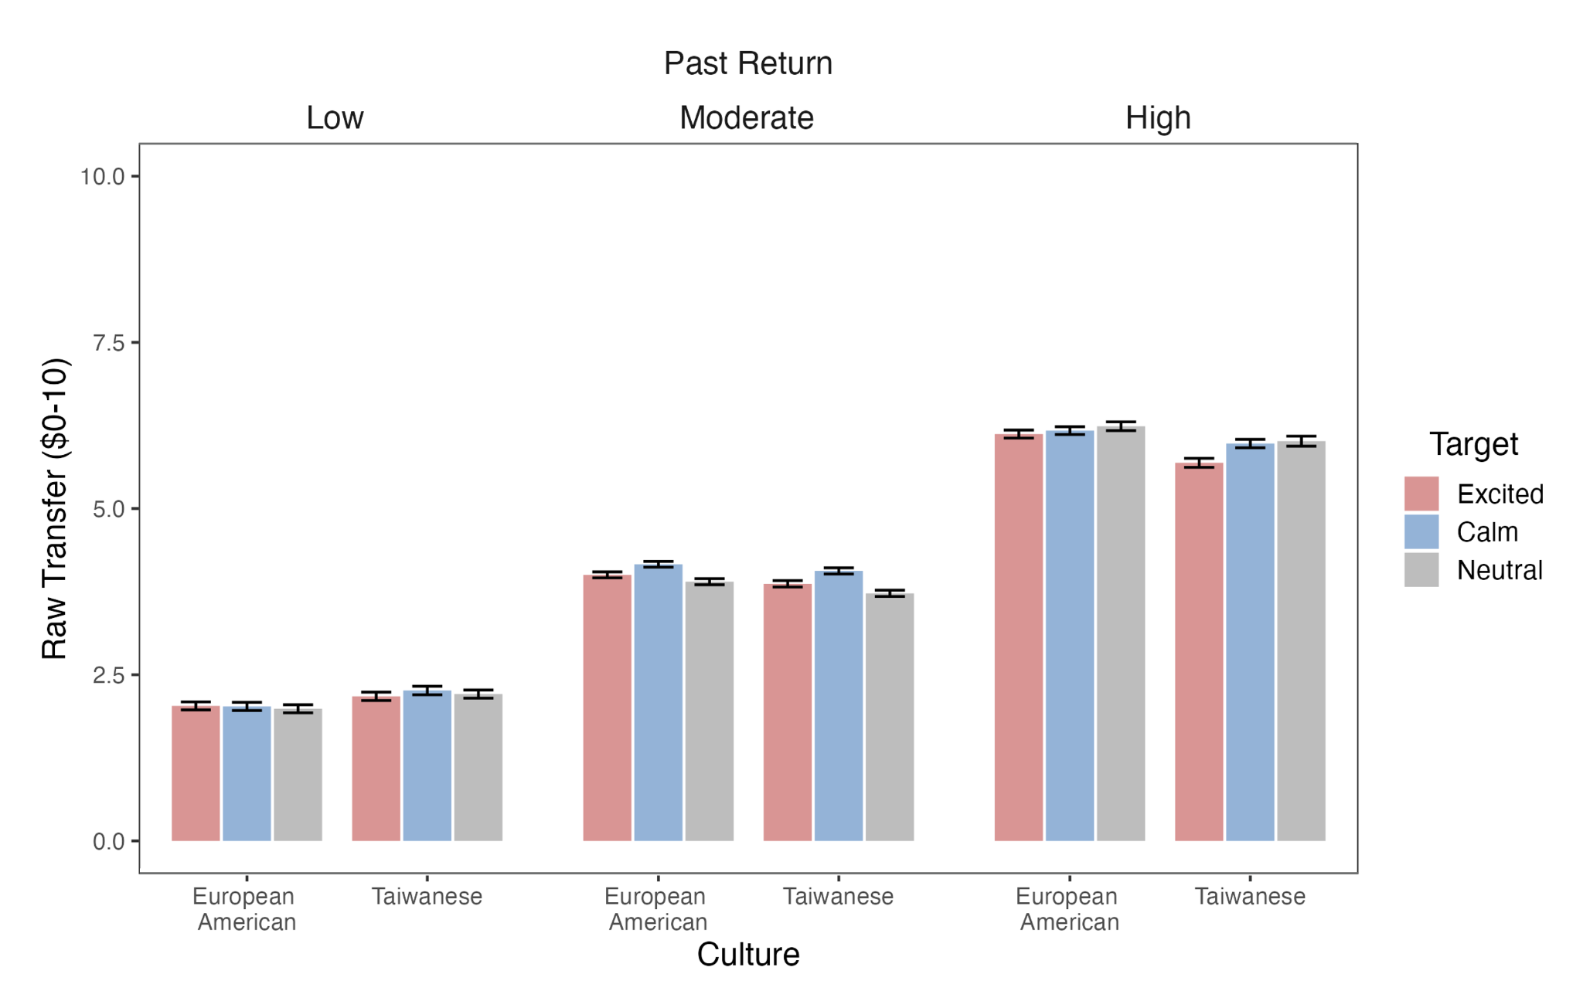
Note. Error bars represent ±1 standard error of the mean.

Table S7c

Means (M) and Standard Errors (SE) of Raw Transfers as a Function of Target Past Behavior, Participant Culture, and Target Expression

 | Target Past Behavior
 | Low |  | Moderate |  | High
 | M | SE | M | SE | M | SE
European American
Excited Target | 2.03 | 0.06 | 4.00 | 0.04 | 6.12 | 0.06
Calm Target | 2.02 | 0.06 | 4.16 | 0.04 | 6.17 | 0.06
Neutral Target | 1.99 | 0.06 | 3.90 | 0.05 | 6.24 | 0.07
Taiwanese
Excited Target | 2.18 | 0.06 | 3.87 | 0.05 | 5.69 | 0.07
Calm Target | 2.26 | 0.06 | 4.06 | 0.05 | 5.98 | 0.06
Neutral Target | 2.21 | 0.06 | 3.72 | 0.05 | 6.01 | 0.08

Study 4: Emotional Stability Reputation
We conducted a three-way repeated-measures ANOVA on raw transfers to test the interaction between Participant Culture (between-subjects: European American, Taiwanese), Target Emotional Expression (within-subjects: excited, calm, neutral), and Target Reputation (within-subjects: low stability, moderate stability, high stability). There was a significant main effect of Participant Culture, F(1, 214) = 17.51, p < .001, η2 = 0.08: European Americans transferred more than Taiwanese (European Americans: M = 5.74, SE = 0.03; Taiwanese: M = 4.66, SE = 0.03).
There was also a significant main effect of Target Reputation, F(2, 428) = 232.17, p < .001, η2 = 0.52: participants transferred more to targets with higher reputation (Low: M = 3.94, SE = 0.03; Moderate: M = 5.18, SE = 0.02; High: M = 6.55, SE = 0.03; Low vs. Moderate: p < .001, 95% CI [0.95, 1.52], d = 0.90; Moderate vs. High: p < .001, 95% CI [1.07, 1.65], d = 1.00).
There was also a significant main effect of Target Emotional Expression, F(2, 428) = 18.21, p < .001, η2 = 0.08: participants transferred more to calm targets compared to both excited and neutral targets (Calm: M = 5.41, SE = 0.03; Excited: M = 5.11, SE = 0.03; Neutral: M = 5.15, SE = 0.03; Calm vs. Excited: p < .001, 95% CI [0.17, 0.42], d = 0.22; Calm vs. Neutral: p < .001, 95% CI [0.13, 0.38], d = 0.11).
There was a significant Participant Culture X Target Reputation interaction, F(2, 428) = 7.06, p < .001, η2 = 0.03, which revealed that while European Americans consistently transferred more than Taiwanese did at all levels of reputation, the difference in transfers increased as the reputation level increased. At low reputation, European Americans transferred more than Taiwanese (p = .030, 95% CI [0.06, 1.22], d = 0.47), and this difference grew larger at moderate (p < .001, 95% CI [0.46, 1.62], d = 0.76) and high levels of reputation (p < .001, 95% CI [0.97, 2.13], d = 1.14).
The Participant Culture X Target Emotional Expression interaction was not significant, F(2, 428) = 2.59, p = .076, and neither was the Participant Culture X Target Emotional Expression X Target Reputation interaction, F(4, 856) = 1.71, p = .147, although the means were in the same direction as reported in the manuscript.
Figure S7d
Raw Transfers by Participant Cultural Group, Target Emotional Expression, and Target Emotional Stability Reputation in Study 4
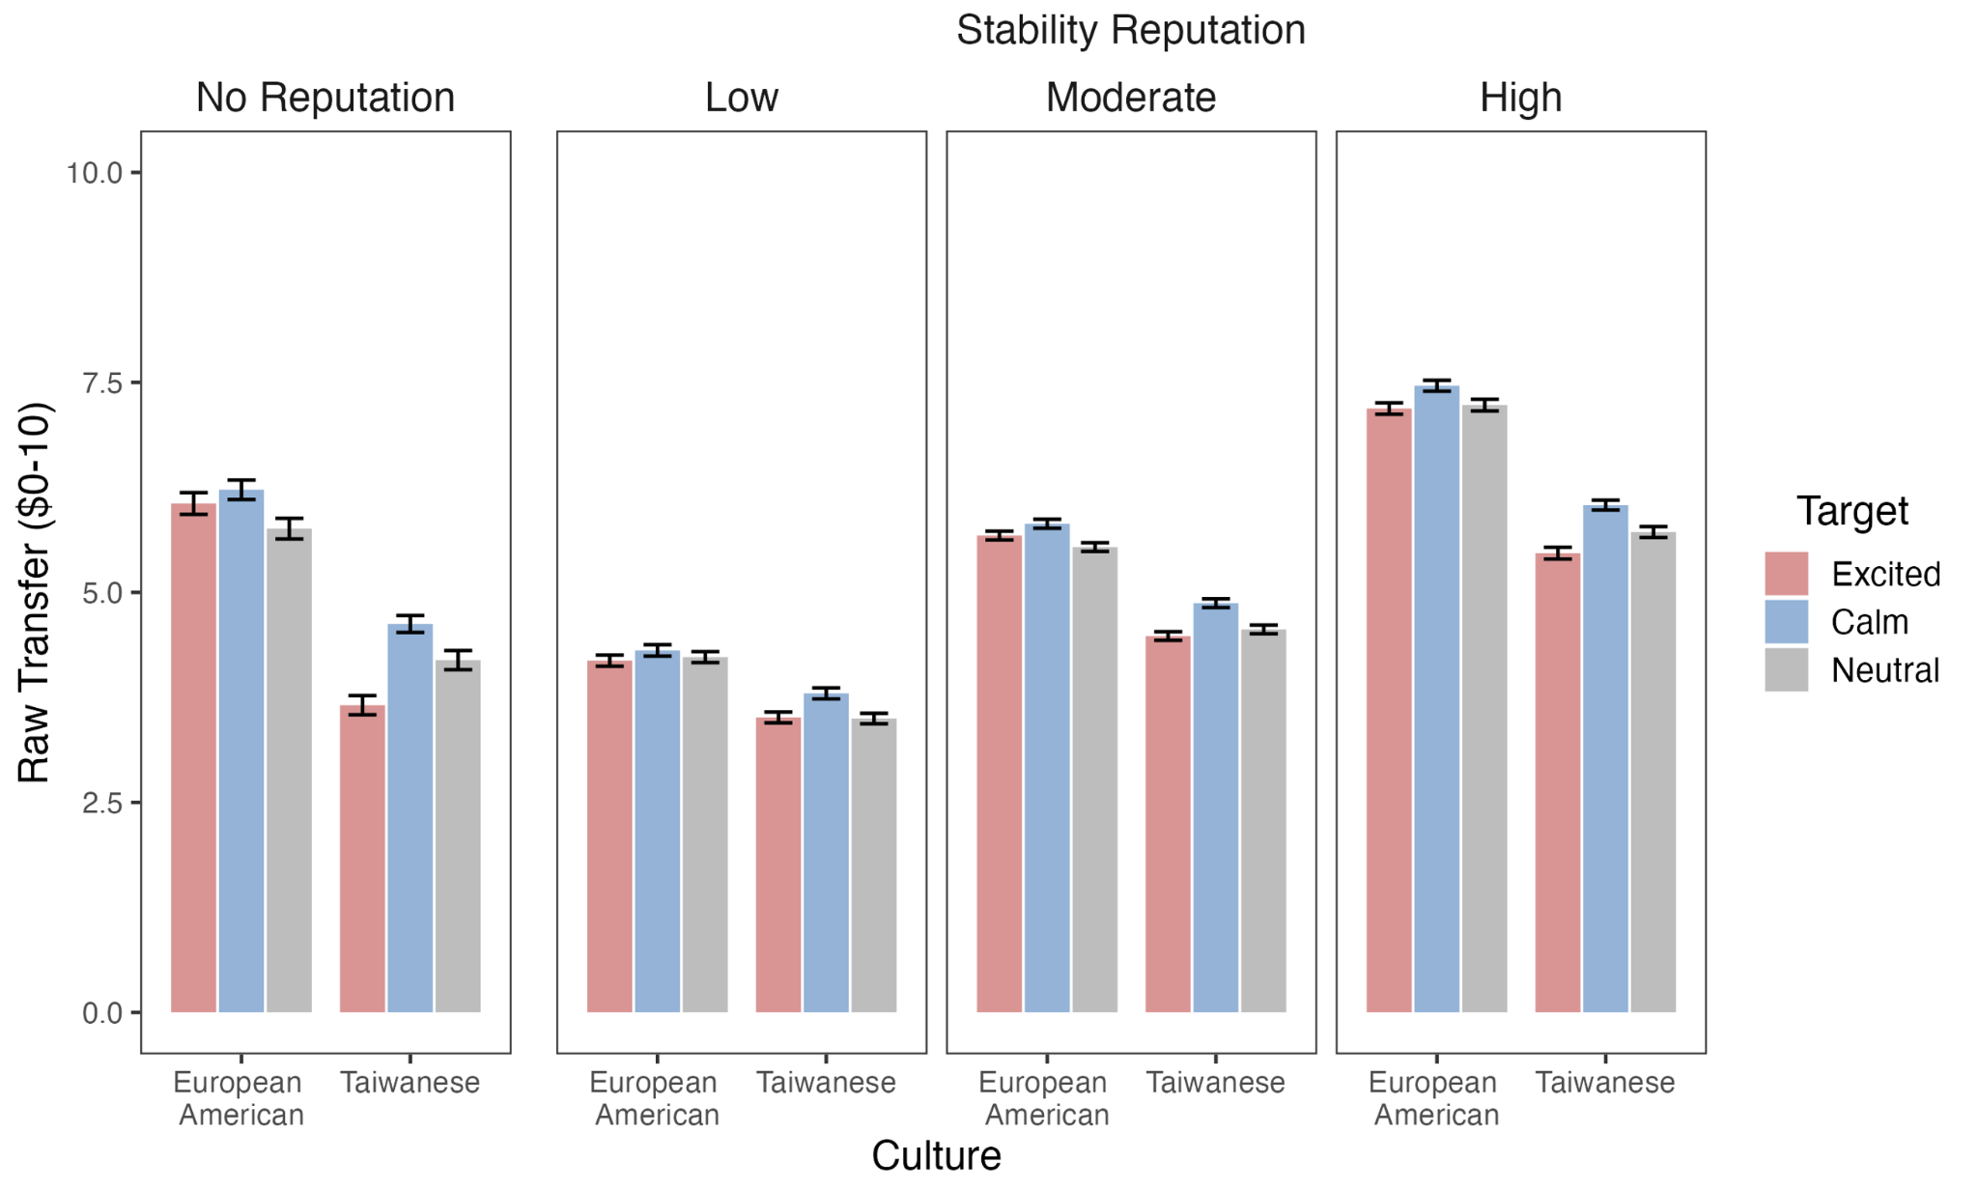

Note. Error bars represent ±1 standard error of the mean.

Table S7d

Means (M) and Standard Errors (SE) of Raw Transfers as a Function of Participant Culture, Target Emotional Expression, and Target Emotional Stability Reputation

 | Target Stability Reputation
 | Low |  | Moderate |  | High
 | M | SE | M | SE | M | SE
European American
Excited Target | 4.19 | 0.07 | 5.68 | 0.05 | 7.19 | 0.07
Calm Target | 4.31 | 0.07 | 5.82 | 0.05 | 7.46 | 0.07
Neutral Target | 4.23 | 0.07 | 5.54 | 0.05 | 7.23 | 0.07
Taiwanese
Excited Target | 3.51 | 0.06 | 4.48 | 0.05 | 5.47 | 0.07
Calm Target | 3.80 | 0.07 | 4.87 | 0.05 | 6.04 | 0.06
Neutral Target | 3.50 | 0.06 | 4.56 | 0.05 | 5.72 | 0.07

Section 8. Testing the Moderating Effect of Target Race and Sex
This section examines whether target race and sex moderated the findings (specifically, the 3-way interaction of Participant Culture X Target Emotional Expression X Target Reputation) reported in the manuscript. All post hoc pairwise comparisons were conducted using Tukey's HSD test. Target race did not moderate any of the findings (Study 1: F(4, 812) = 1.00, p = .405; Study 2: F(4, 824) = 1.67, p = .154; Study 3: F(4, 844) = 1.70, p = .148; Study 4: F(4, 856) = 0.49, p = .743). Similarly, with one exception (Study 1), target sex did not moderate the findings (Study 2: F(4, 824) = 0.75, p = .559; Study 3: F(4, 844) = 0.24, p = .918; Study 4: F(4, 856) = 0.93, p = .444).
For Study 1, target sex did significantly moderate the 3-way interaction of Participant Culture X Target Emotional Expression X Target Reputation, F(4, 812) = 2.92, p = .020, η² = 0.01. Overall, the pattern of findings indicate that for Study 1, the expression preferences among European Americans and Taiwanese were stronger for female targets.
When the target was female,
European Americans transferred more to calm than neutral targets when targets’ reputations were moderate (p < .001, 95% CI [0.10, 0.42], d = 0.44). Additionally, European Americans transferred more to excited than neutral targets when targets’ reputations were low (p = .011, 95% CI [0.02, 0.34], d = 0.31) but did not differentiate among targets when their reputations were high.
Taiwanese transferred more to calm than neutral targets when their reputational status was moderate (p <.001, 95% CI [0.05, 0.37], d = 0.35). Across target reputation levels, Taiwanese transferred less to excited targets compared to calm ones (difference between calm and excited for Low: p < .001, 95% CI [0.06, 0.38], d = 0.38, Moderate: p < .001, 95% CI [0.05, 0.37], d = 0.36, and High: p = .055, 95% CI [-0.001, 0.32], d = 0.27). They also transferred less to excited than neutral targets, except when targets’ reputations were moderate (difference between neutral and excited for Low: p = .010, 95% CI [0.02, 0.34], d = 0.31, and High reputations: p < .001, 95% CI [0.07, 0.39], d = 0.40).
When the target was male,
European Americans did not distinguish among excited, calm, and neutral targets. Taiwanese transferred more to calm and neutral targets than excited targets when targets’ reputations were high (Calm vs. Excited: p < .001, 95% CI [0.25, 0.57], d = 0.70; Neutral vs. Excited: p < .001, 95% CI [0.10, 0.42], d = 0.44).
European Americans transferred more to high reputation excited targets than Taiwanese did (p = .003, 95% CI [0.05, 0.49], d = 0.46).

Thus, the pattern of findings indicates that for Study 1, the expression preferences among European Americans and Taiwanese were stronger for female targets than for male targets. However, in the subsequent studies, target sex did not moderate the rest of the results reported in the manuscript.

Section 9: Alternative Explanations

Section 9A. Presentation Order
In order to rule out the possibility that target reputation mattered more than target expression for European Americans because of order effects (in Study 1, reputation was presented after the target expression), we ran a separate study in which we randomized the order in which target reputation and emotional expression were presented. We found that presentation order did not moderate the effect of emotional expression and/or reputation on European Americans’ transfers, suggesting that presentation order does not account for the European American pattern of results. Results are described in more detail below.
Method
Participants. Since the final sample size of European Americans in Study 1 (after excluding those who gave the same amount across trials) was 102, we aimed for 100 participants per condition (200 participants total), after excluding those who gave the same amount across trials. Thus, before exclusions, we recruited 222 European Americans (46.85% female, 53.15% male) from the online crowd-sourcing platform Prolific (https://www.prolific.co/) for a study titled “Psychology of Decision-Making.” We used Prolific’s default prescreen criteria to recruit participants who matched the European American sample from Study 1 as closely as possible. Participants were required to: 1) self-identify as White/Caucasian, 2) have been born in the U.S., 3) be currently living in the U.S., 4) be between 18-25 years old, 5) speak English as a first language, and 6) report having had at least a high school education. After excluding participants who did not vary their responses across trials, we had 100 participants per condition, as intended.
Participants in the two randomly assigned presentation order conditions (reputation first vs. face first) did not differ by gender (50% female and 50% male in each condition), age (t(196.42) = -0.10, p = .919; Reputation first: M = 21.66, SD = 2.18, Face first: M = 21.63, SD = 1.99), or family income (t(196.44) = -0.15, p = .879; Reputation first: M = 6.11, SD = 1.77, Face first: M = 6.07, SD = 1.94), suggesting successful random assignment to presentation order, our main variable of interest.
Instruments. All instruments were identical to Study 1.
Trust Game. The No Reputation Trust Game and the Reputation Trust Game structure were identical to Study 1, with two differences. First, there was an additional experimental manipulation: half of the participants were randomly assigned to see the face of the target before their reputation (as in Study 1), and the other half were randomly assigned to see the reputation of the target before the face (see Figure S8a). Second, participants received an initial endowment of US$4 instead of US$10. As compensation, participants received US$6.50 plus an average bonus of US$4.20. Thus, as in Study 1, participants understood that their decisions to give on any given trial could have real monetary consequences.

Figure S9a
Sample Trial from “Face First” and “Reputation First” Order Conditions
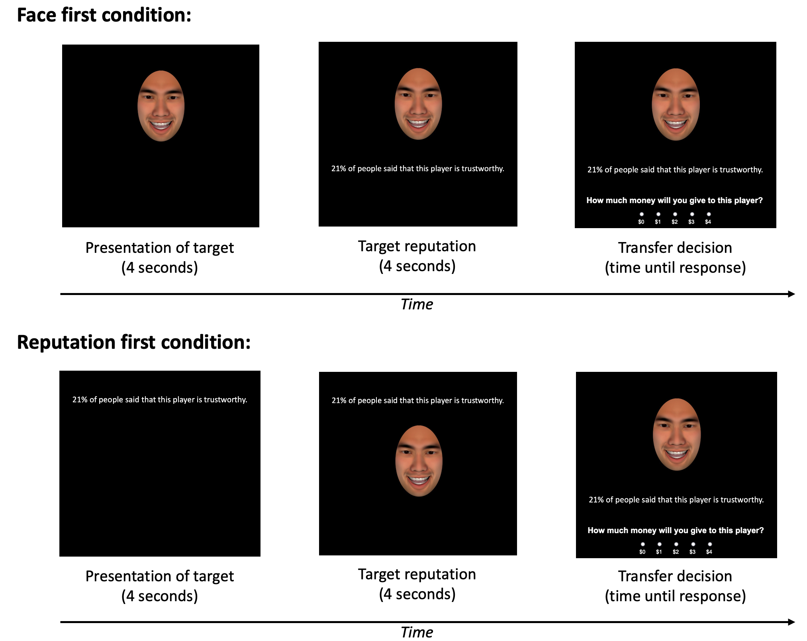
Procedure. The procedure was identical to Study 1. Participants completed the No Reputation Trust Game and then the Reputation Trust Game. All procedures were approved by the Stanford University Institutional Review Board under the protocol title “Psychology of Decision-Making” (IRB-34588).
Data Analyses and Results
Although participants played the No Reputation Trust Game, we did not manipulate presentation order in that game, and therefore, we do not present those findings here.
Does Presentation Order (Reputation first vs Face first) matter?
To test whether presentation order moderates the effects of reputation and expression on transfers, a three-way repeated-measures ANOVA was conducted, testing the interaction between Order (between-subjects: reputation first vs. face first), Target Reputation (within-subjects: “X% of people said that this player is trustworthy”) and Target Emotional Expression (within-subjects: excited, calm, neutral). All post hoc pairwise comparisons were conducted using Tukey's HSD test.
The main effect of Order was not significant, nor were there any significant interactions involving Order. Overall, these data suggest that presentation order did not have a significant effect on European Americans’ transfers, which argues against the alternate hypothesis that presentation order could account for European Americans’ Study 1 results.

Section 9B: Visual Reputation as an Alternative Explanation
To rule out the possibility that European Americans relied more on reputation information because it was presented in text rather than graphically, we ran a separate study in which European American participants were provided information about targets’ reputations in graphic form (i.e., represented by a horizontal bar that reflected how trustworthy the target was). We then compared this group to the control condition (“face-first” condition) of the presentation order study (Supplement, Section 7A), in which participants saw reputation displayed textually (i.e., “X% of people said that this player is trustworthy”, as in Study 1). The way in which reputation was presented (graphically vs. textually) did not moderate the effect of expression and/or reputation on European Americans’ transfers, suggesting that the way in which reputation was presented does not account for European Americans’ pattern of results. Results are described in more detail below.
Method
Participants. Following the same logic as the study described above, we aimed for 100 participants after excluding those who gave the same amount across trials. Thus, before exclusions, we recruited 111 European Americans (47.75% female, 52.25% male) from the online crowd-sourcing platform Prolific (https://www.prolific.co/) for a study titled “Psychology of Decision-Making.” We used Prolific’s default prescreen criteria to recruit participants who matched the European American sample from Study 1 as closely as possible. Participants were required to: 1) self-identify as White/Caucasian, 2) have been born in the U.S., 3) be currently living in the U.S., 4) be between 18-25 years old, 5) speak English as a first language, and 6) report having had at least a high school education. After excluding participants who did not vary their responses across trials, we had 100 participants, as intended.
In order to compare the responses of participants who viewed reputation information in graphic form to those who viewed reputation information in text form, we compared this sample to the control condition (face-first condition) presented in Section 5A. This ensured that the only difference between the two groups was whether reputation information was presented graphically or textually.
Participants in the two reputation presentation conditions did not differ by gender (50% female and 50% male), age (t(195.94) = 0.27, p = .788; Graphical reputation: M = 21.55, SD = 2.20, Textual reputation: M = 21.63, SD = 1.99), or family income (t(197.63) = 0.39, p = .695; Graphical reputation: M = 5.96, SD = 2.02, Textual reputation: M = 6.07, SD = 1.94).
Instruments. All instruments were identical to Study 1.
Trust Game. The No Reputation Trust Game and the Reputation Trust Game structure were identical to Study 1, with two differences. First, participants saw the reputation of the target represented graphically (see Figure S8b). Second, participants received an initial endowment of US$4 instead of US$10. As compensation, participants received US$6.50 plus an average bonus of US$4.08. Thus, as in Study 1, participants understood that their decisions to give on any given trial could have real monetary consequences.

Figure S9b
Sample Trial from Visual Reputation Trust Game
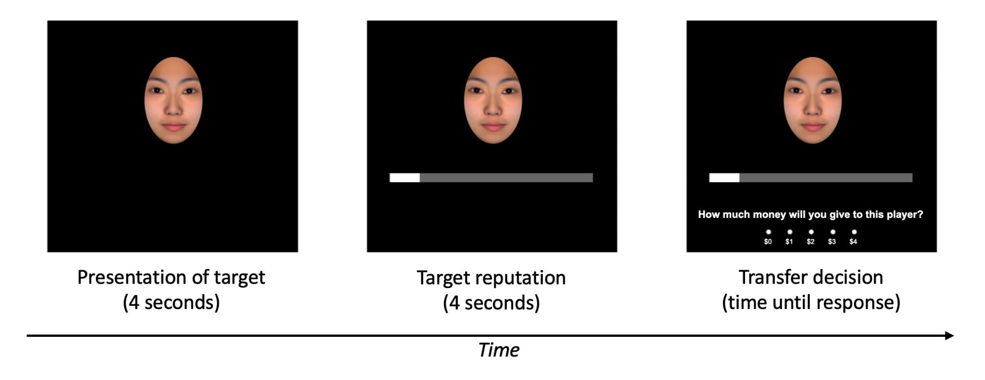
Note. Participants were informed ahead of the Trust Game that the horizontal bar represents the percentage of people who said the target was trustworthy.

Procedure. The procedure was identical to Study 1. All procedures were approved by the Stanford University Institutional Review Board under the protocol title “Psychology of Decision-Making” (IRB-34588).
Data Analyses and Results
Although participants played the No Reputation Trust Game, we did not manipulate presentation order in that game, and therefore, we do not present those findings here.
Does the Format in Which Reputation is Presented (Textual vs Graphical) Matter?
To examine whether the way in which reputation was presented moderated the effect of reputation and expression on transfers, a three-way repeated-measures ANOVA was conducted, testing the interaction between Reputation Presentation Type (between-subjects: textual vs. graphical), Target Reputation (within-subjects: “X% of people said that this player is trustworthy”) and Target Emotional Expression (within-subjects: excited, calm, neutral). All post hoc pairwise comparisons were conducted using Tukey's HSD test.
The main effect of Reputation Presentation Type was not significant, nor was the Reputation Presentation Type X Target Emotional Expression interaction or the Reputation Presentation Type X Target Reputation X Target Emotional Expression interaction. That said, the Presentation Type X Target Reputation interaction was significant, F(2, 396) = 4.17, p = .016, η² = 0.02, such that when targets’ reputations were low, the graphical presentation of reputation led to higher transfers than the textual presentation of reputation (p = .018, 95% CI [0.02, 0.22], d = .21), and when targets’ reputations were high, the graphical presentation of reputation led to lower transfers than the textual presentation of reputation (p = .009, 95% CI [0.03, 0.23], d = .23). When reputation was moderate, the reputation presentation type did not matter. Overall, while presenting reputation graphically seemed to have a different impact on transfers than presenting reputation textually, reputation type did not moderate the effect of emotional expression at different levels of reputation. Thus, we ruled out the possibility that presentation type could have accounted for European Americans’ pattern of results in Study 1.

Section 10. Cultural Differences in Ideal Affect
Across all studies, European Americans valued HAP states more than Taiwanese, and the two groups did not differ in how much they valued LAP states. The results for these ideal affect differences were reported in the manuscript for Study 1. The results were remarkably consistent for the rest of the studies (Studies 2-4), and are reported in detail below.
For each study, under the results for the full sample, we also report the results for the subsamples after excluding participants who gave the same amount across the No Reputation Trust Game and the Reputation Trust Game. Note that for Study 3, we did not run a No Reputation Trust Game. Again, results were remarkably consistent.
Finally, we also examined cultural differences in ideal affect without including ipsatized actual HAP and actual LAP as covariates. The results were consistent with those reported in the main manuscript. Detailed results by study are as follows:
Study 1. The cultural differences in ideal affect for the full sample are reported in the manuscript. We found consistent results within the no-reputation subsample (i.e., after excluding participants who gave the same amount across all no-reputation trials): European Americans valued ideal HAP more than Taiwanese (B = 0.07, SE = .03, z = 2.03, p = .044) and there was no cultural difference in ideal LAP (B = -0.03, SE = .03, z = -0.90, p = .371).
Similarly, we found consistent results within the no-reputation subsample (i.e., after excluding participants who gave the same amount across all reputation trials): European Americans valued ideal HAP more than Taiwanese (B = 0.06, SE = .03, z = 2.21, p = .028) and there was no cultural difference in ideal LAP (B = -0.0006, SE = .03, z = -0.02, p = .982).
When not controlling for actual affect, European Americans valued HAP significantly more than Taiwanese, B = 0.07, SE = .03, z = 2.45, p = .015. In addition, the cultural groups did not significantly differ in their valuation of LAP states, B = -0.03, SE = .03, z = -0.97, p = .333. These findings are consistent with the results reported in the main manuscript, where actual affect was controlled.
Study 2. We conducted similar analyses as in Study 1 for the full sample. As predicted, European Americans valued HAP significantly more than Taiwanese, B = 0.12, SE = .03, z = 4.41, p < .001 (European Americans: M = 0.66, SE = 0.04; Taiwanese: M = 0.41, SE = 0.05). However, European Americans and Taiwanese did not significantly differ in their valuation of LAP states, B = -0.01, SE = .03, z = -0.49, p = .624 (European Americans: M = 1.03, SE = 0.03; Taiwanese: M = 1.10, SE = 0.05). Thus, European Americans valued HAP states more than Taiwanese, but the two groups did not differ in how much they valued LAP states.
We found consistent results within the no-reputation subsample: European Americans valued ideal HAP more than Taiwanese (B = 0.13, SE = .03, z = 4.03, p < .001) and there was no cultural difference in ideal LAP (B = -0.04, SE = .03, z = -1.10, p = .272).
Similarly, we found consistent results within the reputation subsample: European Americans valued ideal HAP more than Taiwanese (B = 0.12, SE = .03, z = 4.29, p < .001) and there was no cultural difference in ideal LAP (B = -0.02, SE = .03, z = -0.61, p = .545).
When not controlling for actual affect, European Americans valued HAP significantly more than Taiwanese, B = 0.13, SE = .03, z = 4.40, p < .001. In addition, the cultural groups did not significantly differ in their valuation of LAP states, B = -0.04, SE = .03, z = -1.31, p = .191. These findings are consistent with the results reported in the main manuscript, where actual affect was controlled.
Study 3. We conducted similar analyses as in Studies 1 and 2 for the full sample. We dropped one European American participant who did not vary in their responses (this was necessary because ipsatization involves dividing by the participant's standard deviation, which in this case was zero). European Americans valued HAP more than Taiwanese, B = 0.08, SE = .03, z = 2.98, p = .003 (European Americans: M = 0.65, SE = 0.03; Taiwanese: M = 0.49, SE = 0.05) but the two groups did not significantly differ in how much they valued LAP, B = -0.05, SE = .03, z = -1.61, p = .109 (European Americans: M = 1.01, SE = 0.04; Taiwanese: M = 1.11, SE = 0.04).
We found consistent results within the reputation subsample: European Americans valued ideal HAP more than Taiwanese (B = 0.07, SE = .03, z = 2.59, p = .010) and there was no cultural difference in ideal LAP (B = -0.04, SE = .03, z = -1.42, p = .158).
When not controlling for actual affect, European Americans valued HAP significantly more than Taiwanese, B = 0.08, SE = .03, z = 2.83, p = .005. In addition, the cultural groups did not significantly differ in their valuation of LAP states, B = -0.05, SE = .03, z = -1.73, p = .085. These findings are consistent with the results reported in the main manuscript, where actual affect was controlled.
Study 4. We conducted similar analyses as in Study 1-3 for the full sample. European Americans again valued HAP significantly more than Taiwanese, B = 0.10, SE = .03, z = 3.66, p < .001 (European Americans: M = 0.64, SE = 0.04; Taiwanese: M = 0.41, SE = 0.04) but the two groups did not significantly differ in their valuation of LAP states, B = 0.02, SE = .03, z = 0.64, p = .524 (European Americans: M = 1.08, SE = 0.03; Taiwanese: M = 1.11, SE = 0.04).
We found consistent results within the no-reputation subsample: European Americans valued ideal HAP more than Taiwanese (B = 0.09, SE = .03, z = 2.82, p = .005) and there was no cultural difference in ideal LAP (B = 0.03, SE = .03, z = 1.01, p = .313).
Similarly, we found consistent results within the reputation subsample: European Americans valued ideal HAP more than Taiwanese (B = 0.11, SE = .03, z = 3.72, p < .001) and there was no cultural difference in ideal LAP (B = 0.02, SE = .03, z = 0.78, p = .436).
When not controlling for actual affect, European Americans valued HAP significantly more than Taiwanese, B = 0.11, SE = .03, z = 3.78, p < .001. In addition, the cultural groups did not significantly differ in their valuation of LAP states, B = -0.02, SE = .03, z = -0.72, p = .474. These findings are consistent with the results reported in the main manuscript, where actual affect was controlled.

Section 11. Additional Trait Ratings of Targets
40 European American (75.0% female, 20.0% male, 2.5% non-binary, 2.5% NA) and 40 Taiwanese students (70.0% female, 30.0% male) were asked to rate targets in terms of how “emotionally stable,” “natural,” “creepy,” and “friendly” they were on a 5-point scale (1: Not at all - 5: Extremely).
We divided the 72 targets in our studies into two sets of 36 targets each, representing the complete factorial combination of 2 (Target Sex: male, female) X 2 (Target Race: White, Asian) X 3 (Target Emotional Expressions: excited, calm, neutral) X 3 Identities. Participants were randomly assigned to rate the targets in one of the two sets. To account for cultural differences in response style, we ipsatized the trait ratings. To test whether the trait ratings differed by expression across the two cultural groups, we ran a two-way repeated-measures ANOVA, testing the interaction between Participant Culture (between-subjects: European American, Taiwanese) and Target Emotional Expression (within-subjects: excited, calm, neutral). We entered the other attributes of the targets, namely Target Sex (within-subjects: male, female) and Target Race (within-subjects: White, Asian) as covariates in our model. All post hoc pairwise comparisons were conducted using Tukey's HSD test (see Table S11 and Figure S11 below).
Emotional stability. There was a significant main effect of Target Emotional Expression on emotional stability ratings, F(2, 2869) = 49.18, p < .001, η² = 0.03, such that overall, participants rated both calm and neutral targets as more emotionally stable than excited targets (Calm: M = 0.34, SE = 0.04; Neutral: M = 0.09, SE = 0.04; Excited: M = -0.44, SE = 0.04; Calm vs. Excited: p < .001, 95% CI [0.71, 1.45], d = 1.18; Neutral vs. Excited: p < .001, 95% CI [0.49, 1.23], d = 0.94).
This was qualified by a significant Participant Culture X Target Emotional Expression interaction, F(2, 2869) = 5.75, p = .003, η² = 0.004, such that Taiwanese rated both calm and neutral targets as more emotionally stable than excited targets (Calm vs. Excited: p < .001, 95% CI [0.75, 1.93], d = 1.46; Neutral vs. Excited: p < .001, 95% CI [0.60, 1.78], d = 1.30). In contrast, European Americans differentiated between calm and neutral targets: they rated calm targets to be the most emotionally stable, followed by neutral, and excited the least (Calm vs. Neutral: p < .001, 95% CI [0.11, 0.49], d = 0.33; Neutral vs. Excited: p < .001, 95% CI [0.33, 0.72], d = 0.57; Calm vs. Excited: p < .001, 95% CI [0.63, 1.02], d = 0.90).
Importantly, Taiwanese rated excited targets as less emotionally stable than did European Americans (p = .007, 95% CI [0.11, 0.68], d = 0.43).
Naturalness. There was a significant main effect of Target Emotional Expression on transfers, F(2, 2869) = 120.22, p < .001, η² = 0.08, such that overall, participants rated both calm and neutral targets as more natural than excited targets (Calm: M = 0.39, SE = 0.04; Neutral: M = 0.12, SE = 0.03; Excited: M = -0.51, SE = 0.04; Calm vs. Excited: p < .001, 95% CI [0.97, 1.70], d = 1.48; Neutral vs. Excited: p < .001, 95% CI [0.83, 1.55], d = 1.31).
This was qualified by a significant Participant Culture X Target Emotional Expression interaction, F(2, 2869) = 3.14, p = .044, η² = 0.002, such that Taiwanese rated both calm and neutral targets to be more natural than excited targets (Calm vs. Excited: p < .001, 95% CI [0.95, 2.12], d = 1.69; Neutral vs. Excited: p < .001, 95% CI [0.84, 2.01], d = 1.58). In contrast, European Americans marginally differentiated between calm and neutral targets: they rated calm targets to be the most natural, followed by neutral, and excited the least (Calm vs. Neutral: p = .053, 95% CI [-0.002, 0.38], d = 0.21; Neutral vs. Excited: p < .001, 95% CI [0.76, 1.14], d = 1.05; Calm vs. Excited: p < .001, 95% CI [0.95, 1.33], d = 1.26).
Additionally, European Americans rated excited targets as even less natural than Taiwanese did (p = .044, 95% CI [0.008, 0.57], d = 0.32).
Creepiness. There was a significant main effect of Target Emotional Expression on creepiness ratings, F(2, 2869) = 87.89, p < .001, η² = 0.06, such that overall, participants rated excited targets as more creepy than both calm and neutral targets (Calm: M = -0.34, SE = 0.03; Neutral: M = -0.18, SE = 0.04; Excited: M = 0.52, SE = 0.04; Excited vs. Calm: p < .001, 95% CI [0.79, 1.51], d = 1.28; Excited vs. Neutral: p < .001, 95% CI [1.02, 1.74], d = 1.54).
This was qualified by a significant Participant Culture X Target Emotional Expression interaction, F(2, 2869) = 11.96, p < .001, η² = 0.008, such that Taiwanese rated excited targets to be the most creepy, followed by neutral, and calm the least, with the difference between neutral and calm being marginal (Excited vs. Neutral: p < .001, 95% CI [1.29, 2.45], d = 2.08; Neutral vs. Calm: p = .072, 95% CI [-0.04, 1.12], d = 0.61; Excited vs. Calm: p < .001, 95% CI [0.75, 1.91], d = 1.48). In contrast, European Americans did not differentiate between calm and neutral targets: they rated excited targets to be more creepy than both calm and neutral targets (Excited vs. Calm: p < .001, 95% CI [0.79, 1.16], d = 1.09; Excited vs. Neutral: p < .001, 95% CI [0.71, 1.08], d = 1.00).
Additionally, Taiwanese rated excited targets as even more creepy than European Americans did (p = .002, 95% CI [0.16, 0.72], d = 0.49), whereas European Americans rated neutral targets as more creepy than Taiwanese did (p < .001, 95% CI [0.25, 0.81], d = 0.59).
Friendliness. There was a significant main effect of Target Emotional Expression on transfers, F(2, 2833) = 118.37, p < .001, η² = 0.08, such that overall, participants rated calm targets to be more friendly than neutral targets (Calm: M = 0.14, SE = 0.04; Neutral: M = -0.45, SE = 0.03; Excited: M = 0.31, SE = 0.04; Calm vs. Neutral: p < .001, 95% CI [0.21, 0.95], d = 0.64).
This was qualified by a significant Participant Culture X Target Emotional Expression interaction, F(2, 2833) = 19.48, p < .001, η² = 0.01, such that Taiwanese rated calm targets to be friendlier than excited targets (Excited vs. Calm: p = .007, 95% CI [0.18, 1.37], d = 0.85). In contrast, European Americans rated excited targets to be the most friendly, followed by calm, and neutral the least (Excited vs. Calm: p = .003, 95% CI [0.08, 0.46], d = 0.30; Calm vs. Neutral: p < .001, 95% CI [0.46, 0.84], d = 0.72; Excited vs. Neutral: p < .001, 95% CI [0.73, 1.11], d = 1.02).
Additionally, European Americans rated excited targets as even more friendly than did Taiwanese (p < .001, 95% CI [0.45, 1.03], d = 0.82), whereas Taiwanese rated both calm and neutral targets as more friendly than European Americans did (Calm: p = .038, 95% CI [0.02, 0.59], d = 0.33; Neutral: p = .003, 95% CI [0.15, 0.73], d = 0.48).
Table S11
Means and Standard Errors of Trait Ratings as a Function of Participant Culture and Target Expression
 | European American |  |  |  | Taiwanese
 | Target |  |  |  | Target
Trait Rating | Excited | Calm | Neutral |  | Excited | Calm | Neutral
Emotional Stability | -0.37 (0.05) | 0.34 (0.05) | 0.03 (0.05) |  | -0.50 (0.05) | 0.35 (0.05) | 0.16 (0.05)
Natural | -0.57 (0.05) | 0.40 (0.05) | 0.17 (0.05) |  | -0.45 (0.05) | 0.38 (0.06) | 0.07 (0.05)
Creepiness | 0.50 (0.05) | -0.36 (0.05) | -0.14 (0.05) |  | 0.54 (0.06) | -0.31 (0.05) | -0.23 (0.05)
Friendliness | 0.50 (0.05) | 0.08 (0.05) | -0.58 (0.05) |  | 0.11 (0.06) | 0.21 (0.06) | -0.32 (0.05)
Note. Values represent the mean, with standard error in parentheses.
Figure S11
Trait Ratings by Participant Cultural Group and Target Expression
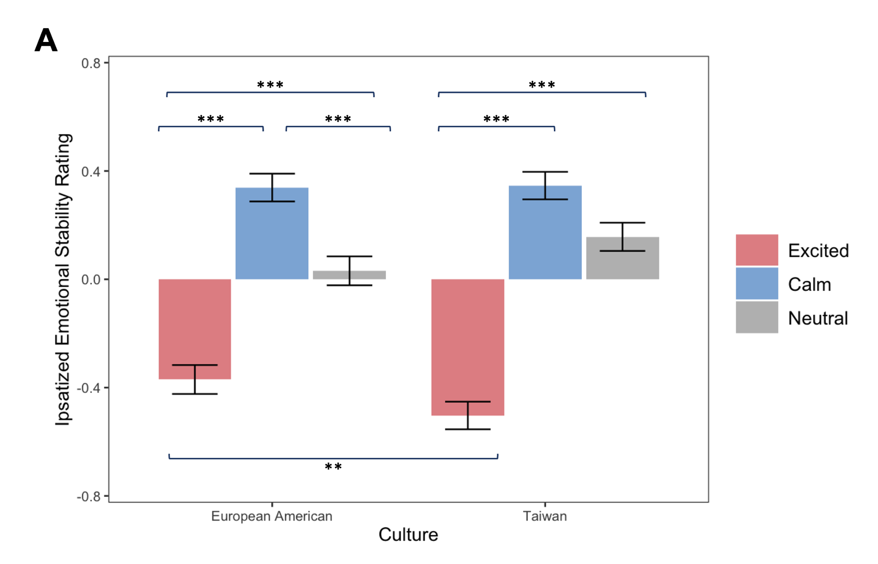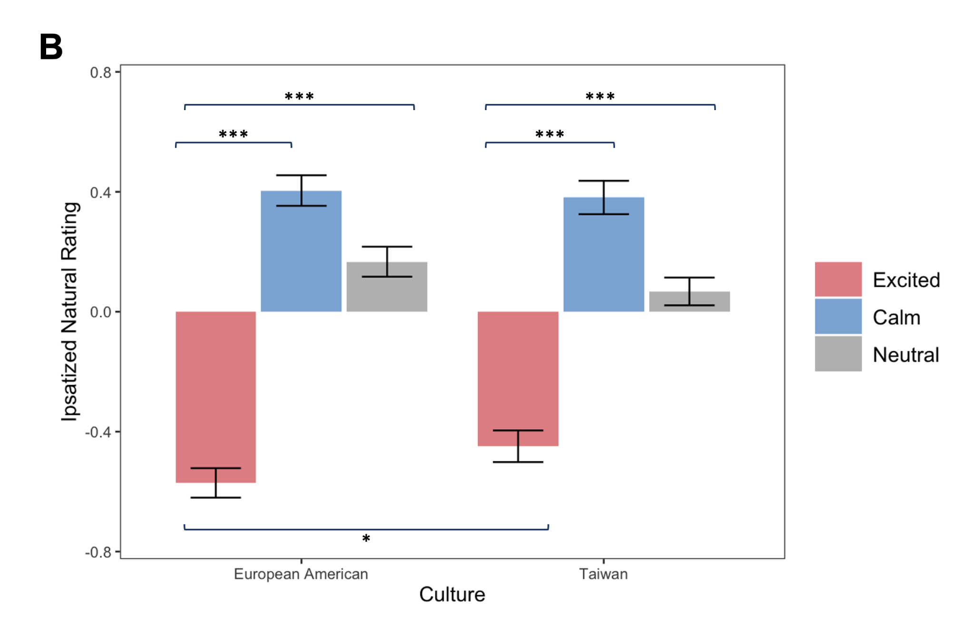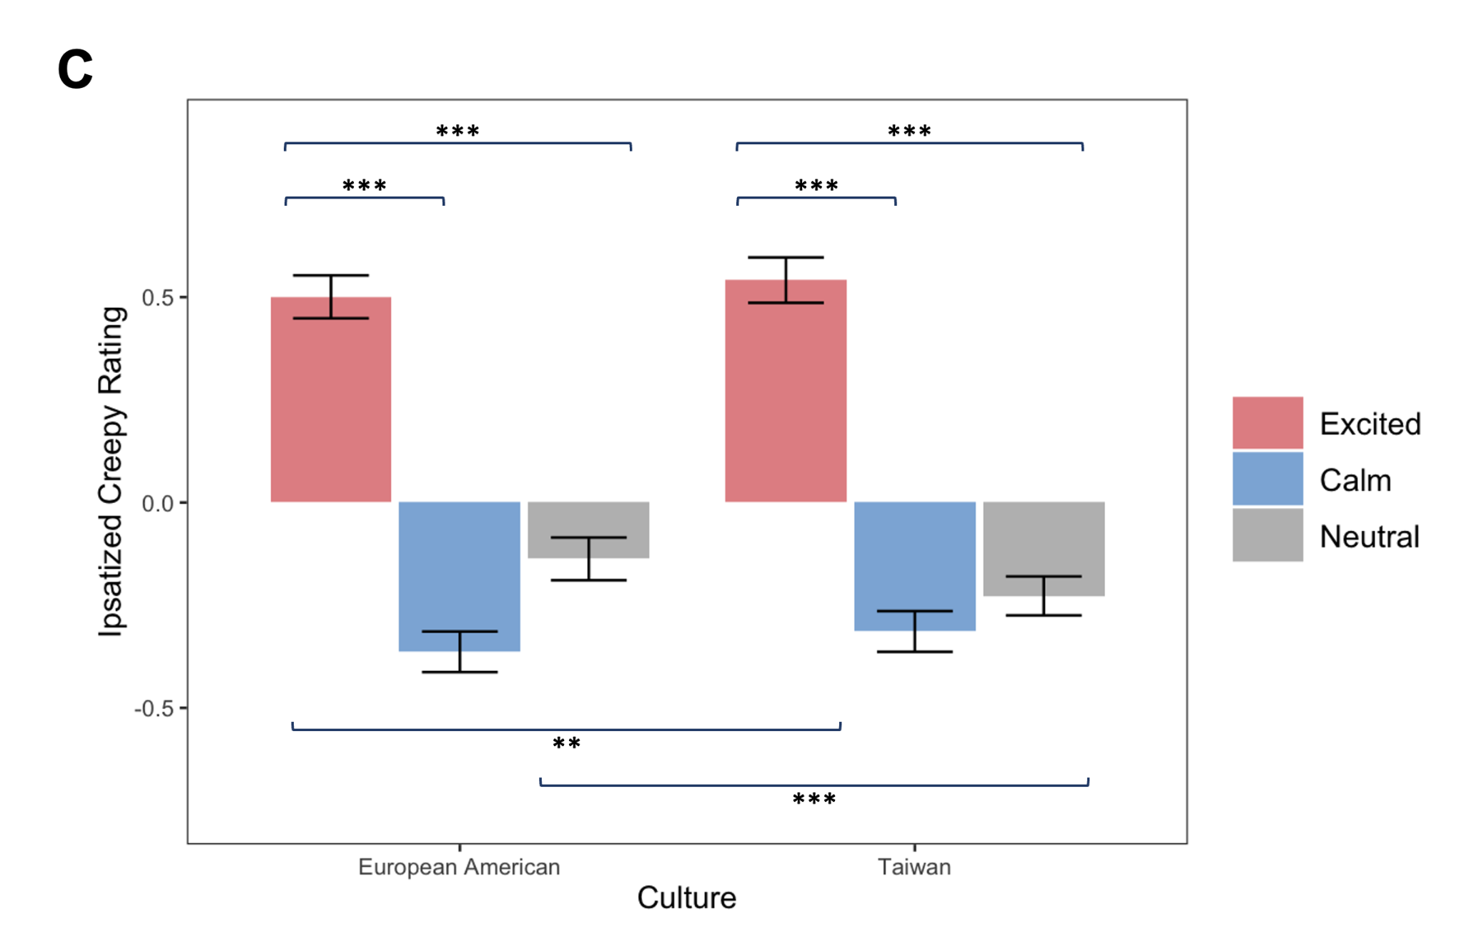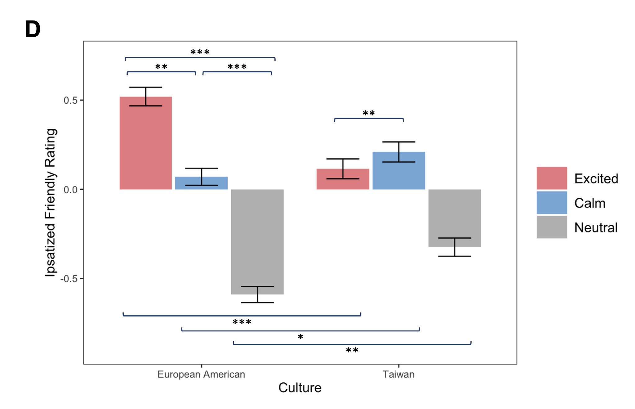
Note. Ratings of target faces for (A) emotional stability, (B) naturalness, (C) creepiness, and (D) friendliness. Error bars represent ±1 standard error of the mean. Significant within-culture comparisons are represented by asterisks above the x-axis, and significant between-culture comparisons are represented by asterisks below the x-axis. * p < .05, ** p < .01, *** p < .001.

Section 12. Trait Ratings for Studies 1-4
In each of the four studies, after participants completed the Trust Game trials, they rated a subset of target faces on a variety of traits (friendliness, trustworthiness, competence, dominance, and financial neediness) on a 5-point scale (1= Not at all to 5= Extremely). We again divided the 72 targets in our studies into two sets of 36 each, representing the complete factorial combination of 2 (target sex: male, female) X 2 (target race: White, Asian) X 3 (target emotional expressions: excited, calm, neutral) X 3 identities. To account for cultural differences in response style, we ipsatized the trait ratings. To test whether trait ratings differed by expression across the two cultural groups, we ran a three-way repeated-measures ANOVA, testing the interaction between Participant Culture (between-subjects: European American, Taiwanese) x Target Emotional Expression (within-subjects: excited, calm, neutral) x Study (Study 1, 2, 3, 4). We collapsed across target sex, race, and reputation. All post hoc pairwise comparisons were conducted using Tukey's HSD test. See Table S12a and Figure S12b for results.
Friendliness. There was a significant main effect of Target Expression on friendliness ratings, F(2, 1682) = 624.89, p < .001, η² = 0.43: overall, participants rated excited targets as the most friendly, followed by calm, and neutral the least (Calm: M = 0.05, SE = 0.01; Neutral: M = -0.40, SE = 0.01; Excited: M = 0.35, SE = 0.01; Excited vs. Calm: p < .001, 95% CI [0.24, 0.34], d = 0.66; Calm vs. Neutral: p < .001, 95% CI [0.41, 0.51], d = 1.04; Excited vs. Neutral: p < .001, 95% CI [0.70, 0.80], d = 1.70).
This was qualified by a significant Participant Culture X Target Emotional Expression interaction, F(2, 1682) = 30.13, p < .001, η² = 0.03. Taiwanese rated excited targets as the most friendly, followed by calm, and neutral the least (Excited vs. Calm: p < .001, 95% CI [0.07, 0.21], d = 0.32; Calm Vs. Neutral: p < .001, 95% CI [0.40, 0.54], d = 1.07; Excited vs. Neutral: p < .001, 95% CI [0.54, 0.69], d = 1.39). In contrast, while European Americans also rated excited targets as the most friendly, followed by calm, and neutral the least, the differences were even greater (Excited vs. Calm: p < .001, 95% CI [0.37, 0.51], d = 1.00; Calm vs. Neutral: p < .001, 95% CI [0.37, 0.51], d = 1.01; Excited vs. Neutral: p < .001, 95% CI [0.81, 0.95], d = 2.00), which is consistent with our previous work (Tsai et al., 2019).
European Americans rated excited targets as more friendly than Taiwanese did (p < .001, 95% CI [0.14, 0.24], d = 0.43), and Taiwanese rated both calm and neutral targets as more friendly than European Americans did (Calm: p < .001, 95% CI [0.06, 0.16], d = 0.25; Neutral: p = .001, 95% CI [0.03, 0.13], d = 0.18).
Notably, the Participant Culture X Target Emotional Expression was not significantly moderated by Study, F(6, 1682) = 0.26, p = .955, demonstrating that the results held regardless of the type of reputation that varied (trustworthiness, competence, past behavior, and emotional stability).
Trustworthiness. There was a significant main effect of Target Emotional Expression on trustworthiness, F(2, 1696) = 52.88, p < .001, η² = 0.06: overall, participants rated calm targets as more trustworthy than excited and neutral targets (Calm: M = 0.09, SE = 0.01; Neutral: M = -0.04, SE = 0.01; Excited: M = -0.05, SE = 0.01; Calm vs. Excited: p < .001, 95% CI [0.11, 0.18], d = 0.45; Calm vs. Neutral: p < .001, 95% CI [0.10, 0.17], d = 0.42).
This was qualified by a significant Participant Culture X Target Emotional Expression interaction, F(2, 1696) = 57.90, p < .001, η² = 0.06. Taiwanese rated calm targets as the most trustworthy, followed by neutral, and excited the least (Calm vs. Neutral: p < .001, 95% CI [0.09, 0.19], d = 0.43; Neutral vs. Excited: p < .001, 95% CI [0.10, 0.21], d = 0.48; Calm vs. Excited: p < .001, 95% CI [0.24, 0.35], d = 0.91). In contrast, European Americans rated both calm and excited targets as more trustworthy than neutral targets (Calm vs. Neutral: p < .001, 95% CI [0.08, 0.19], d = 0.41; Excited vs. Neutral: p < .001, 95% CI [0.08, 0.19], d = 0.41).
European Americans rated excited targets as even more trustworthy than did Taiwanese (p < .001, 95% CI [0.16, 0.23], d = 0.60); Taiwanese rated calm and neutral targets as more trustworthy than European Americans (Calm: p < .001, 95% CI [0.06, 0.14], d = 0.31; Neutral: p < .001, 95% CI [0.06, 0.13], d = 0.30).
Notably, the Participant Culture X Target Emotional Expression was not significantly moderated by Study, F(6, 1696) = 1.28, p = .263, demonstrating again that the results held across the four studies.
Competence. There was a significant main effect of Target Emotional Expression on competence ratings, F(2, 1648) = 109.93, p < .001, η² = 0.12: overall, participants rated calm targets as the most competent, followed by neutral targets, and excited targets the least (Calm: M = 0.10, SE = 0.01; Neutral: M = 0.03, SE = 0.01; Excited: M = -0.14, SE = 0.01; Calm vs. Neutral: p < .001, 95% CI [0.03, 0.11], d = 0.20; Neutral vs. Excited: p < .001, 95% CI [0.13, 0.21], d = 0.51; Calm vs. Excited: p < .001, 95% CI [0.20, 0.28], d = 0.71).
This was qualified by a significant Participant Culture X Target Emotional Expression interaction, F(2, 1648) = 17.82, p < .001, η² = 0.02. Taiwanese rated calm targets as the most competent, followed by neutral, and excited the least (Calm vs. Neutral: p < .001, 95% CI [0.03, 0.14], d = 0.26; Neutral vs. Excited: p < .001, 95% CI [0.19, 0.30], d = 0.73; Calm vs. Excited: p < .001, 95% CI [0.28, 0.37], d = 0.99). In contrast, European Americans rated calm and neutral targets as more competent than excited targets (Calm vs. Excited: p < .001, 95% CI [0.09, 0.20], d = 0.44; Neutral vs. Excited: p < .001, 95% CI [0.04, 0.15], d = 0.29).
European Americans rated excited targets as more competent than did Taiwanese (p < .001, 95% CI [0.07, 0.15], d = 0.33), and Taiwanese rated calm targets as more competent than European Americans (p < .001, 95% CI [0.04, 0.11], d = 0.22).
Notably, the Participant Culture X Target Emotional Expression was not significantly moderated by Study, F(6, 1648) = 1.06, p = .382, again demonstrating that the results held across the four studies.
Dominance. There was a significant main effect of Target Emotional Expression on transfers, F(2, 1654) = 19.25, p < .001, η² = 0.02: overall, participants rated neutral targets as more dominant than calm and excited targets (Calm: M = -0.01, SE = 0.01; Neutral: M = 0.07, SE = 0.01; Excited: M = -0.05, SE = 0.01; Neutral vs. Calm: p < .001, 95% CI [0.03, 0.12], d = 0.18; Neutral vs. Excited: p < .001, 95% CI [0.07, 0.16], d = 0.29).
This was qualified by a significant Participant Culture X Target Emotional Expression interaction, F(2, 1654) = 8.15, p < .001, η² = 0.01. Taiwanese did not significantly differentiate between the three expressions in terms of dominance (all pairwise comparisons p ≥ .296), whereas European Americans rated neutral targets as more dominant than calm and excited targets (Neutral vs. Calm: p < .001, 95% CI [0.07, 0.19], d = 0.33; Neutral vs. Excited: p < .001, 95% CI [0.12, 0.25], d = 0.47).
European Americans rated neutral targets as more dominant than did Taiwanese (p < .001, 95% CI [0.04, 0.13], d = 0.22); Taiwanese rated excited targets as more dominant than European Americans (p = .008, 95% CI [0.02, 0.10], d = 0.15).
Unlike the other ratings, the Participant Culture X Target Emotional Expression X Study interaction was significant, F(6, 1654) = 2.41, p = .025, η² = 0.01 (See Table S11b and Figure S11b, below). We decomposed this interaction and found that the Participant Culture X Target Emotional Expression interaction was not significant in Study 1 (Trustworthiness reputation), F(2, 402) = 2.31, p = .101, or Study 3 (Past behavior reputation), F(2, 406) = 2.76, p = .065, but was significant in Study 2 (Competence reputation), F(2, 426) = 5.97, p = .003, and Study 4 (Emotional Stability reputation) F(2, 420) = 4.04, p = .018), so we broke this interaction down further for these two studies.
In both studies, Taiwanese did not differentiate between the three expressions in terms of dominance (all pairwise comparisons p ≥ .796 for Study 2; p ≥ .688 for Study 4), but across both studies, European Americans rated neutral targets to be more dominant than both calm and excited targets (Study 2: Neutral vs. Excited: p < .001, 95% CI [0.16, 0.42], d = 0.70; Neutral vs. Calm: p = .007, 95% CI [0.04, 0.29], d = 0.40; Study 4: Neutral vs. Excited: p < .001, 95% CI [0.12, 0.37], d = 0.63; Neutral vs. Calm: p = .025, 95% CI [0.01, 0.26], d = 0.35).
In both studies, European Americans rated neutral targets as more dominant than did Taiwanese (Study 2: p = .004, 95% CI [0.04, 0.23], d = 0.33; Study 4: p = .007, 95% CI [0.03, 0.21], d = 0.30), whereas Taiwanese rated excited targets as more dominant than European Americans (Study 2: p = .002, 95% CI [0.05, 0.23], d = 0.34; Study 4: p = .038, 95% CI [0.005, 0.18], d = 0.23).
Thus, while the Participant Culture X Target Emotional Expression interaction only emerged in two studies, the pattern was surprisingly similar: Taiwanese did not differ in how dominant they rated the three targets, whereas European Americans rated neutral targets as more dominant than calm and excited targets. European Americans also rated neutral targets as more dominant and excited targets as less dominant than did Taiwanese.
Financial neediness. There was a significant main effect of Target Emotional Expression on financially neediness ratings, F(2, 1620) = 26.36, p < .001, η² = 0.03: overall, participants rated excited targets as the most financially needy, followed by neutral targets, and calm targets the least (Calm: M = -0.06, SE = 0.01; Neutral: M = 0.00, SE = 0.01; Excited: M = 0.06, SE = 0.01; Excited vs. Neutral: p < .001, 95% CI [0.02, 0.10], d = 0.19; Neutral vs. Calm: p = .002, 95% CI [0.02, 0.09], d = 0.17; Excited vs. Calm: p < .001, 95% CI [0.08, 0.15], d = 0.36).
This was qualified by a marginally significant Participant Culture X Target Emotional Expression interaction, F(2, 1620) = 2.56, p = .078, η² = 0.003. Taiwanese rated excited targets as the most financially needy, followed by neutral, and calm the least (Excited vs. Neutral: p = .034, 95% CI [0.003, 0.11], d = 0.17; Neutral vs. Calm: p < .001, 95% CI [0.03, 0.14], d = 0.27; Excited vs. Calm: p < .001, 95% CI [0.09, 0.19], d = 0.45). In contrast, European Americans rated excited targets as more financially needy than both calm and neutral targets (Excited vs. Neutral: p = .008, 95% CI [0.01, 0.12], d = 0.21; Excited vs. Calm: p < .001, 95% CI [0.04, 0.14], d = 0.28).
Additionally, European Americans rated calm targets as more financially needy than did Taiwanese (p = .027, 95% CI [0.005, 0.08], d = 0.13).
The Participant Culture X Target Emotional Expression was not significantly moderated by Study, F(6, 1620) = 0.91, p = .485, demonstrating that the results held regardless of the type of reputation that varied.

Table S12a

Means and Standard Errors of Trait Ratings as a Function of Participant Culture and Target Expression

 | European American |  |  |  | Taiwanese
 | Target |  |  |  | Target
Trait Rating | Excited | Calm | Neutral |  | Excited | Calm | Neutral
Friendliness | 0.44 (0.02) | 0.00 (0.02) | -0.44 (0.02) |  | 0.25 (0.02) | 0.11 (0.02) | -0.36 (0.02)
Trustworthiness | 0.05 (0.02) | 0.04 (0.02) | -0.09 (0.02) |  | -0.15 (0.02) | 0.14 (0.02) | 0.00 (0.02)
Competence | -0.08 (0.02) | 0.06 (0.02) | 0.02 (0.02) |  | -0.19 (0.02) | 0.14 (0.02) | 0.05 (0.02)
Dominance | -0.09 (0.02) | -0.02 (0.02) | 0.11 (0.02) |  | -0.02 (0.02) | 0.00 (0.02) | 0.02 (0.02)
Financial Neediness | 0.05 (0.02) | -0.04 (0.02) | -0.02 (0.02) |  | 0.07 (0.02) | -0.08 (0.02) | 0.01 (0.02)
Note. Values represent the mean, with standard error in parentheses.
Figure S12a
Trait Ratings by Participant Cultural Group and Target Expression
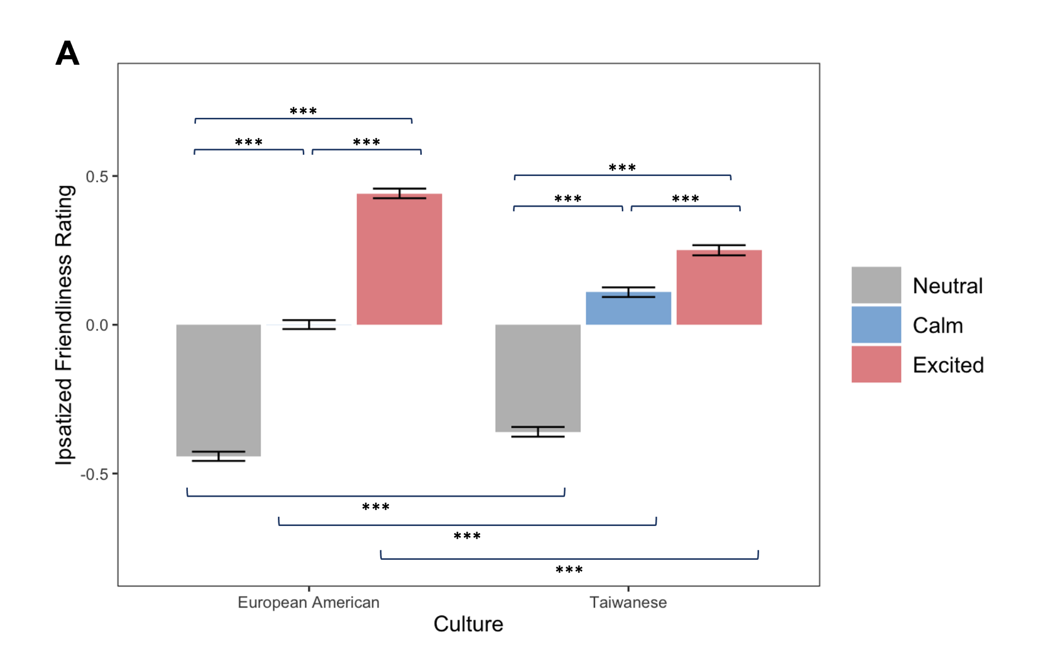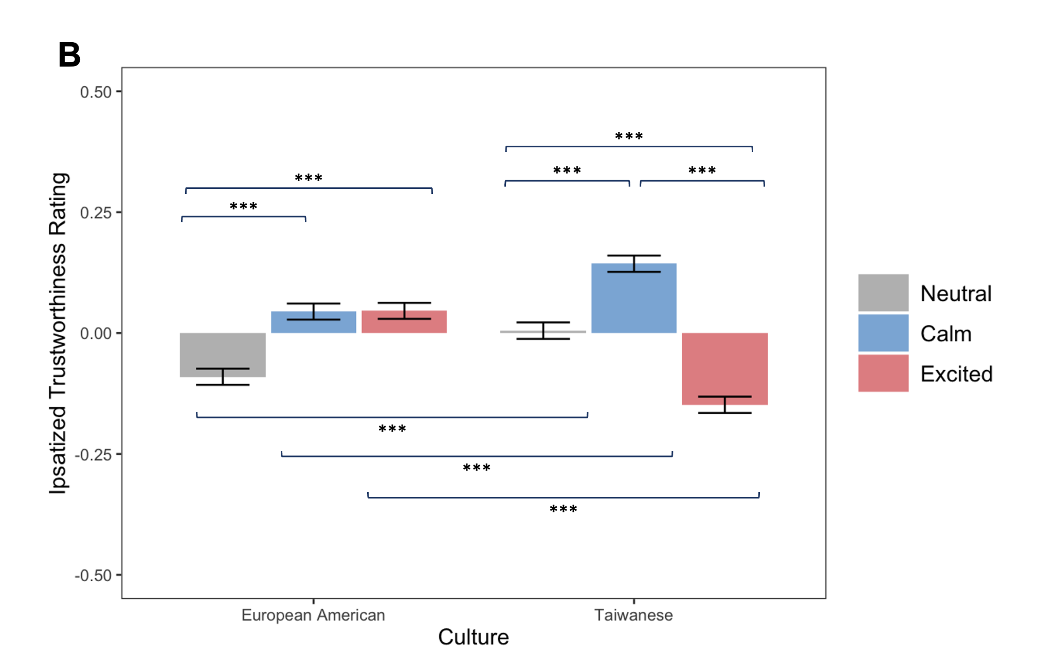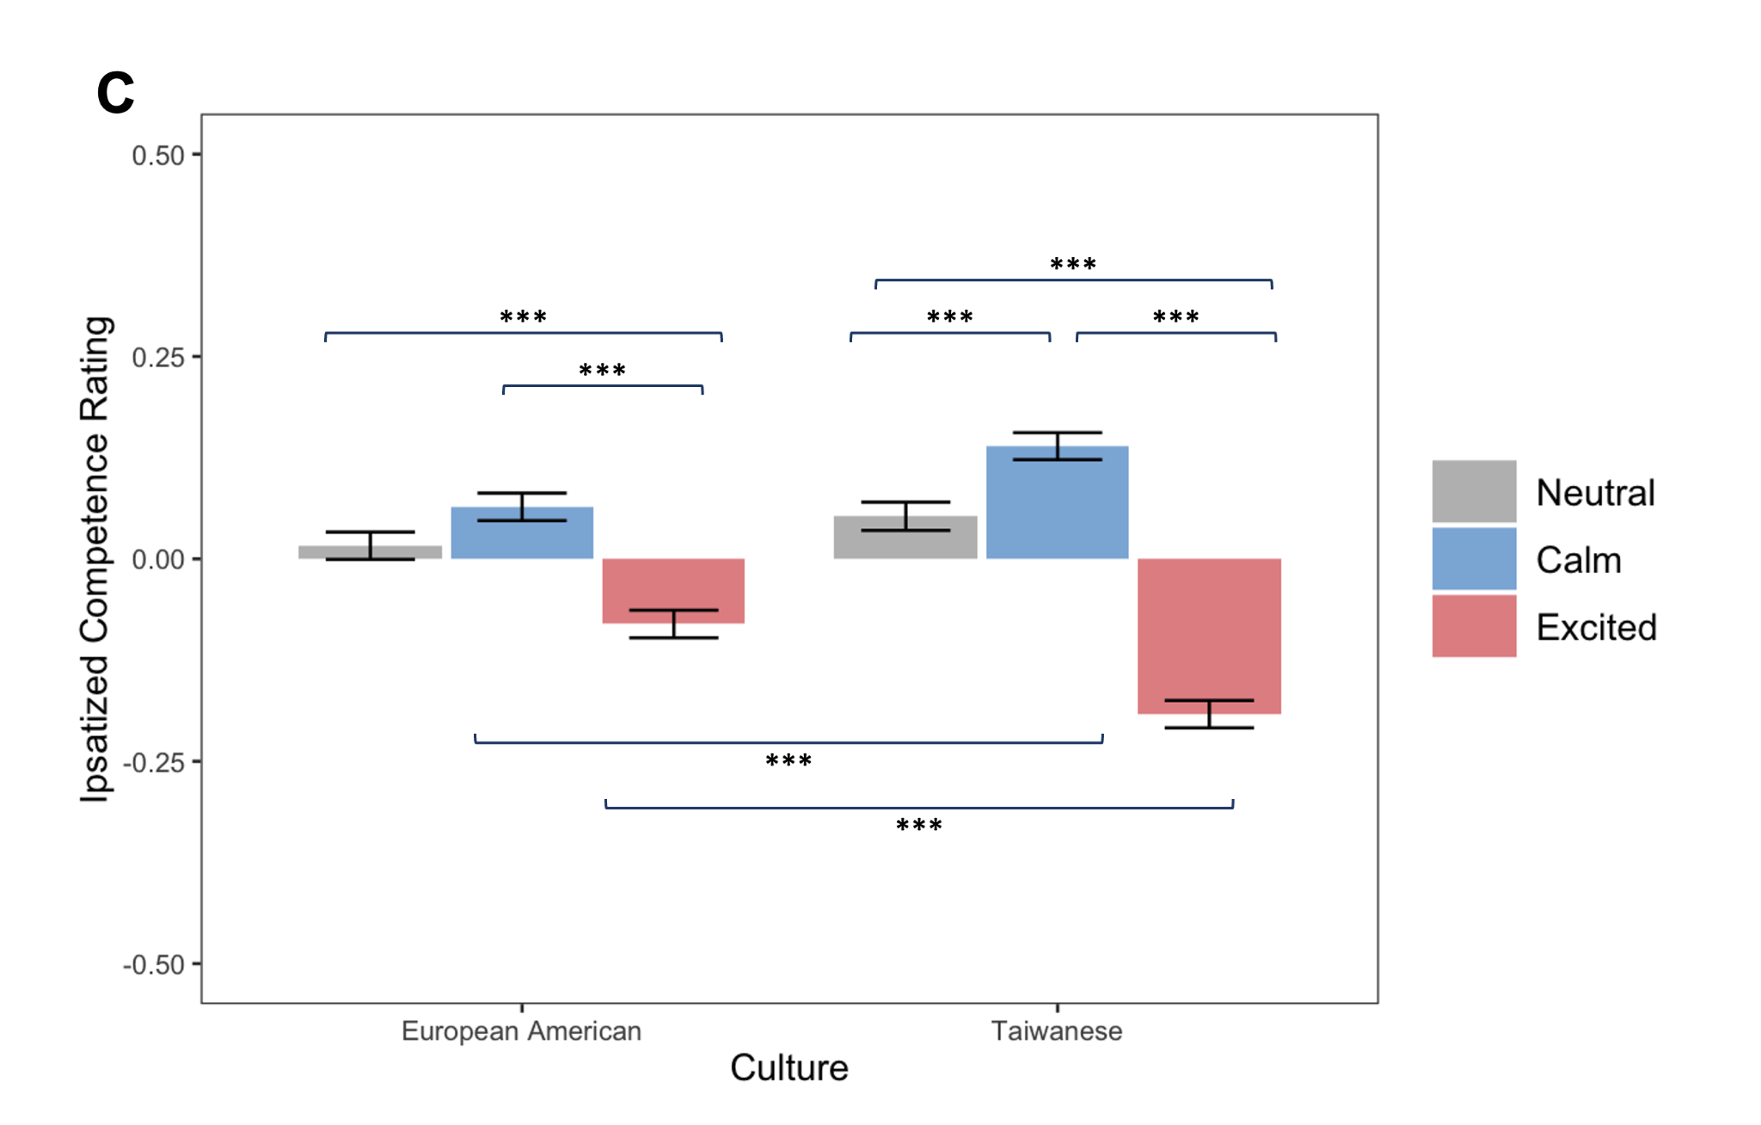
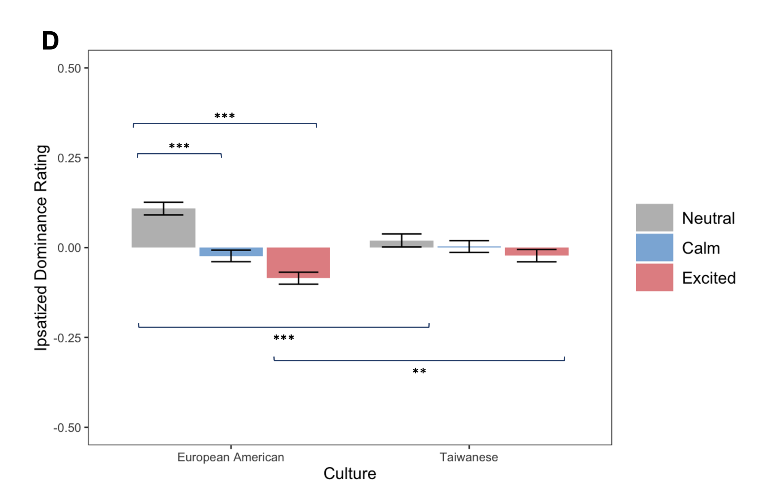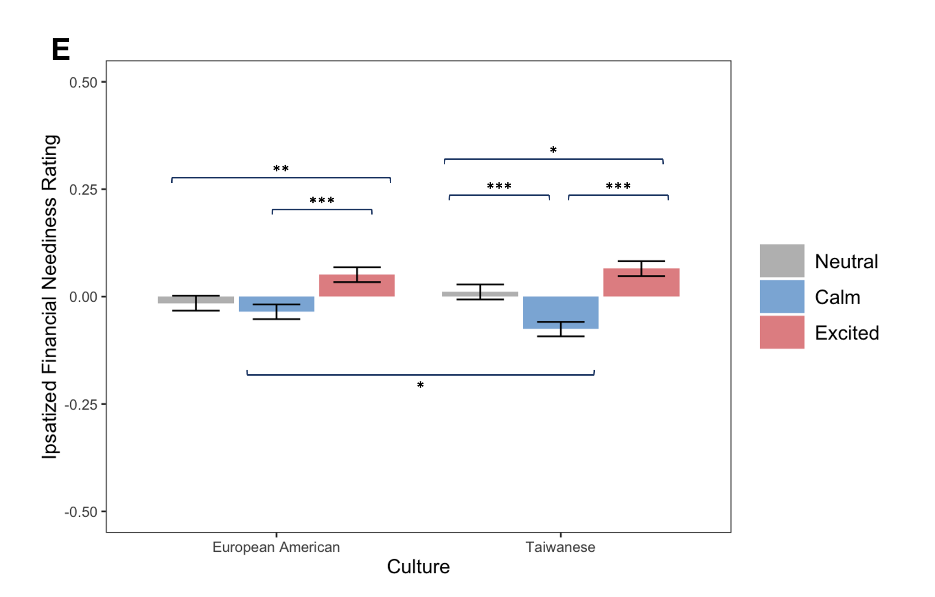
Note. Ratings of target faces for (A) friendliness, (B) trustworthiness, (C) competence, (D) dominance (though these results varied by study; see Table S11b and Figure S11b), and (E) financial neediness. Error bars represent ±1 standard error of the mean. To account for the possibility of response style bias, we ipsatized the raw trait ratings. Significant within-culture comparisons are represented by asterisks above the x-axis, and significant between-culture comparisons are represented by asterisks below the x-axis. * p < .05, ** p < .01, *** p < .001.
Table S12b
Means and Standard Errors of Dominance Ratings as a Function of Participant Culture X Target Emotional Expression for Studies 2 and 4

 |  |  |  | Dominance Ratings
 | Study 2  (Competence Rep) |  |  |  |  | Study 4  (Emotional Stability Rep)
 | M | SE |  |  |  | M |  | SE
European Americans
Excited Target | -0.14 | 0.03 |  |  |  | -0.12 |  | 0.03
Calm Target | -0.01 | 0.03 |  |  |  | -0.01 |  | 0.03
Neutral Target | 0.15 | 0.03 |  |  |  | 0.13 |  | 0.03
Taiwanese
Excited Target | 0.00 | 0.03 |  |  |  | -0.03 |  | 0.03
Calm Target | -0.02 | 0.03 |  |  |  | 0.02 |  | 0.03
Neutral Target | 0.02 | 0.04 |  |  |  | 0.01 |  | 0.04
Note. M and SE represent mean and standard error, respectively.

Figure S12b
Dominance Ratings by Participant Cultural Group, Target Expression, and Study
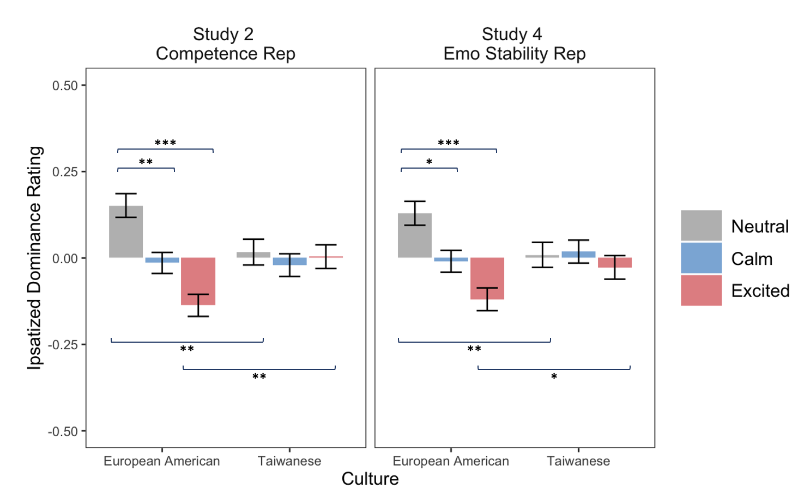
Note. Error bars represent ±1 standard error of the mean. Significant within-culture comparisons are represented by asterisks above the x-axis, and significant between-culture comparisons are represented by asterisks below the x-axis. * p < .05, ** p < .01, *** p < .001.

References
Blevins, E., Park, B., Qu, Y., Chen, Y. -C., Cachia, J. Y. A., & Tsai, J. L. (2024). Cultural variation in resource allocation to emotional targets: The role of deliberation and ideal affect. Manuscript in preparation.
Croson, R., & Buchan, N. (1999). Gender and culture: International experimental evidence from trust games. American Economic Review, 89(2), 386-391.
Erdfelder, E., Faul, F., & Buchner, A. (1996). GPOWER: A general power analysis program. Behavior Research Methods, Instruments, & Computers, 28(1), 1–11. https://doi.org/10.3758/BF03203630
Park, B., Blevins, E., Knutson, B., & Tsai, J. L. (2017). Neurocultural evidence that ideal affect match promotes giving. Social Cognitive and Affective Neuroscience, 12(7), 1083-1096.
Tsai, J. L., Blevins, E., Bencharit, L.Z., Chim, L., Fung, H.H., & Yeung, D.Y. (2019). Cultural variation in social judgments of smiles: The role of ideal affect. Journal of Personality and Social Psychology, 116(6), 966–988. https://doi.org/10.1037/pspp0000192
Tsai, J. L. Knutson, B., & Fung, H. H. (2006). Cultural variation in affect valuation. Journal of Personality and Social Psychology, 90, 288-307.

Croson and Buchan (1999) recruited participants from the United States, China, Japan, and Korea and found no differences in returns based on these national groups. Based on this finding, we decided to assume no difference based on target race.
We added slight random variation (i.e., noise) to this return proportion, but for simplicity, our example continues with the exact amount of 37.4%.
The results did not change when we included all participants (see Section 1 of this Supplement).
The main results did not change when we included all participants. However, there was one minor difference in the pairwise comparisons, which we outline in Section 1 of this Supplement.
We also ran a power analysis using G*Power 3.1.3 (Erdfelder et al., 1996), which indicated that a total sample size of 128 participants was necessary for the study to have 95% power to detect a small effect size (η² = .01) at an alpha level of .05. We surpassed this minimum total sample size.

