Why Do We Engage in Everyday Interpersonal Emotion Regulation?
Supplemental Online Material (SOM)

Anh Tran
Katharine H. Greenaway
Elise K. Kalokerinos

Supplemental Material A: Detailed Sample Demographics
Table S1.
Sample demographics breakdown
Study 1a (N=100) |  |  | Study 1b (N=399) |  |  | Study 2 (N=200)
 | Freq (%) |  |  | Freq (%) |  |  | Freq (%)
Gender |  |  | Gender |  |  | Gender
Woman | 54 (54%) |  | Woman | 200 (50.0%) |  | Woman | 106 (53%)
Man | 43 (43%) |  | Man | 195 (49.0%) |  | Man | 93 (47%)
Non-binary | 2 (2%) |  | Non-binary | 3 (0.8%) |  | Non-binary | -
Prefer to self-identify | 1 (1%) |  | Prefer not to say | 1 (0.3%) |  | Prefer to self-identify | 1 (0.5%)
Ethnicity |  |  | Ethnicity |  |  | Ethnicity
White or Caucasian | 66 (66%) |  | White or Caucasian | 309 (77.0%) |  | White or Caucasian | 179 (90%)
African | 14 (14%) |  | South Asian | 20 (5.0%) |  | Black or African American | 5 (2.5%)
Black or African American | 4 (4%) |  | Mixed ethnicities | 15 (3.8%) |  | East Asian | 4 (2.0%)
Mixed Ethnicities | 4 (4%) |  | Black or African American | 11 (2.8%) |  | Mixed ethnicities | 4 (2.0%)
South-East Asian | 4 (4%) |  | South-East Asian | 10 (2.5%) |  | African | 3 (1.5%)
Latino or Hispanic | 3 (3%) |  | African | 8 (2.0%) |  | South Asian | 2 (1.0%)
East Asian | 2 (2%) |  | East Asian | 8 (2.0%) |  | Latino or Hispanic | 1 (0.5%)
South Asian | 2 (2%) |  | Middle Eastern | 7 (1.8%) |  | South-East Asian | 1 (0.5%)
Other | 1 (1%) |  | Latino or Hispanic | 5 (1.3%) |  | Other | 1 (0.5%)
 |  |  | Other | 6 (1.6%)
Nationality |  |  | Nationality |  |  | Nationality
British | 20 (20%) |  | British | 343 (86.0%) |  | British | 176 (90%)
South African | 20 (20%) |  | American | 9 (2.3%) |  | Irish | 3 (1.5%)
Portuguese | 7 (7%) |  | Nigerian | 6 (1.5%) |  | Nigerian | 3 (1.5%)
American | 6 (6%) |  | Irish | 3 (0.8%) |  | Romanian | 3 (1.5%)
French | 6 (6%) |  | Italian | 3 (0.8%) |  | Italian | 2 (1.0%)
Greek | 5 (5%) |  | Pakistani | 3 (0.8%) |  | Polish | 2 (1.0%)
Australian | 3 (3%) |  | Cypriot | 2 (0.5%) |  | Other | 7 (3.5%)
Italian | 3 (3%) |  | Hungarian | 2 (0.5%)
African | 2 (2%) |  | Indonesian | 2 (0.5%)
Algerian | 2 (2%) |  | Lithuanian | 2 (0.5%)
Canadian | 2 (2%) |  | Romanian | 2 (0.5%)
Chinese | 2 (2%) |  | Saudi Arabian | 2 (0.5%)
Czech | 2 (2%) |  | Other | 20 (6.0%)
German | 2 (2%)
Indonesian | 2 (2%)
Polish | 2 (2%)
Other | 14 (14%)
English as a first language |  |  | English as a first language |  |  | English as a first language
Yes | 52 (52%) |  | Yes | 357 (89.0%) |  | Yes | 181 (91.0%)
No | 48 (48%) |  | No | 42 (11.0%) |  | No | 19 (9.0%)
 |  |  | Relationship status |  |  | Relationship status
 |  |  | In a relationship | 245 (61.0%) |  | In a relationship | 144 (72.0%)
 |  |  | Single | 154 (39.0%) |  | Single | 56 (28.0%)

Supplemental Material B: Study 1b Motive Correlation Matrices
Table S2.
Correlation matrix for intrinsic affect-improving motives.
Variable | 1 | 2 | 3 | 4 | 5 | 6 | 7 | 8 | 9
1. I wanted to feel better | -
2. I wanted to seek validation, comfort, or reassurance | .18*** | -
3. I wanted to seek advice, clarity, or another perspective | .05 | .08 | -
4. I wanted to vent or get something off my chest | .05 | .07 | .22*** | -
5. I wanted to maintain or build a good relationship | .05 | -.01 | -.04 | -.16** | -
6. I wanted to achieve a goal or get something done | .01 | .02 | .06 | -.10* | .07 | -
7. I wanted to distract myself | .17*** | .01 | -.03 | .03 | -.04 | -.03 | -
8. I was unable to resolve things on my own | .07 | .04 | .18*** | .00 | .06 | .23*** | -.00 | -
9. I had another reason | -.03 | .01 | .04 | -.02 | .06 | .07 | -.05 | .04 | -
10. I did not have a reason | -.09 | -.10* | -.08 | -.08 | -.03 | -.03 | -.05 | -.04 | -.01
Note. * p < .05, ** p < .01, *** p < .001.

Table S3.
Correlation matrix for intrinsic affect-worsening motives.
Variable | 1 | 2 | 3 | 4 | 5 | _6 | 7 | 8 | 9 | 10
1. I wanted to punish myself for something I did | -
2. I wanted to express how upset I was about something | -.04 | -
3. I wanted them to give me a reality check or manage my expectations | .02 | -.14* | -
4. I wanted to achieve a goal or get something done | -.05 | -.03 | .05 | -
5. I wanted them to validate my mood | -.11* | .22*** | -.06 | -.09 | -
6. I wanted them to validate how I saw myself | .22*** | .16** | .14* | .03 | .19*** | -
7. I wanted their attention | -.02 | .03 | -.03 | .12* | .02 | .10 | -
8. I wanted to understand their feelings or what they were going through | .04 | .03 | .01 | -.10 | .00 | .02 | .01 | -
9. I wanted to feel powerful | .02 | -.04 | .02 | .16** | -.04 | .09 | .33*** | -.07 | -
10. I had another reason | -.06 | -.03 | -.06 | .00 | -.01 | -.03 | -.01 | -.02 | -.03 | -
11. I did not have a reason | -.06 | -.12* | -.06 | .00 | -.10 | -.08 | -.06 | -.07 | -.03 | -.02
Note. * p < .05, ** p < .01, *** p < .001.

Table S4.
Correlation matrix for extrinsic affect-improving motives.
Variable | 1 | 2 | 3 | 4 | 5 | 6 | 7 | 8 | 9 | 10 | 11
1. I wanted to make them feel better | -
2. I like them or care about them | .37*** | -
3. I wanted to feel helpful or good about myself | .09 | .06 | -
4. I wanted to relieve my own discomfort | .00 | -.09 | .16** | -
5. I wanted to offer advice, clarity, or another perspective | .10 | .10* | .09 | .01 | -
6. I wanted to get them to achieve a goal or do something | .00 | .05 | .16** | .04 | .19*** | -
7. I understood their feelings or what they were going through | .15** | .15** | .13* | .01 | .13** | -.03 | -
8. I felt sorry for them | .17*** | .15** | .16** | .06 | .04 | -.13* | .17*** | -
9. I wanted to maintain or build a good relationship | .22*** | .26*** | .22*** | .04 | .13* | .10 | .03 | .01 | -
10. I wanted to defuse a negative situation | .09 | .00 | .07 | .20*** | .16** | -.00 | .08 | .13* | .09 | -
11. I felt like I had to | .00 | .06 | .07 | .21*** | -.00 | .03 | -.02 | .14** | .09 | .21*** | -
12. I had another reason | -.01 | .00 | -.04 | -.03 | -.01 | .02 | .09 | .04 | .05 | .00 | -.04
Note. * p < .05, ** p < .01, *** p < .001.

Table S5.
Correlation matrix for extrinsic affect-worsening motives.
Variable | 1 | 2 | 3 | 4 | 5 | 6 | 7 | 8 | 9 | 10 | 11 | 12
1. I wanted to seek revenge for something they had done to me | -
2. I wanted to punish them for something they had done to others | .37*** | -
3. I wanted to get them to apologise | .10 | .07 | -
4. I wanted to feel better about myself | .15** | .03 | -.00 | -
5. I wanted to give them a reality check or to manage their expectations | -.05 | .00 | -.05 | -.07 | -
6. I wanted to achieve a goal or get something done | -.02 | .01 | .06 | -.04 | .00 | -
7. I wanted to help them | -.14* | -.06 | -.06 | -.05 | .11 | .16** | -
8. I was in a bad mood | .08 | -.04 | .06 | .11* | -.15** | -.01 | -.11* | -
9. I dislike them | .29*** | .30*** | .05 | .07 | -.14** | .01 | -.16** | .16** | -
10. I wanted them to understand my feelings or what I was going through | .15** | .03 | .27*** | .10 | -.06 | .02 | -.15** | .10 | -.05 | -
11. I was jealous of them | .01 | -.05 | -.06 | .25*** | -.05 | -.08 | -.08 | .19*** | -.08 | -.05 | --
12. I had another reason | -.02 | .02 | -.11* | .10 | .01 | -.07 | -.06 | -.08 | -.01 | -.00 | -.03 | -
13. I did not have a reason | -.05 | -.06 | -.08 | -.03 | -.12* | -.05 | -.05 | .00 | -.05 | -.04 | -.02 | -.02
Note. * p < .05, ** p < .01, *** p < .001.

Supplemental Material C: Exploring Motive Structure in Study 2
Data analytic strategy
To supplement our occasion-level co-occurrence investigation in Study 2, we post-hoc employed several methods aimed at exploring the motive structure. First, we used the Spearman-Brown prediction formula to estimate the internal consistency of each motive pair using the R package splithalfr (Pronk, 2021). This formula estimates the reliability of a two-item scale, and provide further information about whether any two motives appear to share the same latent construct (Eisinga et al., 2013). Spearman-Brown reliability coefficients can range from -1 to 1, with values closer to 1 indicating higher reliability estimates. A value >.70 indicates acceptable reliability (Eisinga et al., 2013).
Second, we conducted non-metric multidimensional scaling (NMDS), a distance-based dimension reduction technique, using the R package vegan (Oksaken et al., 2022). This technique is most suitable for high-dimension presence/absence data (i.e., matrix of ones and zeroes, where ones indicate a “presence” in any given observation; d’Angela & Hennig, 2022). We used Jaccard distance for binary data, with 1000 random starts, in order to two-dimensionally visualize patterns of dissimilarity between motives based on their presence/absence across regulation occasions.
Additionally, we conducted hierarchical clustering using the R packages cluster (Maechler et al., 2022) and factoextra (Kassambara & Mundt, 2020). We used Jaccard distance and Ward’s minimum variance linkage method, interpreting potential clusters by (1) visual inspection of the dendrogram, (2) elbow plot, and (3) average silhouette index. While these two approaches do not account for the nested data structure, they provide additional ways to robustly examine motive co-occurrence and how distinct they are.
Results
Spearman-Brown prediction formula
Tables S6 and S7 present the Spearman-Brown reliability coefficients for each motive pair for intrinsic and extrinsic regulation, respectively, in Study 2. Reliability ranges from -.21 to .54 for intrinsic regulation motives, with the highest reliability between the motives “I wanted their help to resolve something” and “I wanted to seek clarity, perspective, or advice.” For extrinsic regulation motives, reliability ranges from -.34 to .51, with the highest reliability between the motives “I wanted to help them” and “I wanted to make them feel better.” All coefficients were below the acceptable cutoff of .70, suggesting that for both intrinsic and extrinsic regulation, no two motives reliably shared the same underlying construct.
In addition to these empirical differences, we see related but distinct theoretical meanings in these motives. For example, wanting someone’s help resolving something may involve getting their advice, but it may not; instead involving emotional or practical (rather than cognitive) support (Pauw et al., 2018). Further, wanting to help someone need not go hand-in-hand with a prohedonic aim to improve someone’s emotional state—often emotions are helpful when they do not make someone feel better (Tamir, 2009).
Non-metric multidimensional scaling (NMDS)
Figure S1 graphically represents the dissimilarity patterns among intrinsic regulation motives (panel A) and extrinsic regulation motives (panel B) across regulation occasions. The solutions produced a stress value of 0.08 for intrinsic regulation motives and 0.06 for extrinsic regulation motives, indicating good ordination (Clarke, 1993). The NMDS solutions showed no clear tight clusters of points that were well-separated from other clusters, suggesting that no motives could be easily combined to make a conceptually distinct group.
Although motives of “punishment” (and feeling powerful for intrinsic regulation) were clearly delineated from other motives in both forms of interpersonal emotion regulation, it does not seem theoretically justifiable to suggest clustering motives based on a presence vs. absence of a punishment motive.
Hierarchical clustering
Figures S2 and S3 present the dendrogram of intrinsic regulation motives, as well as the elbow and silhouette plots derived from hierarchical clustering. While the dendrogram suggested a two-cluster solution, the elbow plot did not indicate a clear optimal k, and the silhouette plot denoted an 11-cluster solution (i.e., no meaningful clustering given the starting point of 12 motives). The lack of a cluster solution that was robust across methods of determining k suggested no intrinsic regulation motives could be easily clustered together.
Results of hierarchical clustering and potential cluster solutions for extrinsic regulation motives are presented in the dendrogram (Figure S4) and elbow and silhouette plots (Figure S5). The elbow plot for extrinsic regulation motives did not indicate a clear optimal k. Meanwhile, both the dendrogram and silhouette plot suggested a two-cluster solution that was not conceptually meaningful. As such, similar to intrinsic regulation motives, extrinsic regulation motives did not appear to be distinctly clustered.

Variable | 1 | 2 | 3 | 4 | 5 | 6 | 7 | 8 | 9 | 10 | 11 | 12
(1) I wanted to feel better | -
(2) I wanted to achieve a goal or get something done | -.09 | -
(3) I wanted to maintain or build a good relationship | -.02 | .07 | -
(4) I wanted to seek clarity, perspective, or advice | .17 | .33 | -.06 | -
(5) I wanted to seek comfort or reassurance | .46 | .06 | -.19 | .43 | -
(6) I wanted their help to resolve something | .19 | .46 | -.06 | .54 | .31 | -
(7) I wanted to understand their feelings or what they were going through | -.16 | -.05 | .35 | .03 | -.04 | -.08 | -
(8) I wanted them to give me a reality check or manage my expectations | .13 | .18 | -.21 | .41 | .28 | .34 | .34 | -
(9) I wanted to punish myself for something I did | .04 | -.08 | -.15 | .06 | .03 | .08 | .08 | .19 | -
(10) I wanted them to validate how I felt | .19 | -.16 | -.05 | .24 | .25 | .12 | .12 | .23 | .24 | -
(11) I wanted their attention | .15 | .18 | .31 | .14 | .16 | .14 | .14 | .11 | -.06 | .05 | -
(12) I wanted to feel powerful | .11 | .06 | -.02 | -.11 | .10 | -.08 | -.08 | .17 | .41 | .21 | .20 | -
Table S6.
Spearman-Brown reliability coefficient for each intrinsic motive pair in Study 2

Note. Spearman-Brown reliability coefficients can range from -1 to 1, with values closer to 1 indicating higher reliability estimates. A value >.70 indicates acceptable reliability.
Table S7.
Spearman-Brown reliability coefficient for each extrinsic motive pair in Study 2
Variable | 1 | 2 | 3 | 4 | 5 | 6 | 7 | 8 | 9 | 10 | 11 | 12
(1) I wanted to make them feel better | -
(2) I wanted to get them to achieve a goal or get something done | .02 | -
(3) I wanted to maintain or build a good relationship | .01 | .01 | -
(4) I wanted to offer clarity, perspective, or advice | .04 | .23 | -.04 | -
(5) I wanted to avoid uncomfortable feelings or situations | -.16 | -.11 | -.01 | .07 | -
(6) I wanted to feel helpful or good about myself | .19 | .21 | .31 | .02 | .03 | -
(7) I wanted them to understand my feelings, or what I was going through | -.29 | .02 | .07 | .27 | .27 | .04 | -
(8) I personally wanted to achieve a goal or get something done | -.30 | .51 | -.01 | .23 | .14 | .21 | .21 | -
(9) I wanted to give them a reality check or manage their expectations | -.13 | .19 | -.02 | .39 | .24 | -.03 | .23 | .40 | -
(10) I wanted to punish them for something they did | -.13 | -.06 | -.11 | -.08 | -.04 | -.05 | -.04 | -.05 | -.04 | -
(11) I wanted to feel better about myself | .12 | .04 | .19 | -.15 | .04 | .32 | -.01 | .17 | -.05 | .20 | -
(12) I wanted to help them | .51 | .30 | .07 | .41 | -.11 | .16 | -.34 | .06 | .09 | -.11 | -.01 | -

Note. Spearman-Brown reliability coefficients can range from -1 to 1, with values closer to 1 indicating higher reliability estimates. A value >.70 indicates acceptable reliability.
Figure S1.
NMDS plots showing patterns of dissimilarity between (A) intrinsic regulation motives (stress=0.08) and (B) extrinsic regulation motives (stress=0.06)
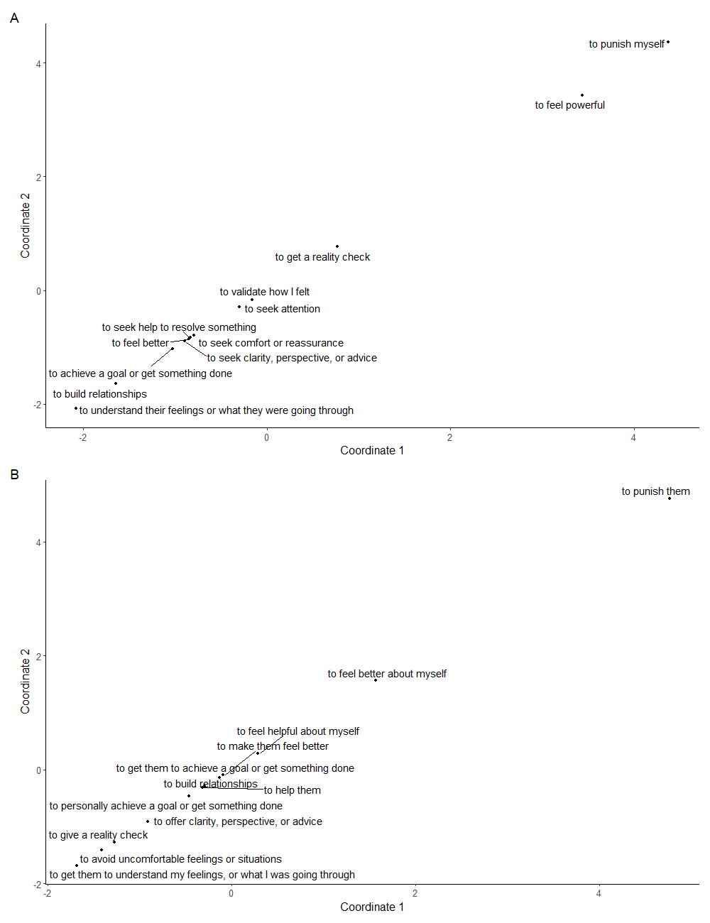
Note. Each point represents a motive. Points that are ordinately closer together are more similar to one another. The orientation and values of the axes have no meaning; they simply establish the ordination space in which the points can be plotted.
Figure S2.
Cluster dendrogram for intrinsic regulation motives
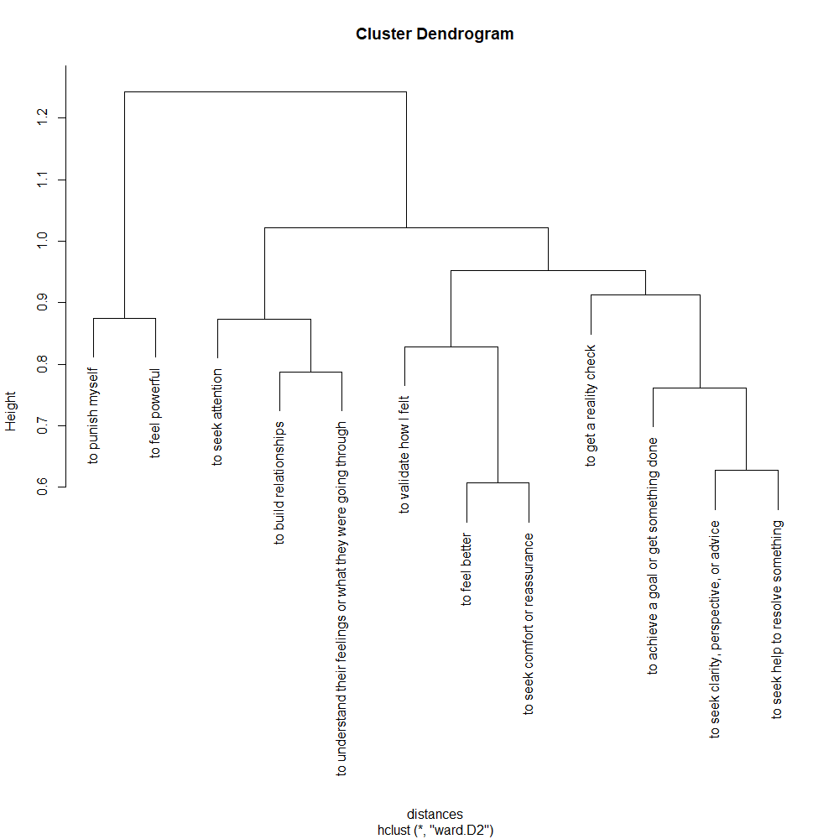
Note. Vertical lines represent similarity between motives, with shorter lines indicating greater similarity.

Figure S3.
Elbow plot (A) and silhouette plot (B) to determine cluster solution for intrinsic regulation motives
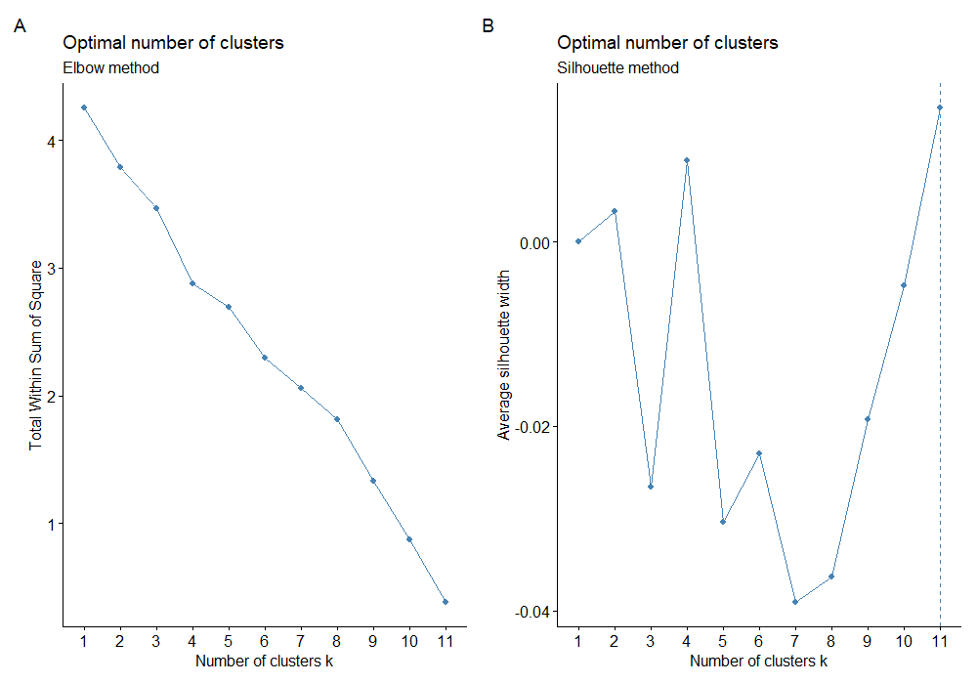
Note. The elbow plot (A) displays the relationship between the number of potential clusters (k) and the within-cluster sum of squares (WCSS). Optimal k is determined by the point at which the reduction in WCSS starts to plateau. The silhouette plot (B) provides a graphical representation of how well each motive fits within their cluster compared to other clusters. Optimal k is determined by the point at which the silhouette index is maximized.

Figure S4.
Cluster dendrogram for extrinsic regulation motives
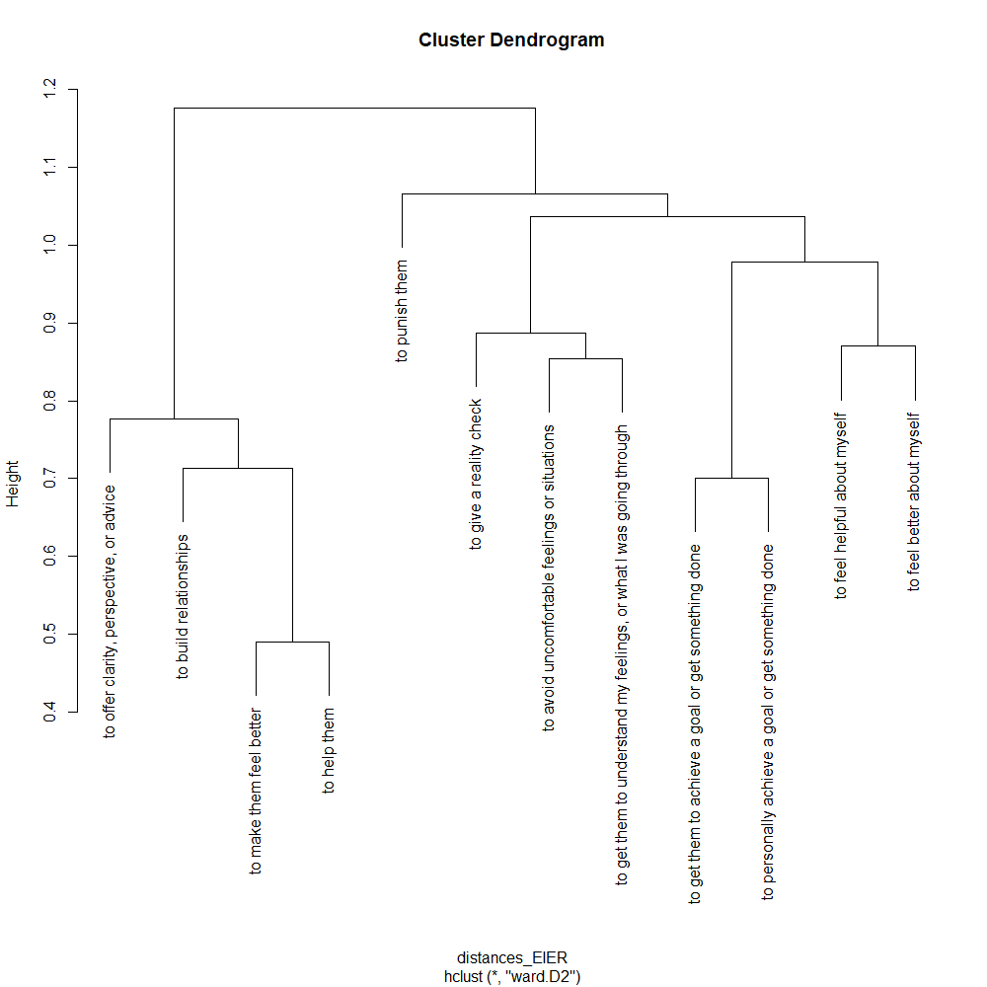
Note. Vertical lines represent similarity between motives, with shorter lines indicating greater similarity.

Figure S5.
Elbow plot (A) and silhouette plot (B) to determine cluster solution for extrinsic regulation motives
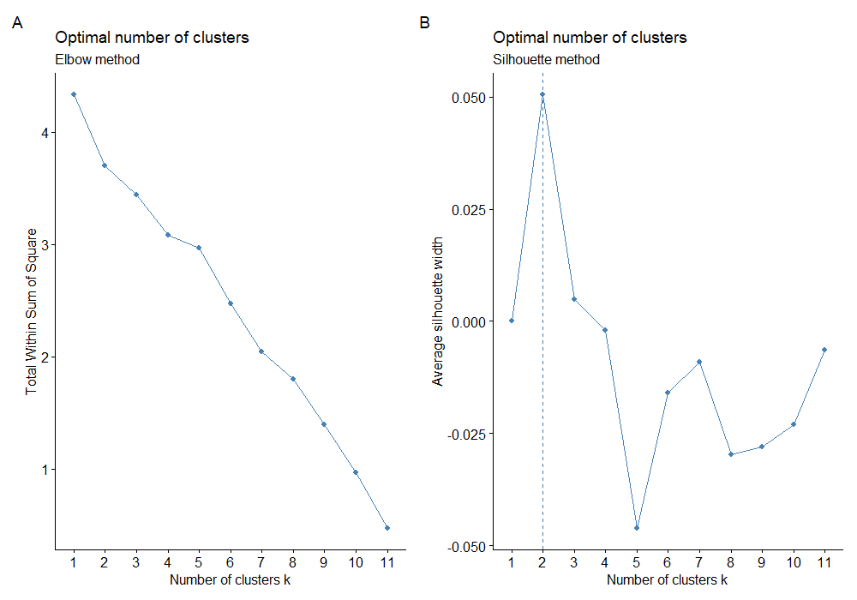
Note. The elbow plot (A) displays the relationship between the number of potential clusters (k) and the within-cluster sum of squares (WCSS). Optimal k is determined by the point at which the reduction in WCSS starts to plateau. The silhouette plot (B) provides a graphical representation of how well each motive fits within their cluster compared to other clusters. Optimal k is determined by the point at which the silhouette index is maximized.

Supplemental Material D: Exploring Motive Structure in Study 1b
Data analytic strategy
In Study 1b, our aim was to refine the list of motives generated in Study 1a through a combination of top-down and bottom-up approaches. To do this, we examined the correlation between each motive pair, and combined motives that were significantly correlated and theoretical meaningful together. To further explore motive structure in Study 1b, we post-hoc employed Spearman-Brown prediction formula, non-metric multidimensional scaling, and hierarchical clustering, using the same data analytic strategies outlined in Supplemental Material C.
Results
Spearman-Brown prediction formula
Spearman-Brown reliability coefficients for each motive pair are presented in Tables S8 (intrinsic affect-improving), S9 (intrinsic affect-worsening), S10 (extrinsic affect-improving), S11 (extrinsic affect-worsening). These reliabilities provided some support for our decisions to combine motives during the refinement process, with the combined motives having the highest reliabilities among other possible pairs. However, our decisions to combine these motives were made prior to this analysis and therefore not informed by reliabilities. Instead, we were guided by theory, correlations, and open-ended responses from participants.
Non-metric multidimensional scaling (NMDS)
Figure S6 graphically represents the dissimilarity patterns among intrinsic affect-improving regulation motives (panel A), intrinsic affect-worsening regulation motives (panel B), extrinsic affect-improving regulation motives (panel C), and extrinsic affect-worsening regulation motives (panel D) across regulation occasions. The NMDS solutions produced stress value ranging 0.02 to 0.09, indicating good to excellent ordination (Clarke, 1993). The NMDS solutions showed no clear tight clusters of points that were both well-separated from other clusters and theoretically meaningful to be clustered together.
Hierarchical clustering
Hierarchical clustering results are presented in Figures S7 (intrinsic affect-improving), S8 (intrinsic affect-worsening), S9 (extrinsic affect-improving), S10 (extrinsic affect-worsening). All elbow plots did not indicate a clear optimal k, while all dendrograms and silhouette plots suggested a two-cluster solution, which was not conceptually meaningful.

Table S8.
Spearman-Brown reliability coefficient for each intrinsic affect-improving motive pair in Study 1b
Variable | 1 | 2 | 3 | 4 | 5 | 6 | 7
(1) I wanted to feel better | -
(2) I wanted to seek validation, comfort, or reassurance | .31 | -
(3) I wanted to seek advice, clarity, or another perspective | .10 | .14 | -
(4) I wanted to vent or get something off my chest ^{x} | .09 | .13 | .35 | -
(5) I wanted to maintain or build a good relationship | .10 | -.02 | -.08 | -.37 | -
(6) I wanted to achieve a goal or get something done | .03 | .03 | .12 | -.23 | .14 | -
(7) I wanted to distract myself ^{x} | .30 | .01 | -.05 | .07 | -.09 | -.06 | -
(8) I was unable to resolve things on my own ^{x} | .12 | .07 | .30 | .00 | .10 | .37 | -.01
Note. ^{x} denote motive that was cut during the refinement process. Spearman-Brown reliability coefficients can range from -1 to 1, with values closer to 1 indicating higher reliability estimates. A value >.70 indicates acceptable reliability.

Table S9.
Spearman-Brown reliability coefficient for each intrinsic affect-worsening motive pair in Study 1b
Variable | 1 | 2 | 3 | 4 | 5 | 6 | 7 | 8
(1) I wanted to punish myself for something I did | -
(2) I wanted to express how upset I was about something | -.07 | -
(3) I wanted them to give me a reality check or manage my expectations | .04 | -.32 | -
(4) I wanted to achieve a goal or get something done | -.10 | -.07 | .09 | -
(5) I wanted them to validate my mood | -.25 | .36⁺ | -.12 | -.20 | -
(6) I wanted them to validate how I saw myself | .36⁺ | .28 | .25 | .05 | .32 | -
(7) I wanted their attention | -.04 | .06 | -.05 | .21 | .04 | .18 | -
(8) I wanted to understand their feelings or what they were going through | .08 | .07 | .02 | -.22 | .01 | .04 | .02 | -
(9) I wanted to feel powerful | .04 | -.09 | .03 | .27 | -.08 | .16 | .50 | -.16
Note. ⁺ denote motives that were combined during the refinement process. Spearman-Brown reliability coefficients can range from -1 to 1, with values closer to 1 indicating higher reliability estimates. A value >.70 indicates acceptable reliability.
Table S10.
Spearman-Brown reliability coefficient for each extrinsic affect-improving motive pair in Study 1b
Variable | 1 | 2 | 3 | 4 | 5 | 6 | 7 | 8 | 9 | 10
(1) I wanted to make them feel better | -
(2) I like them or care about them | .54 | -
(3) I wanted to feel helpful or good about myself | .17 | .12 | -
(4) I wanted to relieve my own discomfort | .01 | -.20 | .27 | -
(5) I wanted to offer advice, clarity, or another perspective | .18 | .18 | .16 | .02 | -
(6) I wanted to get them to achieve a goal or do something | .01 | .09 | .27 | .08 | .32 | -
(7) I understood their feelings or what they were going through ^{x} | .27 | .26 | .23 | .02 | .24 | -.06 | -
(8) I felt sorry for them ^{x} | .30 | .27 | .28 | .11 | .07 | -.30 | .29 | -
(9) I wanted to maintain or build a good relationship | .36 | .41⁺ | .36 | .08 | .23 | .17 | .07 | .02 | -
(10) I wanted to defuse a negative situation | .16 | .00 | .13 | .34⁺ | .28 | .00 | .15 | .23 | .16 | -
(11) I felt like I had to ^{x} | .01 | .11 | . 13 | .35 | -.01 | .06 | -.03 | .24 | .17 | .35
Note. ^{x} denote motive that was cut during the refinement process. ⁺ denote motives that were combined during the refinement process. Spearman-Brown reliability coefficients can range from -1 to 1, with values closer to 1 indicating higher reliability estimates. A value >.70 indicates acceptable reliability.

Table S11.
Spearman-Brown reliability coefficient for each extrinsic affect-worsening motive pair in Study 1b
Variable | 1 | 2 | 3 | 4 | 5 | 6 | 7 | 8 | 9 | 10
(1) I wanted to seek revenge for something they had done to me | -
(2) wanted to punish them for something they had done to others | .54⁺ | -
(3) I wanted to get them to apologize | .18 | .13 | -
(4) I wanted to feel better about myself | .26 | .06 | -.01 | -
(5) I wanted to give them a reality check or to manage their expectations | -.12 | .01 | -.11 | -.16 | -
(6) I wanted to achieve a goal or get something done | -.04 | .01 | .11 | -.08 | .00 | -
(7) I wanted to help them | -.32 | -.12 | -.12 | -.10 | .19 | .28 | -
(8) I was in a bad mood ^{x} | .14 | -.09 | .11 | .21 | -.35 | -.02 | -.24 | -
(9) I dislike them ^{x} | .45 | .46 | .09 | .13 | -.33 | .03 | -.39 | .28 | -
(10) I wanted them to understand my feelings or what I was going through | .27 | .06 | .43⁺ | .18 | -.14 | .04 | -.36 | .18 | -.11 | -
(11) I was jealous of them | .02 | -.11 | -.13 | . 40⁺ | -.11 | -.18 | -.16 | .32 | -.16 | -.11
Note. ^{x} denote motive that was cut during the refinement process. ⁺ denote motives that were combined during the refinement process. Spearman-Brown reliability coefficients can range from -1 to 1, with values closer to 1 indicating higher reliability estimates. A value >.70 indicates acceptable reliability.
Figure S6.
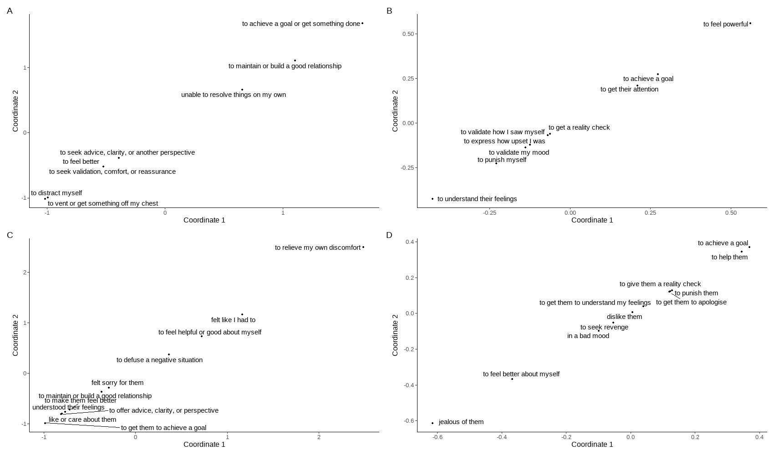
NMDS plots showing patterns of dissimilarity between (A) intrinsic affect-improving motives (stress=0.02), (B) intrinsic affect-worsening motives (stress=0.09), (C) extrinsic affect-improving motives (stress=0.09), and (D) extrinsic affect-worsening (stress=0.07).
Note. Each point represents a motive. Points that are ordinately closer together are more similar to one another. The orientation and values of the axes have no meaning; they simply establish the ordination space in which the points can be plotted.

Figure S7.
Cluster dendrogram (A), elbow plot (B) and silhouette plot (C) to determine cluster solution for intrinsic affect-improving regulation motives
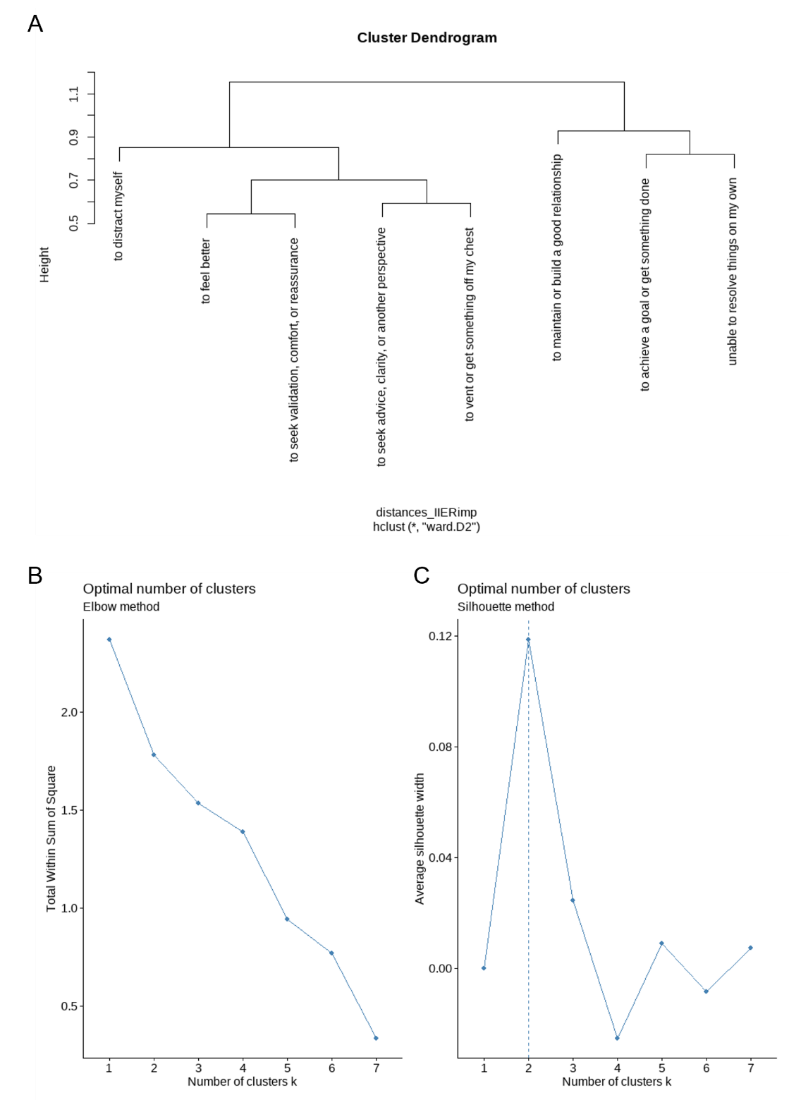
Note. (A) The dendrogram’s vertical lines represent similarity between motives, with shorter lines indicating greater similarity. (B) The elbow plot displays the relationship between the number of potential clusters (k) and the within-cluster sum of squares (WCSS). Optimal k is determined by the point at which the reduction in WCSS starts to plateau. (C) The silhouette plot provides a graphical representation of how well each motive fits within their cluster compared to other clusters. Optimal k is determined by the point at which the silhouette index is maximized.
Figure S8.
Cluster dendrogram (A), elbow plot (B) and silhouette plot (C) to determine cluster solution for intrinsic affect-worsening regulation motives
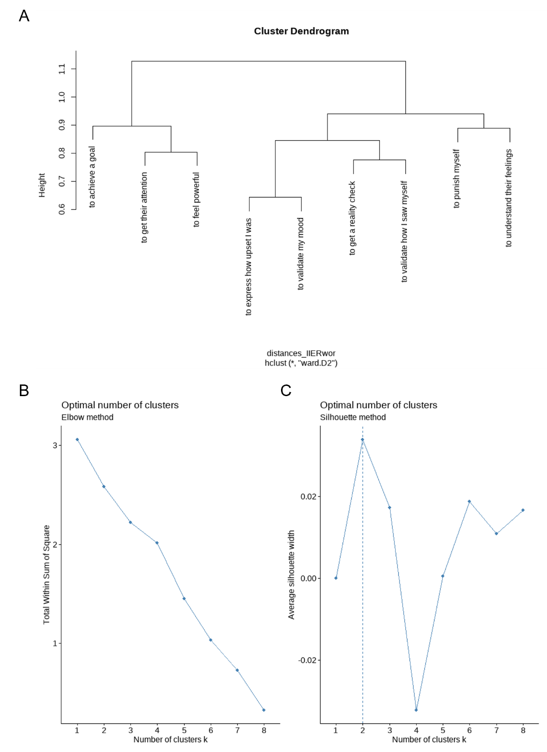
Note. (A) The dendrogram’s vertical lines represent similarity between motives, with shorter lines indicating greater similarity. (B) The elbow plot displays the relationship between the number of potential clusters (k) and the within-cluster sum of squares (WCSS). Optimal k is determined by the point at which the reduction in WCSS starts to plateau. (C) The silhouette plot provides a graphical representation of how well each motive fits within their cluster compared to other clusters. Optimal k is determined by the point at which the silhouette index is maximized.
Figure S9.
Cluster dendrogram (A), elbow plot (B) and silhouette plot (C) to determine cluster solution for extrinsic affect-improving regulation motives
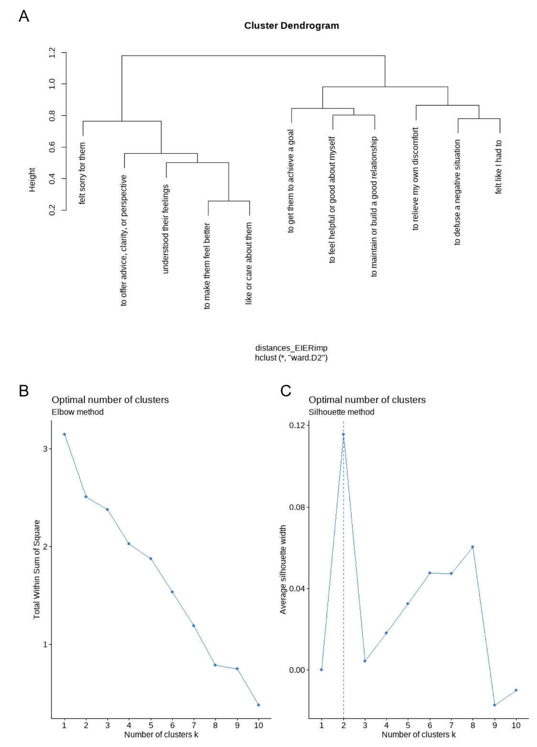
Note. (A) The dendrogram’s vertical lines represent similarity between motives, with shorter lines indicating greater similarity. (B) The elbow plot displays the relationship between the number of potential clusters (k) and the within-cluster sum of squares (WCSS). Optimal k is determined by the point at which the reduction in WCSS starts to plateau. (C) The silhouette plot provides a graphical representation of how well each motive fits within their cluster compared to other clusters. Optimal k is determined by the point at which the silhouette index is maximized.
Figure S10.
Cluster dendrogram (A), elbow plot (B) and silhouette plot (C) to determine cluster solution for extrinsic affect-worsening regulation motives
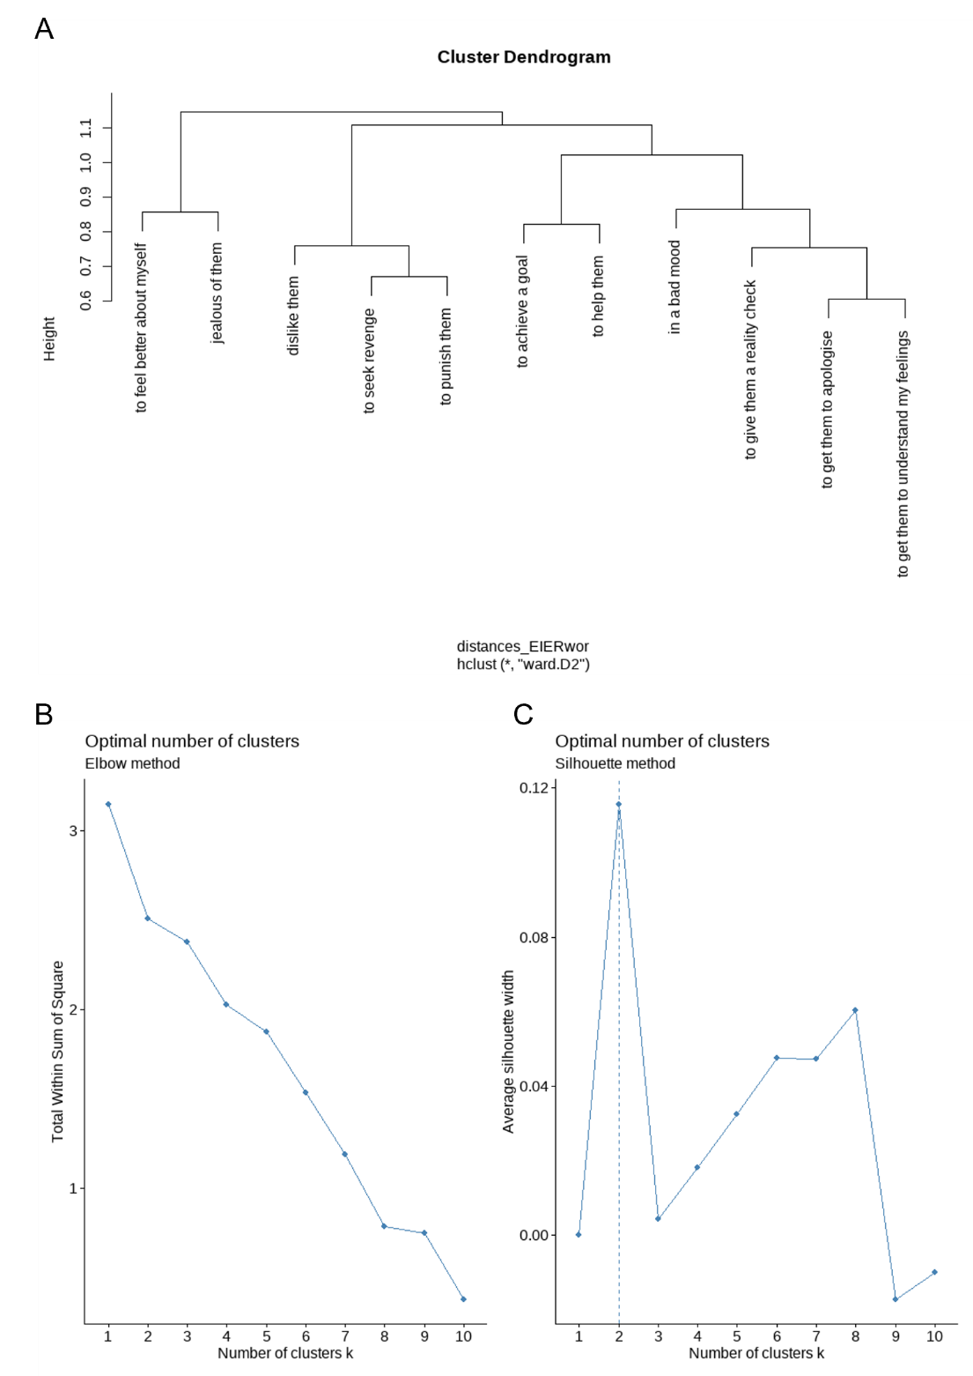
Note. (A) The dendrogram’s vertical lines represent similarity between motives, with shorter lines indicating greater similarity. (B) The elbow plot displays the relationship between the number of potential clusters (k) and the within-cluster sum of squares (WCSS). Optimal k is determined by the point at which the reduction in WCSS starts to plateau. (C) The silhouette plot provides a graphical representation of how well each motive fits within their cluster compared to other clusters. Optimal k is determined by the point at which the silhouette index is maximized.

References
Clarke, K. R. (1993). Non‐parametric multivariate analyses of changes in community structure. Australian journal of ecology, 18(1), 117-143. https://doi.org/10.1111/j.1442-9993.1993.tb00438.x
d’Angella, G. & Hennig, C. (2022). A Comparison of Different Clustering Approaches for High-Dimensional Presence-Absence Data. In Bekker, A., Ferreira, J.T., Arashi, M., Chen, DG. (eds), Innovations in Multivariate Statistical Modeling. Emerging Topics in Statistics and Biostatistics (pp. 299–318). Springer, Cham. https://doi.org/10.1007/978-3-031-13971-0_13
Eisinga, R., te Grotenhuis, M., & Pelzer, B. (2013). The reliability of a two-item scale: Pearson, Cronbach, or Spearman-Brown? International Journal of Public Health, 58(4), 637–642. https://doi.org/10.1007/s00038-012-0416-3
Kassambara, A. & Mundt, F. (2020) Factoextra: Extract and Visualize the Results of Multivariate Data Analyses. R Package Version 1.0.7.
https://CRAN.R-project.org/package=factoextra
Maechler, M., Rousseeuw, P., Struyf, A., Hubert M., & Hornik, K. (2022). cluster: Cluster Analysis Basics and Extensions. R package version 2.1.4, https://CRAN.R-project.org/package=cluster.
Oksanen, J., Simpson, G., Blanchet, F., Kindt, R., Legendre, P., Minchin, P., O'Hara, R., Solymos, P., Stevens, M., Szoecs, E., Wagner, H., Barbour, M., Bedward, M., Bolker, B., Borcard, D., Carvalho, G., Chirico, M., De Caceres, M., Durand, S., Evangelista, H., FitzJohn, R., Friendly, M., Furneaux, B., Hannigan, G., Hill, M., Lahti, L., McGlinn, D., Ouellette, M., Ribeiro Cunha, E., Smith, T., Stier, A., Ter Braak, C., & Weedon, J. (2022). vegan: Community Ecology Package. R package version 2.6-4, https://CRAN.R-project.org/package=vegan
Pauw, L. S., Sauter, D. A., van Kleef, G. A., & Fischer, A. H. (2018). Sense or sensibility? Social sharers’ evaluations of socio-affective vs. cognitive support in response to negative emotions. Cognition and Emotion, 32(6), 1247–1264. https://doi.org/10.1080/02699931.2017.1400949
Pronk, T. (2021). splithalfr: Estimates split-half reliabilities for scoring algorithms of cognitive tasks and questionnaires. R package version 2.2.2, https://CRAN.R-project.org/package=splithalfr
Tamir, M. (2009). What Do People Want to Feel and Why?: Pleasure and Utility in Emotion Regulation. Current Directions in Psychological Science, 18(2), 101-105. https://doi.org/10.1111/j.1467-8721.2009.01617.x

