Information Gathering:
Dissociable Effects of Autistic and Alexithymic Traits in Youths Aged 6 to 25 Years
Supplementary Materials
Description of Computational Modelling
Here we present a detailed description of the key features (and related mathematical specifications) of the computational modelling package (Hauser et al., 2017a, 2017b, 2018).
A key assumption of the model is that the agent makes inference about what emotional state (face emoji) / outfit preference (colour of T-shirt) constitutes the majority among the 25 diary entries P(MH | n_{h}, N). Using the emotional condition as an example here, MH denotes the majority being happy faces, given the current number of happy face emojis (n_{h}) out of N number of diary entries revealed thus far. Since P(MH) concerns the current number of diary entries, it infers the generative probability the agent believes has likely caused this proportion of happy face emojis. Mathematically, this belief is used estimate the value (Q) of making a judgment (i.e., choosing H: happy or S: sad), weighted by the potential rewards (R_{correct}: +100) and losses (R_{incorrect}: -100), as in a no-cost condition as an example:
Q(H | n_{h}, N) = R_{correct} P(MH | n_{h}, N) + R_{incorrect} P(MS | n_{s}, N)
The value of not deciding, i.e., further information gathering (Q(ND)), is estimated as the sum of the Q values of future states (V(s’)), weighted by the likelihood of ending up in that state given the diary entries revealed so far (P(s’ | n_{h}, N). Furthermore, a cost per step, c, is incurred, which represents the internal subjective costs for gathering more information, such as time and effort spend on the task, and rewards/losses (when information gathering is costly).
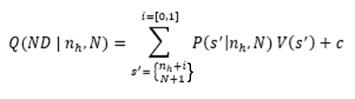
As mentioned in the main text and demonstrated below in Figure S1, the best fitting model is one that models these internal costs (c) in a sigmoidal form, which increase over the course of information gathering. It comprises the scaling parameter cs determining the magnitude of the maximal costs of information gathering, and relevant to the current study, the intercept cs_p, which refers to the number of diary entries (n) after which those internal costs emerged.
$$c= \frac{cs}{1+ e^{-10(n-cs_p)}}$$
Reward Rate Mixed Models Analysing Parent-Reported Alexithymia
Linear mixed models showed that there was a significant main effect of AQ on reward rate (F(1,96.3) = 7.63, p = .007), in that participants with higher AQ earned fewer points per unit time across conditions (Slopes = -0.01 to -0.02, SEs = 0.005). No effects of interest were observed for alexithymia (Fs = 0.19 to 1.55, ps > .22). Table S2 summarizes the reward rate model results.
Mixed Models Analysing Self-Reported Alexithymia
Information Gathering
The AQ model significantly outperformed the null model (χ²(7) = 85.01, p <.001). There was a significant main effect of AQ on total draws (χ²(1) = 5.93, p = .008, one-tailed) (Table S3), where participants with higher AQ revealed more diary entries before making a guess. There was a significant interaction between AQ and information type (χ²(1) = 6.20, p = .01), such that participants with higher AQ tended to reveal more diary entries in the non-emotional (Slope = 0.09 [0.02; 0.17], SE = 0.04) compared to emotional (Slope = 0.07 [-0.002; 0.14], SE = 0.04) condition. The difference in slope of total draws as a function of autistic traits between the two conditions, however, was non-significant, Contrast (emotional – non-emotional) = -0.02, SE = 0.01, t = -1.66, p <.10. No other significant interactions with AQ were found, χ² = 1.28 to 2.90, ps > .15.
When aggregated across trials and conditions, a Spearman correlation suggested that total draws were negatively related to self-reported alexithymia T-scores, r(95) = -.13, p = .21, although it did not reach statistical significance. The self-reported alexithymia model significantly outperformed the null model (χ²(7) = 79.88, p <.001). The main effect of self-reported alexithymia on total draws was not significant (χ²(1) = 2.19, p = .14) (Table S3). No significant interactions with alexithymia were observed, χ² = 0.07 to 2.10, ps > .15.
Analysing the number of same-type draws relative to the point of certainty as the dependent variables yielded similar results. For the AQ model (Table S4), there was a significant main effect of AQ on number of draws (χ²(1) = 38.36, p <.001, one-tailed). There was a significant two-way interaction between AQ and cost conditions (χ²(1) = 11.75, p <.001), in that participants with higher autistic traits had a higher number of same-type draws relative to the point of certainty in the no-cost condition (Slope = 0.02 [0.01; 0.02], SE = 0.003) than in the costly condition (Slope = 0.004 [-0.002; 0.009], SE = 0.003, Contrast (costly – no-cost) = -0.01, SE = 0.004, t = -3.43, p = 0.006).
For the alexithymia model (Table S4), there was a significant main effect of alexithymia on same-type draws (χ²(1) = 8.24, p = .004), but inspecting this main effect more closely in each condition suggested that the seemingly significant simple slopes in the no-cost conditions were in fact not significantly different from the non-significant simple slopes in the costly conditions (Contrast (costly – no-cost) = 0.0006, SE = 0.0004, t = 1.45, p = .15), suggesting that this main effect of alexithymia was not robust.
Emergence of Cost
The AQ model significantly outperformed the null model (χ²(7) = 79.37, p <.001). In the AQ model (Table S5), there was a significant main effect of AQ on the cost emergence parameter cs_p (F(1,77.6) = 4.02, p <.05). Although no interaction with AQ was found, participants with higher autistic traits had a later emergence of internal costs delaying the decision to make a guess in the emotional no-cost condition (Slope = 1.97 [.28; 3.7], SE = .86) than in other conditions (Slopes = 0.58 to 1.27, SEs = 0.74 to 0.86). No other significant interactions with AQ were found, Fs = 0.17 to 1.08, ps > .30.
The self-reported alexithymia model significantly outperformed the null model (χ²(7) = 79.11, p <.001). However, the main effect of alexithymia was not significant (F(1,77.6) = 2.39, p = .13) (Table S5). No significant interactions with alexithymia were observed, Fs = 0.07 to 2.18, ps > .13.
Reward Rate
The AQ model significantly outperformed the null model (χ²(7) = 19.04, p <.01). The main effect of AQ was marginally significant (F(1,97) = 3.61, p = .06), in that participants with higher AQ had lower reward rate across conditions (Slopes = -0.004 to -0.01, SEs = 0.005 to 0.006). The alexithymia model also significantly outperformed the null model (χ²(7) = 15.79, p = .03). However, the main effect of alexithymia on reward rate was not significant (F(1,96.7) = 0, p = 1). No significant interactions with alexithymia were observed (Fs = 0.03 to 2.21, ps > .14). These reward rate model results are summarised in Table S6.
Mixed Models Accounting for Age Group Interaction Effects
Instead of analysing continuous age (years), we introduced a four-way interaction term to the same set of mixed models by adding participants’ age group (childhood/adolescents/young adults) to the three-way interaction term between autistic traits/alexithymia and the information type (emotional/non-emotional) and cost conditions (no-cost/costly) as presented in the main text. Since the purpose of these supplementary analyses is to explore if our primary interaction of interest between traits and study conditions would vary between age groups, we focus on reporting the interaction effects with age group below. Nevertheless, these results should be interpreted with caution as they do not necessarily imply specific developmental stage differences, which would require more strategic sampling in future studies. Summary of model results can be found in Tables S7-8. These supplementary analyses are significant at alpha = .05, two-tailed.
Information Gathering
To explore if our current study found a similar pattern of results that children would gather significantly more information than older age groups when information gathering was not costly as reported in the previous study (Bowler et al., 2021), we first performed a repeated-measures ANOVA (cost conditions as the within-subjects factor) in the aggregated data (Figure S3). Specifically, when analysing data in the non-emotional conditions (which better approximated the study design in Bowler et al, 2021), there was a significant interaction between age group and cost conditions, F(2,188) = 3.77, p = .02, η_{p}² = 0.04. However, pairwise Tukey tests revealed that children only had slightly more draws than adolescents in the no-cost condition (Difference = 1.25 [-2.18; 4.67], p = .90), which did not reach statistical significance. Additionally, young adults were found to reveal significantly more diary entries than adolescents (Difference = 4.16 [0.86; 7.45], p = .005). No age group differences were found when information gathering was costly in the costly condition (Differences = -0.18 to 0.12, ps = .99 to 1) (Bowler et al., 2021). Likewise, when analysing data in the emotional conditions, there was a significant interaction between age group and cost conditions, F(2,188) = 5.02, p = .008, η_{p}² = 0.05. Young adults revealed significantly more diary entries than children (Difference = 4.33 [0.87; 7.79], p = .005) and adolescents (Difference = 3.31 [-0.09; 6.71], p = .06) in the no-cost condition, although the latter reached marginal significance only. No age group differences were found in the costly condition (Differences = -0.88 to -0.25, ps = .98 to .99) (Bowler et al., 2021).
In the mixed models using trial-level data, the AQ model with the four-way interaction term significantly outperformed its null model without the interaction term, χ²(23) = 178.69, p <.001 (Table S7). In particular, there was a significant four-way interaction between age group and AQ and the information type and cost conditions, χ²(2) = 21.63, p <.001. To ease the interpretation of results, we first decomposed its three-way interaction with the cost conditions (χ²(2) = 9.32, p <.01), and then that with the information type conditions (χ²(2) = 31.23, p <.001). Specifically, children with higher autistic traits were found to draw significantly more diary entries in the no-cost condition than in the costly condition, Contrast (costly – no-cost) = -0.27, SE = 0.13, t = -2.15, p =.03. Such differences, however, were neither found in adolescents (Slope = -0.02, SE = 0.09, p = .86) nor in young adults (Slope = 0.06, SE = 0.10, p = .52). Regarding the information type conditions, young adults with higher autistic traits seemed to draw more diary entries in the emotional condition than in the non-emotional condition, Contrast (emotional – non-emotional) = 0.03, SE = 0.02, t = 1.57, p =.12, although this contrast was only observed at a trend level. No differences were observed in children (Slope = -0.04, SE = 0.03, p = .15) and adolescents (Slope = 0.02, SE = 0.02, p = .22).
When analysing alexithymia as the key trait of interest, the four-way interaction model significantly outperformed the null model, χ²(23) = 164.35, p <.001. Specifically, there was a significant three-way interaction between age group and alexithymia and cost conditions (χ²(2) = 8.63, p = .01), in that children with higher alexithymia were found to draw more diary entries in the no-cost condition than in the costly condition, Contrast (costly – no-cost) = -0.02, SE = 0.01, t = -2.24, p =.03. No differences were observed in adolescents (Slope = 0.005, SE = 0.01, p = .64) and young adults (Slope = 0.01, SE = 0.01, p = .15).
Emergence of Cost
The AQ model with the age group interaction term outperformed its null model, χ²(23) = 107.78, p <.001 (Table S8). There was a significant three-way interaction between age group and AQ and cost conditions, F(2,78) = 5.05, p <.01. Specifically, children with higher autistic traits had a later emergence of internal costs of information gathering in the no-cost condition than in the costly condition (where more information gathering was penalised), Contrast (costly – no-cost) = -5.68, SE = 1.72, z = -3.29, p =.001. No such differences were found in adolescents (Slope = 0.48, SE = 1.15, p = .68) and young adults (Slope = 0.40, SE = 1.29, p = .76).
For the alexithymia model, although being statistically superior to its null model (χ²(23) = 96.12, p <.001), none of the interaction terms between age group and alexithymia reached statistical significance (Fs = 0.18 to 1.76, ps = .18 to .83).
Computational Mixed Models in the Full Sample
Emergence of Cost
Consistent with the main text, the AQ model with the three-way interaction was superior to the null model, χ²(7) = 87.52, p <.001 (Table S11). Similarly, there was a significant main effect of AQ on the computational parameter cs_p, F(1,96.8) = 5.17, p = .03. By decomposing this main effect, it was found that participants with higher autistic traits considered the act of gathering more information less costly and delayed their decision to make a guess (Slopes = 0.67 to 2.05, SEs = .70 to .79), especially in the emotional no-cost condition (Slope = 2.05 [0.50; 3.59], SE = .79). However, no interactions with AQ were observed.
The alexithymia model was also superior to the null model, χ²(7) = 82.63, p <.001. However, none of the main effects or interaction terms of interest reached statistical significance (Table S11).

Table S1
Mixed Model Structures
Trait of interest | Alexithymia informant for children and adolescents | Dependent variable | Fixed effects | Random effects
Autistic trait (residualised) | Parent | Total draws | Age + Sex + AQ*Information type*Cost conditions | Cost conditions|Participants + Game sequences
 |  | Emergence of cost (cs_p) | Age + Sex + AQ*Information type*Cost conditions | Cost conditions|Participants
 |  | Reward rate | Age + Sex + AQ*Information type*Cost conditions | Cost conditions|Participants + Game sequences
Alexithymia (raw T-scores) | Parent | Total draws | Age + Sex + Alexithymia*Information type*Cost conditions | Cost conditions|Participants + Game sequences
 |  | Emergence of cost (cs_p) | Age + Sex + Alexithymia*Information type*Cost conditions | Cost conditions|Participants
 |  | Reward rate | Age + Sex + Alexithymia*Information type*Cost conditions | Participants + Game sequences
Autistic trait (residualised) | Self | Total draws | Age + Sex + AQ*Information type*Cost conditions | Cost conditions|Participants + Game sequences
 |  | Emergence of cost (cs_p) | Age + Sex + AQ*Information type*Cost conditions | Cost conditions|Participants
 |  | Reward rate | Age + Sex + AQ*Information type*Cost conditions | Cost conditions|Participants + Game sequences
Alexithymia (raw T-scores) | Self | Total draws | Age + Sex + Alexithymia*Information type*Cost conditions | Cost conditions|Participants + Game sequences
 |  | Emergence of cost (cs_p) | Age + Sex + Alexithymia*Information type*Cost conditions | Cost conditions|Participants
 |  | Reward rate | Age + Sex + Alexithymia*Information type*Cost conditions | Cost conditions|Participants + Game sequences
Notes. Self-reported alexithymia T-scores were used for young adults throughout. For models predicting number of same-type draws relative to the point of certainty, only game sequences were included as random effects for the sake of convergence. These models were compared to the null models comprising only the fixed effects of age and sex and the random effects of participants and game sequences. The alexithymia model (parent reports) predicting reward rate had the random slopes for cost conditions removed due to singularity. AQ = Autism-Spectrum Quotient.

Table S2
Summary of Mixed Model Results Predicting Reward Rate from Autistic Traits and Alexithymia
AQ model | Num df | Den df | F | p
Age | 1 | 96.3 | 56.26 | <0.001
Sex: Male | 1 | 96.3 | 0.85 | 0.358
AQ | 1 | 96.3 | 7.63 | 0.007
Cost conditions | 1 | 5708.9 | 19.79 | <0.001
information type | 1 | 5708.9 | 5.83 | 0.016
AQ x Cost conditions | 1 | 5708.9 | 0.00 | 0.968
AQ x information type | 1 | 5708.9 | 1.88 | 0.170
Cost conditions x information type | 1 | 5708.9 | 0.19 | 0.660
AQ x Cost conditions x information type | 1 | 5708.9 | 1.72 | 0.189
Alexithymia model | Num df | Den df | F | p
Age | 1 | 96.4 | 50.72 | <0.001
Sex: Male | 1 | 96.4 | 0.20 | 0.658
Alexithymia | 1 | 96.4 | 1.55 | 0.216
Cost conditions | 1 | 5708.9 | 3.48 | 0.062
information type | 1 | 5708.9 | 0.80 | 0.370
Alexithymia x Cost conditions | 1 | 5708.9 | 1.02 | 0.311
Alexithymia x information type | 1 | 5708.9 | 0.19 | 0.667
Cost conditions x information type | 1 | 5708.9 | 0.69 | 0.407
Alexithymia x Cost conditions x information type | 1 | 5708.9 | 0.87 | 0.351
Notes. Residualised AQ scores were analysed in the AQ model, whilst raw alexithymia T-scores were analysed in the alexithymia model. Both models used parent-reported alexithymia T-scores as described in the main text. Self-reported alexithymia T-scores were used for young adults throughout. AQ = Autism-Spectrum Quotient.

Table S3
Summary of Mixed Model Results Predicting Total Draws from Autistic Traits and Self-Reported Alexithymia
AQ model | χ² | df | p
(Intercept) | 289.50 | 1 | <0.001
Age | 1.57 | 1 | 0.210
Sex: Male | 5.56 | 1 | 0.018
AQ | 5.93 | 1 | 0.015
Cost conditions | 102.39 | 1 | <0.001
information type | 1.55 | 1 | 0.213
AQ x Cost conditions | 1.28 | 1 | 0.258
AQ x information type | 6.20 | 1 | 0.013
Cost conditions x information type | 6.81 | 1 | 0.009
AQ x Cost conditions x information type | 2.09 | 1 | 0.148
Alexithymia model | χ² | df | p
(Intercept) | 70.09 | 1 | <0.001
Age | 1.78 | 1 | 0.182
Sex: Male | 7.36 | 1 | 0.007
Alexithymia | 2.19 | 1 | 0.138
Cost conditions | 6.93 | 1 | 0.008
information type | 2.89 | 1 | 0.089
Alexithymia x Cost conditions | 0.43 | 1 | 0.511
Alexithymia x information type | 2.10 | 1 | 0.148
Cost conditions x information type | 0.07 | 1 | 0.785
Alexithymia x Cost conditions x information type | 0.07 | 1 | 0.791
Notes. Residualised AQ scores were analysed in the AQ model, whilst raw alexithymia T-scores were analysed in the alexithymia model. Two-tailed p values are presented here for consistency. To reflect our hypothesis, one-tailed p value is reported for the main effect of AQ in text. AQ = Autism-Spectrum Quotient.

Table S4
Summary of Mixed Model Results Predicting Number of Same-Type Draws Relative to Point of Certainty from Autistic Traits and Self-Reported Alexithymia
AQ model | χ2 | df | p
(Intercept) | 352128.82 | 1 | <0.001
Age | 26.16 | 1 | <0.001
Sex: Male | 39.11 | 1 | <0.001
AQ | 38.36 | 1 | <0.001
Cost conditions | 406.41 | 1 | <0.001
AQ x Cost conditions | 11.75 | 1 | <0.001
Alexithymia model | χ² | df | p
(Intercept) | 33480.42 | 1 | <0.001
Age | 28.66 | 1 | <0.001
Sex: Male | 53.46 | 1 | <0.001
Alexithymia | 8.24 | 1 | 0.004
Cost conditions | 15.95 | 1 | <0.001
Information type | 0.36 | 1 | 0.550
Alexithymia x Cost conditions | 1.11 | 1 | 0.291
Alexithymia x Information type | 0.19 | 1 | 0.664
Cost conditions x Information type | 0.06 | 1 | 0.812
Alexithymia x Cost conditions x Information type | 0.00 | 1 | 0.968
Notes. Residualised AQ scores were analysed in the AQ model, whilst raw alexithymia T-scores were analysed in the alexithymia model. Due to non-convergence and the lack of interaction between AQ and information type as informed by the main model (see main text), information type was removed from this supplementary AQ model. Decomposing the main effect of alexithymia suggested that although the 95% confidence intervals of the simple slopes of alexithymia in the no-cost conditions did not cross zero, these slopes were not significantly different from those in the costly conditions, suggesting that the main effect of alexithymia was not robust. Game sequences were included as random effects in both the AQ and alexithymia models. AQ = Autism-Spectrum Quotient.

Table S5
Summary of Mixed Model Results Predicting Cost Emergence from Autistic Traits and Self-Reported Alexithymia
AQ model | Num df | Den df | F | p
Age | 1 | 78 | 1.67 | 0.199
Sex: Male | 1 | 78 | 3.30 | 0.073
AQ | 1 | 77.6 | 4.02 | 0.048
Cost conditions | 1 | 78 | 117.84 | <0.001
Information type | 1 | 156 | 0.22 | 0.640
AQ x Cost conditions | 1 | 78 | 1.08 | 0.302
AQ x Information type | 1 | 156 | 0.17 | 0.685
Cost conditions x Information type | 1 | 156 | 2.05 | 0.154
AQ x Cost conditions x Information type | 1 | 156 | 1.08 | 0.301
Alexithymia model | Num df | Den df | F | p
Age | 1 | 78 | 1.99 | 0.162
Sex: Male | 1 | 78 | 5.25 | 0.025
Alexithymia | 1 | 77.6 | 2.39 | 0.126
Cost conditions | 1 | 78 | 3.18 | 0.078
Information type | 1 | 156 | 0.57 | 0.453
Alexithymia x Cost conditions | 1 | 78 | 0.07 | 0.792
Alexithymia x Information type | 1 | 156 | 0.46 | 0.498
Cost conditions x Information type | 1 | 156 | 1.41 | 0.237
Alexithymia x Cost conditions x Information type | 1 | 156 | 2.18 | 0.142
Notes. Residualised AQ scores were analysed in the AQ model, whilst raw alexithymia T-scores were analysed in the alexithymia model. AQ = Autism-Spectrum Quotient.

Table S6
Summary of Mixed Model Results Predicting Reward Rate from Autistic Traits and Self-Reported Alexithymia
AQ model | Num df | Den df | F | p
Age | 1 | 96.3 | 55.89 | <0.001
Sex: Male | 1 | 96.3 | 0.68 | 0.413
AQ | 1 | 96.8 | 3.61 | 0.060
Cost conditions | 1 | 97 | 6.29 | 0.014
Information type | 1 | 5611.9 | 6.06 | 0.014
AQ x Cost conditions | 1 | 97 | 0.00 | 0.983
AQ x Information type | 1 | 5611.9 | 2.11 | 0.146
Cost conditions x Information type | 1 | 5611.9 | 0.20 | 0.654
AQ x Cost conditions x Information type | 1 | 5611.9 | 0.59 | 0.443
Alexithymia model | Num df | Den df | F | p
Age | 1 | 96.3 | 52.07 | <0.001
Sex: Male | 1 | 96.3 | 0.26 | 0.613
Alexithymia | 1 | 96.7 | 0.00 | 0.995
Cost conditions | 1 | 97 | 2.30 | 0.133
Information type | 1 | 5611.9 | 3.77 | 0.052
Alexithymia x Cost conditions | 1 | 97 | 1.09 | 0.300
Alexithymia x Information type | 1 | 5611.9 | 2.21 | 0.137
Cost conditions x Information type | 1 | 5611.9 | 0.06 | 0.800
Alexithymia x Cost conditions x Information type | 1 | 5611.9 | 0.03 | 0.866
Notes. Residualised AQ scores were analysed in the AQ model, whilst raw alexithymia T-scores were analysed in the alexithymia model. AQ = Autism-Spectrum Quotient.

Table S7
Summary of Mixed Models Predicting Total Draws with Age Group Interaction Terms
AQ model | χ2 | df | p
(Intercept) | 578.02 | 1 | <0.001
Sex: Male | 5.07 | 1 | 0.024
AQ | 1.07 | 1 | 0.301
Cost conditions | 85.72 | 1 | <0.001
Information type | 0.46 | 1 | 0.496
Age group | 10.29 | 2 | 0.006
AQ x Cost conditions | 0.73 | 1 | 0.394
AQ x Information type | 4.87 | 1 | 0.027
Cost conditions x Information type | 0.28 | 1 | 0.598
AQ x Age group | 4.68 | 2 | 0.096
Cost conditions x Age group | 11.69 | 2 | 0.003
Information type x Age group | 28.73 | 2 | <0.001
AQ x Cost conditions x Information type | 1.32 | 1 | 0.251
AQ x Cost conditions x Age group | 9.32 | 2 | 0.009
AQ x Information type x Age group | 31.23 | 2 | <0.001
Cost conditions x Information type x Age group | 30.09 | 2 | <0.001
AQ x Cost conditions x Information type x Age group | 21.63 | 2 | <0.001
Alexithymia model | χ² | df | p
(Intercept) | 41.17 | 1 | <0.001
Sex: Male | 5.87 | 1 | 0.015
Alexithymia | 0.59 | 1 | 0.444
Cost conditions | 11.13 | 1 | 0.001
Information type | 3.28 | 1 | 0.070
Age group | 11.64 | 2 | 0.003
Alexithymia x Cost conditions | 2.33 | 1 | 0.127
Alexithymia x Information type | 3.83 | 1 | 0.050
Cost conditions x Information type | 0.53 | 1 | 0.469
Alexithymia x Age group | 11.36 | 2 | 0.003
Cost conditions x Age group | 10.68 | 2 | 0.005
Information type x Age group | 0.53 | 2 | 0.766
Alexithymia x Cost conditions x Information type | 0.38 | 1 | 0.535
Alexithymia x Cost conditions x Age group | 8.63 | 2 | 0.013
Alexithymia x Information type x Age group | 3.59 | 2 | 0.166
Cost conditions x Information type x Age group | 0.27 | 2 | 0.875
Alexithymia x Cost conditions x Information type x Age group | 2.36 | 2 | 0.308
Notes. Residualised AQ scores were analysed in the AQ model, whilst raw alexithymia T-scores were analysed in the alexithymia model. Both models used parent-reported alexithymia T-scores as described in the main text. Self-reported alexithymia T-scores were used for young adults throughout. AQ = Autism-Spectrum Quotient.

Table S8
Summary of Mixed Models Predicting Emergence of Cost with Age Group Interaction Terms
AQ model | NumDF | DenDF | F | p
Sex: Male | 1 | 78 | 2.84 | 0.096
AQ | 1 | 77.8 | 6.64 | 0.012
Cost conditions | 1 | 78 | 132.57 | <0.001
Information type | 1 | 156 | 0.17 | 0.684
Age group | 2 | 77.8 | 1.23 | 0.297
AQ x Cost conditions | 1 | 78 | 3.86 | 0.053
AQ x Information type | 1 | 156 | 0.81 | 0.370
Cost conditions x Information type | 1 | 156 | 2.83 | 0.094
AQ x Age group | 2 | 77.8 | 0.36 | 0.699
Cost conditions x Age group | 2 | 78 | 3.93 | 0.024
Information type x Age group | 2 | 156 | 0.30 | 0.743
AQ x Cost conditions x Information type | 1 | 156 | 0.97 | 0.327
AQ x Cost conditions x Age group | 2 | 78 | 5.05 | 0.009
AQ x Information type x Age group | 2 | 156 | 0.25 | 0.783
Cost conditions x Information type x Age group | 2 | 156 | 1.33 | 0.266
AQ x Cost conditions x Information type x Age group | 2 | 156 | 1.71 | 0.184
Alexithymia model | NumDF | DenDF | F | p
Sex: Male | 1 | 78 | 3.66 | 0.059
Alexithymia | 1 | 77.9 | 1.31 | 0.255
Cost conditions | 1 | 78 | 1.65 | 0.203
Information type | 1 | 156 | 0.01 | 0.927
Age group | 2 | 77.9 | 1.24 | 0.296
Alexithymia x Cost conditions | 1 | 78 | 0.78 | 0.380
Alexithymia x Information type | 1 | 156 | 0.00 | 0.973
Cost conditions x Information type | 1 | 156 | 0.97 | 0.327
Alexithymia x Age group | 2 | 78 | 1.01 | 0.369
Cost conditions x Age group | 2 | 78 | 2.58 | 0.082
Information type x Age group | 2 | 156 | 0.84 | 0.432
Alexithymia x Cost conditions x Information type | 1 | 156 | 1.75 | 0.187
Alexithymia x Cost conditions x Age group | 2 | 78 | 1.76 | 0.179
Alexithymia x Information type x Age group | 2 | 156 | 1.09 | 0.340
Cost conditions x Information type x Age group | 2 | 156 | 0.07 | 0.931
Alexithymia x Cost conditions x Information type x Age group | 2 | 156 | 0.18 | 0.834
Notes. Residualised AQ scores were analysed in the AQ model, whilst raw alexithymia T-scores were analysed in the alexithymia model. Both models used parent-reported alexithymia T-scores as described in the main text. Self-reported alexithymia T-scores were used for young adults throughout. AQ = Autism-Spectrum Quotient.

Table S9
Summary of Robust Multiple Regressions Predicting Emotional Consistency from Alexithymia
Emotional consistency | Coefficient | Estimate | SE | t | p | Lower 95% CI | Upper 95% CI | VIF
Actual reward | Intercept | 53.09 | 4.38 | 12.12 | <0.001 | 44.50 | 61.67 | --
 | Age | 0.04 | 0.13 | 0.31 | 0.758 | -0.22 | 0.30 | 1.21
 | Sex: Male | -0.71 | 1.61 | -0.44 | 0.659 | -3.87 | 2.44 | 1.47
 | AQ | 0.09 | 0.09 | 1.04 | 0.300 | -0.08 | 0.26 | 1.64
 | Alexithymia | -0.17 | 0.08 | -2.08 | 0.041 | -0.33 | -0.01 | 1.42
Imaginative loss | Intercept | 56.46 | 5.17 | 10.92 | <0.001 | 46.32 | 66.59 | --
 | Age | 0.03 | 0.15 | 0.18 | 0.856 | -0.26 | 0.31 | 1.12
 | Sex: Male | -0.61 | 1.72 | -0.35 | 0.726 | -3.99 | 2.77 | 1.13
 | AQ | 0.07 | 0.09 | 0.80 | 0.426 | -0.10 | 0.24 | 1.22
 | Alexithymia | -0.20 | 0.08 | -2.58 | 0.012 | -0.36 | -0.05 | 1.12
Notes. Raw AQ T-scores and alexithymia T-scores were used. Models were adjusted for age in years, sex, and AQ scores. Two-tailed p values are reported here for consistency. To reflect our hypotheses, one-tailed p values are reported for alexithymia in text. AQ = Autism-Spectrum Quotient.

Table S10
Summary of Robust Multiple Regressions Predicting Emotional Consistency from Self-Reported Alexithymia
Emotional consistency | Coefficient | Estimate | SE | t | p | Lower 95% CI | Upper 95% CI | VIF
Actual reward | Intercept | 54.04 | 4.53 | 11.94 | <0.001 | 45.17 | 62.91 | --
 | Age | 0.03 | 0.13 | 0.25 | 0.800 | -0.22 | 0.29 | 1.20
 | Sex: Male | -0.39 | 1.59 | -0.25 | 0.807 | -3.50 | 2.72 | 1.46
 | AQ | 0.06 | 0.08 | 0.77 | 0.444 | -0.09 | 0.21 | 1.36
 | Alexithymia | -0.16 | 0.07 | -2.36 | 0.021 | -0.29 | -0.03 | 1.11
Imaginative loss | Intercept | 58.67 | 5.80 | 10.12 | <0.001 | 47.31 | 70.03 | --
 | Age | 0.02 | 0.14 | 0.14 | 0.886 | -0.26 | 0.30 | 1.10
 | Sex: Male | -0.22 | 1.85 | -0.12 | 0.906 | -3.85 | 3.41 | 1.10
 | AQ | 0.03 | 0.09 | 0.37 | 0.714 | -0.14 | 0.20 | 1.16
 | Alexithymia | -0.21 | 0.08 | -2.51 | 0.014 | -0.37 | -0.05 | 1.05
Notes. Self-reported alexithymia scores were analysed for all participants. Two-tailed p values are reported here for consistency. AQ = Autism-Spectrum Quotient.

Table S11
Summary of Mixed Models Predicting Emergence of Cost in the Full Sample
AQ model | NumDF | DenDF | F | p
Age | 1 | 97 | 2.14 | 0.147
Sex: Male | 1 | 97 | 1.70 | 0.195
AQ | 1 | 96.8 | 5.17 | 0.025
Cost conditions | 1 | 97 | 117.10 | <0.001
Information type | 1 | 194 | 0.02 | 0.901
AQ x Cost conditions | 1 | 97 | 0.55 | 0.460
AQ x Information type | 1 | 194 | 2.40 | 0.123
Cost conditions x Information type | 1 | 194 | 2.81 | 0.095
AQ x Cost conditions x Information type | 1 | 194 | 0.68 | 0.411
Alexithymia model | NumDF | DenDF | F | p
Age | 1 | 97 | 2.36 | 0.128
Sex: Male | 1 | 97 | 2.73 | 0.102
Alexithymia | 1 | 96.5 | 1.34 | 0.251
Cost conditions | 1 | 97 | 1.60 | 0.208
Information type | 1 | 194 | 0.54 | 0.465
Alexithymia x Cost conditions | 1 | 97 | 0.76 | 0.384
Alexithymia x Information type | 1 | 194 | 0.60 | 0.441
Cost conditions x Information type | 1 | 194 | 0.03 | 0.860
Alexithymia x Cost conditions x Information type | 1 | 194 | 0.26 | 0.608
Notes. Residualised AQ scores were analysed in the AQ model, whilst raw alexithymia T-scores were analysed in the alexithymia model. Both models used parent-reported alexithymia T-scores as described in the main text. Self-reported alexithymia T-scores were used for young adults throughout. AQ = Autism-Spectrum Quotient.

Figure S1
Summary of Predictive Likelihood across Computational Models
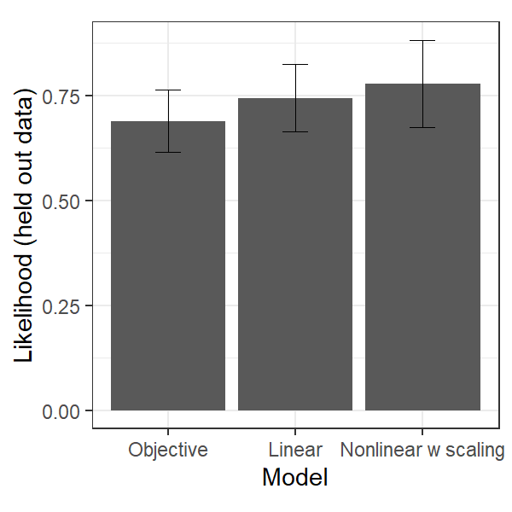
Notes. Resembling previous studies (Bowler et al., 2021; Hauser et al., 2017a, 2017b), the model with a nonlinear increase in subjective information gathering cost was found to fit the participants’ task performance best, and that these subjective costs did not seem to follow either the external costs on the task (i.e., the objective model: 0 points in the no-cost condition and -10 points in the costly condition), or a linear increase (i.e., the linear model). Means and standard deviations of predictive likelihood across conditions are shown. The objective model is treated as the reference model.

Figure S2
Descriptive Summary of Information Gathering Task Performance
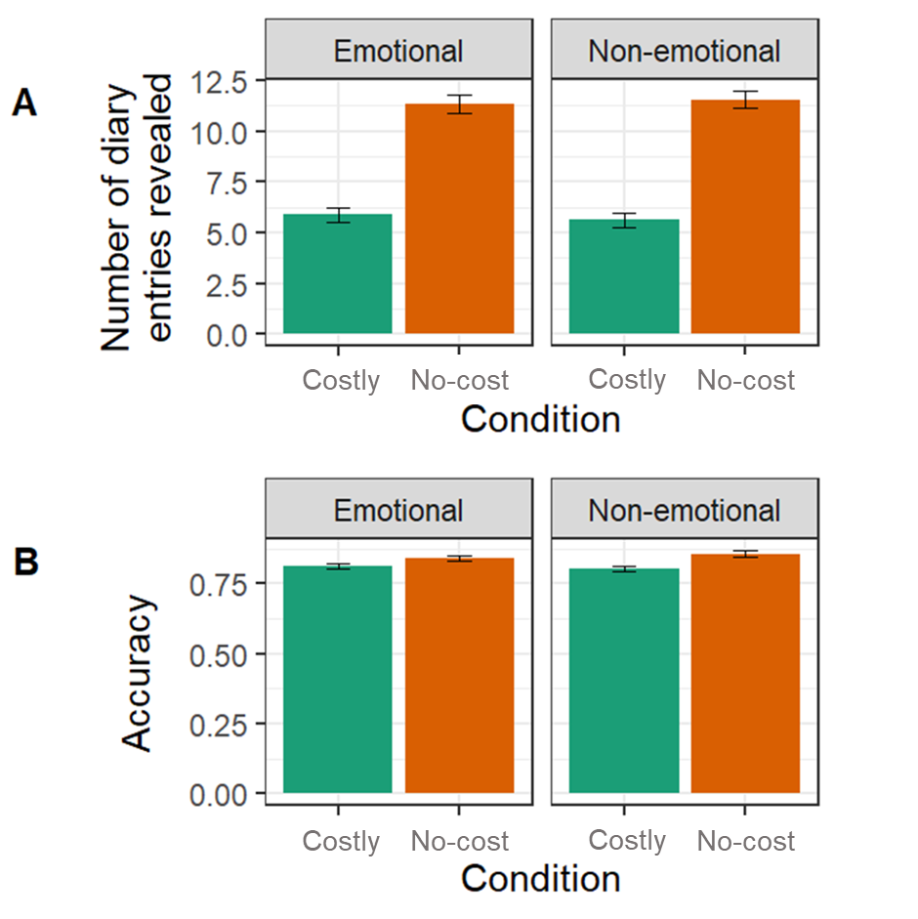
Notes. (A) Total draws defined by the number of diary entries the participant revealed before making a guess by information type and cost conditions. (B) Accuracy by information type and cost conditions. Participants had significantly fewer draws when information gathering was penalised in the costly condition than when it was not in the no-cost condition (F(1,96) = 99.24, p <.001, η_{p}² = .25), replicating past studies (Bowler et al., 2021; Hauser et al., 2017a, 2017b). Means and standard errors are shown here.
Figure S3
Descriptive Summary of Number of Draws by Age Groups
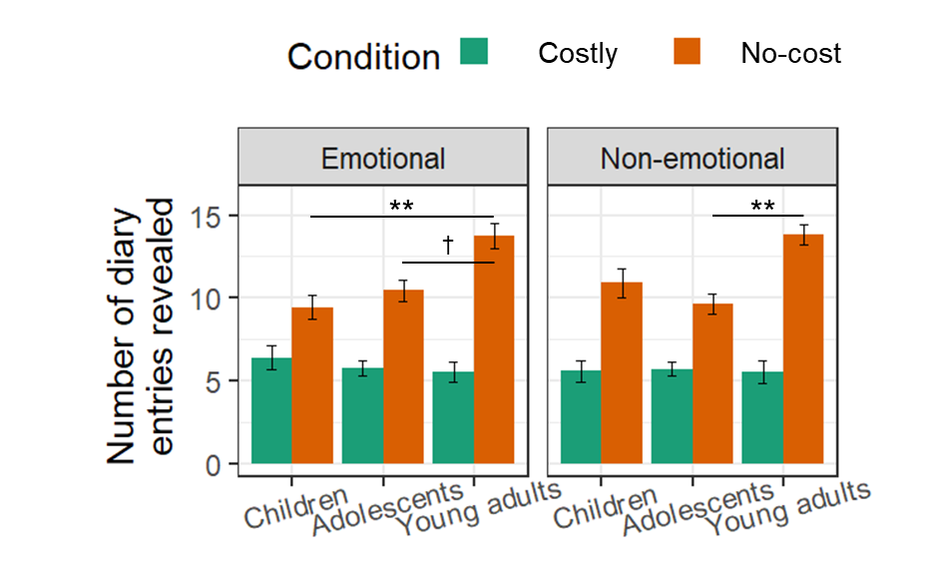
Notes. To provide a more direct comparison with the previous study (Bowler et al., 2021), the current study showed that children (aged 6-10) revealed slightly more diary entries than adolescents (aged 11-15) in the non-emotional no-cost condition, but this did not reach statistical significance. Additionally, young adults (aged 18-25) were found to have more draws than children and adolescents (especially in the emotional conditions). No significant differences were found between age groups in the costly conditions, which were consistent with the previous study. Means and standard errors are shown here.
† p <.10, ** p <.01.

Figure S4
Distributions of Trait Measures
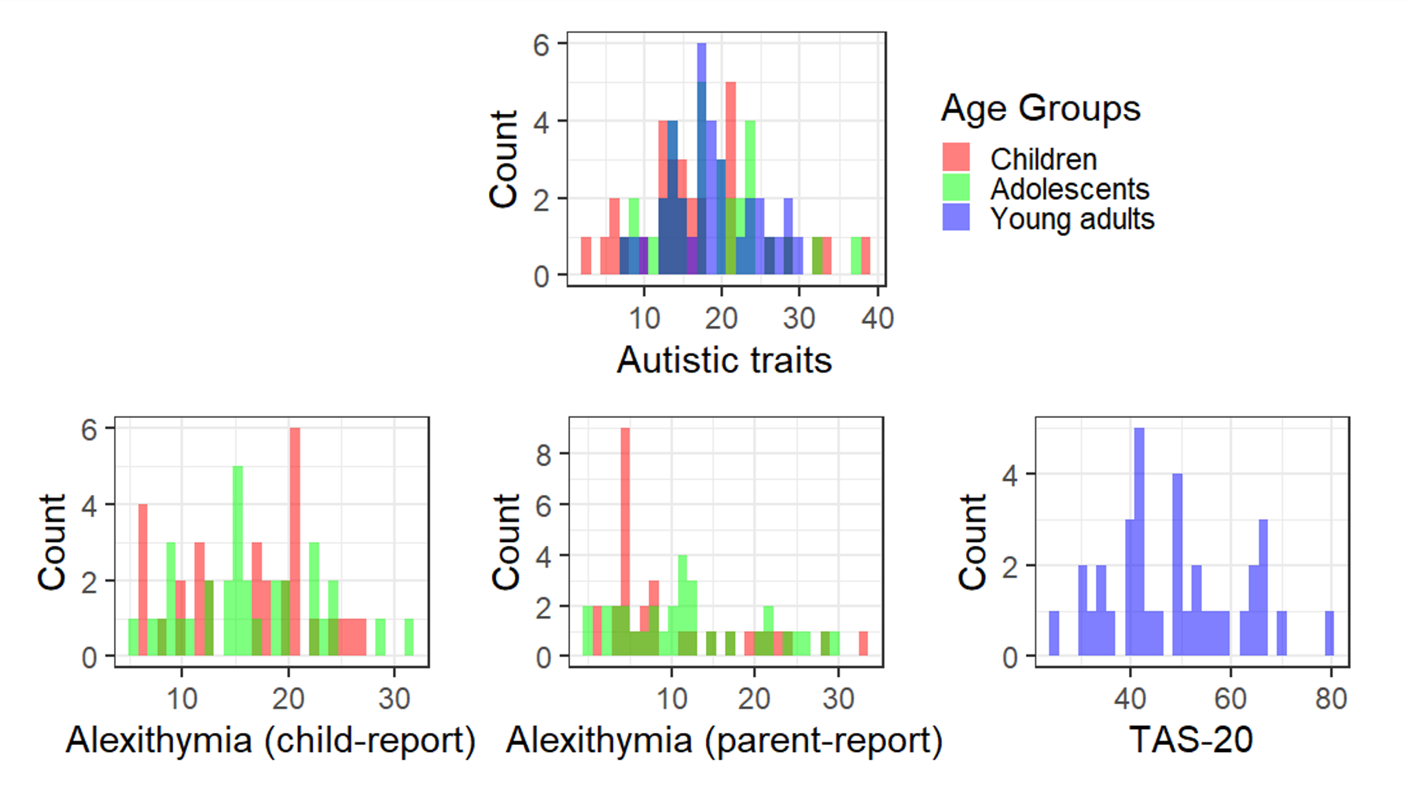
Notes. Raw scores are presented here. TAS-20 = 20-item Toronto Alexithymia Scale, completed by young adults.

