Supplementary Information

Procedure details
Instructions
Instructions were given in connection to the application of the electric pulse stimulator and electrodes to measure skin conductance, before the start of the acquisition block. Participants were informed that stimulators are used to administer brief electric shocks and that the electrodes were used to measure physiological responses. In case they wanted to know more about the electric shocks they were informed that if they were to receive shocks they would be uncomfortable but not painful and that the strength of the shocks was based on previous studies. They were not specifically informed that they would, or would not, receive shocks.
Decision-making trials
Each trial during the instrumental decision-making part of the experiment started with the presentation of a white fixation cross against a black background (duration varied 3.5 – 4.5 s), followed by the stimuli presentation (presented until a choice is made, maximum 2 s). Following the participant’s choice, the decision was indicated with a white frame (1 s). Each trial ended with the presentation of blank black screen (5.5- 6.5 s), during which the shock was administered, for those cases when the decision was supposed to be followed by a shock (between 3.5 to 4.5 s after onset). See also SI Fig. 1.
Failure to make a decision
Participants in some cases failed to make a decision within the 2 s time limit, leading to missing data for on average 2.25 trials per participant. The number of missing decisions per participant included in the analyses ranged from 0 to 16.
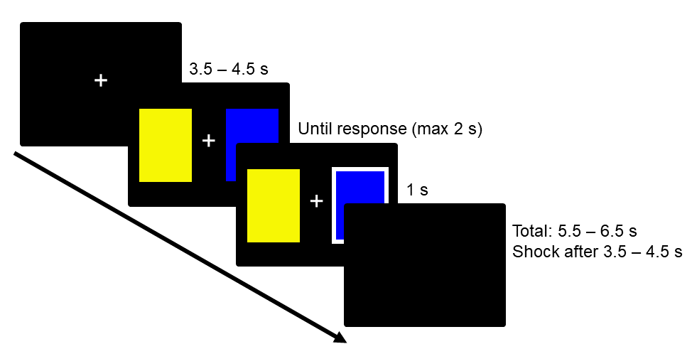
SI Fig. 1. Timing details per trial during the instrumental decision-making task.

Supplementary analyses
Model details – instrumental decision-making
In our main analyses of the behavioral data, for each phase in the instrumental decision-making task we ran two logistic generalized mixed models with choice optimality (optimal choice = 1, suboptimal choice = 0) as the binary outcome: one to test the existence of a transfer effect (effect of Condition), the other to test if this effect was influenced by Group (interaction between Condition and Group). Time was used as a covariate. For all models, Condition was dummy coded (No change = -0.5, Change = 0.5), Time was log(trial) with trial ranging from 1 to 35 centered at log(18) (the middle trial in each phase). We used by-participant random intercepts and random slopes for all within-participant effects. Analysis of variance was calculated with the type II Wald chi-square test using the Anova function in the car package. Here (SI Table 1-8) we present the Anova and summary tables of the four models included in the main analyses.

Acquisition including the SCR to all CS presentations
Analyses of the ΔSCR during acquisition with inclusion of the responses at trial 1 also showed successful threat conditioning as ΔSCR was larger than zero (Estimate = 0.18, SE = 0.04, t = 4.85, p < 0.001). Again, there was no effect of Group on ΔSCR (p= 0.83). Our results where thus not dependent on the removal of the first (unbalanced) trial. See also SI Fig 2.

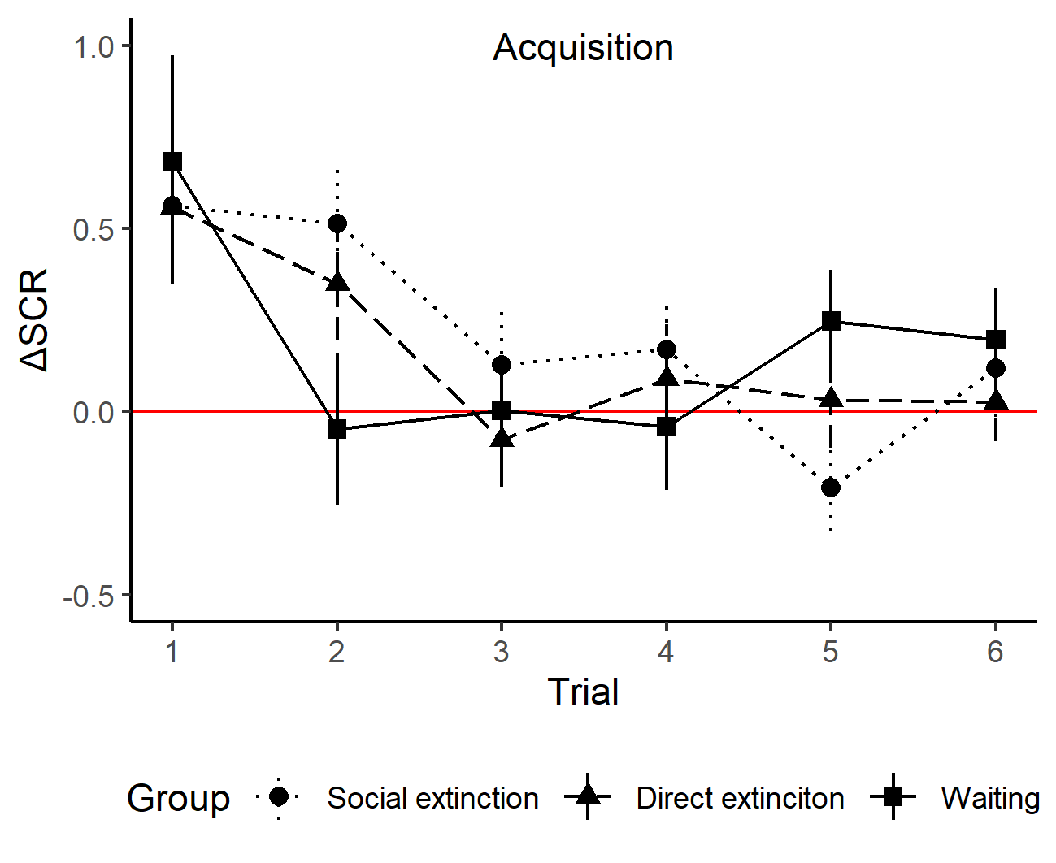
SI Fig. 2. The figure shows the mean difference scores, ΔSCR (CS+ - CS-), for SCR per Group and Trial during acquisition and extinction. Error bars represent the standard error of the mean. The red line indicates no differentiation (ΔSCR = 0).

Model details of the analyses of the transfer effect
- Transfer phase, testing the transfer effect (effect of Condition):

SI Table 1. Anova table, the transfer effect during transfer phase.
 | Optimal
Predictors | Χ² | Df | P
Condition | 70.465 | 1 | <0.001
Time | 80.007 | 1 | <0.001

SI Table 2. Summary table, the transfer effect during transfer phase.
 | Optimal………..
Predictors | Odds Ratios | CI | p
(Intercept) | 4.92 | 4.22 – 5.73 | <0.001
Condition | 0.33 | 0.25 – 0.42 | <0.001
Time | 1.50 | 1.38 – 1.64 | <0.001
Random Effects
σ² | 3.29
τ₀₀ _{Subject} | 1.07
τ₁₁ _{Subject.Time} | 0.20
ρ₀₁ _{Subject} | 0.76
ICC | 0.24
N _{Subject} | 230
Observations | 7815
Marginal R² / Conditional R² | 0.091 / 0.310  1

- Transfer phase, testing the influence of Group on the transfer effect (effect of interaction Condition:Group):
SI Table 3. Anova table, influence of Group on the transfer effect during transfer phase.
 | Optimal
Predictors | Χ² | Df | P
Condition | 71.274 | 1 | <0.001
Time | 80.080 | 1 | <0.001
Group | 0.981 | 2 | 0.612
Condition:Group | 0.565 | 2 | 0.754

SI Table 4. Summary table, influence of Group on the transfer effect during transfer phase.
 | Optimal………..
Predictors | Odds Ratios | CI | p
(Intercept) | 4.47 | 3.49 – 5.71 | <0.001
Condition | 0.34 | 0.21 – 0.54 | <0.001
Time | 1.50 | 1.38 – 1.65 | <0.001
Group[Social] | 1.17 | 0.86 – 1.59 | 0.314
Group[Direct] | 1.12 | 0.83 – 1.52 | 0.454
Condition:Group[Social] | 0.85 | 0.46 – 1.57 | 0.611
Condition:Group[Direct] | 1.06 | 0.58 – 1.93 | 0.861
Random Effects
σ² | 3.29
τ₀₀ _{Subject} | 1.07
τ₁₁ _{Subject.Time} | 0.20
ρ₀₁ _{Subject} | 0.76
ICC | 0.24
N _{Subject} | 230
Observations | 7815
Marginal R² / Conditional R² | 0.092 / 0.311  1

- Reversal phase, testing the transfer effect (effect of Condition):

SI Table 5. Anova table, transfer effect during reversal phase.
 | Optimal
Predictors | Χ² | Df | P
Condition | 10.483 | 1 | 0.001
Time | 231.091 | 1 | <0.001

SI Table 6. Summary table, transfer effect during reversal phase.
 | Optimal………..
Predictors | Odds Ratios | CI | p
(Intercept) | 2.18 | 1.88 – 2.53 | <0.001
Condition | 1.57 | 1.20 – 2.07 | 0.001
Time | 2.24 | 2.02 – 2.48 | <0.001
Random Effects
σ² | 3.29
τ₀₀ _{Subject} | 1.09
τ₁₁ _{Subject.Time} | 0.36
ρ₀₁ _{Subject} | 0.40
ICC | 0.28
N _{Subject} | 230
Observations | 7767
Marginal R² / Conditional R² | 0.103 / 0.350  1

- Reversal phase, testing the influence of Group on the transfer effect (effect of interaction Condition:Group):
SI Table 7. Anova table, influence of Group on transfer effect during reversal phase.
 | Optimal
Predictors | Χ² | Df | P
Condition | 10.811 | 1 | 0.001
Time | 231.164 | 1 | <0.001
Group | 2.475 | 2 | 0.290
Condition:Group | 1.839 | 2 | 0.399

SI Table 8. Summary table,influence of Group on transfer effect during reversal phase.
 | Optimal………..
Predictors | Odds Ratios | CI | p
(Intercept) | 1.85 | 1.42 – 2.41 | <0.001
Condition | 1.29 | 0.77 – 2.18 | 0.331
Time | 2.24 | 2.02 – 2.48 | <0.001
Group[Social] | 1.20 | 0.85 – 1.69 | 0.300
Group[Direct] | 1.32 | 0.94 – 1.86 | 0.111
Condition:Group[Social] | 1.11 | 0.56 – 2.22 | 0.766
Condition:Group[Direct] | 1.55 | 0.78 – 3.09 | 0.209
Random Effects
σ² | 3.29
τ₀₀ _{Subject} | 1.07
τ₁₁ _{Subject.Time} | 0.36
ρ₀₁ _{Subject} | 0.40
ICC | 0.27
N _{Subject} | 230
Observations | 7767
Marginal R² / Conditional R² | 0.107 / 0.349  1

The transfer effect including the linear effect of time
In our analyses testing the effect of Condition, as well as the interaction between Group and Condition, time was included as a covariate of no interest using log(Trial). We also performed additional analyses using the linear effect of time as covariate, Trial, centered at 18 (middle of each phase) and scaled to be within a range of ± 0.5. When testing the effect of Condition the model using log(Trial) provided a better fit of the data for both the transfer phase (AIC difference 9.6) and the reversal phase (AIC difference 158.5). These additional analyses again showed an effect of Condition during both the Transfer and Reversal phase (Transfer: Chisq. = 59.195, p < 0.001; Estimate = -1.02, SE = 0.13, z = -7.69, p < 0.001; Reversal: Chisq. = 10.003, p = 0.002; Estimate = 0.43, SE = 0.14, z = 3.16, p = 0.002), but no interaction between Group and Condition during neither of the phases (Transfer p = 0.85; Reversal: p = 0.33).

Interaction effects of Group, Condition and Time
In addition to our main analyses, we tested if there was an effect of Group on the temporal aspects of the transfer effect, for instance by affecting the rate at which the participants learned the instrumental task over time. For instance, one could imagine that extinction learning might improve the speed with which participants adjusted their responses. There was no significant three-way interaction between Group, Condition and Time during the transfer phase (p = 0.88), nor during the reversal phase (p = 0.23), thus no effect of Group on the temporal aspects of the transfer effect.

Transfer effects after exclusion of individuals with missing SCR
Additional analyses of the behavioral data after exclusion of participants with missing SCR data showed that our results were not dependent on this exclusion/inclusion criteria as the general pattern of results were very similar. In the transfer phase, as expected, there was an effect of Condition (Chisq. = 61.46, p < 0.001; Estimate = -1.07, SE = 0.14, z = -7.84, p < 0.001), evident of a social to instrumental transfer effect. Further, we saw no significant interaction between Group and Condition (p = 0.59). Similarly, in the reversal phase, there was still an effect of Condition (Chisq. = 10.81, p = 0.001; Estimate = 0.52, SE = 0.16, z = 3.35, p < 0.001), in the reversed direction compared to the transfer phase. We saw no significant interaction between Condition and Group (p = 0.52).

Transfer effects after inclusion of individuals who were unable to correctly report which CS had been
paired with a shock
In our main analyses, participants who were unable to correctly report which CS had been paired with a shock were excluded (Social extinction: 6 excluded; Direct extinction: 6 excluded; Waiting:
2 excluded). Additional analyses where these individuals were included showed, as expected, an effect of Condition during both the transfer phase (Chisq. = 65.43, p < 0.001; Estimate = -1.05, SE = 0.13, z = -8.09, p < 0.001) and the reversal phase (Chisq. = 10.21, p = 0.001; Estimate = 0.43, SE = 0.13, z = 3.20, p = 0.001), evident of a social to instrumental transfer effect. There was no significant interaction between Condition and Group in either of the phases (transfer phase: p = 0.89; reversal phase: p = 0.26). Our results can thus not be explained by the exclusion of these participants.

Effects of Extinction (yes/no) on the transfer effect
In order to thoroughly test if any extinction procedure regardless of type could diminish the transfer effect we tested if Extinction (yes, no), rather than Group, interacted with Condition in the instrumental decision-making task. Here, participants in both the Social and the Direct extinction groups were coded as undergoing extinction, while those not undergoing extinction consisted of the Waiting group. We saw no interaction between Condition and Extinction during either the transfer phase (p = 0.86) nor the reversal phase (p = 0.39).

