Supplementary Materials
Affective control in adolescence: The influence of age and depressive symptomatology on working memory.
Griffiths. K^{a, *}, Dunning. D. L ^{a,*}., Parker. Jª., Bennett. Mª., Schweizer. S^{a,c,e}., Foulkes. L^{b}., Ahmed. S^{b}., Leung. J. T^{b}., Griffin. C^{b}., Sakhardande. A^{b}., Kuyken. W^{c}., Williams. J.M.G^{c}., the MYRIAD team^, Blakemore. S-J^{b, d}., Dalgleish. T ^{a,f,+} & Stretton. J ^{a+}.
ª Medical Research Council Cognition and Brain Sciences Unit, Cambridge University, Cambridge, CB2 7EF, UK

^{b} Institute of Cognitive Neuroscience, University College London, London, WC1N 3AR, UK

^{c} Department of Psychiatry, University of Oxford, Oxford, OX3 7JX, UK

^{d} Department of Psychology, Downing Street, University of Cambridge, Cambridge, CB2 3EB, UK

^{e} School of Psychology, University of New South Wales, Sydney, NSW 2052

^{f} Cambridgeshire and Peterborough NHS Foundation Trust

* Joint first authors

+ Joint senior authors

^ The MYRIAD Team comprises Saz Ahmed, PhD, of University College London, Susan Ball, MSc, of University of Exeter, Marc Bennett, PsyD, of University of Cambridge, Nicola Dalrymple, MSc, of University of Oxford, Darren Dunning, PhD, of University of Cambridge, Katie Fletcher, HSD, of University of Oxford, Lucy Foulkes, PhD, of University College London, Poushali Ganguli, MSc, of Kings College London, Cait Griffin, MSc, of University of Cambridge, Kirsty Griffiths, MSc, of University of Cambridge, Konstantina Komninidou, BEd, of University of Oxford, Rachel Knight, MSc, of University of Cambridge, Suzannah Laws, BSc, of University of Oxford, Jovita Leung, MSc, of University College London, Jenna Parker, MSc, of University of East Anglia, Blanca Piera Pi-Sunyer, MSc, of University College London, J. Ashok Sakhardande, BSc Hons, Jem Shackleford, MA, MSc, and Kate Tudor, PhD, of University of Oxford, Maris Vainre, MA, of University of Cambridge, and Brian Wainman, BEng, of Plymouth University. These individuals have worked across the MYRIAD strategic award ‘Promoting Mental Health and Building Resilience in Adolescence: Investigating Mindfulness and Attentional Control’; they are acknowledged as group authors in this article for their substantial contributions to the project development, in accordance with the MYRIAD Dissemination Protocol.

Funding Statement
This work was supported by grants from the Wellcome [104908/Z/14/Z, 107496/Z/15/Z], the UK Medical Research Council (Grant Reference: SUAG/043 G101400) and by the NIHR Cambridge Biomedical Research Centre (BRC-1215-20014).
Supplementary Table S1. Words used in the Affective Picture Span Paradigm (word lists A and B).
Trial block | Word list A | Word list B
Block 1 | Meal; Coat; Sink; Land; String | Seat; Cook; Well; Step; Case
Block 2 | Dime; Stone | Pear; Form
Block 3 | Spoon; Back; Snow | Inch; Spring; Tray
Block 4 | Watch; Drink; Wheel; Hair | Tape; Wood; Stand; Plate
Block 5 | Paint; Group; Phone; Door | Shape; Stair; Farm; Glass
Block 6 | Yawn; Plug; Juice; Note; Floor | Dress; Plug; Juice; Float; Shape
Block 7 | Skirt; Toast; Page | Lamp; Sock; Root
Block 8 | Ounce; Light | Soap; Edge
Note. Wordlists A and B are the lists of target words in each counterbalanced version of the APSP task. For the first counterbalanced condition, two practice blocks with 3-item loadings (Kick, Belt, Dream; Brain, Aunt, Dance) were presented.

Supplementary Table S2. Background APSP image ratings for valence and pleasure.
 | Neutral |  | Negative
 | M | SD | M | SD | t | p | d
Pleasure | 5.50 | 0.31 | 1.87 | 0.32 | 30.39 | <.001 | 11.52
Arousal | 3.92 | 0.57 | 5.68 | 0.47 | 8.97 | <.001 | 3.37
Note. Ratings used 7-point Likert scales completed by n=7 raters. Pleasure ranged from 1 (Unpleasant) to 7 (Pleasant); Arousal ranged from 1 (Calm) to 7 (Excited). (M= mean; SD = Standard Deviation).

Supplementary Methods

Power Analysis for the MYRIAD trial.
The MYRIAD project studies are powered to detect differential effects of Mindfulness Training (MT) versus comparison conditions on tasks measuring the central components of executive control, based on an effect size (ES) of 0.6 derived from the extant literature. At 80% power, with a two-tailed alpha set at 0.05, and assuming 10% attrition from pre- to post-training, recruiting n=90 (Theme 1A), n=150 (Theme 1B), and n=60 (Theme 1C) participants per condition at pre-training to compare the effects of MT vs Psychosocial-Education on our experimental tasks at post-training, will allow us to detect ES’s of 0.44, 0.34 and 0.54, respectively, at post-training. Assuming 20% attrition at two months post-training, these sample sizes at recruitment will allow us to detect controlled ES’s across conditions on our self-report measures at follow-up of 0.47 (Theme 1A), 0.36 (Theme 1B) and 0.58 (Theme 1C). These sample sizes will also permit exploratory analyses of the moderating influence of age and pubertal status on training (1B) and the mediating influence of changes in cognitive task performance across training on subsequent self-report measures two months later (Themes 1A, 1B, 1C).

Adapting the Attention Target Detection Rate (ATDR) to an adolescent cohort.

The ATDR is the degree to which an individual has sustained his or her attention on the trial whilst also attending to the WM component of the task (i.e. the words presented and recalled). In the APSP task, the ATDR is the proportion of trials in which participants correctly report the number of shapes super-imposed on the background images. Attention to the shapes is critical as this represents the operation component of the task, making it a complex span task. It is useful to set an ATDR cut-off as it excludes participants who are not attending sufficiently to the operation element of the task, but rather simply focussing on the storage aspect (encoding the words). In adults, the ATDR cut-off is typically set at around 75% (Conway et al., 2005). The mean ATDR in the present study was lower than this (M=71.62%, SD= 15.48), with 217 adolescents scoring less than 75%.
We revised the ATDR for the adapted APSP. We applied Tukey’s test as a robust cut-off for identifying outliers, which suggested 1.5 times the inter-quartile range (IQR) below the first quartile the cut-off. This generated an ATDR cut-off of 42.75%, with participants scoring below this were set aside from analysis. To ensure attention was maintained to both the operation and the storage components of the task, we also applied a cut-off for participants that performed poorly on word recall, with those that had recall for target words in both WMC neutral and negative conditions lower than 1.5 IQR set aside from analysis; Participants that paid moderate attention to one condition and not the other (i.e., word recall for one WMC condition was within the 1.5 IQR range, but the other condition was below the 2.2 IQR) were also set aside from analysis.

Supplementary Results
Overall WMC performance between negative versus neutral conditions, with increasing cognitive load (2-item; 3-item; 4-item and 5-item)
A one-way MANOVA was run to determine the effect of condition with cognitive load (i.e. target word blocks containing 2-item, 3-item, 4-item and 5-item loading).
Supplementary Table S3; Descriptive Statistics for Each Cognitive Load
 | Load |  |  | Statistic | Std. Error
APSP | Load2 | Mean |  | .8979 | .00633
APSP | Load2 | 95% Confidence Interval for Mean | Lower Bound | .8855
APSP | Load2 | 95% Confidence Interval for Mean | Upper Bound | .9104
APSP | Load2 | 5% Trimmed Mean |  | .9206
APSP | Load2 | Median |  | 1.0000
APSP | Load2 | Variance |  | .034
APSP | Load2 | Std. Deviation |  | .18469
APSP | Load2 | Minimum |  | .00
APSP | Load2 | Maximum |  | 1.00
APSP | Load2 | Range |  | 1.00
APSP | Load2 | Interquartile Range |  | .25
APSP | Load2 | Skewness |  | -1.856 | .084
APSP | Load2 | Kurtosis |  | 2.992 | .168
APSP | Load3 | Mean |  | .7981 | .00827
APSP | Load3 | 95% Confidence Interval for Mean | Lower Bound | .7819
APSP | Load3 | 95% Confidence Interval for Mean | Upper Bound | .8144
APSP | Load3 | 5% Trimmed Mean |  | .8212
APSP | Load3 | Median |  | .8300
APSP | Load3 | Variance |  | .058
APSP | Load3 | Std. Deviation |  | .24099
APSP | Load3 | Minimum |  | .00
APSP | Load3 | Maximum |  | 1.00
APSP | Load3 | Range |  | 1.00
APSP | Load3 | Interquartile Range |  | .33
APSP | Load3 | Skewness |  | -1.153 | .084
APSP | Load3 | Kurtosis |  | .636 | .168
APSP | Load4 | Mean |  | .7132 | .00884
APSP | Load4 | 95% Confidence Interval for Mean | Lower Bound | .6958
APSP | Load4 | 95% Confidence Interval for Mean | Upper Bound | .7305
APSP | Load4 | 5% Trimmed Mean |  | .7314
APSP | Load4 | Median |  | .7500
APSP | Load4 | Variance |  | .066
APSP | Load4 | Std. Deviation |  | .25764
APSP | Load4 | Minimum |  | .00
APSP | Load4 | Maximum |  | 1.00
APSP | Load4 | Range |  | 1.00
APSP | Load4 | Interquartile Range |  | .38
APSP | Load4 | Skewness |  | -.760 | .084
APSP | Load4 | Kurtosis |  | -.200 | .168
APSP | Load5 | Mean |  | .5868 | .00856
APSP | Load5 | 95% Confidence Interval for Mean | Lower Bound | .5700
APSP | Load5 | 95% Confidence Interval for Mean | Upper Bound | .6036
APSP | Load5 | 5% Trimmed Mean |  | .5915
APSP | Load5 | Median |  | .6000
APSP | Load5 | Variance |  | .062
APSP | Load5 | Std. Deviation |  | .24960
APSP | Load5 | Minimum |  | .00
APSP | Load5 | Maximum |  | 1.00
APSP | Load5 | Range |  | 1.00
APSP | Load5 | Interquartile Range |  | .40
APSP | Load5 | Skewness |  | -.165 | .084
APSP | Load5 | Kurtosis |  | -.760 | .168

There was a significant difference between conditions on the combined cognitive loading (F(4,421)=3.32, p=.011, Wilks’ Λ =.97; partial eta²=.03). Follow up univariate ANOVAs showed that a 3-item loadings (F(1,424)=6.04, p=.014; partial eta²=.01) and 4-item loadings (F(1,424)=7.86, p=.005; partial eta²=.02) were significantly different between affective conditions. Pairwise comparison found participant performance in the 3-item loading was worse in the negative condition (M=.78, SE=.01; CI [.76 to .81]) than in the neutral condition (M=.82, SE=.01; CI [.79 to .84]), p=.014, Cohen’s d=.14). In addition, overall participant performance in a 4-item loading was worse in the negative condition (M=.69, SE=.01; CI [.67 to .72]) than in the neutral condition (M=.73, SE=.01; CI [.71 to .76]), p=.005, Cohen’s d=.16). There was no statistically significant differences between affective conditions for the 2-item loadings (F(1,424)=.21, p=.65; partial eta²<.001) and 5-item loadings (F(1,424)=.84, p=.360; partial eta²=.002).
Supplementary Table S4. Correlation matrix for all variables.
 | Age | CES-D | Gender | APSP-Neutral | APSP-Negative
CES-D | .17**
Gender | -.13** | -.23**
APSP-Neutral | .16** | .01 | .00
APSP-Negative | .18** | -.01 | -.01 | .55**
Risk Cut-Off | .15** | .77** | -.20** | -.01 | -.02

Note. Significance level * = p<0.05** = p<0.01. Binary coding for gender = 0 (female); 1(male); Binary coding for Risk cut-off = 0 (low risk) 1 = at risk; CES-D = Center for Epidemiological Studies – Depression Scale. APSP = Affective Picture Span Paradigm.

Risk group comparison

We used a clinically robust cut-off of 16 on the CES-D to create ‘lower risk’ and ‘at risk’ of developing depression.

Supplementary Table S5. Demographic and mental health characteristics for the ‘lower risk’ and ‘at risk’ groups, based on the CES-D cut-off score of 16. CES-D = Center for Epidemiological Studies–Depression Scale; IQ = Intelligence Quotient; df = degrees of freedom; APSP = Affective Picture Span Paradigm.
 |  | CES-D:  ‘lower risk’  (n=221) | CES-D:  ‘at risk’  (n=204) | t (df) | X²(df) | p
Age (Mean, SD) |  | 14.18 (1.63) | 14.69 (1.80) | -3.04 (423) | - |  | .002
Gender (n female, % ) |  | 128 (57.9) | 156 (76.5) | - | 16.47 (1) |  | <.001
CES-D (Mean, SD) |  | 9.47 (3.96) | 26.08 (899) | -24.96 (423) | - |  | <0.001
APSP-Neutral (Mean, SD)  APSP-Negative (Mean, SD) |  | 0.76 (.16)  0.74 (.17) | 0.76 (.15)  0.73 (.16) | 0.27 (423)  0.38 (423) | -  - |  | 0.79  0.71

As expected, the groups significantly differed in terms of their CES-D score. There was also a significant difference in age, with participants in the ‘at risk’ group being slightly older on average than the ‘lower risk’ group, consistent with age-related increases in depression in adolescence (Kwong et al., 2019). Similarly, the ‘at risk’ group contained a significantly larger proportion of females than the lower risk group. There were no significant group differences in APSP performance for each condition (Supplementary Table S5).
Linear Mixed-Effects Models;
Again, there was a significant effect of Age (β =0.15, t =2.49, p=0.013, CI [.003: .027]). However, risk status and the risk*age interaction were not significant predictors of performance (Supplementary Table S6 nb. See Table 3 in the manuscript for the restricted model). The Likelihood Ratio Test of the X² distribution of the full (-2 LL(df) = 139.48(12)) and restricted models was not significant (p = 0.87, Cohen’s w = 0.04) indicating the addition of risk status and its interactions were not significant in predicting performance on the APSP (Supplementary Table S6).
Supplementary Table S6. Full Linear Mixed-Effects Model including Age, Valence, risk status and interactions for predicting APSP Performance (n = 425).
Effect | Estimate | SE | df | 95% CI |  | p
Effect | Estimate | SE |  | LL | UL | p
Fixed effects
Intercept | .56 | .87 | 550.9 | .39 | .74 | <.001
Age | .01 | .00 | 553.1 | .01 | .03 | .013*
Valence | -.07 | .06 | 2769.4 | -.21 | .05 | .25
Risk | .03 | .11 | 405.6 | -.18 | .26 | .46
Valence*Age | .003 | .00 | 2769.4 | -.00 | .01 | .41
Risk*Age | -.003 | .01 | 409.6 | -.02 | .01 | .69
Risk*Age*Valence | .00 | .0 01 | 2769.4 | -.01 | .01 | .96
Random effects
Subject | .0123 | .0013 | n/a | .01 | .015 | <0.001
Repeated effects
Load 2 | .046 | .0028 | n/a | .04 | .05 | <0.001
Load 3 | .043 | .0023 | n/a | .038 | .047 | <0.001
Load 4 | .0504 | .0028 | n/a | .045 | .05 | <0.001
Load 5 | .0812 | .0046 | n/a | .072 | .09 | <0.001
Note. SE = Standard Error; df = Degrees of Freedom; CI = confidence interval; LL = lower limit; UL = upper limit. * Significant p<0.05

ATDR Performance.
A paired t-test revealed a significant difference in performance between the ATDR-Neutral and ATDR-Negative conditions across all participants (t(424)=2.99, p=.003, d=0.14), with participants identifying the correct number of shapes more frequently in the ATDR-Neutral (M=75.38 SE=.59) condition relative to the ATDR-Negative (M=73.75, SE=.63) condition.
The Linear Mixed-Effects Model showed ATDR performance in both conditions improved with age (F(1,405)=7.82, p=0.005)) Similarly to the main analysis of APSP performance, there was no significant main effects of Valence or CESD nor any significant interactions. The restricted model again fit the data well and showed a sole significant main effect of age (F(1,425)=36.9, p<0.001). A Likelihood Ratio Test showed no significant difference (p=0.57, Cohen’s w = 0.05) between the models indicating the addition of CESD and its interaction did not affect ATDR performance.
Supplementary Table S7. CES-D Descriptive and Distribution Statistics
N |  | 425
Mean |  | 17.4411
Median |  | 15
Skewness |  | .993
Std. Error of Skewness |  | .118
Kurtosis |  | .807
Std. Error of Kurtosis |  | .236
Minimum |  | .00
Maximum |  | 56.00

Reliability analysis;
We conducted a split-half reliability analysis to assess the internal consistency of our APSP scores in each condition. For APSP Neutral scores, we obtained a split-half reliability coefficient of 0.58 and for APSP Negative, 0.61 indicating questionable reliability in our dependent measure.

Supplementary Figure 1. Histogram of Age Distribution
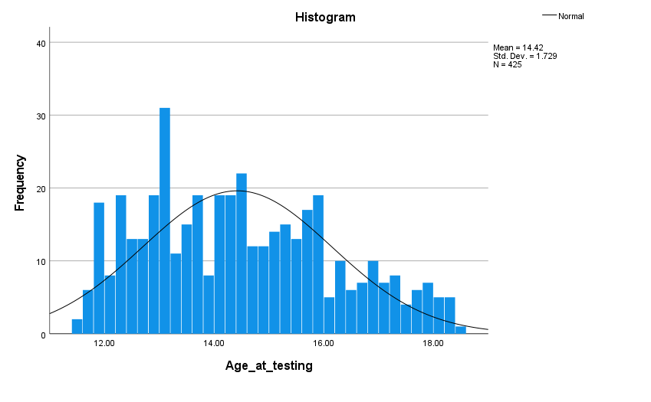

Supplementary Figure 2. Histogram of CES-D Distribution
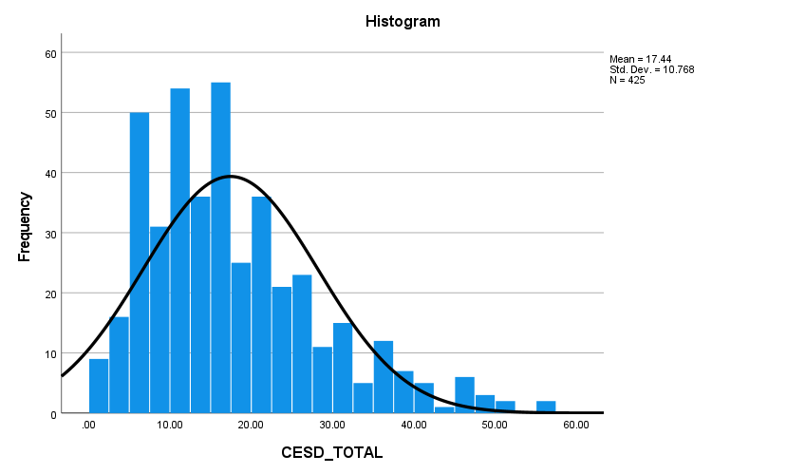

Supplementary References
Conway, A. R., Kane, M. J., Bunting, M. F., Hambrick, D. Z., Wilhelm, O., & Engle, R. W. (2005). Working memory span tasks: A methodological review and user's guide. Psychon Bull Rev, 12(5), 769-786. doi:10.3758/bf03196772
Kwong, A. S. F., Lopez-Lopez, J. A., Hammerton, G., Manley, D., Timpson, N. J., Leckie, G., & Pearson, R. M. (2019). Genetic and Environmental Risk Factors Associated With Trajectories of Depression Symptoms From Adolescence to Young Adulthood. JAMA Netw Open, 2(6), e196587. doi:10.1001/jamanetworkopen.2019.6587

