Supplement
Table S1:
Number of times (out of 50) a discrete emotion label was selected as the one best describing the emotion elicited by a particular scene in Experiment 1.
IAPS No – Content | Sad | Contentment | Happiness | Fear | Surprise | Anger | Disgust
1019 – Snake | 1 | 0 | 0 | 13 | 0 | 0 | 34
1052 – Snake | 0 | 2 | 1 | 41 | 2 | 0 | 4
1113 – Snake | 0 | 1 | 1 | 44 | 1 | 1 | 2
1200 – Spider | 0 | 2 | 1 | 31 | 2 | 0 | 14
1300 – Snarling dog | 0 | 0 | 2 | 33 | 1 | 5 | 9
1930 – Shark | 0 | 1 | 0 | 44 | 3 | 0 | 2
1931 – Shark | 0 | 3 | 1 | 43 | 2 | 1 | 0
9600- Sinking ship | 31 | 0 | 0 | 16 | 0 | 2 | 1
Mean: Fear scenes | 4 | 1.13 | 0.75 | 33.13 | 1.38 | 1.13 | 8.25
1440 – Baby seal | 1 | 13 | 35 | 0 | 1 | 0 | 0
1460 – Kitten | 4 | 14 | 31 | 0 | 1 | 0 | 0
1463 – Kittens | 0 | 5 | 43 | 0 | 1 | 0 | 1
1710 – Puppies | 0 | 5 | 44 | 0 | 1 | 0 | 0
5480 – Fireworks | 0 | 11 | 24 | 0 | 14 | 1 | 0
5760 – Flowers | 0 | 26 | 24 | 0 | 0 | 0 | 0
5814 – Beach | 3 | 31 | 9 | 4 | 3 | 0 | 0
7502 – Disney world | 3 | 31 | 9 | 4 | 3 | 0 | 0
Mean: Pleasant scenes | 1.38 | 17 | 27.38 | 1 | 3 | 0.13 | 0.13

Table S2
Number of times (out of 60) a discrete emotion label was selected as the one best describing the emotion elicited by a particular scene in Experiment 2.
IAPS No – Content | Sad | Contentment | Happiness | Fear | Surprise | Anger | Disgust
1052 – Snake | 0 | 1 | 3 | 44 | 8 | 2 | 2
1200 – Spider | 0 | 5 | 1 | 40 | 3 | 3 | 8
1300 – Snarling dog | 0 | 0 | 1 | 45 | 4 | 9 | 1
1931 – Shark | 1 | 4 | 2 | 51 | 2 | 0 | 0
Mean: Fear Scenes | 0.25 | 2.5 | 1.75 | 45 | 4.25 | 3.5 | 2.75
7380 – Roach on pizza | 0 | 1 | 0 | 3 | 0 | 0 | 56
9300 – Dirty toilet | 0 | 0 | 1 | 2 | 0 | 0 | 57
9570 – Decaying dog | 22 | 0 | 0 | 3 | 1 | 5 | 29
9830 – Rubbish | 3 | 2 | 0 | 3 | 2 | 8 | 42
Mean: Disgust Scenes | 6.25 | 0.75 | 0.25 | 2.75 | 0.75 | 3.25 | 46

Table S3
Number of times (out of 97) a discrete emotion label was selected as the one best describing the emotion elicited by a particular scene in Experiment 3.
IAPS No – Content | Sad | Contentment | Happiness | Fear | Surprise | Anger | Disgust
1110 – Snake | 2 | 17 | 0 | 60 | 15 | 0 | 3
1113 – Snake | 0 | 5 | 0 | 72 | 15 | 1 | 4
1301 – Snarling dog | 2 | 5 | 3 | 54 | 20 | 11 | 2
1930 – Shark | 0 | 1 | 0 | 82 | 11 | 3 | 0
Mean: Fear Scenes | 1 | 7 | 0.75 | 67 | 15.25 | 3.75 | 2.25
2053 – Sick baby | 79 | 4 | 3 | 5 | 1 | 0 | 5
3230 – Sick adult | 89 | 0 | 0 | 7 | 0 | 1 | 0
3350 – Sick baby | 86 | 1 | 3 | 3 | 1 | 1 | 2
9000 – Cemetery | 47 | 21 | 1 | 23 | 2 | 0 | 3
Mean: Sad Scenes | 75.25 | 6.5 | 1.75 | 9.5 | 1 | 0.5 | 2.5

Experiment 1: Error data
Figure S1:
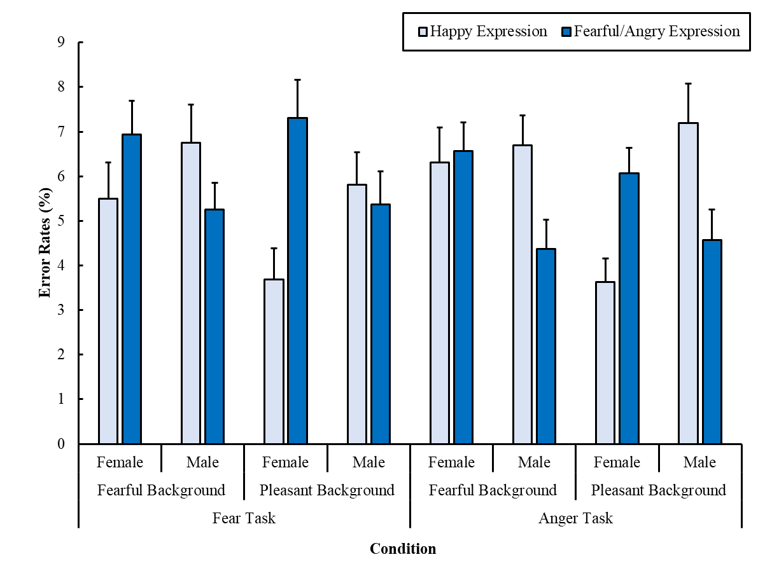
Recognition errors as a percentage for happy or fearful/angry expressions on women’s and men’s faces as a function of Background scene emotion and Task in Experiment 1 (error bars represent standard errors of the mean).
2 (Task: fear vs. anger) × 2 (Background: pleasant vs. fear) × 2 (Poser sex: male vs. female) × 2 (Expression: happy vs. angry/fearful) repeated measures ANOVA of the error data yielded a main effect for background, F(1,49)=4.39, p=.041, η_{p}²=.08, and Task × Expression, F(1,49)=4.30, p=.043, η_{p}²=.08, Background × Sex, F(1,49)=4.92, p=.031, η_{p}²=.09, and Poser Sex × Expression interactions, F(1,49)=31.33, p<.001, η_{p}²=.39. The Background × Expression interaction was not significant at the preset level, F(1,49)=3.39, p=.071, η_{p}²=.07. All other F(1,49)<2.48, p>.122, η_{p}²<.05. The Task × Expression interaction reflects that fewer errors were made recognising anger than fear, F(1,49)=4.41, p=.041, η_{p}²=.08, whereas there was no difference between tasks for happiness, F(1,49)=1.56, p=.218, η_{p}²=.03. The Background × Sex interaction indicates more accurate emotion recognition on female faces in pleasant than in fear scenes, F(1,49)=11.60, p=.001, η_{p}²=.19, whereas there was no difference for male faces, F(1,49)=0.01, p=.941, η_{p}²<.01. The Sex × Expression interaction is due to more accurate recognition of happiness on female than on male faces, F(1,49)=13.45, p<.001, η_{p}²=.22, and more accurate recognition of anger/fear on male than on female faces, F(1,49)=22.39, p<.001, η_{p}²=.31.

Experiment 2: Error data
Figure S2
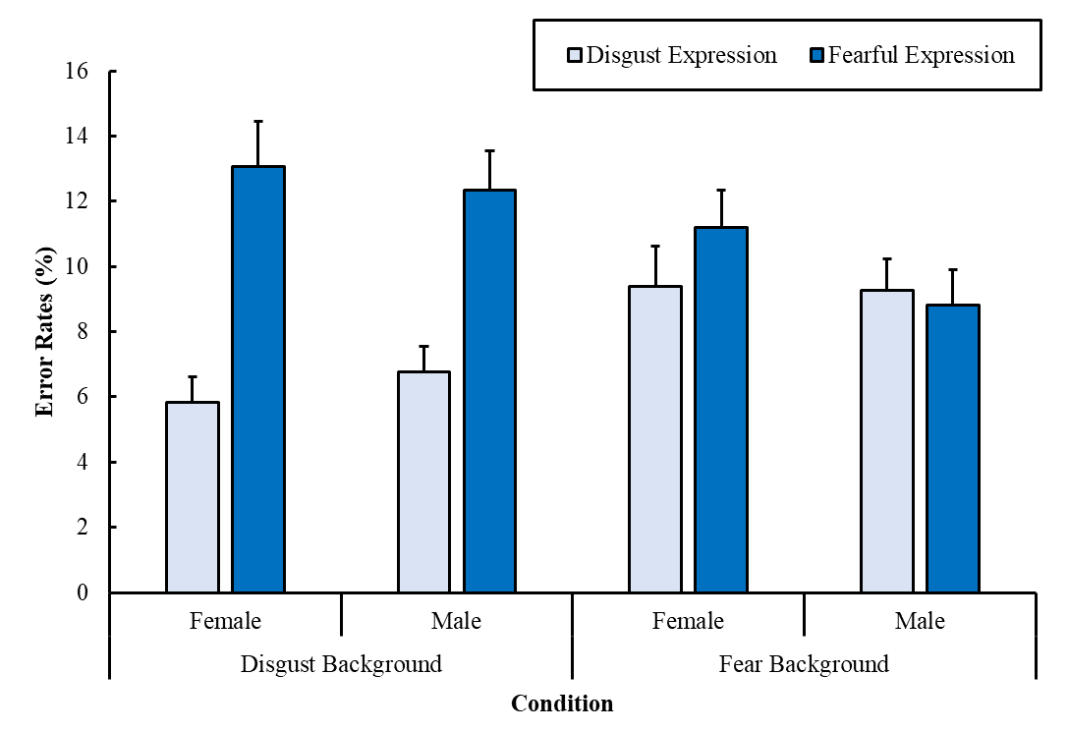
Recognition errors as a percentage for fear and disgust expressions on women’s and men’s faces as a function of background scene emotion in Experiment 2 (error bars represent standard errors of the mean).

Consistent with response times, there was a main effect of expression, F(1,59)=12.65, p<.001, η_{p}²=.18, as participants were more accurate to categorize disgust than fear expressions. There was also a background emotion × facial expression interaction, F(1,59)=11.74, p=.001, η_{p}²=.17, as participants were more accurate to recognize expressions when the face and background were emotionally congruent than when they were incongruent. Follow up comparisons indicated that participants were more accurate to categorize disgust than fear expressions on disgust backgrounds, F(1,59)=24.30, p<.001, η_{p}²=.29, but not in fear backgrounds, F(1,59)=0.32, p=.573, η_{p}²<.01. No other effects were significant, Fs<2.26, p>.138, η_{p}²<.04.

Experiment 3: Error data
Figure S3
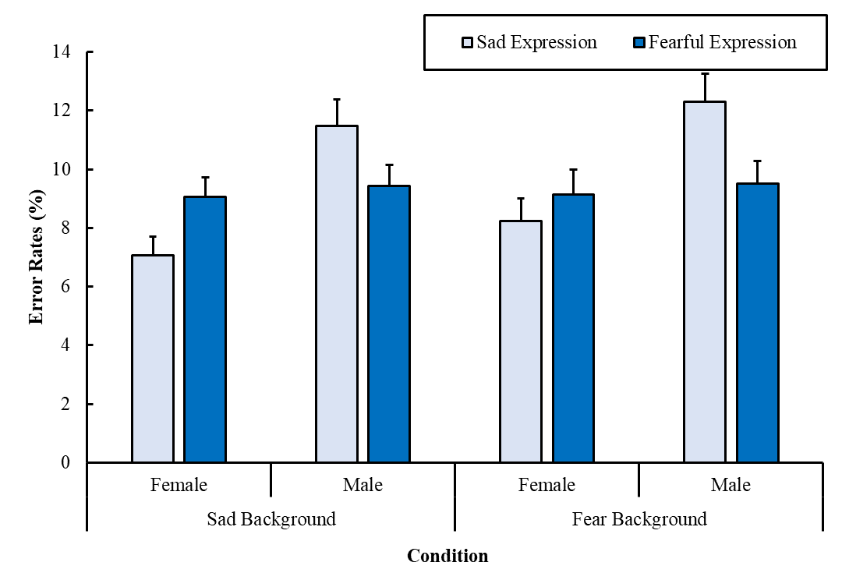
Recognition errors as a percentage for fear and sad expressions on women’s and men’s faces as a function of background scene emotion in Experiment 3 (error bars represent standard errors of the mean).

Overall participants were more accurate to categorize expressions on female than male faces, main effect of poser sex, F(1,96)=24.29, p<.001, η_{p}²=.20. However, this effect was moderated by a significant poser Sex × Expression interaction, F(1,96)=15.14, p<.001, η_{p}²=.14. This interaction emerged as participants were more accurate to categorize fear than anger on Male faces, F(1,96)=7.00, p=.010, η_{p}²=.07, but tended towards more accurate recognition of sadness than fear on female faces, though this difference did not reach significance, F(1,96)=3.58, p=.062, η_{p}²=.04.

