Supplemental Materials
Table S1 Demographics for Experiment 1
Racial  Group¹ | White | Black |  | Asian | Native American, Alaska Native, Native Hawaiian, Pacific Islander | More than 1 race | Other
Full Images
Male² | 34 | 2 |  | 2 | 0 | 3 | 0
Female | 14 | 5 |  | 0 | 0 | 1 | 1
Context Condition
Male | 31 | 3 |  | 3 | 2 | 0 | 1
Female | 16 | 2 |  | 1 | 0 | 2 | 1
Individual Faces Condition: Set 1
Male | 29 | 6 |  | 1 | 1 | 2 | 0
Female | 20 | 3 |  | 0 | 0 | 0 | 0
Individual Faces Condition: Set 2
Male | 33 | 4 |  | 3 | 0 | 0 | 1
Female | 26 | 4 |  | 2 | 0 | 0 | 0
Individual Faces Condition: Set 3
Male | 23 | 5 |  | 1 | 0 | 2 | 0
Female | 27 | 4 |  | 2 | 0 | 2 | 0

Age group | 18-25 | 26-30 | 31-40 (years)
Full Images
Male | 6 | 14 | 21
Female | 1 | 9 | 11
Context Condition
Male | 7 | 20 | 13
Female | 0 | 9 | 13
Individual Faces Condition: Set 1
Male | 2 | 16 | 21
Female | 3 | 6 | 14
Individual Faces Condition: Set 2
Male | 5 | 23 | 13
Female | 3 | 17 | 12
Individual Faces Condition: Set 3
Male | 4 | 11 | 16
Female | 6 | 12 | 17

Note. Participant numbers for Experiment 1 broken down by rating condition, gender and race (top panel) and by rating condition, gender and age group (bottom panel).

Table S2 Intraclass Correlations (ICC) measuring inter-rater reliability for each rating condition in Experiments 1 and 2.
 |  | 95% Confidence Interval |  | F Test with True Value 0
Rating Condition | Intraclass Correlation | Lower Bound | Upper Bound | Value | df1 | df2 | Sig
Valence
Full Image | .98 | .98 | .98 | 55.16 | 167 | 10187 | p < .001
Individual Faces  (set 1) | .98 | .98 | .99 | 65.86 | 213 | 12993 | p < .001
Individual Faces  (set 2) | .97 | .97 | .98 | 36.61 | 221 | 15912 | p < .001
Individual Faces  (set 3) | .98 | .98 | .99 | 56.77 | 199 | 12935 | p < .001
Context | .93 | .92 | .95 | 16.08 | 167 | 10020 | p < .001
Faces without  Context | .96 | .95 | .97 | 24.91 | 167 | 11857 | p < .001
Scrambled Faces | .97 | .96 | .98 | 32.44 | 167 | 10354 | p < .001
Arousal
Full Image | .94 | .92 | .95 | 15.62 | 167 | 10187 | p < .001
Individual Faces  (set 1) | .97 | .97 | .98 | 35.77 | 213 | 12993 | p < .001
Individual Faces  (set 2) | .96 | .95 | .97 | 24.90 | 221 | 15912 | p < .001
Individual Faces  (set 3) | .97 | .97 | .98 | 35.39 | 199 | 12935 | p < .001
Context | .91 | .89 | .93 | 10.73 | 167 | 10020 | p < .001
Faces without  Context | .89 | .87 | .91 | 9.25 | 167 | 11857 | p < .001
Scrambled Faces | .94 | .93 | .95 | 17.44 | 167 | 10354 | p < .001
Dominance
Full Image | .91 | .89 | .93 | 11.42 | 167 | 10187 | p < .001
Individual Faces  (set 1) | .93 | .92 | .95 | 14.87 | 213 | 12993 | p < .001
Individual Faces  (set 2) | .93 | .91 | .94 | 13.50 | 221 | 15912 | p < .001
Individual Faces  (set 3) | .93 | .91 | .94 | 13.60 | 199 | 12935 | p < .001
Context | .91 | .89 | .93 | 11.48 | 167 | 10020 | p < .001
Faces without  Context | .82 | .77 | .85 | 5.42 | 167 | 11857 | p < .001
Scrambled Faces | .88 | .85 | .90 | 7.99 | 167 | 10354 | p < .001
Note. We measured inter-rater reliability using a two-way random effects ICC model, ICC (2, k). Each row shows ICC statistics for participant ratings for each rating condition for a given dimension of affect. We show the ICC value in the left-most column and its 95% confidence interval bounds in the middle column. We then provide F test statistics on the ICC values in the righthand column.
Table S3 Descriptive statistics for each rating condition for Experiments 1 and 2.
 | Statistics Across Images
Rating Condition | Min | Mean | Max | Std
Valence
Full Image | 2.16 | 4.89 | 7.94 | 1.71
Individual Faces  (set 1) | 1.71 | 4.58 | 8.35 | 1.48
Individual Faces  (set 2) | 2.38 | 4.97 | 7.82 | 1.28
Individual Faces  (set 3) | 2.08 | 4.80 | 8.29 | 1.42
Context | 2.82 | 5.26 | 7.66 | 1.02
Faces without  Context | 2.82 | 4.85 | 7.21 | 1.23
Scrambled Faces | 2.33 | 4.61 | 7.79 | 1.15
Arousal
Full Image | 3.08 | 5.34 | 7.13 | 1.05
Individual Faces  (set 1) | 2.35 | 4.82 | 8.11 | 1.41
Individual Faces  (set 2) | 2.82 | 5.06 | 7.84 | 1.24
Individual Faces  (set 3) | 2.02 | 4.82 | 8.08 | 1.35
Context | 2.98 | 4.82 | 6.85 | 0.94
Faces without  Context | 3.74 | 5.42 | 6.83 | 0.78
Scrambled Faces | 2.97 | 4.99 | 7.16 | 0.96
Dominance
Full Image | 3.08 | 4.40 | 7.02 | 0.85
Individual Faces  (set 1) | 2.31 | 4.21 | 7.48 | 0.90
Individual Faces  (set 2) | 2.88 | 4.72 | 7.74 | 0.88
Individual Faces  (set 3) | 2.05 | 4.25 | 7.11 | 0.79
Context | 2.92 | 4.30 | 6.94 | 0.90
Faces without  Context | 3.72 | 4.92 | 6.49 | 0.58
Scrambled Faces | 3.29 | 4.39 | 6.06 | 0.57
Note. Each row gives the summary statistics for each rating condition for a given dimension of affect (averaged across participants). Summary statistics (minimum, mean, maximum, and standard deviation) were calculated using raw ratings across images (non z-scored).

Table S4
Demographics for Experiment 2a
Self-  identified  racial  group | White | Black | Asian | Native American, Alaska Native, Native Hawaiian, Pacific Islander | More than 1 race
Faces without Context
Male | 42 | 4 | 3 | 0 | 3
Female | 12 | 2 | 3 | 0 | 2

Age group | 18-25 | 26-30 | 31-40 (years)
Faces without Context
Male | 3 | 30 | 19
Female | 4 | 5 | 10

Note. Participant numbers for Experiment 2a broken down by gender by race (top panel) and gender by age group (bottom panel).

Table S5
Demographics for Experiment 2b
Self-  identified  racial  group | White | Black | Asian | Native American, Alaska Native, Native Hawaiian, Pacific Islander | More than 1 race | Other
Scrambled Faces
Male | 23 | 6 | 2 | 0 | 1 | 1
Female | 18 | 8 | 1 | 0 | 1 | 2

Age group | 18-25 | 26-30 | 31-40 (years)
Scrambled Faces
Male | 3 | 17 | 13
Female | 3 | 6 | 21

Note. Participant numbers for Experiment 2b broken down by gender by race (top panel) and gender by age group (bottom panel).

Table S6 Demographics for Experiment S1
Self-  identified  racial  group |  | White |  | Black |  | Asian | Native American, Alaska Native, Native Hawaiian, Pacific Islander | More than 1 race
Valence Only
Male |  | 17 |  | 1 |  | 0 | 0 | 1
Female |  | 9 |  | 0 |  | 0 | 0 | 0
Arousal Only
Male | 17 |  | 0 |  | 1 |  | 0 | 0
Female | 11 |  | 1 |  | 0 |  | 0 | 0
Dominance Only
Male | 18 |  | 2 |  | 0 |  | 0 | 0
Female | 8 |  | 1 |  | 0 |  | 0 | 0

Age group | 18-25 | 26-30 | 31-40 (years)
Valence Only
Male | 0 | 7 | 12
Female | 1 | 2 | 6
Arousal Only
Male | 1 | 9 | 8
Female | 4 | 2 | 6
Dominance Only
Male | 2 | 8 | 10
Female | 0 | 2 | 7

Note. Participant numbers for the control experiment where separate groups of participants were asked to rate the Full Image stimuli on just one of the three dimensions of affect (Valence Only, Arousal Only, and Dominance Only. Demographics are broken down by gender by race (top panel) and by gender by age group (bottom panel).

Instructions for Task
Ratings of the Full Image
On each trial you will briefly see a picture with faces in it. You will then be asked to judge the average emotion of the faces in the picture using three ratings. The first rating you will be asked to make is an average VALENCE rating. By average VALENCE, we mean how negative or positive the average emotion of the faces is. The second type of rating you will be asked to make is an average AROUSAL rating. By average AROUSAL, we mean how calm (low arousal) or exciting (high arousal) the average emotion of the faces is. The third and final type of rating you will be asked to make is an average DOMINANCE rating. High dominance is associated with the actual assumed or projected possession of power. Low dominance is associated with submissiveness.
Ratings of Context
On each trial you will briefly see a picture of a scene without faces. You will then be asked to judge the emotion of the scene using three ratings. The first rating you will be asked to make is a VALENCE rating. By VALENCE, we mean how negative or positive the emotion of the scene is. The second type of rating you will be asked to make is an AROUSAL rating. By AROUSAL, we mean how calm (low arousal) or exciting (high arousal) the emotion of the scene is. The third and final type of rating you will be asked to make is a DOMINANCE rating. High dominance is associated with the actual assumed or projected possession of power. Low dominance is associated with submissiveness.
Ratings of Individual Faces
On each trial you will briefly see a picture of a face. You will then be asked to judge the emotion of the face in the picture using three ratings. The first rating you will be asked to make is a VALENCE rating. By VALENCE, we mean how negative or positive the emotion of the face is. The second type of rating you will be asked to make is an AROUSAL rating. By AROUSAL, we mean how calm (low arousal) or exciting (high arousal) the emotion of the face is. The third and final type of rating you will be asked to make is a DOMINANCE rating. High dominance is associated with the actual assumed or projected possession of power. Low dominance is associated with submissiveness.
Faces Without Context and Scrambled Faces
On each trial you will briefly see a picture with faces in it. You will then be asked to judge the average emotion of the faces in the picture using three ratings. The first rating you will be asked to make is an average VALENCE rating. By average VALENCE, we mean how negative or positive the average emotion of the faces is. The second type of rating you will be asked to make is an average AROUSAL rating. By average AROUSAL, we mean how calm (low arousal) or exciting (high arousal) the average emotion of the faces is. The third and final type of rating you will be asked to make is an average DOMINANCE rating. High dominance is associated with the actual assumed or projected possession of power. Low dominance is associated with submissiveness.

Supplementary Experiment 1
In Experiment 1, participants were asked to rate the Full Image stimuli on each of the three dimensions of affect in the following order: valence, arousal, and then dominance. To control for effects of rating order, we conducted a follow-up experiment, Experiment S1, in which separate groups of participants rated the Full Image stimuli on each dimension of affect. That is, one group of new participants made valence judgements (Valence Only), another group made arousal judgements (Arousal Only), and a third group of participants made dominance ratings (Dominance Only). Eighty-seven participants completed these ratings (28 for Valence Only, 30 for Arousal Only, 29 for Dominance Only). Exclusion criteria were identical to Experiment 1. Participant demographics are given in Table S6.
Results
Drop column feature importance analyses were conducted following the same procedure as described in Experiment 1, now with Valence Only, Arousal Only, and Dominance Only ratings as the dependent variables. Our findings largely paralleled those reported for Experiment 1 (see Figure S6). Specifically, for ratings of Valence Only, we found that the MEAN facial emotion and CONTEXT regressors explained a significant amount of unique variance (R²_{adj} = .05, p = .001; R²_{adj} = .03, p = .008, respectively). For ratings of Arousal Only, the MAX facial emotion regressor (R²_{adj} = .16, p < .001) and CONTEXT (R²_{adj} = .02, p = .040) explained significant unique variance. For Dominance Only, the MEAN facial emotion and CONTEXT regressors contributed significantly (R²_{adj} = .04, p = .005; R²_{adj} = .05, p = .003, respectively).
Discussion
Findings for ratings of group facial valence and arousal parallel those reported in Experiment 1. Here, as in experiment 1, mean facial valence but not max facial valence has a significant influence on judgements of group facial valence while max facial arousal, but not mean facial arousal, has a significant influence on judgements of group facial arousal. This provides some evidence that arousal ratings are not influenced by following valence ratings. In contrast, the findings for facial dominance do differ between experiment 1 and experiment S1. Experiment 1 revealed a large significant influence of context and also a significant influence of maximal facial dominance. Here, we see a smaller, though still significant, influence of context and a significant influence of mean facial dominance as opposed to maximal facial dominance. It is possible that ratings of facial group dominance are more influenced by following other ratings of facial affect. In addition, it is possible that group dominance ratings are noisier given that dominance is arguably more commonly attributed to an individual within a group rather than to a group as a whole.

Figure S1
Full model performance with MAX, MEAN, & CONTEXT as regressors in Experiment 1.
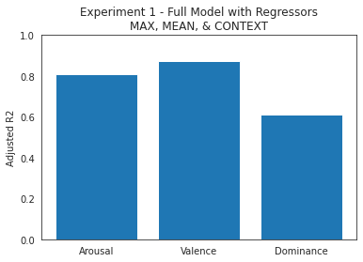
Note. Adjusted R² for each dimension of affect with MAX, MEAN, and CONTEXT as regressors and Full Image ratings as the dependent variable. For arousal, R²_{adj} = .81, R²_{adj} = .87 for valence, and R²_{adj} = .61 for dominance.

Figure S2
Is the effect of max face emotion explainable by face size? A control analysis for Experiment 1.
A.
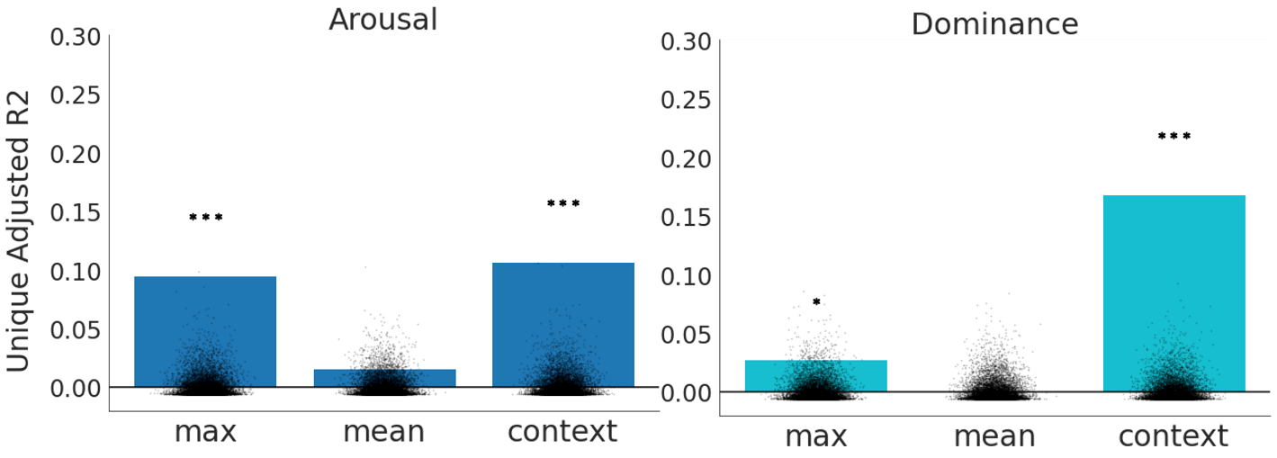
Note. One possibility is that the maximally emotional face is often also the largest and that this might be driving the apparent influence of the most arousing or most dominant face upon ratings of the full image. To control for this, we used the ratings of arousal or dominance for the largest face in each image to predict the rating of the full image on the corresponding dimension of affect. We calculated the residual and used this as the dependent variable in a subsequent drop column analysis. This effectively controls for the ratings of the largest face on the dimension of interest. In the plots shown here, bars represent the unique variance explained by each feature as obtained from this drop column analysis. Scattered dots overlaying the plots show the permuted null distribution of the adjusted R² values. It can be seen that the maximally arousing (R²_{adj} = .10, p < .001) and maximally dominant faces (R²_{adj} = .03, p = .018) contribute significantly to the prediction of full image ratings, even when the variance explained by the arousal and dominance ratings of the largest face have been residualized out of these full image ratings. *p < .05, ** p < .01, *** p < .001.

Figure S3
Is the effect of max face arousal driven by max dominance or vice versa? A control analysis for Experiment 1.
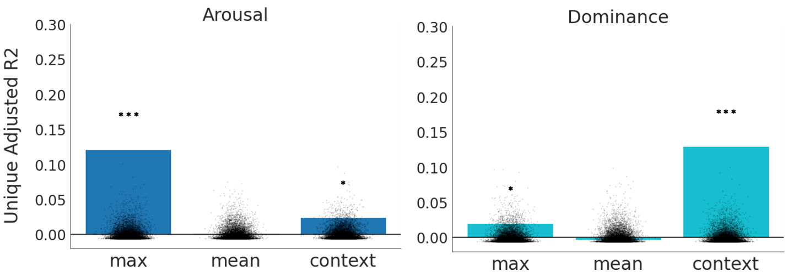
Note. Another possible confound in Experiment 1 is that the MAX arousal face and the MAX dominance face might be the same face. If this is the case, then attentional orienting towards the most arousing face might have a knock-on influence on dominance ratings. To control for this, we used dominance ratings of the maximally arousing face to predict full image dominance ratings and arousal rating of the maximally dominant face to predict full image ratings of arousal. We then calculated the residuals and used these as the dependent variables in two drop column feature importance analyses. To the extent that the maximally arousing face is also the maximally dominant face, it will be prevented from contributing to the unique variance explained by the MAX feature in either drop column analysis. In the plots shown here, bars represent the unique variance in the residual full image arousal ratings (left panel) and dominance ratings (right panel) explained by each feature. Dots overlaying the bars show the permuted null distribution of the adjusted R² values. It can be seen that the maximally arousing (R²_{adj} = .12, p < .001) and maximally dominant faces (R²_{adj} = .02, p = .036) still contribute significantly to the prediction of full image ratings. *p < .05, ** p < .01, *** p < .001
Figure S4
Does the min face for valence contribute significantly to full image ratings for Experiment 1? A control analysis.
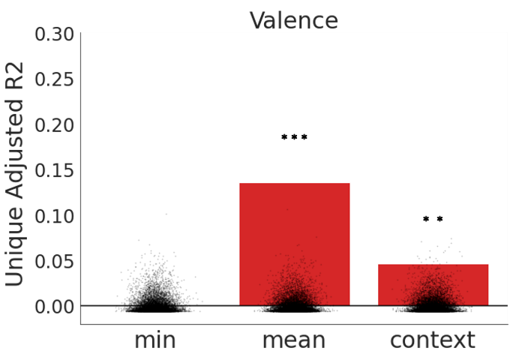
Note. For valence, the scale’s ends are defined as negative (rating of 1) and positive (rating of 9). Thus, the minimally positive face (MIN) is also the maximally negative face. We hence conducted a drop column feature analysis with the MIN (positive) valence face regressor replacing the MAX (positive) valence face regressor to ensure that there was no unique effect of this regressor. The MIN (positive) valence face regressor did not explain a significant level of unique variance for valence (R²_{adj} < .01, p = .29). *p < .05, ** p < .01, *** p < .001

Figure S5
Feature importance analyses for Experiment 1 using sampled images with standard deviation in ratings for faces in each image matched across dimensions of affect.
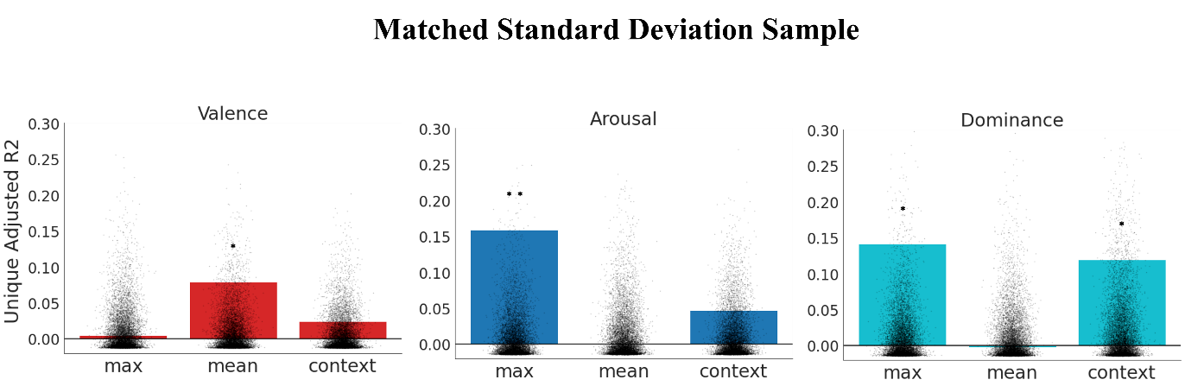
Note. 120 images from the set used for Experiment 1 were randomly resampled until the standard deviation of ratings of faces within each image did not differ significantly across dimensions of affect (t_{val_ars} = 0.08 p_{val_ars} = .936, t_{dom_ars} = 1.42, p_{dom_ars} = .156, t_{dom_val} = 1.33, p_{dom_val} = .185). The drop column feature importance analysis was then repeated. For valence, the MEAN facial emotion regressor contributed significantly to model performance (R²_{adj} = .08, p = .027. For arousal, the MAX facial emotion regressor contributed significantly (R²_{adj} = .16, p= 0.004. For dominance, the MAX facial emotion regressor and CONTEXT regressor had unique contributions (R²_{adj} = .14, p = .010; R²_{adj} = .12, p = .033, respectively). *p < .05, ** p < .01, *** p < .001

Figure S6
Is the effect of max face emotion driven by face size? A control analysis for Experiment 2.
A. Experiment 2a
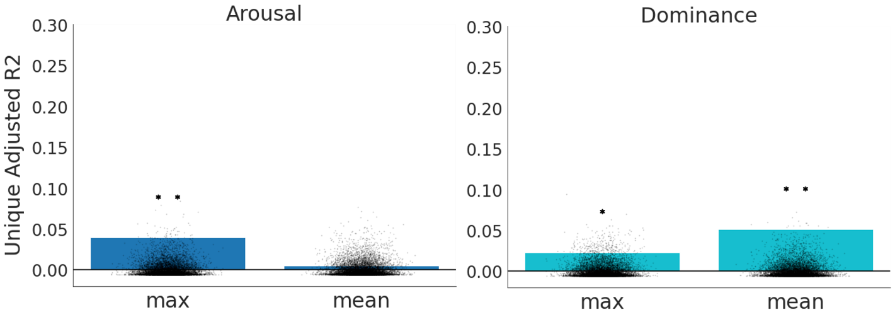
B. Experiment 2b 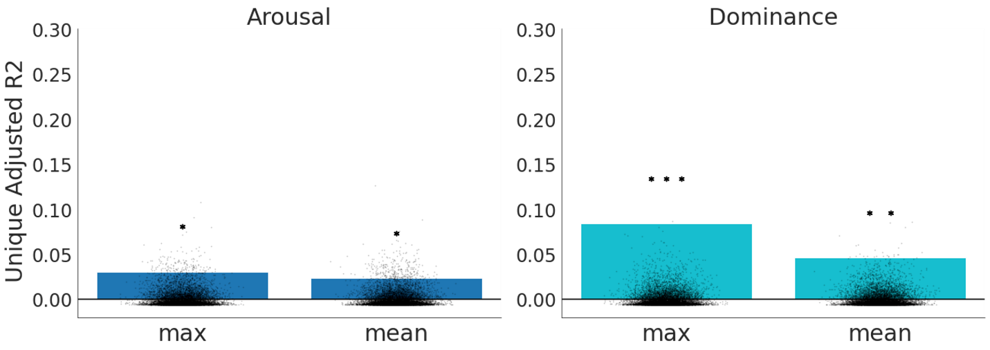
Note. Ratings of arousal and dominance for the largest face in each image were used to predict the rating of group facial arousal and dominance, respectively, for the Faces without Context stimuli in Experiment 2a (panel A) and for the Scrambled Faces stimuli in Experiment 2b (Panel B). The residuals were used as dependent variables in drop column feature importance analyses for the dimensions of arousal (left) and dominance (right), respectively. This controls for any confounding influence of the maximally arousing or dominant face also being the largest in the image. In the plots shown here, bars represent the unique variance in these residual ratings explained by the maximally arousing (left) or dominant (right) face and by mean facial arousal (left) and dominance (right). Scattered dots overlaying the bars show the permuted null distribution of the adjusted R² values. In both Experiment 2a (Panel A) and Experiment 2b (Panel B), the maximally arousing face continued to explain unique variance in the ratings of group arousal after variance explained by arousal ratings for the largest face were regressed out (R²_{adj} = .04, p = .005; R²_{adj} = .03, p = .015, respectively). With the dominance ratings of the largest face regressed out, the maximally dominant face also explained a significant amount of unique variance in group facial dominance ratings across both Experiments 2a (Faces without Context) and Experiment 2b (Scrambled Faces) (R²_{adj} = .02, p = .026; R²_{adj} = .08, p < .001, respectively). *p < .05, ** p < .01, *** p < .001

Figure S7
Does the MIN (negative) valence regressor (i.e., the maximally negative face) contribute significantly to Faces without Context and Scrambled Faces ratings in Experiment 2?
A. Experiment 2a: Faces without Context
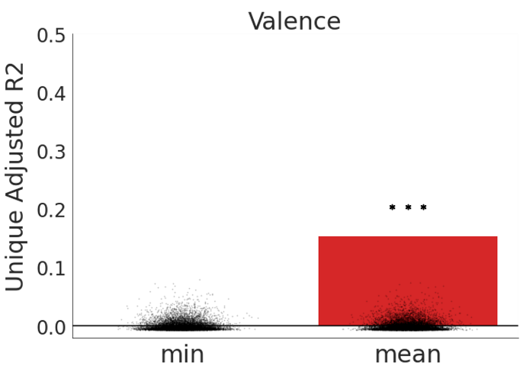
B. Experiment 2b: Scrambled Faces
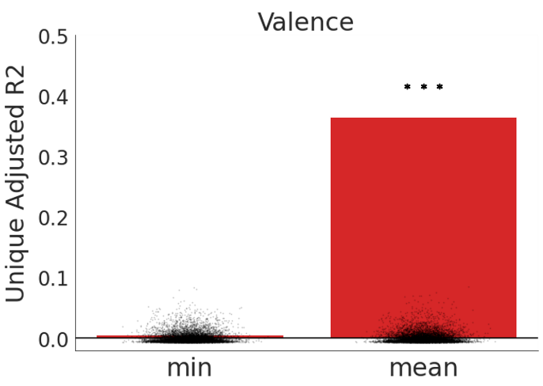
Note. For valence, the scale’s ends are defined as negative (rating of 1) and positive (rating of 9). Thus, the minimally positive face (MIN) is also the maximally negative face. We hence conducted drop column feature analyses with the MIN valence face regressor replacing the MAX (positive) valence face regressor for both Experiment 2a and Experiment 2b. Panel A shows the results of the Experiment 2a drop column analysis with ratings of the Faces Without Context stimuli as the dependent variable. Panel B shows the results of the Experiment 2b drop column feature analysis with ratings of the Scrambled Faces stimuli as the dependent variable. In each case, ratings of the minimally positive valence face (MIN) (i.e., the most negative face) did not account for significant unique variance (R²_{adj} < .01, p = .341; R²_{adj} < .01, p = .147, respectively) in group valence ratings. The mean facial valence regressor continued to explain significant variance in the group facial valence ratings across both analyses.

Figure S8
Feature importance analyses for Experiments 2a and 2b using sampled images where the standard deviation in rating is matched across experiments for each dimension of affect.
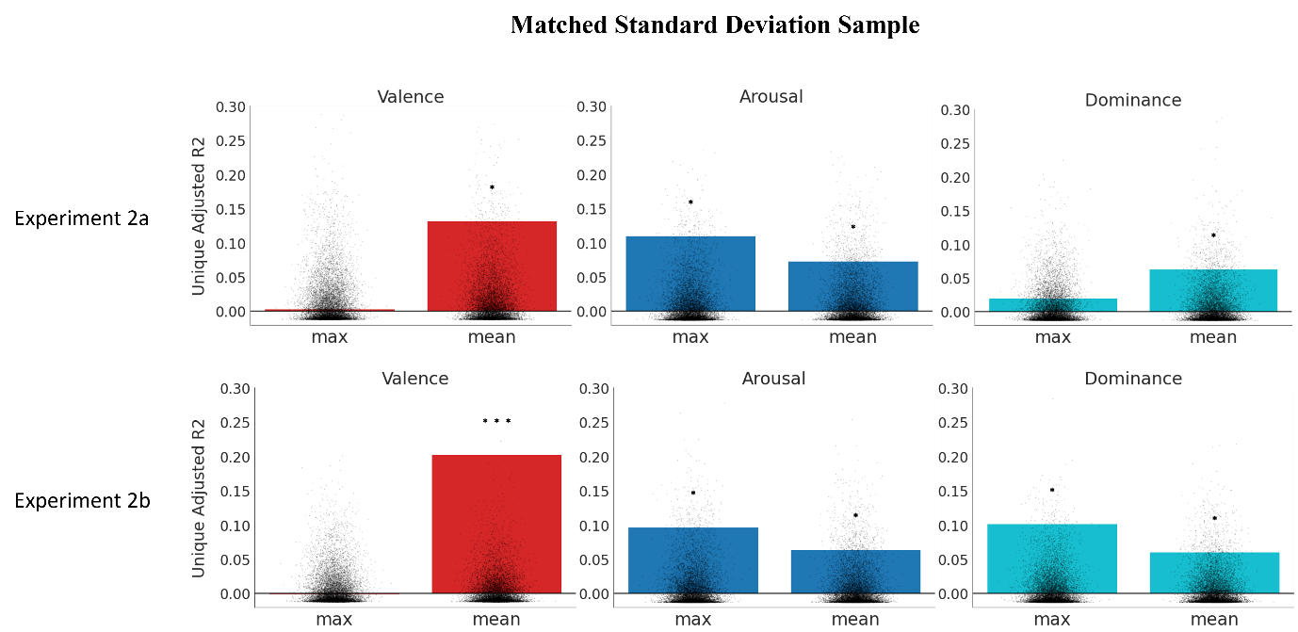
Note. We randomly sampled 120 images from the set used in Experiment 2a (Faces without Context) and from the set used in Experiment 2b (Scrambled Faces) so that the mean standard deviation for ratings on each dimension of affect across faces in each image did not differ significantly between sets (valence: t = 0.29, p = .772; arousal: t = -0.19, p = .849; dominance: t = 0.08, p = .940). We see similar results to that of our original analyses in Experiment 2. MEAN facial emotion explained a significant amount of unique variance for valence in Experiment 2a and 2b (R²_{adj} = .14, p = .013; R²_{adj} = .21, p < .001, respectively). For arousal, both MAX and MEAN facial emotion explained a significant amount of unique variance for both Experiment 2a (MAX: R²_{adj} = .10, p = .018; MEAN: R²_{adj} = .08, p = .034) and Experiment 2b (MAX: R²_{adj} = .08, p = .031; MEAN: R²_{adj} = .07, p = .034). For dominance, MEAN facial emotion contributed significantly for Experiment 2a (R²_{adj} = .06, p = .049) while MAX and MEAN facial emotion contributed significantly for Experiment 2b (R²_{adj} = .10, p = .012, R²_{adj} = .06, p = .040 respectively). *p < .05, ** p < .01, *** p < .001

Figure S9
Experiment S1 drop-column feature importance analysis results.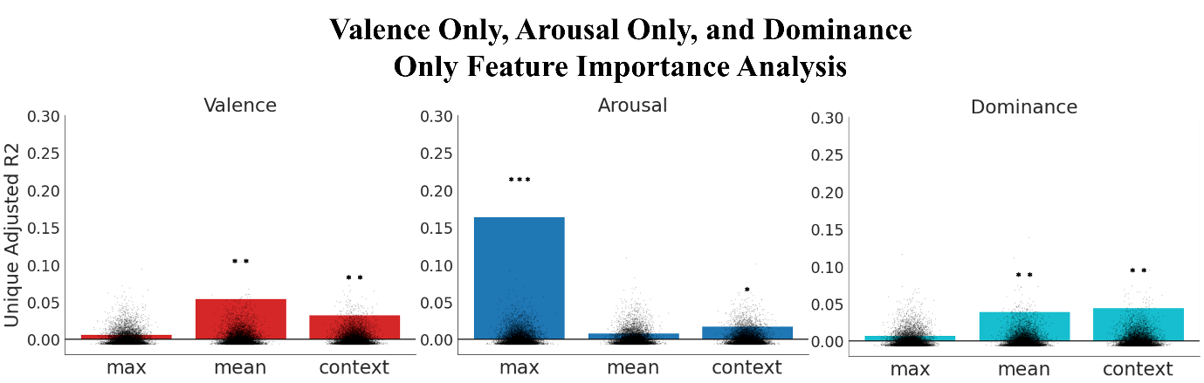
Note. Separate groups of participants rated the Full Image stimuli on just one of the three dimensions of affect (Valence, Arousal, and Dominance). A drop column feature importance analysis was performed for each dimension of affect using the max facial emotion (MAX), mean facial emotion (MEAN), and context regressors as features of interest. The results of this drop column feature analysis largely parallel those reported for Experiment 1. For ratings of Valence Only, we found that the MEAN facial emotion and CONTEXT regressors explained a significant amount of unique variance (R²_{adj} = .05, p = .001; R²_{adj} = .03, p = .008, respectively). For ratings of Arousal Only, the MAX facial emotion regressor (R²_{adj} = .16, p < .001) and CONTEXT (R²_{adj} = .02, p = .040) explained significant unique variance. For Dominance Only, the MEAN facial emotion and CONTEXT regressors contributed significantly (R²_{adj} = .04, p = .005; R²_{adj} = .05, p = .003, respectively).

