Regulating Emotions About Secrets
Supplementary Materials

Table of Contents
Study 2 Mixed Model Specifications (1) 3
Study 2 Mixed Model Specifications (2) 5
Study 2 Tables reporting significance of interactions between features of the secret and emotion regulation strategy use. 8
Study 3 Preprocessing: Sample Size and Data Exclusion 16
Study 3 Mixed Model Specifications 17
Summary of Results for Study 2 and Study 3 Reference Table 26
Study 3 Tables and Figures reporting significance of interactions between features of the secret and emotion regulation strategies 28
Testing for Changes in Emotion Regulation Over Time 54
Supplementary Analyses Predicting Binary Social Sharing from Secret Features 56
References 60

Study 2 Mixed Model Specifications (1)
We conducted analyses using the packages lme4 (Bates et al., 2015) to fit linear mixed-effects models, and lmerTest to calculate p values (Kuznetsova et al., 2017). Our first set of multilevel analyses tested differences in the intensity of the different emotion-regulation strategies used to manage the secrets. We conducted 3-level models (i.e., strategy, nested within day, nested within persons). Variables were recoded so that emotion regulation intensity scores for each person were predicted by a factor variable comparing the different strategies (replacing each strategy as the reference category in subsequent tests). We included each reference strategy as a fixed-effect predictor, and random intercepts for both day (nested within participant) and participant. We allowed strategy to have a random slope for participants. When models presented convergence or singularity fit issues, we first attempted to resolve issues by (1) rescaling the variables, and (2) by removing random slopes with the least variance (Bates et al., 2015). Table S1.1 presents the final model specifications tested in Study 1 after convergence and singularity issues were addressed.
Figure S1. Study 2 Comparisons Between Emotion Regulation Strategies.

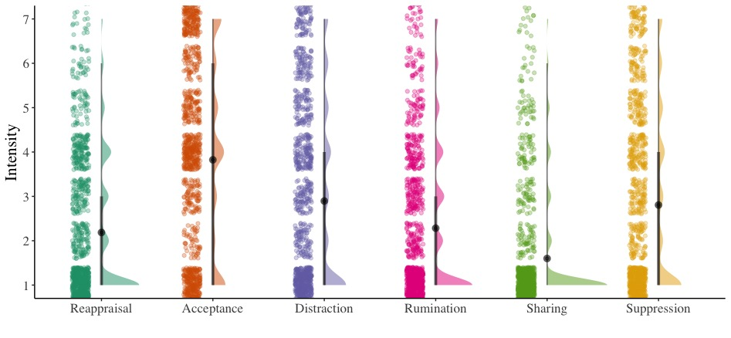

Table S2.2 Mixed Model Specifications Study 2
Model | Outcome Variable | Fixed effects | Random Effects | Random Effects Omitted Due To Convergence Issues
1A | Emotion Regulation Intensity | Cognitive Reappraisal | Random Intercept of Participant  Random Slope of Cognitive Reappraisal for Participant  Random Intercept of Day within Participant | Random Slope of Cognitive Reappraisal for Day within Participant
1B | Emotion Regulation Intensity | Expressive Suppression | Random Intercept of Participant  Random Slope of Expressive Suppression for Participant  Random Intercept of Day within Participant | Random Slope of Expressive Suppression for Day within Participant
1C | Emotion Regulation Intensity | Distraction | Random Intercept of Participant  Random Slope of Distraction for Participant  Random Intercept of Day within Participant | Random Slope of Distraction for Day within Participant
1D | Emotion Regulation Intensity | Rumination | Random Intercept of Participant  Random Slope of Rumination for Participant  Random Intercept of Day within Participant | Random Slope of Rumination for Day within Participant
1E | Emotion Regulation Intensity | Acceptance | Random Intercept of Participant  Random Slope of Acceptance for Participant  Random Intercept of Day within Participant | Random Slope of Acceptance for Day within Participant
1F | Emotion Regulation Intensity | Social Sharing | Random Intercept of Participant  Random Slope of Social Sharing for Participant  Random Intercept of Day within Participant | Random Slope of Social Sharing for Day within Participant
Note. Package used for Analysis: lmerTest in R; p values in the lmerTest package are calculated using a Satterthwaite approximation for degrees of freedom.

Study 2 Mixed Model Specifications (2)
Our second set of multilevel analyses predicted the use of each emotion regulation strategy to manage the secret, from features of the secret assessed at baseline. We conducted 2-level models (i.e., emotion regulation strategy, nested within persons). We included the features of secrets as predictors (grand-mean centered) as fixed effects, and a random intercept for participant (Table S2.3).
For each model returning a significant association between secret feature and emotion regulation strategy, we investigate whether that strategy was used significantly more (or less) than other strategies. We used the same 3-level data structure as the first set of analyses (i.e., strategy, nested within days, nested within persons). We predicted daily differences in the intensity of the strategy from secret feature (grand-mean centered) assessed at baseline as a fixed effect, the interaction between the secret feature and the emotion regulation strategy (vs. the other strategies) as a fixed effect, and included a random intercept for both day (nested within participant) and participant, and random slopes for strategy both for day and for participant.
When models presented convergence or singularity fit issues, we first attempted to resolve issues by (1) rescaling the variables, and (2) by removing random slopes with the least variance (Bates et al., 2015). Table S2.4 presents the final model specifications tested in Study 2 after convergence and singularity issues were addressed.

Table S2.3 Mixed Model Specifications Study 2
Model | Outcome Variable | Fixed effects | Random Effects | Random Effects Omitted Due To Convergence Issues
4AA | Cognitive Reappraisal | Secret Significance | Participant Random Intercept
4AB | Rumination | Secret Significance | Participant Random Intercept
4AC | Distraction | Secret Significance | Participant Random Intercept
4AD | Social Sharing | Secret Significance | Participant Random Intercept
4AE | Acceptance | Secret Significance | Participant Random Intercept
4AF | Expressive Suppression | Secret Significance | Participant Random Intercept
4BA | Cognitive Reappraisal | Secret Negativity | Participant Random Intercept
4BB | Rumination | Secret Negativity | Participant Random Intercept
4BC | Distraction | Secret Negativity | Participant Random Intercept
4BD | Social Sharing | Secret Negativity | Participant Random Intercept
4BE | Acceptance | Secret Negativity | Participant Random Intercept
4BF | Expressive Suppression | Secret Negativity | Participant Random Intercept
Note. Models 4AA to 4DF: Predictors were grand mean-centered. Package used for Analysis: lmerTest in R; p values in the lmerTest package are calculated using a Satterthwaite approximation for degrees of freedom. Bold models indicate significance of relationship.

Table S2.4 Mixed Model Specifications Study 2
Model | Outcome Variable | Fixed effects | Random Effects | Random Effects Omitted Due To Convergence Issues
S4AB | Emotion Regulation Intensity | Interaction between Secret Significance and Rumination | Random Intercept of Participant  Random Slope of Rumination for Participant  Random Intercept of Day within Participant | Random Slope of Rumination for Day within Participant
S4AC | Emotion Regulation Intensity | Interaction between Secret Significance and Distraction | Random Intercept of Participant  Random Slope of Distraction for Participant  Random Intercept of Day within Participant | Random Slope of Distraction for Day within Participant
S4AF | Emotion Regulation Intensity | Interaction between Secret Significance and Expressive Suppression | Random Intercept of Participant  Random Slope of Expressive Suppression for Participant  Random Intercept of Day within Participant | Random Slope of Expressive Suppression for Day within Participant
S4BA | Emotion Regulation Intensity | Interaction between Secret Negativity and Cognitive Reappraisal | Random Intercept of Participant  Random Slope of Cognitive Reappraisal for Participant  Random Intercept of Day within Participant | Random Slope of Cognitive Reappraisal for Day within Participant
S4BB | Emotion Regulation Intensity | Interaction between Secret Negativity and Rumination | Random Intercept of Participant  Random Slope of Rumination for Participant  Random Intercept of Day within Participant | Random Slope of Rumination for Day within Participant
S4BC | Emotion Regulation Intensity | Interaction between Secret Negativity and Distraction | Random Intercept of Participant  Random Slope of Distraction for Participant  Random Intercept of Day within Participant | Random Slope of Distraction for Day within Participant
S4BF | Emotion Regulation Intensity | Interaction between Secret Negativity and Expressive Suppression | Random Intercept of Participant  Random Slope of Expressive Suppression for Participant  Random Intercept of Day within Participant | Random Slope of Expressive Suppression for Day within Participant
Note. Models 4AB to 4DF: Predictors were grand-mean centered. Package used for Analysis: lmerTest in R; p values in the lmerTest package are calculated using a Satterthwaite approximation for degrees of freedom.

Study 2 Tables reporting significance of interactions between features of the secret and emotion regulation strategy use.
In the below tables, we report results for the emotion regulation strategies that were significantly associated with the two features of the secret (significance of the secret, Tables S2.4-S2.6; negativity of the secret, Tables S2.7-S2.10).
Table S2.5 Interactions between Secret Significance and Rumination (Study 2)
 | Intensity
Predictors | Estimate (SE) | 95% CI | p
(Intercept) | 2.27  (0.11) | 2.04 – 2.50 | <.001
Secret significance | 0.15  (0.06) | 0.04 – 0.26 | .010
Rumination (vs. Acceptance) | 1.54  (0.14) | 1.27 – 1.81 | <.001
Rumination (vs. Distraction) | 0.61  (0.08) | 0.45 – 0.77 | <.001
Rumination (vs. Reappraisal) | -0.09  (0.08) | -0.25 – 0.06 | .232
Rumination (vs. Social Sharing) | -0.68  (0.08) | -0.85 – -0.51 | <.001
Rumination (vs. Suppression) | 0.51  (0.09) | 0.35 – 0.68 | <.001
Secret significance x Rumination (vs. Acceptance) | -0.18  (0.08) | -0.34 – -0.01 | .033
Secret significance x Rumination (vs. Distraction) | 0.06  (0.05) | -0.03 – 0.16 | .187
Secret significance x Rumination (vs. Reappraisal) | -0.09  (0.05) | -0.18 – 0.00 | .054
Secret significance x Rumination (vs. Social Sharing) | -0.13  (0.05) | -0.23 – -0.04 | .008
Secret significance x Rumination (vs. Suppression) | 0.01  (0.05) | -0.09 – 0.11 | .912
Note. Predictors were grand-mean centered. A significant interaction indicates that secret significance predicts the mentioned strategies to a different degree.
Table S2.6 Interactions between Secret Significance and Distraction (Study 2)
 | Intensity
Predictors | Estimate (SE) | 95% CI | p
(Intercept) | 2.88  (0.13) | 2.62 – 3.14 | <.001
Secret significance | 0.21  (0.07) | 0.07 – 0.35 | .003
Distraction (vs. acceptance) | 0.93  (0.14) | 0.65 – 1.20 | <.001
Distraction (vs. reappraisal) | -0.70  (0.09) | -0.88 – -0.53 | <.001
Distraction (vs. rumination) | -0.61  (0.08) | -0.77 – -0.45 | <.001
Distraction (vs social sharing) | -1.29  (0.11) | -1.52 – -1.07 | <.001
Distraction (vs. suppression) | -0.10  (0.08) | -0.25 – 0.06 | .211
Secret significance x distraction (vs. acceptance) | -0.24  (0.08) | -0.40 – -0.08 | .004
Secret significance strategy x distraction (vs. reappraisal) | -0.15  (0.05) | -0.26 – -0.05 | .003
Secret significance x distraction (vs. rumination) | -0.06  (0.05) | -0.16 – 0.03 | .187
Secret significance x distraction (vs. social sharing) | -0.20  (0.07) | -0.33 – -0.06 | .004
Secret significance x distraction (vs. suppression) | -0.06  (0.05) | -0.15 – 0.03 | .209
Note. Predictors were grand-mean centered. A significant interaction indicates that secret significance predicts the mentioned strategies to a different degree.
Table S2.7 Interactions between Secret Significance and Suppression (Study 2)
 | Intensity
Predictors |  | Estimate (SE) | 95% CI | p
(Intercept) |  | 2.78  (0.13) | 2.52 – 3.05 | <.001
Secret significance |  | 0.15  (0.07) | 0.01 – 0.29 | .034
Suppression (vs. acceptance) |  | 1.03  (0.14) | 0.75 – 1.30 | <.001
Suppression (vs. distraction) |  | 0.10  (0.08) | -0.06 – 0.25 | .211
Suppression (vs. reappraisal) |  | -0.61  (0.10) | -0.81 – -0.40 | <.001
Suppression (vs. rumination) |  | -0.51  (0.09) | -0.68 – -0.35 | <.001
Suppression (vs. social sharing) |  | -1.19  (0.12) | -1.43 – -0.96 | <.001
Secret significance x suppression (vs. acceptance) |  | -0.18  (0.08) | -0.35 – -0.02 | .028
Secret significance x suppression (vs. distraction) |  | 0.06  (0.05) | -0.03 – 0.15 | .209
Secret significance x suppression (vs. reappraisal) |  | -0.10  (0.06) | -0.22 – 0.03 | .125
Secret significance x suppression (vs. rumination) |  | -0.01  (0.05) | -0.11 – 0.09 | .912
Secret significance x suppression (vs. social sharing) |  | -0.14  (0.07) | -0.28 – 0.00 | .051
Note. Predictors were grand-mean centered. A significant interaction indicates that secret significance predicts the mentioned strategies to a different degree.

Table S2.8 Interactions between Secret Negativity and Reappraisal (Study 2)
 | Intensity
Predictors | Estimate (SE) | 95% CI | p
(Intercept) | 2.18  (0.11) | 1.95 – 2.40 | <.001
Secret negativity | 0.11  (0.05) | 0.00 – 0.22 | .041
Reappraisal (vs. acceptance) | 1.63  (0.12) | 1.39 – 1.88 | <.001
Reappraisal (vs. distraction) | 0.70  (0.09) | 0.54 – 0.87 | <.001
Reappraisal (vs. rumination) | 0.09  (0.08) | -0.06 – 0.25 | .231
Reappraisal (vs. social sharing) | -0.58  (0.08) | -0.74 – -0.43 | <.001
Reappraisal (vs. suppression) | 0.61  (0.10) | 0.40 – 0.82 | <.001
Secret negativity x reappraisal (vs. acceptance) | -0.12  (0.07) | -0.26 – 0.02 | .088
Secret negativity x reappraisal (vs. distraction) | 0.20  (0.05) | 0.11 – 0.30 | <.001
Secret negativity x reappraisal (vs. rumination) | 0.06  (0.05) | -0.03 – 0.15 | .200
Secret negativity x reappraisal (vs. social sharing) | -0.15  (0.05) | -0.24 – -0.06 | .002
Secret negativity x reappraisal (vs. suppression) | 0.04  (0.06) | -0.08 – 0.16 | .490
Note. Predictors were grand-mean centered. A significant interaction indicates that secret negativity predicts the mentioned strategies to a different degree.

Table S2.9 Interactions between Secret Negativity and Rumination (Study 2)
 | Intensity
Predictors | Estimate (SE) | 95% CI | p
(Intercept) | 2.27  (0.11) | 2.05 – 2.50 | <.001
Secret negativity | 0.17  (0.05) | 0.06 – 0.28 | .002
Rumination (vs. acceptance) | 1.54  (0.14) | 1.26 – 1.81 | <.001
Rumination (vs. distraction) | 0.61  (0.08) | 0.45 – 0.77 | <.001
Rumination (vs. reappraisal) | -0.09  (0.08) | -0.25 – 0.06 | .231
Rumination (vs. social sharing) | -0.68  (0.08) | -0.84 – -0.52 | <.001
Rumination (vs. suppression) | 0.51  (0.09) | 0.35 – 0.68 | <.001
Secret negativity x rumination (vs. acceptance) | -0.18  (0.08) | -0.34 – -0.02 | .024
Secret negativity x rumination (vs. distraction) | 0.14  (0.05) | 0.05 – 0.23 | .002
Secret negativity x rumination (vs. reappraisal) | -0.06  (0.05) | -0.15 – 0.03 | .200
Secret negativity x rumination (vs. social sharing) | -0.21  (0.05) | -0.30 – -0.11 | <.001
Secret negativity x rumination (vs. suppression) | -0.02  (0.05) | -0.11 – 0.08 | .737
Note. Predictors were grand-mean centered. A significant interaction indicates that secret negativity predicts the mentioned strategies to a different degree.

Table S2.10 Interactions between Secret Negativity and Distraction (Study 2)
 | Intensity
Predictors | Estimate (SE) | 95% CI | p
(Intercept) | 2.88  (0.13) | 2.63 – 3.14 | <.001
Secret negativity | 0.31  (0.06) | 0.19 – 0.44 | <.001
Distraction (vs. acceptance) | 0.93  (0.14) | 0.66 – 1.20 | <.001
Distraction (vs. reappraisal) | -0.70  (0.09) | -0.87 – -0.54 | <.001
Distraction (vs. rumination) | -0.61  (0.08) | -0.77 – -0.45 | <.001
Distraction (vs. social sharing) | -1.29  (0.11) | -1.50 – -1.08 | <.001
Distraction (vs. suppression) | -0.10  (0.07) | -0.24 – 0.05 | .200
Secret negativity x distraction (vs. acceptance) | -0.33  (0.08) | -0.48 – -0.17 | <.001
Secret negativity x distraction (vs. reappraisal) | -0.20  (0.05) | -0.30 – -0.11 | <.001
Secret negativity x distraction (vs. rumination) | -0.14  (0.05) | -0.23 – -0.05 | .002
Secret negativity x distraction (vs. social sharing) | -0.35  (0.06) | -0.47 – -0.23 | <.001
Secret negativity x distraction (vs. suppression) | -0.16  (0.04) | -0.25 – -0.08 | <.001
Note. Predictors were grand-mean centered. A significant interaction indicates that secret negativity predicts the mentioned strategies to a different degree.

Table S2.11 Interactions between Secret Negativity and Suppression (Study 2)
 | Intensity
Predictors | Estimate (SE) | 95% CI | p
(Intercept) | 2.78  (0.13) | 2.52 – 3.05 | <.001
Secret negativity | 0.15  (0.07) | 0.02 – 0.29 | .028
Suppression (vs. acceptance) | 1.02  (0.14) | 0.75 – 1.30 | <.001
Suppression (vs. distraction) | 0.10  (0.07) | -0.05 – 0.24 | .200
Suppression (vs. reappraisal) | -0.61  (0.10) | -0.82 – -0.40 | <.001
Suppression (vs. rumination) | -0.51  (0.09) | -0.68 – -0.35 | <.001
Suppression (vs. social sharing) | -1.19  (0.12) | -1.43 – -0.96 | <.001
Secret negativity x suppression (vs. acceptance) | -0.16  (0.08) | -0.32 – -0.01 | .042
Secret negativity x suppression (vs. distraction) | 0.16  (0.04) | 0.08 – 0.25 | <.001
Secret negativity x suppression (vs. reappraisal) | -0.04  (0.06) | -0.16 – 0.08 | .490
Secret negativity x suppression (vs. rumination) | 0.02  (0.05) | -0.08 – 0.11 | .737
Secret negativity x suppression (vs. social sharing) | -0.19  (0.07) | -0.32 – -0.05 | .006
Note. Predictors were grand-mean centered. A significant interaction indicates that secret negativity predicts the mentioned strategies to a different degree.

Figure S2
Use of emotion regulation strategy predicted by features of the secret.
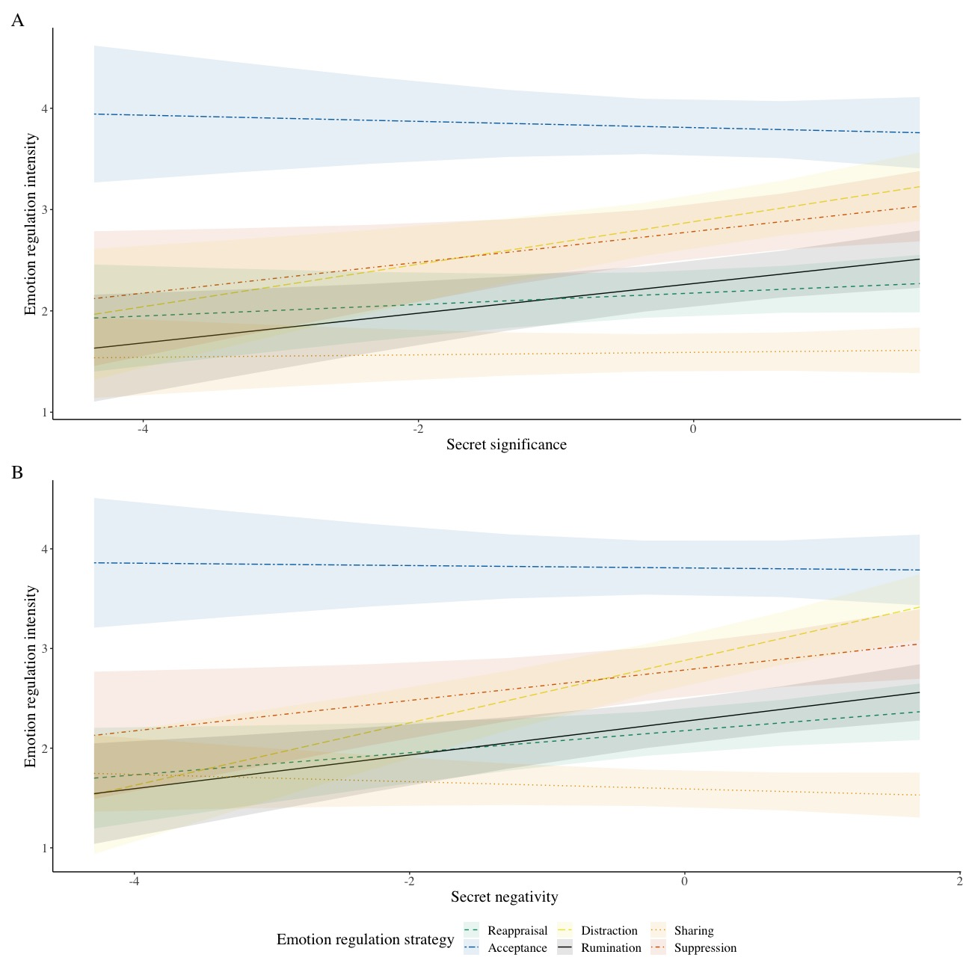
Note. This figure shows daily emotion regulation strategies use, as a function of significance (A) and negativity of the secret (B), as assessed in the baseline phase of Study 2.

Study 3 Preprocessing: Sample Size and Data Exclusion
We invited 482 eligible people to complete the baseline survey from their responses on the initial screener survey. Of those, 349 people completed the baseline survey. More details on the screener survey and relative logbook are available in the pre-registration: https://osf.io/q9fr2/. Although we originally recruited 349 people to complete the baseline survey, 13 were excluded for only partially completing the baseline survey, and 37 were subsequently excluded due to: not having any secrets (n=16); completing the baseline survey impossibly fast (n=5); failing attention checks at baseline (n=10); choosing to withdraw from the study (n=1); and not completing any daily diary surveys (n=5). Of the remaining 312 participants for whom we had daily diary survey responses, we excluded data for 62 participants who passed less than 80% of the attention checks completed in the daily diary phase of the study; 6 people who provided inconsistent answers about their secret still being a secret across the 14 days; and 4 people who provided inconsistent answers about being able to recall the secret across the 14 days. More details on exclusion criteria are provided in the pre-registration.
Figure S3
Flowchart Indicating Participant Inclusion/Exclusion from the Final Sample Size

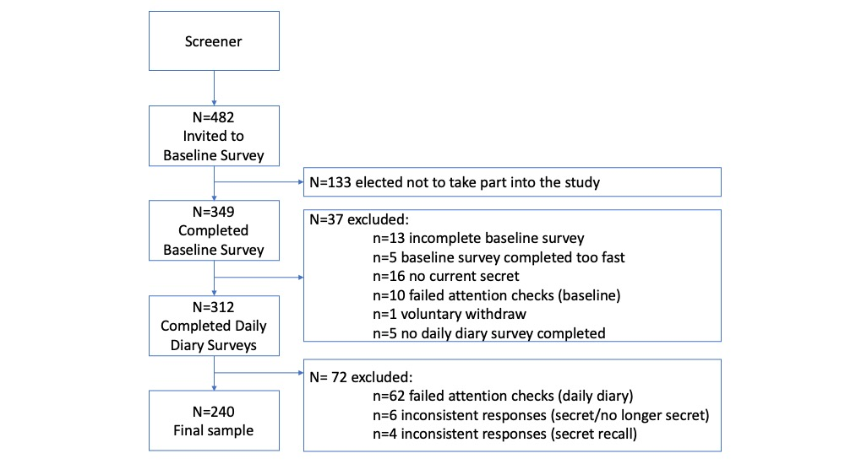

Study 3 Mixed Model Specifications
We conducted analyses using the packages lme4 (Bates et al., 2015) to fit linear mixed-effects models, and lmerTest to calculate p values (Kuznetsova et al., 2017). Our strategy mirrored analyses conducted in Study 1. The first set of multilevel analyses tested differences in the intensity of the different emotion-regulation strategies used to manage the secrets. We conducted 3-level models (i.e., emotion regulation strategy, nested within days, nested within persons). Variables were recoded so that emotion regulation intensity scores for each person were predicted by a factor variable comparing the different strategies (replacing each strategy as the reference category in subsequent tests).
When models presented convergence or singularity fit issues, we first attempted to resolve issues by (1) rescaling the variables, and (2) by removing random slopes with the least variance (Bates et al., 2015). Table S3.1 presents the final model specifications tested in Study 3 after convergence and singularity issues were addressed.
As in Study 2, our second set of multilevel analyses predicted use of each emotion regulation strategy to manage the secret, from features of the secret assessed at baseline (Table S3.2). We conducted 2-level models (i.e., emotion regulation strategy, nested within persons). We included the features of secrets as fixed effects (grand-mean centered), and a random intercept for participant.
Figure S4. Study 3 Comparisons Between Emotion Regulation Strategies Related to Secrets.
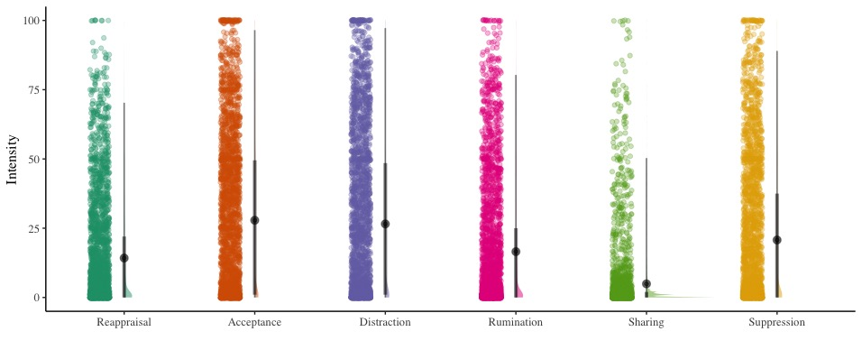

Table S3.1. Within-person correlations for emotion regulation items
Variables | 1 | 2 | 3 | 4 | 5 | 6 | 7 | 8 | 9 | 10 | 11 | 12
1. Reappraisal (Item 1) | —
2. Reappraisal (Item 2) | .46 | —
3. Rumination (Item 1) | .21 | .33 | —
4. Rumination (Item 2) | .21 | .35 | .56 | —
5. Distraction (Item 1) | .18 | .17 | .21 | .26 | —
6. Distraction (Item 2) | .21 | .18 | .20 | .24 | .54 | —
7. Sharing (Item 1) | .15 | .18 | .17 | .12 | .03 | .03 | —
8. Sharing (Item 2) | .12 | .19 | .19 | .17 | .04* | .03 | .69 | —
9. Acceptance (Item 1) | .26 | .30 | .31 | .25 | .22 | .21 | .16 | .17 | —
10. Acceptance (Item 2) | .21 | .30 | .35 | .27 | .15 | .13 | .19 | .18 | .54 | —
11. Suppression (Item 1) | .17 | .19 | .31 | .31 | .34 | .36 | .05 | .06 | .24 | .18 | —
12. Suppression (Item 2) | .16 | .16 | .22 | .22 | .33 | .35 | .05* | .09 | .19 | .13 | .45 | —
Note. *p < .05. All other p <.001.

Table S3.2 Mixed Model Specifications Study 3
Model | Outcome Variable | Fixed effects | Random Effects | Random Effects Omitted Due To Convergence Issues
1A | Emotion Regulation Intensity | Cognitive Reappraisal | Random Intercept of Participant  Random Slope of Cognitive Reappraisal for Participant  Random Intercept of Day within Participant | Random Slope of Cognitive Reappraisal for Day within Participant
1B | Emotion Regulation Intensity | Expressive Suppression | Random Intercept of Participant  Random Slope of Expressive Suppression for Participant  Random Intercept of Day within Participant | Random Slope of Expressive Suppression for Day within Participant
1C | Emotion Regulation Intensity | Distraction | Random Intercept of Participant  Random Slope of Distraction for Participant  Random Intercept of Day within Participant | Random Slope of Distraction for Day within Participant
1D | Emotion Regulation Intensity | Rumination | Random Intercept of Participant  Random Slope of Rumination for Participant  Random Intercept of Day within Participant | Random Slope of Rumination for Day within Participant
1E | Emotion Regulation Intensity | Acceptance | Random Intercept of Participant  Random Slope of Acceptance for Participant  Random Intercept of Day within Participant | Random Slope of Acceptance for Day within Participant
1F | Emotion Regulation Intensity | Social Sharing | Random Intercept of Participant  Random Slope of Social Sharing for Participant  Random Intercept of Day within Participant | Random Slope of Social Share for Day within Participant
Note. Package used for Analysis: lmerTest in R; p values in the lmerTest package are calculated using a Satterthwaite approximation for degrees of freedom.

Table S3.3 Mixed Model Specifications Study 3
Model | Outcome Variable | Fixed effects | Random Effects | Random Effects Omitted Due To Convergence Issues
4AA | Cognitive Reappraisal | Secret Significance | Participant Random Intercept
4AB | Rumination | Secret Significance | Participant Random Intercept
4AC | Distraction | Secret Significance | Participant Random Intercept
4AD | Social Sharing | Secret Significance | Participant Random Intercept
4AE | Acceptance | Secret Significance | Participant Random Intercept
4AF | Expressive Suppression | Secret Significance | Participant Random Intercept
4BA | Cognitive Reappraisal | Secret Negativity | Participant Random Intercept
4BB | Rumination | Secret Negativity | Participant Random Intercept
4BC | Distraction | Secret Negativity | Participant Random Intercept
4BD | Social Sharing | Secret Negativity | Participant Random Intercept
4BE | Acceptance | Secret Negativity | Participant Random Intercept
4BF | Expressive Suppression | Secret Negativity | Participant Random Intercept
4CA | Cognitive Reappraisal | Secret Discoverability | Participant Random Intercept
4CB | Rumination | Secret Discoverability | Participant Random Intercept
4CC | Distraction | Secret Discoverability | Participant Random Intercept
4CD | Social Sharing | Secret Discoverability | Participant Random Intercept
4CE | Acceptance | Secret Discoverability | Participant Random Intercept
4CF | Expressive Suppression | Secret Discoverability | Participant Random Intercept
4DA | Cognitive Reappraisal | Secret Controllability | Participant Random Intercept
4DB | Rumination | Secret Controllability | Participant Random Intercept
4DC | Distraction | Secret Controllability | Participant Random Intercept
4DD | Social Sharing | Secret Controllability | Participant Random Intercept
4DE | Acceptance | Secret Controllability | Participant Random Intercept
4DF | Expressive Suppression | Secret Controllability | Participant Random Intercept
Note. Models 4AA to 4DF: Predictors were Grand-Mean Centered. Package used for Analysis: lmerTest in R; p values in the lmerTest package are calculated using a Satterthwaite approximation for degrees of freedom. Bold models indicate a significant relationship.

Table S3.3 Mixed Model Specifications Study 3 (continued)
Model | Outcome Variable | Fixed effects | Random Effects | Random Effects Omitted Due To Convergence Issues
4EA | Cognitive Reappraisal | Secret Immorality | Participant Random Intercept
4EB | Rumination | Secret Immorality | Participant Random Intercept
4EC | Distraction | Secret Immorality | Participant Random Intercept
4ED | Social Sharing | Secret Immorality | Participant Random Intercept
4EE | Acceptance | Secret Immorality | Participant Random Intercept
4EF | Expressive Suppression | Secret Immorality | Participant Random Intercept
4FA | Cognitive Reappraisal | Social Harm | Participant Random Intercept
4FB | Rumination | Social Harm | Participant Random Intercept
4FC | Distraction | Social Harm | Participant Random Intercept
4FD | Social Sharing | Social Harm | Participant Random Intercept
4FE | Acceptance | Social Harm | Participant Random Intercept
4FF | Expressive Suppression | Social Harm | Participant Random Intercept
4FFA | Cognitive Reappraisal | Social Protection | Participant Random Intercept
4FFB | Rumination | Social Protection | Participant Random Intercept
4FFC | Distraction | Social Protection | Participant Random Intercept
4FFD | Social Sharing | Social Protection | Participant Random Intercept
4FFE | Acceptance | Social Protection | Participant Random Intercept
4FFF | Expressive Suppression | Social Protection | Participant Random Intercept
4GA | Cognitive Reappraisal | Certainty | Participant Random Intercept
4GB | Rumination | Certainty | Participant Random Intercept
4GC | Distraction | Certainty | Participant Random Intercept
4GD | Social Sharing | Certainty | Participant Random Intercept
4GE | Acceptance | Certainty | Participant Random Intercept
4GF | Expressive Suppression | Certainty | Participant Random Intercept
Note. Models 4EA to 4HF: Predictors were Grand-Mean Centered. Package used for Analysis: lmerTest in R; p values in the lmerTest package are calculated using a Satterthwaite approximation for degrees of freedom. Bold models indicate a significant relationship.

Table S3.4 Mixed Model Specifications Study 3
Model | Outcome Variable | Fixed effects | Random Effects | Random Effects Omitted Due To Convergence Issues
S4AB | Emotion Regulation Intensity | Interaction between Secret Significance and Rumination | Random Intercept of Participant  Random Slope of Rumination for Participant  Random Intercept of Day within Participant | Random Slope of Rumination for Day within Participant
S4AC | Emotion Regulation Intensity | Interaction between Secret Significance and Distraction | Random Intercept of Participant  Random Slope of Distraction for Participant  Random Intercept of Day within Participant | Random Slope of Distraction for Day within Participant
S4AE | Emotion Regulation Intensity | Interaction between Secret Significance and Acceptance | Random Intercept of Participant  Random Slope of Acceptance for Participant  Random Intercept of Day within Participant | Random Slope of Acceptance for Day within Participant
S4AF | Emotion Regulation Intensity | Interaction between Secret Significance and Expressive Suppression | Random Intercept of Participant  Random Slope of Expressive Suppression for Participant  Random Intercept of Day within Participant | Random Slope of Expressive Suppression for Day within Participant
S4BC | Emotion Regulation Intensity | Interaction between Secret Negativity and Distraction | Random Intercept of Participant  Random Slope of Distraction for Participant  Random Intercept of Day within Participant | Random Slope of Distraction for Day within Participant
S4BE | Emotion Regulation Intensity | Interaction between Secret Negativity and Acceptance | Random Intercept of Participant  Random Slope of Acceptance for Participant  Random Intercept of Day within Participant | Random Slope of Acceptance for Day within Participant
S4BF | Emotion Regulation Intensity | Interaction between Secret Negativity and Expressive Suppression | Random Intercept of Participant  Random Slope of Expressive Suppression for Participant  Random Intercept of Day within Participant | Random Slope of Expressive Suppression for Day within Participant
Note. Package used for Analysis: lmerTest in R; p values in the lmerTest package are calculated using a Satterthwaite approximation for degrees of freedom.

Table S3.4 Mixed Model Specifications Study 3 (continued)
Model | Outcome Variable | Fixed effects | Random Effects | Random Effects Omitted Due To Convergence Issues
S4CA | Emotion Regulation Intensity | Interaction between Secret Discoverability and Cognitive Reappraisal | Random Intercept of Participant  Random Slope of Cognitive Reappraisal for Participant  Random Intercept of Day within Participant | Random Slope of Cognitive Reappraisal for Day within Participant
S4DA | Emotion Regulation Intensity | Interaction between Secret Controllability and Cognitive Reappraisal | Random Intercept of Participant  Random Slope of Cognitive Reappraisal for Participant  Random Intercept of Day within Participant | Random Slope of Cognitive Reappraisal for Day within Participant
S4DB | Emotion Regulation Intensity | Interaction between Secret Controllability and Rumination | Random Intercept of Participant  Random Slope of Rumination for Participant  Random Intercept of Day within Participant | Random Slope of Rumination for Day within Participant
S4DC | Emotion Regulation Intensity | Interaction between Secret Controllability and Distraction | Random Intercept of Participant  Random Slope of Distraction for Participant  Random Intercept of Day within Participant | Random Slope of Distraction for Day within Participant
S4DE | Emotion Regulation Intensity | Interaction between Secret Controllability and Acceptance | Random Intercept of Participant  Random Slope of Acceptance for Participant  Random Intercept of Day within Participant | Random Slope of Acceptance for Day within Participant
S4DF | Emotion Regulation Intensity | Interaction between Secret Controllability and Expressive Suppression | Random Intercept of Participant  Random Slope of Expressive Suppression for Participant  Random Intercept of Day within Participant | Random Slope of Expressive Suppression for Day within Participant
Note. Package used for Analysis: lmerTest in R; p values in the lmerTest package are calculated using a Satterthwaite approximation for degrees of freedom.

Table S3.4 Mixed Model Specifications Study 3 (continued)
Model | Outcome Variable | Fixed effects | Random Effects | Random Effects Omitted Due To Convergence Issues
S4EA | Emotion Regulation Intensity | Interaction between Secret Immorality and Cognitive Reappraisal | Random Intercept of Participant  Random Slope of Cognitive Reappraisal for Participant  Random Intercept of Day within Participant | Random Slope of Cognitive Reappraisal for Day within Participant
S4FA | Emotion Regulation Intensity | Interaction between Secret Social Harm and Cognitive Reappraisal | Random Intercept of Participant  Random Slope of Cognitive Reappraisal for Participant  Random Intercept of Day within Participant | Random Slope of Cognitive Reappraisal for Day within Participant
S4FB | Emotion Regulation Intensity | Interaction between Secret Social Harm and Rumination | Random Intercept of Participant  Random Slope of Rumination for Participant  Random Intercept of Day within Participant | Random Slope of Rumination for Day within Participant
S4FC | Emotion Regulation Intensity | Interaction between Secret Social Harm and Distraction | Random Intercept of Participant  Random Slope of Distraction for Participant  Random Intercept of Day within Participant | Random Slope of Distraction for Day within Participant
S4FD | Emotion Regulation Intensity | Interaction between Secret Social Harm and Social Sharing | Random Intercept of Participant  Random Slope of Social Sharing for Participant  Random Intercept of Day within Participant | Random Slope of Social Sharing for Day within Participant
S4FF | Emotion Regulation Intensity | Interaction between Secret Social Harm and Expressive Suppression | Random Intercept of Participant  Random Slope of Expressive Suppression for Participant  Random Intercept of Day within Participant | Random Slope of Expressive Suppression for Day within Participant
S4FFF | Emotion Regulation Intensity | Interaction between Secret Social Protection and Expressive Suppression | Random Intercept of Participant  Random Slope of Expressive Suppression for Participant  Random Intercept of Day within Participant | Random Slope of Expressive Suppression for Day within Participant
Note. Package used for Analysis: lmerTest in R; p values in the lmerTest package are calculated using a Satterthwaite approximation for degrees of freedom.

Summary of Results for Study 2 and Study 3 Reference Table
Table S3.5 Summary of findings in Study 2 and Study 3 — Features of the secret predicting emotion regulation strategy employed to manage the secret
Model | Outcome Variable | Feature of the Secret | Study 2 | Study 3
4AA | Cognitive Reappraisal | Secret Significance | û | û
4AB | Rumination | Secret Significance | ü | ü
4AC | Distraction | Secret Significance | ü | ü
4AD | Social Sharing | Secret Significance | û | û
4AE | Acceptance | Secret Significance | û | ü
4AF | Expressive Suppression | Secret Significance | ü | ü
4BA | Cognitive Reappraisal | Secret Negativity | ü | û
4BB | Rumination | Secret Negativity | ü | û
4BC | Distraction | Secret Negativity | ü | ü
4BD | Social Sharing | Secret Negativity | û | û
4BE | Acceptance | Secret Negativity | û | ü(-)
4BF | Expressive Suppression | Secret Negativity | ü | ü
Note. ü significant association; û non-significant association; (-) negative association. Bold models indicate a significant relationship in both studies.

Table S3.6 Summary of findings in Study 3 — Features of the secret predicting emotion regulation strategy employed to manage the secret
Model | Outcome Variable | Feature of the Secret | Results
4CA | Cognitive Reappraisal | Secret Discoverability | ü
4CB | Rumination | Secret Discoverability | û
4CC | Distraction | Secret Discoverability | û
4CD | Social Sharing | Secret Discoverability | û
4CE | Acceptance | Secret Discoverability | û
4CF | Expressive Suppression | Secret Discoverability | û
4DA | Cognitive Reappraisal | Secret Controllability | ü
4DB | Rumination | Secret Controllability | ü
4DC | Distraction | Secret Controllability | ü
4DD | Social Sharing | Secret Controllability | û
4DE | Acceptance | Secret Controllability | ü
4DF | Expressive Suppression | Secret Controllability | ü
4EA | Cognitive Reappraisal | Secret Immorality | ü
4EB | Rumination | Secret Immorality | û
4EC | Distraction | Secret Immorality | û
4ED | Social Sharing | Secret Immorality | û
4EE | Acceptance | Secret Immorality | û
4EF | Expressive Suppression | Secret Immorality | û
Note. ü significant association; û non-significant association; (-) negative association. Bold models indicate a significant relationship in both studies.

Table S3.6 Summary of findings in Study 3 — Features of the secret predicting emotion regulation strategy employed to manage the secret (continued)
Model | Outcome Variable | Feature of the Secret | Results
4FA | Cognitive Reappraisal | Social Harm | ü
4FB | Rumination | Social Harm | ü
4FC | Distraction | Social Harm | ü
4FD | Social Sharing | Social Harm | ü
4FE | Acceptance | Social Harm | û
4FF | Expressive Suppression | Social Harm | ü
4FFA | Cognitive Reappraisal | Social Protection | û
4FFB | Rumination | Social Protection | û
4FFC | Distraction | Social Protection | û
4FFD | Social Sharing | Social Protection | û
4FFE | Acceptance | Social Protection | û
4FFF | Expressive Suppression | Social Protection | ü
4GA | Cognitive Reappraisal | Certainty | û
4GB | Rumination | Certainty | û
4GC | Distraction | Certainty | û
4GD | Social Sharing | Certainty | û
4GE | Acceptance | Certainty | û
4GF | Expressive Suppression | Certainty | û
Note. ü significant association; û non-significant association; (-) negative association. Bold models indicate a significant relationship in both studies.

Study 3 Tables and Figures reporting significance of interactions between features of the secret and emotion regulation strategies
In the below tables, we report results for the emotion regulation strategies that were significantly associated with the features of the secret (significance of the secret, Tables S3.7-S3.10; negativity of the secret, Tables S3.11-S3.13; discoverability of the secret, Table S3.14; controllability of the secret, Tables S3.15-S3.19; immorality of the secret, Table S3.20; social harm, Tables S3.21-S3.25; social protection, Table S3.26). In the tables, we bolded the interactions reflecting significant relationships between each feature of the secret and comparisons between emotion regulation strategies.

Table S3.7 Interactions between Secret Significance and Rumination (Study 3)
 | Intensity
Predictors | Estimate (SE) | 95% CI | p
(Intercept) | 16.02  (1.26) | 13.54 – 18.50 | <.001
Secret significance | 2.32  (0.73) | 0.87 – 3.76 | .002
Rumination (vs acceptance) | 11.48  (1.27) | 8.98 – 13.98 | <.001
Rumination (vs. distraction) | 9.69  (1.21) | 7.31 – 12.07 | <.001
Rumination (vs. reappraisal) | -2.14  (0.91) | -3.93 – -0.35 | .019
Rumination (vs. social sharing) | -11.18  (1.01) | -13.16 – -9.19 | <.001
Rumination (vs. suppression) | 4.18  (0.94) | 2.33 – 6.03 | <.001
Secret Significance x rumination (vs acceptance) | -0.52  (0.81) | -2.11 – 1.08 | .526
Secret Significance x rumination (vs. distraction) | 0.78  (0.77) | -0.74 – 2.30 | .312
Secret Significance x rumination (vs. reappraisal) | -1.42  (0.58) | -2.56 – -0.28 | .015
Secret Significance x rumination (vs. social sharing) | -2.18  (0.64) | -3.45 – -0.91 | .001
Secret Significance x rumination (vs. suppression) | -0.13  (0.60) | -1.31 – 1.05 | .832
Note. Predictors were grand-mean centered. A significant interaction indicates that secret significance predicts the mentioned strategies to a different degree.

Table S3.8 Interactions between Secret Significance and Distraction (Study 3)
 | Intensity
Predictors | Estimate (SE) | 95% CI | p
(Intercept) | 25.70  (1.52) | 22.71 – 28.70 | <.001
Secret significance | 3.10  (0.91) | 1.30 – 4.90 | .001
Distraction (vs. acceptance) | 1.79  (1.68) | -1.51 – 5.10 | .287
Distraction (vs. reappraisal) | -11.83  (1.23) | -14.25 – -9.40 | <.001
Distraction (vs. rumination) | -9.69  (1.21) | -12.07 – -7.31 | <.001
Distraction (vs. social sharing) | -20.87  (1.42) | -23.66 – -18.07 | <.001
Distraction (vs. suppression) | -5.51  (0.93) | -7.33 – -3.68 | <.001
Secret Significance x distraction (vs. acceptance) | -1.30  (1.07) | -3.41 – 0.81 | .227
Secret Significance x distraction (vs. reappraisal) | -2.20  (0.79) | -3.75 – -0.65 | .006
Secret Significance x distraction (vs. rumination) | -0.78  (0.77) | -2.30 – 0.74 | .312
Secret Significance x distraction (vs. social sharing) | -2.96  (0.91) | -4.75 – -1.17 | .001
Secret Significance x distraction (vs. suppression) | -0.91  (0.59) | -2.08 – 0.26 | .126
Note. Predictors were grand-mean centered. A significant interaction indicates that secret significance predicts the mentioned strategies to a different degree.

Table S3.9 Interactions between Secret Significance and Acceptance (Study 3)
 | Intensity
Predictors | Estimate (SE) | 95% CI | p
(Intercept) | 27.50  (1.45) | 24.64 – 30.35 | <.001
Secret significance | 1.80  (0.87) | 0.10 – 3.51 | .039
Acceptance (vs. distraction) | -1.79  (1.68) | -5.10 – 1.51 | .287
Acceptance (vs. reappraisal) | -13.62  (1.19) | -15.96 – -11.27 | <.001
Acceptance (vs. rumination) | -11.48  (1.27) | -13.98 – -8.98 | <.001
Acceptance (vs. social sharing) | -22.66  (1.26) | -25.14 – -20.17 | <.001
Acceptance (vs. suppression) | -7.30  (1.54) | -10.33 – -4.26 | <.001
Secret significance x acceptance (vs. distraction) | 1.30  (1.07) | -0.81 – 3.41 | .227
Secret significance x acceptance (vs. reappraisal) | -0.90  (0.76) | -2.40 – 0.59 | .236
Secret significance x acceptance (vs. rumination) | 0.52  (0.81) | -1.08 – 2.11 | .526
Secret significance x acceptance (vs. social sharing) | -1.66  (0.80) | -3.25 – -0.08 | .040
Secret significance x acceptance (vs. suppression) | 0.39  (0.98) | -1.55 – 2.33 | .694
Note. Predictors were grand-mean centered. A significant interaction indicates that secret significance predicts the mentioned strategies to a different degree.

Table S3.10 Interactions between Secret Significance and Suppression (Study 3)
 | Intensity
Predictors | Estimate (SE) | 95% CI | p
(Intercept) | 20.20  (1.34) | 17.55 – 22.85 | <.001
Secret significance | 2.19  (0.79) | 0.63 – 3.75 | .006
Suppression (vs. acceptance) | 7.30  (1.54) | 4.26 – 10.33 | <.001
Suppression (vs. distraction) | 5.51  (0.93) | 3.68 – 7.33 | <.001
Suppression (vs. reappraisal) | -6.32  (1.07) | -8.43 – -4.21 | <.001
Suppression (vs. rumination) | -4.18  (0.94) | -6.03 – -2.33 | <.001
Suppression (vs. social sharing) | -15.36  (1.18) | -17.69 – -13.03 | <.001
Secret significance x suppression (vs. acceptance) | -0.39  (0.98) | -2.33 – 1.55 | .694
Secret significance x suppression (vs. distraction) | 0.91  (0.59) | -0.26 – 2.08 | .126
Secret significance x suppression (vs. reappraisal) | -1.29  (0.68) | -2.64 – 0.06 | .061
Secret significance x suppression (vs. rumination) | 0.13  (0.60) | -1.05 – 1.31 | .832
Secret significance x suppression (vs. social sharing) | -2.05  (0.76) | -3.54 – -0.56 | .007
Note. Predictors were grand-mean centered. A significant interaction indicates that secret significance predicts the mentioned strategies to a different degree.

Table S3.11 Interactions between Secret Negativity and Distraction (Study 3)
 | Intensity
Predictors | Estimate (SE) | 95% CI | p
(Intercept) | 25.75  (1.51) | 22.77 – 28.73 | <.001
Secret negativity | 3.26  (0.84) | 1.61 – 4.90 | <.001
Distraction (vs. acceptance) | 1.74  (1.54) | -1.29 – 4.77 | .258
Distraction (vs. reappraisal) | -11.87  (1.19) | -14.21 – -9.53 | <.001
Distraction (vs. rumination) | -9.72  (1.18) | -12.04 – -7.40 | <.001
Distraction (vs. social sharing) | -20.92  (1.39) | -23.66 – -18.18 | <.001
Distraction (vs. suppression) | -5.52  (0.93) | -7.35 – -3.70 | <.001
Secret negativity x distraction (vs. acceptance) | -6.06  (0.90) | -7.84 – -4.28 | <.001
Secret negativity x distraction (vs. reappraisal) | -3.55  (0.70) | -4.93 – -2.18 | <.001
Secret negativity x distraction (vs. rumination) | -2.40  (0.69) | -3.76 – -1.03 | .001
Secret negativity x distraction (vs. social sharing) | -3.83  (0.82) | -5.44 – -2.22 | <.001
Secret negativity x distraction (vs. suppression) | -0.97  (0.54) | -2.04 – 0.11 | .077
Note. Predictors were grand-mean centered. A significant interaction indicates that secret negativity predicts the mentioned strategies to a different degree.

Table S3.12 Interactions between Secret Negativity and Acceptance (Study 3)
 | Intensity
Predictors | Estimate (SE) | 95% CI | p
(Intercept) | 27.49  (1.43) | 24.68 – 30.30 | <.001
Secret negativity | -2.80  (0.78) | -4.34 – -1.26 | <.001
Acceptance (vs. distraction) | -1.74  (1.54) | -4.77 – 1.29 | .258
Acceptance (vs. reappraisal) | -13.61  (1.16) | -15.89 – -11.33 | <.001
Acceptance (vs. rumination) | -11.46  (1.20) | -13.83 – -9.09 | <.001
Acceptance (vs. social sharing) | -22.66  (1.25) | -25.12 – -20.20 | <.001
Acceptance (vs. suppression) | -7.26  (1.43) | -10.08 – -4.45 | <.001
Secret negativity x acceptance (vs. distraction) | 6.06  (0.90) | 4.28 – 7.84 | <.001
Secret negativity x acceptance (vs. reappraisal) | 2.51  (0.68) | 1.16 – 3.85 | <.001
Secret negativity x acceptance (vs. rumination) | 3.66  (0.71) | 2.27 – 5.05 | <.001
Secret negativity x acceptance (vs. social sharing) | 2.23  (0.73) | 0.78 – 3.67 | .003
Secret negativity x acceptance (vs. suppression) | 5.09  (0.84) | 3.44 – 6.74 | <.001
Note. Predictors were grand-mean centered. A significant interaction indicates that secret negativity predicts the mentioned strategies to a different degree.
Table S3.13 Interactions between Secret Negativity and Suppression (Study 3)
 | Intensity
Predictors | Estimate (SE) | 95% CI | p
(Intercept) | 20.23  (1.34) | 17.59 – 22.87 | <.001
Secret negativity | 2.29  (0.73) | 0.86 – 3.72 | .002
Suppression (vs. acceptance) | 7.26  (1.43) | 4.45 – 10.08 | <.001
Suppression (vs. distraction) | 5.52  (0.93) | 3.70 – 7.35 | <.001
Suppression (vs. reappraisal) | -6.35  (1.04) | -8.40 – -4.30 | <.001
Suppression (vs. rumination) | -4.20  (0.93) | -6.02 – -2.38 | <.001
Suppression (vs. social sharing) | -15.40  (1.16) | -17.68 – -13.11 | <.001
Secret negativity x suppression (vs. acceptance) | -5.09  (0.84) | -6.74 – -3.44 | <.001
Secret negativity x suppression (vs. distraction) | 0.97  (0.54) | -0.11 – 2.04 | .077
Secret negativity x suppression (vs. reappraisal) | -2.59  (0.61) | -3.79 – -1.38 | <.001
Secret negativity x suppression (vs. rumination) | -1.43  (0.54) | -2.50 – -0.36 | .009
Secret negativity x suppression (vs. social sharing) | -2.86  (0.68) | -4.21 – -1.52 | <.001
Note. Predictors were grand-mean centered. A significant interaction indicates that secret negativity predicts the mentioned strategies to a different degree.
Figure S5
Use of emotion regulation strategy predicted by features of the secret.

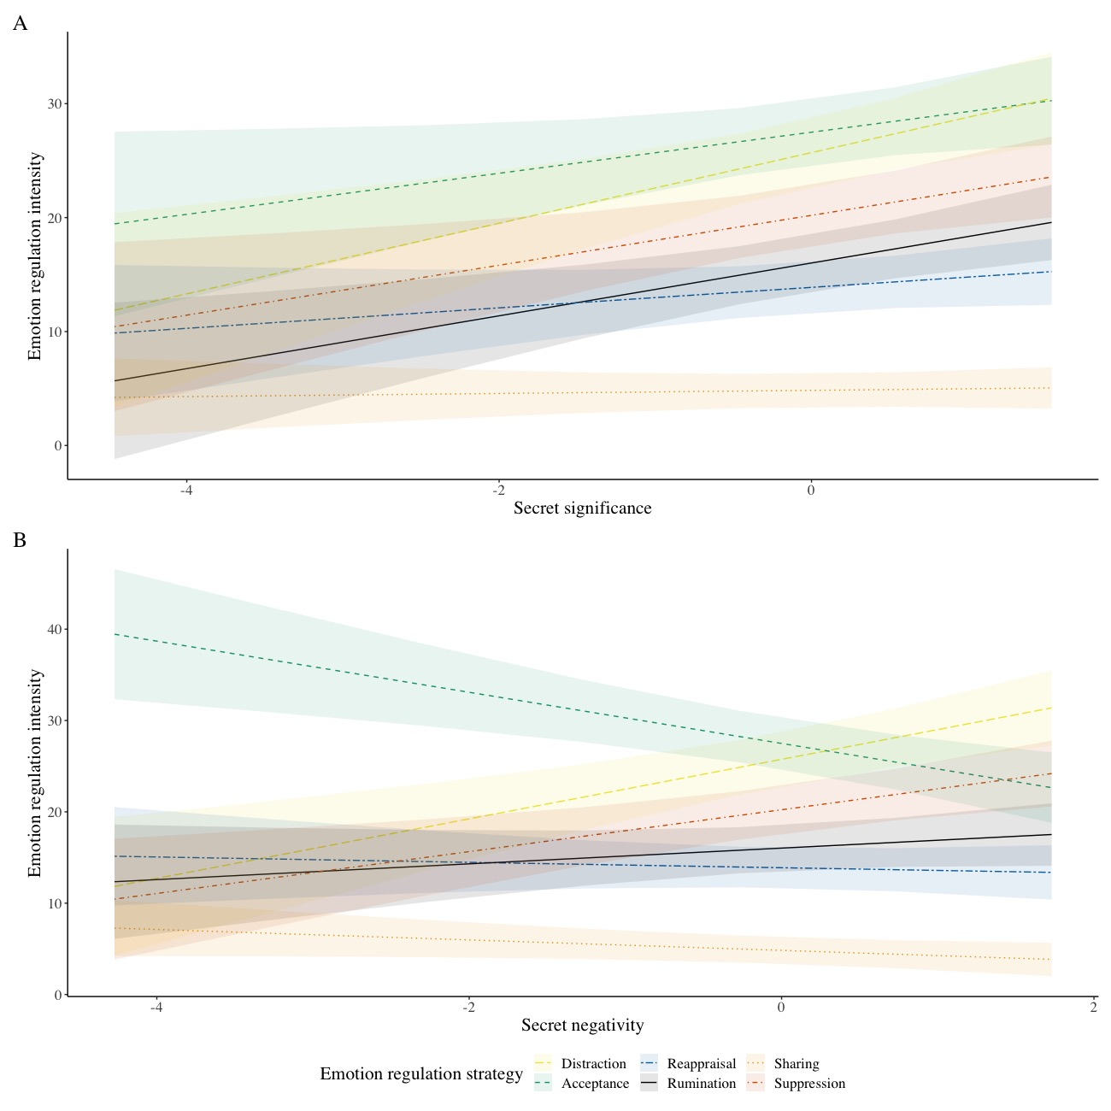
Table S3.14 Interactions between Secret Discoverability and Reappraisal (Study 3)
 | Intensity
Predictors | Estimate (SE) | 95% CI | p
(Intercept) | 13.88  (1.12) | 11.67 – 16.09 | <.001
Secret discoverability | 1.03  (0.52) | 0.01 – 2.04 | .048
Reappraisal (vs. acceptance) | 13.62  (1.19) | 11.27 – 15.96 | <.001
Reappraisal (vs. distraction) | 11.82  (1.25) | 9.35 – 14.28 | <.001
Reappraisal (vs. rumination) | 2.13  (0.92) | 0.32 – 3.94 | .021
Reappraisal (vs. social sharing) | -9.04  (0.88) | -10.77 – -7.31 | <.001
Reappraisal (vs. suppression) | 6.32  (1.08) | 4.19 – 8.44 | <.001
Secret discoverability x reappraisal (vs. acceptance) | -0.11  (0.62) | -1.34 – 1.11 | .854
Secret discoverability x reappraisal (vs. distraction) | -0.31  (0.65) | -1.59 – 0.97 | .630
Secret discoverability x reappraisal (vs. rumination) | -0.05  (0.48) | -0.99 – 0.89 | .922
Secret discoverability x reappraisal (vs. social sharing) | -0.73  (0.45) | -1.62 – 0.17 | .111
Secret discoverability x reappraisal (vs. suppression) | -0.09  (0.56) | -1.19 – 1.01 | .873
Note. Predictors were grand-mean centered. A significant interaction indicates that secret discoverability predicts the mentioned strategies to a different degree.
The below figure shows the association between emotion regulation strategies and discoverability of the secret.

Figure S6
Use of emotion regulation strategy predicted by features of the secret.
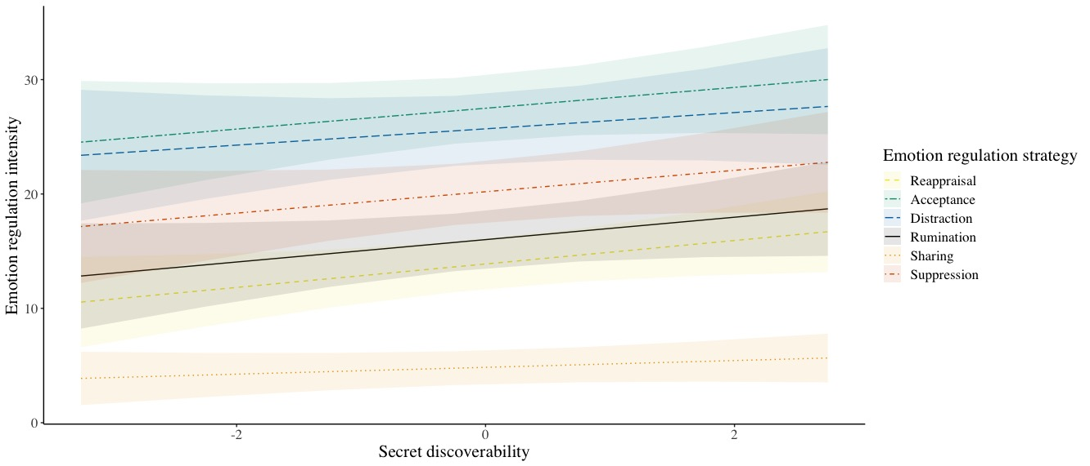
Note. This figure shows daily emotion regulation strategies use, as a function of discoverability of the secret, as assessed in the baseline phase of Study 3.

Table S3.15 Interactions between Secret Controllability and Reappraisal (Study 3)
 | Intensity
Predictors | Estimate (SE) | 95% CI | p
(Intercept) | 13.91  (1.10) | 11.74 – 16.09 | <.001
Secret controllability | 2.15  (0.54) | 1.09 – 3.20 | <.001
Reappraisal (vs acceptance) | 13.65  (1.20) | 11.30 – 16.01 | <.001
Reappraisal (vs distraction) | 11.86  (1.25) | 9.40 – 14.32 | <.001
Reappraisal (vs rumination) | 2.08  (0.92) | 0.26 – 3.90 | .025
Reappraisal (vs social sharing) | -9.05  (0.86) | -10.75 – -7.35 | <.001
Reappraisal (vs suppression) | 6.28  (1.08) | 4.15 – 8.40 | <.001
Secret controllability x reappraisal (vs acceptance) | 0.24  (0.66) | -1.05 – 1.54 | .713
Secret controllability x reappraisal (vs distraction) | 1.08  (0.69) | -0.28 – 2.43 | .119
Secret controllability x reappraisal (vs rumination) | 0.00  (0.51) | -1.00 – 1.01 | .993
Secret controllability x reappraisal (vs social sharing) | -1.74  (0.48) | -2.67 – -0.80 | <.001
Secret controllability x reappraisal (vs suppression) | 0.81  (0.60) | -0.36 – 1.99 | .172
Note. Predictors were grand-mean centered. A significant interaction indicates that secret controllability predicts the mentioned strategies to a different degree.

Table S3.16 Interactions between Secret Controllability and Rumination (Study 3)
 | Intensity
Predictors | Estimate (SE) | 95% CI | p
(Intercept) | 15.99  (1.26) | 13.51 – 18.48 | <.001
Secret controllability | 2.15  (0.63) | 0.90 – 3.40 | .001
Rumination (vs acceptance) | 11.57  (1.27) | 9.06 – 14.08 | <.001
Rumination (vs distraction) | 9.78  (1.20) | 7.40 – 12.15 | <.001
Rumination (vs reappraisal) | -2.08  (0.92) | -3.90 – -0.26 | .025
Rumination (vs social sharing) | -11.13  (1.01) | -13.13 – -9.13 | <.001
Rumination (vs suppression) | 4.20  (0.94) | 2.35 – 6.05 | <.001
Secret controllability x rumination (vs acceptance) | 0.24  (0.70) | -1.14 – 1.62 | .734
Secret controllability x rumination (vs distraction) | 1.07  (0.66) | -0.23 – 2.38 | .107
Secret controllability x rumination (vs reappraisal) | -0.00  (0.51) | -1.01 – 1.00 | .993
Secret controllability x rumination (vs social sharing) | -1.74  (0.56) | -2.84 – -0.64 | .002
Secret controllability x rumination (vs suppression) | 0.81  (0.52) | -0.21 – 1.83 | .119
Note. Predictors were grand-mean centered. A significant interaction indicates that secret controllability predicts the mentioned strategies to a different degree.
Table S3.17 Interactions between Secret Controllability and Distraction (Study 3)
 | Intensity
Predictors | Estimate (SE) | 95% CI | p
(Intercept) | 25.77  (1.51) | 22.80 – 28.75 | <.001
Secret controllability | 3.22  (0.78) | 1.69 – 4.76 | <.001
Distraction (vs. acceptance) | 1.80  (1.69) | -1.53 – 5.12 | .288
Distraction (vs. reappraisal) | -11.86  (1.25) | -14.32 – -9.40 | <.001
Distraction (vs. rumination) | -9.78  (1.20) | -12.15 – -7.40 | <.001
Distraction (vs. social sharing) | -20.91  (1.42) | -23.71 – -18.11 | <.001
Distraction (vs. suppression) | -5.58  (0.93) | -7.42 – -3.74 | <.001
Secret controllability x distraction (vs. acceptance) | -0.84  (0.93) | -2.66 – 0.99 | .369
Secret controllability x distraction (vs. reappraisal) | -1.08  (0.69) | -2.43 – 0.28 | .119
Secret controllability x distraction (vs. rumination) | -1.07  (0.66) | -2.38 – 0.23 | .107
Secret controllability x distraction (vs. social sharing) | -2.82  (0.78) | -4.35 – -1.28 | <.001
Secret controllability x distraction (vs. suppression) | -0.26  (0.51) | -1.28 – 0.75 | .609
Note. Predictors were grand-mean centered. A significant interaction indicates that secret controllability predicts the mentioned strategies to a different degree.

Table S3.18 Interactions between Secret Controllability and Acceptance (Study 3)
 | Intensity
Predictors | Estimate (SE) | 95% CI | p
(Intercept) | 27.57  (1.44) | 24.73 – 30.40 | <.001
Secret controllability | 2.39  (0.74) | 0.93 – 3.84 | .001
Acceptance (vs. distraction) | -1.80  (1.69) | -5.12 – 1.53 | .288
Acceptance (vs. reappraisal) | -13.65  (1.20) | -16.01 – -11.30 | <.001
Acceptance (vs. rumination) | -11.57  (1.27) | -14.08 – -9.06 | <.001
Acceptance (vs. social sharing) | -22.71  (1.25) | -25.18 – -20.24 | <.001
Acceptance (vs. suppression) | -7.38  (1.54) | -10.41 – -4.34 | <.001
Secret controllability x acceptance (vs. distraction) | 0.84  (0.93) | -0.99 – 2.66 | .369
Secret controllability x acceptance (vs. reappraisal) | -0.24  (0.66) | -1.54 – 1.05 | .713
Secret controllability x acceptance (vs. rumination) | -0.24  (0.70) | -1.62 – 1.14 | .734
Secret controllability x acceptance (vs. social sharing) | -1.98  (0.69) | -3.34 – -0.62 | .004
Secret controllability x acceptance (vs. suppression) | 0.57  (0.85) | -1.10 – 2.24 | .501
Note. Predictors were grand-mean centered. A significant interaction indicates that secret controllability predicts the mentioned strategies to a different degree.

Table S3.19 Interactions between Secret Controllability and Suppression (Study 3)
 | Intensity
Predictors | Estimate (SE) | 95% CI | p
(Intercept) | 20.19  (1.32) | 17.58 – 22.80 | <.001
Secret controllability | 2.96  (0.67) | 1.64 – 4.28 | <.001
Suppression (vs. acceptance) | 7.38  (1.54) | 4.34 – 10.41 | <.001
Suppression (vs. distraction) | 5.58  (0.93) | 3.74 – 7.42 | <.001
Suppression (vs. reappraisal) | -6.28  (1.08) | -8.40 – -4.15 | <.001
Suppression (vs. rumination) | -4.20  (0.94) | -6.05 – -2.35 | <.001
Suppression (vs. social sharing) | -15.33  (1.17) | -17.63 – -13.03 | <.001
Secret controllability x suppression (vs. acceptance) | -0.57  (0.85) | -2.24 – 1.10 | .501
Secret controllability x suppression (vs. distraction) | 0.26  (0.51) | -0.75 – 1.28 | .609
Secret controllability x suppression (vs. reappraisal) | -0.81  (0.60) | -1.99 – 0.36 | .172
Secret controllability x suppression (vs. rumination) | -0.81  (0.52) | -1.83 – 0.21 | .119
Secret controllability x suppression (vs. social sharing) | -2.55  (0.64) | -3.82 – -1.28 | <.001
Note. Predictors were grand-mean centered. A significant interaction indicates that secret controllability predicts the mentioned strategies to a different degree.

The below figure shows the associations between emotion regulation strategies and controllability of the secret.

Figure S7
Use of emotion regulation strategy predicted by features of the secret.
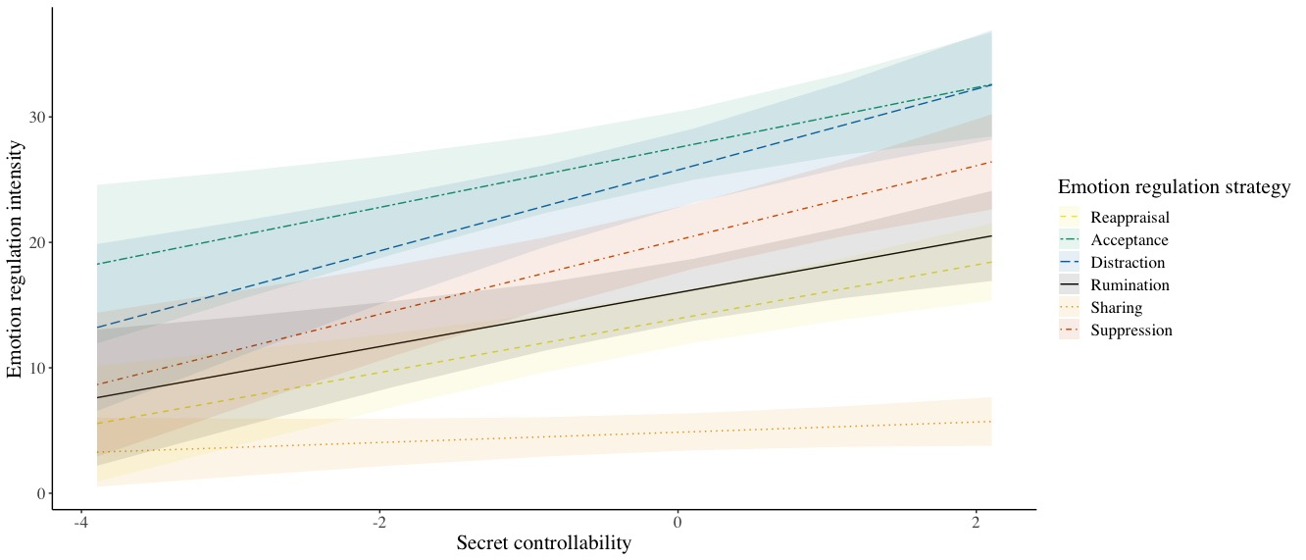
Note. This figure shows daily emotion regulation strategies use, as a function of controllability of the secret, as assessed in the baseline phase of Study 3.

Table S3.20 Interactions between Secret Immorality and Reappraisal (Study 3)
 | Intensity
Predictors | Estimate (SE) | 95% CI | p
(Intercept) | 13.84  (1.11) | 11.65 – 16.04 | <.001
Secret immorality | 1.73  (0.59) | 0.56 – 2.89 | .004
Reappraisal (vs. acceptance) | 13.66  (1.17) | 11.36 – 15.97 | <.001
Reappraisal (vs. distraction) | 11.86  (1.24) | 9.42 – 14.30 | <.001
Reappraisal (vs. rumination) | 2.15  (0.92) | 0.34 – 3.96 | .020
Reappraisal (vs. social sharing) | -9.00  (0.87) | -10.71 – -7.29 | <.001
Reappraisal (vs. suppression) | 6.34  (1.08) | 4.21 – 8.46 | <.001
Secret immorality x reappraisal (vs. acceptance) | -1.94  (0.70) | -3.33 – -0.56 | .006
Secret immorality x reappraisal (vs. distraction) | -1.45  (0.75) | -2.92 – 0.02 | .053
Secret immorality x reappraisal (vs. rumination) | -0.56  (0.55) | -1.64 – 0.52 | .311
Secret immorality x reappraisal (vs. social sharing) | -1.44  (0.52) | -2.46 – -0.41 | .006
Secret immorality x reappraisal (vs. suppression) | -0.63  (0.65) | -1.90 – 0.65 | .332
Note. Predictors were grand-mean centered. A significant interaction indicates that secret immorality predicts the mentioned strategies to a different degree.

The below figure shows the associations between emotion regulation strategies and immorality of the secret.

Figure S8
Use of emotion regulation strategy predicted by features of the secret.
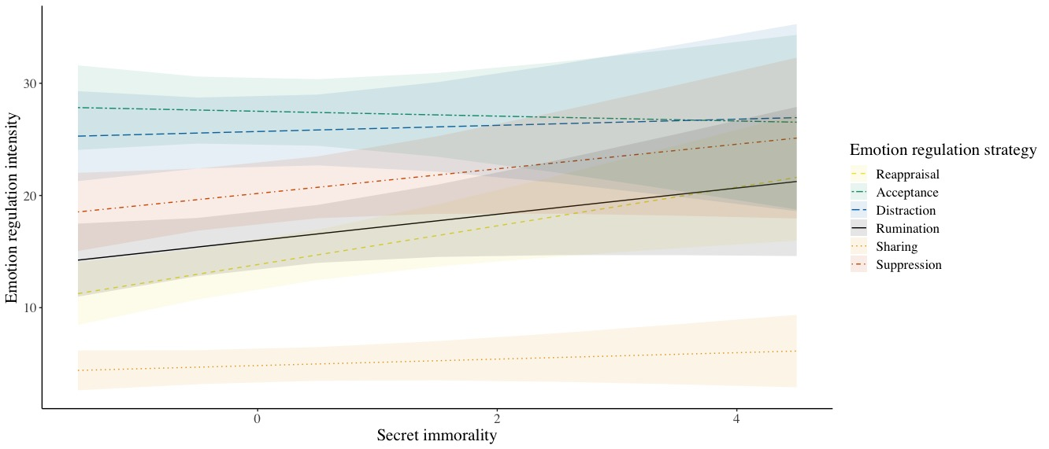
Note. This figure shows daily emotion regulation strategies use, as a function of immorality of the secret, as assessed in the baseline phase of Study 3.

Table S3.21 Interactions between Social Harm and Reappraisal (Study 3)
 | Intensity
Predictors | Estimate (SE) | 95% CI | p
(Intercept) | 13.92  (1.10) | 11.74 – 16.10 | <.001
Social Harm | 1.51  (0.46) | 0.60 – 2.42 | .001
Reappraisal (vs. acceptance) | 13.58  (1.18) | 11.26 – 15.91 | <.001
Reappraisal (vs. distraction) | 11.80  (1.25) | 9.34 – 14.27 | <.001
Reappraisal (vs. rumination) | 2.13  (0.92) | 0.32 – 3.94 | .022
Reappraisal (vs. social sharing) | -9.06  (0.87) | -10.78 – -7.34 | <.001
Reappraisal (vs. suppression) | 6.33  (1.07) | 4.22 – 8.45 | <.001
Social Harm x reappraisal (vs. acceptance) | -1.16  (0.56) | -2.26 – -0.06 | .039
Social Harm x reappraisal (vs. distraction) | 0.31  (0.59) | -0.86 – 1.47 | .603
Social Harm x reappraisal (vs. rumination) | 0.23  (0.43) | -0.62 – 1.09 | .592
Social Harm x reappraisal (vs. social sharing) | -0.99  (0.41) | -1.80 – -0.18 | .017
Social Harm x reappraisal (vs. suppression) | 0.90  (0.51) | -0.10 – 1.90 | .076
Note. Predictors were grand-mean centered. A significant interaction indicates that social harm of the secret predicts the mentioned strategies to a different degree.

Table S3.22 Interactions between Social Harm and Rumination (Study 3)
 | Intensity
Predictors | Estimate (SE) | 95% CI | p
(Intercept) | 16.05  (1.25) | 13.57 – 18.52 | <.001
Social Harm | 1.75  (0.54) | 0.68 – 2.81 | .001
Rumination (vs. acceptance) | 11.46  (1.26) | 8.98 – 13.93 | <.001
Rumination (vs. distraction) | 9.68  (1.21) | 7.30 – 12.06 | <.001
Rumination (vs. reappraisal) | -2.13  (0.92) | -3.94 – -0.32 | .022
Rumination (vs. social sharing) | -11.19  (1.02) | -13.19 – -9.18 | <.001
Rumination (vs. suppression) | 4.20  (0.93) | 2.36 – 6.05 | <.001
Social Harm x rumination (vs. acceptance) | -1.39  (0.59) | -2.56 – -0.22 | .020
Social Harm x rumination (vs. distraction) | 0.07  (0.57) | -1.05 – 1.20 | .896
Social Harm x rumination (vs. reappraisal) | -0.23  (0.43) | -1.09 – 0.62 | .592
Social Harm x rumination (vs. social sharing) | -1.22  (0.48) | -2.17 – -0.28 | .012
Social Harm x rumination (vs. suppression) | 0.67  (0.44) | -0.20 – 1.54 | .130
Note. Predictors were grand-mean centered. A significant interaction indicates that social harm of the secret predicts the mentioned strategies to a different degree.

Table S3.23 Interactions between Social Harm and Distraction (Study 3)
 | Intensity
Predictors | Estimate (SE) | 95% CI | p
(Intercept) | 25.72  (1.53) | 22.71 – 28.74 | <.001
Social Harm | 1.82  (0.68) | 0.48 – 3.16 | .008
Distraction (vs. acceptance) | 1.78  (1.67) | -1.52 – 5.07 | .289
Distraction (vs. reappraisal) | -11.80  (1.25) | -14.27 – -9.34 | <.001
Distraction (vs. rumination) | -9.68  (1.21) | -12.06 – -7.30 | <.001
Distraction (vs. social sharing) | -20.86  (1.44) | -23.70 – -18.03 | <.001
Distraction (vs. suppression) | -5.47  (0.93) | -7.30 – -3.64 | <.001
Social Harm x distraction (vs. acceptance) | -1.46  (0.79) | -3.02 – 0.09 | .065
Social Harm x distraction (vs. reappraisal) | -0.31  (0.59) | -1.47 – 0.86 | .603
Social Harm x distraction (vs. rumination) | -0.07  (0.57) | -1.20 – 1.05 | .896
Social Harm x distraction (vs. social sharing) | -1.30  (0.68) | -2.64 – 0.04 | .058
Social Harm x distraction (vs. suppression) | 0.59  (0.44) | -0.27 – 1.46 | .176
Note. Predictors were grand-mean centered. A significant interaction indicates that social harm of the secret predicts the mentioned strategies to a different degree.

Table S3.24 Interactions between Social Harm and Social Sharing (Study 3)
 | Intensity
Predictors | Estimate (SE) | 95% CI | p
(Intercept) | 4.86  (0.75) | 3.35 – 6.37 | <.001
Social Harm | 0.52  (0.26) | 0.01 – 1.03 | .044
Social Sharing (vs. acceptance) | 22.64  (1.27) | 20.14 – 25.15 | <.001
Social Sharing (vs. distraction) | 20.86  (1.44) | 18.03 – 23.70 | <.001
Social Sharing (vs. reappraisal) | 9.06  (0.87) | 7.34 – 10.78 | <.001
Social Sharing (vs. rumination) | 11.19  (1.02) | 9.18 – 13.19 | <.001
Social Sharing (vs. suppression) | 15.39  (1.17) | 13.08 – 17.70 | <.001
Social Harm x social sharing (vs. acceptance) | -0.17  (0.60) | -1.35 – 1.02 | .783
Social Harm x social sharing (vs. distraction) | 1.30  (0.68) | -0.04 – 2.64 | .058
Social Harm x social sharing (vs. reappraisal) | 0.99  (0.41) | 0.18 – 1.80 | .017
Social Harm x social sharing (vs. rumination) | 1.22  (0.48) | 0.28 – 2.17 | .012
Social Harm x social sharing (vs. suppression) | 1.89  (0.55) | 0.80 – 2.98 | .001
Note. Predictors were grand-mean centered. A significant interaction indicates that social harm of the secret predicts the mentioned strategies to a different degree.

Table S3.25 Interactions between Social Harm and Suppression (Study 3)
 | Intensity
Predictors | Estimate (SE) | 95% CI | p
(Intercept) | 20.25  (1.32) | 17.65 – 22.85 | <.001
Social Harm | 2.41  (0.58) | 1.28 – 3.55 | <.001
Suppression (vs. acceptance) | 7.25  (1.52) | 4.27 – 10.24 | <.001
Suppression (vs. distraction) | 5.47  (0.93) | 3.64 – 7.30 | <.001
Suppression (vs. reappraisal) | -6.33  (1.07) | -8.45 – -4.22 | <.001
Suppression (vs. rumination) | -4.20  (0.93) | -6.05 – -2.36 | <.001
Suppression (vs. social sharing) | -15.39  (1.17) | -17.70 – -13.08 | <.001
Social Harm x suppression (vs. acceptance) | -2.06  (0.72) | -3.47 – -0.65 | .004
Social Harm x suppression (vs. distraction) | -0.59  (0.44) | -1.46 – 0.27 | .176
Social Harm x suppression (vs. reappraisal) | -0.90  (0.51) | -1.90 – 0.10 | .076
Social Harm x suppression (vs. rumination) | -0.67  (0.44) | -1.54 – 0.20 | .130
Social Harm x suppression (vs. social sharing) | -1.89  (0.55) | -2.98 – -0.80 | .001
Note. Predictors were grand-mean centered. A significant interaction indicates that social harm of the secret predicts the mentioned strategies to a different degree.
Table S3.26 Interactions between Social Protection and Suppression (Study 3)
 | Intensity
Predictors | Estimate (SE) | 95% CI | p
(Intercept) | 20.22  (1.35) | 17.55 – 22.88 | <.001
Social Protection | 1.09  (0.57) | -0.04 – 2.22 | .059
Suppression (vs. acceptance) | 7.29  (1.54) | 4.25 – 10.33 | <.001
Suppression (vs. distraction) | 5.48  (0.93) | 3.65 – 7.30 | <.001
Suppression (vs. reappraisal) | -6.32  (1.08) | -8.45 – -4.20 | <.001
Suppression (vs. rumination) | -4.21  (0.93) | -6.05 – -2.37 | <.001
Suppression (vs. social sharing) | -15.37  (1.19) | -17.73 – -13.02 | <.001
Social Protection x suppression (vs. acceptance) | -0.44  (0.71) | -1.83 – 0.95 | .533
Social Protection x suppression (vs. distraction) | -0.73  (0.42) | -1.57 – 0.10 | .085
Social Protection x suppression (vs. reappraisal) | -0.41  (0.49) | -1.38 – 0.56 | .409
Social Protection x suppression (vs. rumination) | -0.67  (0.43) | -1.51 – 0.17 | .117
Social Protection x suppression (vs. social sharing) | -0.94  (0.55) | -2.01 – 0.14 | .088
Note. Predictors were grand-mean centered. A significant interaction indicates that social protection of the secret predicts the mentioned strategies to a different degree.

Figure S9
Use of emotion regulation strategy predicted by features of the secret.

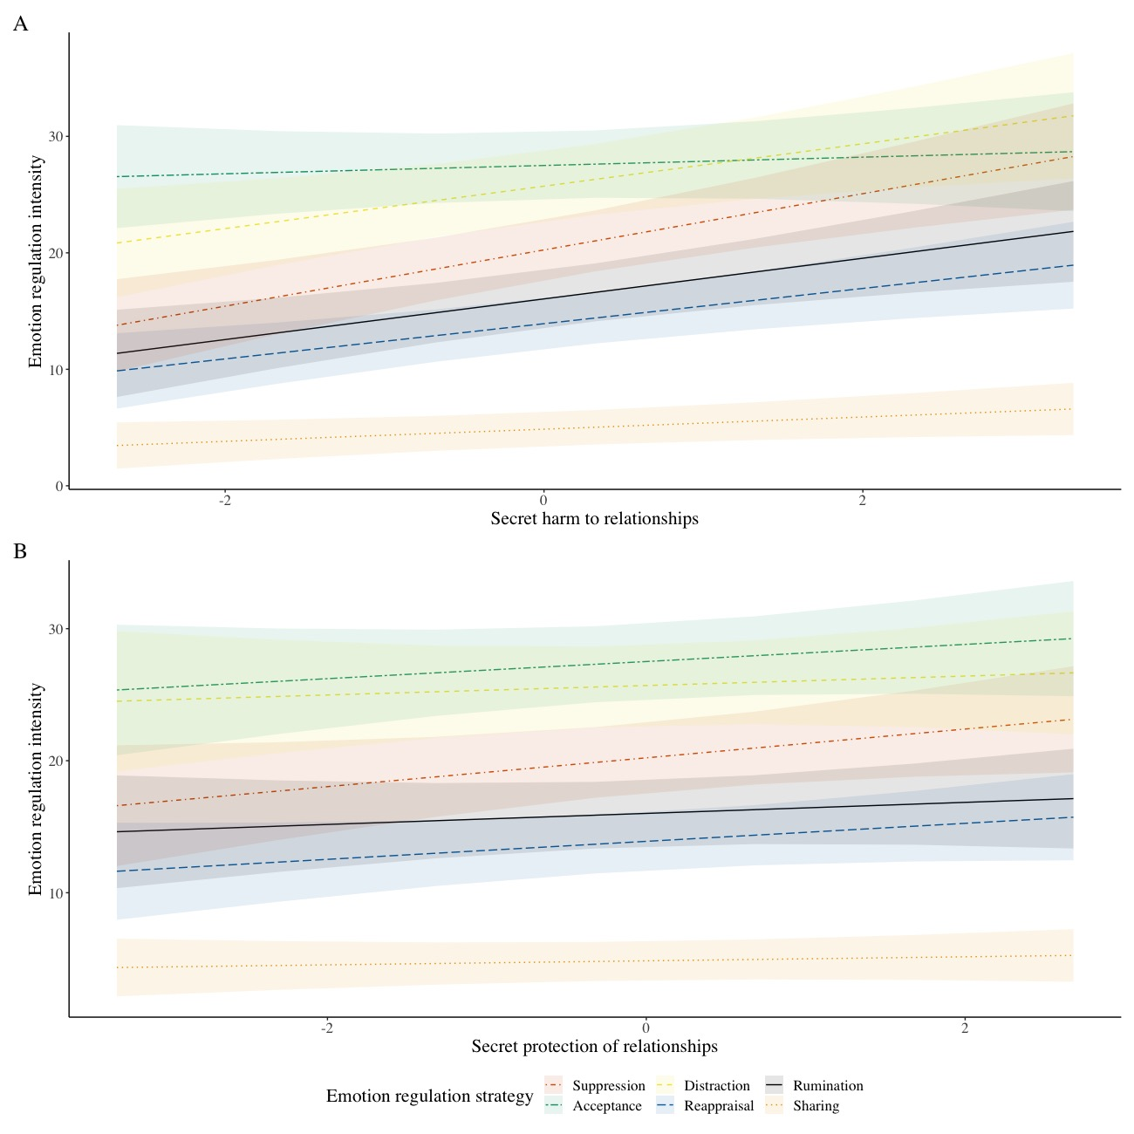

Testing for Changes in Emotion Regulation Over Time
One common concern of ESM studies is reactivity, such that asking participants to report frequently on a certain phenomenon might increase people’s tendency to notice and report that phenomenon (Bolger & Laurenceau, 2013). To identify whether we observed such an issue in Study 2 and 3, we ran multilevel models predicting intensity of each emotion regulation strategy from day of study over the seven (Study 2) and 14 (Study 3) days of the daily diary phase of the studies. Although we found significant effects for all strategies (except for social sharing), they were in the opposite direction to what would be expected in case of reactivity—participants reported less intense use of regulation strategies as they progressed through the study. This effect could be interpreted as an initial elevation bias in subjective reports (Shrout et al., 2018). Results are outlined in Table S2.12 and Table S3.27.

Table S2.12. Study 2: Predicting Intensity of Emotion Regulation from Day of Study.
 | Reappraisal |  |  | Sharing |  |  | Rumination |  |  | Acceptance |  |  | Distraction |  |  | Suppression
 | Est (SE) | 95% CI | p | Est (SE) | 95% CI | p | Est (SE) | 95% CI | p | Est (SE) | 95% CI | p | Est (SE) | 95% CI | p | Est (SE) | 95% CI | p
Intercept | 2.47  (0.12) | 2.24  2.69 | <.001 | 1.67  (0.09) | 1.48  1.85 | <.001 | 2.46  (0.12) | 2.22  2.70 | <.001 | 4.35  (0.16) | 4.04  4.65 | <.001 | 3.30  (0.15) | 3.01  3.60 | <.001 | 3.00  (0.15) | 2.71  3.29 | <.001
Day | -0.07  (0.02) | -0.10  -0.04 | <.001 | -0.02  (0.02) | -0.05  0.01 | .235 | -0.05  (0.02) | -0.08  -0.01 | .020 | -0.14  (0.02) | -0.18  -0.09 | <.001 | -0.10  (0.02) | -0.15  -0.06 | <.001 | -0.05  (0.02) | -0.10  -0.01 | .015
Note. N=174, 1056 observations included (1055 for Acceptance). Regulation Strategies were assessed on a 7-point scale ranging from ‘not at all’ to ‘very much’. Bold indicates significant fixed effects.

Table S3.27. Study 3: Predicting Intensity of Emotion Regulation from Day of Study.
 | Reappraisal |  |  | Sharing |  |  | Rumination |  |  | Acceptance |  |  | Distraction |  |  | Suppression
 | Est (SE) | 95% CI | p | Est (SE) | 95% CI | p | Est (SE) | 95% CI | p | Est (SE) | 95% CI | p | Est (SE) | 95% CI | p | Est (SE) | 95% CI | p
Intercept | 15.43  (1.11) | 13.25 17.60 | <.001 | 5.36  (0.67) | 4.05  6.68 | <.001 | 18.02  (1.28) | 15.50 – 20.54 | <.001 | 31.98  (1.55) | 28.93 35.03 | <.001 | 30.77  (1.62) | 27.58 33.95 | <.001 | 24.39  (1.42) | 21.59 27.19 | <.001
Day | -0.19  (0.07) | -0.32  -0.06 | .005 | -0.05  (0.05) | -0.15  0.06 | 0.381 | -0.26  (0.08) | -0.41  -0.11 | .001 | -0.58  (0.10) | -0.78  -0.38 | <.001 | -0.68  (0.10) | -0.86  -0.49 | <.001 | -0.54  (0.09) | -0.72  -0.36 | <.001
Note. N=238 (239 for Rumination, Social Sharing, and Acceptance), 2698 observations included (2695 for Rumination, 2702 for Distraction, 2695 for Social Sharing, 2705 for Acceptance). Regulation Strategies were assessed on a visual sliding scale ranging from 0 ‘Not at all’ to 100 ‘Very much’ (average of two items). Bold indicates significant fixed effects.

Supplementary Analyses Predicting Binary Social Sharing from Secret Features
Considering the relatively low-level endorsement of social sharing in both Study 2 (M=1.58; SD_{between}=0.90; 7-point scale) and Study 3 (M=5.11; SD_{between}=8.79; 100-point scale), we conducted supplementary analyses as robustness checks of our main findings (reported on pages 21, and 29-31 of the manuscript). Our thanks to an anonymous reviewer for suggesting this supplementary analysis.
We conducted logistic MLM regressions, after transforming the outcome variable (social sharing) into a binomial factor variable (i.e., 0=no sharing, 1=sharing). Results are presented in Tables S2.13 to S2.14 (Study 2) and S3.28 to 3.35 (Study 3). Across studies, neither secret significance nor secret negativity predicted likelihood of using social sharing to regulate emotions about their secrets. (ps>.526). The results in Study 3 revealed people shared more when they appraised the secret as more controllable and more socially harmful.
Table S2.13 Study 2: Secret Features predicting Social Sharing (binomial models)
 | Social Sharing
Predictors | Odds Ratio (SE) | 95% CI | p
(Intercept) | 0.03  (0.01) | 0.01 – 0.06 | <.001
Secret Significance | 1.11  (0.23) | 0.74 – 1.66 | .626
Note. Predictors were grand-mean centered. Social Sharing is a binary variable coded as 0, no social sharing (set as the reference level), 1, social sharing. SE=standard errors. CI=confidence interval.
Table S2.14 Study 2: Secret Features predicting Social Sharing (binomial models)

 | Social Sharing
Predictors | Odds Ratio (SE) | 95% CI | p
(Intercept) | 0.03  (0.01) | 0.01 – 0.06 | <.001
Secret Negativity | 1.06  (0.22) | 0.71 – 1.58 | .777
Note. Predictors were grand-mean centered. Social Sharing is a binary variable coded as 0, no social sharing (set as the reference level), 1, social sharing. SE=standard errors. CI=confidence interval.

Table S3.28 Study 3: Secret Features predicting Social Sharing (binomial models)
 | Social Sharing
Predictors | Odd Ratio  (SE) | 95% CI | p
Intercept | 12.66  (6.58) | 4.57 – 35.05 | <.001
Secret Significance | 0.82  (0.25) | 0.45 – 1.51 | .526
Note. Predictors were grand-mean centered. Social Sharing is a binary variable coded as 0, no social sharing (set as the reference level), 1, social sharing. SE=standard errors. CI=confidence interval.

Table S3.29 Study 3: Secret Features predicting Social Sharing (binomial models)
 | Social Sharing
Predictors | Odd Ratio  (SE) | 95% CI | p
Intercept | 12.41  (6.43) | 4.49 – 34.28 | <.001
Secret Negativity | 0.91  (0.23) | 0.55 – 1.50 | .705
Note. Predictors were grand-mean centered. Social Sharing is a binary variable coded as 0, no social sharing (set as the reference level), 1, social sharing. SE=standard errors. CI=confidence interval.

Table S3.30 Study 3: Secret Features predicting Social Sharing (binomial models)

 | Social Sharing
Predictors | Odd Ratio  (SE) | 95% CI | p
Intercept | 12.28  (6.36) | 4.45 – 33.89 | <.001
Secret Discoverability | 1.16  (0.28) | 0.72 – 1.87 | .543
Note. Predictors were grand-mean centered. Social Sharing is a binary variable coded as 0, no social sharing (set as the reference level), 1, social sharing. SE=standard errors. CI=confidence interval.

Table S3.31 Study 3: Secret Features predicting Social Sharing (binomial models)
 | Social Sharing
Predictors | Odd Ratio  (SE) | 95% CI | p
Intercept | 13.11  (6.81) | 4.74 – 36.30 | <.001
Secret Controllability | 1.83  (0.48) | 1.10 – 3.07 | .020
Note. Predictors were grand-mean centered. Social Sharing is a binary variable coded as 0, no social sharing (set as the reference level), 1, social sharing. SE=standard errors. CI=confidence interval.

Table S3.32 Study 3: Secret Features predicting Social Sharing (binomial models)
 | Social Sharing
Predictors | Odd Ratio  (SE) | 95% CI | p
Intercept | 12.53  (6.49) | 4.54 – 34.56 | <.001
Secret Immorality | 1.08  (0.30) | 0.63 – 1.86 | .771
Note. Predictors were grand-mean centered. Social Sharing is a binary variable coded as 0, no social sharing (set as the reference level), 1, social sharing. SE=standard errors. CI=confidence interval.

Table S3.33 Study 3: Secret Features predicting Social Sharing (binomial models)

 | Social Sharing
Predictors | Odd Ratio  (SE) | 95% CI | p
Intercept | 12.90  (6.69) | 4.67 – 35.67 | <.001
Secret Social Harm | 1.62  (0.36) | 1.04 – 2.51 | .033
Note. Predictors were grand-mean centered. Social Sharing is a binary variable coded as 0, no social sharing (set as the reference level), 1, social sharing. SE=standard errors. CI=confidence interval.

Table S3.34 Study 3: Secret Features predicting Social Sharing (binomial models)
 | Social Sharing
Predictors | Odd Ratio  (SE) | 95% CI | p
Intercept | 12.56  (6.50) | 4.55 – 34.66 | <.001
Secret Social Protection | 1.30  (0.28) | 0.86 – 1.98 | .213
Note. Predictors were grand-mean centered. Social Sharing is a binary variable coded as 0, no social sharing (set as the reference level), 1, social sharing. SE=standard errors. CI=confidence interval.

Table S3.35 Study 3: Secret Features predicting Social Sharing (binomial models)
 | Social Sharing
Predictors | Odd Ratio  (SE) | 95% CI | p
Intercept | 12.56  (6.50) | 4.55 – 34.66 | <.001
Secret Uncertainty of the Goal  in Keeping the Secret | 1.24  (0.46) | 0.59 – 2.57 | .570
Note. Predictors were grand-mean centered. Social Sharing is a binary variable coded as 0, no social sharing (set as the reference level), 1, social sharing. SE=standard errors. CI=confidence interval.

References
Bates, D., Mächler, M., Bolker, B., & Walker, S. (2015). Fitting Linear Mixed-Effects Models Using lme4. Journal of Statistical Software, 67(1), 1–48. https://doi.org/10.18637/jss.v067.i01
Kuznetsova, A., Brockhoff, P. B., & Christensen, R. H. B. (2017). lmerTest Package: Tests in Linear Mixed Effects Models. Journal of Statistical Software, 82(13), 1 - 26. https://doi.org/10.18637/jss.v082.i13

