**Negative Emotions Disrupt Intentional Synchronization during Group Sensorimotor Interaction**

Andrii Smykovskyi1

Stefan Janaqi1

Simon Pla1

Pierre Jean1

Marta M. N. Bieńkiewicz1

Benoit G. Bardy1

1EuroMov Digital Health in Motion, University of Montpellier, IMT Mines Ales, Montpellier, France

**Supplemental Materials**

Contents:

1. Descriptive statistics on the synchronization metrics of different levels
2. Interpersonal Finger Synchronization: Time-To-Sync metric
3. Choosing a threshold duration for calculating the Time-To-Sync metric
4. Order of counterbalanced trials

**1) Descriptive statistics on the synchronization metrics of different levels**

Table 1

*Descriptive statistics on the synchronization metrics Time-In-Sync and Time-To-Sync of different levels*

|  |  |  |  |  |  |  |
| --- | --- | --- | --- | --- | --- | --- |
| **Metric** | **Variable** | ***M*** | ***SD*** | ***SEM*** | ***N*** | ***Not***  ***Attained*** |
| Time-In-Sync: Q1 |  |  |  |  |  |  |
|  | 1. Negative | 14.27 | 1.07 | 0.24 | 20 | 0 |
|  | 2. Neutral | 15.05 | 1.09 | 0.24 | 20 | 0 |
|  | 3. Positive | 15.96 | 1.26 | 0.28 | 20 | 0 |
| Time-In-Sync: Q2 |  |  |  |  |  |  |
|  | 1. Negative | 8.04 | 1.60 | 0.36 | 20 | 0 |
|  | 2. Neutral | 10.89 | 1.75 | 0.39 | 20 | 0 |
|  | 3. Positive | 11.90 | 1.69 | 0.38 | 20 | 0 |
| Time-In-Sync: Q3 |  |  |  |  |  |  |
|  | 1. Negative | 1.04 | 1.50 | 0.33 | 20 | 0 |
|  | 2. Neutral | 6.51 | 1.62 | 0.36 | 20 | 0 |
|  | 3. Positive | 7.31 | 1.59 | 0.35 | 20 | 0 |
| Time-To-Sync: Q1 |  |  |  |  |  |  |
|  | 1. Negative | 4.49 | 2.35 | 0.53 | 20 | 0 |
|  | 2. Neutral | 3.51 | 1.85 | 0.41 | 20 | 0 |
|  | 3. Positive | 3.09 | 2.27 | 0.51 | 20 | 0 |
| Time-To-Sync: Q2 |  |  |  |  |  |  |
|  | 1. Negative | 6.74 | 4.87 | 1.41 | 20 | **8** |
|  | 2. Neutral | 4.53 | 3.61 | 0.81 | 20 | 0 |
|  | 3. Positive | 5.41 | 3.63 | 0.81 | 20 | 0 |
| Time-To-Sync: Q3 |  |  |  |  |  |  |
|  | 1. Negative | NA | NA | NA | 20 | **20** |
|  | 2. Neutral | 5.79 | 5.57 | 1.97 | 20 | 12 |
|  | 3. Positive | 6.43 | 4.58 | 1.27 | 20 | 7 |

*Note.* *M* indicates mean. *SD* indicates standard deviation. *SEM* indicates the standard error of the mean. *N* indicates the number of values per variable, i.e. triads. *Not Attained* indicates the number of trials in which participants failed to achieve the specified synchronisation level.

**2) Interpersonal Finger Synchronization: Time-To-Sync metric**

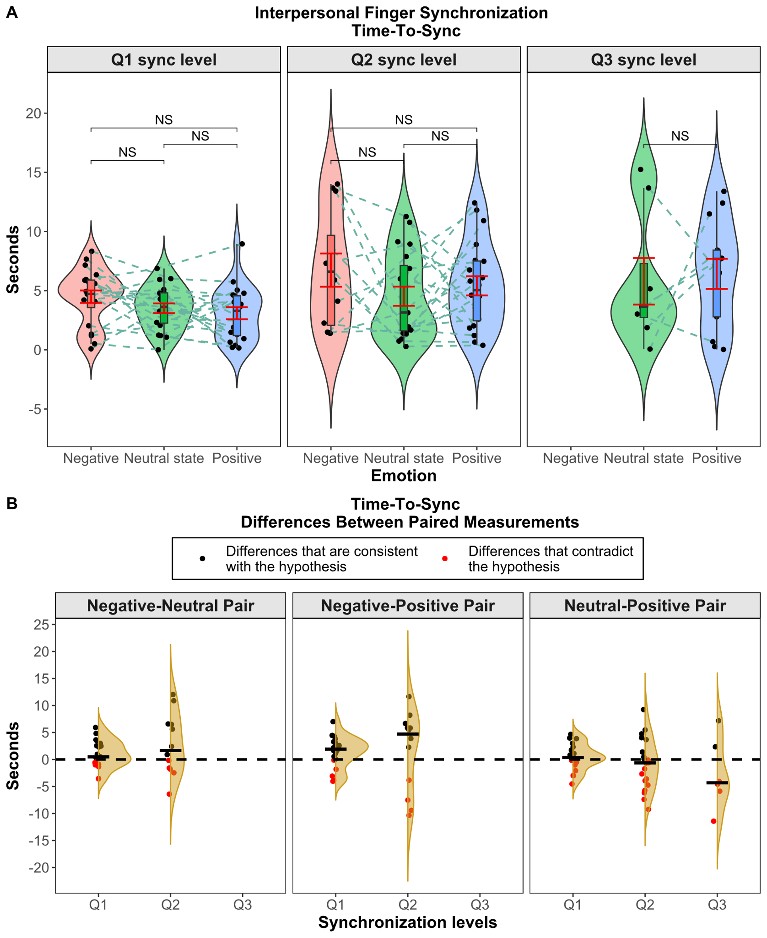

*Figure 1.* (A) Time-To-Sync violin plots demonstrating distributions of scattered data points for Q1, Q2, and Q3 synchronization level. The red error bars are quantified with the standard error of the mean. Each triad’s data points are connected with dashed lines. (B) Differences between paired Time-To-Sync measurements with flat violin plots. The black dashed line indicates the hypothesis threshold, where the values lower than 0 align with the hypothesis (black data points), and the values above 0 contradict the hypothesis (red data points). The black vertical crossbars indicate medians of emotion pairs.

**3) Choosing a threshold duration for calculating the Time-To-Sync metric**

Table 2

*Inferential statistics results for different duration thresholds for the Time-To-Sync metric of different levels*

|  |  |  |  |  |  |  |
| --- | --- | --- | --- | --- | --- | --- |
| **Time-To-Sync**  **threshold durations** | **Sync level** | ***F*** | ***DFn*** | ***DFd*** | ***p*** | ***Ges*** |
| **3 seconds** |  |  |  |  |  |  |
|  | Q1 | 2.98 | 2 | 38 | .063 | .07 |
|  | Q2 | 1.14 | 2 | 22 | .337 | .07 |
|  | Q3 | 1.05 | 1 | 5 | .353 | .11 |
| **2.5 seconds** |  |  |  |  |  |  |
|  | **Q1** | **6.33** | **2** | **38** | **.004** | **.16** |
|  | Q2 | 2.75 | 2 | 30 | .080 | .10 |
|  | Q3 | 0.02 | 1 | 9 | .893 | .00 |
| **2 seconds** |  |  |  |  |  |  |
|  | Q1 | 3.03 | 1.44 | 27.43 | .079 | .10 |
|  | Q2 | 3.03 | 2 | 32 | .062 | .10 |
|  | Q3 | NA | 2 | 0 | NA | 1 |
| **1.5 second** |  |  |  |  |  |  |
|  | Q1 | 1.50 | 2 | 38 | .236 | .04 |
|  | **Q2** | **8.47** | **2** | **36** | **.000** | **.20** |
|  | Q3 | 0.66 | 2 | 4 | .564 | .02 |
| **1 second** |  |  |  |  |  |  |
|  | **Q1** | **3.59** | **2** | **38** | **.037** | **.07** |
|  | **Q2** | **9.01** | **2** | **38** | **.000** | **.22** |
|  | Q3 | 1.88 | 2 | 12 | .194 | .08 |
| **0.5 second** |  |  |  |  |  |  |
|  | Q1 | 1.34 | 2 | 38 | .274 | .03 |
|  | **Q2** | **3.95** | **1.46** | **27.65** | **.043** | **.12** |
|  | Q3 | 3.61 | 2 | 16 | .051 | .13 |

*Note.* *F* indicates a F-value. *DFn* indicates nominator degrees of freedom. *DFd* indicates denominator degrees of freedom. *p* indicates the probability of obtaining equal or more extreme sample. *Ges* indicates generalized eta squared.

**4) Order of counterbalanced trials**

Table 3

*Two different orders of trials*

|  |  |  |
| --- | --- | --- |
| **Trial #** | **Order 1** | **Order 2** |
| 1 | Neg | Neg |
| 2 | Netr | Pos |
| 3 | Pos | Neg |
| 4 | Pos | Neg |
| 5 | Pos | Netr |
| 6 | Neg | Netr |
| 7 | Netr | Pos |
| 8 | Netr | Netr |
| 9 | Neg | Netr |
| 10 | Netr | Pos |
| 11 | Pos | Neg |
| 12 | Neg | Pos |
| 13 | Neg | Pos |
| 14 | Pos | Neg |
| 15 | Netr | Netr |

*Note.* Neg, Netr, and Pos indicate negative, neutral, and positive emotion induction, respectively.