Genetic Algorithms Reveal Identity Independent Representation of Emotional Expressions – Supplemental Material

GA task
Figure S1
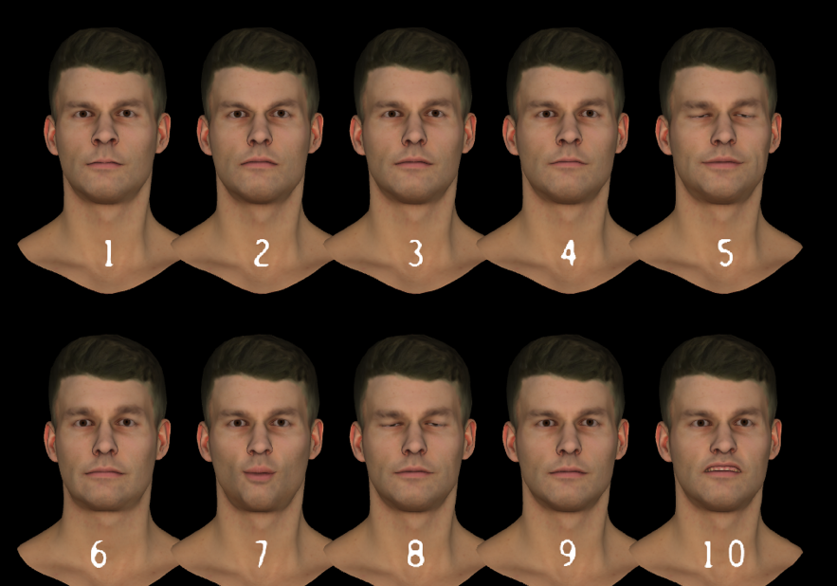
An example of faces presented in a single trial. Participants were required to indicate which faces were the best matches to a target emotion.

Participant satisfaction with closeness of faces to internal representations
Ratings of satisfaction on the preferred faces was high across all face categories (all medians = 6; Table S1). We examined whether there were any differences between the ratings for each of the face categories. Using a Friedman test, we found no significant effect of emotion category on satisfaction ratings for the male (χ²(3) = 4.382, p = .223) or female (χ²(3) = 0.541, p = .910) faces. Using pairwise Wilcoxon signed rank tests, we also found no differences between the ratings for the male and female faces for any emotion category (Angry: Z = .735, p = .462; Fearful: Z = 0.540, p = .589; Happy: Z = 1.032, p = .302; Sad: Z = 0.092, p = .927). These results suggest that there are no differences in how closely the faces belonging to each category represent the participants’ representation of the emotion.

Table S1
Mean, standard deviation, median, minimum and maximum satisfaction scores for the 8 face categories.
ID | Emotion | Mean | S.D. | Median | Min | Max
Male | Angry | 5.819 | 1.128 | 6 | 2 | 7
 | Fearful | 5.512 | 1.176 | 6 | 2 | 7
 | Happy | 5.686 | 0.999 | 6 | 3 | 7
 | Sad | 5.572 | 1.279 | 6 | 3 | 7
Female | Angry | 5.747 | 1.304 | 6 | 3 | 7
 | Fearful | 5.572 | 1.371 | 6 | 1 | 7
 | Happy | 5.548 | 1.020 | 6 | 3 | 7
 | Sad | 5.554 | 1.212 | 6 | 3 | 7

Visualisations
Figure S2
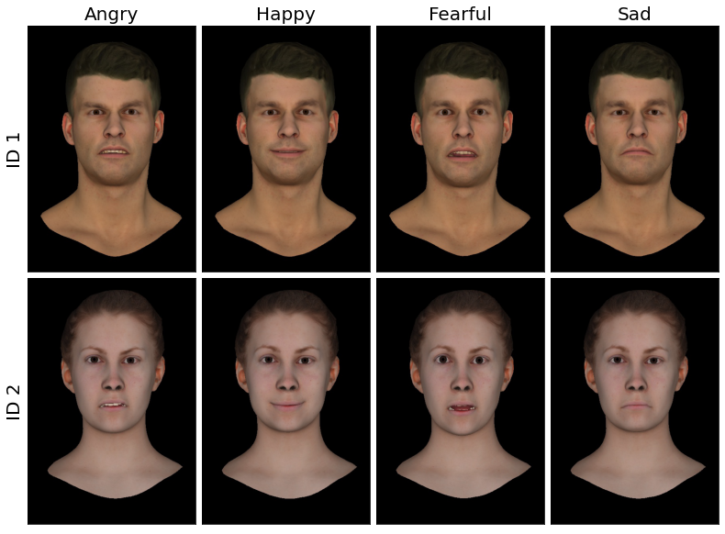
Averages of the preferred faces rendered using the avatars with which they were created

Figure S3
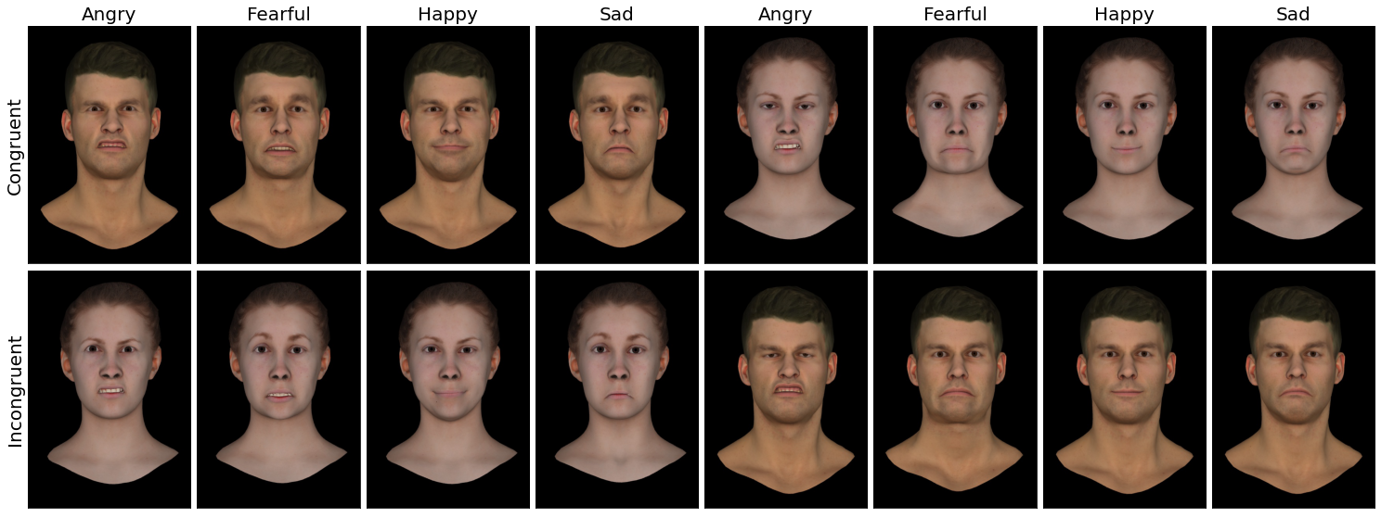
Preferred expressions from an example participant.
Note. Blendshape weights were rendered onto the avatar identity from which the expressions were initially created (congruent) and from which the expressions were not (incongruent) created.

Blendshape comparisons
Table S2
Core blendshapes displaying significant differences between the two identities (uncorrected (left) and FDR corrected (right)
Emotion | Blendshape name | FACs name | Mean weight (ID1) | Mean weight (ID2) | W | p(unc.) | p(FDR)
Angry | Lower lip tight | Lip Tightener | 0.124 | 0.204 | 602 | .050 | .417
 | Lower funneler | Lip Funneler | 0.099 | 0.047 | 161 | .012 | .319
 | Brow lowerer | Brow lowerer | 0.471 | 0.372 | 1085 | .016 | .319
Fearful | Lower lip suck | Lip suck | 0.016 | 0.057 | 146 | .046 | .468
 | Upper funneler | Lip Funneler | 0.093 | 0.039 | 373 | .043 | .468
 | Lower lip depressor | Lower lip depressor | 0.207 | 0.121 | 773 | .034 | .468
 | Upper lid raiser | Upper lid raiser | 0.375 | 0.521 | 1002 | .001 | .050
Happy | Lower funneler | Lip Funneler | 0.077 | 0.012 | 245 | <.001 | .006
 | Dimpler | Dimpler | 0.246 | 0.160 | 1111 | .032 | .443
 | Puff cheek | [Cheek] puff | 0.090 | 0.162 | 446 | .017 | .349
Sad | Nostril Pinch | Nostril compressor | 0.087 | 0.173 | 776 | .015 | .313
 | Brow lowerer | Brow lowerer | 0.073 | 0.166 | 741 | .005 | .216

