Supplement
Childhood Emotion Dysregulation Mediates the Relationship between Preschool Emotion Labeling and Adolescent Depressive Symptoms

Supplement Table 1. Multilevel models of emotion recognition at T1-T3 (n=304)

DV = N Happy faces | Estimate | SE | t | p
Intercept | 4.29 | 0.07 | 57.65 | <0.0001
Time | 0.25 | 0.05 | 5.23 | <0.0001
T1 age | 0.16 | 0.05 | 3.54 | 0.0004
DV = N Sad faces | Estimate | SE | t | p
Intercept | 4.45 | 0.15 | 30.05 | <0.0001
Time | 2.18 | 0.26 | 8.24 | <0.0001
Time squared | -1.01 | 0.13 | -8.02 | <0.0001
T1 age | 1.14 | 0.18 | 6.42 | <0.0001
T1 age X Time | -0.41 | 0.11 | -3.62 | 0.0003
DV = N Anger faces | Estimate | SE | t | p
Intercept | 2.93 | 0.08 | 34.66 | <0.0001
Time | 0.26 | 0.06 | 4.68 | <0.0001
T1 age | 0.43 | 0.08 | 5.68 | <0.0001
DV = N Scared faces | Estimate | SE | t | p
Intercept | 1.74 | 0.09 | 19.44 | <0.0001
Time | 0.99 | 0.18 | 5.61 | <0.0001
Time squared | -0.50 | 0.09 | -5.85 | <0.0001
T1 age | 0.27 | 0.08 | 3.52 | 0.0005
DV = N Surprised faces | Estimate | SE | t | p
Intercept | 1.49 | 0.09 | 17.39 | <0.0001
Time | 0.51 | 0.06 | 8.39 | <0.0001
T1 age | 0.53 | 0.09 | 5.78 | <0.0001
DV = N Disgust faces | Estimate | SE | t | p
Intercept | 3.05 | 0.09 | 34.12 | <0.0001
Time | 0.84 | 0.17 | 5.09 | <0.0001
Time squared | -0.19 | 0.08 | -2.39 | 0.0177
T1 age | 0.60 | 0.11 | 5.57 | <0.0001
T1 age X Time | -0.17 | 0.07 | -2.56 | 0.0109

Supplemental Table 2. Childhood Emotion Lability and Emotion Regulation as Parallel Mediators of the Relationship Between Preschool Emotion Recognition Intercepts/Slopes and Adolescent Average Depression Symptom Core Score Covarying for Sex and Preschool Depression Severity (N=258)
Independent Variable | Mediator/Model | Path | Estimate | SE | t | p | 95%  Lower CI | 95%  Upper CI
Happy intercept | ERC Lability/Negativity | A | -0.94 | 0.49 | -1.89 | 0.06 | -1.91 | 0.04
 |  | B | 0.11 | 0.02 | 5.87 | <0.001 | 0.07 | 0.14
 |  | Indirect Effect | -0.10 | 0.06 | - | - | -0.24 | 0.004
 | ERC Emotion Regulation | A | 0.36 | 0.27 | 1.34 | 0.18 | -0.17 | 0.89
 |  | B | -0.05 | 0.03 | -1.47 | 0.14 | -0.12 | 0.02
 |  | Indirect Effect | -0.02 | 0.02 | - | - | -0.09 | 0.006
 | Full Model | Indirect Effect | -0.12 | 0.07 | - | - | -0.26 | 0.009
Happy slope | ERC Lability/Negativity | A | 1.77 | 0.93 | 1.89 | 0.06 | -0.07 | 3.61
 |  | B | 0.11 | 0.02 | 5.87 | <0.001 | 0.07 | 0.14
 |  | Indirect Effect | 0.19 | 0.11 | - | - | -0.008 | 0.44
 | ERC Emotion Regulation | A | -0.68 | 0.51 | -1.34 | 0.18 | -1.68 | 0.32
 |  | B | -0.05 | 0.03 | -1.47 | 0.14 | -0.12 | 0.02
 |  | Indirect Effect | 0.03 | 0.04 | - | - | -0.01 | 0.15
 | Full Model | Indirect Effect | 0.22 | 0.13 | - | - | -0.01 | 0.48
Anger intercept | ERC Lability/Negativity | A | -1.47 | 0.65 | -2.26 | 0.02 | -2.74 | -0.19
 |  | B | 0.11 | 0.02 | 5.78 | <0.001 | 0.07 | 0.14
 |  | Indirect Effect | -0.15 | 0.08 | - | - | -0.33 | -0.019
 | ERC Emotion Regulation | A | 0.61 | 0.35 | 1.73 | 0.09 | -0.09 | 1.30
 |  | B | -0.05 | 0.03 | -1.44 | 0.15 | -0.11 | 0.02
 |  | Indirect Effect | -0.03 | 0.03 | - | - | -0.11 | 0.004
 | Full Model | Indirect Effect | -0.18 | 0.09 | - | - | -0.36 | -0.024
Supplemental Table 2. Childhood Emotion Lability and Emotion Regulation as Parallel Mediators of the Relationship Between Preschool Emotion Recognition Intercepts/Slopes and Adolescent Average Depression Symptom Core Score Covarying for Sex and Preschool Depression Severity (N=258) (Continued, page 2)
Independent Variable | Mediator/Model | Path | Estimate | SE | t | p | 95%  Lower CI | 95%  Upper CI
Anger slope | ERC Lability/Negativity | A | 8.06 | 3.26 | 2.47 | 0.01 | 1.63 | 14.48
 |  | B | 0.10 | 0.02 | 5.73 | <0.001 | 0.07 | 0.14
 |  | Indirect Effect | 0.84 | 0.40 | - | - | 0.16 | 1.75
 | ERC Emotion Regulation | A | -3.18 | 1.77 | -1.79 | 0.07 | -6.67 | 0.32
 |  | B | -0.05 | 0.03 | -1.44 | 0.15 | -0.11 | 0.02
 |  | Indirect Effect | 0.15 | 0.14 | - | - | -0.03 | 0.56
 | Full Model | Indirect Effect | 1.00 | 0.44 | - | - | 0.21 | 1.93
Surprised intercept | ERC Lability/Negativity | A | -1.06 | 0.50 | -2.09 | 0.04 | -2.05 | -0.06
 |  | B | 0.11 | 0.02 | 5.83 | <0.001 | 0.07 | 0.14
 |  | Indirect Effect | -0.11 | 0.05 | - | - | -0.23 | -0.02
 | ERC Emotion Regulation | A | 0.50 | 0.27 | 1.83 | 0.07 | -0.04 | 1.04
 |  | B | -0.05 | 0.03 | -1.43 | 0.16 | -0.11 | 0.02
 |  | Indirect Effect | -0.02 | 0.02 | - | - | -0.09 | 0.004
 | Full Model | Indirect Effect | -0.14 | 0.06 | - | - | -0.27 | -0.03
Surprised slope | ERC Lability/Negativity | A | -1.51 | 1.29 | -1.17 | 0.24 | -4.05 | 1.03
 |  | B | 0.11 | 0.02 | 5.96 | <0.001 | 0.07 | 0.14
 |  | Indirect Effect | -0.16 | 0.15 | - | - | -0.49 | 0.10
 | ERC Emotion Regulation | A | 1.27 | 0.70 | 1.83 | 0.07 | -0.10 | 2.64
 |  | B | -0.04 | 0.03 | -1.31 | 0.19 | -0.11 | 0.02
 |  | Indirect Effect | -0.06 | 0.06 | - | - | -0.23 | 0.01
 | Full Model | Indirect Effect | -0.22 | 0.16 | - | - | -0.55 | 0.09
Supplemental Table 3. Descriptive Information for FACE – Emotion Labeling Task

 | Sadness | Happiness | Anger (Mad) | Surprise | Disgust (Yucky) | Fear (Scared)
 | T1 FACE – Emotion Labeling Task
N | 249 | 248 | 249 | 249 | 249 | 249
Mean(SD) | 3.94(2.38) | 2.58(.83) | 2.34(1.33) | 1.49(1.60) | 3.15(1.69) | 1.07(.90)
Range | 0 - 7 | 0 - 3 | 0 - 4 | 0 - 5 | 0 - 5 | 0 - 3
Total possible | 7 | 3 | 4 | 5 | 5 | 3
 | T2 FACE – Emotion Labeling Task
N | 240 | 240 | 240 | 240 | 240 | 240
Mean(SD) | 4.97(1.93) | 2.75(.62) | 2.67(1.20) | 2.09(1.69) | 3.67(1.43) | 1.36(.93)
Range | 0 - 7 | 0 - 3 | 0 - 4 | 0 - 5 | 0 - 5 | 0 - 3
Total possible | 7 | 3 | 4 | 5 | 5 | 3
 | T3 FACE – Emotion Labeling Task
N | 231 | 231 | 231 | 231 | 231 | 231
Mean(SD) | 4.78(1.97) | 4.77(.58) | 3.37(1.23) | 2.45(1.84) | 3.97(1.27) | 1.74(1.32)
Range | 0 - 8 | 2 - 5 | 0 - 5 | 0 - 5 | 0 - 5 | 0 - 5
Total possible | 8 | 5 | 5 | 5 | 5 | 5

Supplement Figure 1. Relationship Between Preschool Sadness Recognition Intercepts (T1)/Slopes (T1-T3) and T1 Age

Supplement Figure 2. Relationship Between Preschool Disgust Recognition Intercepts (T1)/Slopes (T1-T3) and T1 Age

Supplemental Figure 3. Box Plots for Childhood Emotion Labeling T1-T3 (Surprise, Anger).
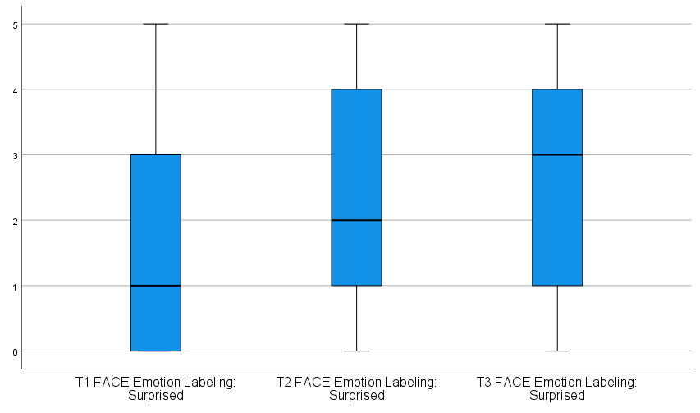
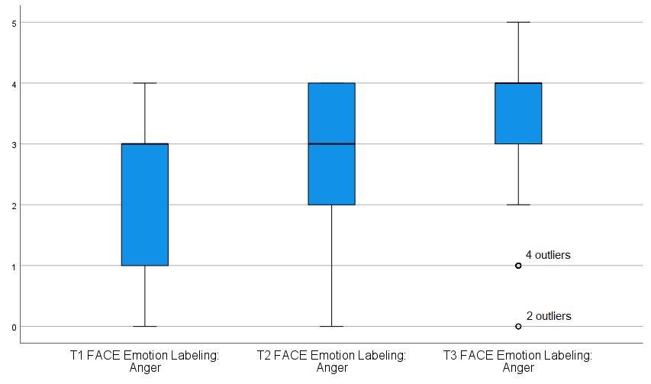
*Note: # of angry facial stimuli differed by wave. T1/T2 – 4 items; T3 – 5 items.

