Supplementary Materials

Patterns of emotion-network dynamics are orthogonal to mood disorder status: an experience sampling investigation
Monica Kullar¹, Scott Carter², Caitlin Hitchcock^{1,3}, Steve Whittaker⁴, Aidan G. C. Wright⁵, Tim Dalgleish^{1,6}

¹ Medical Research Council Cognition and Brain Sciences Unit, University of Cambridge, Cambridge, UK, CB2 7EF
² Targhetta Design, LLC, San Jose, CA, USA 95118
³ Melbourne School of Psychological Sciences, University of Melbourne, Melbourne, Australia, VIC 3010
⁴ Department of Computational Media, University of California, Santa Cruz, CA, USA 94022
⁵ Department of Psychology, University of Pittsburgh, Pittsburgh, PA, USA 15260
⁶ Cambridgeshire and Peterborough NHS Foundation Trust

Supplementary Introduction
Advantages of Group Iterative Multiple Model Estimation (GIMME). GIMME has five key features that arguably provide advantages over comparable methods. First, GIMME has been extensively evaluated via simulation studies against benchmark person-specific data (Gates & Molenaar, 2012). GIMME is consistently and reliably better able to detect true patterns of effects even in heterogeneous samples relative to the majority of other connectivity methods (Gates & Molenaar, 2012; Smith et al., 2011). Secondly, GIMME’s capacity to compile individual-level paths provides a significant benefit over, for example, multi-level modelling, which requires that all individuals have the same pattern of relations. Thirdly, GIMME’s approach to identifying the pattern of relations for individuals has a robust stopping criterion that minimizes the risk of overfitting (Mumford & Ramsey, 2014) in addition to its ability to parse signal-to-noise adequately from an initial group-level model, and then iteratively add or prune paths between individual and group models to uncover final structure (Gates & Molenaar, 2012). Fourthly, each effect is estimated separately for each study participant with no assumptions placed on the distribution of estimates. Finally, the capacity to cluster individuals in a data driven manner based on their patterns and estimates of effects (Gates et al., 2017) greatly facilitates our understanding of the varied patterns of results that may occur across individuals, as noted in the main manuscript.
Supplementary Methods
Measures. Emotion item selection. A diverse set of emotion items was selected for the study based on prior and established emotion differentiation tasks (Nook et al., 2018; Nummenmaa et al., 2014, 2018), reliable and validated affective self-report scales including the Positive and Negative Affect Schedule (PANAS)(Watson et al., 1988), Differential Emotions Scale-IV (DES-IV)(Blumberg & Izard, 1986), and the circumplex model of affect (Russell, 1980). Emotion terms that were consistently present across these different studies and measures were included (e.g., happy). This resulted in a synthesized set of emotion items spanning each quadrant of positive and negative valence and high and low arousal, which were further reduced down to the final nine emotion terms used in this study for feasibility, two from each affective quadrant along with one extra high-arousal negative emotion term of ‘stress’. The most highly co-occurring emotion terms were reduced (‘happy’ and ‘pleased’ to form ‘happy’, and ‘angry’ and ‘irritated’ to form ‘angry’; see Main Text) resulting in 7 emotion items. Chronometry of the overall emotion state was also assessed to capture information about the duration of the emotion. We also probed whether the participant was thinking about something other than what they were currently doing (see Table S1 for affective norms of items and psychometric properties).
Experience Sampling Item Properties
Item | Valence (M, SD) | Arousal (M, SD) | Within-person reliabilityª (M, SD)
Happy | 8.47 (1.28) | 6.05 (2.13) | .70 (.03)
Enthusiastic | 7.55 (1.61) | 5.90 (2.53) | .76 (.03)
Relaxed | 7.25 (1.92) | 2.49 (2.51) | .83 (.02)
Sad | 2.01 (0.91) | 3.49 (2.21) | .86 (.02)
Nervous | 3.56 (1.79) | 5.51 (2.65) | .78 (.03)
Angry | 2.53 (1.74) | 6.20 (2.57) | .82 (.02)
Stressed | 2.09 (1.41) | 7.45 (2.38) | .88 (.02)
Table S1. Affective norms for emotion terms including reported valence and arousal from the Affective Norms for English Words (ANEW) database (Warriner et al., 2013) and psychometric properties for all experience sampling items. ªWithin-person coupling reliability (WPCR) M and SD was estimated following validated methods for calculating within-person variance in nested data for items contributing to positive emotion and items contributing to negative emotion (Neubauer et al., 2019). Chronometry and occurrence of mind wandering were single-items and not related to an affect construct. Here, Happy=Happy and Pleased collapsed, Angry=Angry and Irritated collapsed as noted in main text for variable reduction of highest co-occurring emotion items.

Mind wandering follow up items. In addition to the key set of ratings included in the GIMME analysis, participants were asked to elaborate if they answered ‘yes’ at any given probe to the question of whether they were thinking about something other than what they were doing (labelled MWoccur). These additional contingent questions formed part of a separate study on the content of mind-wandering and were not included within the GIMME analysis for these theoretical and for a number of methodological reasons outlined below.
These follow up questions included asking participants if their extraneous thought was: positive or negative, referred to themselves or to others, about the past or future, a thought in which they were fully immersed or more distanced from, one they had control of, and specific or general. All of these follow up questions were rated on 7-point Likert scales.
As noted, there are multiple methodological reasons why these follow-up questions which were only answered to a subset of probes are not suitable for GIMME. These relate to the nature of the sampling frequency of these items, the number of variables deemed reasonable for inclusion in model estimations, and the interpretable ‘missingness’ of the event-based design on assessing patterns over time. With respect to sampling frequency, individuals will unsurprisingly differ in the number of datapoints collected for the follow-up questions as they are contingent on a ‘yes’ answer to the original probe. The follow-up responses therefore do not correspond to the frequency of the emotion ratings used in GIMME. GIMME also emphasizes the need for a reasonable number of variables for modeling in order to uncover accurate final estimations, with prior robust simulations suggesting between five to ten variables is ideal, but with higher numbers of timepoints strongly recommended when including higher variable counts (Beltz & Gates, 2017; Lane et al., 2019; Lane & Gates, 2017). The main emotion variables central to our research questions, and collected at every timepoint, along with our exogenous time variable approached the recommended upper limit of 10 variables. Including mind-wandering follow-up variables would have significantly exceeded this limit and required a far greater number of timepoints, even if there was complete data at each timepoint. Finally, including event-based items in GIMME (i.e., contingent on an initial affirmative answer to the first probe) would lead to incorrect assumptions about missingness patterns, and the overall unequal spacing of these collected event-based follow up items would violate statistical assumptions (Lane et al., 2019).
Analytic plan. Additional information on Group Iterative Multiple Model Estimation (GIMME). As outlined in the main text, GIMME is an approach to person-specific (i.e., ideographic) data analysis that is efficient and scalable, because it uses automatic searches to arrive at individual participant associative network models in time-series data. GIMME is iterative, searching for model features present in the majority of the sample at the group-level, then iteratively adjusting individual and group models by iteratively adding significant paths shared in all models, and pruning non-significant paths. It estimates these models through unified structural equation models (uSEM), combining the features of traditional SEM and structural vector autoregressive (VAR) techniques, to map how variables covary across time in terms of both time-lagged and contemporaneous relationships (Kim et al., 2007).
Though GIMME estimates person-specific models, it also identifies group/subgroup-level features that are significant for a majority of the participant sample while identifying individual-level features that vary uniquely (or less-frequently) across individuals. It thus conceptually combines nomothetic and ideographic approaches (Gates & Molenaar, 2012). Unlike multilevel modeling-based approaches, GIMME respects the individuality of participants, and does not constrain them to the same model such that variables can differ in directionality, sign, and strength across all individuals. GIMME only identifies common features (i.e., group/subgroup-level paths) that are significant for the majority of individuals and does not assume a particular distributional form for parameter estimates, as in multilevel modeling. All generated solutions are generated using alternative fit indices: a root mean square error of approximation (RMSEA)<.05, the standardized root mean residual (SRMR)<.05, a comparative fit index (CFI)>.95, and a non-normed fit index (NNFI)>.95. At least two of these four indices are required meet criteria to indicate excellent fit (Brown, 2015).
GIMME Preprocessing. To guard against within-person associations emerging that merely reflect shared trajectories of change and to eliminate stationarity from the data to fulfil uSEM assumptions, linear trends in the data were removed (Beltz & Gates, 2017). Raw data were imputed with local means and then regressed against time so that resulting standardized residuals could be used in analysis as recommended for time-series analysis (Beltz & Gates, 2017).
With respect to scaling time for the intraday measures, spacing of observations nested in each day for each participant were approximately equidistant in measurement (i.e., every two hours with a randomized jitter of 15 minutes), with the exception of the overnight time between subsequent days. To account for this, a single value of missingness was included as an overnight value to account for approximate equidistant intervals in the final time-series data estimations as typical in experience sampling analysis with GIMME (Beltz & Gates, 2017; Ellison et al., 2020).
An exogenous variable of time-of-day was included in the final analyses. Exogenous variables in time-series models influence variables in the model but are not influenced by them (e.g., passage of time (exogenous) may influence a person’s memory, but a memory cannot influence the passage of time). Time of day, or diurnal time, has been shown to influence subsequent emotion experiences in mental health research (van de Maat et al., 2020). Thus, we included diurnal time in the model to capture how variables may covary across diurnal time. The square root of intraday time was calculated as a proxy for the pattern of diurnal emotion rising around midday and stabilizing until evening (van de Maat et al., 2020).

Supplementary Results
Clinical characteristics. Additional details for symptom severity and group differences on clinical measures across the a priori diagnostic groups and the uncovered data-driven subgroupings are presented in Figure S1, Table S2, Table S3. Currently depressed participants (n=37) were diagnosed with chronic (n=5, 13.51%) or recurrent (n=32, 86.49%) major depressive disorder and a current major depressive episode according to the DSM-5 (n=15, 40.54% reported too many lifetime episodes to count, remaining participants reported episodes M=5.43). Remitted depressed participants (n=28) were diagnosed with recurrent major depressive disorder, currently in remission (n=8, 28.57% reported too many episodes to count, remaining participants reported M=5.32). The 11 bipolar participants were diagnosed with either bipolar I (n=6, 54.54%) or bipolar II (n=5, 38.46%) disorder, with the majority (n=9, 81.81%) currently meeting criteria for a depressive episode, and no individuals currently in manic episode (lifetime episodes were not recorded). No healthy participants (n=29) met criteria for any current or past mood or anxiety disorders. Diagnostic group differences on clinical self-report subscales were assessed using Kruskal-Wallis tests with a Bonferroni-corrected α for the multiple comparisons (critical p=.0023), with subsequent pairwise Wilcoxon tests (Bonferroni-corrected adjusted p-values reported; see Main Text Figure 2).
Significant differences between the depressed and remitted groups included: PHQ-9: p<.001, r=.50 95%CI [.30,.65]; GAD-7: p<.001, r=.48 95%CI[.27,.63]. Between the depressed and healthy groups: PHQ-9: p<.001, r=.80 95%CI[.73,.85]; GAD-7: p<.001, r=.75 95%CI[.62,.85]. Between the remitted and healthy groups: PHQ-9: p<.001, r=.59 95%CI[.39,.75]; GAD-7: p=.01, r=.40 95%CI [.17,.65]. And between the bipolar disorder and healthy groups: PHQ-9: p<.001, r=.61 95%CI[.37,.78]; GAD-7: p<.001, r=.60 95%CI[.32,.75].
Group differences were assessed using Kruskal-Wallis tests across all measures and subscales and were Bonferroni-corrected for multiple comparisons for the 19 tests by applying an alpha of 0.0026 to indicate significance. Follow-up pairwise comparisons between clinical groups conducted on significant findings have also been Bonferroni corrected with the adjusted p-values reported. Group data across the IDAS-II subscales are also listed for the data-driven subgroups, with no significant difference on any subscale even at an uncorrected alpha of p<.05 (see Table S3).
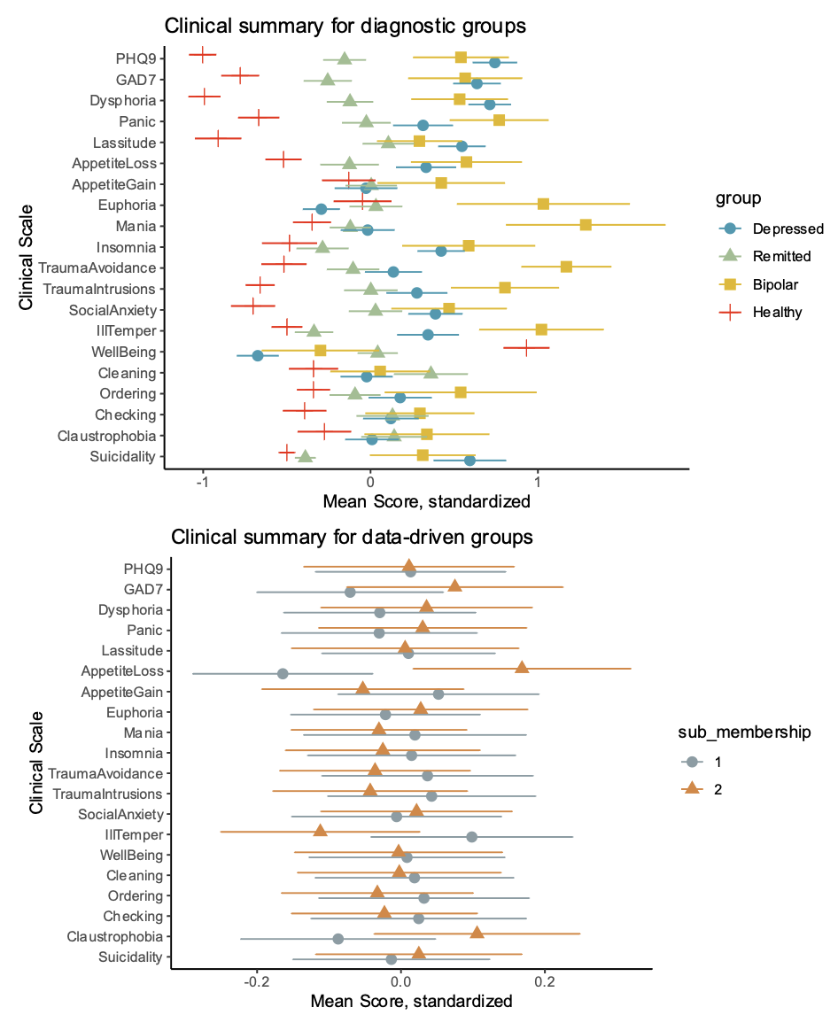
Figure S1. Standardized clinical measure means plotted across all measures and subscales for a priori diagnostic groups (top) and discovered data-driven Subgroups 1 and 2 (bottom). Means are depicted by points with accompanying standard error of the mean depicted by lines. PHQ9=Patient Health Questionnaire-9 depression summary score, GAD7=Generalized Anxiety Disorder-7 anxiety summary score, with all other subscale names of the Inventory of Depression and Anxiety Symptoms (IDAS-II).

Clinical Measures |  | Data-driven subgroups |  | Clinical diagnostic groups
M (SD) | Cronbach’s α | Subgroup 1 | Subgroup 2 | Depressed | Remitted | Bipolar | Healthy
PHQ-9 | .91 | 10.11 (6.76) | 10.10 (7.33) | 15.24 (5.70) | 8.93 (4.77) | 13.82 (6.68) | 2.97 (3.10)
GAD-7 | .92 | 6.04 (5.46) | 6.88 (6.21) | 10.14 (5.03) | 4.96 (4.43) | 9.73 (6.56) | 1.93 (3.54)
IDAS-II subscales
General Depression | .94 | 36.27 (15.75) | 37.75 (17.59) | 49.50 (12.38) | 34.42 (10.21) | 45.91 (15.74) | 19.97 (9.23)
Dysphoria | .93 | 25.22 (9.81) | 25.88 (10.60) | 32.73 (7.87) | 24.28 (7.45) | 30.91 (9.70) | 15.48 (5.25)
Panic | .91 | 16.26 (7.67) | 16.73 (7.99) | 18.93 (8.46) | 16.30 (5.98) | 22.45 (7.61) | 18.82 (5.16)
Lassitude | .86 | 15.26 (5.40) | 15.24 (6.95) | 18.57 (5.33) | 15.86 (5.04) | 17.00 (5.20) | 9.57 (4.62)
Appetite Loss | .90 | 5.09 (2.80) | 6.12 (3.32) | 6.62 (3.37) | 5.21 (2.86) | 7.36 (3.38) | 4.00 (1.79)
Appetite Gain | .86 | 7.38 (3.45) | 7.02 (3.40) | 7.11 (3.88) | 7.21 (2.77) | 8.64 (4.30) | 6.76 (2.94)
Euphoria | .85 | 6.70 (2.83) | 6.84 (3.14) | 5.89 (2.00) | 6.86 (2.48) | 9.82 (5.08) | 6.62 (2.76)
Mania | .83 | 8.65 (4.43) | 8.45 (3.43) | 8.50 (3.87) | 8.09 (2.58) | 13.64 (6.23) | 7.19 (2.41)
Insomnia | .89 | 14.77 (6.92) | 14.51 (6.36) | 17.46 (5.68) | 12.79 (5.45) | 18.55 (8.70) | 11.48 (5.85)
Traumatic Avoidance | .85 | 9.68 (4.84) | 9.35 (4.28) | 10.14 (4.70) | 9.04 (3.76) | 14.82 (4.05) | 7.17 (3.30)
Traumatic Intrusions | .87 | 8.49 (4.34) | 8.14 (3.99) | 9.46 (4.60) | 8.32 (3.50) | 11.64 (4.43) | 5.59 (1.94)
Social Anxiety | .86 | 15.46 (7.49) | 15.66 (6.69) | 18.24 (6.97) | 15.71 (5.97) | 18.82 (8.09) | 10.55 (5.02)
Ill-temper | .90 | 9.19 (4.61) | 8.24 (4.46) | 10.30 (5.09) | 7.21 (2.75) | 13.36 (5.59) | 6.48 (2.24)
Well-being | .89 | 21.70 (5.99) | 21.63 (6.23) | 17.57 (4.63) | 21.91 (3.86) | 19.84 (7.05) | 27.29 (4.49)
Cleaning | .87 | 10.79 (5.39) | 10.68 (5.42) | 10.57 (5.10) | 12.63 (6.29) | 11.00 (5.31) | 8.86 (4.27)
Ordering | .91 | 8.23 (4.68) | 7.94 (4.18) | 8.86 (5.07) | 7.68 (3.55) | 10.45 (6.62) | 6.59 (2.35)
Checking | .90 | 5.43 (3.01) | 5.30 (2.55) | 5.70 (2.80) | 5.72 (3.16) | 6.18 (2.99) | 4.28 (1.94)
Claustrophobia | .85 | 9.53 (5.11) | 8.53 (5.29) | 9.03 (5.07) | 9.71 (5.41) | 10.73 (6.42) | 7.55 (4.48)
Suicidality | .72 | 7.33 (2.43) | 7.42 (2.50) | 8.81 (3.24) | 6.41 (0.81) | 8.12 (2.57) | 6.14 (0.58)

Table S2. Reliability (Cronbach’s α) across the whole sample, mean and standard deviation of symptom measures across data-driven subgroups and diagnostic groups. PHQ-9=Patient Health Questionnaire-9 depression summary score, GAD-7=Generalized Anxiety Disorder-7 anxiety summary score, with all other subscale names of the expanded Inventory of Depression and Anxiety Symptoms (IDAS-II)

Clinical Measures | Group differences |  |  | Pairwise clinical group differences, Bonferroni adjusted p-value reported
Statistic | Wilcoxon rank sum (p) | Kruskal-Wallis (p) | Effect size (η_{p}2) 95% CI [LL, UL] | Kruskal-Wallis
Groups | Subgroup 1  -Subgroup 2 | Diagnostic  groups |  | Depressed  -Remitted | Depressed  -Bipolar | Depressed  -Healthy | Remitted  -Bipolar | Remitted  -Healthy | Bipolar  -Healthy
PHQ-9 | .84 | <.001*** | .51 [.40, .65] | <.001*** | 1.00 | <.001*** | .08 | <.001*** | <.001***
GAD-7 | .59 | <.001*** | .41 [.26, .55] | <.001*** | 1.00 | <.001*** | .02* | .01* | <.001***
IDAS-II subscales
General Depression | .71 | <.001*** | .54 [.4, .67] | <.001*** | 1.00 | <.001*** | .02* | <.001*** | <.001***
Dysphoria | .73 | <.001*** | .50 [.39, .64] | <.001*** | 1.00 | <.001*** | .05 | <.001*** | <.001***
Panic | .85 | <.001*** | .22 [.10, .40] | 1.00 | 1.00 | <.001*** | .16 | 0.004** | <.001***
Lassitude | .73 | <.001*** | .34 [.20, .54] | .03* | 1.00 | <.001*** | 1.00 | <.001*** | 0.003**
Appetite Loss | .05 | 0.002* | .11 [.04, .28] | .53 | 1.00 | 0.006** | .43 | .91 | 0.02*
Appetite Gain | .62 | 0.59
Euphoria | .59 | 0.003
Mania | .57 | 0.007
Insomnia | .92 | <.001*** | .18 [.06, .33] | 0.006** | 1.00 | <.001*** | 0.51 | 1.00 | .15
Traumatic Avoidance | .79 | <.001*** | .18 [.09, .36] | 1.00 | .05 | .04* | .003** | .35 | <.001***
Traumatic Intrusions | .88 | <.001*** | .21 [.10, .37] | 1.00 | .89 | <.001*** | .27 | 0.01* | <.001***
Social Anxiety | .65 | <.001*** | .25 [.13, .44] | 1.00 | 1.00 | <.001*** | 1.00 | <.001*** | 0.006**
Ill-temper | .12 | <.001*** | .24 [.08, .37] | .02* | .62 | <.001*** | 0.005** | 1.00 | <.001***
Well-being | .99 | <.001*** | .44 [.28, .58] | <.001*** | 1.00 | <.001*** | 1.00 | <.001*** | 0.01*
Cleaning | .69 | 0.07
Ordering | .88 | 0.15
Checking | .99 | 0.03
Claustrophobia | .18 | 0.10
Suicidality | .66 | <.001*** | .26 [.11, .44] | <.001*** | 1.00 | <.001*** | .08 | 1.00 | .03*
Table S3. Differences on symptom measures (listed in Column 1) between data-driven (Column 2: Subgroup1 compared to Subgroup2) and a priori diagnostic groups (Columns 3:10). P-value and effect size of each subscale test are reported and compared to a critical p=.0023, alongside subsequent pairwise comparisons of clinical groups. Pairwise clinical group p-values are already Bonferroni corrected and thus pairwise significance corresponds to: *: p < .05, **: p < .01, ***: p < .001. PHQ9=Patient Health Questionnaire-9 depression summary score, GAD7=Generalized Anxiety Disorder-7 anxiety summary score, and all other scale names reference subscales of the expanded Inventory of Depression and Anxiety Symptoms (IDAS-II).
Demographics of data-driven subgroups. Table S4 shows the summary statistics for the two data-driven Subgroups on demographic measures, alongside evaluation of the group differences, all of which were statistically non-significant.
 |  |  | Subgroup 1 | Subgroup 2 | Statistic
n |  |  | 53 | 51
Demographics
 | Age, years: M (SD) |  | 41.96 (11.78) | 38.62 (15.24) | F=1.57, p=.21
 |  | Female | 37 (69.81%) | 39 (76.47 %) | p=.51*
 |  | Male | 16 (30.19%) | 12 (23.53 %)
Ethnicity |  |  |  |  | p=.27*
 | White (British) |  | 45 (84.91%) | 48 (94.12%)
 | White (other) |  | 4 (7.55%) | 1 (1.96%)
 | Asian |  | 3 (5.66%) | 1 (1.96%)
 | Black |  | - | 1 (1.96%)
 | Mixed White/Asian |  | 1 (1.89%) | -
Income (£) |  |  |  |  | p=.99*
 | <10,000 |  | 11 (20.75%) | 12 (23.53%)
 | 10,000-29,999 |  | 24 (45.28%) | 24 (47.06%)
 | 30,000-49,999 |  | 9 (16.98%) | 7 (13.73%)
 | 50,000-69,999 |  | 3 (5.66%) | 2 (3.92%)
 | Preferred not to say |  | 6 (11.32%) | 6 (11.76%)
Highest Education Level |  |  |  |  | p=.91*
 | GCSE |  | 4 (87.55%) | 5 (9.80%)
 | A-levels |  | 6 (11.32%) | 9 (17.65%)
 | HND/BTEC/NVQ levels |  | 7 (13.02%) | 7 (13.73%)
 | Bachelor’s degree |  | 21 (39.62%) | 17 (33.33%)
 | Master’s degree |  | 10 (18.87%) | 10 (19.61%)
 | Doctorate degree |  | 5 (9.43%) | 3 (5.88%)

Table S4. Demographic sample characteristics for the two data-driven subgroups. *Fisher’s exact test was used with p-value noted, no other test statistic generated.
Note. GCSE = General Certificate of Secondary Education; A-Level = Advanced level; HND = Higher National Diploma; BTEC = Business and Technology Education Council; NVQ = National Vocational Qualifications.

Additional detail on the assessment of data-driven subgroup robustness. Within GIMME there are several ways one can further evaluate a subgroup solution including (i) assessing the robustness of the solution to minor perturbations of edges (paths) when nodes (individuals) are randomly switched; and (ii) assessing the distribution of modularity values (Q) to determine whether the solution modularity is higher than expected by chance.
The modularity values from our derived two-subgroup solution (Q=.1008) was first compared to a modularity significance level (i.e., the value for the upper 5th percentile in a distribution of random perturbed matrices) that had similar properties to the dataset (Q₉₅=.0641). Our data-driven solution modularity was indeed above this calculated cut-off value (Q=.1008> Q₉₅=.0641). Figure S2a shows the histogram of comparison modularity values from the randomly perturbed matrices, with our derived solution modularity clearly delineated from that distribution.
In our derived solution, the variance of information (VI) measured the distance between the two subgroup clusters. In other words, 43.31% of the obtained two-subgroup solution paths would need to be changed in order to be as different as when 20% of participant subgroup assignments are switched. In contrast, a randomized solution at chance would only need as few as 2% of paths perturbed if groupings were altered (Figure S2b). Cluster solutions are considered robust if the resulting matrix requires 20% or more of its paths to be perturbed (α > 0.20) before crossing the line representing 20% of the nodes being in different clusters (Karrer et al., 2008). Figure S2b shows indeed that 43.31% of solution paths (in black) appear to require perturbation to cross this threshold, compared to the near immediate crossover at 2% of a comparison solution (in red).
The Adjusted Rand Index (ARI) – a cluster validation measure of agreement on subgroup partitions – was also computed for our two-subgroup solution. The distribution of the ARI value at α=.20 was significantly higher than the ARI value obtained when 20% of the subgroup assignments for participants were randomly changed indicating that our solution was robust. Figure S2c shows our solution (in black) again requiring further perturbation than the near immediate drop in a comparison solution at chance (in red).
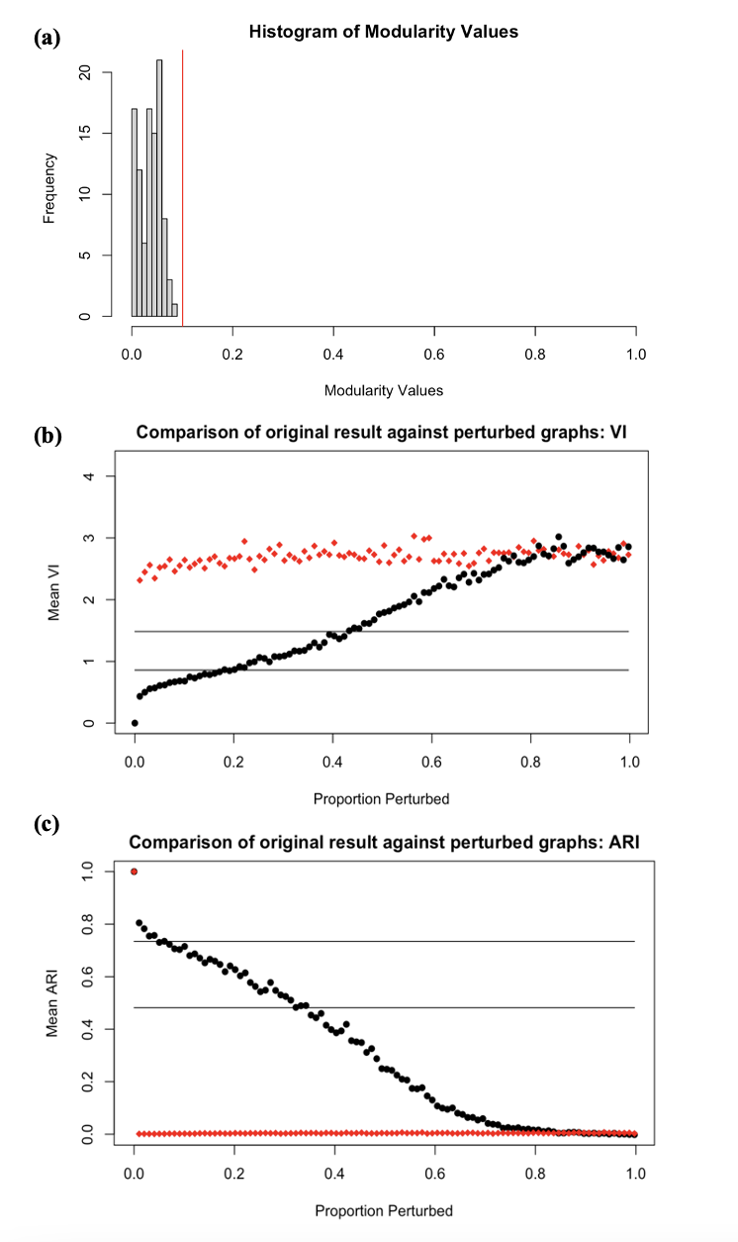

Figure S2. Three tests to evaluate whether the two data-driven subgroups were robust, including: (a) the modularity obtained from GIMME depicted by the red vertical line versus the plotted distribution of randomly perturbed modularity values; (b) the comparison of the variance of information (VI) between cluster assignments from our derived original matrix in black compared to the same comparisons made on an appropriate null matrix in red. The black horizontal lines indicate the values of similarity found between the original matrix and a matrix where 10 to 20% of participants were randomly assigned to different subgroups; and (c) the Adjusted Rand Index (ARI) of our derived original solution in black compared to the null matrix when proportion perturbed increased in red.

Additional detail on the assessment of data-driven subgroup paths. As noted in the main text and illustrated in Figure 1b in the main article, the data-driven iterative estimation discovered one group-level path linking a pair of emotions that was present for the majority of the sample (in addition to the autoregressive paths from each emotion to itself, which are estimated by default), and a total of nine subgroup-level paths that were present across the two data driven sub-groupings. Eight of these paths were between pairs of emotions that were the same for the two subgroups, albeit with different directionality per subgroup as indicated by the arrows in Figure 1b, suggesting that for one subgroup, directionality of the relationship occurred in one direction, while for the other, the opposing direction. One path was unique to Subgroup 1. All group and subgroup paths that satisfied these majority-level thresholds were contemporaneous, (i.e., were between measures taken at the same experience sampling probe), although there are frequent lagged relationships between emotions evident in the underlying individual level paths (see below for some examples).
The group-level majority path of co-occurring contemporaneous ‘Happy’ emotion’ predicting “Enthusiastic’ indicates that across most individuals in the sample, high arousal positive states tend to be coupled. The unique path in Subgroup 1 of ‘Angry’ predicting ‘Sad’ emotion suggests that for the majority of Subgroup 1 individuals these negative emotions frequently co-occur, potentially reflecting the lower overall levels of emotion granularity in that subgroup (see main results).
Within-person model examples from the data-driven subgroups. To illustrate GIMME’s ability to elucidate within-person dynamics for each participant, in addition to patterns shared across the whole sample or across subgroups, it is helpful to look at data from sample individual participants. Four sample within-person level plots are presented in Figure S3. Taken together, the first thing to note about these visualizations is the heterogeneity both across the within-person models but also in their participant-specific divergences from the subgroup-level majority pathways illustrated in Figure 2b in the main text. For example, in the first example from Subgroup 1 (Figure S3a) there are fewer lagged relationship with feeling ‘Stressed’ predicting reductions in later feelings of ‘Relaxed’, or ‘Sad’ predicting a possible increase in feeling ‘Relaxed’ later (possibly after engaging in regulation efforts), but there are multiple lagged pathways in the model for the second sample participant (Figure S3b). This second example participant also shows multiple relationships between emotions and the self-reported durations of emotion experience (EmotionChronometry) node, whereas these are absent in the first example. Similarly, for the Subgroup 2 examples, there is a marked difference in the numbers of pathways identified with the participant in Figure S3d showing quite a sparse set of relationships. Interestingly, both of the exemplars from Subgroup 1 show the unique Subgroup 1 majority pathway with ‘Angry’ (labeled as HighCorrNeg in individual models) predicting ‘Sad’ while neither of the exemplars from Subgroup 2 showing this relationship.

a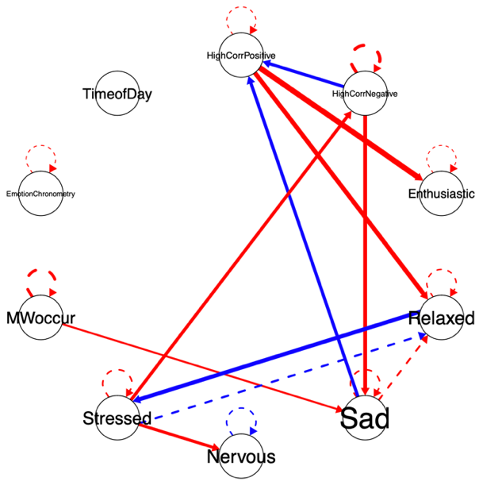 b
c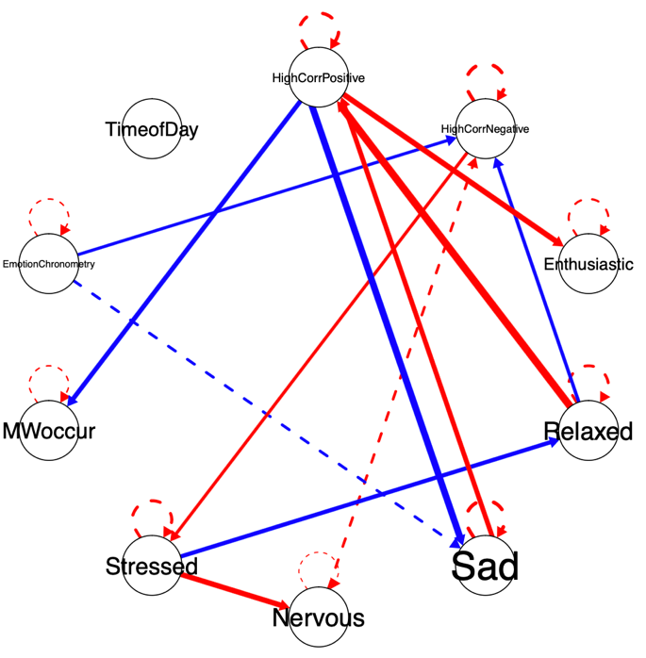 d
Figure S3. Individual person-specific models generated by GIMME for (a, b) example participants from Subgroup 1 and (c, d) from Subgroup 2. Red paths are positive weights, blue paths are negative weights, dashed lines are lagged relationships of lag-1 (autoregressive effects depicted above each variable node), and solid lines are contemporaneous from the same timepoint. Line thickness corresponds to strength of weight. HighCorrPositive=Happy, HighCorrNegative=Angry.

Emotion inertia multilevel modeling results for the data-driven subgroups.
Fixed Effect | b (SE) | t(104) | p
Positive Emotion
Intercept (mean level)
Subgroup 1 | 3.00 (.07) | 43.47 | <.001***
Subgroup 2 | –0.20 (.10) | –2.06 | .04*
Slope (inertia)
Subgroup 1 | 0.17 (.02) | 9.58 | <.001***
Subgroup 2 | 0.11 (.03) | 4.41 | <.001***
Negative Emotion
Intercept (mean level)
Subgroup 1 | 2.16 (.11) | 19.38 | <.001***
Subgroup 2 | 0.06 (.16) | 0.37 | .71
Slope (inertia)
Subgroup 1 | 0.19 (.02) | 11.59 | <.001***
Subgroup 2 | 0.19 (.03) | 7.67 | <.001***

Table S5. Group differences in inertia for data-driven subgroups. Effects were modelled separately for positive and negative emotion. In the models, Subgroup 1 was the referent group.

Diagnostic Group Emotion Features.
We compared the three diagnostic groups (depressed, remitted, and healthy subgroups) on features of intensity, instability, granularity, and inertia (see Figure S3) for both positive and negative emotion following the same methods detailed in the main text, with all results Bonferroni corrected for this analysis as well. Due to the modest size of the bipolar subgroup, it was excluded from these analyses.
Intensity. There were significant group differences in overall intensity of positive emotion (p<.001, η_{p}²=.36 95%CI[.22,.54]). This was present in all three pairwise comparisons between groups; between depressed and healthy (p<.001, r=.67 95%CI[.52,.78]) and remitted groups (p=.02, r=.41 95%CI[.18, .60]), and between remitted and healthy groups (p=.008, r=.45 95%CI[.22,.65]), with the depressed group showing the least intensity, then the remitted group, then the healthy group.
There were also significant group differences between all three groups in negative emotion intensity levels (p<.001, η_{p}²=.43 95%CI[.27,.59]); with pairwise differences significant between depressed and healthy (p<.001, r=.72 95%CI[.58,.82]) and remitted groups (p=.006, r=.43 95%CI[.23,.62]), and between remitted and healthy groups (p=.002, r=.49 95%CI[.26,.68]), with the depressed group showing the greater intensity, then the remitted group, then the healthy group.
Instability. There were no significant differences between any groups for instability of positive emotion (p=.27, η_{p}²=.007), thus possible pairwise differences did not need to be further assessed.
There was a significant difference between groups on negative emotion instability (p<.001, η_{p}²=.15 95%CI[.04,.31]). The depressed and healthy groups differed in negative emotion instability (p=.001, r=.47 95%CI[.25,.65]), with the depressed group showing greater instability than the remitted group. There were no significant differences between the remitted and depressed group (p=.52, r=.27) or healthy group (p=.99, r=.22).
Granularity. There were no significant group differences in granularity of positive emotion (p=.16, η_{p}²=.02) or negative emotion (p=.09, η_{p}²=.03) between any clinical groups at our corrected significance levels, thus further pairwise differences were not further assessed.
Inertia. The healthy group did not significantly differ from the depressed group on positive emotion inertia (b=0.07, SE=.03, t(95)=–2.23, p=.03), but did show significantly lower negative emotion inertia (b=–0.14, SE=.03, t(95)=–4.33, p<.001)(see Figure S3, Table S6). There were no other significant pairwise group differences in emotion inertia.
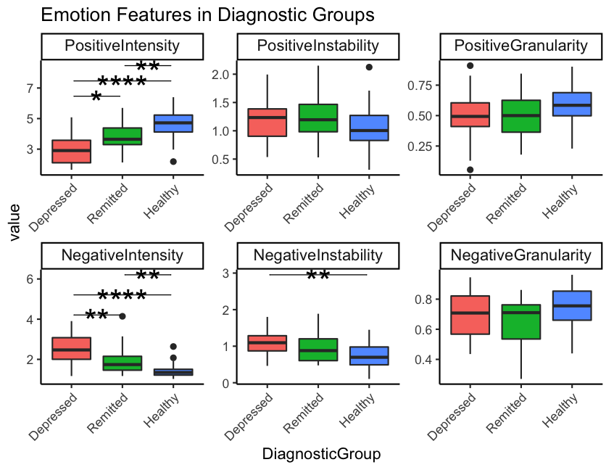
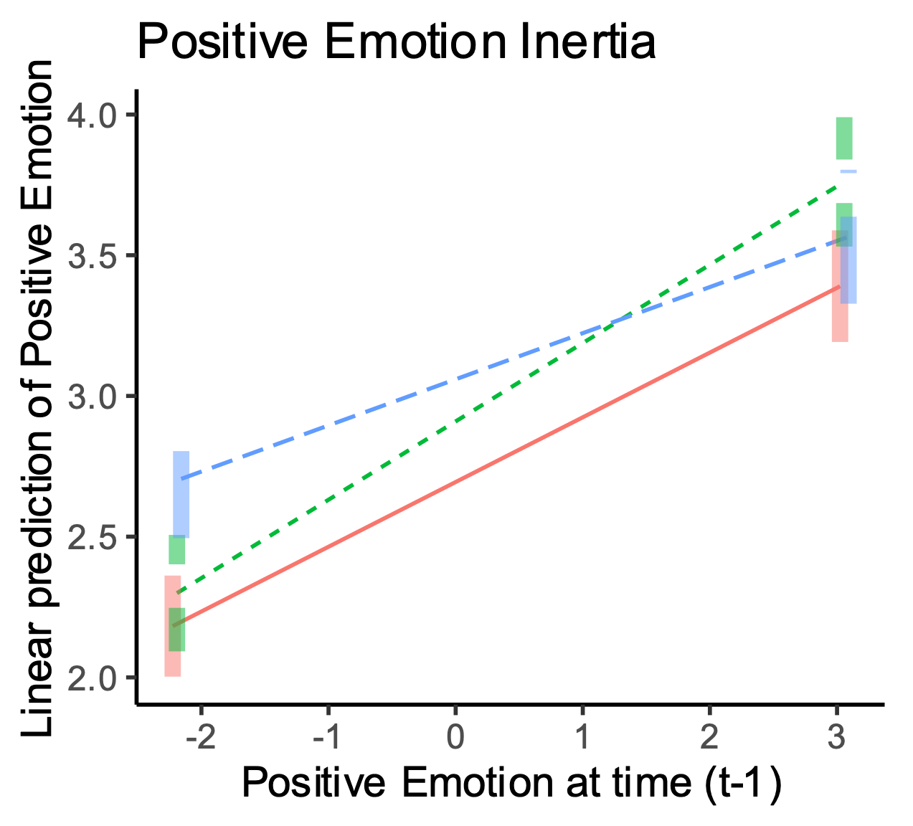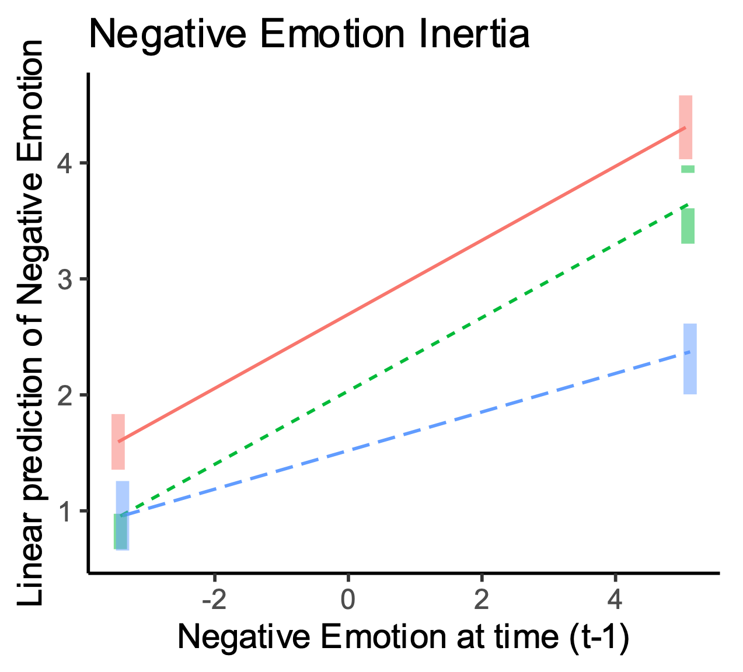

Figure S3. Emotion intensity, instability, and granularity for positive (row 1) and negative emotion (row 2), as well positibe and negative emotion inertia (row 3) across diagnostic groups. Reported p-values are Bonferroni adjusted, *p<.05, **p<.01, ****p<.001.

Emotion inertia multilevel modeling results for the diagnostic subgroups.

 | b (SE) | t(95) | p
Positive Emotion
Intercept
Depressed | 2.69 (.08) | 33.91 | <.001***
Remitted | 0.22 (.12) | 1.85 | .07
Healthy | 0.38 (.12) | 3.23 | .002**
Slope (Positive Emotion, day t–1)
Depressed | 0.23 (.02) | 11.37 | <.001***
Remitted | 0.05 (.03) | 1.55 | .12
Healthy | –0.07 (.03) | –2.23 | .03
Negative Emotion
Intercept
Depressed | 2.68 (.10) | 25.87 | <.001***
Remitted | –0.65 (.16) | –4.11 | <.001***
Healthy | –1.18 (.15) | –7.67 | <.001***
Slope (Negative Emotion, day t–1)
Depressed | 0.32 (.02) | 17.41 | <.001***
Remitted | –0.005 (.03) | –0.16 | .88
Healthy | –0.14 (.03) | –4.33 | <.001***
Table S6. Model estimates for positive and negative emotion inertia of diagnostic groups, t–1. A Bonferroni corrected alpha of .0125 to consider significance and correct for multiple comparisons.

Appendix S1
Experience Sampling Items
Each of the following questions was presented one at a time on phone screens during the daily experience sampling collection prompt, with response options also listed below.

- When this signal arrived, what were you currently doing?
  - Open-ended response, text characters
- When this signal arrived, were you thinking about something other than what you were currently doing?
  - Binary response, yes or no
  - If yes, follow up questions:
    - How positive or negative were these thoughts?
      - Likert response, (1) very negative to (7) very positive
    - Are these thoughts related to yourself or others?
      - Likert response, (1) yourself to (7) others
    - Were these thoughts related to things taking place in the…?
      - Likert response, (1) distant past to (7) distant future
    - Were you completely immersed in these thoughts, or ‘watching them’ with an awareness they are fleeting and temporary mental events?
      - Likert response, (1) completely immersed to (7) completely aware
    - How much control do you feel you had over what you were thinking?
      - Likert response, (1) none at all to (7) very much
    - Were these thoughts very specific (such as a specific scene or image) or general in nature (such as a broad feeling or general thought)?
      - Likert response, (1) very specific to (7) very broad
For the following nine emotion terms (Question 3 to Question 11), ratings were all Likert responses, (1) not at all to (7) very much.

- Please rate how strongly you are currently feeling this emotion right now: ENTHUSIASTIC
- Please rate how strongly you are currently feeling this emotion right now: HAPPY
- Please rate how strongly you are currently feeling this emotion right now: PLEASED
- Please rate how strongly you are currently feeling this emotion right now: RELAXED
- Please rate how strongly you are currently feeling this emotion right now: NERVOUS
- Please rate how strongly you are currently feeling this emotion right now: SAD
- Please rate how strongly you are currently feeling this emotion right now: ANGRY
- Please rate how strongly you are currently feeling this emotion right now: IRRITATED
- Please rate how strongly you are currently feeling this emotion right now: STRESSED
- How long has your current emotional state been lasting?
  - Numerical response, number of minutes

Appendix S2
Experience Sampling Temporal Design Rationale
We referenced past experience sampling designs in clinical samples to develop the rationale for the time-based prompts of the present study. Most experience sampling studies have used signal-contingent study designs (i.e., prompting participants throughout the day at random intervals) although some have also used a time-contingent data recording approach (i.e., having participants record data during a fixed time in the day; e.g., (aan het Rot et al., 2012)). Across 48 studies using experience sampling designs in mental health populations, the average number of measurement days ranged from 11 (with a range of three to 54 days), and the average total number of repeated measurements per day was seven (with a range of two to ten signals) making the average total number of repeated measurements 70 (with a total range of 12 to 240 measurements)(aan het Rot et al., 2012), hence the decision to use 70 timepoints over 14 days in the present study. This was also vital in applying an approach like GIMME which can be successful in uncovering effects with at least 60 timepoints based on past work (Gates et al., 2017; Lane et al., 2019). To encourage participants to respond to the multiple datapoint collections, we offered a bonus payment for high compliance (75%=£2, 85%=£4, 95%%=£6).

Supplementary References
aan het Rot, M., Hogenelst, K., & Schoevers, R. A. (2012). Mood disorders in everyday life: A systematic review of experience sampling and ecological momentary assessment studies. Clinical Psychology Review, 32(6), 510–523.
Beltz, A. M., & Gates, K. M. (2017). Network mapping with GIMME. Multivariate Behavioral Research, 52(6), 789–804.
Blumberg, S. H., & Izard, C. E. (1986). Discriminating patterns of emotions in 10-and 11-yr-old children’s anxiety and depression. Journal of Personality and Social Psychology, 51(4), 852.
Brown, T. A. (2015). Confirmatory factor analysis for applied research. Guilford publications.
Ellison, W. D., Trahan, A. C., Pinzon, J. C., Gillespie, M. E., Simmons, L. M., & King, K. Y. (2020). For whom, and for what, is experience sampling more accurate than retrospective report? Personality and Individual Differences, 163, 110071.
Gates, K. M., Lane, S. T., Varangis, E., Giovanello, K., & Guiskewicz, K. (2017). Unsupervised classification during time-series model building. Multivariate Behavioral Research, 52(2), 129–148.
Gates, K. M., & Molenaar, P. C. (2012). Group search algorithm recovers effective connectivity maps for individuals in homogeneous and heterogeneous samples. NeuroImage, 63(1), 310–319.
Karrer, B., Levina, E., & Newman, M. E. (2008). Robustness of community structure in networks. Physical Review E, 77(4), 046119.
Kim, J., Zhu, W., Chang, L., Bentler, P. M., & Ernst, T. (2007). Unified structural equation modeling approach for the analysis of multisubject, multivariate functional MRI data. Human Brain Mapping, 28(2), 85–93.
Lane, S. T., & Gates, K. M. (2017). Evaluating the use of the automated unified structural equation model for daily diary data. Multivariate Behavioral Research, 52(1), 126.
Lane, S. T., Gates, K. M., Pike, H. K., Beltz, A. M., & Wright, A. G. (2019). Uncovering general, shared, and unique temporal patterns in ambulatory assessment data. Psychological Methods, 24(1), 54.
Mumford, J. A., & Ramsey, J. D. (2014). Bayesian networks for fMRI: A primer. Neuroimage, 86, 573–582.
Neubauer, A. B., Voelkle, M. C., Voss, A., & Mertens, U. K. (2019). Estimating reliability of within-person couplings in a multilevel framework. Journal of Personality Assessment.
Nook, E. C., Sasse, S. F., Lambert, H. K., McLaughlin, K. A., & Somerville, L. H. (2018). The nonlinear development of emotion differentiation: Granular emotional experience is low in adolescence. Psychological Science, 29(8), 1346–1357.
Nummenmaa, L., Glerean, E., Hari, R., & Hietanen, J. K. (2014). Bodily maps of emotions. Proceedings of the National Academy of Sciences, 111(2), 646–651.
Nummenmaa, L., Hari, R., Hietanen, J. K., & Glerean, E. (2018). Maps of subjective feelings. Proceedings of the National Academy of Sciences, 115(37), 9198–9203.
Russell, J. A. (1980). A circumplex model of affect. Journal of Personality and Social Psychology, 39(6), 1161.
Smith, S. M., Miller, K. L., Salimi-Khorshidi, G., Webster, M., Beckmann, C. F., Nichols, T. E., Ramsey, J. D., & Woolrich, M. W. (2011). Network modelling methods for FMRI. Neuroimage, 54(2), 875–891.
van de Maat, R., Lataster, J., & Verboon, P. (2020). Why and how to deal with diurnal cyclic patterns in ambulatory assessment of emotions. European Journal of Psychological Assessment.
Watson, D., Clark, L. A., & Tellegen, A. (1988). Development and validation of brief measures of positive and negative affect: The PANAS scales. Journal of Personality and Social Psychology, 54(6), 1063.

