Supplementary Information for Altering Experienced Utility by Incidental Affect: The Interplay of Valence and Arousal in Incidental Affect Infusion Processes

1. Additional materials and analyses for study 1 4
1.1. Instructions to participants 4
1.2. Affect infusion on music pleasantness rating 4
1.3. Robustness check: Removing participants who correctly guessed the study goal 5
1.4. SAM scores in responding to affect inducer conditions 6
1.5. Salience of affect and SAM scores 7
1.6. Participants’ baseline emotional states 7
2. Additional materials and analyses for study 2 9
2.1. Instructions to participants 9
2.2. Experimental apparatus 11
2.3. Define the regressors for univariate fMRI analyses 11
2.4. Model specifications of multilevel mediation and moderated mediation analyses 12
2.5. Robustness of the BAS in moderating the mediation effect of the BVS 14
3. Additional materials and analyses for study 3 16
3.1. Instructions to participants 16
3.2. Detailed behavioural analyses 17
3.3. Model specifications of sequential mediation and moderated sequential mediation analyses 18
3.4. Robustness of the FAR valence in mediating aesthetic evaluation of images 19
3.5. Robustness of SCRs in moderating the mediation effect of the FAR valence 20
3.6. Temporal dynamics of FAR valence infusion on aesthetic evaluation of images 20
4. Supplementary Figures 21
Figure S1. Images presented as affect inducers in study 1. 21
Figure S2. The experimental design and the event sequences of study 2 22
Figure S3. The BVS mediates the impact of incidental rewards on reported enjoyment of wines 23
Figure S4. The neural activity of the BVS in responding to different amounts of incidental rewards at the lottery outcome period 24
Figure S5. The neural activity of the BAS in responding to different amounts of incidental rewards at the lottery outcome period 25
Figure S6. Robustness check of whether the BAS might be the mediator and the BVS might be the moderator 26
Figure S7. Statistical parametric maps of whole-brain neural activity correlated with the amounts of incidental rewards at lottery outcome period 27
Figure S8. Statistical parametric maps of whole-brain neural activity correlated with the amount of incidental rewards at wine tasting period 28
Figure S9. The experimental design and the event sequences of study 3 29
Figure S10. The FAR valence mediated the impact of incidental rewards on aesthetic evaluation of images 30
Figure S11. Robustness check of whether the arousal of affect might play the mediation role 31
Figure S12. Facial affective responses (FAR) valences in responding to different types of images during the image viewing period 32
Figure S13. Skin conductance responses (SCRs) in responding to different types of images during the image viewing period 33
Figure S14. Images presented at the baseline period and the incidental reward task in study 3 34
Figure S15. The time course of FAR valences over key experimental events 35
5. Supplementary Tables 36
Table S1: Valence and Arousal Scores of Affect Inducing Images in Study 1 36
Table S2. Reported Enjoyment of Music Conditional on Affect Inducer Conditions 37
Table S3. Brain Regions Positively Correlated with Incidental Rewards at Lottery Outcome Period 38
Table S4. Brain Regions Positively Correlated with Incidental Rewards at Wine Tasting Period 39
Table S5. Moderated Mediation Coefficients in Study 2 40
Table S6. Correlations of the Neural Activity of the BVS and the BAS 41
Table S7. Moderated Sequential Mediation Coefficients in Study 3 42
Table S8. Correlations of FAR and SCR Measures in Study 3 43
Table S9. Valence and Arousal Scores of Presented Images in Study 3 44
6. References for Supplementary Information 45

Additional materials and analyses for study 1

Instructions to participants
Participants were provided the following instructions about the goal and the general procedure of the study:
“In this study, we would like to investigate in different tasks your memories of visual and auditorial stimuli, and your emotional reactions towards these stimuli. In the first part, we are going to present you with a sequence of 5 pictures. Each picture will be presented for only a few seconds. Please view the pictures carefully for the time when they are on the screen. In the second part, we will play a short musical piece. You need to wear your headset to listen to the music. In the third part, we will ask you some questions about the pictures and the music pieces. Those who correctly answer these questions will enter a lottery. We will draw 10 people to win an additional €10 each. In the last part of the study, we will ask some questions about your past and current emotional states.
We have adapted the pictures and music pieces to different genders since males and females have different reactions to the pictures and music pieces.”

Affect infusion on music pleasantness rating
In addition to the music enjoyment rating, we also asked participants to rate how pleasant the music was on a nine-point scale. This question emphasizes the music as an evaluative object, which is different from the question about participants’ experiences with the music. The question was motivated by previous research suggesting that self-referential questions (e.g., your experience with the music) are better to capture the loading of affect infusion than object-referential questions (e.g., the pleasantness of the music) (Gorn et al., 2001).
We found a significant main effect of affect inducer conditions on participants’ music pleasantness rating (F(4, 717) = 13.03, p < .001). Planned contrast analyses further revealed that although music pleasantness rating was significantly higher after viewing positive low-arousal images (M_{positive low-arousal} = 7.673 vs. M_{neutral} = 7.114; F(1, 717) = 10.62, p < .001, 95% CI [.222 .895]) and positive high-arousal images (M_{positive high-arousal} = 7.791 vs. M_{neutral} = 7.114; F(1, 717) = 16.36, p < .001, 95% CI [.347 1.004]) than neutral images, the rating did not differ between the two positive image conditions (F(1, 717) = .47, p = .492, 95% CI [-.217 .451]).
Contrast analyses on negative incidental affect conditions revealed that the music pleasantness rating was marginally lower after viewing negative high-arousal images than neutral images (M_{negative high-arousal} = 6.791 vs. M_{neutral} = 7.114; F(1, 717) = 3.63, p = .057, 95% CI [-.009 .656]). The rating in the negative low-arousal condition was not significantly different from the neutral image condition (M_{negative low-arousal} = 7.014 vs. M_{neutral} = 7.114; F(1, 717) = .34, p = .557, 95% CI [-.235 .436]).
Taken together, these results demonstrate that being in different affective states could also influence participants’ evaluation of music quality (e.g., higher evaluation of music pleasantness in the positive affect conditions; lower evaluation of music pleasantness in the negative high-arousal condition). In line with previous research (Gorn et al., 2001), we found that such influences were lesser when the evaluative question was object-referential. However, because the object- and self-referential measures were highly correlated (r₍₇₂₂₎ = .795, p < .001), we focused on the original self-referential measure in the main text.

Robustness check: Removing participants who correctly guessed the study goal
Participants were asked to guess the purposes of the study. Their answers were coded by two research assistants to investigate whether the participants made connections between their affective states and the evaluation of the music. Eighteen participants (2.5%) made the correct guess. Excluding these participants did not change our results; we found a significant main effect of affect infusion on reported enjoyment of music (F(4, 699) = 12.68, p < .001). Consistent with the key findings in the main text, we found that participants reported significantly higher music enjoyment after the exposure to positive low-arousal images (M_{positive low-arousal} = 7.257 vs. M_{neutral} = 6.861; F(1, 699) = 4.01, p = .045, 95% CI [.007 .785]) and positive high-arousal images (M_{positive high-arousal} = 7.642 vs. M_{neutral} = 6.861; F(1, 699) = 16.39, p < .001, 95% CI [.402 1.16]) than neutral images. The reported enjoyment of music was also higher after viewing positive high-arousal images than viewing positive low-arousal images (M_{positive high-arousal} = 7.642 vs. M_{positive low-arousal} = 7.257; F(1, 699) = 3.87, p =.049, 95% CI [.0005 .769]).
In contrast, participants reported significantly lower music enjoyment after viewing negative high-arousal images (M_{negative high-arousal} = 6.435 vs. M_{neutral} = 6.861; F(1, 699) = 4.68, p = .03, 95% CI [.039 .811]). The reported music enjoyment was indifferent after viewing negative low-arousal images as compared to neutral images (M_{negative low-arousal} = 6.601 vs. M_{neutral} = 6.861; F(1, 699) = 1.7, p = .193, 95% CI [-.131 .651]).

SAM scores in responding to affect inducer conditions
Participants rated the arousal and valence of their current affective states after listening to the music on the nine-point SAM scale. The SAM scores could be used to verify affect induction manipulation. However, we would like to caution that this measure reflects a mixture of effects of affect induction and participants’ immediate affective states after listening to the moderately pleasant music excerpts.
We found a significant main effect of affect inducer conditions on SAM valence (F(4, 717) = 13.41, p < .001). Contrast analyses revealed that participants who viewed positive images indicated marginally higher valence than those who viewed neutral images (M_{positive} = 6.655 vs. M_{neutral} = 6.358; F(1, 717) = 3.04, p = .081, 95% CI [-.632 .037]), whereas those who viewed negative images indicated significantly lower valence as compared those who viewed neutral images (M_{negative} = 5.663 vs. M_{neutral} = 6.358; F(1, 717) = 16.39, p < .001, 95% CI [.357 1.031]). We also found a significant main effect of affect inducer conditions on SAM arousal (F(4, 717) = 8.48, p < .001). Contrast analyses showed that those who viewed high-arousal images indicated significantly higher arousal than those who viewed low-arousal images (M_{high arousal} = 4.392 vs. M_{low arousal} = 3.971; F(1, 717) = 6.03, p = .014, 95% CI [.084 .757]). Results from these analyses are consistent with affect inducer conditions in the anticipated directions.

Salience of affect and SAM scores
Prior research proposed that the salience of affect could moderate the extent of affect infusion (Albarracín & Kumkale, 2003; Siemer & Reisenzein, 1998; White & McFarland, 2009). Salience of affect has been defined as “how much a feeling stands out or is attended to than other information when making judgments and evaluations” (Greifeneder et al., 2011). Previous work does not specify exactly how salience of affect is related to arousal, but it suggests that this factor could be measured as a personality disposition, such as being more open to one’s affective state (e.g., captured by the openness to feeling scale) (Booth-Butterfield & Booth-Butterfield, 1990; Ciarrochi & Forgas, 2000). We administered the openness to feeling (OF) scale to explore whether salience of affect is related to arousal. We found a significant correlation between participants’ reported valence and arousal that were measured by SAM scale (r = .271, p < .001). However, neither the valence scores (r = .05, p = .146) nor the arousal scores (r = .04, p = .211) were correlated with the OF scores. These results indicated that the salience of affect and arousal are not the same concepts.

Participants’ baseline emotional states
The study was conducted during the COVID-19 pandemic, when governments have implemented measures to restrict individuals’ social mobility. This has resulted in depressive symptoms due to social isolation and loss of connections (Bavel et al., 2020). We asked participants to complete the social isolation scale (SIS) (Hughes et al., 2004) and the generalised anxiety disorder (GAD) scale (Spitzer et al., 2006) to examine their baseline emotional states in respective experimental conditions.
We found that the main effect of affect inducer conditions was insignificant for the SIS scores (F(4, 717) = .27, p = .895), indicating no difference on the extent of isolation among our participants. We found a marginally significant main effect of affect inducer conditions on the GAD scores (F(4, 717) = 2.34, p = .054). Contrast analyses revealed that participants who were in the negative high-arousal images condition reported the highest GAD score (i.e., high anxiety) as compared to participants in the other conditions. This result could be interpreted as the lingering effect of affect induction after viewing negative high-arousal images.
To be statistically conservative, we re-ran the ANOVA adding the GAD score as the control variable (see Table S2 for summaries of results). Consistent with the key results in the main text, we found a significant main effect of affect inducer conditions on reported enjoyment of music (F(4, 696) = 12.31, p < .001). Participants who viewed positive high-arousal images indicated the highest music enjoyment (M_{positive high-arousal} = 7.657 vs. M_{neutral} = 6.855; F(1, 696) = 17.24, p < .001, 95% CI [.422 1.181]) and those who viewed negative high-arousal images indicated the lowest music enjoyment (M_{negative high-arousal} = 6.469 vs. M_{neutral} = 6.855; F(1, 696) = 3.79, p = .052, 95% CI [-.003 .776]) as compared to the neutral condition.

Additional materials and analyses for study 2

Instructions to participants
Participants were provided the following instructions about the goal and the general procedure of the study:
“The goal of this experiment is to study the neural basis of primary and secondary rewards. You have already earned $25 by showing up for the experiment. In addition, you will have the possibility to make up to $200 during the experiment. In each trial you will win or not win money and then receive a drink. Only one trial will count for the amount of money you will be allowed to keep. At the end of the experiment we will draw a random trial number. This number determines the trial that will count.
The drinks we will ask you to taste are two different wines and a tasteless neutral drink prepared with water and salts. The wines you will taste are Californian Cabernet Sauvignons from different regions/vineyards.
During the experiment we will deliver the wines to your mouth using a tubing system that is connected to different pumps in the control room. Please hold the tube with your teeth during the scan. The pumps allow us to deliver a precise amount of wine with highly accurate timing. As indicated before, in some of the trials, we will deliver a tasteless, neutral drink. Note that only 1 ml of wine is administered in each trial. Thus, because you will drink less than 100 ml, you don’t need to worry about getting intoxicated. Furthermore, we will measure your blood alcohol concentration with the help of a Breathalyzer at the end of the study.
Your task during the wine tasting part of the experiment is to (1) keep each administered wine/neutral drink in your mouth for a particular duration (i.e., until you are instructed to swallow) and (2) during this duration, focus on the taste of the wine/drink in your mouth (i.e., how much you like the taste).”
To ensure that participants were able to appropriately taste the wines while being scanned, the following points were emphasized:
- “Please DO NOT SWALLOW the wine immediately, but instead keep the wine in your mouth until the next screen instructs you to swallow. This is a critical component of the experiment.
- During this time, please swirl the wine around your mouth WITHOUT MOVING YOUR HEAD.
- While you swirl the wine around your tongue, please try to keep the wine in the front part of your mouth. If the liquid enters the back part of your mouth you might trigger a swallow reflex. This is a problem because we want you to swallow at a PRECISE TIME within the trial.
- Please DO NOT MOVE YOUR HEAD at any time, and be especially careful about head movement when swallowing the wine.
- Focus on the taste of the wine while it is in your mouth.
- Please wait until the wine is pumped into your mouth. DO NOT SUCK the wine out of the tubes.”
Finally, participants were instructed to use MRI-compatible response boxes to provide their tasting ratings as follows:
- “Whenever you see the instruction ‘RATE LIKING’ please respond based on your taste experience for that particular trial. Answer this question as fast as you can and enter the rating using the response boxes in your left and right hands.
- Please enter your ratings using an eight-point scale from 1 = not at all liked to 8 = very much liked. To place ratings between 1 and 4 use the four buttons on your LEFT hand, and to place ratings between 5 and 8 use your RIGHT hand.”

Experimental apparatus
The wines and the neutral control solution were delivered by means of electronic syringe pumps (one for each stimulus) positioned in the scanning control room. These pumps transferred the stimuli to the participants via ~10 m polyethylene plastic special feeding tubes (6.4 mm diameter) and a perfusion manifold. The perfusion manifold allowed three incoming tubes to be connected to one output tube with a minimum of dead space to avoid the mixing of the wines and control solution. The participants were instructed to hold the output tube between their lips like a straw while they lay in a supine position in the scanner. We made efforts to keep the tubes free of air bubbles to avoid wine oxygenation and to ensure the administration of a constant amount of liquid in each trial. Between experiments the wines were preserved with a special corking system that is typically used by wineries and wine shops to prevent oxidation.
Visual stimuli were presented to participants using a pair of video goggles (Resonance Technologies Inc.; http://www.mrivideo.com). The stimulus presentation, responses, and scanner trigger pulses were controlled and recorded by Cogent 2000 (Wellcome Department of Imaging Neuroscience; http://www.vislab.ucl.ac.uk/Cogent/index.html) installed on a computer in the scanner control room.

Define the regressors for univariate fMRI analyses
The regressors in the general linear model (GLM) for the univariate analyses
are defined as follows:
(1) I_{outcome} modelled onsets of receipt of incidental reward. The onsets were orthogonalized using SPM’s orth function, and the duration was modelled as the stick function.
(2) I_{outcome} × reward modelled parametric modulation of the amounts of incidental rewards. First-order polynomial expansion modelled the stick function, and the regressor was orthogonalized within trial types.
(3) I_{wine tasting} modelled onsets of wine tasting for trials in which wines were tasted (tasting of neutral water was modelled separately as a regressor of no interest). The onsets were orthogonalized using SPM’s orth function, and the duration was modelled as the boxcar function.
(4) I_{wine tasting} × reward modelled parametric modulation of the amounts of incidental rewards for valid wine tasting trials (tasting of water was excluded). First-order polynomial expansion modelled the stick function, and the regressor was orthogonalized within trial types.
(5) The regressors of no interest included the following events: (a) viewing the slot machine, (b) jittered random delays before delivery of wines, (c) swallowing wines, (d) entering liking ratings, (e) rinsing mouth with neutral solution, (f) swallowing rinse solution, (g) tasting neutral water at wine tasting period .
(6) The motion regressors included the six motion parameters (x, y, z, roll, pitch, and yaw) generated from realignment. Motion realignment reflects movements of each scan with respect to the first scan in each session.
(7) Outlier scans were analysed by EPI quality assessment using NeuroElf (v1.5062) for each scan and for each session. Outlier scans were flagged as 1 and 0 otherwise in this regressor.
(8) Session constant was flagged as 1 for each scan session.

Model specifications of multilevel mediation and moderated mediation analyses
We built a multilevel mediation model to test whether the neural activity of the BVS (Med) mediated the relationship between receipt of incidental rewards (X) and reported enjoyment of wines (Y). Formally, the model is represented by the following regression specifications:
Y_{ij} = d_{Yj} + b_{j} Med_{ij} + c'_{j} X_{ij} + e_{Yij} (1.1)
Med_{ij} = d_{Medj} + a_{j} X_{ij} + e_{Medij} (1.2)

in which the random slope coefficients of two mediation paths (a and b) are expressed as

a_{j} = γ_{a0} + μ_{aj} (1.3)
b_{j} = γ_{b0} + μ_{bj} (1.4)

Following this mediation model, we further introduced the neural activity of the BAS (Mod) to moderate the mediating effects of the BVS with the following specifications:

Y_{ij} = d_{Yj} + b_{j} Med_{ij} + c'_{j} X_{ij} + m_{j} Mod_{ij} + e_{Yij} (2.1)
Med_{ij} = d_{Medj} + a_{j} X_{ij} + e_{Medij} (2.2)

in which the random slope coefficients of two mediation paths (a and b) are expressed as linear functions of Mod_{ij}:
a_{j} = γ_{a0} + γ_{a1}Mod_{ij} + μ_{aj} (2.3)
b_{j} = γ_{b0} + γ_{b1}Mod_{ij} + μ_{bj} (2.4)

Mod was suggested to be included as a predictor of the random intercept in equation 2.1 in order to control for its main effect (Bauer et al., 2006).
In these equations, the subscript i denotes the number of the trial (i.e., from 1 to 90) as the first-level variable, and j denotes the number of the participant (i.e., from 1 to 20 participants) as the second-level variable. The variables X_{ij}, Y_{ij}, Med_{ij}, and Mod_{ij} represent trial-by-trial data vectors clustered on each participant corresponding to receipt of incidental rewards (X_{ij}), reported enjoyment of wines (Y_{ij}), beta estimates from the refined BVS (Med_{ij}), and beta estimates from the BAS (Mod_{ij}). Mod_{ij} was mean-centred to create a meaningful zero to evaluate the moderation effects at different levels.
The direct effects (i.e., β_{direct}) of these two models are indicated by c' in equations 1.1 and 2.1 respectively. The indirect effect (i.e., β_{indirect}) in the mediation model is represented by the expected values of E(ab) = (γ_{a0} × γ_{b0}) + COV(μ_{a}, μ_{b}). The moderated indirect effects are represented by the expected values of E(ab | Mod_{ij} = w) = (γ_{a0} + γ_{a1} × w)(γ_{b0} + γ_{b1} × w) + COV(μ_{a}, μ_{b}) at different levels of w. We reported results at conventional ±1 SD levels of Mod (i.e., β_{indirect low} and β_{indirect high}) in the main text and summarized results at ±0.5 SD and ±1.5 SD levels in Table S5.

Robustness of the BAS in moderating the mediation effect of the BVS
In the main text, we reported that the mediation effects of BVS on wine tasting experiences were positively moderated by the BAS at ±1 SD levels. To demonstrate the robustness of such a moderated mediation relationship between the BVS and the BAS, we repeated the multilevel moderated mediation analyses with the moderator (i.e., the BAS) at ±0.5 SD and ±1.5 SD around its mean.
In line with the results reported in the main text, we found that the moderated mediation effects were positive and significant when the neural activity of BAS was above its mean (β_{indirect +0.5 SD} = .0006, 95% BCI [.0002 .0011]; β_{indirect +1.5 SD} = .0018, 95% BCI [.0006 .0031]), whereas the mediation path was negative and significant when the neural activity of BAS was below its mean (β_{indirect –0.5 SD} = –.0004, 95% BCI [–.0007 –.001]; β_{indirect –1.5 SD} = –.0014, 95% BCI [–.0023 –.0002]) (see Table S5 for the summaries of the moderated mediation coefficients in these models). These results provide further evidence to support the ATH that the impact of the BVS on mediating wine tasting experiences was greater when the BAS was more active, whereas the impact was suppressed when the BAS was inactive.

N

Additional materials and analyses for study 3

Instructions to participants
Participants were provided with the following instructions about the goal and the general procedure of the study:
“The purpose of the study is to investigate the neurobiological basis of your appreciation of different types of ‘rewards,’ such as watching different types of images and winning or not winning monetary rewards. Some of the pictures you will see may be disturbing. However, you are free to withdraw from the study at any time if you feel uncomfortable with these pictures. There is no risk involved in this study. You will receive €10 for your participation in this study. In addition, you have a chance of receiving an additional €15 during the study.
In the first section of the experiment, you will see a series of pictures. You don’t need to evaluate these pictures or give any answers. Simply, you just need to look at these pictures when they are presented. In the second section, for each trial, you will first see a slot machine, which will disclose whether you win €15 or €0. At the end of the study, the computer will randomly select a trial number that determines how much you will earn from the study. In other words, whatever result has been disclosed by the slot machine in a given trial may be the amount you will win for REAL. Subsequent to the slot machine, we will show you a picture and ask you to evaluate how much you like the image. Press the button 1 to 9 (1 = not at all; 9 = very much) on the keyboard that corresponds to your evaluation as quickly as possible.
In addition to your ratings, we will measure the activity of your sweat glands, called skin conductance, to learn more about the response of your nervous system when receiving different types of rewards. We will attach electrodes to the underside of the index and middle fingers of your non-dominant hand.
It is important that your skin is clean, dry, and free of any lotions or oils in order for the electrodes to adhere properly to your fingers. We will ask you to wash your hands with warm water and a neutral soap and let your hands dry naturally. DO NOT dry them with paper, and DO NOT use any hand sanitizers or cleaning products containing alcohol. After the electrodes are attached, a very small electrical current will pass through them to measure the conductance of your skin. The current will not cause you to feel any pain, if you are able to feel it at all.
We will ask you to take a series of four short, deep breaths prior to the experiment to ensure that your skin conductance response changes as expected. The electrodes must remain on your fingers for the duration of the task. Please do not remove or adjust them yourself, though you may rest your arm on a cushion that will make you comfortable during the experiment. You will be able to freely use your dominant hand to complete the experiment.
There will be a camera mounted on top centre of the computer in front of you. This is to record and evaluate your facial expressions while you are doing the experiment. Please allow yourself to respond naturally to the monetary rewards or pictures as they appear on the screen. After you complete the experiment, the experimenter will ask you to show certain facial expressions, which will provide a reference for evaluating the facial expressions. Finally, you need to fill out a few questionnaires, and we will debrief you about the study.”

Detailed behavioural analyses
We reported a significant main effect of reward (β_{reward} = .323, p < .001, 95% CI [.188 .458] in the main text. In addition to that, we also found a significant main effect of image types (β_{images} = 2.599, p < .001, 95% CI [2.516 2.681]) on the evaluation of images. Planned contrast analyses indicated that receipt of a monetary gain increased the evaluations of neutral images (M_{€15} = 4.332 vs. M_{€0} = 3.832, χ²(1, N = 47) = 17.78, p < .001, 95% CI [.267 .732]) and positive images (M_{€15} = 7.226 vs. M_{€0} = 6.853, χ²(1, N = 47) = 9.86, p = .002, 95% CI [.139 .604]). The evaluation of negative images did not increase significantly after receiving the incidental rewards (M_{€15} = 1.891 vs. M_{€0} = 1.792, χ²(1, N = 47) = .69, p = .406, 95% CI [-.134 .331]).

Model specifications of sequential mediation and moderated sequential mediation analyses
We built a sequential mediation model to test whether moment-based FAR valence in responding to receipt of incidental rewards (Med₁) and when participants were viewing images (Med₂) jointly mediated the reported aesthetic evaluation of images. The sequential mediation model can be expressed by the following regression specifications:

Med₁ = d_{Med1} + a₁X + e_{Med1} (3.1)
Med₂ = d_{Med2} + qMed₁ + a₂X + e_{Med2} (3.2)
Y = d_{Y} + b₂Med₂ + b₁Med₁ + c'X + e_{Y} (3.3)

The variables X, Y, Med₁, and Med₂ represent data vectors corresponding to manipulation of incidental rewards (X), evaluative ratings of images (Y), FAR valence at receipt of incidental rewards period (Med₁), and FAR valence at image viewing period (Med₂) for each participant and for each trial. The direct effect (i.e., β_{direct}) is indicated by c' in equation 3.3, and the sequential mediation effect (i.e., β_{sequential indirect}) is reflected by the production of a₁qb₂.
We built a moderated sequential mediation model to further test whether the mediating effect of FAR valence at these two phases is moderated by the arousal of incidental affect (Mod) triggered by receipt of incidental rewards. The model was built on the sequential mediation analysis by including a moderator on two mediation paths such that the strength of the mediation was dependent on the values of Mod. Formally, the model is expressed by the following regression specifications:

Med₁ = β_{Med1} + a₁X + e_{Med1} (4.1)
Med₂ = d_{Med2} + qMed₁ + a₂X + m₁Mod + moda(Mod × Med₁) + e_{Med2} (4.2)
Y = d_{Y} + b₂Med₂ + b₁Med₁ + c'X + m₂Mod + modb(Mod × Med₂) + e_{Y} (4.3)

In these equations, Mod describes the trial-based SCRs for each participant in responding to receipt of incidental rewards. Mod was mean-centred to create a meaningful zero point to evaluate its moderation effects at different levels. The direct effect (i.e., β_{direct}) of this model is indicated by c' in equation 4.3, whereas the moderated sequential effects are represented by the expected values of E(a₁qb₂ | Mod = w) = (a₁)(q + moda × w)(b₂ + modb × w) at different levels of w. We reported results at conventional ±1 SD levels of Mod (i.e., β_{sequential} _{indirect low} and β_{sequential} _{indirect high}) in the main text and summarised results at ±0.5 SD and ±1.5 SD levels in Table S7.

Robustness of the FAR valence in mediating aesthetic evaluation of images
Because the simple effect of aesthetic evaluations of negative images was not significantly influenced by receipt of incidental rewards, we re-ran the sequential mediation analysis with the data associated with negative images dropped. We still found that the sequential mediation path was significant (β_{sequential indirect} = .03, 95% BCI [.016 .052]), supporting the ATH that moment-based FAR valence, triggered by receipt of incidental rewards and when viewing images, mediated the aesthetic evaluation of neutral and positive images.

Robustness of SCRs in moderating the mediation effect of the FAR valence
In the main text, we reported that the mediating effects of FAR valence were moderated by moment-based arousal (i.e., SCRs) triggered by receipt of incidental rewards at ±1 SD levels. To demonstrate the robustness of such a moderated mediation relationship between FAR valence and SCRs, we repeated the moderated sequential mediation analyses with the moderator (i.e., SCRs) at ±0.5 SD and ±1.5 SD around the mean.
We found that the moderated sequential coefficients were significant at both ±0.5 SD levels (β_{sequential indirect –0.5 SD} = .054, 95% BCI [.03 .084]; β_{sequential indirect +0.5 SD} = .074, 95% BCI [.042 .121]). In contrast, when SCRs were at ±1.5 SD from the mean, the moderated sequential coefficient was insignificant at the low level (β_{sequential indirect –1.5 SD} = .017, 95% BCI [–.027 .056]), and the coefficient was significant at the high level (β_{sequential indirect +1.5 SD} = 0.077, 95% BCI [0.037 0.15]) (see Table S7 for the summaries of the moderated mediation coefficients from these models). Taken together, these moderated mediation patterns are consistent with the ATH that the more the arousal of incidental affect negatively deviates from its mean, the weaker the mediating effects of valence. Conversely, the more the arousal of incidental affect positively deviates from its mean, the stronger the mediating effects of valence.

Temporal dynamics of FAR valence infusion on aesthetic evaluation of images
Because facial affect recording enabled fast data sampling, we were able to illustrate the temporal dynamics of evolvement of FAR valence in responding to receipt of incidental rewards and infusion of aesthetic evaluation of images. We reprocessed the FAR data, in which FAR valence data were binned into 500 ms units and averaged across all events with respect to six experimental conditions. To make the illustration concise, we truncated the initial black screen and plotted the time course of remaining events in Figure S15.

Supplementary Figures

Figure S1. Images presented as affect inducers in study 1.

Figure S2. The experimental design and the event sequences of study 2

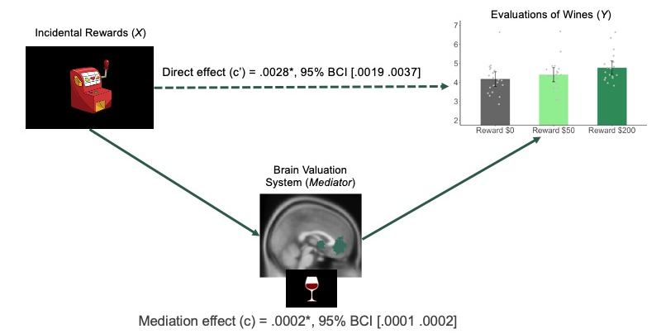

Figure S3. The BVS mediates the impact of incidental rewards on reported enjoyment of wines
In this multilevel mediation model, the mediator represents beta estimates from the brain’s valuation system (BVS) during the wine tasting period. The mediation effect is inferred from the product of a-path (i.e., influences of incidental rewards on the BVS) and b-path (i.e., influences of the BVS on reported wine tasting experiences) coefficients within participants plus the covariance across participants. The coefficients of the mediation effect (β_{indirect} = .0002, 95% bias-corrected confidence interval (BCI) [.0001 .0002]) and the direct effect (β_{direct} = .0028, 95% BCI [.0019 .0037]) are both significant. *p < .05 under bootstrapping. Error bars represent 95% confidence intervals.

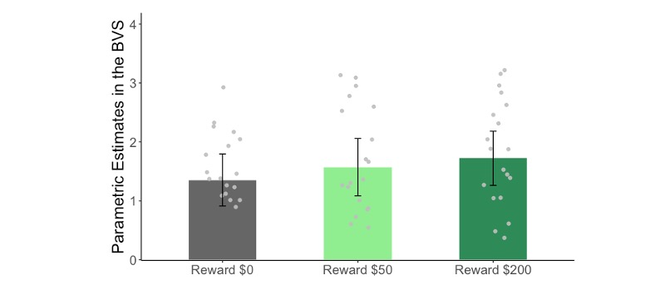

Figure S4. The neural activity of the BVS in responding to different amounts of incidental rewards at the lottery outcome period
We found a significant main effect of reward magnitudes such that higher reward induced greater BVS neural activity (β = .0017, p = .04, 95% CI [.00008 .0033]). Error bars represent 95% confidence intervals.

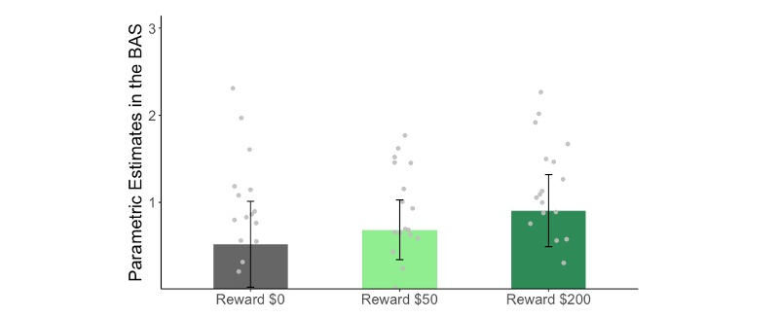

Figure S5. The neural activity of the BAS in responding to different amounts of incidental rewards at the lottery outcome period
We found a significant main effect of reward magnitudes such that higher reward induced greater BAS neural activity (β = .0019, p = .011, 95% CI [.0004 .0033]). Error bars represent 95% confidence intervals.

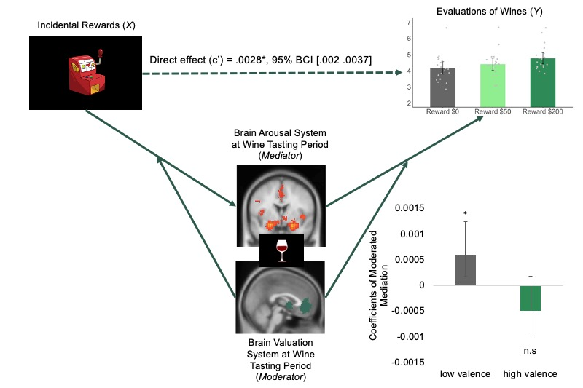

Figure S6. Robustness check of whether the BAS might be the mediator and the BVS might be the moderator
In this moderated mediation model, the mediator represents beta estimates of the BAS and the moderator represents beta estimates of the BVS. Coefficient of the moderated mediation effect is negative and insignificant when the BVS is more active (β_{indirect +1 SD} = –.0005, 95% BCI [–.0011 .00003]) and is positive and significant when the BVS is less active (β_{indirect –1 SD} = .0006, 95% BCI [.00004 .0011]). *p < .05 under bootstrapping. Error bars represent 95% confidence intervals.
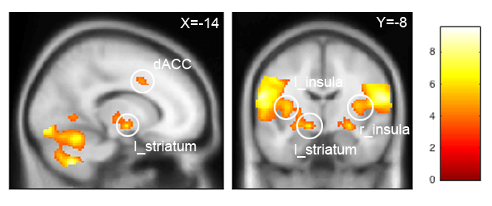

Figure S7. Statistical parametric maps of whole-brain neural activity correlated with the amounts of incidental rewards at lottery outcome period
The graph is created for display purposes at p < .001 uncorrected with five contiguous voxels. The thermometer bar indicates t-values. Abbreviations: dACC: dorsal anterior cingulate cortex; l_striatum: left striatum; l_insula: left insula; r_insula: right insula.

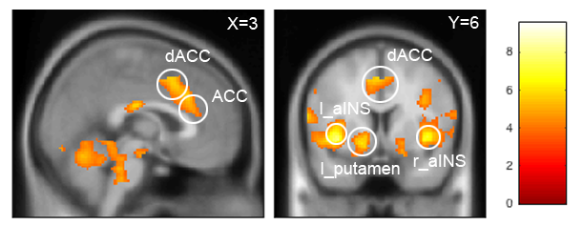

Figure S8. Statistical parametric maps of whole-brain neural activity correlated with the amount of incidental rewards at wine tasting period
The graph is created for display purpose at p < .001 uncorrected with five contiguous voxels. The thermometer bar indicates t-values. Abbreviations: dACC: dorsal anterior cingulate cortex; ACC: anterior cingulate cortex; l_putamen: left putamen; l_aINS: left anterior insula; r_aINS: left anterior insula.

Figure S9. The experimental design and the event sequences of study 3

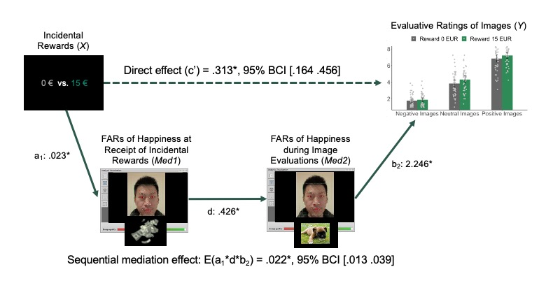

Figure S10. The FAR valence mediated the impact of incidental rewards on aesthetic evaluation of images
In this sequential mediation model, mediators are the FAR valence at lottery outcome and at image viewing periods. Coefficients of the direct effect (β_{direct} = .313, 95% BCI [.164 .456]) and the sequential mediation effect (β_{sequential indirect} = .022, 95% BCI [.013 .039]) are both significant. *p < .05 using bootstrapping. Error bars represent 95% confidence intervals. We obtained permission to use the photo of this person to create this figure for illustrative purposes.

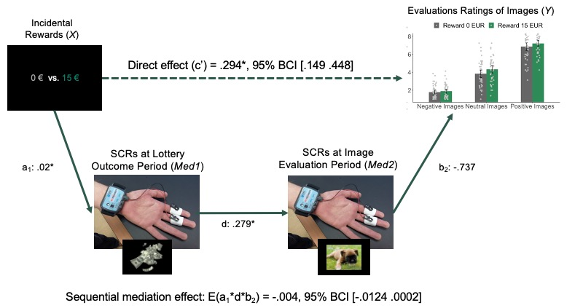

Figure S11. Robustness check of whether the arousal of affect might play the mediation role
In this sequential mediation model, mediators are SCRs at receipt of incidental rewards and at image viewing periods. Coefficient of the direct effect is still significant (β_{direct} = .294, 95% BCI [.149 .448]). However, the sequential mediation effect is negative and insignificant tested by the bias-corrected bootstrapping procedure (β_{sequential indirect} = –.004, 95% BCI [–.0124 .0002]). *p < .05 under bootstrapping. Error bars represent 95% confidence intervals.

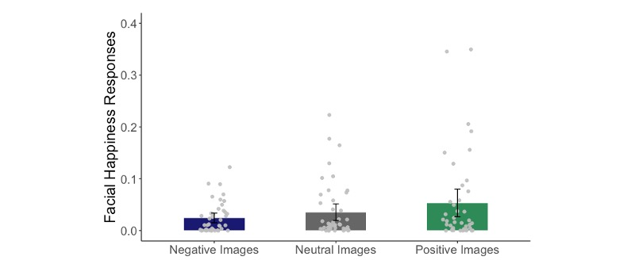

Figure S12. Facial affective responses (FAR) valences in responding to different types of images during the image viewing period
FAR valences were significantly higher when viewing positive images than when viewing neutral images (β_{positive vs. neutral} = .017, p < .001, 95% CI [.008 .027]) or negative images (β_{positive vs. negative} = .027, p < .001, 95% CI [.018 .036]). Error bars represent 95% confidence intervals.

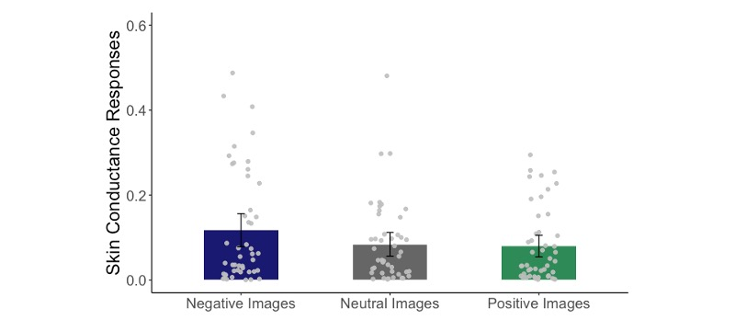

Figure S13. Skin conductance responses (SCRs) in responding to different types of images during the image viewing period
SCRs were significantly higher when viewing negative images than when viewing neutral images (β_{negative vs. neutral} = 0.033, p = .001, 95% CI [.014 .052]) or positive images (β_{negative vs. positive} = .037, p < .001, 95% CI [.017 .056]). Error bars represent 95% confidence intervals.

Figure S14. Images presented at the baseline period and the incidental reward task in study 3

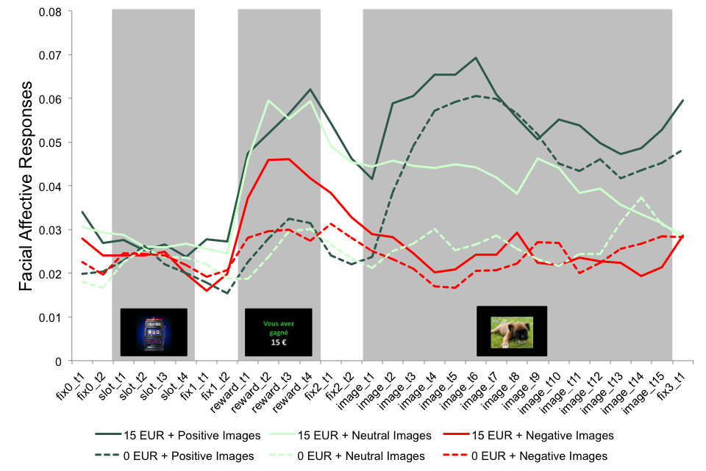

Figure S15. The time course of FAR valences over key experimental events
FAR valences were binned into 500 ms units and averaged across these events with respect to six experimental conditions. FAR valences in the initial black screen were truncated for better visualization. fix_ stands for fixation cross; slot_ stands for slot machine; reward_ stands for lottery outcome period; image_ stands for image viewing period.

Supplementary Tables

Table S1: Valence and Arousal Scores of Affect Inducing Images in Study 1
Gender | Affective Dimensions | Negative High-Arousal Images  (SD) | Negative Low-Arousal Images  (SD) | Neutral Images  (SD) | Positive Low-Arousal Images  (SD) | Positive High-Arousal Images  (SD)
Males | Valence | 2.378^{b}  (1.59) | 2.601^{b}  (1.49) | 4.585ª  (1.49) | 6.384^{c}  (1.63) | 6.361^{c}  (1.63)
Males | Arousal | 5.695^{c}  (2.02) | 4.292^{b}  (1.89) | 3.177ª  (1.82) | 3.673^{d}  (2.11) | 6.284e  (1.82)
Females | Valence | 2.362^{b}  (1.56) | 2.553^{b}  (1.66) | 4.688ª  (1.45) | 6.409^{c}  (1.59) | 6.361^{c}  (1.63)
Females | Arousal | 5.426^{c}  (2.36) | 4.4^{b}  (2.23) | 3.149ª  (1.81) | 3.537^{d}  (2.12) | 6.284e  (1.82)
Note: The table summarises the mean and the standard deviation of perceived valence and arousal of the images used in study 1 as affect inducers. For each row, numbers that share the same superscripts are similar to each other, whereas numbers that are marked with different superscripts are statistically different from each other at p < .001.

Table S2. Reported Enjoyment of Music Conditional on Affect Inducer Conditions
 | Negative High-arousal Affect Inducers (s.e.) | Negative Low-arousal Affect Inducers (s.e.) | Neutral Affect Inducers (s.e.) | Positive Low-arousal Affect Inducers (s.e.) | Positive High-arousal Affect Inducers (s.e.)
Model 1 | 6.465 (.137)^{d} | 6.604 (.139)ª | 6.851 (.135)ª | 7.253 (.14)^{b} | 7.653 (.133)^{c}
Model 2 | 6.469 (.148)^{d} | 6.649 (.155)ª | 6.855 (.148)ª | 7.279 (.153)^{b} | 7.657 (.147)^{c}
Model 3 | 6.435 (.14)^{d} | 6.601 (.143)ª | 6.861 (.138)ª | 7.257 (.142)^{b} | 7.642 (.134)^{c}
Note: Model 1 represents the ANOVA results of Fig. 1 in the main text conducted on N = 722 participants. Model 2 builds on model 1 by adding GAD scores as the control variable. Model 3 builds on model 1 by dropping the participants who made the link between their affective states and the evaluation of music. For each row, numbers that share the same superscripts are indifferent from the result in the neutral condition, whereas numbers that are marked with different superscripts are statistically different from the neural condition at p < .05.

Table S3. Brain Regions Positively Correlated with Incidental Rewards at Lottery Outcome Period
Region | BA | Side | Cluster Size | x | y | z | Peak Z Score
Postcentral gyrus | 3 | L | 10532 | –60 | –12 | 22 | 5.72
Postcentral gyrus | 3 | R |  | 62 | 0 | 18 | 5.5
Striatum |  | L |  | –14 | –8 | –8 | 4.59
Insula | 16 | R |  | 36 | 22 | 8 | 4.63
Insula | 16 | L |  | –30 | 12 | 8 | 4.45
Fusiform | 19 | L | 10468 | –40 | –80 | –18 | 5.51
Cerebellum |  | R |  | 18 | –60 | –20 | 5.47
Cerebellum |  | L |  | –24 | –58 | –22 | 5.17
Lingual gyrus | 17 | R |  | 18 | –84 | –12 | 5.17
Lingual gyrus | 17 | L |  | –18 | –88 | –12 | 5.16
IOG | 18 | L |  | –42 | –86 | –10 | 4.82
IOG | 18 | R |  | 38 | –82 | –14 | 4.77
dACC | 32 | L | 979 | –8 | 8 | 40 | 5.17
dACC | 32 | R |  | 10 | 8 | 42 | 5.06
Note: Results obtained from the parametric regressor at receipt of reward in GLM at p < 0.001 (uncorrected). The activation survived whole-brain correction for multiple comparisons (p_{FWE} < .05) at cluster level (height threshold t = 3.58; extent k = 979). Abbreviations: IOG: inferior occipital gyrus; dACC: dorsal anterior cingulate cortex.

Table S4. Brain Regions Positively Correlated with Incidental Rewards at Wine Tasting Period
Region | BA | Side | Cluster Size | x | y | z | Peak Z Score
Anterior insula | 16 | L | 3925 | –38 | 14 | –2 | 5.6
IFG | 13 | L |  | –46 | –24 | 20 | 4.51
Putamen |  | L |  | –18 | 8 | –6 | 4.41
Premotor cortex | 6 | L |  | –62 | 0 | 14 | 4.37
Anterior insula | 16 | R | 4109 | 40 | 16 | –2 | 5.16
Cerebellum Crus |  | L | 10392 | –44 | –58 | –30 | 4.96
IOG | 18 | L |  | –36 | –86 | –8 | 4.96
Lingual gyrus | 17 | L |  | –20 | –84 | –14 | 4.91
Cerebellum |  | L |  | –30 | –50 | –32 | 4.68
Pons |  | L |  | –8 | –36 | –40 | 4.44
Thalamus | 23 | L | 393 | –22 | –16 | –2 | 4.37
Hippocampus | 28 | L |  | –22 | –26 | –6 | 3.79
dACC | 32 | R | 1449 | 6 | 22 | 34 | 5.63
SMA | 6 | L |  | 0 | 10 | 48 | 4.21
ACC | 32 | R |  | 6 | 26 | 24 | 4.14
MFG | 9 | R | 927 | 42 | 36 | 36 | 4.17
MFG | 9 | L | 495 | –30 | 40 | 26 | 3.8
Note: Results obtained from the parametric regressor at wine tasting period in GLM at p < 0.001 (uncorrected). The activation survived whole-brain correction for multiple comparisons (p_{FWE} < 0.05) at cluster level (height threshold t = 3.58; extent k = 393). Abbreviations: IFG: inferior frontal gyrus; SMA: supplementary motor area; dACC: dorsal anterior cingulate cortex; MFG: middle frontal gyrus.

Table S5. Moderated Mediation Coefficients in Study 2
Levels of Moderation | Coefficients of Moderated Sequential Mediation
–0.5 SD | –.0003  [–.0006 –.0001]
+0.5 SD | .0006  [.0002 .0009]
–1 SD | –.0007  [–.0013 –.0002]
+1 SD | .0011  [.0003 .0016]
–1.5 SD | –.0011  [–.0021 –.00001]
+1.5 SD | .0016  [.0005 .0026]
Note: The table summarizes the coefficients and 95% bias-corrected confidence intervals from the moderated mediation analyses at different moderation levels in study 2.

Table S6. Correlations of the Neural Activity of the BVS and the BAS
Reward Amounts | Correlations of the BVS and the BAS at Lottery Outcome Period | Correlations of the BVS and the BAS at Wine Tasting Period
$0 | r₍₂₀₎ = .733 (p < .001) | r₍₂₀₎ = .758 (p < .001)
$50 | r₍₂₀₎ = .755 (p < .001) | r₍₂₀₎ = .748 (p < .001)
$200 | r₍₂₀₎ = .741 (p < .001) | r₍₂₀₎ = .641 (p < .001)
Note: The table summarises pairwise correlations and p-values of the neural activity of the BVS and the BAS at lottery outcome period and at wine tasting period.

Table S7. Moderated Sequential Mediation Coefficients in Study 3
Levels of Moderation | Coefficients of Moderated Sequential Mediation
–0.5 SD | .054  [.03 .084]
+0.5 SD | .074  [.042 .121]
–1 SD | .037  [.015 .068]
+1 SD | .077  [.045 .134]
–1.5 SD | .017  [–.027 .056]
+1.5 SD | .077  [.037 .15]
Note: The table summarizes the coefficients and 95% bias-corrected confidence intervals from the moderated sequential mediation analyses at different moderation levels in study 3.

Table S8. Correlations of FAR and SCR Measures in Study 3
Reward Types | Correlation of FAR and SCR Measures at Lottery Outcome Period | Correlation of FAR and SCR Measures at Image Viewing Period
Receiving Reward | r₍₄₇₎ = .04 (p = .77) | r₍₄₇₎ = –.1 (p = .5)
Not Receiving Reward | r₍₄₇₎ = –.1 (p = .5) | r₍₄₇₎ = –.03 (p = .8)
Note: The table summarizes pairwise correlations and p-values of FAR and SCR measures at lottery outcome period and at image viewing period.

Table S9. Valence and Arousal Scores of Presented Images in Study 3
Experimental Phases | Affective Dimensions | Negative Images  (SD) | Neutral Images  (SD) | Positive Images  (SD)
Baseline | Valence | 3.22ª  (1.69) | 5.19^{b}  (1.49) | 6.63^{c}  (1.66)
Baseline | Arousal | 4.58ª  (2.27) | 3.29^{b}  (2.11) | 3.87^{c}  (2.42)
Incidental Reward Task | Valence | 2.97ª  (1.68) | 4.77^{b}  (1.42) | 6.46^{c}  (1.71)
Incidental Reward Task | Arousal | 4.83ª  (2.48) | 2.72^{b}  (1.88) | 3.78^{c}  (2.34)
Note: The table summarizes the mean and the standard deviation of perceived valence and arousal of the images that were used in the baseline phase and the incidental reward task in study 3. For each row, numbers that are marked with different superscripts are statistically different from each other at p < .05.

References for Supplementary Information

Albarracín, D., & Kumkale, T. (2003). Affect as information in persuasion: a model of affect identification and discounting. Journal of Personality and Social Psychology, 84(3), 453–469. https://doi.org/10.1097/CCM.0b013e31823da96d.Hydrogen
Bauer, D. J., Preacher, K. J., & Gil, K. M. (2006). Conceptualizing and testing random indirect effects and moderated mediation in multilevel models: New procedures and recommendations. Psychological Methods, 11(2), 142–163. https://doi.org/10.1037/1082-989X.11.2.142
Bavel, J. J. V., Baicker, K., Boggio, P. S., Capraro, V., Cichocka, A., Cikara, M., Crockett, M. J., Crum, A. J., Douglas, K. M., Druckman, J. N., Drury, J., Dube, O., Ellemers, N., Finkel, E. J., Fowler, J. H., Gelfand, M., Han, S., Haslam, S. A., Jetten, J., … Willer, R. (2020). Using social and behavioural science to support COVID-19 pandemic response. Nature Human Behaviour, 4(5), 460–471. https://doi.org/10.1038/s41562-020-0884-z
Booth-Butterfield, M., & Booth-Butterfield, S. (1990). Conceptualizing Affect as Information in Communication Production. Human Communication Research, 16(4), 451–476. https://doi.org/10.1111/j.1468-2958.1990.tb00219.x
Ciarrochi, J., & Forgas, J. P. (2000). The pleasure of possessions: Affective influences and personality in the evaluation of consumer items. European Journal of Social Psychology, 30(5), 631–649. https://doi.org/10.1002/1099-0992(200009/10)30:5<631::AID-EJSP12>3.0.CO;2-T
Gorn, G. J., Pham, M. T., & Sin, L. Y. (2001). When Arousal Influences Ad Evaluation and Valence Does Not (and Vice Versa). Journal of Consumer Psychology, 11(1), 43–55. https://doi.org/10.1207/S15327663JCP1101_4
Greifeneder, R., Bless, H., & Pham, M. T. (2011). When do people rely on affective and cognitive feelings in judgment? a review. Personality and Social Psychology Review, 15(2), 107–141. https://doi.org/10.1177/1088868310367640
Hughes, M. E., Waite, L. J., Hawkley, L. C., & Cacioppo, J. T. (2004). A Short Scale for Measuring Loneliness in Large Surveys. Research on Aging, 26(6), 655–672. https://doi.org/10.1177/0164027504268574
Siemer, M., & Reisenzein, R. (1998). Effects of Mood on Evaluative Judgements: Influence of Reduced Processing Capacity and Mood Salience. Cognition and Emotion, 12(6), 783–805. https://doi.org/10.1080/026999398379439
Spitzer, R. L., Kroenke, K., Williams, J. B. W., & Löwe, B. (2006). A Brief Measure for Assessing Generalized Anxiety Disorder. Archives of Internal Medicine, 166(10), 1092. https://doi.org/10.1001/archinte.166.10.1092
White, K., & McFarland, C. (2009). When are moods most likely to influence consumers’ product preferences? The role of mood focus and perceived relevance of moods. Journal of Consumer Psychology, 19(3), 526–536. https://doi.org/10.1016/j.jcps.2009.05.004

