Emotion Regulation and Psychological and Physical Health during a
Nationwide COVID-19 Lockdown

Online Supplemental Materials
These online supplemental materials include additional information on the samples, method, procedure and analyses presented in the paper, and outline additional analyses to support the interpretation of the results and conclusions presented in the paper.

Table of Contents
1.0 Further Sample Information for Study 1 1
2.0 Emotion Regulation Measures Used in Study 1 5
3.0 Analyses of Additional RAND-36 Measures Used in Study 1 11
4.0 SPSS Syntax of Primary Analyses for Study 1 19
5.0 Primary and Additional Analyses for Study 2 20

- Further Sample Information for Study 1
Participants from an ongoing study examining family resilience and well-being were invited to participate. The original sample involved 237 families (two parents and one child) who were recruited from advertisements posted in a parenting magazine, at early childhood centers and on Facebook, and from a database of parents who had expressed interest in contributing to studies investigating children’s socioemotional, cognitive, and language development. Couples who had been cohabiting for at least 1 year, spoke fluent English, and who had a child between 4-5 years old who had not been formally diagnosed with a social or cognitive impairment were eligible for the study. Participation in the original study that started in June 2018 (prior to the COVID-19 pandemic) involved couples attending a laboratory session with their child, which included parents completing measures of psychological and physical health. Parents and children also participated in a series of lab-based tasks. Seventy-eight of the families who completed the lockdown questionnaire had also completed a second assessment phase that started in June 2019. At both prior assessment phases, parents completed an online questionnaire assessing their psychological and physical health, which were used as baseline measures to examine psychological and physical health during the lockdown. For the current project, we drew on the most recent assessment of psychological and physical health completed, which was on average 207 days (SD = 127.75; range 25-658 days) before participants completed the lockdown questionnaire.
Parents who continued to live together in New Zealand (N = 468 individuals) were emailed an invitation to complete a questionnaire two weeks into a nationwide lockdown involving mandatory confinement for 5 weeks (March 26 to April 27, 2020). The questionnaire was sent two weeks into the lockdown and open for completion for three weeks (between April 8 and 27, 2020) so that all assessments occurred when participants were in mandatory lockdown. Each participant received $NZ25 for completing the lockdown questionnaire. Of the 468 participants who were contacted, 78% agreed to participate providing a sample of 365 individuals (51 individuals, 157 dyads). Completion of the lockdown questionnaire occurred, on average, 20 days (SD = 4; range 14-33) into the nationwide lockdown. Day of completion was not significantly associated with any of the primary variables and controlling for day of completion produced identical results. Below, we present the results from models testing the main and moderating effects of days in between the most recent assessment and the lockdown questionnaire on the links between emotion regulation and health (See Table SM1). See Table 1 in the paper for further demographic information.

Predictors | Depressive Symptoms |  |  |  |  | Emotional Well-being |  |  |  |  | Energy (Low Fatigue) |  |  |  |  | General Health
Predictors | B | 95% CI | t | p | r | B | 95% CI | t | p | r | B | 95% CI | t | p | r | B | 95% CI | t | p | r
PLD health outcome | .12 | .04, .20 | 3.17 | .002 | .17 | .12 | .04, .20 | 3.03 | .003 | .16 | .35 | .27, .44 | 8.18 | <.001 | .40 | .57 | .49, .64 | 14.33 | <.001 | .61
Days in between | .00 | -.00, .00 | 0.31 | .755 | .02 | .00 | -.01, .01 | 0.67 | .504 | .05 | .00 | -.01, .01 | 0.18 | .859 | .01 | .00 | -.09, .01 | 0.38 | .705 | .03
Rumination | 2.31 | 1.98, 2.64 | 13.88 | <.001 | .61 | -7.64 | -8.77, -6.51 | -13.30 | <.001 | .59 | -7.31 | -8.81, -5.80 | -9.53 | <.001 | .46 | -1.33 | -2.75, .09 | -1.85 | .066 | .10
Emotional suppression | .57 | .25, .89 | 3.48 | <.001 | .19 | -1.83 | -2.94, -.71 | -3.23 | .001 | .17 | -1.14 | -2.59, .32 | -1.53 | .127 | .08 | -.17 | -1.57, 1.23 | -0.24 | .808 | .01
Cognitive reappraisal | .07 | -.17, .30 | 0.56 | .577 | .03 | .28 | -.53, 1.10 | 0.68 | .497 | .04 | -1.02 | -2.10, .06 | -1.86 | .064 | .10 | -.50 | -1.53, .53 | -0.96 | .338 | .05
PLD health outcome X  Days in between | .00 | .00, .00 | 2.18 | .030 | .12 | .00 | -.00, .00 | 0.72 | .471 | .04 | .00 | -.00, .00 | 0.37 | .712 | .02 | -.00 | -.00, .00 | -1.50 | .135 | .08
RuminationX Days in between | -.00 | -.00, .00 | -1.49 | .137 | .08 | .00 | -.00, .01 | 0.96 | .339 | .05 | .01 | -.00, .02 | 1.14 | .257 | .06 | .00 | -.01, .01 | 0.28 | .777 | .02
Emotional suppression X Days in between | .00 | -.00, .00 | 1.49 | .138 | .08 | -.00 | -.01, .00 | -1.13 | .260 | .06 | -.01 | -.02, .00 | -1.17 | .241 | .06 | -.00 | -.02, .01 | -0.90 | .367 | .05
Cognitive reappraisal Days in between | .00 | -.00, .00 | 0.17 | .863 | .01 | .00 | -.01, .01 | 0.22 | .824 | .01 | .01 | -.00, .01 | 1.42 | .156 | .08 | -.00 | -.01, .01 | -0.45 | .653 | .02
Table SM1.
Main and Moderating Effects of Days in Between Pre-Lockdown and Lockdown Assessments on the Links Between Emotion Regulation and Health Outcomes (Controlling for Pre-lockdown Health Outcomes)
Note. PLD = Pre-lockdown assessment. Effect sizes (r) were computed using Rosenthal and Rosnow’s (2008) formula: r = √(t² / t² + df). In these multilevel models, the Satterthwaite approximation is applied to provide specific degrees of freedom for each effect representing the weighted average of the dyad- and individual-level degrees of freedom, which were used to calculate the effect sizes.

1.1 Sample Attrition

Of the 468 participants who participated in the larger study prior to the pandemic and provided measures relevant to the study, 365 (78%) provided lockdown data for the current study. Table SM2 presents comparisons of psychological and physical health measures for participants who completed versus did not complete the lockdown measures. There were no significant differences in psychological and physical health prior to the pandemic.

Table SM2.
Comparisons of Pre-Pandemic Assessments for Participants who Completed vs Did not Complete the Lockdown Questionnaire
Measures | Completed Lockdown Questionnaire | Did Not Complete Lockdown Questionnaire | Test of Differences
Measures | Mean (SD) | Mean (SD) | t | p
Depressive Symptoms | 6.34 (4.52) | 5.97 (4.12) | -0.75 | .452
Emotional Well-being | 74.54 (15.20) | 76.03 (13.25) | 0.92 | .356
Energy (Low Fatigue) | 53.32 (18.37) | 56.48 (18.81) | 1.57 | .117
General Health | 66.85 (18.91) | 67.61 (18.39) | 0.37 | .709

Table SM3 illustrates that the demographic makeup of the participants who completed versus did not complete the lockdown measures were very similar. There were no differences across age, number of children, or relationship length (ts < 1.53, ps > .127) or marital vs cohabiting status (ꭓ2 = .77, p = .382). Significant differences only emerged on two of the demographic variables. First, participants who did not complete the lockdown questionnaire were less likely to have some form of postgraduate qualification (ꭓ2 = 4.08, p = .044). However, postgraduate qualification status was not associated with psychological and physical health prior to the pandemic (ps > .105). Second, participants who did not complete the lockdown had a higher income (ꭓ2 = 5.11, p = .025), and a higher income was associated with less depressive symptoms (ps > .001) prior to the pandemic. Thus, those who did not complete lockdown measures may have been in a more affluent, less difficult position than those that were included in the current study. Although there were very few differences between the participants who completed versus did not complete the lockdown questionnaire, we acknowledge in the discussion of the paper that the sample in Study 1, and the larger nationally representative sample in Study 2, included people who were relatively healthy. We expect that the risks to psychological and physical health illustrated here might be even stronger in more vulnerable samples, such as people who live alone, are at more at risk of health concerns, or are encountering greater economic hardship.
Table SM3.
Demographic Information at Pre-Pandemic Assessments for Participants who Completed vs Did not Complete the Lockdown Assessments
Demographic Variables | Completed Lockdown Assessment |  | Did Not Complete Lockdown Assessment
Demographic Variables | Mean (SD) | Frequency | Mean (SD) | Frequency
Age | 37.06 (4.85) |  | 37.32 (5.72)
No. of Children | 2.26 (0.87) |  | 2.23 (1.04)
Relationship length (years) | 11.85 (4.54) |  | 11.09 (4.53)
Marital Status
Married |  | 86% |  | 83%
Cohabiting |  | 14% |  | 17%
Ethnicity
Other Ethnicity not listed |  | 4.1% |  | 4.6%
Indian |  | 4.9% |  | 3.7%
Pacific Nations |  | 5.5% |  | 11.9%
Māori |  | 5.8% |  | 12.8%
Asian |  | 10.7% |  | 5.5%
Non-NZ European |  | 12.6% |  | 13.8%
New Zealand European/Pākehā |  | 55.9% |  | 45%
Education
Postgraduate (e.g., Postgraduate Diploma, Honours degree, Masters degree) |  | 32.6% |  | 21.1%
Tertiary (e.g., College/University Degree, Technical Qualification, Trade Certificate) |  | 49.0% |  | 48.6%
High School Certificate |  | 14.5% |  | 25.7%
Income (per annum)
< 40,000 |  | 35.1% |  | 19.4%
41-60,000 |  | 11.5% |  | 15.7%
61-80,000 |  | 17.5% |  | 24.1%
81-100,000 |  | 16.2% |  | 14.8%
> 100,000 |  | 19.7% |  | 25.9%
Note. Income for participants who completed the lockdown assessment differs from the data presented in the paper which is the income participants reported that they had immediately before the lockdown (assessed during the lockdown assessment). By contrast, the income in this table reports the income recorded entering the study prior to the pandemic for comparison to parents who did not complete the lockdown.

2.0 Emotion Regulation Measures Used in Study 1

We asked people to report their use of emotion regulation strategies within the specific time-bound context of the COVID-19 lockdown rather than general habitual tendencies to use these strategies. Accordingly, the different assessments of emotion regulation were positively correlated (see Table 2 in the paper) and stronger than the typical associations between habitual assessments (self-reports of people’s general tendencies to use each strategy). As shown by other investigations of the enactment of emotion regulation within specific contexts (e.g., daily or weekly use of emotion regulation or during specific emotionally-relevant situations), the associations between these emotion regulation strategies within specific contexts are stronger that habitual assessments because, when people experience emotional or stressful situations, they typically employ a range of strategies to regulate emotions (e.g., Brockman et al., 2016; Ford et al., 2019; Low et al., 2017, 2019).

2.1 Distinctions across Emotion Regulation Measures (Study 1)

To illustrate the distinctions across measures, we conducted Confirmatory factor analyses in Mplus 8.3 (Muthén & Muthén, 2017), which supported the established distinction between emotional suppression, rumination, and cognitive reappraisal. As shown in Figure SM1, the model fit of a three-factor model in which emotional suppression, rumination, and cognitive reappraisal items were specified to load onto distinct factors (CFI = .97, RMSEA = .07) was significantly better than the model fit of a one-factor model, in which all items were specified to load on a factor assessing general emotion regulation (CFI = .82, RMSEA = .17; ꭓ² diff (3) = 241.792, p < .001).
Figure SM1.
Confirmatory factor analyses demonstrating that the emotion regulation items are best represented by three factors assessing emotional suppression, rumination, and cognitive reappraisal
Three-factor model | One-factor model
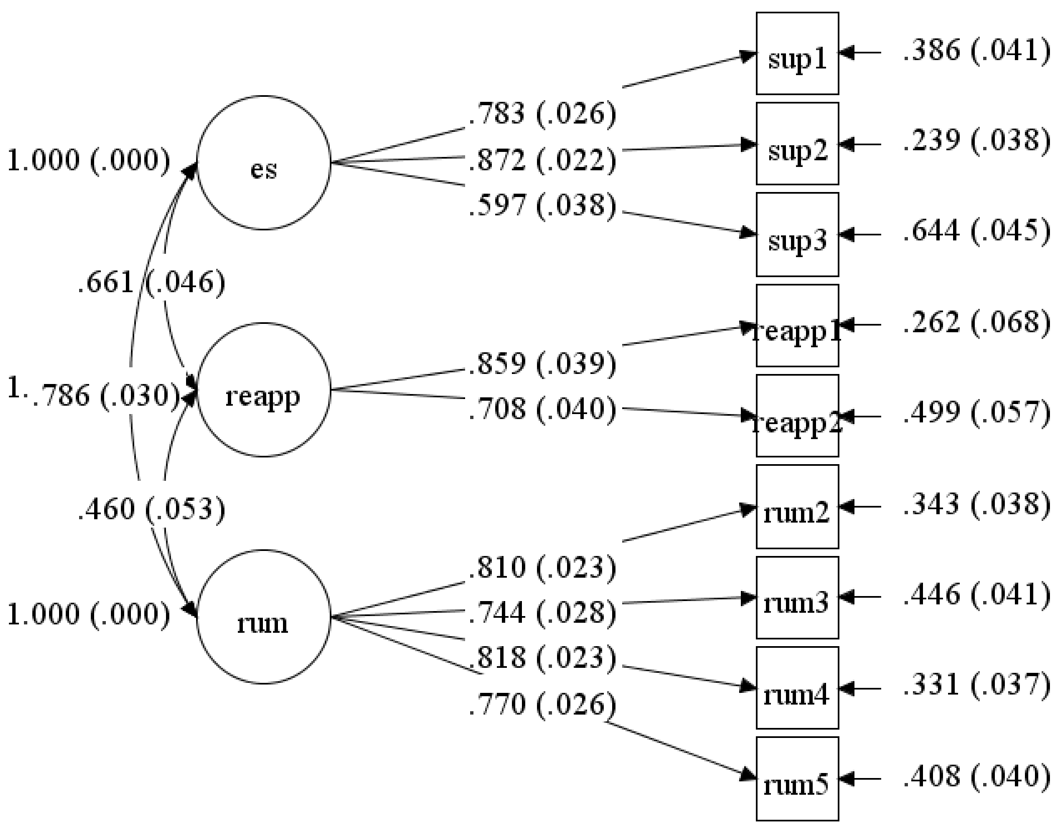 | 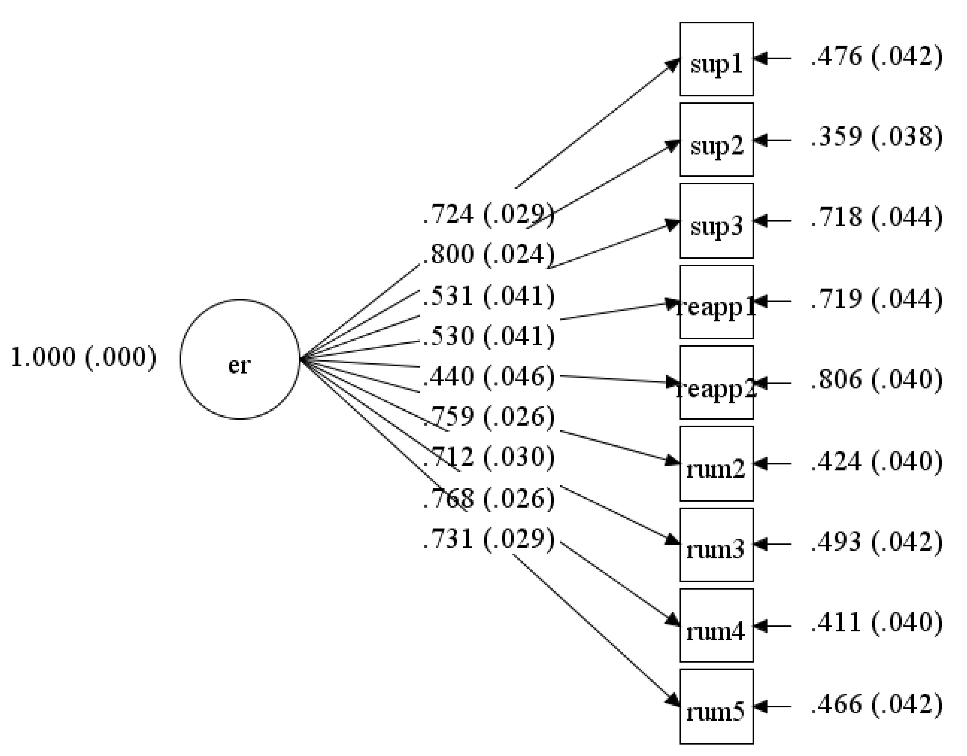

In addition, the variance inflation factor (VIF) and tolerance statistic calculated in SPSS 27 indicated that multicollinearity was not a problem in the models in which emotion regulation strategies were specified as simultaneous predictors. Following the guidelines by Bowerman & O’Connell (1990) and Myers (1990), we calculated the variance inflation factor (VIF) and the tolerance statistic in SPSS 27, which quantifies how much the variance is inflated due to one predictor having a strong linear relationship with the other predictor variables. A VIF greater than 10 or tolerance statistic below 0.1 indicates a serious issue. Similarly, another indicator used to assess multicollinearity issues is the average VIF. If the average VIF is substantially greater than 1 (i.e., closer to 10), then the regression may be biased. Lastly, a tolerance statistic below 0.2 also indicates a potential problem (Menard, 1995). Because the tests are based on the associations between the independent variables, the tests produce the same VIF and tolerance statistics across analyses in which emotion regulation strategies were specified as simultaneous predictors. We will illustrate the results predicting depressive symptoms (see below). The VIF values are well below 10 and the tolerance statistics are above 0.2. The average VIF is also close to 1 (and not anywhere close to 10). Therefore, it seems unlikely that we need to worry about collinearity between the predictor variables, which would most likely hinder (rather than enhance) a pattern of robust replicated patterns.
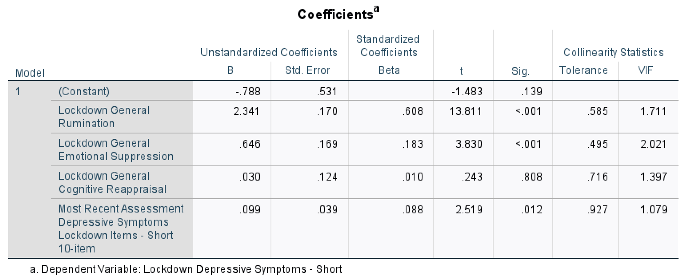
2.2 Distinctions across Emotion Regulation Measures and Emotion Control Difficulties (Study 1)

To ensure that the effects of the specific emotion regulation strategies were not simply due to more general difficulties regulating emotions, we also included items to assess emotion control difficulties. Prior research has shown that, similar to habitual emotional suppression and rumination, greater difficulties controlling or regulating emotions is associated with greater symptoms of depression and anxiety (Bjureberg et al., 2016). Thus, it is possible that any emotion regulation strategy is associated with outcomes because the greater use of emotion regulation strategies (particularly rumination and emotional suppression) all involve difficulties in controlling or regulating emotions. For this reason, we expected there to be high correlations between the emotion regulation strategies and emotion control difficulties measures, but we wanted to apply conservative tests to identify the specific and unique effects of each emotion regulation strategy. After removing the shared variance between emotion regulation strategies and emotion control difficulties, the pattern of findings demonstrated that emotional suppression and rumination continued to predict relative levels of psychological health (accounting for pre-pandemic health).

Confirmatory factor analyses in Mplus 8.3 (Muthén & Muthén, 2017) supported the distinction between the three emotion regulation measures and emotion control difficulties. The analyses supported the distinction between these measures. As shown in Figure SM2, the model fit of a four-factor model specifying the items for emotional suppression, rumination, cognitive reappraisal, and emotion control difficulties on distinct factors (CFI = .96, RMSEA = .079) was significantly better compared to the model fit of a one-factor model, in which all items loaded onto an overarching factor of emotion regulation difficulties (CFI = .83, RMSEA = .16; ꭓ² diff (6) = 369.156, p < .001).
Figure SM2.
Confirmatory factor analyses demonstrating that the emotion regulation and emotion control difficulty items are best represented by four factors assessing emotional suppression, rumination, cognitive reappraisal, and emotion control difficulties
Four-factor model | One-factor model
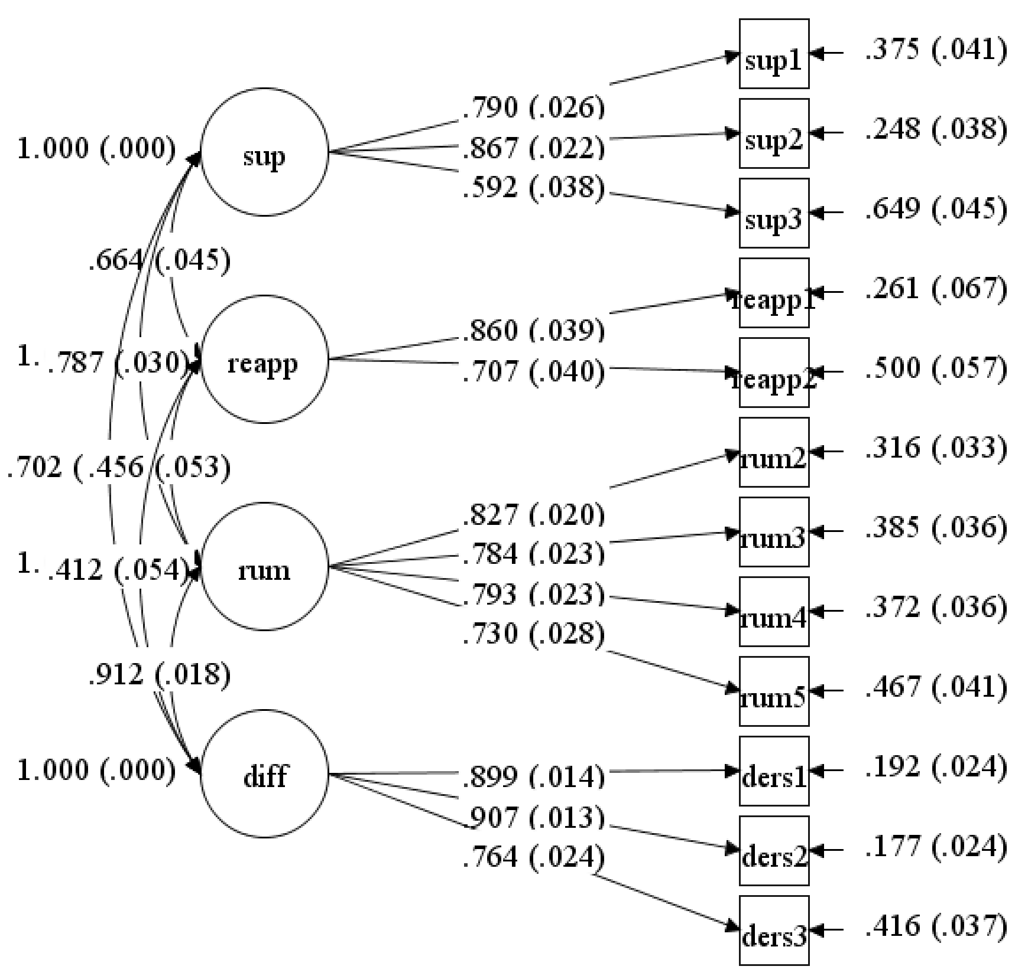 | 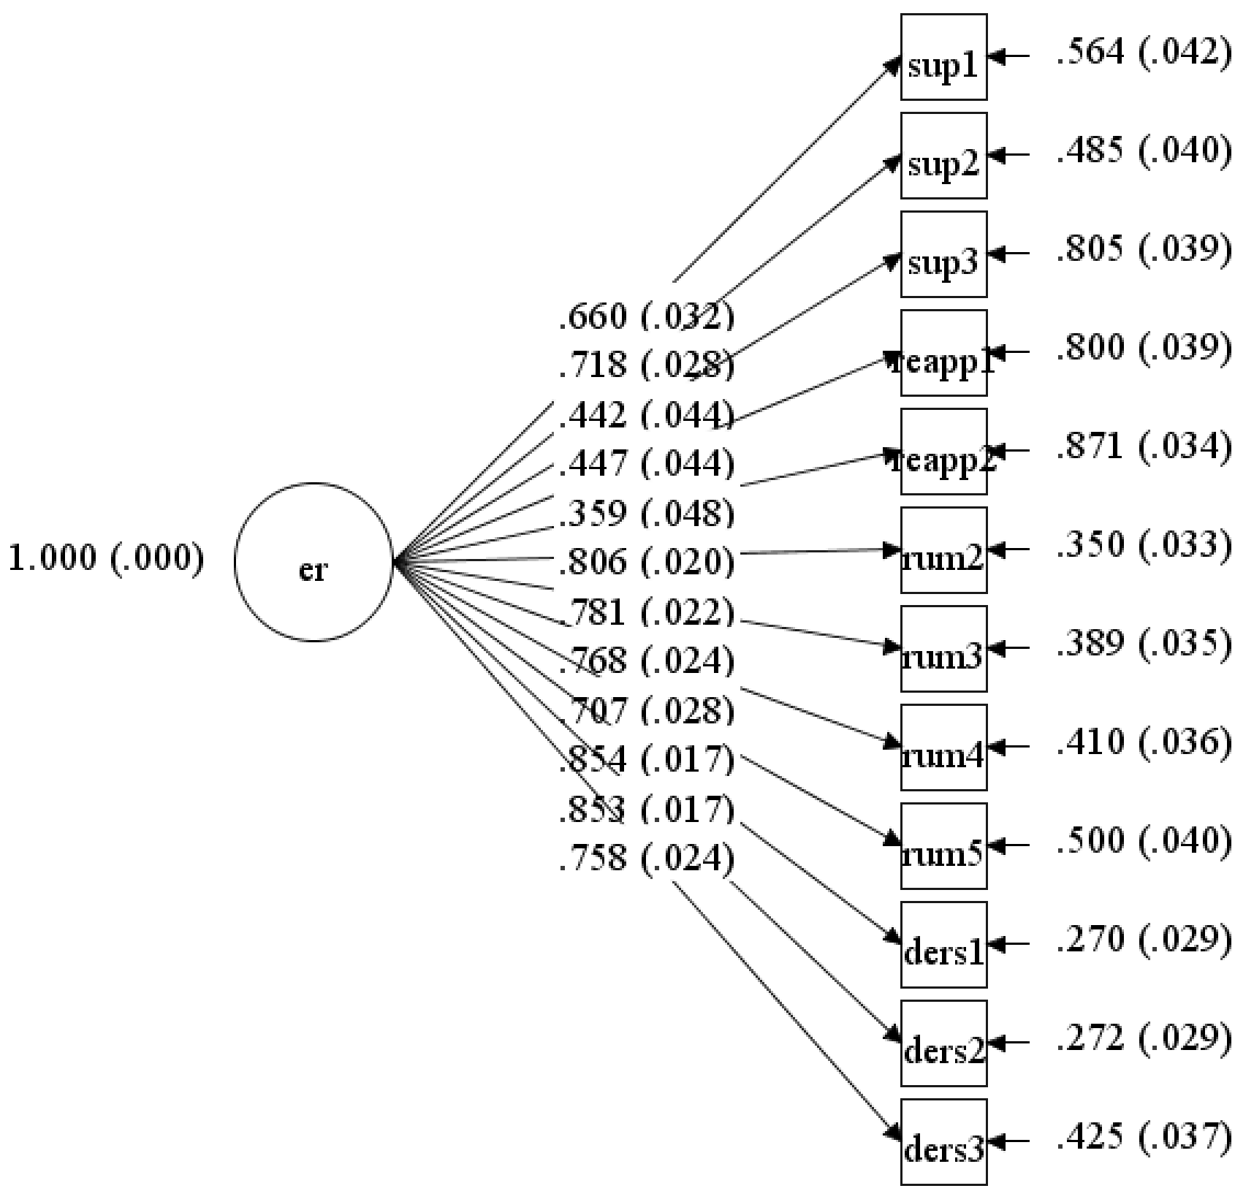

We also calculated the VIF and tolerance statistics to check if multicollinearity was an issue. When including three of the emotion regulation strategies and emotion control difficulties as simultaneous predictors, the VIF and tolerance statistics indicated that multicollinearity was not a problem. Specifically, the VIF values are well below 10 and the tolerance statistics are above 0.2. The average VIF is also closer to 1 (and not approaching 10).
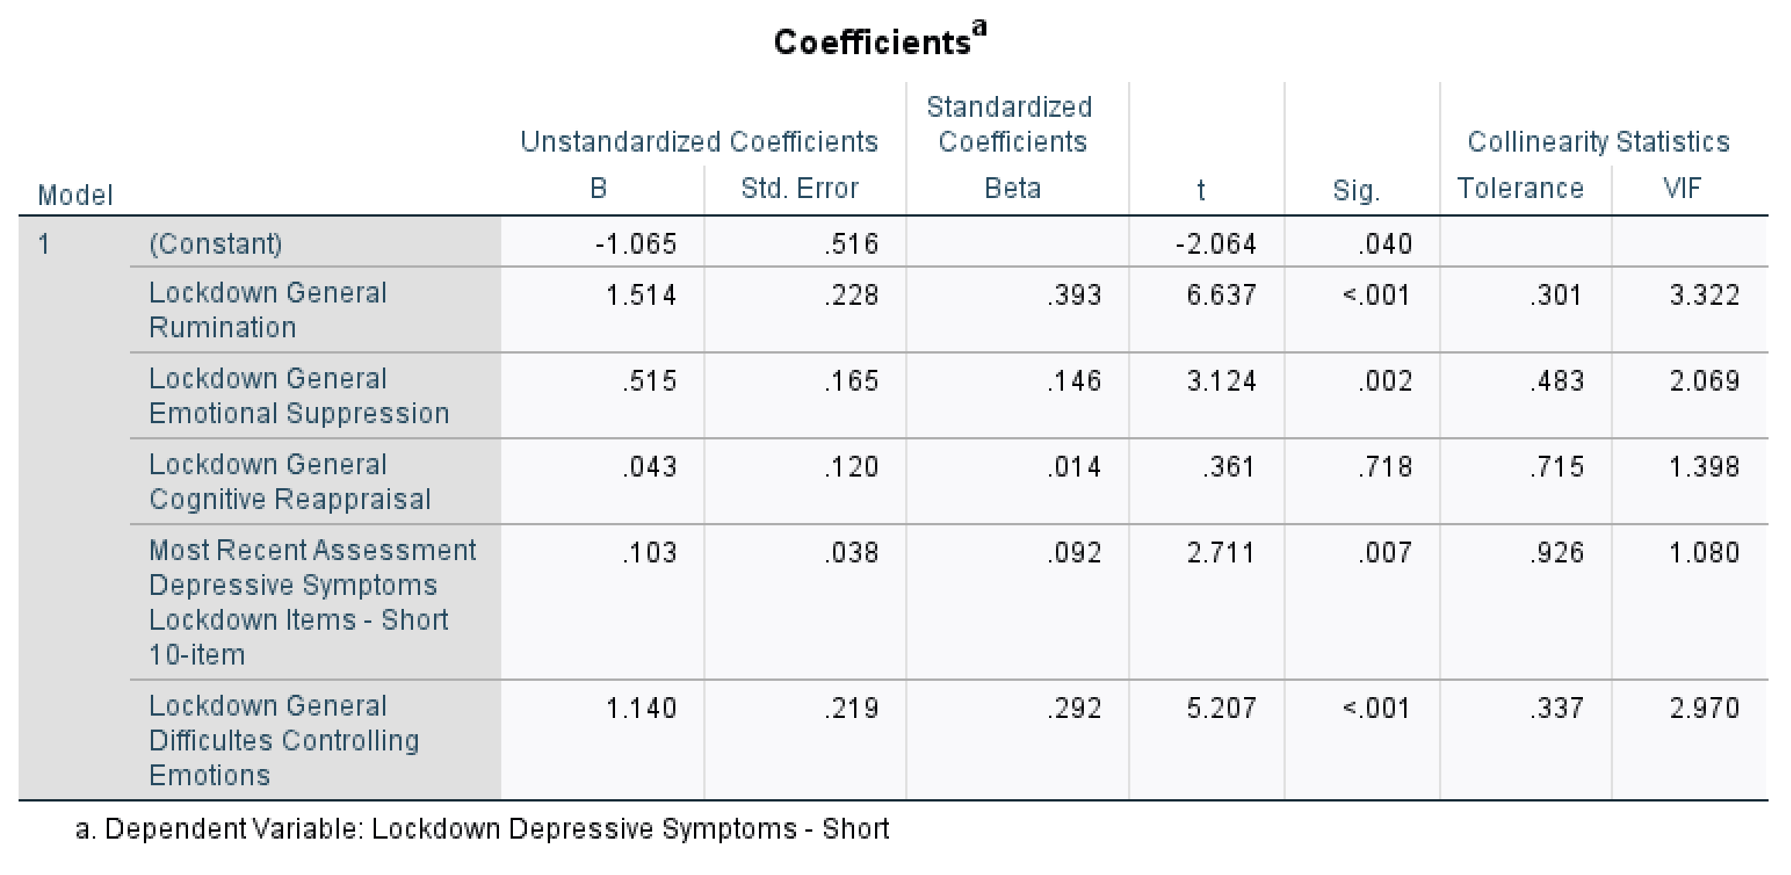

2.3 Distinctions across Emotion Regulation Measures and Psychological Well-being (Study 1)

The strong correlations between rumination and depressive symptoms at (r = .75) and emotional suppression and depressive symptoms (r = .60) are typical of investigations that have examined these measures. For example, the correlations between habitual assessments of rumination and depression typically range from r = .51 to .76 (e.g., Berman et al., 2011; Moulds et al., 2007; Wang et al., 2015). Recall that we are assessing emotion regulation strategies and psychological health experienced within specific contexts, which also increases the associations. Other investigations also show that emotion regulation and psychological health measures are typically stronger when assessed within specific contexts (e.g., during each day, across specific weeks, or during specific emotionally-relevant situations; Brockman et al., 2016; Ford et al., 2019; Low et al., 2017, 2019).
Emotion Regulation Measures and Depressive Symptoms. Given the strong associations between rumination and depressive symptoms, and emotional suppression and depressive symptoms, we wanted to ensure these measures were distinct. To do this, we conducted Confirmatory factor analyses in Mplus 8.3 (Muthén & Muthén, 2017), which supported the established distinction between emotional suppression, rumination, cognitive reappraisal, and depressive symptoms. As shown in Figure SM3 below, the model of a four factor model representing each emotion regulation strategy and depressive symptoms (CFI = .94, RMSEA = .06) was significantly better than the fit of a one-factor model (CFI = .82, RMSEA = .10; ꭓ² diff (6) = 337.888, p < .001).
Figure SM3.
Confirmatory factor analyses demonstrating that the emotion regulation and depressive symptoms items are best represented by four factors assessing emotional suppression, rumination, cognitive reappraisal, and depressive symptoms

Four-factor model | One-factor model
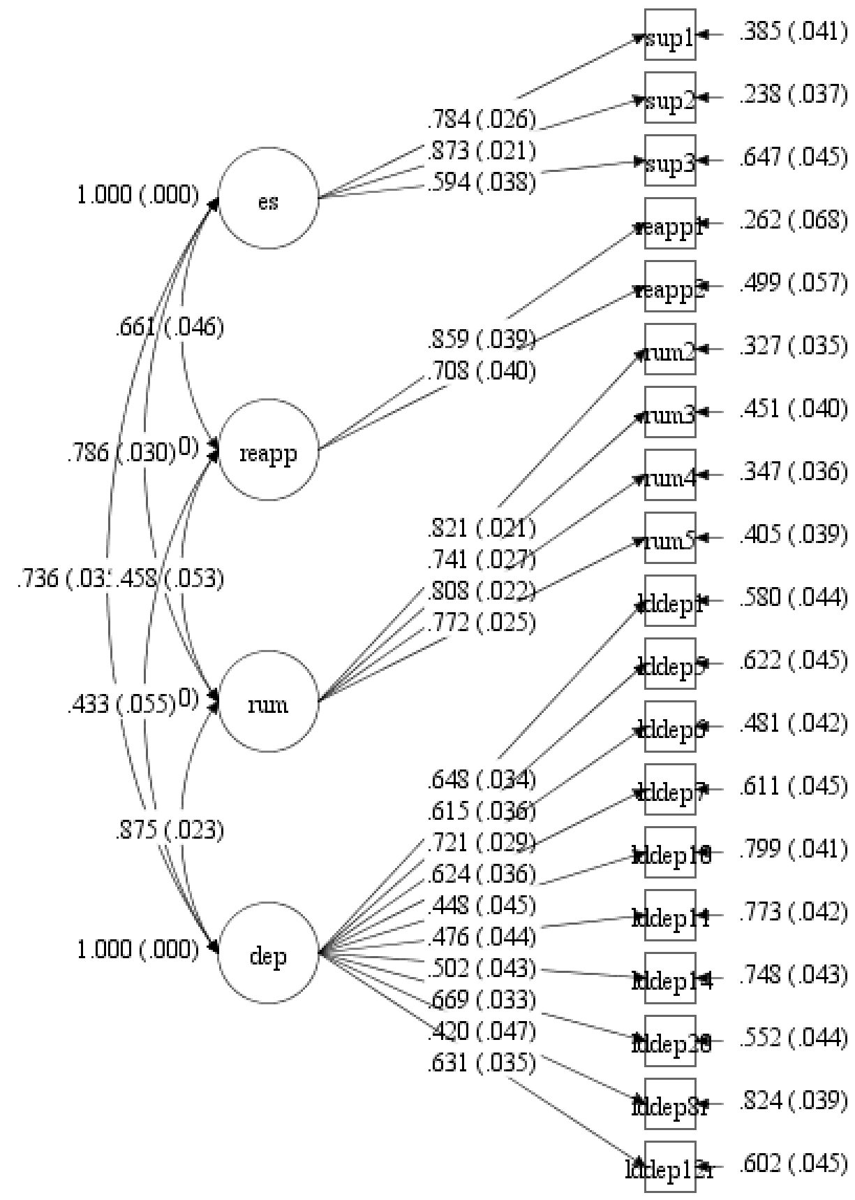 | 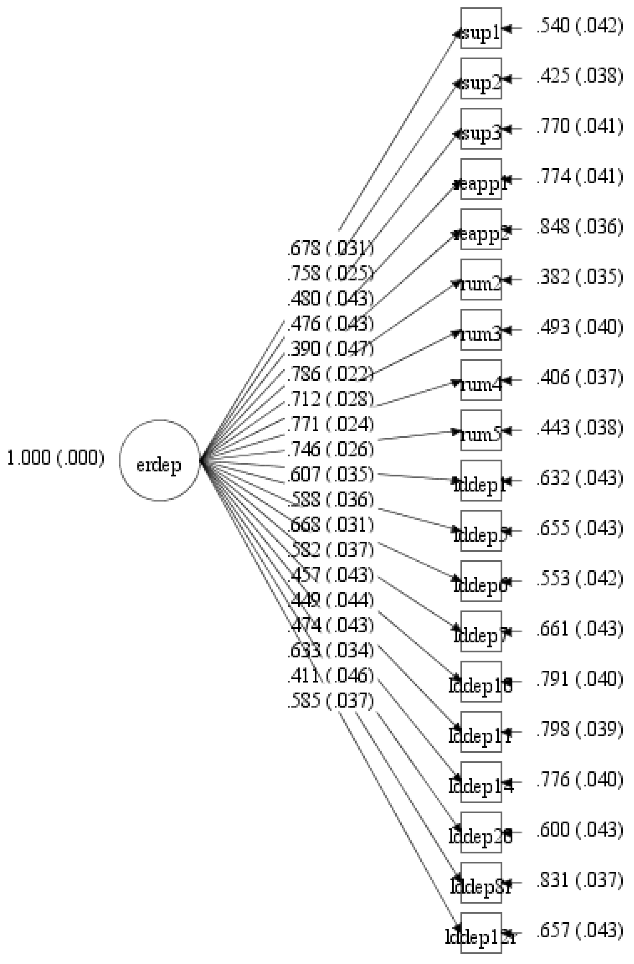

Emotion Regulation Measures and Emotional Well-being. There were also strong associations between rumination and emotional well-being (r = -.74), and emotional suppression and emotional well-being (r = -.56). To demonstrate that these measures were distinct, we conducted Confirmatory factor analyses in Mplus 8.3 (Muthén & Muthén, 2017), which supported the established distinction between emotional suppression, rumination, cognitive reappraisal, and emotional well-being. As shown in Figure SM4 (next page), the model fit of a four factor model representing each emotion regulation strategy and emotional well-being (CFI = .94, RMSEA = .08) was significantly better than the fit of a one-factor model (CFI = .81, RMSEA = .14; ꭓ² diff (6) = 368.568, p < .001).

Figure SM4.
Confirmatory factor analyses demonstrating that the emotion regulation and emotional well-being items are best represented by four factors assessing emotional suppression, rumination, cognitive reappraisal, and emotional well-being

Four-factor model | One-factor model
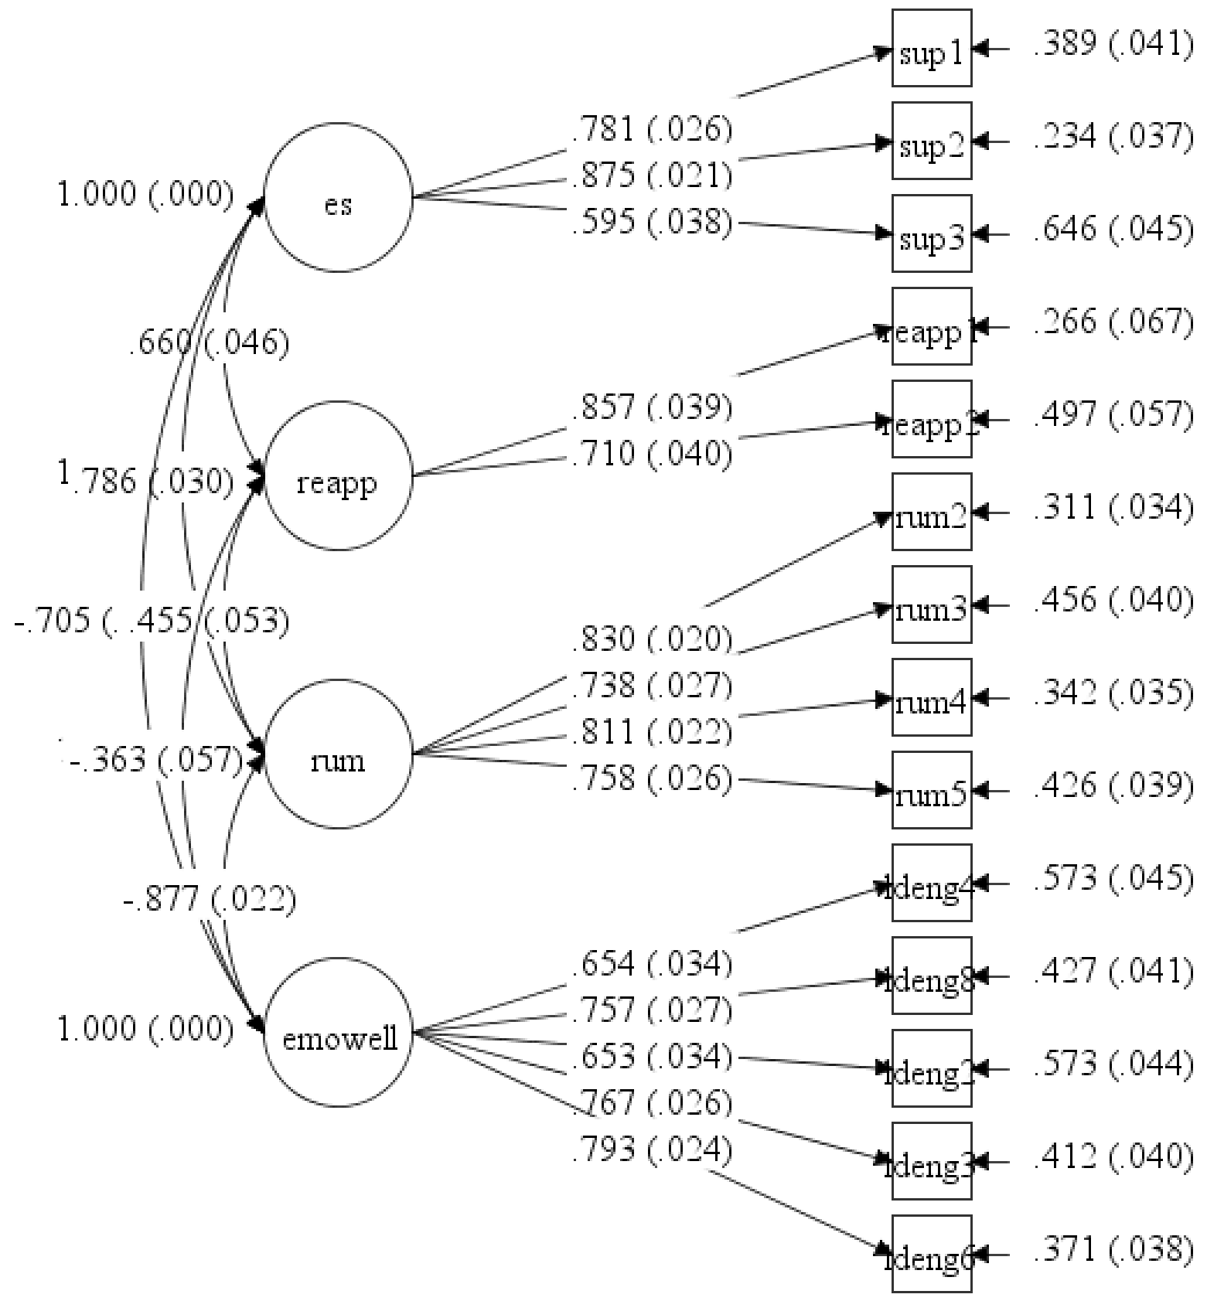 | 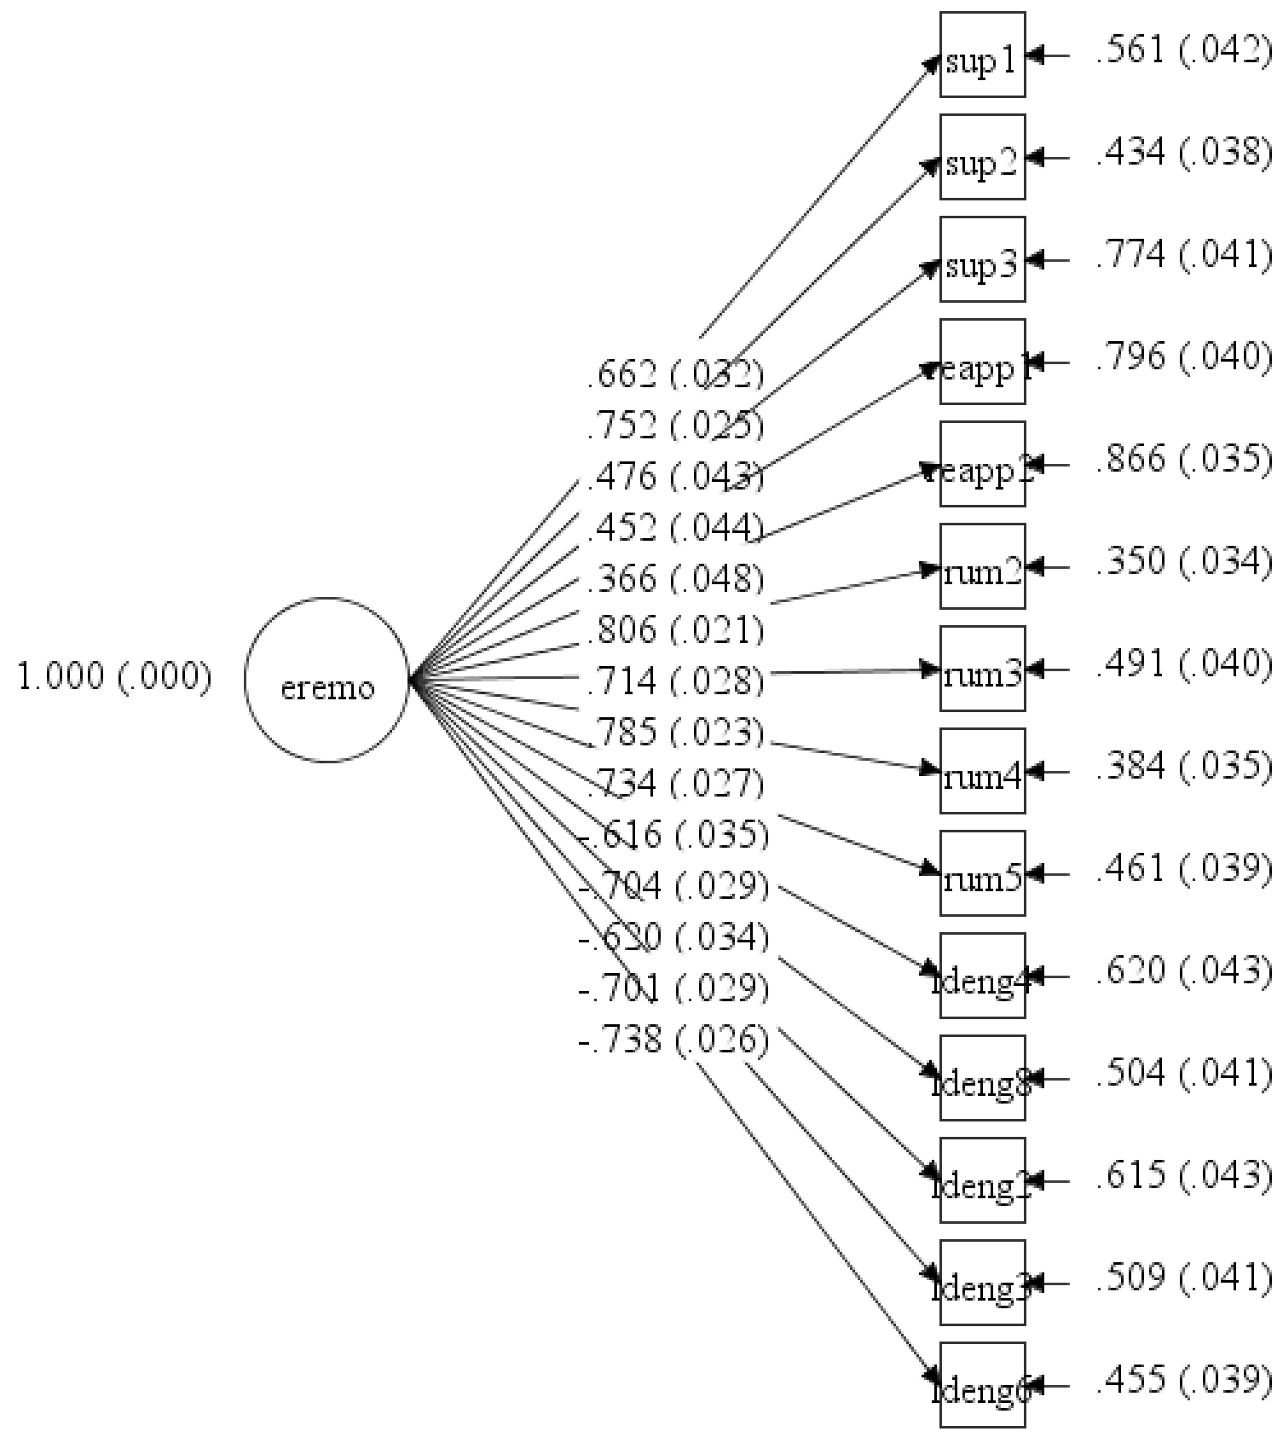

3.0 Analyses of Additional RAND-36 Measures Used in Study 1

We used the RAND 36-Item Health Survey 1.0 (Ware et al., 1980) to assess psychological and physical health. This survey also captured other indices of psychological health (role limitations due to emotional problems, social functioning) and physical health (physical functioning, role limitations due to physical health, pain) that we did not include in the paper. All measures and primary data are available here: https://osf.io/e5ftj/?view_only=eeccf5b10c1d486782ef0c278443e4d0

Our initial plan was to focus on the global measures of health from the RAND-36 survey (emotional well-being, energy, and perceptions of general health) that along with the depressive symptoms provided two broad indicators of psychological (depressive symptoms, emotional well-being) and physical health (energy, perceptions of general health). However, in our initial submission of these data we decided to present all the analyses across all health indicators included in the RAND-36 measure for completeness and transparency. These indices replicated the other analyses and so offered redundant information except for readers who have specific interests in particular RAND-36 scales. On reflection, we felt that the number of measures and analyses added unnecessary complexity and may have hindered readers’ ability to digest the central findings of the paper. Thus, we reverted to our original approach and present two indicators of psychological (depressive symptoms, emotional well-being) and two indicators of physical health (energy, perceptions of general health) in the paper. In this section, we describe the additional indices in the RAND 36-Item Health Survey and present analyses of these variables, which supported the same conclusions.
3.1 Additional RAND 36-Item Health Survey Measures (Study 1)

Role limitations due to Emotional Problems. Participants were asked “have you had any of the following problems with your work or other activities as a result of any emotional problems (such as feeling depressed or anxious)?” and rated three items such as “Cut down the amount of time you spent on work or other activities”, “Accomplished less than you would like” (1 = None of the time, 5 = All of the time; Pre-Lockdown α = .85, Lockdown α = .86).
Social functioning. Two items assessed “how much of the time” (1 = None of the time, 5 = All of the time) and “to what extent” (1 = Not at all, 5 = Extremely) physical health or emotional problems interfered with social activities with family and friends? Examples given in the pre-lockdown assessment (e.g., visiting with friends, relatives) were altered to be relevant in the lockdown questionnaire (e.g., social activities with your family at home or talking with family/friends on the phone or online); Pre-Lockdown α = .85, Lockdown α = .76).
Physical functioning. Participants rated 10 items assessing whether their health limited them in routine activities, such as “lifting or carrying groceries”, “bathing or dressing yourself” (1 = No, not limited at all, 3 = Yes, limited a lot; Pre-Lockdown α = .91, Lockdown α = .89).
Role limitations due to Physical Health. Participants were asked “how much of the time have you had any of the following problems with your work or other regular activities as result of your physical health?” and rated four items, such as “Cut down the amount of time you spent on work or other activities”, “Accomplished less than you would like” (1 = None of the time, 5 = All of the time; Pre-Lockdown α = .91, Lockdown α = .89).
Pain. Participants rated two items assessing how much bodily pain they had during the past 4 weeks (pre-lockdown) or during the lockdown (1 = none, 6 = very severe), and how much pain interfered with normal work inside and outside the home (1 = not at all, 5 = extremely; Pre-Lockdown α = .84, Lockdown α = .85).

3.1 Associations across RAND 36-Item Health Survey Measures (Study 1)

As shown in Table SM4 below, some of the scales were highly correlated prior to the lockdown and during the lockdown. We kept these indicators separate to ensure that readers are able to interpret these effects in line with how they are typically used in the wider literature. We also present more information below providing evidence that these measures offer distinct assessments.

Table SM4.
Correlations Across All Psychological and Physical Health Measures (Study 1)
Measures | 1. | 2. | 3. | 4. | 5. | 6. | 7. | 8. | 9.
- Depressive symptoms | .28** | -.79** | -.60** | -.64** | -.67** | -.44** | -.21** | -.31** | -.28**
- Emotional well-being | -.82** | .34** | .60** | .61** | .66** | .37** | .13* | .26** | .25**
- Role limitations due to emotional problems | -.64** | .65** | .36** | .58** | .47** | .35** | .20** | .34** | .20**
- Social functioning | -.50** | .54** | .49** | .26** | .48** | .32** | .23** | .48** | .37**
- Energy/Fatigue | -.69** | .73** | .56** | .46** | .47** | .51** | .22** | .33** | .33**
- General health | -.30** | .33** | .26** | .33** | .37** | .64** | .32** | .30** | .27**
- Physical functioning | -.10 | .10* | .14** | .26** | .11* | .25** | .31** | .44** | .42**
- Role limitations due to physical problems | -.21** | .24** | .22** | .37** | .25** | .34** | .54** | .34** | .57**
- Pain | -.20** | .23** | .21** | .33** | .32** | .38** | .41** | .59** | .45**
Note. Correlations for pre-lockdown measures are above the diagonal. Correlations across measures assessed during the lockdown are below the diagonal. Bold correlations on the diagonal represent the within-measure associations across pre-lockdown and lockdown assessments. *p < .05. **p < .01.

Distinctions across Measures of Psychological Health

With regards to the associations between the psychological health outcomes, confirmatory factor analyses in Mplus 8.3 supported the distinction between emotional well-being, role limitations due to emotional problems and social functioning. We also included depressive symptoms in the confirmatory factor analyses given the high correlation between depressive symptoms and emotional well-being. As shown in Figure SM5, compared to the model fit of a one-factor model (CFI = .782, RMSEA = .113), the model fit of the four-factor model (CFI = 0.90, RMSEA = .078) was significantly better (ꭓ² diff (6) = 436.387, p < .001).

Figure SM5.
Confirmatory Factor Analyses supporting the Distinctions between the Four Measures of Psychological Health.
Four-factor model | One-factor model
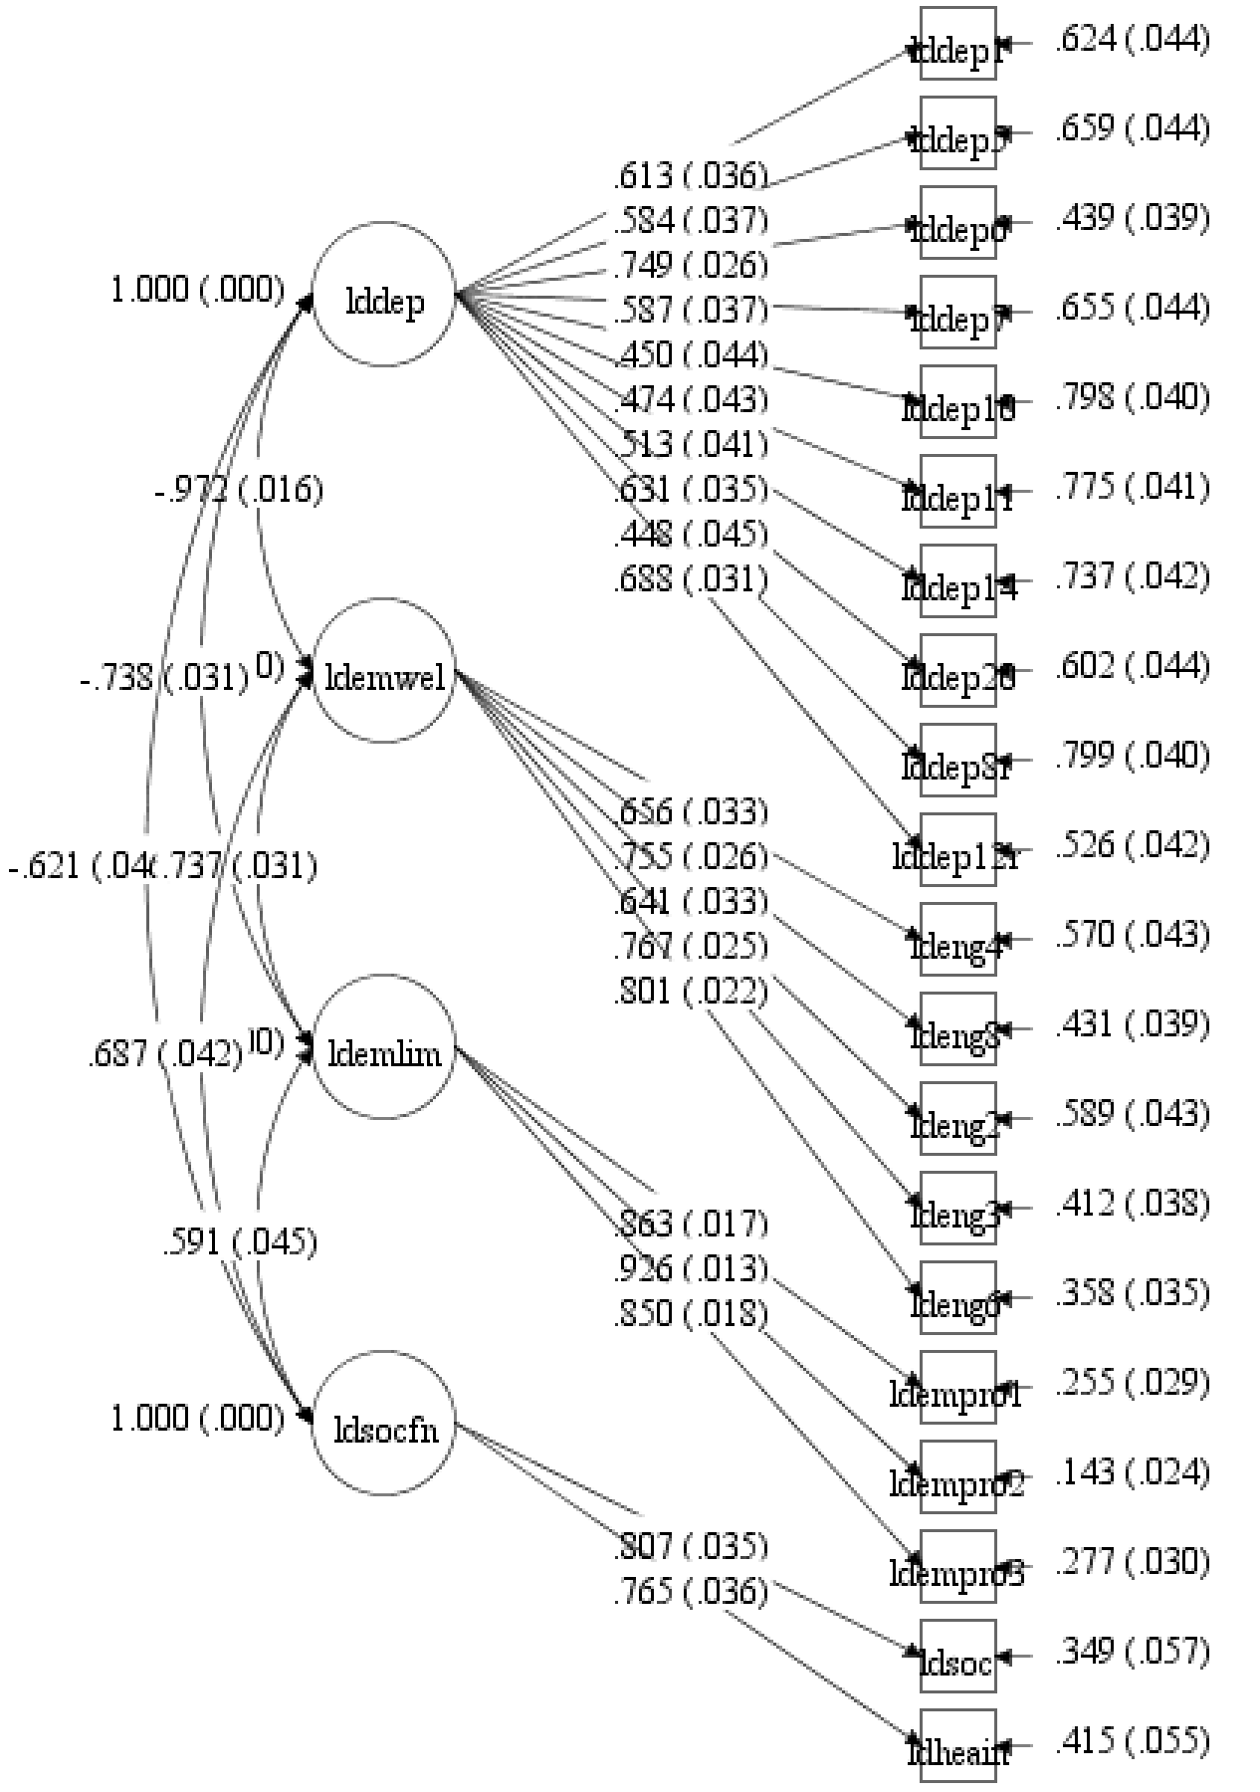 | 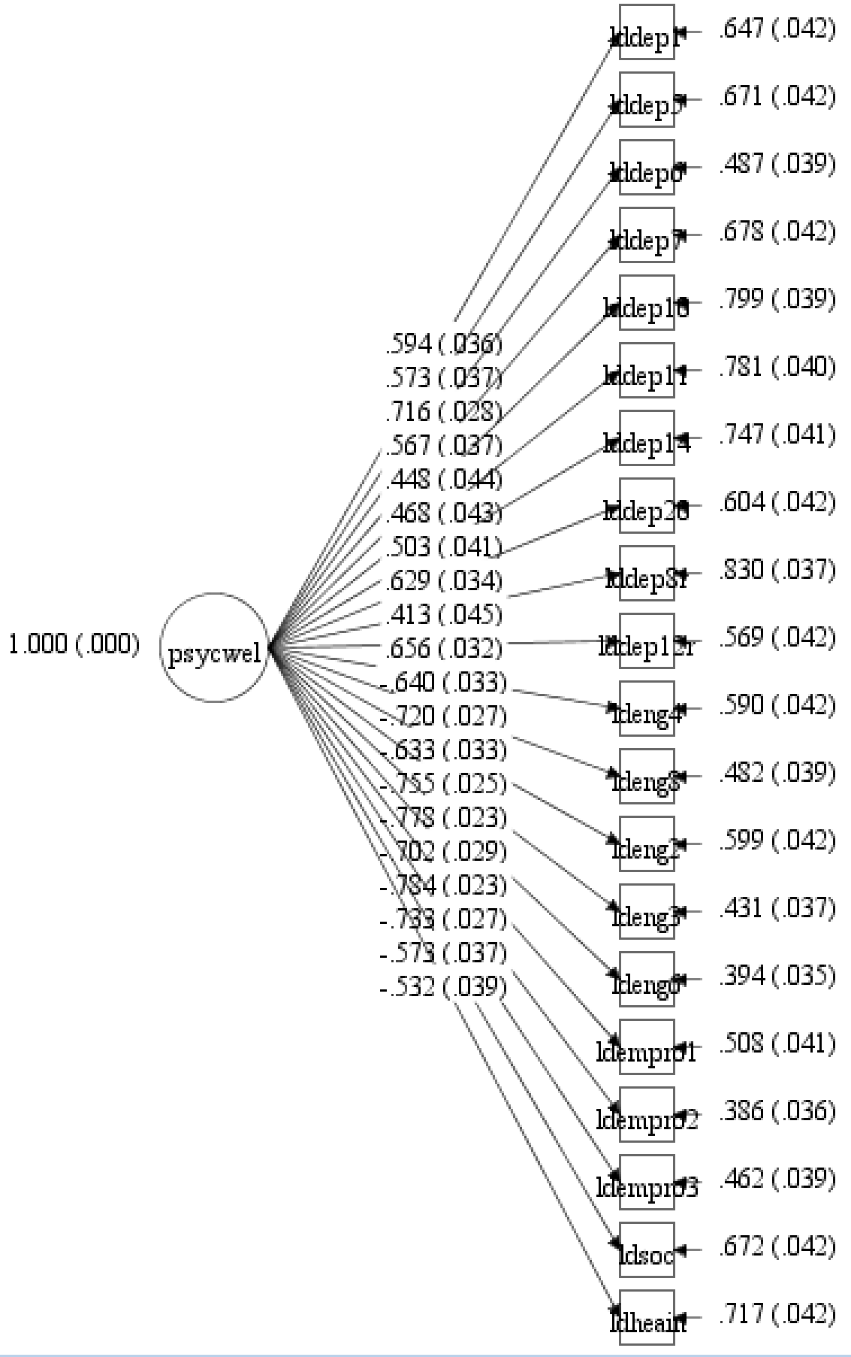

Distinctions across Measures of Physical Health

As shown in Figure SM6 below, compared to the model fit of a one-factor model (CFI = .462, RMSEA = .17), the model fit of the five-factor model (CFI = 0.82, RMSEA = .10) was a significantly better (albeit not perfect) fit (ꭓ² diff (10) = 1880.611, p < .001).

Figure SM6.
Confirmatory Factor Analyses Examining the Distinctions between the Five Measures of Physical Health.
Five-factor model | One-factor model
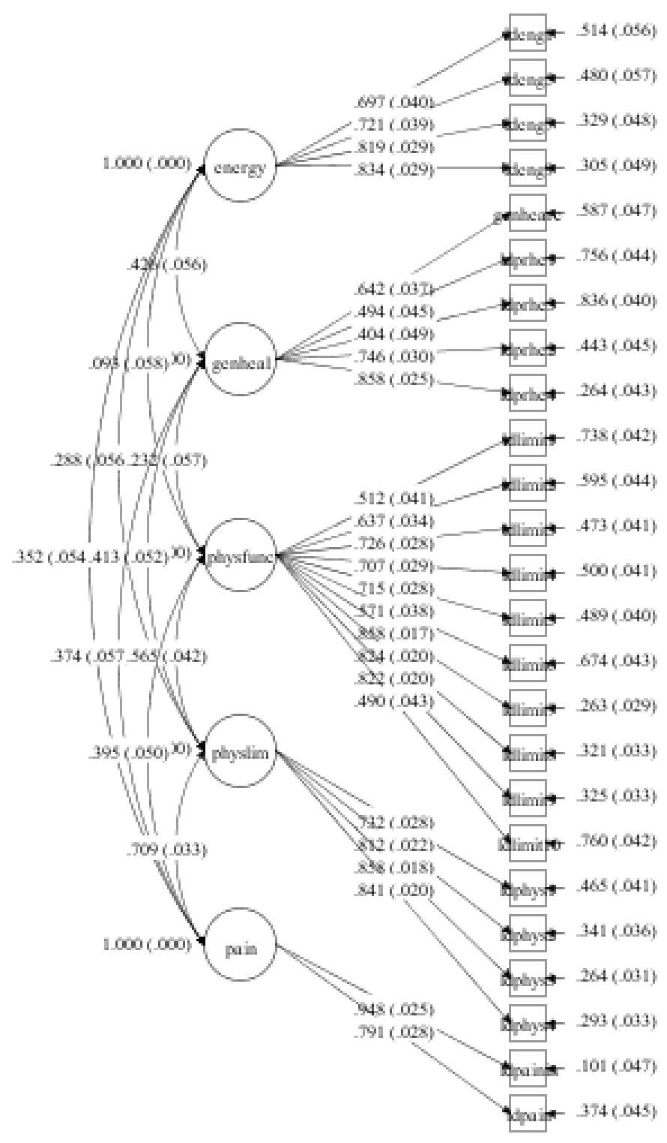 | 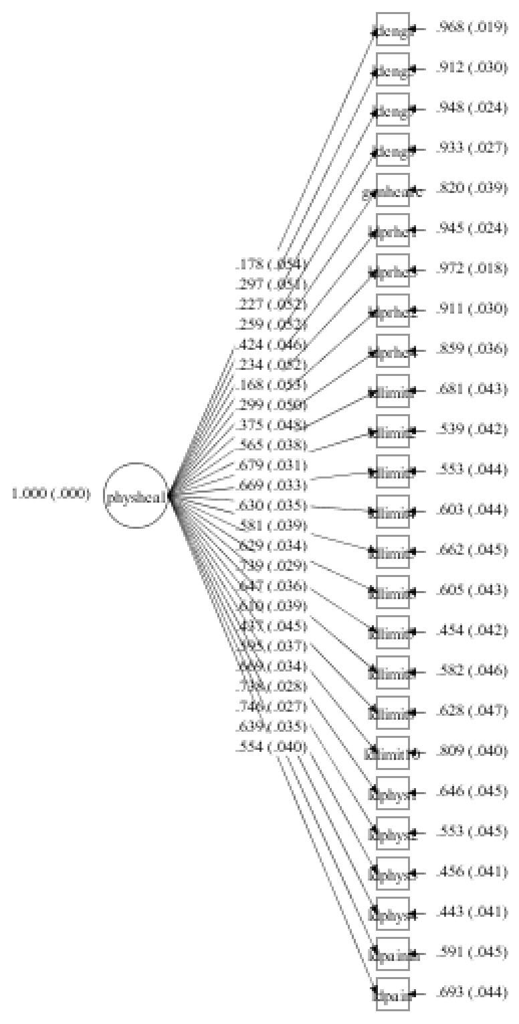

3.3 Analyses of Additional RAND-36 Measures Used in Study 1

The analyses below examine whether emotion regulation predicted residual increases in (1) the two additional indices of psychological health: role limitations due to emotional problems and social functioning, and (2) the three additional indices of physical health: physical functioning, role limitations due to physical health, and pain. In each analysis, we regressed health on (1) the most recent assessment of health prior to the lockdown so that any significant associations represented the degree to which emotion regulation during the lockdown predicted residual changes in health, and (2) emotional suppression, rumination or cognitive reappraisal (in separate analyses).

Emotion Regulation and Psychological Health

Analyses examining the links between emotion regulation and limitations due to emotional problems and social functioning revealed the same pattern of findings in the paper. As shown in the top of Table SM5, greater rumination, emotional suppression, and cognitive reappraisal predicted greater limitations due to emotional problems and poorer social functioning. When all three emotion regulation strategies were entered as simultaneous predictors, the negative effects of emotional suppression and rumination across both outcomes remained, with one exception: greater emotional suppression no longer predicted social functioning (p = .148). By contrast, no unique effects of cognitive reappraisal emerged.

Emotion Regulation and Physical Health

Analyses assessing the links between each emotion regulation strategy and residual change also revealed rumination was more consistently and robustly associated with physical health (see Table SM6). Only rumination showed unique effects with physical functioning (p = .046), role limitations due to physical health (p = .051), and pain (p =.018) when controlling for the shared associations across emotion regulation strategies, although these associations were weaker than those with the more global assessments of physical health.

Final Comment on Multiple Tests

Given the number of analyses conducted on the same dataset, there might be concern that significant results capitalized on chance. However, we do not believe that this is a concern. Our initial plan was to focus on the global measures of health from the RAND-36 survey (emotional well-being, energy, and perceptions of general health) along with the CES-D assessment of depressive symptoms. We provide the associations across all health indicators for readers who are interested in the other components from the RAND-36 survey, and to fully disclose the results across all of the relevant health measures we assessed prior to and during the lockdown. The additional analyses demonstrate equivalent findings as reported in the paper with a few exceptions that likely relate to the reliability of shorter measures that were affected by the mandatory quarantine context (social functioning). More importantly, we did not expect or demonstrate a pattern of distinct effects, which is most relevant to concerns about multiple testing. Most important, the pattern of results for the general measures presented in the paper, and associated conclusion, would remain unchanged if applying a Bonferroni correction to an adjusted alpha criterion of p = .001(Perneger, 1998), even after controlling for alternative explanations.
Table SM5.

The Associations between Emotion Regulation Strategies and Psychological Health during Lockdown (Study 1)

Predictors | Role Limitations due to Emotional Problems |  |  |  |  | Social Functioning
Predictors | B | 95% CI | t | p | r | B | 95% CI | t | p | r
Three Separate Models Assessing the Effects of Each Emotion Regulation Strategy
Emotional suppression | -5.54 | -6.67, -4.42 | -9.68 | <.001 | .46 | -5.07 | -6.30, -3.84 | -8.11 | <.001 | .39
Rumination | -8.01 | -9.17, -6.85 | -13.56 | <.001 | .60 | -7.40 | -8.65, -6.15 | -11.65 | <.001 | .53
Cognitive reappraisal | -2.98 | -4.03, -1.92 | -5.54 | <.001 | .28 | -2.88 | -4.01, -1.75 | -5.02 | <.001 | .25
One Model Assessing the Unique Effects of Each Emotion Regulation Strategy
Emotional suppression | -1.84 | -3.26, -.42 | -2.54 | .011 | .14 | -1.17 | -2.75, .41 | -1.45 | .148 | .08
Rumination | -6.66 | -8.12, -5.20 | -8.97 | <.001 | .44 | -6.39 | -7.98, -4.80 | -7.90 | <.001 | .39
Cognitive reappraisal | -.19 | -1.24, .86 | -.35 | .728 | .02 | -.46 | -1.62, .71 | -.77 | .443 | .04

Note. All analyses control for the pre-lockdown assessment of the psychological health outcome. The top section presents results from three separate models assessing the effect of each emotion regulation strategy controlling for psychological health prior to the lockdown. The bottom section presents results from one model including each emotion regulation strategy as simultaneous predicts to assessing the unique effects of each emotion regulation strategy controlling for psychological health prior to the lockdown. Effect sizes (r) were computed using Rosenthal and Rosnow’s (2008) formula: r = √(t² / t² + df). In these multilevel models, the Satterthwaite approximation is applied to provide specific degrees of freedom for each effect representing the weighted average of the dyad- and individual-level degrees of freedom, which were used to calculate the effect sizes.

Table SM6.

Predictors | Physical Functioning |  |  |  |  | Role Limitations due to Physical Health |  |  |  |  | Pain
 | B | 95% CI | t | p | r | B | 95% CI | t | p | r | B | 95% CI | t | p | r
Three Separate Models Assessing the Effects of Each Emotion Regulation Strategy
Emotional suppression | -.09 | -1.17, .99 | -.17 | .867 | .01 | -.92 | -1.96, .11 | -1.75 | .081 | .09 | -1.15 | -2.26, -.04 | -2.04 | .043 | .11
Rumination | -1.04 | -2.22, .14 | -1.74 | .084 | .09 | -1.51 | -2.65, -.37 | -2.60 | .010 | .14 | -2.00 | -3.22, -.78 | -3.22 | .001 | .17
Cognitive reappraisal | -.63 | -1.58, .32 | -1.30 | .195 | .07 | -.47 | -1.39, .44 | -1.02 | .307 | .05 | -1.35 | -2.33, -.37 | -2.70 | .007 | .14
One Model Assessing the Unique Effects of Each Emotion Regulation Strategy
Emotional suppression | 1.25 | -.26, 2.77 | 1.63 | .105 | .09 | -.06 | -1.52, 1.39 | -.09 | .930 | .00 | .59 | -.97, 2.16 | .74 | .457 | .04
Rumination | -1.55 | -3.06, -.02 | -2.00 | .046 | .11 | -1.47 | -2.94, .01 | -1.96 | .051 | .10 | -1.91 | -3.49, -.33 | -2.38 | .018 | .12
Cognitive reappraisal | -.74 | -1.86, .38 | -1.30 | .196 | .07 | .01 | -1.07, 1.08 | .01 | .990 | .00 | -1.00 | -2.17, .16 | -1.70 | .090 | .09
The Associations between Emotion Regulation Strategies and Physical Health during Lockdown (Study 1)
Note. All analyses control for the pre-lockdown assessment of the physical health outcome. The top section presents results from three separate models assessing the effect of each emotion regulation strategy controlling for physical health prior to the lockdown. The bottom section presents results from one model including each emotion regulation strategy as simultaneous predicts to assessing the unique effects of each emotion regulation strategy controlling for physical health prior to the lockdown. Effect sizes (r) were computed using Rosenthal and Rosnow’s (2008) formula: r = √(t² / t² + df). In these multilevel models, the Satterthwaite approximation is applied to provide specific degrees of freedom for each effect representing the weighted average of the dyad- and individual-level degrees of freedom, which were used to calculate the effect sizes.

- SPSS Syntax of Primary Analyses for Study 1
Our primary analyses examine whether different emotion regulation strategies predicted residual changes in psychological and physical health by calculating the associations controlling for baseline (pre-lockdown) assessments of psychological and physical health (see Table 3 in the paper). Below, we provide example syntax for the different analyses conducted in the study by using depressive symptoms as the example outcome across all analyses. SPSS 27 was used to estimate the model, but any other multilevel modeling program (e.g., SAS or HLM) could be used. Each record is the data for each individual participant. The syntax follows that provided by Kenny et al. (2006). Upper case words in bold are required SPSS syntax, and the remaining represent variables and specifications that need to be selected. Variable names have been altered from the data available on osf for ease of presentation.

- Model Assessing the Effect of Emotional Suppression
MIXED Lockdown_Dep WITH Baseline_Dep_c Suppression_c
/FIXED=Baseline_Dep_c Suppression_c
/REPEATED=obs | SUBJECT(FAMILY_ID) COVTYPE(CSH).

- One Model Assessing the Unique Effects of Each Emotion Regulation Strategy
MIXED Lockdown_Dep WITH Baseline_Dep_c Suppression_c Reappraisal_c Rumination_c
/FIXED=Baseline_Dep_c Suppression_c Reappraisal_c Rumination_c
/REPEATED=obs | SUBJECT(FAMILY_ID) COVTYPE(CSH).

This syntax specifies analyses for examining the couple as the unit of analysis or subject (familyid). Each model estimates the equations pooled across couple members but distinguishes couple members by specifying that each unit is made of two sets of observations (the REPEATED statement obs variable distinguishes couple members). The REPEATED statement treats each individual’s scores as repeated measures in the dyad, which accounts for within-couple dependence of observations by modeling a heterogenous compound symmetry error structure (CSH). These analyses include all 365 individuals who completed the relevant assessments, including 314 who comprised 157 dyads from the same family as well as 51 individuals whose partners did not complete the lockdown assessment. The model effectively deals with the ‘missing’ data by 51 partners who did not complete lockdown measures by weighting the estimates based on the available data (i.e., only data available for each dyad informs the sample level estimates).
The MIXED line specifies the structure of the multilevel model. The dependent variable ‘Lockdown_Dep’ represents participants’ reports of depressive symptoms during the COVID-19 lockdown. All of the remaining variables on the first line (following WITH) are those included in the model to specify the fixed effects of predictors.
The FIXED line models all of the effects reported in Table 3 of the paper. All predictor variables were mean-centered. ‘Baseline_Dep’ represents reported depressive symptoms prior to lockdown, which ensures that any significant prediction of depressive symptoms in the lockdown represents prediction of residual change from the most recent assessment. ‘Suppression’ represents emotional suppression, ‘Rumination’ represents rumination and ‘Reappraisal’ represents cognitive reappraisal assessed during the lockdown.

- Primary and Additional Analyses for Study 2

5.1 Results of Demographic Covariates

Given the larger and more diverse sample in Study 2, and following procedures applied across analyses using the New Zealand Attitudes and Values Study (NZAVS) data, we included in all regression models a standard set of demographic covariates, including gender, age, ethnicity, socioeconomic status, education attainment, employment, relationship and parent status, urban residence and born in NZ; see Table 5).
In general, the demographic variables did not predict variation in outcomes although older participants reported lower depressive symptoms and fatigue, people in close relationships reported higher personal well-being, and greater deprivation was associated with poorer general health (see Table SM7). These demographic differences were controlled for across analyses.
Table SM7.
The Associations between Emotion Regulation Strategies and Demographic Covariates and Psychological and Physical Health (Study 2)

Predictors | Psychological Distress |  |  |  |  | Personal Well-being |  |  |  |  | Fatigue (Low Energy) |  |  |  |  |  |  | General Health
Predictors | B | 95% CI | t | p | β | B | 95% CI | t | p | β |  | B | 95% CI | t | p | β | B |  | 95% CI | t | p | β
Emotion Regulation Strategies
Rumination | .29 | .267, .315 | 23.87 | <.001 | .43 | -.24 | -.301, -.171 | -7.12 | <.001 | -.13 |  | .24 | .197, .287 | 10.49 | <.001 | .22 | -.12 |  | -.169, -.077 | -5.24 | <.001 | -.10
Emotional suppression | .03 | .020, .044 | 5.04 | <.001 | .08 | -.04 | -.078, -.006 | -2.29 | .022 | -.04 |  | .06 | .036, .086 | 4.79 | <.001 | .10 | -.04 |  | -.065, -.013 | -2.93 | .003 | -.05
Cognitive reappraisal | -.02 | -.036, -.008 | -3.01 | <.001 | -.05 | .10 | .053, .137 | 4.46 | <.001 | .08 |  | -.01 | -.043, .015 | -0.94 | .347 | .02 | .05 |  | .011, .081 | 3.32 | .001 | .06
Demographic Covariates
Gender | -.05 | -.094, -.009 | -2.38 | .017 | -.04 | -.14 | -.262, -.015 | -2.20 | .028 | -.04 |  | -.13 | -.212, -.039 | -2.84 | .004 | -.06 | -.11 |  | -.197, -.019 | -2.38 | .017 | -.04
Age | -.01 | -.006, -.003 | -5.12 | <.001 | -.10 | .00 | -.003, .007 | 0.66 | .511 | .01 |  | -.01 | -.010, -.003 | -3.71 | .000 | -.09 | -.00 |  | -.006, .001 | -1.19 | .232 | -.03
Māori | .02 | -.046, .089 | 0.63 | .529 | .01 | -.02 | -.218, .175 | -0.22 | .827 | -.00 |  | -.03 | -.169, .104 | -0.47 | .639 | -.01 | -.11 |  | -.251, .032 | -1.52 | .129 | -.03
Pacific | .00 | -.138, .142 | 0.02 | .981 | .00 | .01 | -.402, .417 | 0.04 | .972 | .00 |  | -.12 | -.401, .167 | -0.81 | .420 | -.02 | -.01 |  | -.300, .289 | -0.04 | .970 | -.00
Asian | -.02 | -.133, .090 | -0.38 | .708 | -.01 | -.21 | -.539, .112 | -1.28 | .199 | -.02 |  | -.11 | -.331, ,120 | -0.92 | .358 | -.02 | -.02 |  | -.253, .215 | -0.16 | .873 | -.00
Deprivation | -.00 | -.009, .006 | -0.34 | .735 | -.01 | -.01 | -.033, .011 | -0.98 | .329 | -.02 |  | -.00 | -.018, .012 | -0.39 | .697 | -.01 | -.02 |  | -.033, -.002 | -2.22 | .027 | -.04
Education | .00 | -.005, .013 | 0.88 | .380 | .02 | .01 | -.017, .036 | 0.71 | .480 | .02 |  | .00 | -.017, .020 | 0.18 | .855 | .00 | -.00 |  | -.023, .015 | -0.40 | .693 | -.01
Socioeconomic status | -.00 | -.002, .001 | -0.78 | .425 | -.02 | .00 | -.001, .008 | 1.49 | .137 | .03 |  | -.00 | -.005, .001 | -1.53 | .126 | -.04 | .00 |  | -.001, .005 | 1.07 | .283 | .02
Parent | .02 | -.028, .073 | 0.87 | .387 | .02 | -.10 | -.251, .045 | -1.37 | .171 | -.03 |  | .09 | -.015, .190 | 1.67 | .096 | .04 | .04 |  | -.063, .150 | 0.80 | .424 | .02
Partner | .03 | -.014, .081 | 1.39 | .164 | .02 | .17 | .024, .309 | 2.29 | .022 | .04 |  | .03 | -.071, .121 | 0.51 | .610 | .01 | -.02 |  | -.124, .076 | -0.47 | .638 | -.01
Employed | -.02 | -.070, .034 | -0.68 | .497 | -.01 | .06 | -.088, .212 | 0.81 | .416 | .02 |  | -.07 | -.173, .036 | -1.29 | .198 | -.03 | .09 |  | -.021, .197 | 1.59 | .113 | .03
Urban | .05 | -.003, .101 | 1.83 | .067 | .03 | -.07 | -.225, .078 | -0.95 | .343 | -.02 |  | .10 | -.009, .204 | 1.80 | .072 | .04 | .06 |  | -.050, .168 | 1.07 | .287 | .02
Born in NZ | .01 | -.042, .059 | 0.32 | .749 | .01 | -.03 | -.174, .118 | -0.38 | .705 | -.01 |  | -.05 | -.154, .050 | -1.00 | .316 | -.02 | .02 |  | -.081, .129 | 0.45 | .654 | .01
Note. All analyses control for the pre-pandemic assessment of the health outcome assessed 1-year earlier along with the demographic covariates. Ns for these analyses varied from 1,595 to 1,607 due to small amounts of missing data in the health outcomes.
5.2 Additional Analyses Examining Emotion Regulation Prior to the Pandemic

The longitudinal design of NZAVS allowed us to test the degree to which emotion regulation assessed during the lockdown predicted residual changes in psychological/physical health controlling for the stable associations between emotion regulation and health prior to the pandemic (see Table 7). We first ran analyses examining the effects of emotion regulation assessed prior to the pandemic on psychological/physical health during the lockdown (accounting for pre-pandemic health) by rerunning the primary analyses in Table 8 replacing lockdown emotion regulation strategies with pre-pandemic assessments of emotion regulation strategies. We present these effects in Table SM8 below. Rumination assessed prior to the pandemic significantly predicted poorer health outcomes during the lockdown, including greater psychological distress, lower personal well-being, greater fatigue, and poorer general health. Greater pre-pandemic emotional suppression also predicted greater psychological distress and fatigue during lockdown accounting for pre-pandemic health. There were no significant effects of pre-pandemic cognitive reappraisal on health during the lockdown.

We next reran our primary analyses in Table 8 assessing the effects of emotion regulation during lockdown adding in each of the emotion regulation strategies assessed prior to the pandemic. As expected, when including all three emotion regulation strategies assessed at both time points, the effects of the emotion regulation strategies assessed during lockdown remained significant across all health outcomes, whereas the effects of emotion regulation assessed prior to the lockdown described above were no longer significant (see Table SM9). These analyses illustrate that the effects of emotion regulation on psychological and physical health arise from the specific emotion regulation strategies assessed at the time of the lockdown and were independent of the stable associations between emotion regulation and psychological and physical health across time points.

Table SM8.
Predictors | Psychological Distress |  |  |  |  | Personal Well-being |  |  |  |  | Fatigue (Low Energy) |  |  |  |  | General Health
Predictors | B | 95% CI | t | p | β | B | 95% CI | t | p | β | B | 95% CI | t | p | β | B | 95% CI | t | p | β
Rumination | .05 | .032, .134 | 3.21 | .001 | .08 | -.15 | -.215, -.078 | -4.22 | <.001 | -.08 | .08 | .032, .128 | 3.28 | .001 | .07 | -.09 | -.136, -.043 | -3.78 | <.001 | -.07
Emotional suppression | .03 | .046, .123 | 4.33 | <.001 | .09 | -.03 | -.070, .005 | -1.70 | .088 | -.03 | .06 | .031, .083 | 4.29 | <.001 | .09 | -.02 | -.047, .006 | -1.54 | .123 | -.03
Cognitive reappraisal | -.01 | -.066, .011 | -1.41 | .160 | -.03 | .03 | -.016, .071 | .02 | .219 | .02 | -.03 | -.056, .004 | -1.68 | .093 | -.04 | .02 | -.008, .053 | 1.44 | .149 | .03
The Associations between Pre-Lockdown Emotion Regulation Strategies and Psychological and Physical Health (Study 2)

Table SM9.

The Associations between Lockdown (LD) Emotion Regulation Strategies and Psychological and Physical Health in Study 2 (Controlling for Pre-lockdown [PLD] emotion regulation strategies)
Predictors | Psychological Distress |  |  |  |  | Personal Well-being |  |  |  |  | Fatigue (Low Energy) |  |  |  |  | General Health
Predictors | B | 95% CI | t | p | β | B | 95% CI | t | p | β | B | 95% CI | t | p | β | B | 95% CI | t | p | β
Rumination  (PLD) | -.08 | -.108, -.047 | -5.02 | <.001 | -.12 | -.03 | -.111, .042 | -0.88 | .381 | -.02 | -.04 | -.095, .011 | -1.54 | .124 | -.04 | -.02 | -.078, .030 | -0.87 | .387 | -.02
Emotional suppression  (PLD) | .01 | -.002, .026 | 1.73 | .084 | .03 | -.00 | -.043, .040 | -0.08 | .938 | -.00 | .03 | -.004, .053 | 1.70 | .089 | .04 | -.00 | -.032,.027 | -0.18 | .861 | -.00
Cognitive reappraisal (PLD) | .00 | -.012, .019 | 0.41 | .680 | .01 | -.02 | -.063, .030 | -0.69 | .490 | -.01 | -.02 | -.047, .017 | -0.92 | .360 | -.02 | .01 | -.028, .038 | 0.31 | .755 | .01
Rumination  (LD) | .31 | .287, .338 | 23.64 | <.001 | .47 | -.22 | -.298, -.146 | -5.74 | <.001 | -.12 | .25 | .194, .299 | 9.24 | <.001 | .22 | -.11 | -.162, -.054 | -3.92 | <.001 | -.09
Emotional suppression  (LD) | .03 | .015, .044 | 4.10 | <.001 | .08 | -.05 | -.091, -.008 | -2.32 | .020 | -.05 | .06 | .026, .084 | 3.76 | <.001 | .09 | -.04 | -.068, -.008 | -2.50 | .012 | -.05
Cognitive reappraisal (LD) | -.02 | -.039, -.007 | -2.86 | .004 | -.05 | .11 | .060, .153 | 4.48 | <.001 | .09 | -.02 | -.048, .017 | -0.94 | .348 | -.02 | .05 | .018, .084 | 3.01 | .003 | .06
Note. PLD = Pre-lockdown assessment. LD = Lockdown assessment.

References

Berman, M. G., Peltier, S., Nee, D. E., Kross, E., Deldin, P. J., & Jonides, J. (2011). Depression, rumination and the default network. Social cognitive and affective neuroscience, 6(5), 548-555. https://doi.org/10.1093/scan/nsq080
Bjureberg, J., Ljótsson, B., Tull, M. T., Hedman, E., Sahlin, H., Lundh, L. G., ... & Gratz, K. L. (2016). Development and validation of a brief version of the difficulties in emotion regulation scale: the DERS-16. Journal of psychopathology and behavioral assessment, 38(2), 284-296. https://doi.org/10.1007/s10862-015-9514-x
Bowerman, B. L., & O'connell, R. T. (1990). Linear statistical models: An applied approach. Brooks/Cole.
Brockman, R., Ciarrochi, J., Parker, P., & Kashdan, T. (2017). Emotion regulation strategies in daily life: Mindfulness, cognitive reappraisal and emotion suppression. Cognitive Behaviour Therapy, 46(2), 91-113. https://doi.org/10.1080/16506073.2016.1218926
Ford, B. Q., Gross, J. J., & Gruber, J. (2019). Broadening our field of view: The role of emotion polyregulation. Emotion Review, 11(3), 197-208. https://doi.org/10.1177/1754073919850314
Jacobson, N. S., & Truax, P. (1991). Clinical significance: A statistical approach to defining meaningful change in psychotherapy research. In A. E. Kazdin (Ed.), Methodological issues & strategies in clinical research, 631–648. American Psychological Association. https://doi.org/10.1037/10109-042
Low, R. S., Overall, N. C., Cross, E. J., & Henderson, A. M. (2019). Emotion regulation, conflict resolution, and spillover on subsequent family functioning. Emotion, 19(7), 1162-1182. https://doi.org/10.1037/emo0000519
Low, R. S., Overall, N. C., Hammond, M. D., & Girme, Y. U. (2017). Emotional suppression during personal goal pursuit impedes goal strivings and achievement. Emotion, 17(2), 208-223. https://doi.org/10.1037/emo0000218
Menard, S. (1995). Applied logistic regression analysis. Sage University Paper Series on
Quantitative Applications in the Social Sciences, 07–106. Thousand Oaks, CA: Sage.
Moulds, M. L., Kandris, E., Starr, S., & Wong, A. C. (2007). The relationship between rumination, avoidance and depression in a non-clinical sample. Behaviour research and therapy, 45(2), 251-261. https://doi.org/10.1016/j.brat.2006.03.003
Muthén, L.K. and Muthén, B.O. (1998-2017). Mplus User’s Guide. Eighth Edition. Los Angeles, CA: Muthén & Muthén
Myers, R. (1990). Classical and modern regression with applications (2nd ed.). Boston: Duxbury.
Perneger, T. V. (1998). What's wrong with Bonferroni adjustments. Bmj, 316(7139), 1236-1238. https://doi.org/10.1136/bmj.316.7139.1236
Rosenthal, R., & Rosnow, R. L. (2008). Essentials of behavioral research: Methods and data analysis (3rd ed.). McGraw-Hill.
Wang, K., Wei, D., Yang, J., Xie, P., Hao, X., & Qiu, J. (2015). Individual differences in rumination in healthy and depressive samples: association with brain structure, functional connectivity and depression. Psychological medicine, 45(14), 2999-3008. https://doi.org/10.1017/S0033291715000938
Ware, J.E., Brook, R.H., Davies-Avery, A., Williams, K.N., Stewart, A.L., Rogers, W.H., Donald, C.A. & Johnston, S.A. (1980). Conceptualisation and measurement of health for adults in the Health Insurance study. Volume I: Model of health and methodology. Santa Monica, CA: The RAND Corporation.

