**Supplementary material**

The ratings of faces with broad spatial frequency (the Fig. 2 in manuscript) in each cuteness level were normalized to 1. The ratings of faces with other spatial frequencies were divided by the ratings of faces with broad spatial frequency. The normalized cuteness ratings were as following.

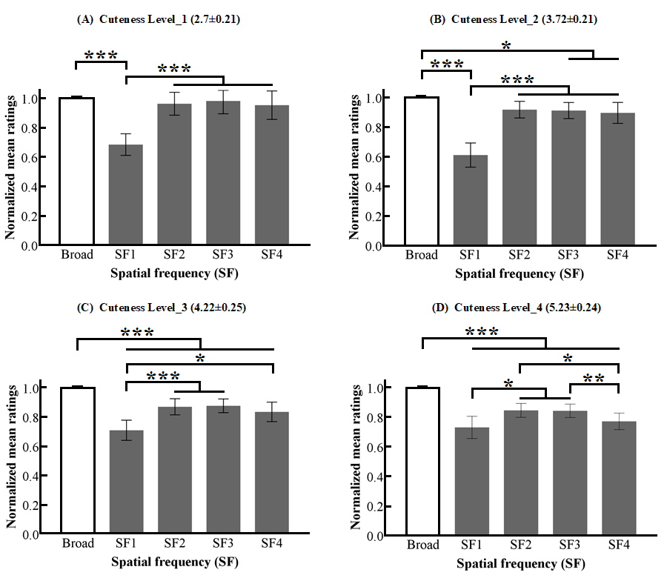

Fig. S1. Normalized mean ratings of perceived cuteness for each SF in images with the same cuteness level. Error bars represent 95% CI. Statistical significance is indicated by asterisks (***p < .001, **p < .01, *p < .05). The results of four cuteness levels are shown in image (A), image (B), image (C) and image (D).