**Distribution of probe responses by participant across the day (9am to 9pm)**

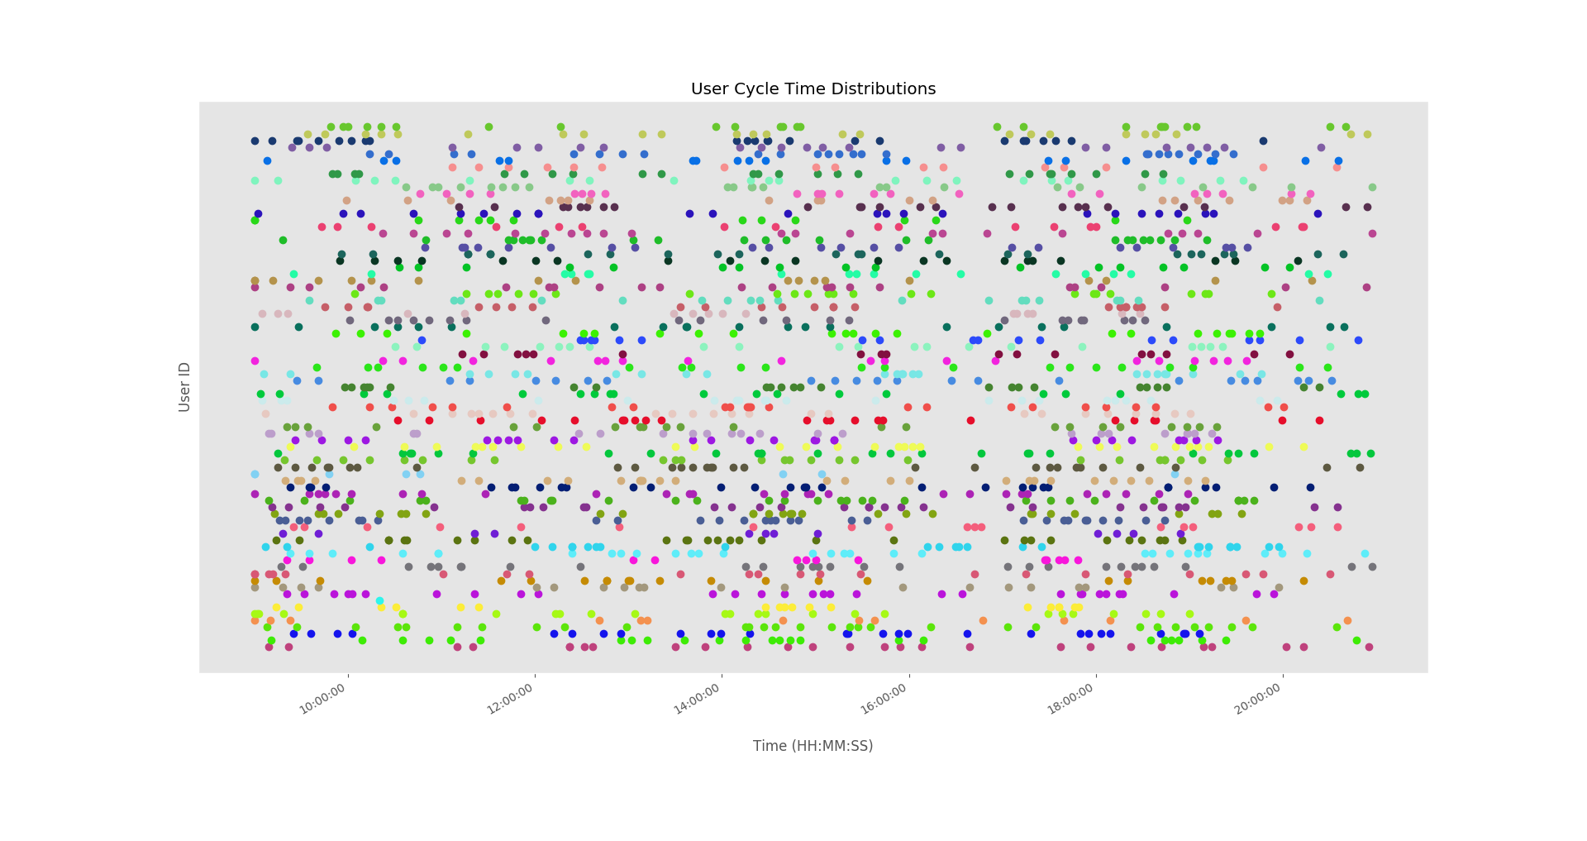

**Figure.** Probe timing distribution

Table S1. Model details when interaction term (task-unrelated thought × freely-moving thought) included.

|  |  |  |  |  |  |  |  |  |
| --- | --- | --- | --- | --- | --- | --- | --- | --- |
|  | **Concurrent Affect** | | | | **Subsequent Affect** | | | |
|  | **Valence** |  | **Arousal** |  | **Valence** |  | **Arousal** |  |
|  | **ß (95% CI)** | **p-value** | **ß (95% CI)** | **p-value** | **ß (95% CI)** | **p-value** | **ß (95% CI)** | **p-value** |
| **Study 1** | | | | | | | | |
| TUT | -.08 [-.13, -.03] | .003 | -.05 [-.10, .00] | .161 | -.01 [-.08, .05] | .631 | .01 [-.05, .07] | .931 |
| FMT | .12 [.07, .18] | <.001 | .09 [.04, .15] | .004 | .11 [.04, .18] | .001 | .01 [-.05, .07] | .668 |
| Interaction | -.01 [-.07, .04] | .583 | -.07 [-.12, -.02] | .007 | .03 [-.04, .09] | .450 | .04 [-.02, .10] | .208 |
|  |  |  |  |  |  |  |  |  |
| Valence t0 |  |  |  |  | .47 [.41, .53] | <.001 |  |  |
| Arousal t0 |  |  |  |  |  |  | .57 [.51, .63] | <.001 |
|  |  |  |  |  |  |  |  |  |
|  |  |  |  |  |  |  |  |  |
| Study 2 | | | | | | | | |
| TUT | -.13 [-.18, -.07] | <.001 | .06 [.01, .11] | .040 | .01 [-.06, .07] | .783 | .02 [-.04, .09] | .471 |
| FMT | .06 [.01, .12] | .016 | -.01 [-.06, .05] | .856 | -.03 [-.10, .03] | .301 | .02 [-.04, .09] | .560 |
| Interaction | -.01 [-.05, .04] | .790 | .05 [.00, .09] | .043 | -.03 [-.08, .03] | .369 | -.03 [-.08, .03] | .362 |
|  |  |  |  |  |  |  |  |  |
| Valence t0 |  |  |  |  | .53 [.47, .59] | <.001 |  |  |
| Arousal t0 |  |  |  |  |  |  | .53 [.47, .59] | <.001 |