**Supplementary Materials**

**Does facial action modulate neural responses of emotion?**

**An examination with the late positive potential (LPP)**

**A. Trial Level Correlation Between LPP Amplitude and Subjective Rating of Pictures**

We tested whether the subjective rating of the pictures and the LPP amplitude were correlated. We used a linear mixed model implemented in the lme4 package in *R* (Bates, Mächler, Bolker, & Walker, 2015), to model the correlation at the trial level (Bakdash & Marusich, 2017). Both rating of pictures and LPP amplitude were extracted from each valid trial for each participant. Because LPP amplitude is greater in response to more arousing stimuli (i.e., positive and negative pictures vs. neutral pictures), we included a quadratic term of the rating of pictures to test for the curvilinear relationship. In this model, the rating of pictures and the squared value of it were modelled as fixed factors, and participants and pictures were modelled as random factors, with LPP amplitude being the dependent variable. The rating of pictures was first mean-centered within each participant before squaring it to avoid multicollinearity. The model and the model output are included below.

my.model.cor <- lmer(LPP ~ Rating.c + Rating.c.s + (Rating.c|subject) + (Rating.c|stimuli), data = my.data, control = lmerControl(optCtrl = list(maxfun = 100000)))

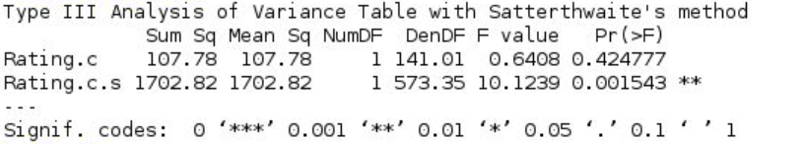

**B. Full 3 x 3 Repeated Measure ANOVA on LPP Amplitude and Subjective Rating of Pictures**

**LPP**

There was a significant main effect of the valence of pictures on LPP amplitude (*F*(2, 82) = 18.758, *p* < .001, ηp2 = .314). The LPP amplitude was greater in response to positive or negative pictures than to neutral pictures (*t*(41) = 4.601, *p* < .001, 95% CI [1.046, 2.682]; *t*(41) = 5.350, *p* < .001, 95% CI [1.391, 3.079], respectively), suggesting that participants were more aroused when viewing positive or negative pictures, compared to when viewing neutral pictures. The LPP amplitude was not different between positive and negative pictures (*t*(41) = -1.071, *p* = .290, 95% CI [-1.072, .329]). There was neither a significant main effect of the type of facial actions on LPP amplitude (*F*(2, 82) = .207, *p* = .813, ηp2 = .005), nor a significant two-way interaction between the type of facial actions and the valence of pictures (*F*(4, 164) = 1.642, *p* = .166, ηp2 = .039). See Fig. S1-A for the mean of LPP amplitude in each of the 9 conditions. See Fig. S1-B for scalp maps illustrating the location and time course of the LPP in response to positive, neutral and negative pictures.

**Subjective Rating of Pictures**

There was a significant main effect of the valence of pictures on participant’s rating of the pictures (*F*(2, 82) = 555.559, *p* < .001, ηp2 = .931), which was expected given how we selected our stimuli. Participants found positive pictures to be the most pleasant (*M* = 7.12), negative pictures to be the most unpleasant (*M* = 2.45), and neutral pictures to be in the middle range (*M* = 5.10). More importantly, we found a significant main effect of the type of facial actions on participants’ rating of the pictures (*F*(2, 82) = 3.389, *p* = .039, ηp2 = .076) (see Fig. S2). In particular, participants found the pictures to be less pleasant when frowning compared to when smiling (*t*(41) = -2.450, *p* = .019, 95% CI [-.126, -.012]) or when holding a blank expression (*t*(41) = -2.494, *p* = .017, 95% CI [-.147, -.015]). Their rating of the pictures did not differ when smiling compared to when holding a blank expression (*t*(41) = -.304, *p* = .763, 95% CI [-.091, .067]). There was no significant interaction between the valence of pictures and the type of facial actions on participants’ rating of the pictures (*F*(4, 164) = 2.098, *p* = .082, ηp2 = .049).

References

Bakdash, J. Z., & Marusich, L. R. (2017). Repeated Measures Correlation. *Frontiers in Psychology*, *8*, 456. https://doi.org/10.3389/fpsyg.2017.00456

Bates, D., Mächler, M., Bolker, B., & Walker, S. (2015). Fitting Linear Mixed-Effects Models Using lme4. *Journal of Statistical Software*, *67*(1), 1–48. https://doi.org/10.18637/jss.v067.i01

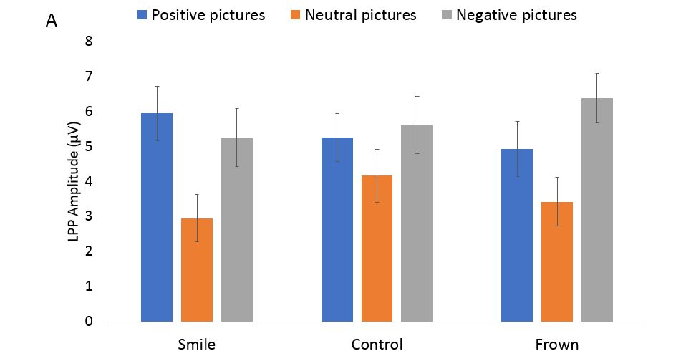

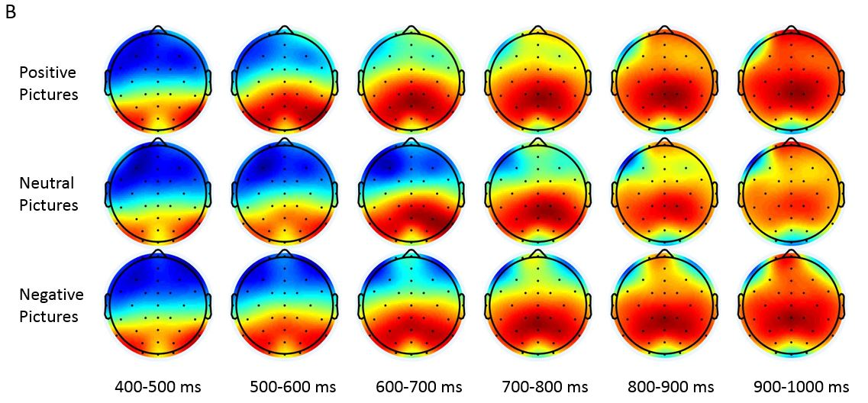

Fig. S1. The effect of the facial action manipulation on the magnitude of early late positive potential (LPP). A. The LPP amplitude (600-1000ms) as a function of the facial actions (“smile”, “control”, and “frown”) and the valence of the pictures shown (positive, neutral, and negative). B. Topographical distribution of the early LPP in response to positive, neutral, and negative pictures within the six time windows from 400 to 1000ms.

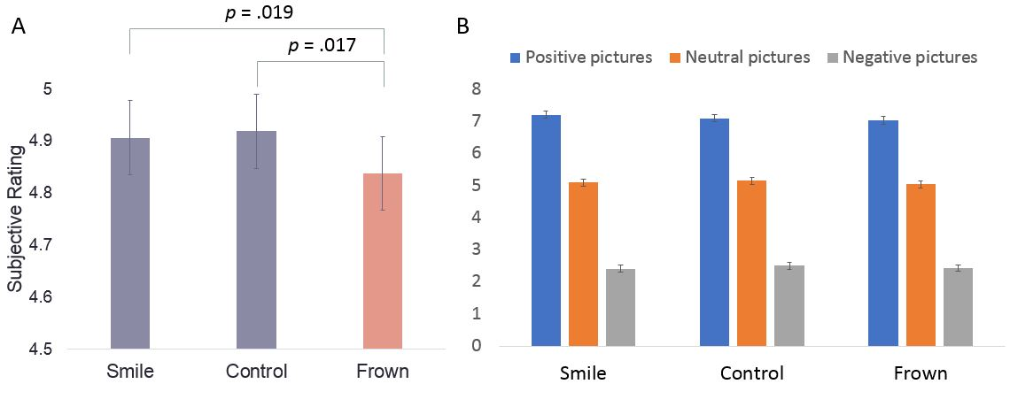

Fig. S2. Subjective rating of the pictures as a function of facial action manipulation. A. Mean of the subjective rating in each of the facial action conditions (valence collapsed). B. Mean of the subjective rating in each of the 9 conditions defined by facial action and valence of pictures.