Supplemental Materials for

Morality is relative: Anger, disgust and aggression as contingent responses to sibling versus acquaintance harm

Lukas D. Lopez,* Karie Moorman,* Sara Schneider, Melissa N. Baker, & Colin Holbrook
University of California, Merced

* Authors contributed equally to this manuscript

All datasets and analysis syntax for these studies have been archived and may be accessed at: https://osf.io/8fz6r/
Table of Contents

1. List of Tables and Figures.…………….………………………………………………….……3
2. Description of Measures....…………….………………………………………………….……5
3. Descriptive Statistics and Bivariate Correlations………………………………………………6
4. Equations for Multivariate Mediation Modeling……………………………………………...20
5. Analyses Controlling for Gender, Trait Aggression, and Trait Disgust..……………………..23
6. Potential Interactions Between Sibling Closeness and Condition………………....…….........41
7. Potential Interactions Between Friend Closeness and Condition………………....……..........47
8. Analyses Including Only Participants with an Adult Sibling…………………………………51
9. Political Affiliation Criterion Study.……………………………………...……….….……….53
10. References………………………………………………….………………………………...56
11. Study Materials……..……………..…………………………….………………………..….57

1. List of Tables and Figures

Tables
Table S1. Means, Standard Deviations and Zero-order Correlations among the Emotions Reported, Study 1.
Table S2. Means, Standard Deviations and Zero-order Correlations among State Anger, State Disgust, and Individual Difference Variables, Study 1.
Table S3. Means and Standard Deviations among the Emotions Reported by condition, Study 1.
Table S4. Scale reliabilities for Trait Emotion and Sibling Closeness Measures Used, Study 1.
Table S5. Means, Standard Deviations, and Zero-order Correlations among the Emotions Reported, Study 2.
Table S6. Means, Standard Deviations and Zero-order Correlations among State Anger, State Disgust, State Aggression, and Individual Difference Variables, Study 2.
Table S7. Means and Standard Deviations among the Emotions Reported by condition, Study 2.
Table S8. Scale reliabilities for Trait Emotion and Sibling Closeness Measures Used, Study 2.
Table S9. Means, Standard Deviations, and Zero-order Correlations among the Emotions Reported, Study 3.
Table S10. Means, Standard Deviations and Zero-order Correlations among State Anger, State Disgust, State Aggression, and Individual Difference Variables, Study 3.
Table S11. Means and Standard Deviations among the Emotion Facial Arrays Reported by condition, Study 3.
Table S12. Means and Standard Deviations among the Emotion Lexical Items Reported by condition, Study 3.
Table S13. Scale reliabilities for Trait Emotion and Closeness Measures Used, Study 3.
Table S14. Effects of Scenario Target on State Emotion, Controlling for Gender, Study 1.
Table S15. Effects of Scenario Target on State Emotion, Controlling for Gender, Trait Aggression, and Trait Disgust, Study 1.
Table S16. Effects of Scenario Target on State Emotion, Controlling for Gender, Study 2.
Table S17. Effects of Scenario Target on State Aggression, Controlling for Gender, Trait Aggression, and Trait Disgust, Study 2.
Table S18. Effects of Scenario Target on State Aggression, Controlling for Gender, Study 2.
Table S19. Effects of Scenario Target on State Aggression, Controlling for Gender, Trait Aggression, and Trait Disgust, Study 2.
Table S20. Unstandardized Regression Coefficients and 95% CIs for the Effects of Anger and Disgust on Direct Aggression, Controlling for Participant Sex, Indirect Aggression, Trait Aggression and Trait Disgust, Study 2.
Table S21. Unstandardized Regression Coefficients and 95% CIs for the Effects of Anger and Disgust on Indirect Aggression, Controlling for Participant Sex, Direct Aggression, Trait Aggression and Trait Disgust, Study 2.
Table S22. Effects of Scenario Target on State Emotion Facial Arrays, Controlling for Gender, Study 3.
Table S23. Effects of Scenario Target on State Emotion Lexical Items, Controlling for Gender, Study 3.
Table S24. Effects of Scenario Target on State Aggression by Facial Arrays, Controlling for Gender, Trait Aggression, and Trait Disgust, Study 3.
Table S25. Effects of Scenario Target on State Aggression by Lexical Items, Controlling for Gender, Trait Aggression, and Trait Disgust, Study 3.
Table S26. Effects of Scenario Target on State Aggression, Controlling for Gender, Study 3.
Table S27. Effects of Scenario Target on State Aggression, Controlling for Gender, Trait Aggression, and Trait Disgust, Study 3.
Table S28. Unstandardized Regression Coefficients and 95% CIs for the Effects of Anger and Disgust Facial Arrays on Direct Aggression, Controlling for Participant Sex, Indirect Aggression, Trait Aggression and Trait Disgust, Study 3.
Table S29. Unstandardized Regression Coefficients and 95% CIs for the Effects of Anger and Disgust Lexical Items on Direct Aggression, Controlling for Participant Sex, Indirect Aggression, Trait Aggression and Trait Disgust, Study 3.
Table S30. Unstandardized Regression Coefficients and 95% CIs for the Effects of Anger and Disgust Facial Arrays on Indirect Aggression, Controlling for Participant Sex, Direct Aggression, Trait Aggression and Trait Disgust, Study 3.
Table S31. Unstandardized Regression Coefficients and 95% CIs for the Effects of Anger and Disgust Lexical Items on Indirect Aggression, Controlling for Participant Sex, Direct Aggression, Trait Aggression and Trait Disgust, Study 3.

Figures
Figure S1. Multiple Mediation Model in Path Diagram Form Using a Multicategorical Independent Variable with 3 Categories: Acquaintance (reference), Sibling, and Self.
Figure S2. Interaction between Sibling Objective Closeness, Target Condition, and Disgust, Study 1.
Figure S3. Interaction between Friend Subjective Closeness (Long), Target Condition, and Anger (facial arrays), Study 3.
Figure S4. Mean Ratings of State Anger and State Disgust by Target Condition, Political Affiliation Criterion Study.

2. Description of Measures
Following Molho et al (2017), we administered the Brief Aggression Questionnaire (BAQ; Webster et al., 2014; α = .81) and the Three-Domain Disgust Scale (TDDS; Tybur et al., 2009; pathogen disgust: α = .82; sexual disgust: α = .87; moral disgust: α = .94). Additionally, participants who had reported having a sibling (or all participants answered in regard to a friend in Study 3) were assigned the Adult Sibling Relationship Questionnaire (Lanthier & Stacker, 1992). The overall closeness measure was comprised of two 4-item subscales: subjective closeness (e.g., “How often do you talk to your [sibling/friend] about things that are important to you?”; sibling closeness α = .92, friend closeness α = .94) and objective closeness (e.g., “How often do you and your [sibling/friend] see each other?”; sibling α = .96, friend α = .85). The two subscales utilized distinct rating scales (objective closeness: 1 = At least once a week, 2 = At least once a month, 3 = At least once in 6 months, 4 = At least once a year, 5 = Less than once a year; subjective closeness: 1 = Never; 2 = Rarely; 3 = Occasionally; 4 = Regularly). In addition, in Study 3 we administered versions of the Relationship Closeness Scale (Dibble, Levine & Park, 2012), which also measures feelings of affiliation, customized to apply to a friend or to a sibling. The scale consisted of ten items (e.g., “When we are apart, I miss my [sibling/friend] a great deal,” “My relationship with my [sibling/friend] is close,” sibling α = .97, friend α = .95) rated according to a 7-point Likert scale (1 = Strongly disagree; 7 = Strongly agree) and is here on out referred to as “Sibling/Friend subjective long”.
3. Descriptive Statistics and Bivariate Correlations
Study 1
Table S1
Means, Standard Deviations, and Zero-order Correlations among the Emotions Reported, Study 1.
 |  | M | SD | 1 | 2 | 3 | 4 | 5
1 | Fear | 3.31 | 1.75 | -
2 | Sadness | 4.22 | 1.79 | .40** | -
3 | Happiness | 1.42 | 1.02 | .02 | -.05 | -
4 | Anger | 5.70 | 1.42 | -.01 | .08 | -.45** | -
5 | Surprise | 3.40 | 1.74 | .57** | .34** | -.01 | .02 | -
6 | Disgust | 4.46 | 1.80 | .35** | .18** | -.11* | .16** | .30**
Note. N = 465. *p > .05, **p > .001.

Table S2
Means, Standard Deviations and Zero-order Correlations among State Anger, State Disgust, and Individual Difference Variables, Study 1.
 |  | M | SD | 1 | 2 | 3 | 4 | 5 | 6 | 7
1 | Anger | 5.70 | 1.42 | -
2 | Disgust | 4.46 | 1.80 | .16** | -
3 | Trait aggression | 2.50 | .66 | -.10* | .09* | -
4 | Pathogen disgust | 5.26 | .95 | .12* | .11* | .13** | -
5 | Sexual disgust | 3.71 | 1.45 | .04 | .08 | .02 | .40** | -
6 | Moral disgust | 4.80 | 1.49 | .08 | .20** | .02 | .29** | .28** | -
7 | Sibling objective closeness | 3.34 | 1.24 | .09 | -.02 | .04 | .05 | .01 | .05 | -
8 | Sibling subjective closeness | 2.66 | .93 | .13** | -.01 | -.04 | .17** | .08 | .17** | .63**
Note. N = 465. *p < .05, **p < .001.

Table S3
Means and Standard Deviations among the Emotions Reported by condition, Study 1.
 | Anger | Disgust | Fear | Sadness | Surprise | Happy
Self  (N = 154) | 5.84 (1.38) | 4.31 (1.85) | 3.14 (1.73) | 4.31 (1.85) | 3.41 (1.72) | 1.23 (0.63)
Sibling  (N = 145) | 5.85 (1.17) | 4.24 (1.76) | 3.19 (1.67) | 4.37 (1.65) | 3.31 (1.70) | 1.52 (1.13)
Acquaintance  (N = 166) | 5.43 (1.60) | 4.80 (1.63) | 3.59 (1.79) | 4.02 (1.83) | 3.46 (1.74) | 1.50 (1.18)
Note. N = 465. Standard deviations in parenthesis.

Table S4
Scale reliabilities for Trait Emotion and Sibling Closeness Measures Used, Study 1.
Scale | α
Trait aggression | .81
Pathogen disgust | .82
Sexual disgust | .87
Moral disgust | .94
Sibling objective closeness | .92
Sibling subjective closeness | .95
Note. N = 465.

Study 2

Table S5
Means, Standard Deviations, and Zero-order Correlations among the Emotions Reported, Study 2.
 |  | M | SD | 1 | 2 | 3 | 4 | 5
1 | Fear | 3.89 | 1.87 | -
2 | Sadness | 3.37 | 1.80 | .45** | -
3 | Happiness | 1.69 | 1.50 | .02 | .14** | -
4 | Anger | 5.72 | 1.42 | -.01 | .10* | -.35** | -
5 | Surprise | 4.40 | 1.78 | .53** | .29** | .02 | -.07 | -
6 | Disgust | 4.93 | 1.78 | .29** | .21** | -.17* | .13** | .28**
Note. N = 568. *p > .05, **p > .001.

Table S6
Means, Standard Deviations and Zero-order Correlations among State Anger, State Disgust, State Aggression, and Individual Difference Variables, Study 2.
 |  | M | SD | 1 | 2 | 3 | 4 | 5 | 6 | 7 | 8 | 9
1 | Anger | 5.72 | 1.42 | -
2 | Disgust | 4.93 | 1.78 | .13** | -
3 | Direct aggression | 3.67 | 1.48 | .11** | .03 | -
4 | Indirect aggression | 3.69 | 1.60 | .00 | .09* | .47** | -
5 | Trait aggression | 2.58 | .72 | -.04 | .01 | .52** | .38* | -
6 | Pathogen disgust | 5.22 | .98 | .09* | .12** | .03 | .09* | -.01 | -
7 | Sexual disgust | 3.82 | 1.39 | -.08 | -.002 | -.11* | .10* | -.04 | .32** | -
8 | Moral disgust | 4.86 | 1.39 | .07 | .05 | -.05 | -.01 | -.11** | .28** | .27** | -
9 | Sibling objective | 3.27 | 1.20 | .04 | .07 | -.01 | -.05 | -.11* | .06 | -.05 | .02 | -
10 | Sibling subjective | 2.70 | .90 | .04 | .03 | .04 | -.07 | -.09 | .09* | .10* | .18** | .57**
Note. N = 568. *p < .05, **p < .001.

Table S7

Means and Standard Deviations among the Emotions Reported by condition, Study 2.

 | Anger | Disgust | Fear | Sadness | Surprise | Happy | Direct Aggress | Indirect Aggress
Self  (N = 188) | 5.91 (1.24) | 4.79 (1.87) | 3.75 (1.91) | 3.55 (1.85) | 4.24 (1.84) | 1.59  (1.47) | 3.96 (1.52) | 3.67 (1.62)
Sibling  (N = 202) | 5.81 (1.44) | 4.88 (1.84) | 3.77 (1.84) | 3.17 (1.71) | 4.41 (1.76) | 1.65  (1.21) | 3.80 (1.44) | 3.84 (1.59)
Acquaintance  (N = 178) | 5.42 (1.51) | 5.13 (1.59) | 4.19 (1.83) | 3.40 (1.83) | 4.56 (1.74) | 1.83  (1.61) | 3.23 (1.38) | 3.55 (1.58)
Note. N = 568. Standard deviations in parenthesis.

Table S8
Scale reliabilities for Aggression, Trait Emotion, and Sibling Closeness Measures Used, Study 2.
Scale | α
Direct aggression | .84
Indirect aggression | .88
Trait aggression | .84
Pathogen disgust | .83
Sexual disgust | .85
Moral disgust | .93
Sibling objective closeness | .91
Sibling subjective closeness | .94
Note. N = 568.

Study 3

Table S9
Means, Standard Deviations, and Zero-order Correlations among the Emotions Reported, Study 3.
 |  | M | SD | 1 | 2 | 3 | 4 | 5 | 6 | 7 | 8 | 9 | 10 | 11
1 | Fear (facial) | 3.33 | 1.76 | -
2 | Fear (lexical) | 2.86 | 1.74 | .34** | -
3 | Sadness (facial) | 4.32 | 1.77 | .38** | .21** | -
4 | Sadness (lexical) | 5.01 | 1.57 | .24** | .26** | .52** | -
5 | Happiness (facial) | 1.16 | .49 | .05 | .03 | .03 | -.05 | -
6 | Happiness (lexical) | 1.21 | .66 | .07 | .08 | .01 | -.01 | .52** | -
7 | Anger (facial) | 6.16 | 1.06 | .06 | .08* | .02 | .07 | -.27** | -.24** | -
8 | Anger (lexical) | 6.46 | .96 | -.03 | .06 | -.08 | .08 | -.31 | .40** | .50** | -
9 | Surprise (facial) | 3.66 | 1.76 | .53** | .22** | .28** | .14** | .05 | .10* | .04 | .00 | -
10 | Surprise (lexical) | 4.40 | 1.71 | .25** | .19** | .10* | .16** | -.10* | -.05 | .18** | .22** | .51** | -
11 | Disgust (facial) | 4.30 | 1.87 | .27** | .14** | .13** | .06 | .00 | .02 | .04 | .04 | .20** | .05 | -
12 | Disgust (lexical) | 3.90 | 1.90 | .25** | .22** | .12** | .20** | -.05 | -.04 | -.10* | .14** | .14** | .11** | .38**
Note. N = 575. *p > .05, **p > .001.

Table S10
Means, Standard Deviations and Zero-order Correlations among State Anger, State Disgust, State Aggression, and Individual Difference Variables, Study 3.
 |  | M | SD | 1 | 2 | 3 | 4 | 5 | 6 | 7
1 | Anger (facial) | 6.16 | 1.06 | -
2 | Anger (lexical) | 6.46 | .96 | .51** | -
3 | Disgust (facial) | 4.30 | 1.87 | .04 | .04 | -
4 | Disgust (lexical) | 3.90 | 1.90 | .10* | .14** | .38** | -
5 | Direct aggression | 3.90 | 1.73 | .21** | .30** | .07 | .06 | -
6 | Indirect aggression | 4.50 | 1.58 | .16** | .20** | .12** | .09* | .51** | -
7 | Trait aggression | 2.50 | .67 | .04 | .07 | .12** | .10* | .45** | .28** | -
8 | Pathogen disgust | 5.25 | .98 | .18** | .19** | .05 | .11* | .09* | .21** | .15**
9 | Sexual disgust | 3.58 | 1.43 | .03 | .00 | -.07 | .12** | -.10* | -.02 | .06
10 | Moral disgust | 4.52 | 1.53 | .11** | .09* | .22** | .36** | .00 | .04 | .01
11 | Sibling objective | 3.19 | .95 | -.05 | -.10* | -.07 | -.18** | -.01 | .03 | .07
12 | Sibling subjective | 2.59 | 1.19 | -.07 | -.10* | -.06 | -.14** | -.07 | -.03 | -.05
13 | Sibling subjective long | 4.20 | 1.74 | .09 | .15** | .08 | .21** | .04 | -.03 | -.08
14 | Friend objective | 3.98 | .93 | .08 | .10* | .06 | .04 | .04 | .06 | -.03
15 | Friend subjective | 3.26 | .74 | .11** | .12** | -.03 | .00 | -.01 | .03 | -.15**
16 | Friend subjective long | 4.99 | 1.32 | .08 | .11* | .08 | .06 | .02 | .03 | -.10*
Note. N = 575. *p < .05, **p < .001.

Table S10 (continued)
Means, Standard Deviations and Zero-order Correlations among State Anger, State Disgust, State Aggression, and Individual Difference Variables, Study 3.
 |  | 8 | 9 | 10 | 11 | 12 | 13 | 14 | 15
8 | Pathogen disgust | -
9 | Sexual disgust | .39** | -
10 | Moral disgust | .13** | .23** | -
11 | Sibling objective | -.10* | -.07 | -.09 | -
12 | Sibling subjective | -.12** | -.03 | .01 | .69** | -
13 | Sibling subjective long | .15** | .07 | .09* | -.85** | -.67** | -
14 | Friend objective | -.01 | -.11* | .07 | -.16** | -.19** | .11** | -
15 | Friend subjective | .11** | .04 | .13** | -.15** | -.04 | .09* | .46** | -
16 | Friend subjective long | .07 | -.02 | .11** | -.24** | -.19** | .28** | .50** | .68**
Note. N = 575. *p < .05, **p < .001.

Table S11

Means and Standard Deviations among the Emotion Facial Arrays Reported by condition, Study 3.

 | Anger | Disgust | Fear | Sadness | Surprise | Happy | Direct Aggress | Indirect Aggress
Self  (N = 150) | 6.27 (1.03) | 4.23 (1.89) | 3.43 (1.83) | 4.29 (1.81) | 3.70 (1.82) | 1.14 (.45) | 4.45 (1.71) | 4.75 (1.61)
Sibling  (N = 133) | 6.31 (.98) | 3.88 (1.87) | 3.17 (1.79) | 4.28 (1.77) | 3.62 (1.79) | 1.15 (.47) | 4.39 (1.73) | 4.50 (1.64)
Friend  (N = 152) | 6.10 (1.09) | 4.43 (1.89) | 3.39 (1.70) | 4.55 (1.68) | 3.67 (1.73) | 1.17 (.54) | 3.72 (1.64) | 4.54 (1.58)
Acquaintance  (N = 140) | 5.96 (1.12) | 4.64 (1.76) | 3.33 (1.72) | 4.32 (1.77) | 3.66 (1.76) | 1.16 (.49) | 3.90 (1.73) | 4.50 (1.58)
Note. N = 575. Standard deviations in parenthesis.

Table S12

Means and Standard Deviations among the Emotion Lexical Items Reported by condition, Study 3.

 | Anger | Disgust | Fear | Sadness | Surprise | Happy | Direct Aggress | Indirect Aggress
Self  (N = 150) | 6.67 (.73) | 3.71 (1.84) | 3.63 (1.91) | 5.09 (1.44) | 4.86 (1.53) | 1.21  (.68) | 4.45 (1.71) | 4.75 (1.61)
Sibling  (N = 133) | 6.53 (.94) | 3.56 (1.91) | 2.82 (1.78) | 5.05 (1.57) | 4.31 (1.72) | 1.25  (.87) | 4.39 (1.73) | 4.50 (1.64)
Friend  (N = 152) | 6.41 (1.03) | 3.93 (1.92) | 2.58 (1.53) | 5.06 (1.53) | 4.34 (1.67) | 1.18 (.55) | 3.72 (1.64) | 4.54 (1.58)
Acquaintance  (N = 140) | 6.22 (1.05) | 4.38 (1.85) | 2.40 (1.45) | 4.83 (1.75) | 4.07 (1.85) | 1.20  (.48) | 3.04 (1.45) | 4.19 (1.45)
Note. N = 575. Standard deviations in parenthesis.

Table S13

Scale reliabilities for Aggression, Trait Emotion, and Closeness Measures Used, Study 3.
Scale | α
Direct aggression | .90
Indirect aggression | .86
Trait aggression | .82
Pathogen disgust | .84
Sexual disgust | .86
Moral disgust | .94
Sibling objective closeness | .96
Sibling subjective closeness | .91
Sibling subjective closeness long | .97
Friend objective closeness | .84
Friend subjective closeness | .94
Friend subjective closeness long | .95
Note. N = 575.

4. Equations for Multivariate Mediation Modeling

Below, we report on the equations we used for the multivariate mediation model analyses in Study 2. Using PROCESS in SPSS (Hayes, 2013) we estimated mediation models using a multicategorical independent variable: scenario target. We examined the degree to which two variables, anger and disgust, mediated the relationship between the multicategorical variable, scenario target, and the outcome variable, direct aggression (see Figure S1 for representation of path diagram; also see Hayes & Preacher, 2014). We are contrasting the Self, Sibling, and Acquaintance groups using indicator or dummy coding, with the Acquaintance group functioning as the reference group. As the reference group, Acquaintance receives a coding of 0 on Sibling (D₁) and Self groups (D₂); as such, the Acquaintance group is not explicitly coded. The mediation model is parameterized with two general equations:

M_{anger} = i₁ + a₁D_{sibling} + a₂D_{self} + e_{M} , (1)
M_{disgust} = i₁ + a₁D_{sibling} + a₂D_{self} + e_{M},

Y_{DA} = i₂ + c’₁D_{sibling} + bM_{anger} + bM_{disgust} + e_{Y}, (2)
Y_{DA} = i₂ + c’₂D_{self} + bM_{anger} + bM_{disgust} + e_{Y}.

The a-coefficients in equation (1) and quantify differences between the scenario target groups on M_{anger} and M_{disgust}. The c’-coefficients in equation (2) quantify the differences between groups on Y, direct aggression (DA), while holding M constant, and a single b estimates the effect of M on Y while statistically equating the groups on average on the independent variable, X. The relative direct effect of X on Y is captured in the estimates of c’_{i} paths from equation (2). The relative indirect effect of X on Y through M is estimated by the products a_{i}b from equations (1) and (2). This is to say, a_{i}b is the indirect effect on Y via M of being in group i relative to the reference group, Acquaintance, and c’_{i} represents the direct effect of being in group i on Y relative to the Acquaintance reference group.
The relative total effect is quantified with a set of k – 1 parameter estimates resulting from the estimation of Y from the k – 1 dummy variables coding groups in a linear model:

Y_{DA} = i₃ + c₁D_{sibling} + e_{Y}, (3)
Y_{DA} = i₃ + c₂D_{self} + e_{Y}.

In equation (3) the k – 1 estimates of c_{i} quantify mean differences between the groups on Y. Because we are using indicator coding, c_{i} quantifies the mean difference in Y between the group coded with D_{i}, Self, and the reference group, Acquaintance. In general, the relative total effects are equal to the sum of the corresponding relative direct effects (c’_{i}) and indirect effects ( a_{i}b):

Sibling: c₁ = c’₁ + a₁b, (4)
Self: c₂ = c’₂ + a₂b.

Figure S1. Multiple mediation model in path diagram form using a multicategorical independent variable with 3 levels: Acquaintance (reference), Sibling, and Self.

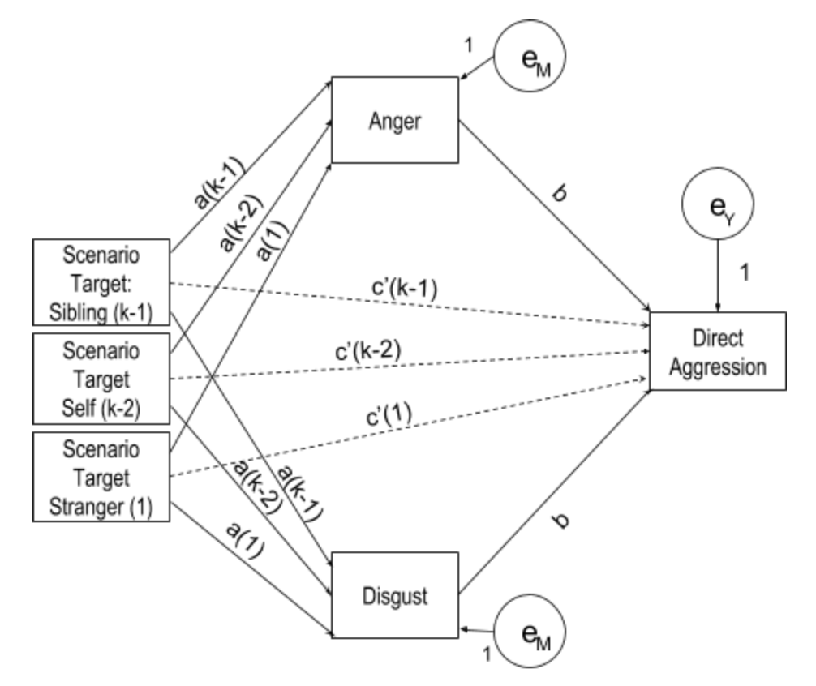

5. Analyses Controlling for Gender, Trait Aggression, and Trait Disgust

Study 1
Table S14
Effects of Scenario Target on State Emotion, Controlling for Gender, Study 1.
 |  | β | t | p | 95% CI | η_{p}²
Anger
 | Self | .41 | 2.64 | .009 | .11, .72 | .015
 | Sibling | .41 | 2.59 | .010 | .10, .73 | .014
 | Gender | .17 | 1.27 | .204 | -.09, .42 | .003
Disgust
 | Self | -.49 | -2.44 | .015 | -.88, -.09 | .013
 | Sibling | -.55 | -2.73 | .007 | -.95, -.16 | .016
 | Gender | -.13 | -.76 | .449 | -.45, .20 | .001
Note. N = 465. 3 (scenario target; between-subjects) × 2 (emotion; within-subjects) analysis of variance (ANOVA), controlling for gender. Contrast conditions are relative to the Acquaintance condition. Gender: 0 = Male, 1 = Female.

Table S15
Effects of Scenario Target on State Emotion, Controlling for Gender, Trait Aggression and Trait Disgust, Study 1.
 |  | β | t | p | 95% CI | η_{p}²
Anger
 | Self | .39 | 2.54 | .011 | .09, .72 | .014
 | Sibling | .41 | 2.58 | .010 | .09, .72 | .014
 | Gender | .08 | 0.55 | .582 | -.20, .36 | .001
 | Trait Aggression | -.23 | -2.26 | .024 | -.43, -.03 | .011
 | Pathogen Disgust | .17 | 2.25 | .025 | .02, .32 | .011
 | Sexual Disgust | -.03 | 0.57 | .568 | -.14, .07 | .001
 | Moral Disgust | .05 | 0.24 | .242 | -.04, .15 | .003
Disgust
 | Self | -.48 | -2.44 | .015 | -.86, -.09 | .013
 | Sibling | -.49 | -2.48 | .013 | -.89, -.10 | .013
 | Gender | -.21 | -1.17 | .242 | -.57, .14 | .003
 | Trait Aggression | .18 | 1.44 | .151 | -.07, .43 | .005
 | Pathogen Disgust | .10 | 1.02 | .310 | -.09, .29 | .002
 | Sexual Disgust | .04 | 0.62 | .536 | -.09, .17 | .001
 | Moral Disgust | .21 | 3.64 | .000 | .10, .33 | .028
Note. N = 465. 3 (scenario target; between-subjects) × 2 (emotion; within-subjects) analysis of variance (ANOVA), controlling for gender, BAQ (Trait Aggression) and TDDS (Trait Disgust) measures. Contrast conditions are relative to the Acquaintance condition. Gender: 0 = Male, 1 = Female.

Study 2
Table S16
Effects of Scenario Target on State Emotion, Controlling for Gender, Study 2.
 |  | β |  | t |  | p |  | 95% CI |  | η_{p}²
Anger
 | Self | .484 | 3.302 |  | <.001 |  | .196, .773 |  | .019
 | Sibling | .383 | 2.657 |  | .008 |  | .100, .667 |  | .012
 | Gender | .134 | 1.141 |  | .254 |  | -.097, .366 |  | .002
Disgust
 | Self | -.354 | -1.915 |  | .056 |  | -.717, .009 |  | .006
 | Sibling | -.275 | -1.515 |  | .130 |  | -.632, .082 |  | .004
 | Gender | .425 | 2.866 |  | .004 |  | .134, .717 |  | .014
Note. N = 568. 3 (scenario target; between-subjects) × 2 (emotion; within-subjects) analysis of variance (ANOVA), controlling for gender. Contrast conditions are relative to the Acquaintance condition. Gender: 0 = Male, 1 = Female.

Table S17
Effects of Scenario Target on State Aggression, Controlling for Gender, Trait Aggression, and Trait Disgust, Study 2.
 |  | β | t | p | 95% CI | η_{p}²
Anger
 | Self | .438 | 2.989 | .003 | .150, .725 | .016
 | Sibling | .374 | 2.613 | .009 | .093, .655 | .012
 | Gender | .195 | 1.495 | .136 | -.061, .452 | .004
 | Trait Aggression | -.054 | -.643 | .520 | -.219, .111 | .001
 | Pathogen Disgust | .133 | 2.041 | .042 | .005, .261 | .007
 | Sexual Disgust | -.150 | -3.131 | .002 | -.245, -.056 | .017
 | Moral Disgust | .071 | 1.586 | .113 | -.017, .160 | .004
Disgust
 | Self | -.423 | -2.287 | .023 | -.786, -.060 | .009
 | Sibling | -.301 | -1.666 | .096 | -.656, .054 | .005
 | Gender | .501 | 3.036 | .003 | .177, .825 | .016
 | Trait Aggression | .114 | 1.007 | .282 | -.094, .322 | .002
 | Pathogen Disgust | .209 | 2.534 | .012 | -.047, .370 | .011
 | Sexual Disgust | -.133 | -2.185 | .029 | -.252, -.013 | .008
 | Moral Disgust | .052 | .905 | .366 | -.060, .163 | .001
Note. N = 568. 3 (scenario target; between-subjects) × 2 (emotion; within-subjects) analysis of variance (ANOVA), controlling for gender, Trait Aggression (BAQ) and Trait Disgust (TDDS) measures. Contrast conditions are relative to the Acquaintance condition. Scenario Target: 0 = Acquaintance, 1 = Self, 2 = Sibling. Gender: 0 = Male, 1 = Female.

Table S18

Effects of Scenario Target on Aggression, Controlling for Gender, Study 2.
 |  | β | t | p | 95% CI | η_{p}²
Direct Aggression
 | Self | .758 | 5.323 | <.001 | .478, 1.037 | .048
 | Sibling | .629 | 4.494 | <.001 | .354, .904 | .035
 | Gender | -1.010 | -8.838 | <.001 | -1.235, -7.86 | .122
Indirect Aggression
 | Self | .133 | .808 | .420 | -.191, .458 | .001
 | Sibling | .311 | 1.914 | .056 | -.008, .630 | .006
 | Gender | -.492 | -.3710 | <.001 | -.752, -231 | .024
Note. N = 568. 3 (scenario target; between-subjects) × 2 (aggression; within-subjects) analysis of variance (ANOVA), controlling for gender. Contrast conditions are relative to the Acquaintance condition. Gender: 0 = Male, 1 = Female.

Table S19
 |  | β | t | p | 95% CI | η_{p}²
Direct Aggression
 | Self | .634 | 5.032 | <.001 | .387, .882 | .043
 | Sibling | .557 | 4.524 | <.001 | .315, .799 | .035
 | Gender | -.728 | -6.478 | <.001 | -.949, -.507 | .070
 | Trait Aggression | .917 | 12.709 | <.001 | .775, 1.059 | .224
 | Pathogen Disgust | .119 | 2.115 | .035 | .008, .229 | .008
 | Sexual Disgust | -.020 | -4.81 | .631 | -.101, .061 | .000
 | Moral Disgust | .010 | .268 | .789 | -.066, .087 | .000
Indirect
Aggression
 | Self | .057 | .372 | .710 | -.244, .358 | .000
 | Sibling | .253 | 1.690 | .092 | -.041, .548 | .005
 | Gender | -.438 | -3.203 | .001 | -.706, -.169 | .018
 | Trait Aggression | .784 | 8.928 | <.001 | .611, .956 | .125
 | Pathogen Disgust | .129 | 1.896 | .059 | -.005, .263 | .006
 | Sexual Disgust | .157 | 3.119 | .002 | .058, .256 | .017
 | Moral Disgust | -.012 | -.262 | .794 | -.105, .080 | .000
Effects of Scenario Target on State Aggression, Controlling for Gender, Trait Aggression, and Trait Disgust, Study 2.

Note. N = 568. 3 (scenario target; between-subjects) × 2 (aggression; within-subjects) analysis of variance (ANOVA), controlling for gender, Trait Aggression (BAQ) and Trait Disgust (TDDS) measures. Contrast conditions are relative to the Acquaintance condition. Gender: 0 = Male, 1 = Female.

Table S20
Unstandardized Regression Coefficients and 95% CIs for the Effects of Anger and Disgust on Direct Aggression, Controlling for Participant Sex, Indirect Aggression, Trait Aggression and Trait Disgust, Study 2.
 | t | b (SE) | p | 95% CI
Constant  (Acquaintance) | 1.36 | .54 (.40) | .18 | -.24, 1.32
Sibling | 3.87 | .45 (.12) | < .001 | .22, .68
Self | 4.83 | .58 (.12) | < .001 | .34, . 81
M₁: Anger | 3.21 | .11 (.03) | < .001 | .04, .18
M₂: Disgust | .55 | .02 (.03) | .58 | -.04, .07
Gender | -5.94 | -.64 (.11) | < .001 | -.84, -.43
IA | 8.47 | .28 (.03) | < .001 | .21, .34
BAQ | 9.79 | .71 (.07) | < .001 | .56, .85
moral | .14 | .01 (.04) | .89 | -.07, .08
sexual | -1.14 | -.04 (.04) | .26 | -.12, . 03
pathogen | 1.23 | .07 (.05) | .22 | -.04, .17
Note. N = 568. Contrast conditions are relative to the Acquaintance condition. Gender: 0 = Male, 1 = Female. Trait Aggression was measured via the BAQ scale and Trait Disgust was measured by the TDDS scale.

Table S21
Unstandardized Regression Coefficients and 95% CIs for the Effects of Anger and Disgust on Indirect Aggression, Controlling for Participant Sex, Direct Aggression, Trait Aggression and Trait Disgust, Study 2.
 | t | b (SE) | p | 95% CI
Constant (Acquaintance) | .71 | .35 (.49) | .48 | -.61, 1.30
Sibling | .42 | .06 (.14) | .68 | -.22, .34
Self | -1.05 | -.16 (.15) | .29 | -.45, .14
M₁: Anger | -.86 | -.04 (.04) | .39 | -.12, .05
M₂: Disgust | 2.35 | .08 (.03) | .02 | .01, .14
Gender | -1.26 | -.17 (.13) | .21 | -.43, .10
DA | 8.47 | .41 (.05) | <.001 | .32, .51
BAQ | 4.20 | .39 (.09) | <.001 | .21, .58
moral | -.41 | -.02 (.04) | .68 | -.11, .07
sexual | 3.56 | .17 (.05) | <.001 | .08, .26
pathogen | 1.07 | .07 (.06) | .29 | -.06, .20
Note. N = 568. Contrast conditions are relative to the Acquaintance condition. Gender: 0 = Male, 1 = Female. Trait Aggression was measured using the BAQ scale and Trait Disgust was measured using the TDDS scale.

Study 3
Table S22
Effects of Scenario Target on State Emotion Facial Arrays, Controlling for Gender, Study 3.
 |  | β |  | t |  | p |  | 95% CI |  | η_{p}²
Anger
 | Self | .311 | 2.505 |  | .013 |  | .067, .556 |  | .011
 | Sibling | .356 | 2.777 |  | .006 |  | .104, .608 |  | .013
 | Friend | .145 | 1.172 |  | .242 |  | -.098, .389 |  | .002
 | Gender | .087 | . 990 |  | .322 |  | -.086, .261 |  | .002
Disgust
 | Self | -.424 | -1.951 |  | .052 |  | -.851, .003 |  | .007
 | Sibling | -.783 | -3.491 |  | .001 |  | -1.223, -.342 |  | .021
 | Friend | -.224 | -1.032 |  | .302 |  | -.650, .202 |  | .002
 | Gender | -.359 | -2.325 |  | .020 |  | -.663, -.056 |  | .009
Note. N = 575. 4 (scenario target; between-subjects) × 2 (emotion; within-subjects) analysis of variance (ANOVA), controlling for gender. Contrast conditions are relative to the Acquaintance condition. Gender: 0 = Male, 1 = Female.

Table S23
Effects of Scenario Target on State Emotion Lexical Items, Controlling for Gender, Study 3.
 |  | β |  | t |  | p |  | 95% CI |  | η_{p}²
Anger
 | Self | .452 | 4.070 |  | < .001 |  | .234, .670 |  | .028
 | Sibling | .313 | 2.731 |  | .007 |  | .088, .538 |  | .013
 | Friend | .187 | 1.686 |  | .092 |  | -.031, .404 |  | .005
 | Gender | .005 | . 070 |  | .944 |  | -.149, .160 |  | .000
Disgust
 | Self | -.664 | -3.000 |  | .003 |  | -1.098, -.229 |  | .016
 | Sibling | -.811 | -3.555 |  | < .001 |  | -1.259, -.363 |  | .022
 | Friend | -.448 | -2.031 |  | .043 |  | -.881, -.015 |  | .007
 | Gender | .070 | .444 |  | .657 |  | -.239, .378 |  | .000
Note. N = 575. 4 (scenario target; between-subjects) × 2 (emotion; within-subjects) analysis of variance (ANOVA), controlling for gender. Contrast conditions are relative to the Acquaintance condition. Gender: 0 = Male, 1 = Female.

Table S24
Effects of Scenario Target on State Aggression by Facial Arrays, Controlling for Gender, Trait Aggression, and Trait Disgust, Study 3.
 |  | β | t | p | 95% CI | η_{p}²
Anger
 | Self | .310 | 2.538 | .011 | .070, .551 | .011
 | Sibling | .331 | 2.618 | .009 | .083, .579 | .012
 | Friend | .154 | 1.262 | .207 | -.086, .393 | .003
 | Gender | .098 | .991 | .322 | -.096, .292 | .002
 | Trait Aggression | .028 | .423 | .673 | -.104, .161 | .000
 | Pathogen Disgust | .202 | 4.126 | < .001 | .106, .297 | .029
 | Sexual Disgust | -.061 | -1.642 | .101 | -.133, .012 | .005
 | Moral Disgust | .074 | 2.514 | .012 | .016, .132 | .011
Disgust
 | Self | -.478 | -2.275 | .023 | -.891, -.065 | .009
 | Sibling | -.802 | -3.697 | < .001 | -1.228, -.376 | .024
 | Friend | -.197 | -.943 | .346 | -.609, .214 | .002
 | Gender | -.100 | -.591 | .555 | -.433, .233 | .001
 | Trait Aggression | .338 | 2.926 | .004 | .111, .565 | .015
 | Pathogen Disgust | .134 | 1.599 | .110 | -.031, .299 | .004
 | Sexual Disgust | -.203 | -3.204 | .001 | -.328, -.079 | .018
 | Moral Disgust | .292 | 5.791 | < .001 | .193, .391 | .056
Note. N = 575. 4 (scenario target; between-subjects) × 2 (emotion; within-subjects) analysis of variance (ANOVA), controlling for gender, Trait Aggression (BAQ) and Trait Disgust (TDDS) measures. Contrast conditions are relative to the Acquaintance condition. Scenario Target: 0 = Acquaintance, 1 = Self, 2 = Sibling, 3 = Friend. Gender: 0 = Male, 1 = Female.

Table S25
Effects of Scenario Target on State Aggression by Lexical Items, Controlling for Gender, Trait Aggression, and Trait Disgust, Study 3.
 |  | β | t | p | 95% CI | η_{p}²
Anger
 | Self | .449 | 4.122 | < .001 | .235, .663 | .029
 | Sibling | .282 | 2.507 | .012 | .061, .503 | .011
 | Friend | .192 | 1.766 | .078 | -.021, .405 | .005
 | Gender | .027 | .302 | .763 | -.146, .199 | .000
 | Trait Aggression | .047 | .785 | .433 | -.071, .165 | .001
 | Pathogen Disgust | .207 | 4.769 | < .001 | .122, .293 | .039
 | Sexual Disgust | -.066 | -1.995 | .047 | -.130, -.001 | .007
 | Moral Disgust | .052 | 2.004 | .046 | .001, .104 | .007
Disgust
 | Self | -.683 | -3.313 | .001 | -1.087, -.278 | .019
 | Sibling | -.764 | -3.593 | < .001 | -1.182, -.346 | .022
 | Friend | -.365 | -1.780 | .076 | -.768, .038 | .006
 | Gender | .062 | .372 | .710 | -.265, .388 | .000
 | Trait Aggression | .272 | 2.404 | .017 | .050, .495 | .010
 | Pathogen Disgust | .086 | 1.045 | .297 | -.076, .247 | .002
 | Sexual Disgust | .005 | .079 | .937 | -.117, .127 | .000
 | Moral Disgust | .435 | 8.801 | < .001 | .338, .532 | .120
Note. N = 575. 4 (scenario target; between-subjects) × 2 (emotion; within-subjects) analysis of variance (ANOVA), controlling for gender, Trait Aggression (BAQ) and Trait Disgust (TDDS) measures. Contrast conditions are relative to the Acquaintance condition. Scenario Target: 0 = Acquaintance, 1 = Self, 2 = Sibling, 3 = Friend. Gender: 0 = Male, 1 = Female.

Table S26

Effects of Scenario Target on Aggression, Controlling for Gender, Study 3.
 |  | β | t | p | 95% CI | η_{p}²
Direct Aggression
 | Self | 1.398 | 7.497 | <.001 | 1.032, 1.765 | .090
 | Sibling | 1.313 | 6.827 | <.001 | .935, 1.690 | .076
 | Friend | .646 | 3.473 | .001 | .281, 1.011 | .021
 | Gender | -.808 | -6.096 | <.001 | -1.068, -.547 | .061
Indirect Aggression
 | Self | .561 | 3.048 | .002 | .200, .923 | .016
 | Sibling | .298 | 1.572 | .117 | -.074, .671 | .004
 | Friend | .340 | 1.854 | .064 | -.020, .701 | .006
 | Gender | -.221 | -1.692 | .091 | -.478, .036 | .005
Note. N = 575. 4 (scenario target; between-subjects) × 2 (aggression; within-subjects) analysis of variance (ANOVA), controlling for gender. Contrast conditions are relative to the Acquaintance condition. Gender: 0 = Male, 1 = Female.

Table S27
 |  | β | t | p | 95% CI | η_{p}²
Direct Aggression
 | Self | 1.296 | 7.707 | <.001 | .966, 1.627 | .095
 | Sibling | 1.244 | 7.165 | <.001 | .903, 1.585 | .083
 | Friend | .666 | 3.976 | <.001 | .337, .995 | .027
 | Gender | -.493 | -3.632 | <.001 | -.760, -.226 | .023
 | Trait Aggression | 1.035 | 11.190 | <.001 | .854, 1.217 | .181
 | Pathogen Disgust | .130 | 1.942 | .053 | -.001, .262 | .007
 | Sexual Disgust | -.089 | -1.757 | .079 | -.189, .011 | .005
 | Moral Disgust | .016 | .399 | .690 | -.063, .095 | .000
Indirect
Aggression
 | Self | .509 | 2.919 | .004 | .167, .852 | .015
 | Sibling | .218 | 1.209 | .227 | -.136, .571 | .003
 | Friend | .353 | 2.030 | .043 | .011, .694 | .007
 | Gender | -.052 | -.373 | .710 | -.329, .224 | .000
 | Trait Aggression | .573 | 5.970 | <.001 | .384, .761 | .059
 | Pathogen Disgust | .352 | 5.061 | <.001 | .216, .489 | .043
 | Sexual Disgust | -.120 | -2.271 | .024 | -.223, -.016 | .009
 | Moral Disgust | .037 | .881 | .379 | -.045, .119 | .001
Effects of Scenario Target on State Aggression, Controlling for Gender, Trait Aggression, and Trait Disgust, Study 3.

Note. N = 575. 4 (scenario target; between-subjects) × 2 (aggression; within-subjects) analysis of variance (ANOVA), controlling for gender, Trait Aggression (BAQ) and Trait Disgust (TDDS) measures. Contrast conditions are relative to the Acquaintance condition. Gender: 0 = Male, 1 = Female.
Table S28
Unstandardized Regression Coefficients and 95% CIs for the Effects of Anger and Disgust Facial Arrays on Direct Aggression, Controlling for Participant Sex, Indirect Aggression, Trait Aggression and Trait Disgust, Study 3.
 | t | b (SE) | p | 95% CI
Constant (Acquaintance) | -1.287 | -.607 (.4713) | .199 | -1.533, .319
Friend | 3.287 | .494 (.1502) | < .001 | .199, .789
Sibling | 6.921 | 1.092 (.1578) | < .001 | .782, 1.402
Self | 6.757 | 1.030 (.1526) | < .001 | .731, 1.330
M₁: Anger | 3.807 | .197 (.0518) | < .001 | .096, .299
M₂: Disgust | .053 | .002 (.0301) | .958 | -.058, .061
Gender | -4.052 | -.491 (.1212) | < .001 | -.729, -.253
IA | 11.063 | .404 (.0365) | < .001 | .332, .475
BAQ | 9.336 | .798 (.0855) | < .001 | .630, .966
moral | -.371 | -.014 (.0372) | .711 | -.087, .059
sexual | -.624 | -.029 (.0459) | .533 | -.119, .062
pathogen | -.836 | -.052 (.0619) | .403 | -.174, .070
Note. N = 575. Contrast conditions are relative to the Acquaintance condition. Gender: 0 = Male, 1 = Female. Trait Aggression was measured via the BAQ scale and Trait Disgust was measured by the TDDS scale.

Table S29
Unstandardized Regression Coefficients and 95% CIs for the Effects of Anger and Disgust Lexical Items on Direct Aggression, Controlling for Participant Sex, Indirect Aggression, Trait Aggression and Trait Disgust, Study 3.
 | t | b (SE) | p | 95% CI
Constant (Acquaintance) | -2.605 | -1.269 (.487) | .009 | -2.225, -.312
Friend | 3.218 | .478 (.149) | .001 | .186, .770
Sibling | 7.014 | 1.092 (.156) | < .001 | .786, 1.398
Self | 6.385 | .976 (.153) | < .001 | .676, 1.276
M₁: Anger | 5.365 | .312 (.058) | < .001 | .198, .426
M₂: Disgust | .895 | .027 (.031) | . 371 | -.033, .087
Gender | -4.043 | -.482 (.119) | < .001 | -.717, -.248
IA | 10.891 | .392 (.036) | < .001 | .321, .462
BAQ | 9.378 | .789 (.084) | < .001 | .624, .954
moral | -.700 | -.027 (.038) | .484 | -.101, .048
sexual | -.491 | -.022 (.045) | .624 | -.110, .066
pathogen | -1.218 | -.075 (.061) | .224 | -.195, .046
Note. N = 575. Contrast conditions are relative to the Acquaintance condition. Gender: 0 = Male, 1 = Female. Trait Aggression was measured via the BAQ scale and Trait Disgust was measured by the TDDS scale.

Table S30
Unstandardized Regression Coefficients and 95% CIs for the Effects of Anger and Disgust Facial Arrays on Indirect Aggression, Controlling for Participant Sex, Direct Aggression, Trait Aggression and Trait Disgust, Study 3.
 | t | b (SE) | p | 95% CI
Constant (Acquaintance) | 1.189 | .587 (.494) | .235 | -.383, 1.557
Friend | .393 | .062 (.159) | .695 | -.250, .374
Sibling | -1.764 | -.303 (.172) | .078 | -.640, .034
Self | -.308 | -.051 (.166) | .758 | -.378, .275
M₁: Anger | .752 | .041 (.055) | .453 | -.067, .149
M₂: Disgust | 1.731 | .054 (.031) | .084 | -.007, .116
Gender | 1.300 | .167 (.129) | .194 | -.085, .420
DA | 11.063 | .443 (.040) | < .001 | .364, .521
BAQ | .991 | .095 (.096) | .322 | -.094, .284
moral | .277 | .011 (.039) | .782 | -.066, .087
sexual | -1.387 | -.067 (.048) | .166 | -.161, .028
pathogen | 4.374 | .279 (.064) | < .001 | .154, .405
Note. N = 575. Contrast conditions are relative to the Acquaintance condition. Gender: 0 = Male, 1 = Female. Trait Aggression was measured using the BAQ scale and Trait Disgust was measured using the TDDS scale.

Table S31
Unstandardized Regression Coefficients and 95% CIs for the Effects of Anger and Disgust Lexical Items on Indirect Aggression, Controlling for Participant Sex, Direct Aggression, Trait Aggression and Trait Disgust, Study 3.
 | t | b (SE) | p | 95% CI
Constant (Acquaintance) | 1.466 | .763 (.521) | .143 | -.260, 1.786
Friend | .366 | .058 (.160) | .715 | -.255, .372
Sibling | -1.905 | -.328 (.172) | .057 | -.667, .010
Self | -.392 | -.066 (.169) | .696 | -.397, .265
M₁: Anger | .427 | .027 (.063) | .670 | -.097, .152
M₂: Disgust | .583 | .019 (.033) | .560 | -.045, .083
Gender | 1.279 | .165 (.129) | .201 | -.088, .418
DA | 10.891 | .444 (.041) | < .001 | .364, .524
BAQ | 1.106 | .107 (.096) | .269 | -.083, .296
moral | .498 | .020 (.040) | .619 | -.059, .099
sexual | -1.639 | -.078 (.048) | .102 | -.172, .016
pathogen | 4.479 | .287 (.064) | < .001 | .161, .413
Note. N = 575. Contrast conditions are relative to the Acquaintance condition. Gender: 0 = Male, 1 = Female. Trait Aggression was measured using the BAQ scale and Trait Disgust was measured using the TDDS scale.

6. Potential Interactions Between Sibling Closeness and Condition
The sociofunctional account of moral emotions predicts that anger and related tendencies to directly aggress should be elicited to a greater extent when the inherent costs of aggression are offset by the benefits of confronting transgressors. To the extent that feelings of subjective closeness with another person index investment in a mutually beneficial relationship, anger and aggression are incentivized. In the present studies, the other person in question was an adult sibling. We therefore sought to test whether feelings of subjective closeness with one’s sibling moderated emotional reactions to transgressions against that sibling. However, prior work indicates that individuals provide altruistic helping behaviors towards kin even when controlling for relative emotional closeness, in a pattern hypothesized to reflect a “kinship premium”, wherein genetic fitness incentives propel helping above and beyond emotional closeness (Curry, Roberts, & Dunbar, 2013). Thus, the kinship premium hypothesis suggests, inasmuch as anger and aggression on siblings’ behalf constitute helping, that feelings of subjective closeness may not moderate responses to transgressions against siblings.
We also tested whether objective frequency of interaction with a sibling, distinct from subjective feelings of closeness, might modulate emotional reactions, as individuals who are in frequent and direct contact with their siblings may be better positioned to intervene on their behalf (e.g., due to being embedded in overlapping social networks or geographically proximal to the transgressor).
To explore these possibilities, we collected additional measures of both subjective and objective closeness using measures modified from Lanthier, Stocker, and Furman (1992). The overall sibling closeness measure was comprised of two 4-item subscales: subjective closeness (e.g., “How often do you talk to this sibling about things that are important to you?”; α = .92) and objective closeness (e.g., “How often do you and your sibling see each other?”; α = .95). The two subscales utilized distinct rating scales (objective closeness: 1 = At least once a week, 2 = At least once a month, 3 = At least once in 6 months, 4 = At least once a year, 5 = Less than once a year; subjective closeness: 1 = Never; 2 = Rarely; 3 = Occasionally; 4 = Regularly). Lastly, in Study 3 we administered versions of the Relationship Closeness Scale (Dibble, Levine & Park, 2012), which also measures feelings of affiliation, customized to apply to a friend or to a sibling. The scale consisted of ten items (e.g., “When we are apart, I miss my sibling a great deal,” “My relationship with my sibling is close,” sibling α = .97) rated according to a 7-point Likert scale (1 = Strongly disagree; 7 = Strongly agree) and measured subjective closeness, referred to here as “Sibling subjective long”.

Study 1
Analyses of potential effects of sibling closeness apply to the subsample of participants who reported having an adult sibling and completed the closeness measure (N = 399). The objective closeness subscale was reverse-coded, then both subscales were z-scored and averaged to create a measure of overall sibling closeness, r(398) = .63, p < .001.
We first assessed potential interactions between target condition and sibling closeness (i.e., self versus sibling, relative to the Acquaintance condition). We observed no interactions between overall sibling closeness or either the subjective or objective closeness subscales on ratings of state anger, ps .15-.84, or state disgust, ps .26-62.
We next assessed whether sibling closeness correlated with state anger or disgust outcomes, pooling all three target conditions. Overall sibling closeness was mildly positively associated with reported feelings of state anger, r = .12, p = .014, in an effect driven by the subjective closeness subscale, r = .13, p = .007, with no significant correlation observed with the objective closeness subscale, r = .09, p = .08. This finding may suggest that the capacity for warmth with a sibling predicts tendencies to feel moral outrage whether the target of harm is a sibling or not. For state disgust outcomes, after pooling conditions, there were no significant correlations between the overall sibling closeness measure or either subscale with reported feelings of disgust, rs -.02 - -.01, ps > .68.

Study 2

Once again, analyses of potential effects of sibling closeness apply to the subsample of participants who reported having an adult sibling and completed the closeness measure (N = 496; subjective closeness: α = .94; objective closeness: α = .91). The objective closeness subscale was again reverse-coded, then both subscales were z-scored and averaged to create the measure of overall sibling closeness, r(496) = .62, p < .001.
We first assessed potential interactions between target condition and sibling closeness. As in Study 1, we observed no interactions between overall sibling closeness and either the subjective or objective closeness subscales on state anger, ps = .27 - .76. We then pooled all three target conditions and found, departing from the results of Study 1, that neither overall sibling closeness nor either subscale significantly correlated with state anger, rs = .01 - .05, ps > .27. For state disgust outcomes, we observed an interaction between overall sibling closeness and the sibling condition on state disgust, F(2, 496) = 3.33, p = .037, η_{p}² = .02, an effect driven by sibling objective closeness, F(2, 496) = 4.78, p = .009, η_{p}² = .02, not sibling subjective closeness, p = .30. Sibling objective closeness showed a significant positive correlation with state disgust in the Sibling condition, r(202) = .61, p = .002, but not the Self condition, r(155) = .37, p = .076 (see Figure S2). As this interaction was not hypothesized, nor did it emerge in Study 1, we regard it as preliminary pending replication.
We observed no interactions between overall sibling closeness and either the subjective or objective closeness subscales on direct aggression, ps .26-.65, or indirect aggression, ps .44-.68.

Figure S2. Interaction between Sibling Objective Closeness, Target Condition, and Disgust, Study 2.

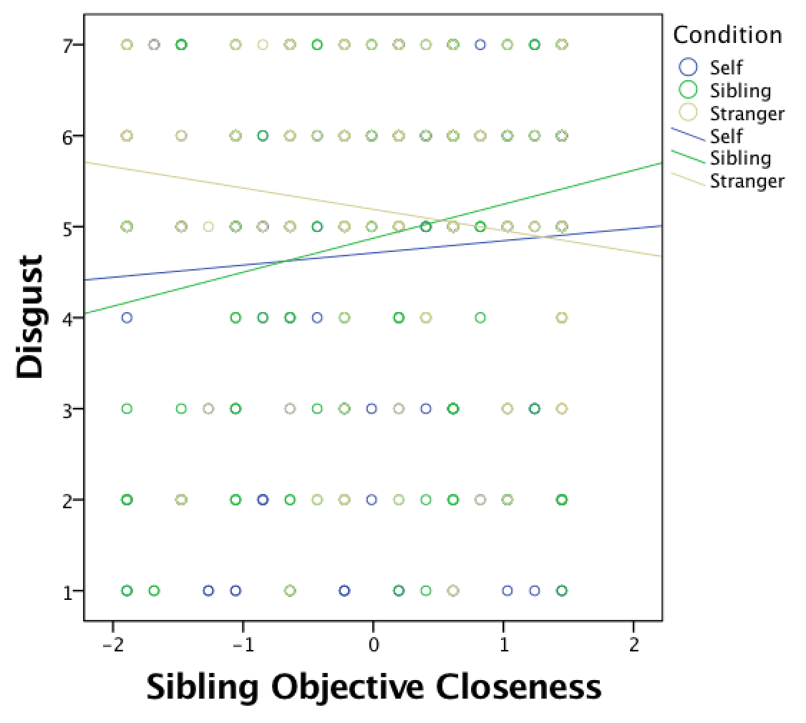

Study 3

Again, analyses of potential effects of sibling closeness apply to the subsample of participants who reported having an adult sibling and completed the closeness measure (subjective closeness: N = 498, α = .91; subjective closeness long: N = 490, α = .97; objective closeness: N = 497, α = .96). The objective closeness subscale was again reverse-coded, all subscales were z-scored, and objective closeness and sibling closeness z-scores were averaged to create two measures of overall sibling closeness (sibling closeness: r(496) = .67, p < .001; sibling closeness long: r(489) = .85, p < .001).
We first assessed potential interactions between target condition and sibling closeness. As in Studies 1 and 2, we observed no interactions between either overall sibling closeness measures and either the subjective or objective closeness subscales on state anger, ps .47 - .78. We then pooled all three target conditions and found that neither overall sibling closeness nor either subscale significantly correlated with state anger facial arrays, rs = -.07 - .09, ps > .06. However, overall sibling closeness demonstrated a moderate significant negative correlation with anger lexical items, r(496) = -.11, p = .013, which appeared to be driven both by sibling objective, r(497) = -.10, p = .022, and subjective closeness, r(496) = -.10, p = .020. In contrasts, there was a positive correlation between subjective closeness long and anger lexical items, r(489) = .15, p = .001. For disgust, we observed no interactions between overall sibling closeness measures and either the subjective or objective closeness subscales, ps .18 - .98.
Like in Study 2, we observed no interactions between overall sibling closeness and either the subjective or objective closeness subscales on direct aggression, ps .66 - .92, or indirect aggression, ps .12 - .83.

7. Potential Interactions Between Friend Closeness and Condition
As stated previously, a sociofunctional account of moral emotions incentivizes anger and directly aggressive tendencies when the costs of aggression are offset by the benefits of confronting transgressors. Since subjective closeness with another person demonstrates an investment in a mutually beneficial relationship, anger and aggression should be utilized to protect and fortify relational investments that could in turn lead to reciprocal self-beneficial actions from the other person in the future. Although relationship closeness did not provide many significant interactions previously when emotional reactions to harm to kin was assessed, this was expected due to the kinship premium account. In absence of such inherent incentives to fitness, relationship closeness should play a more important role. Thus, subjective and objective closeness to friends could influence the emotional reactions to transgressions against them.
Again, in Study 3 a modified scale from Lanthier, Stocker, and Furman (1992) measured two 4-item subscales: subjective closeness (e.g., “How often do you talk to this friend about things that are important to you?”; α = .92) and objective closeness (e.g., “How often do you and your friend see each other?”; α = .95) and a modified Relationship Closeness Scale (Dibble, Levine & Park, 2012), consisting of ten items (e.g., “When we are apart, I miss my friend a great deal,” “My relationship with my friend is close,” α = .95) measured friend subjective closeness long.
Analyses of potential effects of friend closeness apply to the subsample of participants who reported having an adult friend and completed the closeness measure (subjective closeness: N = 561, α = .94; subjective closeness long: N = 555, α = .95; objective closeness: N = 559, α = .84). The objective closeness subscale was reverse-coded, then both subscales were z-scored and averaged to create two measures of overall friend closeness (friend closeness: r(558) = .46, p < .001; friend closeness long: r(554) = .50, p < .001).
We first assessed potential interactions between target condition and friend closeness. We observed an interaction between overall friend closeness and condition on state anger (facial: F(3,548) = 4.98, p = .002, η_{p}² = .03; lexical: F(3,548) = 8.81, p < .001, η_{p}² = .05), specific to the Friend condition (facial: p = .025, 95% CI = [.05, .69]; lexical: p < .001, 95% CI = [.24, .80]) and Sibling condition, although only on lexical items (facial: p = .44; lexical: p = .026, 95% CI = [.03, .54]). Likewise, we observed a significant interaction between target condition and friend closeness long on state anger, (facial: F(3,548) = 4.98, p = .002, η_{p}² = .03; lexical: F(3,548) = 8.81, p < .001, η_{p}² = .05), specific to the Friend condition (facial: p = .025, 95% CI = [.05, .69]; lexical: p < .001, 95% CI = [.24, .80]) and Sibling condition, but again only on lexical items (facial: p = .44; lexical: p = .026, 95% CI = [.03, .54]). For the anger facial arrays, this interaction is driven by friend subjective closeness long, F(3,559) 4.20, p = .006, η_{p}² = .02, in the Friend condition (p = .043, 95% CI = [.01, .54]). For the anger lexical items, this interaction is driven by friend objective closeness, F(3,558) = 4.74, p = .003, η_{p}² = .03, in the Friend condition (p = .013, 95% CI = [.07, .54]), and friend subjective closeness long F(3,555) = 7.17, p < .001, η_{p}² = .04 (see Figure S3), in the Friend condition (p = .002, 95% CI = [.13, .59]). These findings support the notion that friend subjective and objective closeness may play a role in evoking anger responses to transgressions targeting friends.
We also observed an interaction between overall friend closeness and condition on state disgust facial arrays (facial: F(3,548) = 3.21, p = .023, η_{p}² = .02; lexical: p = .752), specific to the Self condition (facial: p = .037, 95% CI = -1..04, -.03]). This interaction is driven by friend subjective closeness long, F(3,555) = 2.32, p = .074, η_{p}² = .01, in the Self condition (p = .049, 95% CI = [-.85, .00]).
We also observed an interaction between overall friend closeness measures and condition on direct aggression, F(3,548) = 3.33, p = .019, η_{p}² = .02, specific to the Self condition (p = .018, 95% CI = [-.93, -.01]), an effect driven by friend objective closeness, F(3,559) = 2.65, p = .048, η_{p}² = .01, (Self condition: p = .017, 95% CI = [-.85, -.08]). Interactions between overall friend closeness measures and condition on indirect aggression were not significant, ps .12,

Figure S3. Interaction Between Friend Subjective Closeness (Long), Target Condition, and Anger (facial arrays), Study 3. 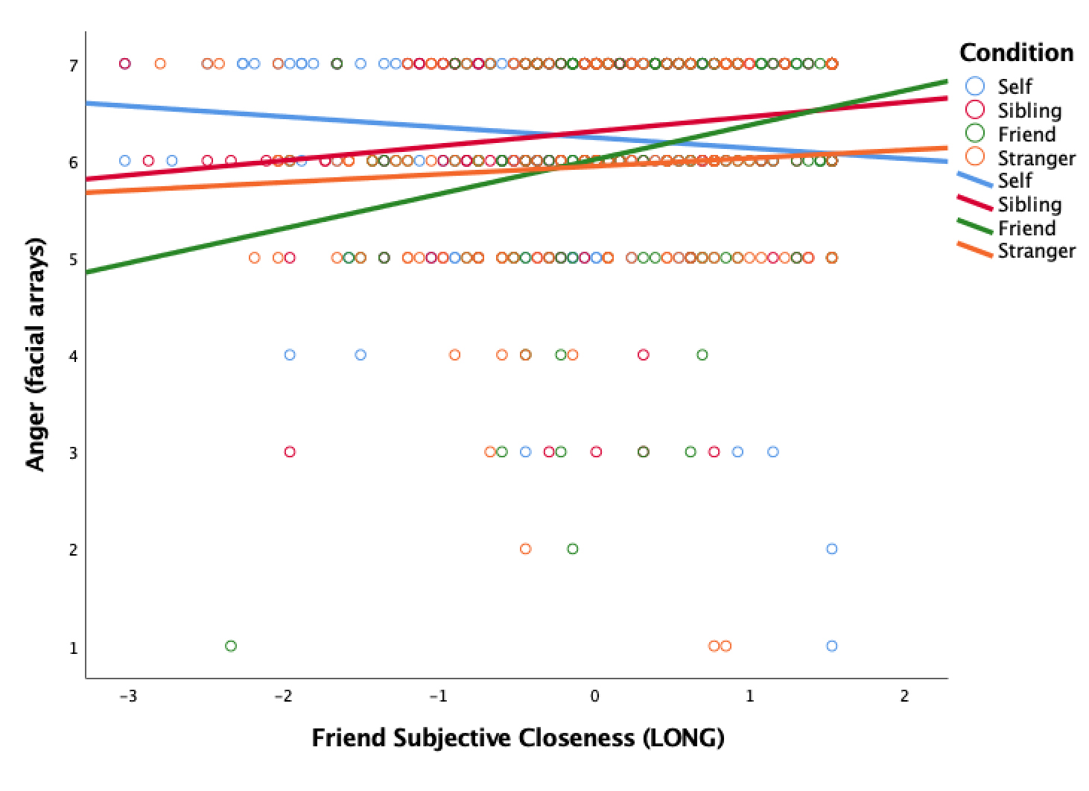
8. Analyses Including Only Participants with an Adult Sibling
Because we assigned participants to experimental conditions contingent on whether they had at least one adult sibling, with those lacking siblings assigned to either the Self or Acquaintance conditions, the possibility exists that a third variable related to this difference in family structure might have contributed to the observed effects of condition reported in the main text. We therefore conducted follow-up analyses including only those participants who reported possessing an adult sibling. We found the same overall pattern of effects as reported in the main text. The interactions between scenario target and emotion were statistically significant (Study 1: F[2, 401] = 10.77, p < .001, η_{p}² = .05; Study 2: F[2, 493] = 7.45, p < .001, η_{p}² = .03; Study 3; facial: F[3, 495] = 6.05, p < .001, η_{p}² = .04; lexical: F[3, 495] = 7.43, p < .001, η_{p}² = .04) and follow-up ANOVAs with planned contrasts revealed that, relative to the Acquaintance condition, anger was significantly higher in both the Self condition (Study 1: p = .034, 95% CI = [-.71 , -.03]; Study 2: p = .005, 95% CI = [-.77 , -.13]; Study 3 lexical: p = .004, 95% CI = [-.55 , .05]), and the Sibling condition (Study 1: p = .015, 95% CI = [-.74 , -.08]; Study 2: p = .039, 95% CI = [-.62 , -.02]; Study 3 facial: p = .040, 95% CI = [-.54 , -.01). Although planned contrasts in Study 3 did not reach significance in the Self condition facial arrays, p = .096, 95% CI = [-.50 , .04] and Sibling condition lexical items, p = .133, 95% CI = [-.39 , .03], there were still no differences between the Self and Sibling conditions in any of the three studies, ps > .15.
In Study 1 and Study 3 (lexical items), consistent with Prediction 2, relative to the Acquaintance condition, ratings of disgust were lower in both the Self condition (Study 1: p = .005, 95% CI = [.19, 1.06]; Study 3 lexical: p = .007, 95% CI = [.18, 1.11]), and the Sibling condition (Study 1: p = .004, 95% CI = [.20, 1.03]; Study 3 lexical: p < .001, 95% CI = [.38, 1.30]), with no significant difference between the Self and Sibling, ps > .40. However, when only including participants with siblings in Study 2, ratings of disgust were significantly lower in the Self condition, p = .019, 95% CI = [.08, .89] but not the Sibling condition, p = .096, 95% CI = [-.06, .71], with no significant difference between the Self and Sibling conditions, p = .62. Conversely, when only including participants with siblings in Study 3 facial arrays, ratings of disgust were significantly lower in the Sibling condition, p < .001, 95% CI = [.37, 1.30], but not the Self condition, p = .089, 95% CI = [-.06, .88], with no significant difference between the Self and Sibling conditions, p = .07.
The findings with respect to aggression were also consistent when only using participants with siblings in both Study 2 and Study 3. Specifically, the interaction between scenario target and aggression was significant (Study 2: F[2, 493] = 5.62, p = .004, η_{p}² = .02; Study 3: F[3, 495] = 12.92, p < .001, η_{p}² = .07). A follow-up ANOVA with planned contrasts showed that ratings of direct aggression were significantly lower in the Acquaintance condition relative to both the Self condition (Study 2: p < .001, 95% CI = [-1.03, -.36]; Study 3: p < .001, 95% CI = [-1.17, -.66]), Sibling condition (Study 2: p < .001, 95% CI = [-.86, -.23]; Study 3: p < .001, 95% CI = [-1.17, -.48]), and in regard to Study 3, Friend condition, p = .014, 95% CI = [-.79, -.09], with no significant difference between the Self and Sibling, ps > .28.

9. Political Affiliation Criterion Study
In the course of research on potential links between moral emotions, political orientation, and related individual differences, we conducted a similar experiment to Study 1, in which Amazon Mechanical Turk participants were recruited on the basis of a self-reported political party affiliation filtering criterion (i.e., Democrats versus Republicans). Importantly, the study we replicated and extended in our Study 1 that was originally conducted by Molho and colleagues (2017, Study 1) did not recruit in this manner, which necessarily excludes the large segment of participants who either do not follow politics, identify with other political parties, or identify as Independents. However, in the interests of transparency, we report those aspects of the study which duplicate the design of Study 1 here, while withholding aspects of the study involving hypotheses related to political psychology for separate publication elsewhere.
The raw sample size for this study was 554. Filtering for age and catch questions reduced the sample size to 524 (self = 174, sibling = 158, acquaintance = 192; 40.1% male; mean age = 41.55, SD = 13.09). Of the six emotion options, most participants endorsed the anger array (61%) or the disgust array (17%) as best reflecting their feelings. As in Studies 1, 2, and 3, with regard to participants’ mean ratings, anger (M = 5.85, SD = 1.20) and disgust (M = 4.45, SD = 1.73) were also most strongly endorsed, with lower ratings for sadness (M = 4.34, SD = 1.74), surprise (M = 3.39, SD = 1.77), fear (M = 3.18, SD = 1.72), or happiness (M = 1.26, SD = .73). When forced to choose between the anger or disgust arrays, the majority of participants selected anger (79.7%) over disgust (20.3%), in a slightly higher percentage favoring anger relative to Studies 1,2, and 3.
Effect of target identity on feelings of anger versus disgust. We next tested whether manipulating the target influenced ratings of anger versus disgust, using a 3 (scenario target; between-subjects) × 2 (emotion; within-subjects) analysis of variance (ANOVA). As found in Study 1, the interaction between target condition and state emotion was statistically significant, F(2, 521) = 3.80, p = .023, η_{p}² = .01. Relative to the Acquaintance condition, state anger was significantly higher in the Self condition, p = .039, but was insignificantly different in the Sibling condition, p = .890. Somewhat unlike Study 1, ratings of state disgust were significantly lower in the Sibling condition, p = .010, and not the Self condition, p = .474, relative to the Acquaintance condition (see Figure S3).
In sum, the political affiliation criterion affiliation study partially replicated the main findings of both Molho and colleagues’ first study (2017) and our own Study 1, in that state anger was significantly elevated in the Self relative to Acquaintance condition. However, state anger was not similarly greater in the Sibling condition, and state disgust was significantly higher in the Acquaintance condition relative to the Sibling, but not the Self. Future research should explore which covarying individual differences related to formally affiliating (or not affiliating) with political parties influence emotional responses.

Figure S4. Mean Ratings of State Anger and State Disgust by Target Condition in Political Criterion Study. Error bars indicate 95% confidence intervals, Political Criterion Study.
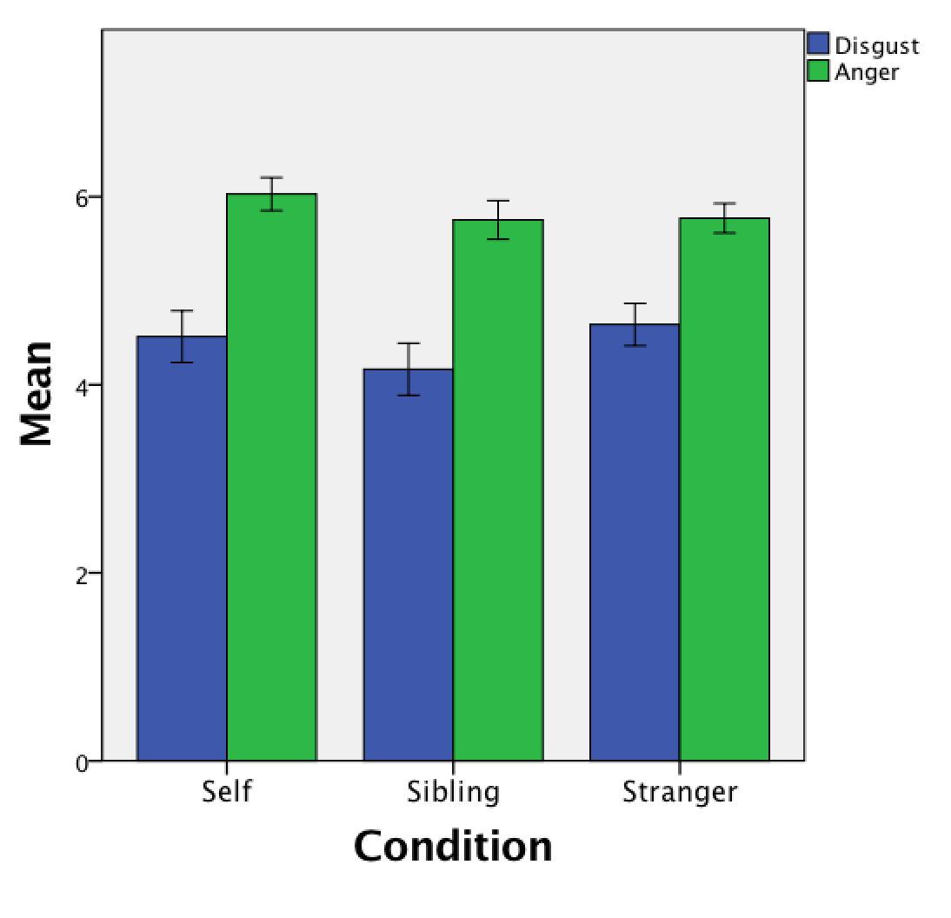

10. References
Curry, O., Roberts, S. G., & Dunbar, R. I. (2013). Altruism in social networks: Evidence for a
‘kinship premium’. British Journal of Psychology, 104(2), 283-295.

Dibble, J. L., Levine, T. R., & Park, H. (2012). The Unidimensional Relationship Closeness
Scale (URCS): Reliability and validity evidence for a new measure of relationship closeness. Psychological Assessment, 24, 565-572.

Hayes, A. F. (2013). PROCESS SPSS Macro [Computer software and manual]. Google Scholar.

Hayes, A. F., & Preacher, K. J. (2014). Statistical mediation analysis with a multicategorical
independent variable. British Journal of Mathematical and Statistical Psychology, 67(3), 451-470.

Lanthier, R. P., Stocker, C., & Furman, W. (1992). The adult sibling relationship
questionnaire. Handbook of Family Measurement Techniques, 2, 53-54.

Molho, C., Tybur, J. M., Güler, E., Balliet, D., & Hofmann, W. (2017). Disgust and anger relate
to different aggressive responses to moral violations. Psychological Science, 28(5), 609-619.

11. Study Materials

Study 1
Demographics Questions
- What is your age in years? (please use numbers, e.g., 20)
- With which gender do you most identify?
- Male
- Female
- Transgender/other
- Do you have an adult brother or sister?
- Brother
- Sister
- Both
- Neither

Moral Violation Scenarios

Instructions
In this task, we would like you to read some statements. When you read the statements, carefully focus on how you feel in response to the statements. There are five statements in total. Please read each one carefully, and try to experience what is described in the scenario as vividly as possible.
After you read the scenarios, we will ask you about how the scenarios made you feel.
Each scenario is only a few sentences long. Once you have read one scenario, simply click to the next screen to read the next scenario. Again, please read each one carefully and focus on how you feel when reading it.

Scenarios

Self condition:
1. Imagine you are a student. A guy cheats off of you every time he takes a test. At the end of the semester, he gets an A in the class, and he is proud of it.
2. Your best friend betrays you. They sleep with someone you were dating.
3. A girl was rude to you and didn’t care about anyone but themselves. She was mean and said little things all the time just to make you upset. She was just a bad person overall.
4. A person you knew stole your ATM card and spent all of your money.
5. You find out that the guy who sold you a used car lied about the car’s mileage and accident history.

Acquaintance condition:
1. Imagine you are a student. A guy cheats off of someone else in your class every time he takes a test. At the end of the semester, he gets an A in the class, and he is proud of it.
2. Someone you know betrays his best friend. He sleeps with someone his friend was dating.
3. A girl was mean to someone you know and she didn’t care about anyone but herself. She was mean and said little things all the time just to make your acquaintance upset. She was just a bad person overall.
4. A person you knew stole someone else’s ATM card and spent all of their money.
5. You find out that the guy who sold a used car to someone you know lied about the car’s mileage and accident history.

Brother condition:
- Imagine your brother is a student. A guy cheats off of your brother in your class every time he takes a test. At the end of the semester, he gets an A in the class, and he is proud of it.
- Your brother’s best friend betrays him. He sleeps with someone your brother was dating.
- A girl was mean to your brother and she didn’t care about anyone but herself. She was mean and said little things all the time just to make your brother upset. She was just a bad person overall.
- A person you knew stole your brother’s ATM card and spent all of his money.
- You find out that the guy who sold a used car to your brother lied about the car’s mileage and accident history.

Sister condition:
- Imagine your sister is a student. A guy cheats off of your sister in your class every time she takes a test. At the end of the semester, he gets an A in the class, and he is proud of it.
- Your sister’s best friend betrays her. She sleeps with someone your sister was dating.
- A girl was mean to your sister and she didn’t care about anyone but herself. She was mean and said little things all the time just to make your sister upset. She was just a bad person overall.
- A person you knew stole your sister’s ATM card and spent all of her money.
- You find out that the guy who sold a used car to your sister lied about the car’s mileage and accident history.

Emotional Endorsements

Instructions
Now we would like to know how you felt while reading the scenarios. We would like you to look at some pictures of faces and tell us which picture of faces best matches with how you felt. So, pick the picture of faces that most closely fits with how you felt while reading the scenarios.

Items
Please click the set of faces that best matches how you felt.
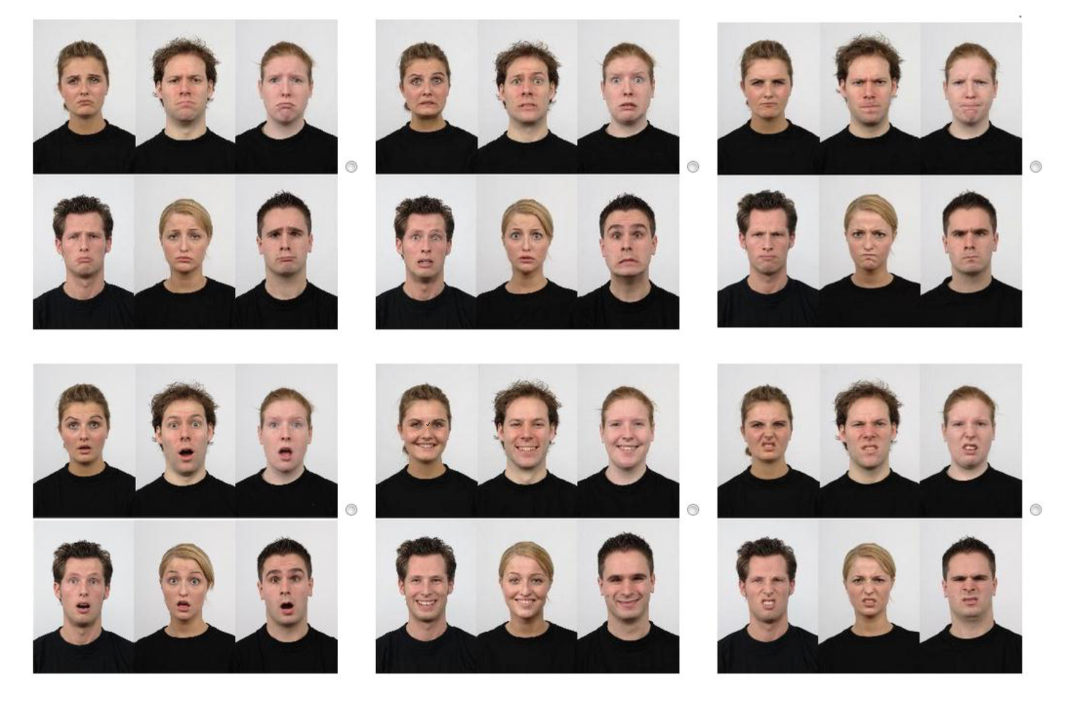

After this, you will see each set of faces separately, and you will rate how well each face set matches how you felt while reading the scenarios.

(Fear)
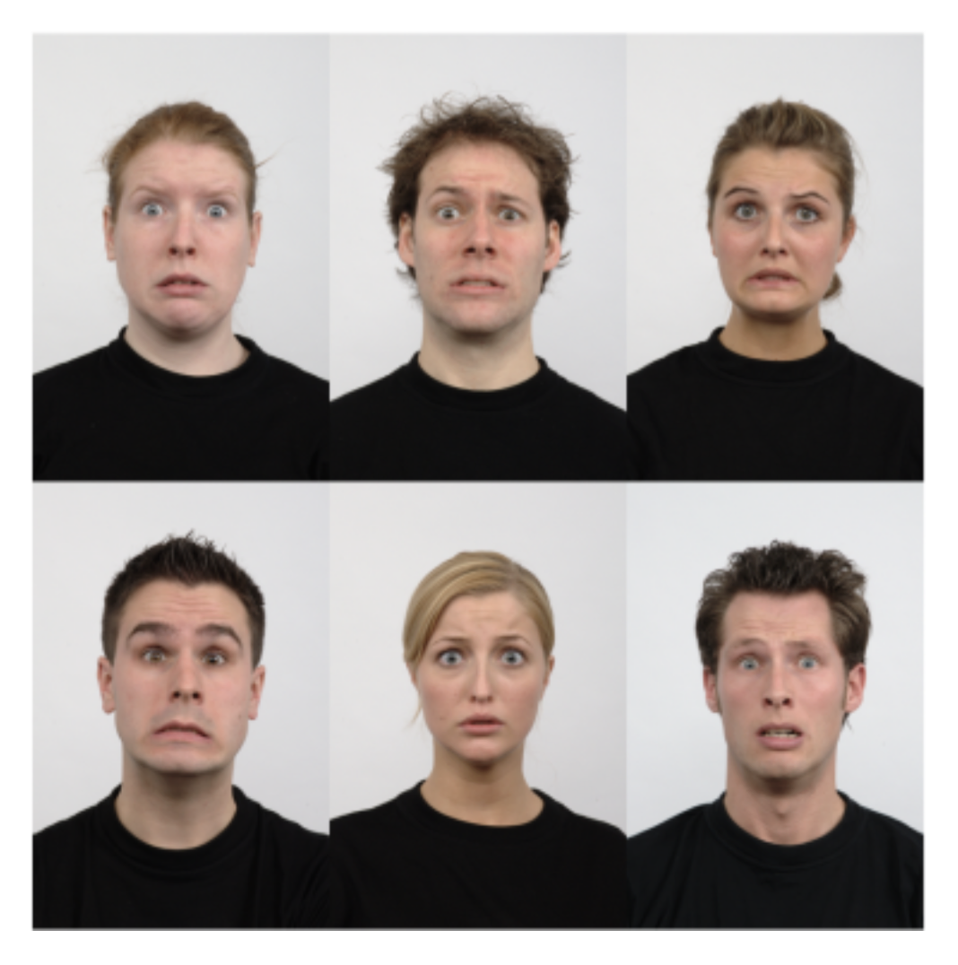
These faces match how I felt when I read scenarios.
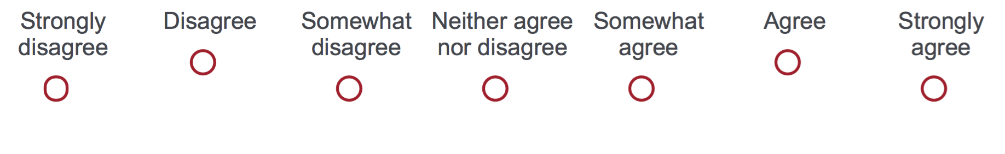

(Sadness)
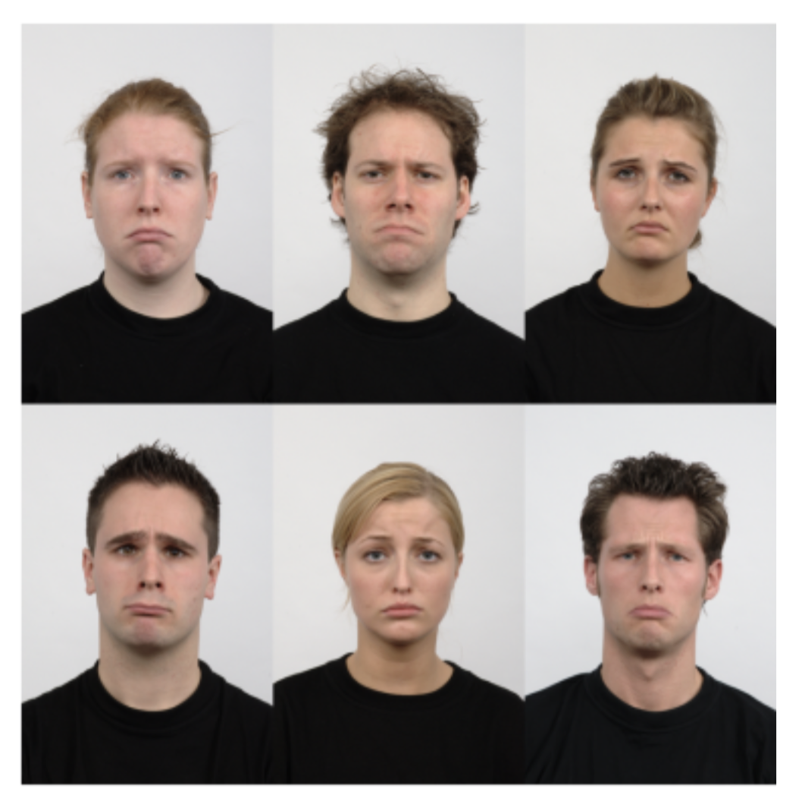

(Happiness)
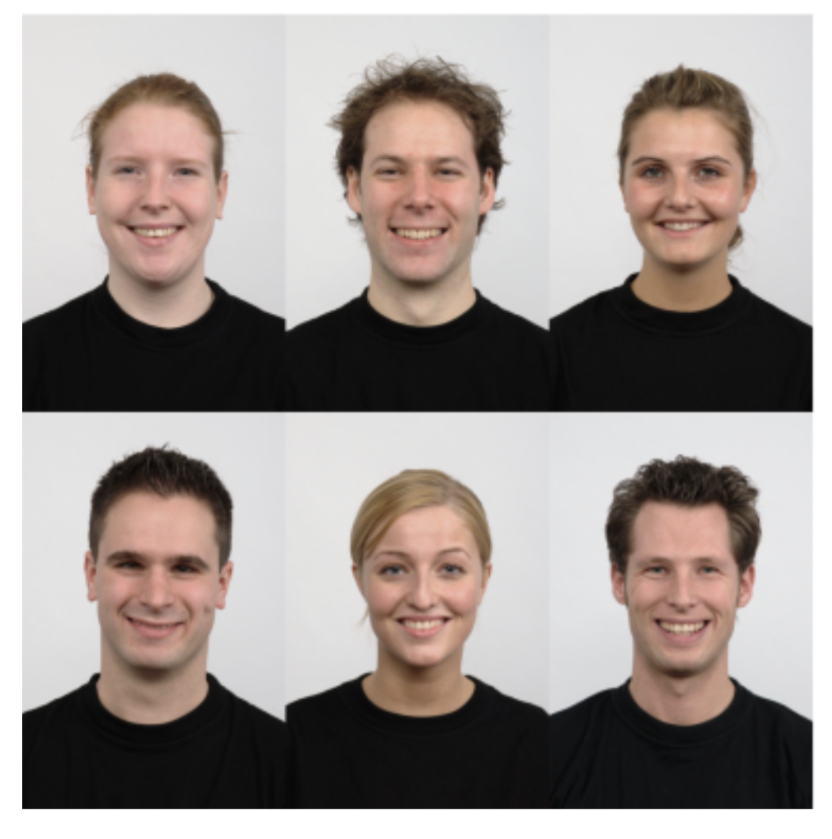

(Anger)
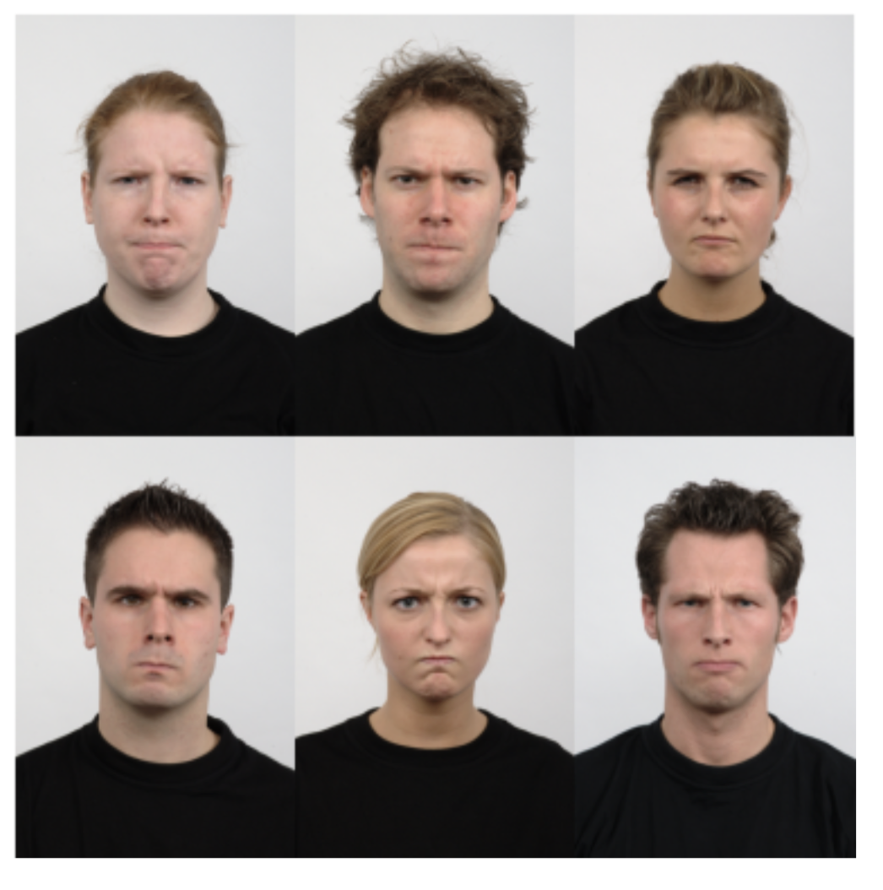

(Surprise)
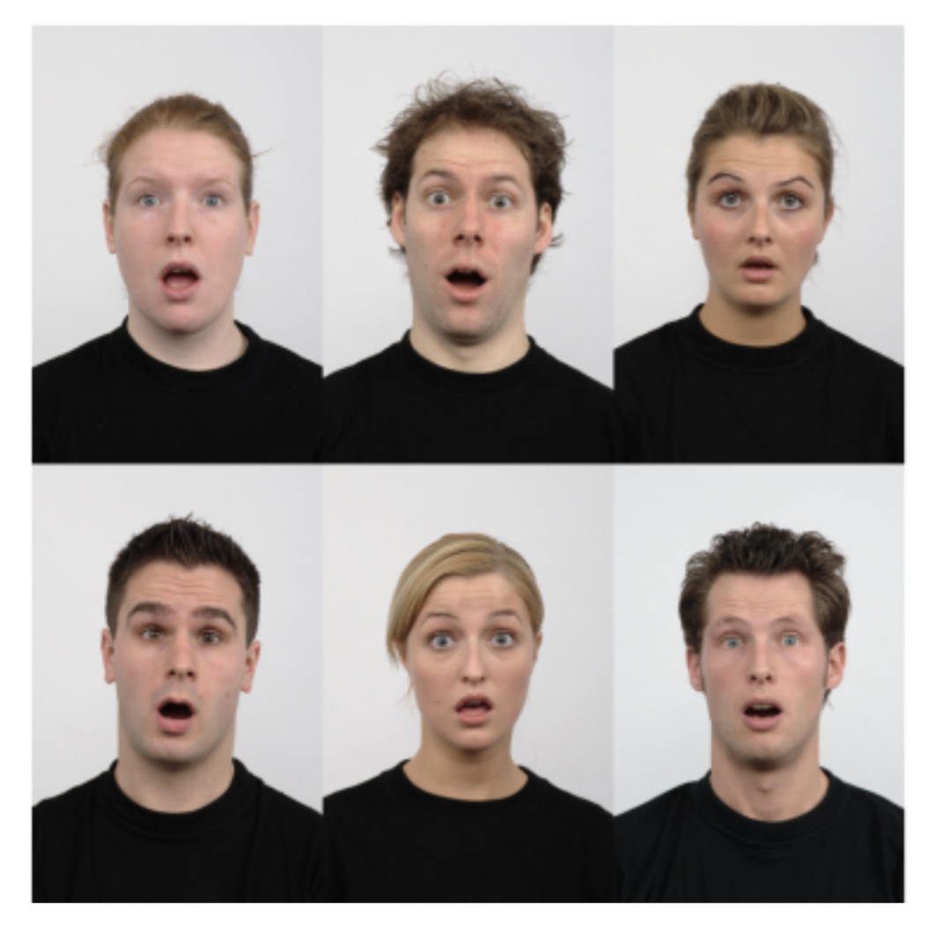

(Disgust)
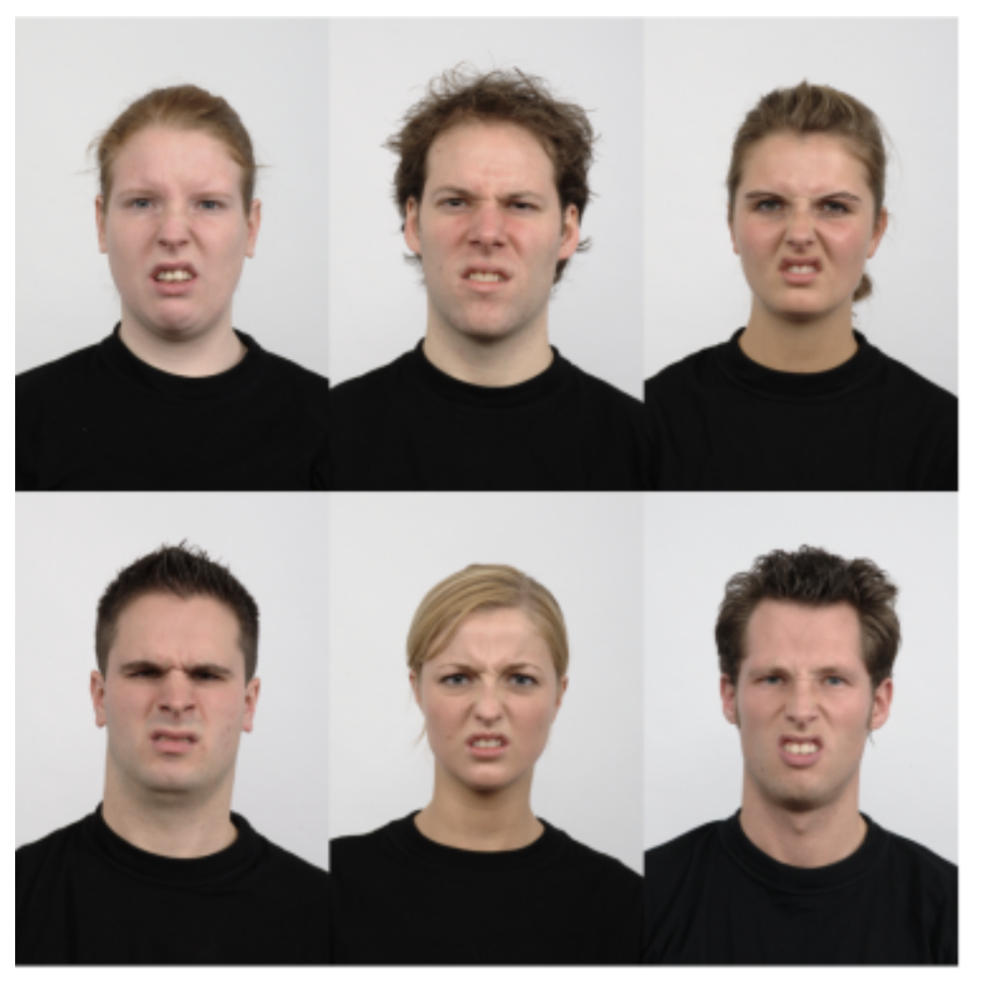

(Anger vs. Disgust)
Which of these two sets of faces matches how you felt when you read the scenarios?
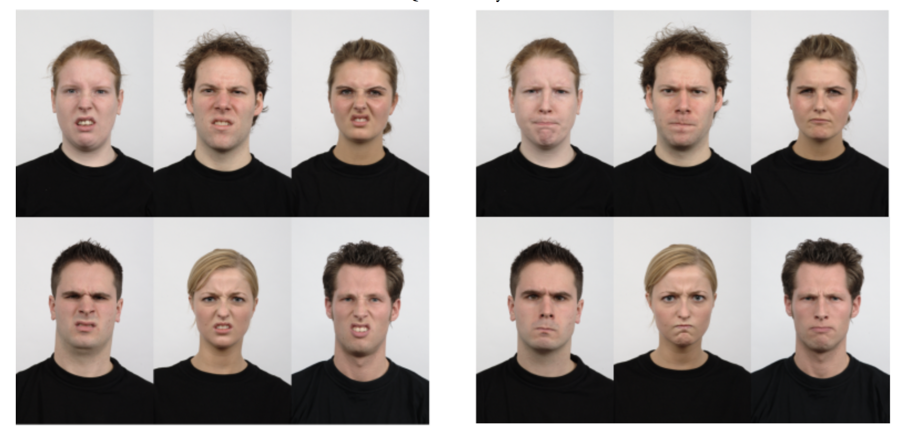

Three-Domain Disgust Scale (TDDS; Tybur et al., 2009)

Instructions
Psychologists are often interested in emotions. For these questions, we are interested in the emotion disgust. Now we would like you to rate how disgusting you find the concepts described in the following items, from not disgusting at all to extremely disgusting.

Items
- Shoplifting a candy bar from a convenience store
- Hearing two strangers having sex
- Stepping on dog poop
- Stealing from a neighbor
- Performing oral sex
- Sitting next to someone who has red sores on their arm
- A student cheating to get good grades
- Watching a pornographic video
- Shaking hands with a stranger who has sweaty palms
- Deceiving a friend
- Finding out that someone you don’t like has sexual fantasies about you
- Seeing some mold on old leftovers in your refrigerator
- Forging someone’s signature on a legal document
- Bringing someone you just met back to your room to have sex
- Standing close to a person who has body odor
- Cutting to the front of a line to purchase the last few tickets to a show
- A stranger of the opposite sex intentionally rubbing your thigh in an elevator
- Seeing a cockroach run across the floor
- Intentionally lying during a business transaction
- Having anal sex with someone of the opposite sex
- Accidentally touching a person’s bloody cut

Brief Aggression Questionnaire (BAQ; Webster et al., 2014)

Instructions
Next, we would like you to rate the following items in terms of how characteristic each item is of you.

Items
- Given enough provocation, I may hit another person.
- If I have to resort to violence to protect my rights, I will.
- There are people who pushed me so far that we came to blows.
- I tell my friends openly when I disagree with them.
- When people annoy me, I may tell them what I think of them.
- My friends say that I’m somewhat argumentative.
- I am an even‐tempered person.
- Sometimes I fly off the handle for no good reason.
- I have trouble controlling my temper.
- Other people always seem to get the breaks.
- I sometimes feel that people are laughing at me behind my back.
- When people are especially nice, I wonder what they want.

Sibling Closeness Measure (modified from Lanthier, Stocker, & Furman, 1992)

Objective closeness subscale:
      - How often do you and your sibling see each other?
      - How often does this sibling contact you?
      - How often do you contact this sibling?
      - How often do you and this sibling see each other for family gatherings and events?

[Rated on a 5-point scale:

1 = At least once a week; 2 = At least once a month; 3 = At least once in 6 months; 4 = At least once a year; 5 = Less than once a year]

Subjective closeness subscale:

1. How often do you talk to this sibling about things that are important to you?

2. How often does this sibling talk to you about things that are important to him or her?

3. How much does this sibling try to cheer you up when you are feeling down?

4. How much do you try to cheer this sibling up when he or she is feeling down?

[Rated on a 4-point scale:

1 = Never; 2 = Rarely; 3 = Occasionally; 4 = Regularly]

[The following questions were also asked for use in potential future exploratory analysis:]
- What is the age of your sibling in years? (please use numbers, e.g., 20)
- What is your birth order?
- First
- Second
- Third
- Fourth
- Fifth
- Sixth
- Other
3. What is your sibling’s birth order?
- First
- Second
- Third
- Fourth
- Fifth
- Sixth
- Other
4. How far does your sibling live from you?
- Same City
- Different City, less than 60 miles
- Between 60 & 120 miles
- Between 120 & 320 miles
- Between 320 & 620 miles
- More than 620 miles
5. Amount of contact between siblings: (Contact=social media, texts, calls, and any other forms of communication)
- How often do you and your sibling see each other?
- How often does this sibling contact you?
- How often do you contact this sibling?
- How often do you and this sibling see each other for family gatherings and events?
6. What is your relationship with your sibling?
- Biological sibling
- Twin
- Step-sibling
- Half-sibling
- Other
7. How close are your siblings political beliefs to your own?
- Same
- Similar
- Not Similar or Dissimilar
- Dissimilar
- Opposite

Study 2
Demographics Questions
The demographics questions used in Study 2 were identical to those used in Study 1.

Moral Violation Scenarios

Instructions
Welcome! On the next page, you will read a scenario. We would like you to focus on how you would feel in response to the situation described in the scenario. Please read the scenario carefully and try to experience what is described in it as vividly as possible.

Scenarios
Picture attending a large party that is being hosted by a casual friend of yours. Some of your close friends are at the party, but most of the people there are just acquaintances. After you've been at the party for a while, you realize that you need to make a phone call. You go to the room where you and the other guests have left your coats to make the call. When you enter the room, you see that another guest - a man that you recognize, but whom you're not friends with - is already in the room. You see that he is smoking a cigarette and that he has been casually flicking ashes onto the top jacket on a pile of jackets. He looks at you and gives you a tight smile before flicking another bit of ash on the jacket.

Self condition:
You look closer and see that your jacket is on the top of the pile. It has been badly damaged by the ashes.

Acquaintance condition:
You look closer and see that your jacket is near the bottom of the pile. It has not been damaged, but the jacket on the top of the pile has been badly damaged by the ashes.

Brother condition:
You look closer and see that your brother’s jacket is on the top of the pile. It has been badly damaged by the ashes.

Sister condition:
You look closer and see that your sister’s jacket is on the top of the pile. It has been badly damaged by the ashes.

Emotional Endorsements
In Study 3 we assessed participants’ emotional responses to the moral violation scenarios exactly as in Study 1 and 2.

Aggression Items

Instructions
Now we would like to know how you would react in the situation described in the scenario.
We would like you to read some statements and rate how well each of them describes how you would react towards the person in the scenario you read.

Direct aggression items:
- I would hit the person described in the scenario.
- I would insult the person described in the scenario to his face.
- I would shove the person described in the scenario.
- I would get in the face of the person described in the scenario.
- I would yell at or argue with the person described in the scenario.

Indirect aggression items:
- I would spread negative information about the person described in the scenario to others.
- I would mention something bad I've heard about the person described in the scenario to other people who know him.
- I would try to get others to dislike the person described in the scenario.
- I would try to exclude this person from a social group.
- I would tell a friend an embarrassing secret I've heard about this person.

Individual Differences Questions
In Study 2, we administered the TDDS and BAQ as in Study 1, to measure individual differences in trait aggression and trait disgust. In Study 2, we administered the Sibling Closeness Questions as in Study 1, to measure individual differences in sibling closeness.

Demographics Questions
- What is your marital status?
- Single (never married)
- Married, or in a domestic partnership
- Widowed
- Divorced
- Separated
2. What state or U.S. territory do you live in?
3. What state or U.S. territory did you grow up in?
4. What is your level of education?
- Less than a high school diploma
- High school diploma
- Some college
- Associate’s degree (e.g., AA, AS)
- Bachelor’s degree
- Master’s degree
- Doctoral degree
5. What is your current estimated household income?
Less than 20,000 / 20,000-34,999 / 35,000-49,999 / 50,000-74,999 / 75,000-99,999 / 100,000-124,999 / 125,000-149,999 / 150,000- 174,999 / 175,000-199,999 / 200,000-224,999 / 225,000-249,999 / 250,000-274,999 / 275,000-299,999 / 300,000 or more
6. What is your political affiliation?
- Democrat
- Republican
- Independent
- Other
- None

Study 3
Demographics Questions
The demographics questions used in Study 3 were identical to those used in Study 1 and 2.

Moral Violation Scenarios

Instructions
In this task, we would like you to read some statements. When you read the statements, carefully focus on how you feel in response to the statements. There are four statements in total. Please read each one carefully, and try to experience what is described in the scenario as vividly as possible.
After you read the scenarios, we will ask you about how the scenarios made you feel.
Each scenario is only a few sentences long. Once you have read one scenario, simply click to the next screen to read the next scenario. Again, please read each one carefully and focus on how you feel when reading it.

Scenarios

Self condition:
1. Imagine you are a student. A guy you know cheats off of you every time he takes a test. At the end of the semester, he gets an A in the class, and he is proud of it.
2. A guy you know was rude to you and didn’t care about anyone but themselves. He was mean and said little things all the time just to make you upset. He was just a bad person overall.
3. A guy you knew stole your ATM card and spent all of your money.
4. You find out that the guy you knew who sold you a used car lied about the car’s mileage and accident history.

Acquaintance condition:
1. Imagine you are a student. A guy you know cheats off of someone else in your class every time he takes a test. At the end of the semester, he gets an A in the class, and he is proud of it.
2. A guy you know was mean to someone you know, and he didn’t care about anyone but himself. He was mean and said little things all the time just to make your acquaintance upset. He was just a bad person overall.
3. A guy you knew stole someone else’s ATM card and spent all of their money.
4. You find out that the guy you knew who sold a used car to someone you know lied about the car’s mileage and accident history.

Brother condition:
1. Imagine your brother is a student. A guy you know cheats off of your brother in your class every time he takes a test. At the end of the semester, he gets an A in the class, and he is proud of it.
2. A guy you know was mean to your brother and he didn’t care about anyone but himself. He was mean and said little things all the time just to make your brother upset. He was just a bad person overall.
3. A person you knew stole your brother’s ATM card and spent all of their money.
4. You find out that the guy you knew who sold a used car to your brother lied about the car’s mileage and accident history.

Sister condition:
1. Imagine your sister is a student. A guy you know cheats off of your sister in class every time he takes a test. At the end of the semester, he gets an A in the class, and he is proud of it.
2. A guy you know was mean to your sister and he didn’t care about anyone but himself. He was mean and said little things all the time just to make your sister upset. He was just a bad person overall.
3. A person you knew stole your sister’s ATM card and spent all of her money.
4. You find out that the guy who sold a used car to your sister lied about the car’s mileage and accident history.

Friend condition:
1. Imagine your friend is a student. A guy you know cheats off of your friend in class every time they take a test. At the end of the semester, he gets an A in the class, and he is proud of it.
2. A guy you know was mean to your friend and he didn’t care about anyone but himself. He was mean and said little things all the time just to make your sister upset. He was just a bad person overall.
3. A person you knew stole your friend’s ATM card and spent all of their money.
4. You find out that the guy who sold a used car to your friend lied about the car’s mileage and accident history.

Scenario selection

Which of the of the four scenarios was most upsetting to you?
- Imagine you (your acquaintance/friend/brother/sister) are/is a student. A guy you know cheats off of your friend in class every time they take a test. At the end of the semester, he gets an A in the class, and he is proud of it.
- A guy you know was mean to you (your acquaintance/friend/brother/sister) and he didn’t care about anyone but himself. He was mean and said little things all the time just to make you (your acquaintance/friend/brother/sister) upset. He was just a bad person overall.
- A person you knew stole your (acquaintance/friend/brother/sister) ATM card and spent all of their money.
- You find out that the guy who sold a used car to you (acquaintance/friend/brother/sister) lied about the car’s mileage and accident history.

Emotional Endorsements
In Study 3 we assessed participants’ emotional responses to the moral violation scenarios using facial arrays exactly as in Study 1 and 2 but also added lexical items.
Lexical Items
Please click the emotion that best matched what you felt
- Fear
- Anger
- Sadness
- Grossed out/Disgusted
- Joy
When I read the scenario I felt fear
When I read the scenario I felt anger
When I read the scenario I felt sadness

When I read the scenario I felt grossed out/disgusted

When I read the scenario I felt joy

Which one of these two emotions matched how you felt while reading the scenarios?

- Anger Grossed out/disgusted

Aggression Items
In Study 3 we assessed participants’ aggression responses to the moral violation scenarios exactly as in Study 2.
Individual Differences Questions
In Study 3, we administered the TDDS and BAQ as in Study 1 and 2, to measure individual differences in trait aggression and trait disgust. In Study 3, we administered the Sibling Closeness Questions as in Study 1 and 2, to measure individual differences in sibling closeness and friend closeness. In addition, we also administered a modified Relationship Closeness Scale (Dibble, Levine & Park, 2012) in Study 3.
Modified Relationship Closeness Scale (Dibble, Levine & Park, 2012)
1. I think about my sibling/friend a lot
2. My sibling/friend and I do a lot together
3. My relationship with my sibling/friend is close
4. When we are apart, I miss my sibling/friend a great deal
5. My sibling/friend and I disclose important personal things to one another
6. I consider my sibling/friend when making important decisions
7. My sibling/friend and I have a strong connection
8. My sibling/friend and I enjoy spending time together
9. My sibling/friend is a priority in my life
10. When I have free time, I choose to spend it with my sibling/friend

[Rated on a 7-point Likert scale: from 1 = Strongly disagree to 7 Strongly agree]

Catch Questions
How would you feel if you saw someone use a smartphone in the afternoon?
- Extremely surprised
- Slightly surprised
- Not surprised
- Surprised
- Fairly Surprised

During this study did occurrences in your environment (e.g., loud noises, phone calls) cause significant distraction?
- Yes
- Maybe
- No

How many letters are there in the English alphabet?
__________

Facial arrays of emotional expressions were presented in randomized order.
Across all questions, participants only saw the arrays of facial expressions. They did not see labels for any emotion.
Responses were measured on a 7-point scale ranging from not at all disgusting (1) to extremely disgusting (7).
Responses were measured on a 5-point scale ranging from extremely uncharacteristic of me (1) to extremely characteristic of me (5).
Responses were measured on a 5-point scale ranging from at least once a week (1) to less than a year (5).
Responses were measured on a 7-point scale ranging from strongly disagree (1) to strongly agree (7). All aggression items were presented in randomized order.
The presentation of the facial arrays and lexical items was counterbalanced
Lexical emotion labels were presented in randomized order
Simply by replacing ‘sibling’ with ‘friend’.

