Supplemental Materials
Effects of Compassion Meditation on a Psychological Model of Charitable Donation
by Y. K. Ashar et al., 2015, Emotion
http://dx.doi.org/10.1037/emo0000119

Study 1

Stimuli
Each participant was presented 16 unique, four-sentence biographies, each paired with an adult face photograph (see Table S1 for examples). Biographies were randomly generated according to an algorithm designed to produce cohesive narratives and induce variability in target psychological processes. The first sentence was randomly chosen from a pool of sentences describing a basic hardship, such as disease, homelessness, or injury. The second sentence was randomly chosen from a pool of sentences providing further information about the hardship, such as the person’s level responsibility for, distress due to, or neediness resulting from the hardship. The third and fourth sentences were randomly chosen from pools of sentences describing the person’s personality, religious affiliation, or socioeconomic status. Finally, a name was randomly selected, pronouns were gender matched, and a gender matched photograph was randomly selected from a collection of identically sized, half Black half White photographs drawn from adult face photograph databases (“Flickr Creative Commons,” 2014; Milborrow, Morkel, & Nicolls, 2010; Minear & Park, 2004). Sentences and photographs never repeated across biographies for a given participant. Members of the research team reviewed hundreds of randomly generated biographies to check the sensibility of the biographies.

Analyses and Results
To confirm that the Study 1 questions empirically grouped according to the posited theoretical structure, we clustered the question responses, mean-centered within subject, by their standardized Euclidean distance using the MATLAB clustering toolkit. Questions intended to measure the same construct did cluster together, with one exception: the instrumental value of helping questions and the socioeconomic similarity questions were intermixed (Figure S1). We nonetheless treated these as separate constructs due to their clear conceptual distinction.

Nondonating participants
We considered two possible explanations for why some Study 1 participants did not donate at all: (a) our stimuli failed to elicit an emotional response of sufficient strength to motivate donation, or (b) despite a sufficient emotional response, participants adhered to a no-donation policy for other reasons (i.e., financial need). To test these competing hypotheses, we compared participant-average FAS scores among nondonors and participants who donated at least once. Nondonors had overall lower FAS scores than donors, T(2, 267) = 3.38, p < .001, but their FAS scores demonstrated a relatively robust response to stimuli that was higher than FAS scores for donors’ nondonating trials (Figure S2). This suggests that nondonors probably largely adhered to a policy of no donations, rather than being emotionally unaffected by the stimuli. To the extent that this was the case, this policy may have acted as a conceptual moderator of the relationship between FAS variables and donations: when a policy was present, FAS variables had no relationship to donation.
The exclusion of nondonors from both studies does not confound our within-person design, but rather limits its generalizability. Our findings do not generalize to the entire population of individuals, but only to those individuals willing in principle to donate at least a small amount of money in the context of our experiment.

Study 2
Stimuli
Study 2 biographies were true stories adapted from the Web sites of charitable organizations to vary along the feelings, attributions, and similarities of interest. Actual photographs of these same individuals were presented, while participants listened to these biographies. Three example biographies are provided here:
- Crystal had an abusive childhood. She developed Anorexia, causing her internal damage from repeated cycles of overeating and vomiting. She suffered from depression, suicidal thoughts, and prescription drug abuse, leading her to self-harm. A charity, her religious community, and prayer helped free her from this harmful lifestyle. She graduated from Louisiana Tech University with a degree in nutrition and dietetics, and now wants to be a dietician who helps others with eating disorders.
- Mike is two-years old. He was born without an epiglottis, a throat structure that helps control breathing and swallowing. He now eats through a feeding tube inserted into his stomach, and he sometimes contracts bronchitis from breathing saliva into his lungs. He is an orphan, so a charity cares for him. Despite his struggles, Mike is warm and joyful. He is close with his brother, and they like playing with their train set together. He also likes being held and having books read to him.
- Bill is homeless. He sleeps in Manhattan's subway cars, finding warm shelter wherever he can, and is often sick because of exhaustion and exposure. He struggles with mental illness, including untreated depression, making it difficult for him to hold onto jobs and housing. Bill is a veteran, a proud, 50-year-old former Marine who served his country honorably for many years. A homeless shelter has recently been able to secure Bill with food, shelter, and medical attention.

Additional measures of compassion and related constructs
Questionnaires. Participants completed five questionnaire measures pre- and postintervention: the Interpersonal Reactivity Index (Davis, 1983), Personal Altruism Scale (Tankersley, Stowe, & Huettel, 2007), Self-Compassion Scale (Neff, 2003), Five Factor Mindfulness Questionnaire (Baer, Smith, Hopkins, Krietemeyer, & Toney, 2006), and the Inclusion of Other in Self Scale (Aron, Aron, & Smollan, 1992). Participants also completed a brief questionnaire postintervention only to assess the strength of their belief that the intervention increased their compassion. The questionnaire included 7 Likert items measuring perceived increases in compassionate feeling and behavior toward the self, close others, and strangers (6 items crossing feeling/behavior and self/close others/strangers, and a 7th item measuring perceived overall increases in compassion).
Empathic accuracy. Participants completed a task pre and postintervention assessing the ability to correctly infer others’ mental states from photographs of the eye-region of the face (Reading the Mind in the Eyes; Baron-Cohen, Wheelwright, Hill, Raste, & Plumb, 2001).
Experience sampling. Participants completed an audio experience sampling measure (the Electronically Activated Recorder; Mehl, Pennebaker, Crow, Dabbs, & Price, 2001) for one weekend, both before and after the intervention. Audio sampling data will be presented in a separate manuscript.

Compassion Meditation program
The CM program was designed to progressively develop both sensitivity to others’ suffering and equanimity in the face of suffering. Throughout the program, participants were asked to feel the strength of their back and the softness of their chest and stomach while considering others’ suffering, which served as metaphors or felt experiences of sensitivity and equanimity. Additionally, sensitivity and equanimity were practiced by attending to present-moment physical sensations, especially in the heart area of the chest, which served to heighten attention to emotions and provided an anchor preventing feeling overwhelmed. Additionally, participants were asked to feel compassion for the suffering of various specific individuals. This was operationalized by repeating certain phrases regarding the suffering individual (e.g., may you be free from suffering, may you find peace, etc.), by taking that individual’s perspective, and by attempting to spontaneously generate feelings of care and concern for them.
Participants listened to a different meditation each of the four weeks. The Week 1 meditation asked participants to feel compassion for one’s self, for a close other, and for the individual described in the audio biography that played during the meditation. The Week 2 meditation asked participants to imagine themselves as young children, innocent and happy, and then to imagine the individual described in the biography as a young child and to feel compassion for him or her. The Week 3 meditation asked participants to take the perspective of a close other who was suffering, and then to take the perspective of the individual described in the biography and feel compassion for him or her.
The Week 4 meditation featured the modified and simplified version of tong-len: “sending and receiving.” Participants were instructed to breath in another’s suffering, visualized as hot smoke, to imagine that suffering “melting” the armor of the heart and being transformed to relief and healing, and then to exhale relief and healing (visualized as cool air) back to the suffering individual. Sending and receiving was practiced toward a close friend or family member and toward the individual described in the biography. Sending and receiving practices have been almost completely unexplored in CM and LKM research (but see Wallmark, Safarzadeh, Daukantaite, & Maddux, 2013), despite the potential power of these practices to cultivate compassion.
Participants seeking additional meditation guidance were given the option to speak with a clinical psychologist experienced with contemplative interventions (author SD) by phone at any point during the intervention. Due to a lack of expressed interest among participants, and to logistical challenges in scheduling such calls in the few cases where participants did express interest, no such phone calls took place. Also, a 3-minute audio recording with general meditation instructions was included in the smartphone application and available for participants to listen to at any time.

Additional measures of compassion and related constructs
Questionnaires. There were no significant changes over the course of the intervention in any of the questionnaires for any group (Table S5). This contrasts both with the increases and with the decreases in feelings, attributions, similarities, and donations observed in the CM and Familiarity conditions, respectively (see Table S3), suggesting that the task-based measures developed in this study may provide a more accurate, reliable measure relative to questionnaires.
Group differences were observed in the ad hoc questionnaire measuring perceived increases in compassion, administered postintervention only. The pattern of results was similar for all items on this questionnaire: CM participants reported significantly higher increases in compassion relative to both OxyPla and Familiarity participants, who did not differ. For illustrative purposes, data for the item measuring overall increases in compassion is presented in Table S5. This provides some converging evidence for the specific efficacy of CM.
Empathic accuracy. OxyPla participants’ Reading the Mind in the Eyes scores significantly increased, while CM and Familiarity participants showed no change (Table S5). OxyPla participants’ increased empathic accuracy could be interpreted as a placebo response. However, since OxyPla participants increased on no other measures of compassion or donation, this interpretation may not be justified, and we note it here only for archival purposes.

Bootstrapped mediation analyses
Bootstrapping (Efron & Tibshirani, 1994) provides a more accurate and generally more sensitive test for assessing the magnitude of indirect (Path a × b) effects than the Sobel test (Sobel, 1982), which assumes a normal distribution of Path a × b estimates. Even if Paths a and b estimates may both be normally distributed, the Path a × b product is not expected to be normally distributed (MacKinnon, Lockwood, Hoffman, West, & Sheets, 2002). We estimated distributions of subject-level path coefficients by randomly sampling with replacement 10,000 observations (rows) from the matrix of [a b c’ c (a × b)] path coefficients. Two-tailed p-values were calculated from the bootstrap confidence interval, which was accelerated and bias corrected (DiCiccio & Efron, 1996).

References
Aron, A., Aron, E. N., & Smollan, D. (1992). Inclusion of Other in the Self Scale and the structure of interpersonal closeness. Journal of Personality and Social Psychology, 63(4), 596–612. doi:10.1037/0022-3514.63.4.596
Baer, R. a, Smith, G. T., Hopkins, J., Krietemeyer, J., & Toney, L. (2006). Using self-report assessment methods to explore facets of mindfulness. Assessment, 13(1), 27–45. doi:10.1177/1073191105283504
Baron-Cohen, S., Wheelwright, S., Hill, J., Raste, Y., & Plumb, I. (2001). The “Reading the Mind in the Eyes” Test revised version: a study with normal adults, and adults with Asperger syndrome or high-functioning autism. Journal of Child Psychology and Psychiatry, and Allied Disciplines, 42(2), 241–251. doi:10.1111/1469-7610.00715
Davis, M. H. (1983). Measuring individual differences in empathy: Evidence for a multidimensional approach. Journal of Personality and Social Psychology, 44(1), 113–126. doi:10.1037/0022-3514.44.1.113
DiCiccio, T. J., & Efron, B. (1996). Bootstrap Confidence Intervals. Statistical Science, 11(3), 189–228. doi:10.1002/sim.4134
Efron, B., & Tibshirani, R. (1994). An introduction to the bootstrap (Vol. 57). Chapman & Hall. doi:10.1111/1467-9639.00050
Flickr Creative Commons. (2014). Retrieved January 1, 2013, from https://www.flickr.com/creativecommons/
Galante, J., Galante, I., Bekkers, M.-J., & Gallacher, J. (2014). Effect of Kindness-Based Meditation on Health and Well-Being: A Systematic Review and Meta-Analysis. Journal of Consulting and Clinical Psychology, No–Specified. doi:10.1037/a0037249
MacKinnon, D. P., Lockwood, C. M., Hoffman, J. M., West, S. G., & Sheets, V. (2002). A comparison of methods to test mediation and other intervening variable effects. Psychological Methods, 7(1), 83–104. doi:10.1037//1082-989X.7.1.83
Mehl, M. R., Pennebaker, J. W., Crow, D. M., Dabbs, J., & Price, J. H. (2001). The Electronically Activated Recorder (EAR): a device for sampling naturalistic daily activities and conversations. Behavior Research Methods, Instruments, & Computers, 33(4), 517–523.
Milborrow, S., Morkel, J., & Nicolls, F. (2010). The MUCT landmarked face database. Pattern Recognition Association of South Africa, 1(4).
Minear, M., & Park, D. C. (2004). A lifespan database of adult facial stimuli. Behavior Research Methods, Instruments, & Computers, 36(4), 630–633. doi:10.3758/BF03206543
Neff, K. D. (2003). The development and validation of a scale to measure self-compassion. Self and Identity, 2, 223–250. doi:10.1080/15298860390209035
Sobel, M. E. (1982). Asymptotic confidence intervals for indirect effects in structural equation models. Sociological Methodology, 13(1982), 290–312. doi:10.2307/270723
Tankersley, D., Stowe, C. J., & Huettel, S. a. (2007). Altruism is associated with an increased neural response to agency. Nature Neuroscience, 10(2), 150–151. doi:10.1038/nn1833
Wallmark, E., Safarzadeh, K., Daukantaite, D., & Maddux, R. E. (2013). Promoting Altruism Through Meditation: An 8-Week Randomized Controlled Pilot Study. Mindfulness, 4(3), 223–234. doi:10.1007/s12671-012-0115-4

Table S1
Study 1 Example Stimuli
 | Peggy has liver cancer. She drank heavily for many years. She has a bachelor's degree. She has a reputation as being somewhat of a gossip.
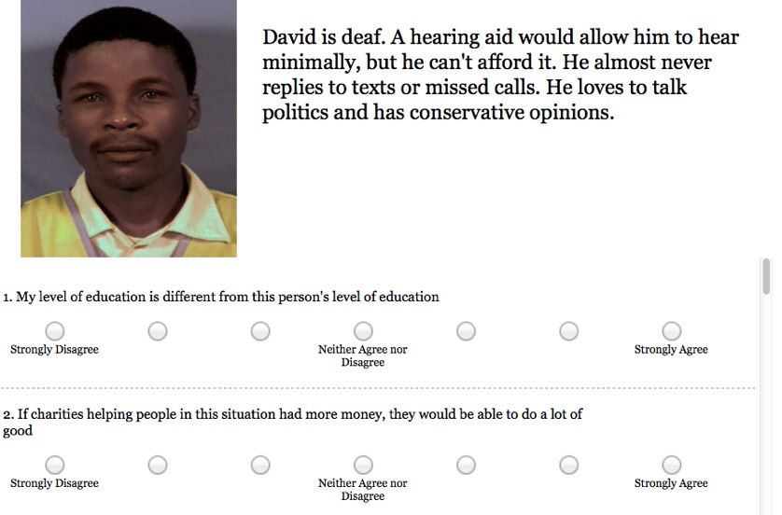 | Joshua has lung cancer. He still performs everyday tasks in spite of his diagnosis. He is a regular at the monthly American Atheists meeting. He often achieves his goals by planning well for them.
 | Peter had his house destroyed by a tornado. He needs a few months rent to get back on his feet. He owns a popular restaurant. He keeps secrets well and others confide in him often.

Table S2
Questions Measuring Feelings Toward, Attributions About, and Perceived Similarity to Suffering Individuals
Feeling/Attribution | Questions
Tenderness | (1) I feel tender towards this person  (2) I don’t care about this person (R)  (3) I feel emotionally connected to this person
Personal Distress | (4) I feel distressed by this person's suffering  (5) This person's story does not upset me (R)  (6) I feel guilty about this person’s suffering
Instrumental value of helping | (7) This person really needs help  (8) Having more money would not improve this person's situation (R)  (9) If charities helping people in this situation had more money, they would be able to do a lot of good
Blame | (10) This person is responsible for their suffering  (11) I blame this person for their suffering  (12) This person's suffering is unjust or unfair (R)
SES Similarity | (13) My position in society is similar to this person's position in society  (14) My economic status is similar to this person's economic status  (15) My level of education is different from this person's level of education (R)
Internal Similarity | (16) My personal morals and values are similar to this person's morals and values  (17) My interests and hobbies are similar to this person's interests and hobbies  (18) My joys and fears are different from this person's joy and fears (R)
Note: In Study 1, all 18 questions were presented for each biography, while in Study 2 only the bolded question was presented. Reverse scored items indicated by (R).

Table S3
Charitable Donations, Feelings, Attributions, and Similarities
 | Pre | 95% CI | Post |  | 95% CI | Δ | 95% CI
Tenderness
CM | 73.59 | [68.88, 78.30] |  | 79.28 | [74.45, 84.12] | 5.69 | [1.95, 9.44]**
OxyPla | 75.43 | [67.00, 83.86] |  | 74.48 | [67.28, 81.68] | −0.95 | [−4.72, 2.81]
Familiarity | 75.11 | [69.36, 80.86] |  | 72.53 | [65.63, 79.44] | −2.58 | [−5.72, 0.57]
Personal distress
CM | 58.74 | [48.46, 69.02] | 61.02 |  | [49.85, 72.18] | 2.28 | [−4.12, 8.67]
OxyPla | 58.08 | [47.43, 68.73] | 57.31 |  | [46.01, 68.61] | −1.02 | [−6.52, 4.48]
Familiarity | 60.02 | [50.12, 69.92] | 50.55 |  | [38.37, 62.73] | −9.47 | [−18.03, −0.92]*
Instrumental value of helping
CM | 58.74 | [48.46, 69.02] | 81.04 |  | [74.79, 87.29] | 6.68 | [2.55, 10.81]**
OxyPla | 58.08 | [47.43, 68.73] | 78.16 |  | [70.25, 86.06] | 1.33 | [−3.03, 5.69]
Familiarity | 60.02 | [50.12, 69.92] | 78.24 |  | [72.01, 84.46] | −0.79 | [−5.42, 3.84]
Blame
CM | 16.34 | [12.17, 20.51] | 13.46 |  | [8.71, 18.21] | −2.88 | [−7.14, 1.37]
OxyPla | 17.27 | [13.03, 21.51] | 17.45 |  | [11.18, 23.73] | 0.19 | [−3.83, 4.20]
Familiarity | 16.15 | [11.05, 21.25] | 17.51 |  | [11.33, 23.70] | 1.36 | [−2.01, 4.74]
Internal similarity
CM | 52.69 | [50.82, 54.56] |  | 56.78 | [54.85, 58.70] | 4.08 | [0.05, 8.12]*
OxyPla | 46.00 | [38.75, 53.26] |  | 45.72 | [37.47, 53.97] | −0.28 | [−6.49, 5.92]
Familiarity | 52.54 | [44.02, 61.06] |  | 52.52 | [42.59, 62.45] | −0.02 | [−5.19, 5.14]
SES Similarity
CM | 30.83 | [28.56, 33.10] |  | 36.59 | [34.10, 39.07] | 5.75 | [1.01, 10.50]*
OxyPla | 30.23 | [23.47, 36.99] |  | 32.40 | [26.91, 37.89] | 2.17 | [−2.24, 6.58]
Familiarity | 30.06 | [23.05, 37.08] |  | 32.61 | [23.55, 41.68] | 2.55 | [−3.00, 8.10]
Note: Preintervention, postintervention, and change scores for donation (from $0 to $100) and for FAS scores and each of the individual feelings, attributions, and similarities (from 0 = no intensity to 100 = maximum intensity). Change scores significantly different from zero are indicated with * = p < .05, ** = p < .01.

Table S4
Mediation Results
 |  | Path a |  | Path b | Path c’ | Path c | Path ab
 |  | X = CM vs. OxyPla, M = FAS scores
Β |  | 1.07* |  | 1.26** | 1.72 | 3.05 | 1.37*
95% CIs |  | [0.13, 2.09] |  | [0.38, 2.08] | [−0.09, 8.00] | [−1.30, 6.71] | [0.20, 3.74]
 |  | X = CM vs. Familiarity, M = FAS scores
β |  | 1.80*** |  | 1.03* | 2.13† | 4.00** | 1.87**
95% CIs |  | [0.94, 2.82] |  | [0.23, 1.84] | [−0.06, 4.76] | [1.43, 7.26] | [0.52, 4.42]
 |  | X = CM vs. combined OxyPla & Familiarity, M = FAS scores
β |  | 0.94*** |  | 1.13** | 1.31 | 2.36* | 1.07**
95% CIs |  | [0.43, 1.53] |  | [0.30, 1.93] | [−0.13, 3.23] | [0.72, 4.52] | [0.32, 2.52]
 |  |  | X = CM vs. combined OxyPla & Familiarity, M = Tenderness
β |  | 2.49*** |  | 0.18 | 1.99* | 2.35* | 0.36
95% CIs |  | [1.14, 3.91] |  | [−0.22, 0.56] | [0.14, 4.54] | [0.76, 4.47] | [−0.60, 1.65]
 |  | X = CM vs. combined OxyPla & Familiarity, M = Personal Distress
β |  | 2.50* |  | 0.24* | 1.76* | 2.33* | 0.60*
95% CIs |  | [0.08, 5.25] |  | [0.06, 0.40] | [0.25, 3.81] | [0.79, 4.50] | [0.03, 1.66]
 |  | X = CM vs. combined OxyPla & Familiarity, M = Instrumentality
β |  | 2.12** |  | 0.25 | 1.35† | 2.35* | 0.53†
95% CIs |  | [0.68, 3.85] |  | [−0.07, 0.57] | [−0.06, 3.24] | [0.76, 4.47] | [−0.04, 1.60]
 |  | X = CM vs. combined OxyPla & Familiarity, M = Blame
β |  | −1.24 |  | −0.03 | 2.21** | 2.36** | 0.05
95% CIs |  | [−2.54, 0.54] |  | [−0.44, 0.31] | [0.66, 4.11] | [0.72, 4.52] | [−0.37, 1.04]
 |  | X = CM vs. combined OxyPla & Familiarity, M = Internal similarity
β |  | 1.60† |  | 0.14 | 1.64* | 2.33* | 0.24
95% CIs |  | [−0.07, 3.44] |  | [−0.19, 0.44] | [0.21, 3.50] | [0.79, 4.50] | [−0.17, 1.20]
 |  | X = CM vs. combined OxyPla & Familiarity, M = SES similarity
β |  | 1.35 |  | 0.08 | 1.79* | 2.36* | 0.10
95% CIs |  | [−0.45, 3.17] |  | [−0.20, 0.31] | [0.28, 3.71] | [0.72, 4.53] | [−0.20, 0.72]
Note: Results of analyses testing FAS scores and the individual feelings, attributions, and similarities as potential mediators of the effect of the intervention on pre-to-post change in donation. ‘Y’ in all analyses was change in donation amounts. † = p < .1, * = p < .05, ** = p < .01, *** = p < .001.

Table S5
Additional Measures of Compassion and Related Constructs
 | Pre |  |  | 95% CI |  |  | Post |  |  | 95% CI | Δ |  | 95% CI
 | Interpersonal Reactivity Index
CM | 60.58 |  |  | [57.69, 63.47] |  |  | 58.31 |  | [55.47, 61.15] |  |  | −2.27 |  | [−5.36, 0.81]
OxyPla | 58.35 |  |  | [55.13, 61.58] |  |  | 58.29 |  | [55.58, 61.01] |  |  | −0.06 |  | [−2.11, 1.99]
Familiarity | 60.99 |  |  | [57.80, 64.18] |  |  | 61.89 |  | [58.11, 65.67] |  |  | 1.60 |  | [−1.79, 4.99]
 | Self Compassion Scale
CM | 3.30 |  |  | [3.16, 3.43] |  | 3.24 |  |  | [3.11, 3.36] |  |  | −0.06 |  | [−0.19, 0.06]
OxyPla | 3.19 |  |  | [3.04, 3.34] |  | 3.23 |  |  | [3.05, 3.41] |  |  | 0.04 |  | [−0.09, 0.16]
Familiarity | 3.29 |  |  | [3.13, 3.45] |  | 3.32 |  |  | [3.17, 3.47] |  |  | 0.03 |  | [−0.09, 0.14]
 | Five Factor Mindfulness Scale
CM | 123.87 |  | [120.09, 127.65] |  | 121.36 |  |  | [116.29, 126.43] |  |  |  | −2.51 |  | [−5.20, 0.17]
OxyPla | 119.53 |  | [113.21, 125.85] |  | 119.91 |  |  | [112.83, 126.99] |  |  |  | 0.38 |  | [−4.03, 4.79]
Familiarity | 119.80 |  | [114.58, 125.02] |  | 121.17 |  |  | [116.58, 125.75] |  |  |  | 1.20 |  | [−2.24, 4.64]
 | Personal Altruism Scale
CM | 66.58 |  |  | [64.77, 68.39] |  | 63.75 |  |  | [63.75, 68.95] |  |  | −0.23 |  | [−3.19, 2.73]
OxyPla | 65.00 |  |  | [62.01, 67.99] |  | 65.60 |  |  | [62.70, 68.49] |  |  | 0.60 |  | [−1.57, 2.77]
Familiarity | 66.35 |  |  | [64.30, 68.41] |  | 65.78 |  |  | [63.40, 68.15] |  |  | −0.06 |  | [−1.72, 1.60]
 |  | Inclusion of Self in Other
CM | 4.22 |  |  | [3.72, 4.72] |  | 4.20 |  |  | [3.66, 4.74] |  |  | 0.06 |  | [−0.41, 0.52]
OxyPla | 3.75 |  |  | [3.09, 4.41] |  | 3.68 |  |  | [3.07, 4.29] |  |  | −0.09 |  | [−0.49, 0.30]
Familiarity | 3.88 |  |  | [3.40, 4.35] |  | 63.76 |  |  | [3.27, 4.26] |  |  | −0.06 |  | [−0.47, 0.35]
 | Reading the Mind in the Eyes (% correct)
CM | 73.33 |  |  | [68.74, 77.92] |  | 75.56 |  |  | [71.47, 79.64] |  |  | 2.22 |  | [−2.09, 6.54]
OxyPla | 75.16 |  |  | [70.95, 79.37] |  | 78.82 |  |  | [73.45, 84.19] |  |  | 4.69 |  | [0.84, 8.54]*
Familiarity | 75.15 |  |  | [71.89, 78.42] |  | 72.99 |  |  | [68.01, 77.98] |  |  | −2.16 |  | [−6.14, 1.82]
 | Perceived changes in compassion
CM | - |  |  | - |  | 6.04 |  |  | [5.10, 6.99] |  |  | - |  | -
OxyPla | - |  |  | - |  | 4.25 |  |  | [2.98, 5.49] |  |  | - |  | -
Familiarity | - |  |  | - |  | 2.91 |  |  | [1.80, 4.01] |  |  | - |  | -

Note: Preintervention, postintervention, and change scores on measures administered. There were no significant changes on any measure for any group, except for OxyPla increases on the Reading the Mind in they Eyes task. An ad hoc questionnaire measuring perceived changes in compassion was administered postintervention only, in which CM was greater than OxyPla and Familiarity, which did not differ. Data are reported here primarily for archival purposes. * = p < .05.

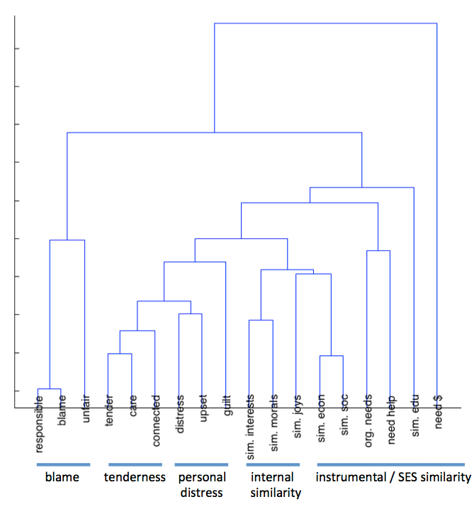
Figure S1. A clustering analysis conducted on the Study 1 question responses confirmed that they grouped according to the posited theoretical structure.

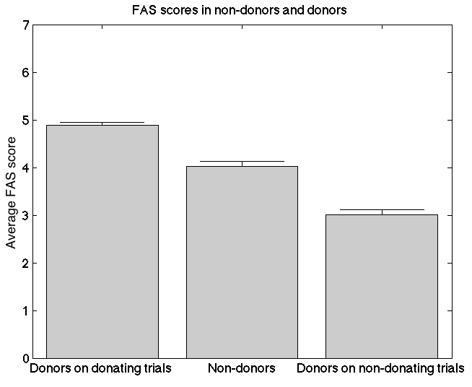

Figure S2. Nondonors’ average FAS scores donors fell between donors’ average FAS scores on donating and nondonating trials. This suggests that nondonors did have a FAS-response sufficiently strong to motivate donation, but chose not to donate for other reasons (i.e., financial duress). Error bars show standard error; all differences significant at p < .001.
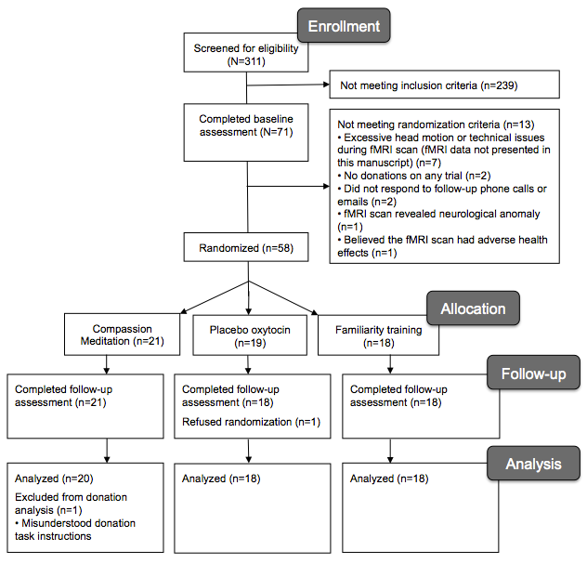
Figure S3. Flow diagram of participants through each stage of Study 2.

