Table S1. Cohort Differences in the Study Variables
Table S2. Descriptive Statistics and Measures of Internal Consistency
Table S3. Descriptive Statistics and Measures of Internal Consistency for Emergent Literacy Skills
Table S4. Correlational Analyses
Table S5. Family and Child Characteristics as Predictors of the Home Literacy Environment Profile Membership
Table S6. Profiles of the Home Literacy Environment as Predictors of Children’s Emergent Vocabulary
Table S7. Profiles of the Home Literacy Environment as Predictors of Children’s Emergent Phonological Awareness Skills
Table S8. Profiles of the Home Literacy Environment as Predictors of Children’s Emergent Letter Knowledge Skills
Table S9. Results of the Tested Structural Equation Model: Covariates Predicting Home Literacy Environment Indicators
Table S10. Results of the Tested Structural Equation Model (Part 1 – T1)
Table S11. Results of the Tested Structural Equation Model (Part 2 – T2)
Table S12. Results of the Tested Structural Equation Model (Part 3 – T3)
Table S13. Results of the Tested Structural Equation Model (Part 4 – Correlations)
Figure S1. Profiles of the Home Literacy Environment
Figure S2. Differences in Vocabulary at T1 Between the Profiles
Figure S3. Differences in Vocabulary at T2 Between the Profiles Controlling for Vocabulary at T1
Figure S4. Differences in Vocabulary at T3 Between the Profiles Controlling for Vocabulary at T1
Figure S5. Descriptive Differences in Vocabulary at T2 Between the Profiles
Figure S6. Descriptive Differences in Vocabulary at T3 Between the Profiles
Figure S7. Differences in Phonological Awareness at T1 Between the Profiles
Figure S8. Differences in Phonological Awareness at T2 Between the Profiles Controlling for Phonological Awareness at T1
Figure S9. Differences in Phonological Awareness at T3 Between the Profiles Controlling for Phonological Awareness at T1
Figure S10. Descriptive Differences in Phonological Awareness Skills at T2 Between the Profiles
Figure S11. Descriptive Differences in Phonological Awareness Skills at T3 Between the Profiles
Figure S12. Differences in Letter Knowledge at T1 Between the Profiles
Figure S13. Differences in Letter Knowledge at T2 Between the Profiles Controlling for Letter Knowledge at T1
Figure S14. Differences in Letter Knowledge at T3 Between the Profiles Controlling for Letter Knowledge at T1
Figure S15. Descriptive Differences in Letter Knowledge at T2 Between the Profiles
Figure S16. Descriptive Differences in Letter Knowledge at T3 Between the Profiles
Figure S17. Method Triangulation: Variable-Centered Path Model of Family and Child Characteristics, Home Literacy Environment, and Children’s Emergent Literacy Development

Table S1
Cohort Differences in the Study Variables
Variable | t | df | p | M  (Cohort 1) | M  (Cohort 2) | Cohen’s d
Sexª | -0.12 | 399.41 | 0.903 | 0.51 | 0.52 | −0.01
Age | 10.80 | 365.19 | <.001 | 0.57 | -0.35 | 1.13
Socioeconomic status | -5.82 | 339.38 | <.001 | -0.34 | 0.21 | -0.63
Migration background^{b} | 0.99 | 388.05 | .321 | 0.41 | 0.36 | 0.10
Parental attitudes | -4.00 | 310.38 | <.001 | -0.24 | 0.15 | -0.45
Reading aloud | -3.03 | 340.52 | .003 | -0.17 | 0.07 | -0.33
Child interest | -4.07 | 302.21 | <.001 | -0.22 | 0.12 | -0.47
Access to books | -4.63 | 314.35 | <.001 | -0.27 | 0.16 | -0.52
Formal HLE | -0.51 | 382.43 | .610 | -0.02 | 0.01 | -0.05
Parental Reading | -0.08 | 404.07 | .938 | -0.01 | 0.00 | -0.01
Vocabulary (T1) | -1.11 | 363.86 | .270 | -0.07 | 0.04 | -0.12
Phonological awareness (T1) | -0.68 | 382.07 | .496 | -0.04 | 0.02 | -0.07
Letter knowledge (T1) | 0.24 | 390.23 | .808 | 0.01 | -0.01 | 0.02
Vocabulary (T2) | -1.02 | 352.72 | .307 | -0.06 | 0.04 | -0.11
Phonological awareness (T2) | 2.21 | 378.76 | .027 | 0.13 | -0.08 | 0.23
Letter knowledge (T2) | 2.31 | 382.66 | .021 | 0.13 | -0.08 | 0.24
Vocabulary (T3) | -1.97 | 332.99 | .050 | -0.12 | 0.07 | -0.22
Phonological awareness (T3) | 4.46 | 373.59 | <.001 | 0.26 | -0.16 | 0.46
Letter knowledge (T3) | 9.41 | 418.42 | <.001 | 0.49 | -0.30 | 0.92
Note. All variables were z-standardized. HLE = home literacy environment. ª boys = 0, girls = 1; ^{b} family language, German only = 0, German and/or a language other than German = 1. Significant findings are marked in bold.

Table S2
Descriptive Statistics and Measures of Internal Consistency
Variable | N | M | SD | Min | Max | Skew | Kurtosis | Cronbach’s  α
Sexª | 500 | 0.51 |  | 0 | 1 | -0.06 | -2.00
Age | 500 | 60.97 | 4.61 | 51 | 75 | 0.21 | -0.62
Socioeconomic status^{b} | 500 | 0 | 1 | -3.42 | 1.71 | -0.85 | 0.51 | .72
- Highest prestige of the parental occupation | 494 | 101.03 | 36.47 | 20.00 | 186.80 | 0.36 | 0.14
- Parents’ highest educational qualification | 495 | 6 | 1.68 | 0 | 7 | -1.70 | 2.01
- Net household income | 495 | 7.47 | 3.01 | 0 | 11 | -0.62 | -0.44
Migration background^{c} | 486 | 0.38 |  | 0 | 1 | 0.50 | -1.75
Parental attitudes towards reading | 500 | 2.82 | 0.84 | 0 | 4 | -0.94 | 0.88 | .83
- We like reading in our family | 500 | 3.02 | 0.95 | 0 | 4 | -0.96 | 0.68
- We talk about things we’ve read | 497 | 2.38 | 0.96 | 0 | 4 | -0.31 | -0.19
- Reading is an important activity | 496 | 3.07 | 0.99 | 0 | 4 | -1.05 | 0.80
Reading aloud | 492 | -0.02 | 0.83 | -3.07 | 3.5 | 0.41 | 2.01 | .73
- Frequency of shared reading | 490 | 2.91 | 0.95 | 0 | 4 | -0.98 | 1.04
- Parental-child reading on a working day^{d} | 477 | 23.01 | 13.74 | 0 | 100 | 1.67 | 4.52
- Parental-child reading on the weekend^{d} | 464 | 33.52 | 21.02 | 0 | 150 | 1.76 | 5.20
Child interest in reading | 498 | 3.08 | 0.77 | 0 | 4 | -1.15 | 1.97 | .49
- Frequency child’s reading | 486 | 2.71 | 0.85 | 0 | 4 | -0.57 | 0.05
- Child interested in being read to | 496 | 3.40 | 0.84 | 0 | 4 | -1.60 | 2.68
Access to books | 498 | 4.56 | 1.48 | 0 | 6 | -1.09 | 0.47 | .89
- Number of books at home (no e-books) | 496 | 4.49 | 1.37 | 0 | 6 | -0.81 | -0.56
- Number of children’s books | 498 | 4.62 | 1.37 | 0 | 6 | -1.22 | 1.13
Formal home literacy environment | 497 | 2.56 | 0.95 | 0 | 4 | -0.73 | 0.01 | .77
- Explain how to read | 496 | 2.11 | 1.41 | 0 | 4 | -0.12 | -1.38
- Explain the letters | 495 | 3.01 | 1.22 | 0 | 4 | -1.20 | 0.41
- Practice the alphabet | 497 | 2.53 | 1.41 | 0 | 4 | -0.62 | -0.99
- Recognize and read letters and words | 494 | 2.99 | 1.22 | 0 | 4 | -1.17 | 0.29
- Memorize poems, rhymes, and songs | 496 | 2.17 | 1.34 | 0 | 4 | -0.32 | -1.16
Parental reading behavior | 497 | 1.71 | 1.13 | 0 | 4 | 0.07 | -0.98 | .67
- Parent 1 printed reading | 496 | 1.89 | 1.26 | 0 | 4 | -0.07 | -1.06
- Parent 2 printed reading | 483 | 1.51 | 1.31 | 0 | 4 | 0.34 | -1.07
Note.ª boys = 0, girls = 1; ^{b} z-transformed; ^{c} family language, German only = 0, German and/or a language other than German = 1; ^{d} in minutes.
Table S3
Descriptive Statistics and Measures of Internal Consistency for Emergent Literacy Skills
Variables | N (T1/T2/T3) | T1 M (SD) | T2 M (SD) | T3 M (SD) | Cronbach’s α (T1/T2/T3)
Vocabulary | 494/495/453 | 0 (1) | 0 (1) | 0 (1) | .84/.79/.80
- Productive | 494/495/453 | 7.19 (3.83) | 8.48 (4) | 9.77 (4.58)
- Receptive | 488/489/452 | 64.59 (23.61) | 73.16 (22.01) | 85.98 (18.92)
Phonological awareness | 494/495/453 | 3.56 (2.08) | 4.62 (2.08) | 8.65 (2.64) | .85/.85/.88
- Rhyming | 494/495/453 | 4.04 (2.35) | 4.20 (2.82) | 7.50 (2.63)
- initial phoneme identification | 493/495/453 | 3.08 (2.79) | 5.03 (2.20) | 9.80 (3.82)
Letter knowledge | 495/495/453 | 4.74 (2.81) | 6.06 (2.85) | 10.93 (3.71) | .90/.91/.94
- productive | 492/495/453 | 3.78 (3.19) | 5.22 (2.31) | 10.14 (4.25)
- receptive | 495/495/453 | 5.71 (2.78) | 6.90 (2.71) | 11.72 (3.56)
Note. Vocabulary was z-standardized. T1 = penultimate year of preschool; T2 = six months later; T3 = one year later at the beginning of primary school.

Table S4
Correlational Analyses
Variable | 1 | 2 | 3 | 4 | 5 | 6 | 7 | 8 | 9 | 10 | 11 | 12 | 13 | 14 | 15 | 16 | 17 | 18 | 19 | 20
1. Sexª | —
2. Age | -.05 | —
3. SES | -.01 | -.21** | —
4. MB^{b} | -.02 | .01 | -.29** | —
5. Att | -.02 | -.19** | .43** | -.30** | —
6. Cohort^{c} | .01 | -.45** | .26** | -.05 | .19** | —
7. Read aloud | -.00 | -.17** | .26** | -.19** | .53** | .14** | —
8. Interest | .04 | -.19** | .37** | -.28** | .60** | .19** | .51** | —
9. Books | .05 | -.20** | .63** | -.43** | .54** | .22** | .37** | .47** | —
10. fHLE | .08 | .02 | -.09 | .14** | .18** | .02 | .14** | .13** | -.01 | —
11. Par. read | -.03 | -.05 | .19** | -.11* | .37** | .00 | .31** | .28** | .26** | .11* | —
12. Vocab T1 | .02 | .10* | .44** | -.62** | .41** | .05 | .27** | .36** | .58** | -.01 | .09 | —
13. PA T1 | .08 | .07 | .32** | -.24** | .24** | .03 | .13** | .22** | .34** | .06 | .07 | .53** | —
14. LK T1 | .13** | .14** | .18** | -.03 | .18** | -.01 | .12** | .12** | .15** | .32** | .02 | .31** | .49** | —
15. Vocab T2 | .05 | .06 | .46** | -.60** | .39** | .05 | .21** | .37** | .59** | -.05 | .10* | .89** | .50** | .29** | —
16. PA T2 | .08 | .15** | .34** | -.29** | .30** | -.10* | .18** | .27** | .41** | .01 | .07 | .56** | .61** | .49** | .56** | —
17. LK T2 | .09* | .16** | .17** | -.03 | .15** | -.10* | .11* | .10* | .15** | .25** | .01 | .28** | .44** | .75** | .29** | .57** | —
18. Vocab T3 | -.00 | .09 | .45** | -.56** | .43** | .09* | .26** | .41** | .56** | -.02 | .08 | .82** | .49** | .31** | .82** | .56** | .29** | —
19. PA T3 | -.00 | .26** | .20** | -.13** | .20** | -.20** | .10* | .19** | .27** | .07 | .03 | .39** | .48** | .44** | .42** | .59** | .49** | .44** | —
20. LK T3 | .01 | .30** | .06 | -.01 | .05 | -.39** | .04 | .03 | .08 | .13** | -.06 | .28** | .38** | .58** | .28** | .50** | .64** | .29** | .62** | —
Note. N = 475-500. SES = socioeconomic status; MB = migration background; Att = parental attitudes towards reading; Interest = child interest in reading; Books = access to books at home; fHLE = formal home literacy environment; Par. read = parental reading behavior; Vocab = vocabulary; PA = phonological awareness; LK = letter knowledge. ª Sex: 0 = boys, 1 = girls. ^{b}MB =: family language, German only = 0, German and/or a language other than German = 1. ^{c}Cohort: 0 = first cohort, 1 = second cohort.
*p < .05. **p < .01.

Table S5
Family and Child Characteristics as Predictors of the Home Literacy Environment Profile Membership
Predictor | Estimate | SE | p-value
Sexª
Profile 1 vs. 2 | 6656.555 | 0.387 | <.001
Profile 1 vs. 3 | 6656.744 | 0.624 | <.001
Profile 1 vs. 4 | 6656.760 | 0.490 | <.001
Profile 1 vs. 5 | 6656.853 | 0.000 | <.001
Profile 2 vs. 3 | 0.189 | 0.554 | .733
Profile 2 vs. 4 | 0.205 | 0.401 | .609
Profile 2 vs. 5 | 0.298 | 0.387 | .441
Profile 3 vs. 4 | 0.016 | 0.631 | .980
Profile 3 vs. 5 | 0.109 | 0.624 | .862
Profile 4 vs. 5 | 0.093 | 0.490 | .850
Age
Profile 1 vs. 2 | 144.431 | 0.199 | <.001
Profile 1 vs. 3 | 144.754 | 0.344 | <.001
Profile 1 vs. 4 | 144.249 | 0.268 | <.001
Profile 1 vs. 5 | 144.561 | 0.000 | 1.000
Profile 2 vs. 3 | 0.323 | 0.329 | .326
Profile 2 vs. 4 | -0.182 | 0.239 | .446
Profile 2 vs. 5 | 0.130 | 0.199 | .512
Profile 3 vs. 4 | -0.505 | 0.382 | .186
Profile 3 vs. 5 | -0.193 | 0.344 | .575
Profile 4 vs. 5 | 0.312 | 0.268 | .243
Cohort^{b}
Profile 1 vs. 2 | 449.510 | 0.391 | <.001
Profile 1 vs. 3 | 449.781 | 0.785 | <.001
Profile 1 vs. 4 | 449.396 | 0.587 | <.001
Profile 1 vs. 5 | 448.990 | 0.000 | 1.000
Profile 2 vs. 3 | 0.271 | 0.746 | .717
Profile 2 vs. 4 | -0.115 | 0.555 | .836
Profile 2 vs. 5 | -0.520 | 0.391 | .184
Profile 3 vs. 4 | -0.386 | 0.804 | .631
Profile 3 vs. 5 | -0.791 | 0.785 | .314
Profile 4 vs. 5 | -0.405 | 0.587 | .490
Migration background^{c}
Profile 1 vs. 2 | -8882.848 | 1.507 | <.001
Profile 1 vs. 3 | -8880.617 | 1.434 | <.001
Profile 1 vs. 4 | -8883.660 | 1.620 | <.001
Profile 1 vs. 5 | -8881.941 | 1.554 | <.001
Profile 2 vs. 3 | 2.230 | 0.609 | <.001
Profile 2 vs. 4 | -0.812 | 0.609 | .182
Profile 2 vs. 5 | 0.906 | 0.480 | .059
Profile 3 vs. 4 | -3.042 | 0.754 | <.001
Profile 3 vs. 5 | -1.324 | 0.731 | .070
Profile 4 vs. 5 | 1.719 | 0.661 | .009
Parental attitudes towards reading
Profile 1 vs. 2 | 11659.231 | 1.460 | <.001
Profile 1 vs. 3 | 11658.252 | 1.356 | <.001
Profile 1 vs. 4 | 11661.809 | 1.675 | <.001
Profile 1 vs. 5 | 11660.062 | 1.434 | <.001
Profile 2 vs. 3 | -0.980 | 0.447 | .028
Profile 2 vs. 4 | 2.577 | 0.540 | <.001
Profile 2 vs. 5 | 0.831 | 0.347 | .017
Profile 3 vs. 4 | 3.557 | 0.792 | <.001
Profile 3 vs. 5 | 1.811 | 0.474 | <.001
Profile 4 vs. 5 | -1.746 | 0.651 | .007
Socioeconomic status
Profile 1 vs. 2 | 7083.639 | 0.374 | <.001
Profile 1 vs. 3 | 7081.313 | 0.521 | <.001
Profile 1 vs. 4 | 7083.419 | 0.450 | <.001
Profile 1 vs. 5 | 7082.898 | 0.000 | 1.000
Profile 2 vs. 3 | -2.325 | 0.417 | <.001
Profile 2 vs. 4 | -0.219 | 0.321 | .494
Profile 2 vs. 5 | -0.740 | 0.374 | .048
Profile 3 vs. 4 | 2.106 | 0.492 | <.001
Profile 3 vs. 5 | 1.585 | 0.521 | .002
Profile 4 vs. 5 | -0.521 | 0.450 | .247
Note. Profile 1 = “very low HLE” (n = 20, 4.1%); Profile 2 = “average HLE” (n = 230, 47.4%); Profile 3 = “few books–above average formal HLE” (n = 84, 17.3%); Profile 4 = “high HLE–average formal HLE” (n = 96, 19.8%); Profile 5 = “average HLE–very frequent parental reading” (n = 55, 11.3%). Significant associations are marked in bold.
ª boys = 0, girls = 1; ^{b} Cohort 1 = 0, cohort 2 = 1; ^{c} family language. German only = 0. German and/or a language other than German = 1. Including covariates in a latent profile analysis adds a structure akin to multinomial regression: The parameters representing the likelihood to be in each of the HLE profiles (i.e., the profile sizes) are predicted by the covariates. Profile probabilities are modeled via logit link functions, meaning that the predictors affect the logarithm of the odds ratio between any two HLE profiles. These profile probabilities can be interpreted as follows: “The likelihood of being in profile 2 instead of in profile 1 is higher for girls” or “the likelihood of being in profile 2 instead of in profile 1 is lower for families with a migration background”. For a broad comparison between all profiles, see Appendix A. The very large estimates for comparisons involving profile 1 likely reflect minimal variability in these covariates within that profile. Low within-profile variance can result in inflated parameter estimates when comparing profiles, and therefore, these coefficients should be interpreted with caution, as they primarily indicate strong profile separation rather than meaningful effect sizes. For further explanations and example interpretations of multinomial regression, please see Hilbe (2009; https://doi.org/10.1201/9781420075779).
Table S6
Profiles of the Home Literacy Environment as Predictors of Children’s Emergent Vocabulary
Outcome | Differences in the estimate between profiles for T1 (SE) | p-value (T1) | Cohen’s d (T1) | Differences in the estimate between profiles for T2 (SE) | p-value (T2) | Cohen’s d (T2) | Differences in the estimate between profiles for T3 (SE) | p-value (T3) | Cohen’s d (T3)
Profile 1 vs. 2 | -0.84 (0.28) | .003 | -0.14 | -0.09 (0.20) | .655 | -0.02 | -0.16 (0.27) | .555 | -0.03
Profile 1 vs. 3 | -0.22 (0.22) | .307 | -0.05 | -0.09 (0.18) | .599 | -0.02 | 0.11 (0.26) | .663 | 0.02
Profile 1 vs. 4 | -0.81 (0.34) | .017 | -0.11 | -0.42 (0.24) | .085 | -0.08 | -0.08 (0.49) | .825 | -0.01
Profile 1 vs. 5 | -0.62 (0.29) | .034 | -0.10 | -0.18 (0.21) | .403 | -0.04 | -0.04 (0.28) | .876 | -0.01
Profile 2 vs. 3 | 0.61 (0.18) | .001 | 0.16 | -0.01 (0.13) | .971 | -0.00 | 0.27 (0.16) | .089 | 0.08
Profile 2 vs. 4 | 0.03 (0.12) | .789 | 0.01 | -0.33 (0.01) | .001 | -0.15 | 0.08 (0.14) | .541 | 0.03
Profile 2 vs. 5 | 0.22 (0.12) | .070 | 0.09 | -0.09 (0.08) | .291 | -0.05 | 0.12 (0.10) | .262 | 0.05
Profile 3 vs. 4 | -0.58 (0.22) | .009 | -0.12 | -0.33 (0.16) | .047 | -0.09 | -0.19 (0.22) | .396 | -0.04
Profile 3 vs. 5 | -0.39 (0.19) | .035 | -0.10 | -0.08 (0.13) | .539 | -0.03 | -0.16 (0.17) | .364 | -0.04
Profile 4 vs. 5 | 0.19 (0.14) | .192 | 0.06 | 0.24 (0.10) | .017 | 0.11 | 0.03 (0.15) | .840 | 0.01
Note. The reported differences represent the estimated mean difference between the first and second profile listed in each comparison (Profile A – Profile B). A positive value indicates that the first profile has a higher estimated mean than the second profile. A negative value indicates that the first profile has a lower estimated mean than the second profile. HLE = Home Literacy Environment; Profile 1 = “very low HLE” (n = 20, 4.1%); Profile 2 = “average HLE” (n = 230, 47.4%); Profile 3 = “few books–above average formal HLE” (n = 84, 17.3%); Profile 4 = “high HLE–average formal HLE” (n = 96, 19.8%); Profile 5 = “average HLE–very frequent parental reading” (n = 55, 11.3%). All results controlled for family and child characteristics as well as for emergent literacy skills at T1 for the prediction of outcomes at T2 and T3. Cohen’s d was calculated using the estimated and for all covariates-controlled differences between the profiles and divided using the sample SD for vocabulary presented in Table 1 in the manuscript. Significant associations are marked in bold.

Table S7
Profiles of the Home Literacy Environment as Predictors of Children’s Emergent Phonological Awareness Skills
Outcome | Differences in the estimate between profiles for T1 (SE) | p-value (T1) | Cohen’s d (T1) | Differences in the estimate between profiles for T2 (SE) | p-value (T2) | Cohen’s d (T2) | Differences in the estimate between profiles for T3 (SE) | p-value (T3) | Cohen’s d (T3)
Profile 1 vs. 2 | -1.15 (0.72) | .112 | -0.07 | -1.01 (0.73) | .169 | -0.06 | -1.86 (1.18) | .116 | -0.07
Profile 1 vs. 3 | -0.83 (0.50) | .099 | -0.08 | -0.86 (0.62) | .164 | -0.07 | -1.46 (1.11) | .190 | -0.06
Profile 1 vs. 4 | -1.30 (0.92) | .156 | -0.07 | -0.78 (0.94) | .408 | -0.04 | -2.11 (1.42) | .137 | -0.07
Profile 1 vs. 5 | -0.90 (0.70) | .199 | -0.06 | -0.69 (0.81) | .394 | -0.04 | -0.36 (1.23) | .772 | -0.01
Profile 2 vs. 3 | 0.32 (0.49) | .512 | 0.03 | 0.15 (0.56) | .791 | 0.01 | 0.40 (0.84) | .634 | 0.02
Profile 2 vs. 4 | -0.15 (0.37) | .677 | -0.02 | 0.23 (0.60) | .701 | 0.02 | -0.25 (0.85) | .768 | -0.01
Profile 2 vs. 5 | 0.25 (0.36) | .489 | 0.03 | 0.32 (0.53) | .543 | 0.03 | 1.50 (0.74) | .043 | 0.09
Profile 3 vs. 4 | -0.47 (0.64) | .455 | -0.04 | 0.08 (0.71) | .907 | 0.01 | -0.65 (1.03) | .526 | -0.03
Profile 3 vs. 5 | -0.07 (0.47) | .875 | -0.01 | 0.18 (0.64) | .782 | 0.01 | 1.10 (0.90) | .218 | 0.06
Profile 4 vs. 5 | 0.40 (0.46) | .384 | 0.04 | 0.09 (0.69) | .894 | 0.01 | 1.75 (0.97) | .072 | 0.08
Note. The reported differences represent the estimated mean difference between the first and second profile listed in each comparison (Profile A – Profile B). A positive value indicates that the first profile has a higher estimated mean than the second profile. A negative value indicates that the first profile has a lower estimated mean than the second profile. HLE = Home Literacy Environment; Profile 1 = “very low HLE” (n = 20, 4.1%); Profile 2 = “average HLE” (n = 230, 47.4%); Profile 3 = “few books–above average formal HLE” (n = 84, 17.3%); Profile 4 = “high HLE–average formal HLE” (n = 96, 19.8%); Profile 5 = “average HLE–very frequent parental reading” (n = 55, 11.3%). All results controlled for family and child characteristics as well as for emergent literacy skills at T1 for the prediction of outcomes at T2 and T3. Cohen’s d was calculated using the estimated and for all covariates-controlled differences between the profiles and divided using the sample SD for vocabulary presented in Table 1 in the manuscript. Significant associations are marked in bold.

Table S8
Profiles of the Home Literacy Environment as Predictors of Children’s Emergent Letter Knowledge Skills
Outcome | Differences in the estimate between profiles for T1 (SE) | p-value (T1) | Cohen’s d (T1) | Differences in the estimate between profiles for T2 (SE) | p-value (T2) | Cohen’s d (T2) | Differences in the estimate between profiles for T3 (SE) | p-value (T3) | Cohen’s d (T3)
Profile 1 vs. 2 | -0.86 (1.00) | .387 | -0.04 | -1.47 (0.78) | .059 | -0.09 | 0.40 (1.82) | .824 | 0.01
Profile 1 vs. 3 | -0.91 (0.70) | .193 | -0.06 | -1.96 (0.69) | .005 | -0.13 | -0.27 (1.76) | .880 | -0.01
Profile 1 vs. 4 | -0.70 (1.29) | .587 | -0.03 | -0.87 (1.02) | .393 | -0.04 | 2.80 (2.09) | .181 | 0.06
Profile 1 vs. 5 | -1.25 (1.02) | .219 | -0.06 | -0.41 (0.92) | .656 | -0.02 | 3.31 (2.09) | .113 | 0.07
Profile 2 vs. 3 | -0.05 (0.66) | .940 | -0.00 | -0.49 (0.81) | .541 | -0.03 | -0.67 (1.12) | .550 | -0.03
Profile 2 vs. 4 | 0.16 (0.54) | .762 | 0.01 | 0.60 (0.66) | .363 | 0.04 | 2.39 (0.94) | .011 | 0.12
Profile 2 vs. 5 | -0.39 (0.45) | .381 | -0.04 | 1.06 (0.71) | .138 | 0.07 | 2.91 (1.33) | .028 | 0.10
Profile 3 vs. 4 | 0.21 (0.89) | .811 | 0.01 | 1.09 (0.92) | .232 | 0.05 | 3.06 (1.30) | .018 | 0.11
Profile 3 vs. 5 | -0.34 (0.67) | .607 | -0.02 | 1.55 (0.92) | .091 | 0.08 | 3.58 (1.50) | .017 | 0.11
Profile 4 vs. 5 | -0.55 (0.59) | .350 | -0.04 | 0.46 (0.82) | .575 | 0.03 | 0.52 (1.49) | .729 | 0.02
Note. The reported differences represent the estimated mean difference between the first and second profile listed in each comparison (Profile A – Profile B). A positive value indicates that the first profile has a higher estimated mean than the second profile. A negative value indicates that the first profile has a lower estimated mean than the second profile. HLE = Home Literacy Environment; Profile 1 = “very low HLE” (n = 20, 4.1%); Profile 2 = “average HLE” (n = 230, 47.4%); Profile 3 = “few books–above average formal HLE” (n = 84, 17.3%); Profile 4 = “high HLE–average formal HLE” (n = 96, 19.8%); Profile 5 = “average HLE–very frequent parental reading” (n = 55, 11.3%). Cohen’s d was calculated using the estimated and for all covariates-controlled differences between the profiles and divided using the sample SD for vocabulary presented in Table 1. All results controlled for family and child characteristics as well as for emergent literacy skills at T1 for the prediction of outcomes at T2 and T3. Significant associations are marked in bold.
Table S9
Results of the Tested Structural Equation Model: Covariates Predicting Home Literacy Environment Indicators
Regressions | b | SE | β | p | R²
Reading aloud ~ |  |  |  |  | .303
Migration background | -0.086 | 0.070 | -.050 | .216
SES | 0.034 | 0.038 | .041 | .360
Sex | -0.003 | 0.063 | -.002 | .962
Age | -0.033 | 0.036 | -.039 | .368
Attitudes | 0.431 | 0.037 | .511 | .000
Cohort | 0.056 | 0.075 | .032 | .453
fHLE ~ |  |  |  |  | .110
Migration background | 0.285 | 0.068 | .191 | .000
SES | -0.118 | 0.036 | -.163 | .001
Sex | 0.125 | 0.062 | .086 | .042
Age | 0.052 | 0.035 | .071 | .138
Attitudes | 0.224 | 0.035 | .309 | .000
Cohort | 0.071 | 0.072 | .047 | .328
Child interest ~ |  |  |  |  | .392
Migration background | -0.163 | 0.065 | -.094 | .013
SES | 0.095 | 0.035 | .112 | .006
Sex | 0.069 | 0.059 | .041 | .241
Age | -0.026 | 0.034 | -.030 | .445
Attitudes | 0.446 | 0.034 | .528 | .000
Cohort | 0.086 | 0.069 | .049 | .215
Books ~ |  |  |  |  | .535
Migration background | -0.441 | 0.064 | -.225 | .000
SES | 0.423 | 0.034 | .444 | .000
Sex | 0.100 | 0.058 | .053 | .086
Age | -0.029 | 0.033 | -.030 | .385
Attitudes | 0.269 | 0.033 | .282 | .000
Cohort | 0.034 | 0.068 | .017 | .619
Parental reading ~ |  |  |  |  | .163
Migration background | 0.013 | 0.081 | .007 | .877
SES | 0.054 | 0.042 | .061 | .206
Sex | -0.048 | 0.073 | -.027 | .510
Age | 0.004 | 0.041 | .005 | .923
Attitudes | 0.324 | 0.041 | .367 | .000
Cohort | -0.148 | 0.085 | -.081 | .082
Note. Migration background (0 = German only as family language, 1 = German and/or a language other than German); Sex (0 = boys, 1 = girls); fHLE = formal home literacy environment; Attitudes = parental attitudes towards reading; Cohort (0 = Cohort 1, 1 = Cohort 2). χ²(9) = 53.301, p = .000; Comparative Fit Index (CFI) = .991; Root Mean Square Error of Approximation (RMSEA) = .099; Standardized Root Mean Square Residual (SRMR) = .057. Significant associations are marked in bold.

Table S10
Results of the Tested Structural Equation Model (Part 1 – T1)
Regressions | b | SE | β | p | R²
Vocabulary (T1) ~ |  |  |  |  | .591
Migration background | -0.856 | 0.069 | -.409 | .000
SES | 0.135 | 0.039 | .133 | .001
Sex | 0.023 | 0.059 | .011 | .694
Age | 0.212 | 0.033 | .207 | .000
Attitudes | 0.089 | 0.043 | .087 | .039
Reading aloud | 0.061 | 0.044 | .050 | .170
Child interest | 0.060 | 0.047 | .050 | .199
Books | 0.316 | 0.046 | .295 | .000
fHLE | 0.051 | 0.043 | .036 | .238
Parental reading | -0.138 | 0.037 | -.120 | .000
Cohort | -0.035 | 0.069 | -.017 | .612
Phonological awareness (T1) ~ |  |  |  |  | .214
Migration background | -0.236 | 0.096 | -.113 | .014
SES | 0.207 | 0.054 | .204 | .000
Sex | 0.164 | 0.082 | .081 | .045
Age | 0.159 | 0.046 | .156 | .001
Attitudes | 0.049 | 0.059 | .048 | .405
Reading aloud | -0.018 | 0.061 | -.015 | .764
Child interest | 0.067 | 0.065 | .056 | .298
Books | 0.167 | 0.063 | .157 | .008
fHLE | 0.105 | 0.060 | .075 | .078
Parental reading | -0.061 | 0.051 | -.053 | .234
Cohort | -0.031 | 0.095 | -.015 | .749
Letter knowledge (T1) ~ |  |  |  |  | .226
Migration background | 0.076 | 0.095 | .037 | .422
SES | 0.211 | 0.054 | .208 | .000
Sex | 0.238 | 0.081 | .118 | .003
Age | 0.198 | 0.045 | .195 | .000
Attitudes | 0.072 | 0.059 | .071 | .222
Reading aloud | 0.076 | 0.061 | .063 | .216
Child interest | -0.035 | 0.064 | -.029 | .589
Books | 0.063 | 0.063 | .059 | .313
fHLE | 0.418 | 0.059 | .299 | .000
Parental reading | -0.104 | 0.051 | -.090 | .041
Cohort | -0.039 | 0.095 | -.019 | .677
Note. Migration background (0 = German only as family language, 1 = German and/or a language other than German); Sex (0 = boys, 1 = girls); fHLE = formal home literacy environment; Attitudes = parental attitudes towards reading; Cohort (0 = Cohort 1, 1 = Cohort 2). χ²(9) = 53.301, p = .000; Comparative Fit Index (CFI) = .991; Root Mean Square Error of Approximation (RMSEA) = .099; Standardized Root Mean Square Residual (SRMR) = .057. Significant associations are marked in bold.

Table S11
Results of the Tested Structural Equation Model (Part 2 – T2)
Regressions | b | SE | β | p | R²
Vocabulary (T2) ~ |  |  |  |  | .811
Migration background | -0.158 | 0.054 | -.075 | .004
SES | 0.040 | 0.027 | .040 | .134
Sex | 0.050 | 0.040 | .024 | .219
Age | 0.002 | 0.024 | .002 | .933
Attitudes | -0.007 | 0.029 | -.007 | .812
Reading aloud | -0.067 | 0.031 | -.056 | .028
Child interest | 0.069 | 0.032 | .057 | .033
Books | 0.095 | 0.033 | .089 | .003
fHLE | -0.028 | 0.030 | -.020 | .344
Parental reading | 0.010 | 0.026 | .008 | .703
Cohort | -0.061 | 0.047 | -.029 | .196
Vocabulary (T1) | 0.764 | 0.031 | .765 | .000
Phonological awareness (T2) ~ |  |  |  |  | .519
Migration background | -0.105 | 0.078 | -.049 | .175
SES | 0.070 | 0.044 | .067 | .112
Sex | 0.070 | 0.066 | .034 | .285
Age | 0.125 | 0.037 | .120 | .001
Attitudes | 0.073 | 0.047 | .071 | .122
Reading aloud | 0.056 | 0.049 | .046 | .254
Child interest | 0.050 | 0.052 | .041 | .331
Books | 0.192 | 0.051 | .177 | .000
fHLE | -0.038 | 0.048 | -.027 | .430
Parental reading | -0.087 | 0.041 | -.074 | .033
Cohort | -0.315 | 0.076 | -.148 | .000
Phonological awareness (T1) | 0.477 | 0.036 | .467 | .000
Letter knowledge (T2) ~ |  |  |  |  | .598
Migration background | 0.004 | 0.069 | .002 | .950
SES | 0.055 | 0.040 | .054 | .164
Sex | -0.016 | 0.060 | -.008 | .795
Age | 0.033 | 0.034 | .033 | .325
Attitudes | 0.005 | 0.043 | .005 | .910
Reading aloud | 0.045 | 0.045 | .037 | .317
Child interest | 0.005 | 0.047 | .004 | .910
Books | 0.030 | 0.046 | .028 | .512
fHLE | 0.033 | 0.046 | .023 | .478
Parental reading | -0.037 | 0.037 | -.032 | .311
Cohort | -0.228 | 0.069 | -.108 | .001
Letter knowledge (T1) | 0.717 | 0.033 | .713 | .000
Note. Migration background (0 = German only as family language, 1 = German and/or a language other than German); Sex (0 = boys, 1 = girls); fHLE = formal home literacy environment; Attitudes = parental attitudes towards reading; Cohort (0 = Cohort 1, 1 = Cohort 2). χ²(9) = 53.301, p = .000; Comparative Fit Index (CFI) = .991; Root Mean Square Error of Approximation (RMSEA) = .099; Standardized Root Mean Square Residual (SRMR) = .057. Significant associations are marked in bold.

Table S12
Results of the Tested Structural Equation Model (Part 3 – T3)
Regressions | b | SE | β | p | R²
Vocabulary (T3) ~ |  |  |  |  | .712
Migration background | -0.140 | 0.070 | -.067 | .047
SES | 0.032 | 0.035 | .032 | .356
Sex | -0.019 | 0.052 | -.009 | .712
Age | 0.094 | 0.030 | .093 | .002
Attitudes | 0.042 | 0.037 | .041 | .262
Reading aloud | -0.024 | 0.040 | -.020 | .548
Child interest | 0.108 | 0.041 | .090 | .008
Books | 0.120 | 0.041 | .112 | .004
fHLE | -0.029 | 0.038 | -.021 | .442
Parental reading | -0.067 | 0.033 | -.058 | .040
Cohort | 0.095 | 0.061 | .045 | .117
Vocabulary (T1) | 0.645 | 0.039 | .647 | .000
Phonological awareness (T3) ~ |  |  |  |  | .393
Migration background | 0.151 | 0.090 | .071 | .093
SES | 0.024 | 0.052 | .023 | .647
Sex | -0.062 | 0.076 | -.030 | .418
Age | 0.193 | 0.043 | .186 | .000
Attitudes | 0.051 | 0.055 | .049 | .356
Reading aloud | 0.031 | 0.060 | .025 | .602
Child interest | 0.076 | 0.060 | .062 | .211
Books | 0.211 | 0.059 | .195 | .000
fHLE | 0.044 | 0.055 | .031 | .430
Parental reading | -0.105 | 0.047 | -.090 | .027
Cohort | -0.412 | 0.089 | -.194 | .000
Phonological awareness (T1) | 0.382 | 0.042 | .375 | .000
Letter knowledge (T3) ~ |  |  |  |  | .524
Migration background | 0.072 | 0.079 | .034 | .359
SES | 0.023 | 0.046 | .022 | .620
Sex | -0.109 | 0.068 | -.053 | .106
Age | 0.079 | 0.038 | .076 | .041
Attitudes | -0.003 | 0.049 | -.003 | .943
Reading aloud | 0.051 | 0.053 | .042 | .332
Child interest | 0.026 | 0.054 | .021 | .633
Books | 0.102 | 0.052 | .094 | .052
fHLE | -0.047 | 0.052 | -.033 | .363
Parental reading | -0.119 | 0.042 | -.102 | .005
Cohort | -0.780 | 0.079 | -.368 | .000
Letter knowledge (T1) | 0.543 | 0.038 | .535 | .000
Note. Migration background (0 = German only as family language, 1 = German and/or a language other than German); Sex (0 = boys, 1 = girls); fHLE = formal home literacy environment; Attitudes = parental attitudes towards reading; Cohort (0 = Cohort 1, 1 = Cohort 2). χ²(9) = 53.301, p = .000; Comparative Fit Index (CFI) = .991; Root Mean Square Error of Approximation (RMSEA) = .099; Standardized Root Mean Square Residual (SRMR) = .057. Significant associations are marked in bold.

Table S13
Results of the Tested Structural Equation Model (Part 4 – Correlations)
Correlations | r | SE | p
Reading aloud ~~
Child interest | .298 | .023 | .000
Books | .112 | .021 | .014
fHLE | .116 | .022 | .011
Parental reading | .157 | .026 | .001
Child interest ~~
Books | .125 | .019 | .006
fHLE | .100 | .020 | .028
Parental reading | .077 | .024 | .088
fHLE ~~
Books | .007 | .020 | .870
Parental reading | .062 | .025 | .167
Books ~~
Parental reading | .066 | .024 | .146
Migration background ~~
SES | -.289 | .023 | .000
Attitudes | -.293 | .023 | .000
SES ~~
Attitudes | .427 | .049 | .000
Vocabulary (T1) ~~
Phonological awareness (T1) | .396 | .028 | .000
Letter knowledge (T1) | .268 | .027 | .000
Phonological awareness (T2) | .162 | .020 | .000
Letter knowledge (T2) | .038 | .018 | .390
Phonological awareness (T3) | .106 | .023 | .015
Letter knowledge (T3) | .154 | .021 | .001
Phonological awareness (T1) ~~
Letter knowledge (T1) | .435 | .039 | .000
Vocabulary (T2) | .070 | .017 | .093
Letter knowledge (T2) | .102 | .024 | .014
Vocabulary (T3) | .093 | .021 | .031
Letter Knowledge (T3) | .138 | .028 | .001
Letter knowledge (T1) ~~
Vocabulary (T2) | .106 | .017 | .017
Phonological awareness (T2) | .270 | .027 | .000
Vocabulary (T3) | .126 | .022 | .006
Phonological awareness (T3) | .215 | .032 | .000
Vocabulary (T2) ~~
Phonological awareness (T2) | .118 | .014 | .009
Letter knowledge (T2) | .066 | .013 | .144
Vocabulary (T3) | .330 | .012 | .000
Phonological awareness (T3) | .164 | .017 | .000
Letter knowledge (T3) | .083 | .015 | .074
Phonological awareness (T2) ~~
Letter knowledge (T2) | .290 | .021 | .000
Vocabulary (T3) | .153 | .019 | .001
Phonological awareness (T3) | .336 | .029 | .000
Letter knowledge (T3) | .181 | .024 | .000
Letter knowledge (T2) ~~
Vocabulary (T3) | .050 | .017 | .289
Phonological awareness (T3) | .200 | .024 | .000
Letter knowledge (T3) | .365 | .023 | .000
Vocabulary (T3) ~~
Phonological awareness (T3) | .204 | .021 | .000
Letter knowledge (T3) | .111 | .018 | .017
Phonological awareness (T3) ~~
Letter knowledge (T3) | .389 | .028 | .000

Note. Migration background (0 = German only as family language, 1 = German and/or a language other than German); Sex (0 = boys, 1 = girls); fHLE = formal home literacy environment; Attitudes = parental attitudes towards reading; Cohort (0 = Cohort 1, 1 = Cohort 2). χ²(9) = 53.301, p = .000; Comparative Fit Index (CFI) = .991; Root Mean Square Error of Approximation (RMSEA) = .099; Standardized Root Mean Square Residual (SRMR) = .057. Significant associations are marked in bold.

Figure S1
Profiles of the Home Literacy Environment
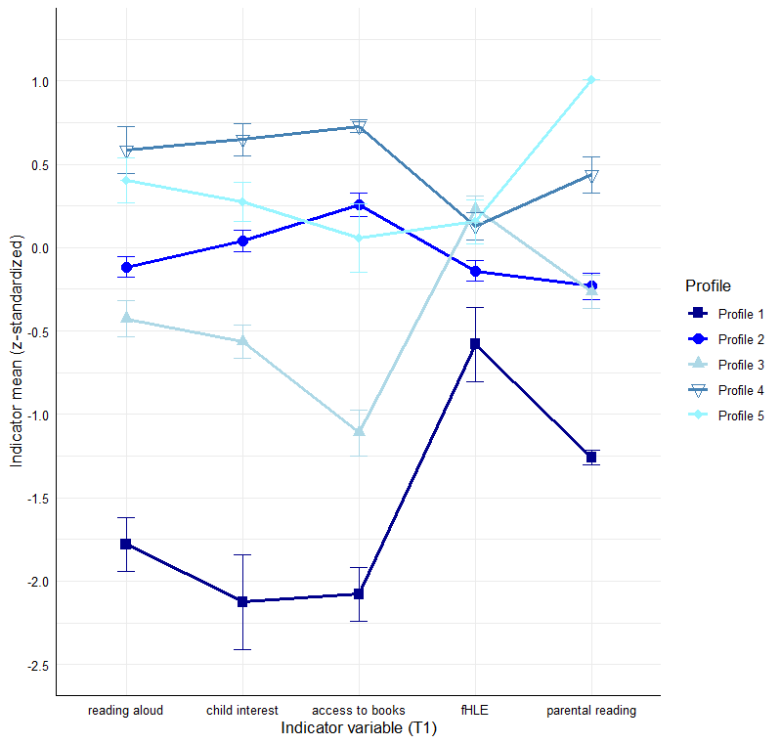
Note. fHLE = formal home literacy environment. Profile 1 = “very low HLE” (n = 20, 4.1%); Profile 2 = “average HLE” (n = 230, 47.4%); Profile 3 = “few books–above average formal HLE” (n = 84, 17.3%); Profile 4 = “high HLE–average formal HLE” (n = 96, 19.8%); Profile 5 = “average HLE–very frequent parental reading” (n = 55, 11.3%).

Figure S2

Differences in Vocabulary at T1 Between the Profiles

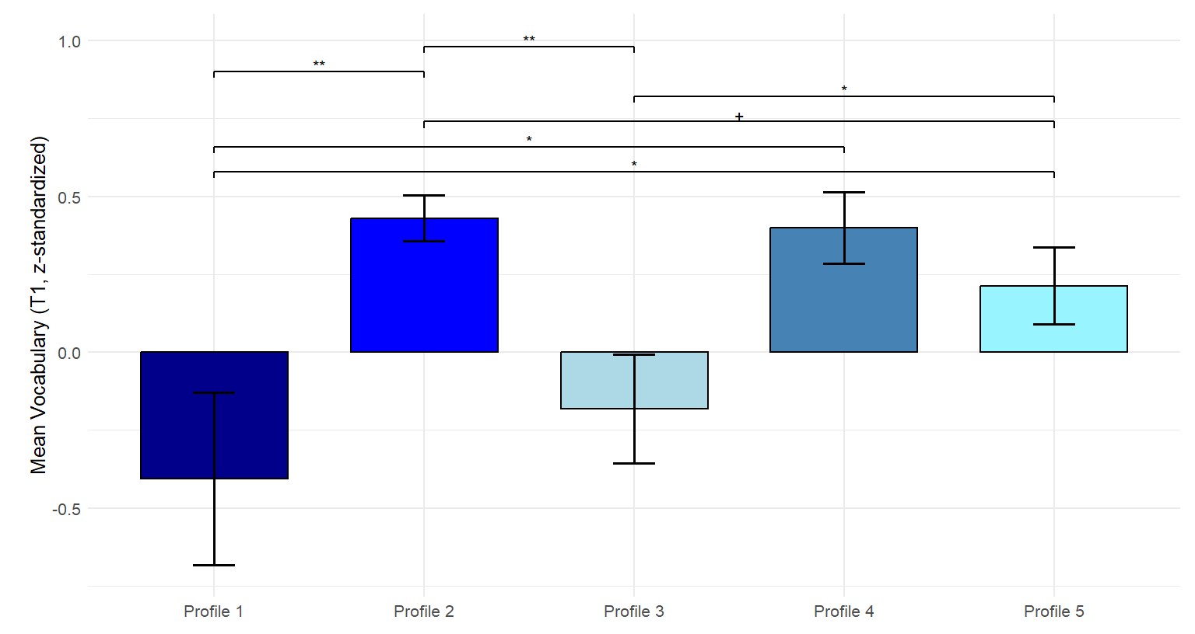
Note. Estimated vocabulary ± SE at T1 controlled for cohort, family, and child characteristics. Profile 1 = “very low HLE” (n = 20, 4.1%); Profile 2 = “average HLE” (n = 230, 47.4%); Profile 3 = “few books–above average formal HLE” (n = 84, 17.3%); Profile 4 = “high HLE–average formal HLE” (n = 96, 19.8%); Profile 5 = “average HLE–very frequent parental reading” (n = 55, 11.3%).
⁺ p < .10. *p < .05. **p < .01.

Figure S3

Differences in Vocabulary at T2 Between the Profiles Controlling for Vocabulary at T1
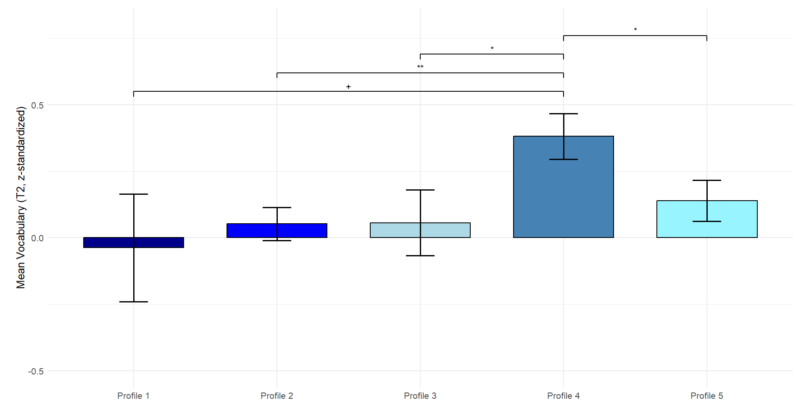
Note. Estimated vocabulary ± SE at T2 controlled for vocabulary at T1, cohort, family, and child characteristics. Profile 1 = “very low HLE” (n = 20, 4.1%); Profile 2 = “average HLE” (n = 230, 47.4%); Profile 3 = “few books–above average formal HLE” (n = 84, 17.3%); Profile 4 = “high HLE–average formal HLE” (n = 96, 19.8%); Profile 5 = “average HLE–very frequent parental reading” (n = 55, 11.3%).
⁺ p < .10. *p < .05. **p < .01.

Figure S4

Differences in Vocabulary at T3 Between the Profiles Controlling for Vocabulary at T1

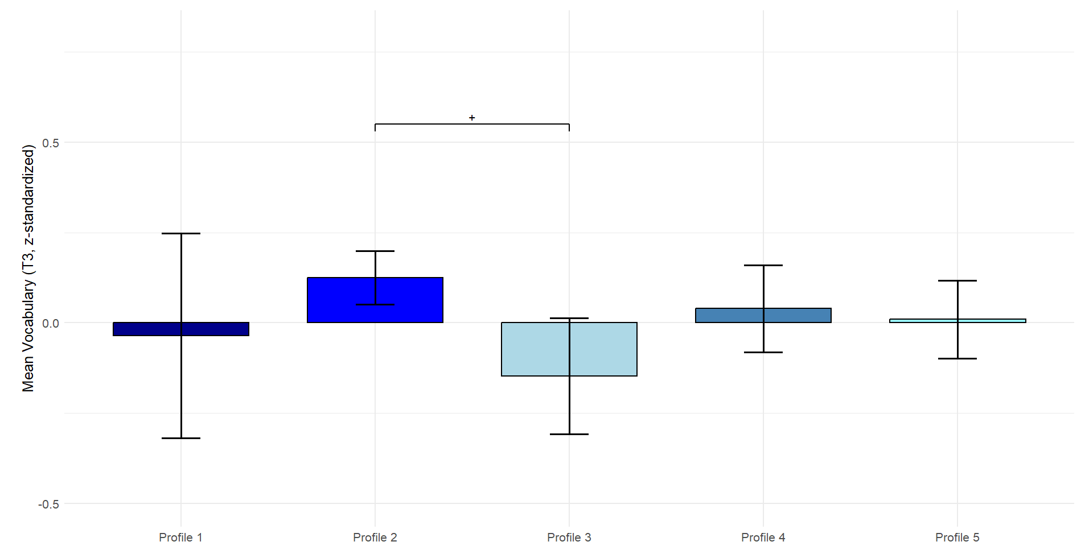
Note. Estimated vocabulary ± SE at T3 controlled for vocabulary at T1, cohort, family, and child characteristics. Profile 1 = “very low HLE” (n = 20, 4.1%); Profile 2 = “average HLE” (n = 230, 47.4%); Profile 3 = “few books–above average formal HLE” (n = 84, 17.3%); Profile 4 = “high HLE–average formal HLE” (n = 96, 19.8%); Profile 5 = “average HLE–very frequent parental reading” (n = 55, 11.3%).
⁺ p < .10.

Figure S5

Descriptive Differences in Vocabulary at T2 Between the Profiles

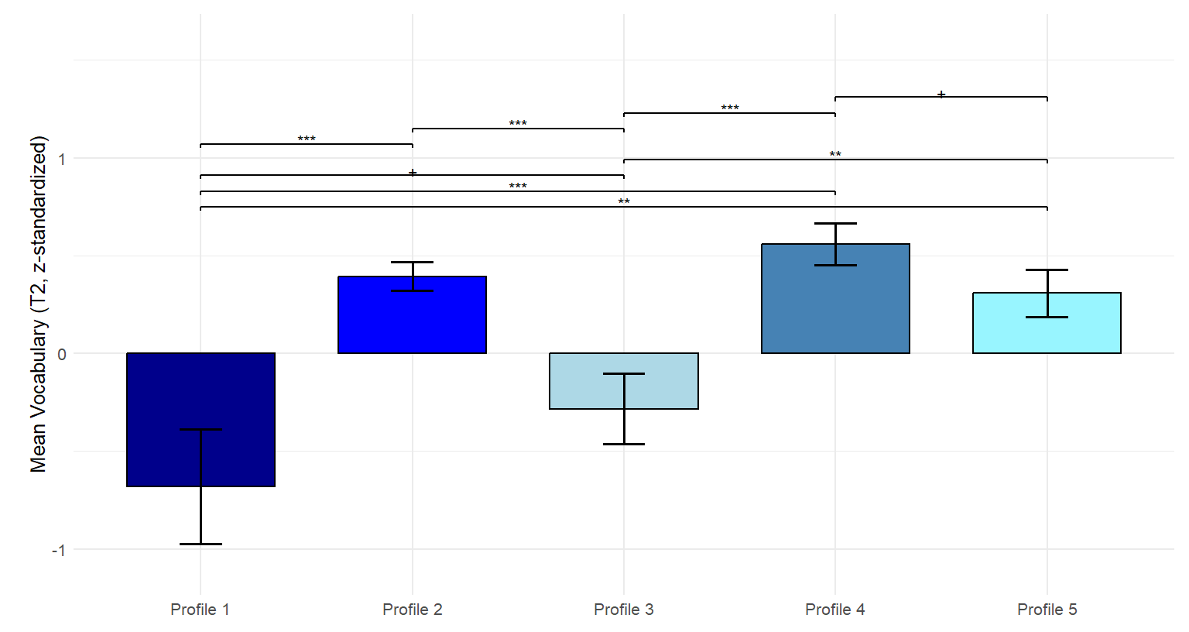
Note. Estimated vocabulary ± SE at T2 controlled for cohort, family, and child characteristics. Profile 1 = “very low HLE” (n = 20, 4.1%); Profile 2 = “average HLE” (n = 230, 47.4%); Profile 3 = “few books–above average formal HLE” (n = 84, 17.3%); Profile 4 = “high HLE–average formal HLE” (n = 96, 19.8%); Profile 5 = “average HLE–very frequent parental reading” (n = 55, 11.3%).
⁺ p < .10. **p < .01. ***p < .001.

Figure S6

Descriptive Differences in Vocabulary at T3 Between the Profiles
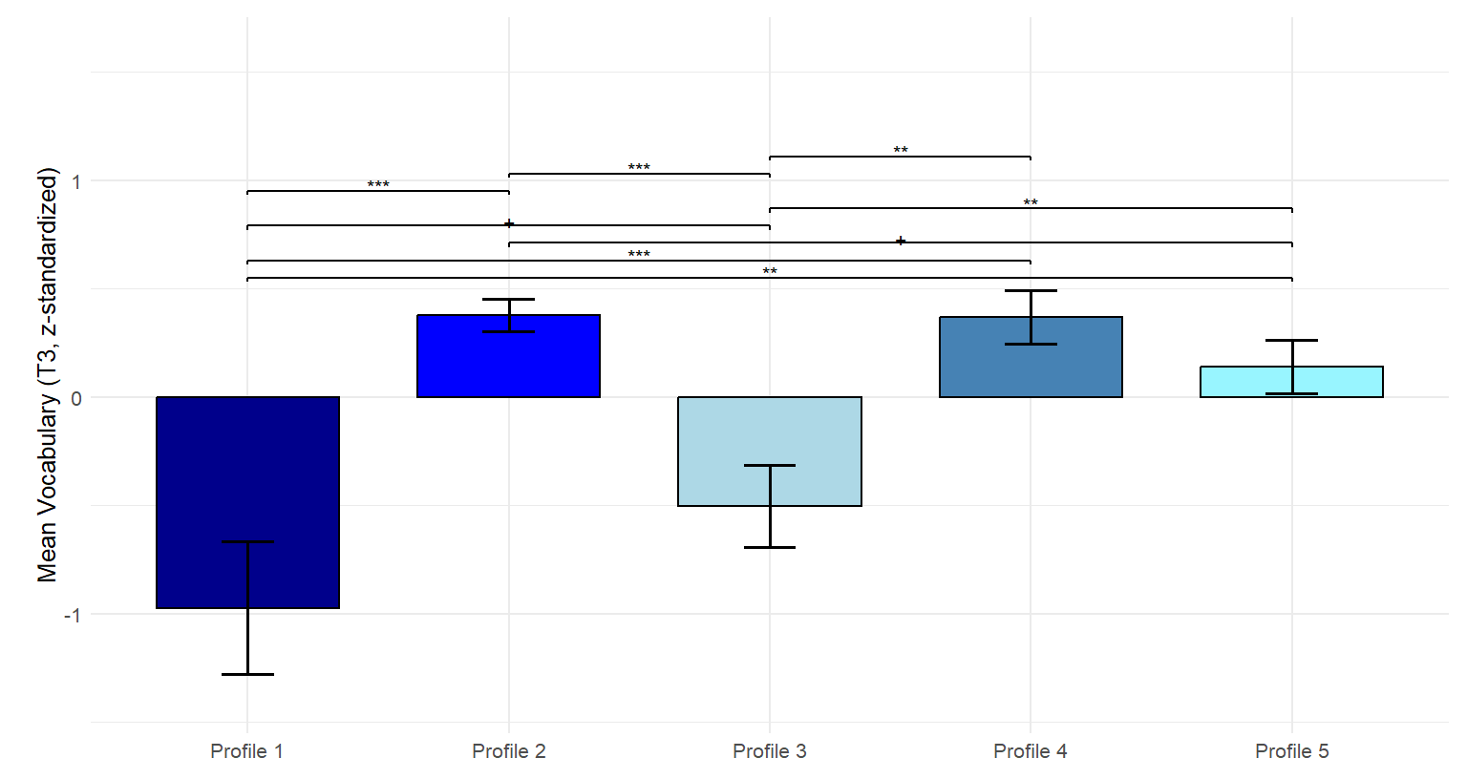
Note. Estimated vocabulary ± SE at T3 controlled for cohort, family, and child characteristics. Profile 1 = “very low HLE” (n = 20, 4.1%); Profile 2 = “average HLE” (n = 230, 47.4%); Profile 3 = “few books–above average formal HLE” (n = 84, 17.3%); Profile 4 = “high HLE–average formal HLE” (n = 96, 19.8%); Profile 5 = “average HLE–very frequent parental reading” (n = 55, 11.3%).
⁺ p < .10. **p < .01. ***p < .001.

Figure S7

Differences in Phonological Awareness at T1 Between the Profiles
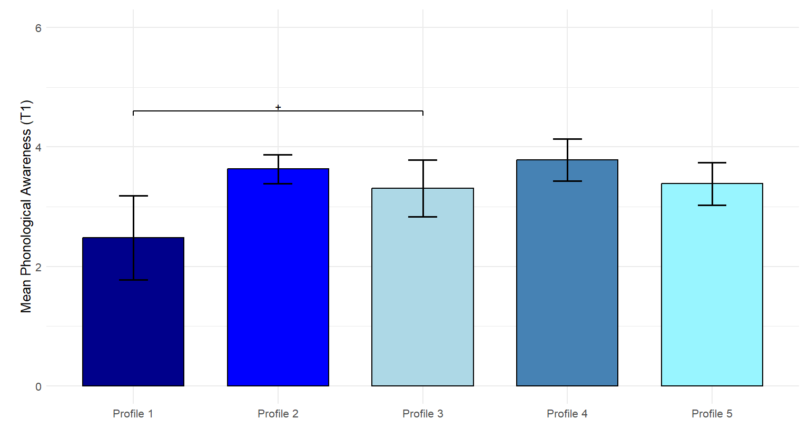
Note. Estimated phonological awareness skills ± SE at T1 controlled for cohort, family, and child characteristics. Profile 1 = “very low HLE” (n = 20, 4.1%); Profile 2 = “average HLE” (n = 230, 47.4%); Profile 3 = “few books–above average formal HLE” (n = 84, 17.3%); Profile 4 = “high HLE–average formal HLE” (n = 96, 19.8%); Profile 5 = “average HLE–very frequent parental reading” (n = 55, 11.3%).
⁺ p < .10.

Figure S8

Differences in Phonological Awareness at T2 Between the Profiles Controlling for Phonological Awareness at T1

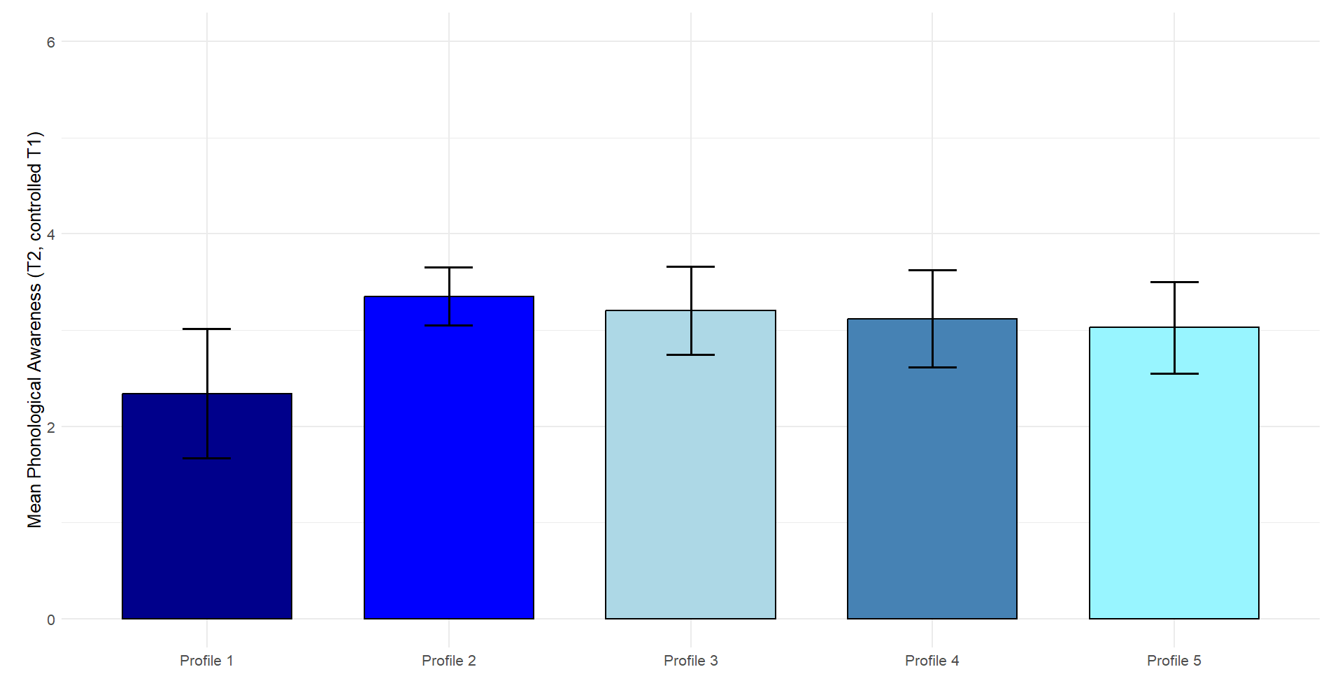
Note. Estimated phonological awareness skills ± SE at T2 controlled for phonological awareness skills at T1, cohort, and family and child characteristics. Profile 1 = “very low HLE” (n = 20, 4.1%); Profile 2 = “average HLE” (n = 230, 47.4%); Profile 3 = “few books–above average formal HLE” (n = 84, 17.3%); Profile 4 = “high HLE–average formal HLE” (n = 96, 19.8%); Profile 5 = “average HLE–very frequent parental reading” (n = 55, 11.3%).

Figure S9

Differences in Phonological Awareness at T3 Between the Profiles Controlling for Phonological Awareness at T1

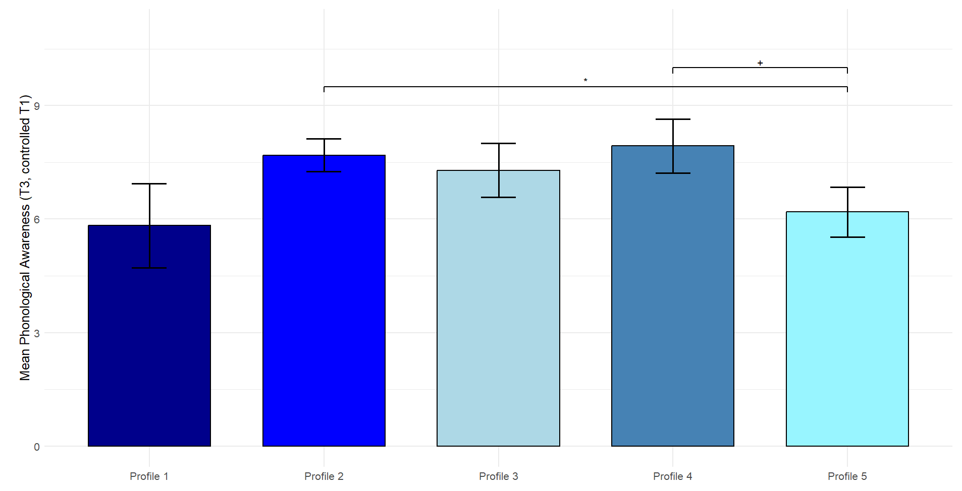
Note. Estimated phonological awareness skills ± SE at T3 controlled for phonological awareness skills at T1, cohort, and family and child characteristics. Profile 1 = “very low HLE” (n = 20, 4.1%); Profile 2 = “average HLE” (n = 230, 47.4%); Profile 3 = “few books–above average formal HLE” (n = 84, 17.3%); Profile 4 = “high HLE–average formal HLE” (n = 96, 19.8%); Profile 5 = “average HLE–very frequent parental reading” (n = 55, 11.3%).
⁺ p < .10. *p < .05.

Figure S10

Descriptive Differences in Phonological Awareness Skills at T2 Between the Profiles
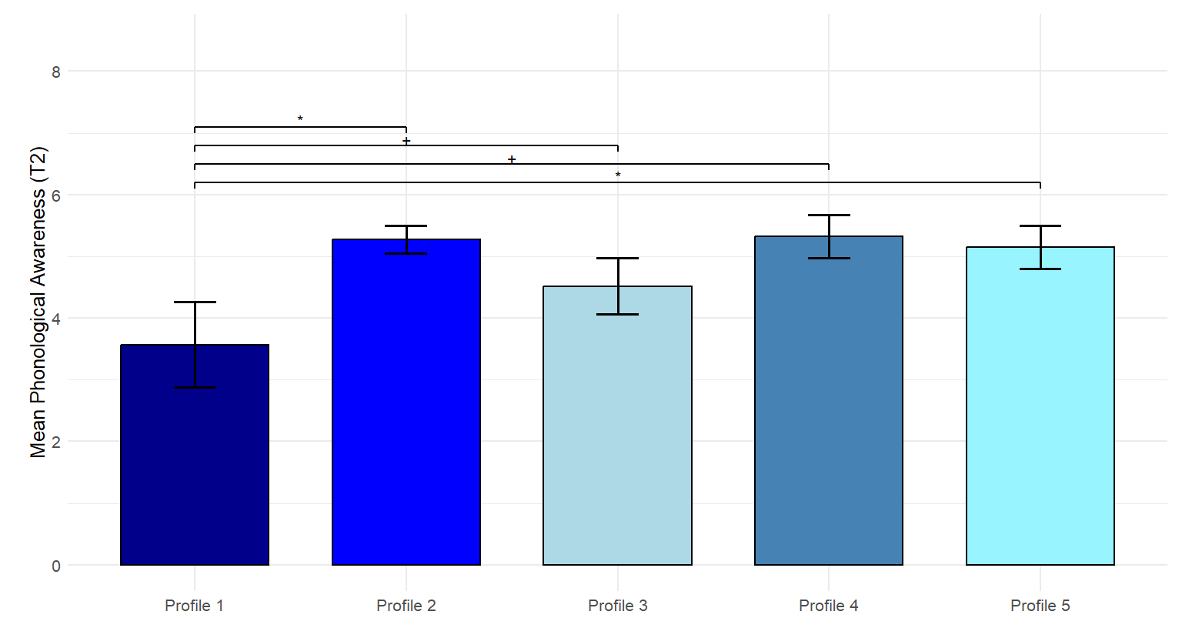

Note. Estimated phonological awareness skills ± SE at T2 controlled for cohort, family, and child characteristics. Profile 1 = “very low HLE” (n = 20, 4.1%); Profile 2 = “average HLE” (n = 230, 47.4%); Profile 3 = “few books–above average formal HLE” (n = 84, 17.3%); Profile 4 = “high HLE–average formal HLE” (n = 96, 19.8%); Profile 5 = “average HLE–very frequent parental reading” (n = 55, 11.3%).
⁺ p < .10. *p < .05.

Figure S11

Descriptive Differences in Phonological Awareness Skills at T3 Between the Profiles
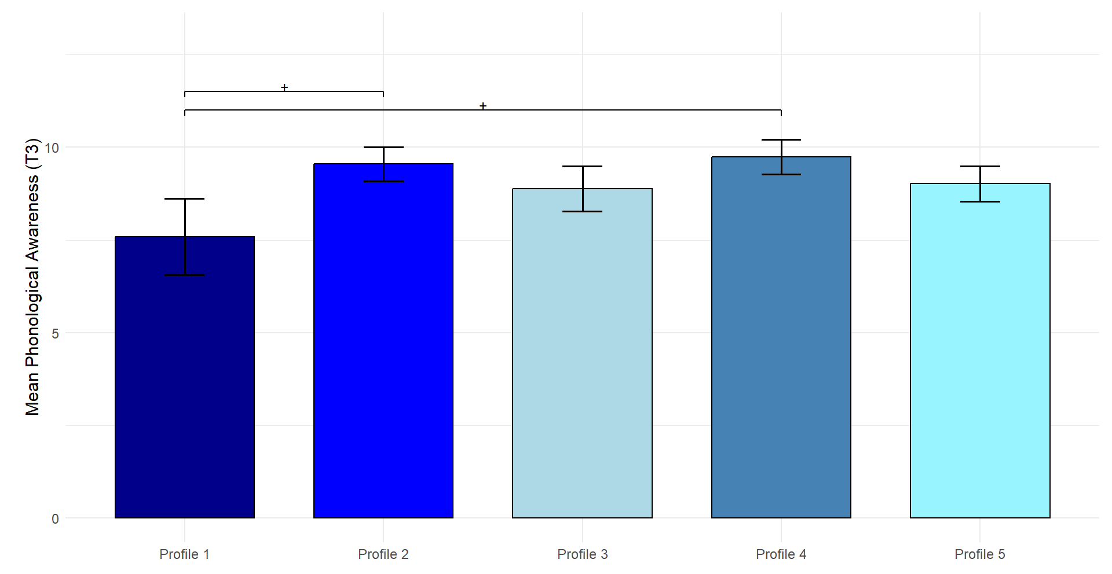

Note. Estimated phonological awareness skills ± SE at T3 controlled for cohort, family, and child characteristics. Profile 1 = “very low HLE” (n = 20, 4.1%); Profile 2 = “average HLE” (n = 230, 47.4%); Profile 3 = “few books–above average formal HLE” (n = 84, 17.3%); Profile 4 = “high HLE–average formal HLE” (n = 96, 19.8%); Profile 5 = “average HLE–very frequent parental reading” (n = 55, 11.3%).
⁺ p < .10.

Figure S12

Differences in Letter Knowledge at T1 Between the Profiles

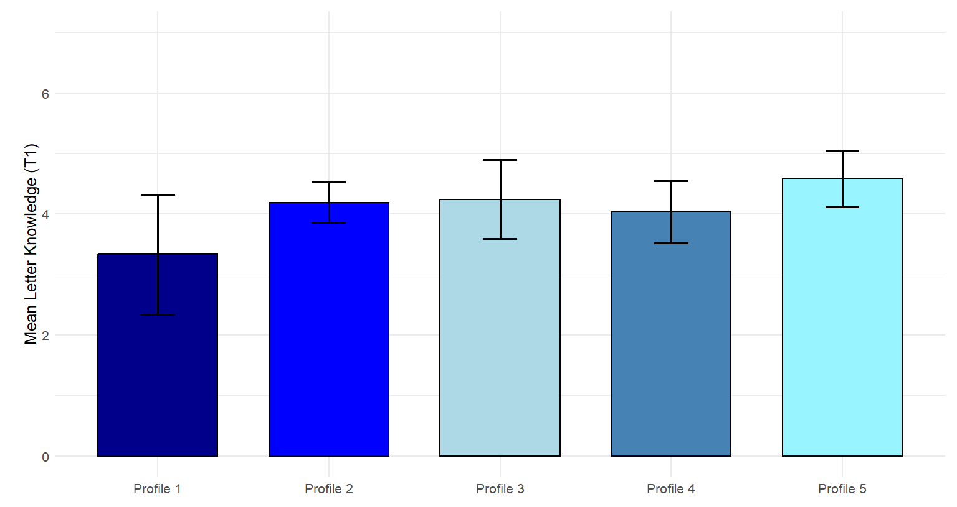
Note. Estimated letter knowledge skills ± SE at T1 controlled for cohort, family, and child characteristics. Profile 1 = “very low HLE” (n = 20, 4.1%); Profile 2 = “average HLE” (n = 230, 47.4%); Profile 3 = “few books–above average formal HLE” (n = 84, 17.3%); Profile 4 = “high HLE–average formal HLE” (n = 96, 19.8%); Profile 5 = “average HLE–very frequent parental reading” (n = 55, 11.3%).

Figure S13

Differences in Letter Knowledge at T2 Between the Profiles Controlling for Letter Knowledge at T1

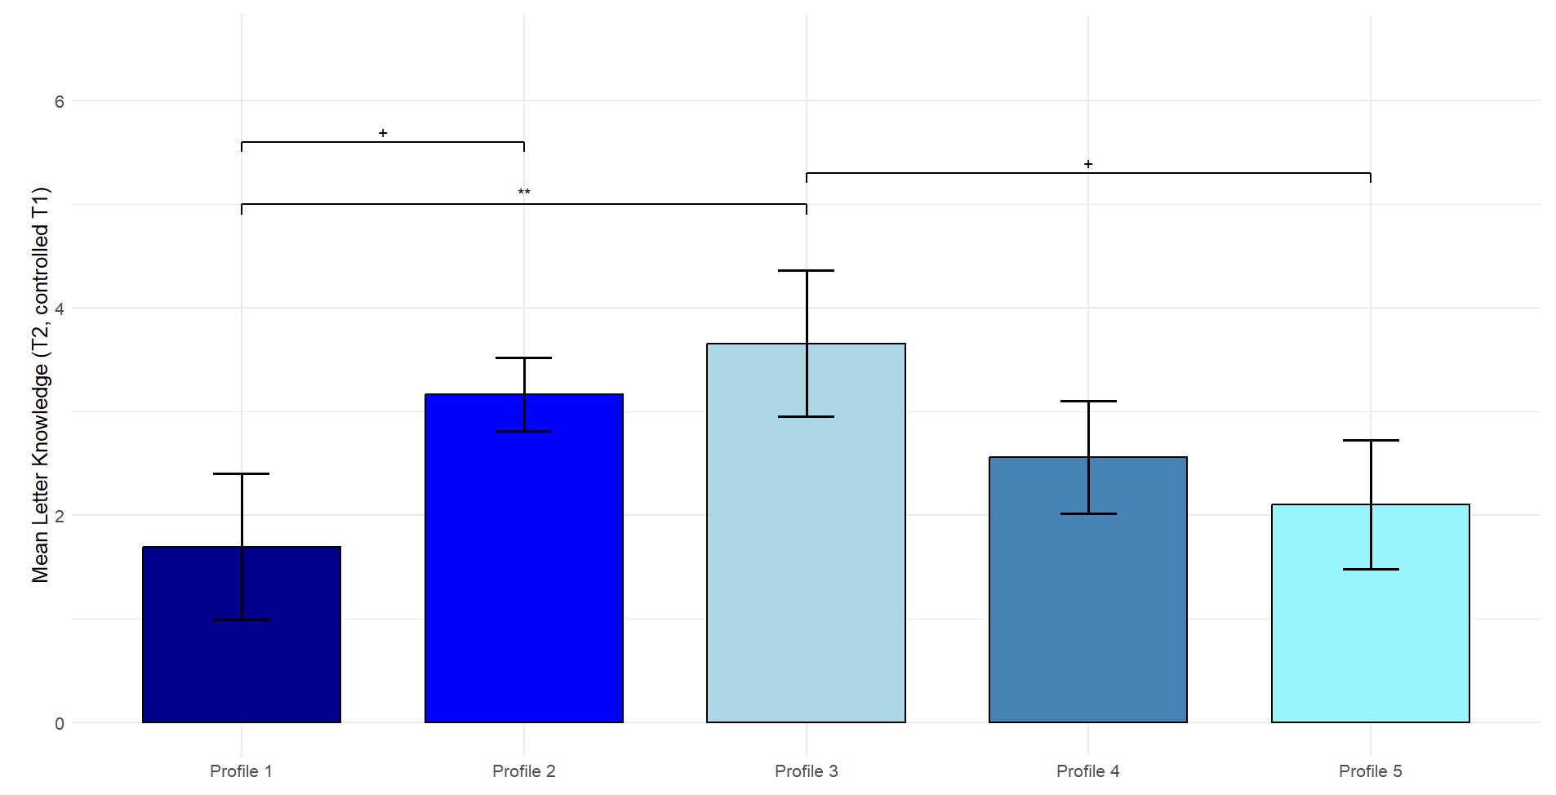
Note. Estimated letter knowledge skills ± SE at T2 controlled for letter knowledge skills at T1, cohort, and family and child characteristics. Profile 1 = “very low HLE” (n = 20, 4.1%); Profile 2 = “average HLE” (n = 230, 47.4%); Profile 3 = “few books–above average formal HLE” (n = 84, 17.3%); Profile 4 = “high HLE–average formal HLE” (n = 96, 19.8%); Profile 5 = “average HLE–very frequent parental reading” (n = 55, 11.3%).
⁺ p < .10. **p < .01.

Figure S14

Differences in Letter Knowledge at T3 Between the Profiles Controlling for Letter Knowledge at T1

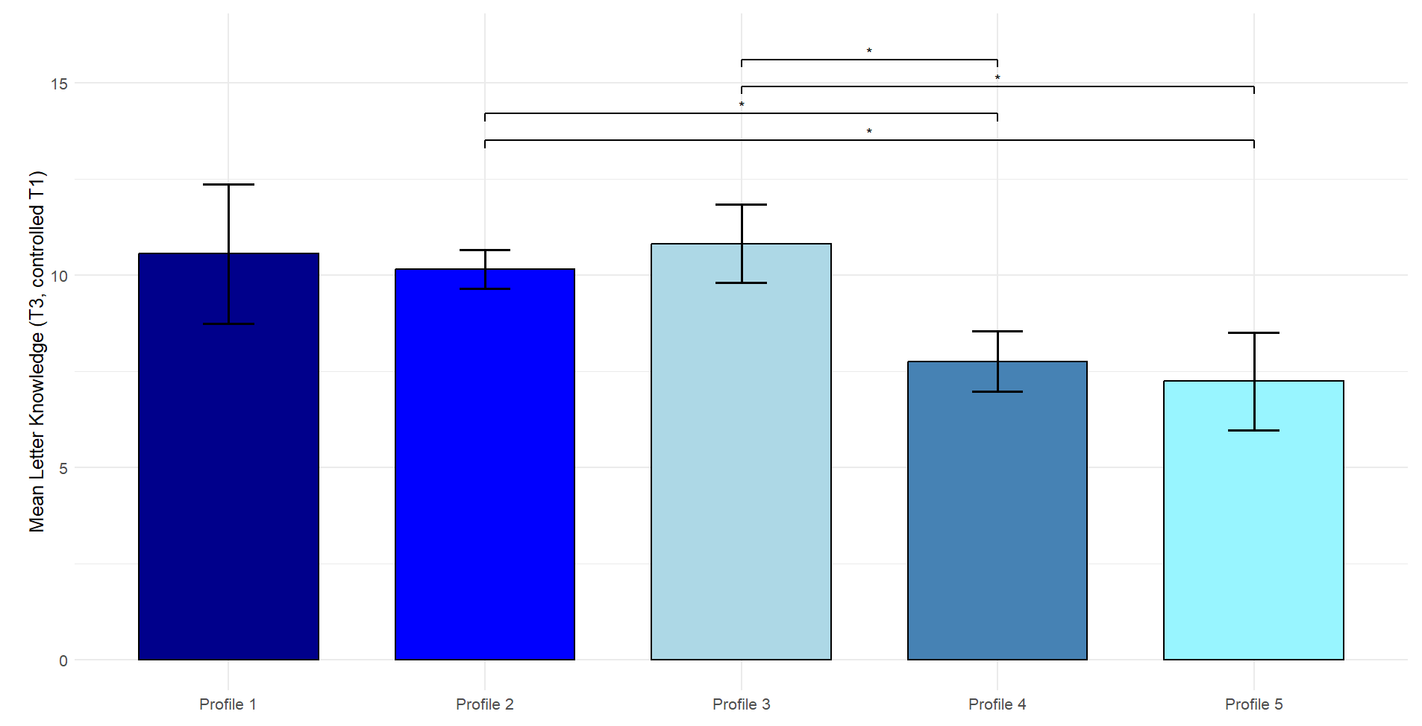
Note. Estimated letter knowledge skills ± SE at T3 controlled for letter knowledge skills at T1, cohort, and family and child characteristics. Profile 1 = “very low HLE” (n = 20, 4.1%); Profile 2 = “average HLE” (n = 230, 47.4%); Profile 3 = “few books–above average formal HLE” (n = 84, 17.3%); Profile 4 = “high HLE–average formal HLE” (n = 96, 19.8%); Profile 5 = “average HLE–very frequent parental reading” (n = 55, 11.3%).
*p < .05.

Figure S15

Descriptive Differences in Letter Knowledge at T2 Between the Profiles
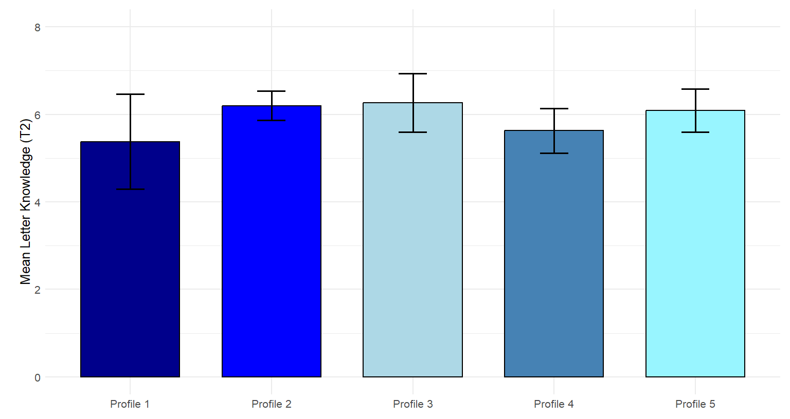

Note. Estimated letter knowledge ± SE at T2 controlled for cohort, family, and child characteristics. Profile 1 = “very low HLE” (n = 20, 4.1%); Profile 2 = “average HLE” (n = 230, 47.4%); Profile 3 = “few books–above average formal HLE” (n = 84, 17.3%); Profile 4 = “high HLE–average formal HLE” (n = 96, 19.8%); Profile 5 = “average HLE–very frequent parental reading” (n = 55, 11.3%).

Figure S16

Descriptive Differences in Letter Knowledge at T3 Between the Profiles
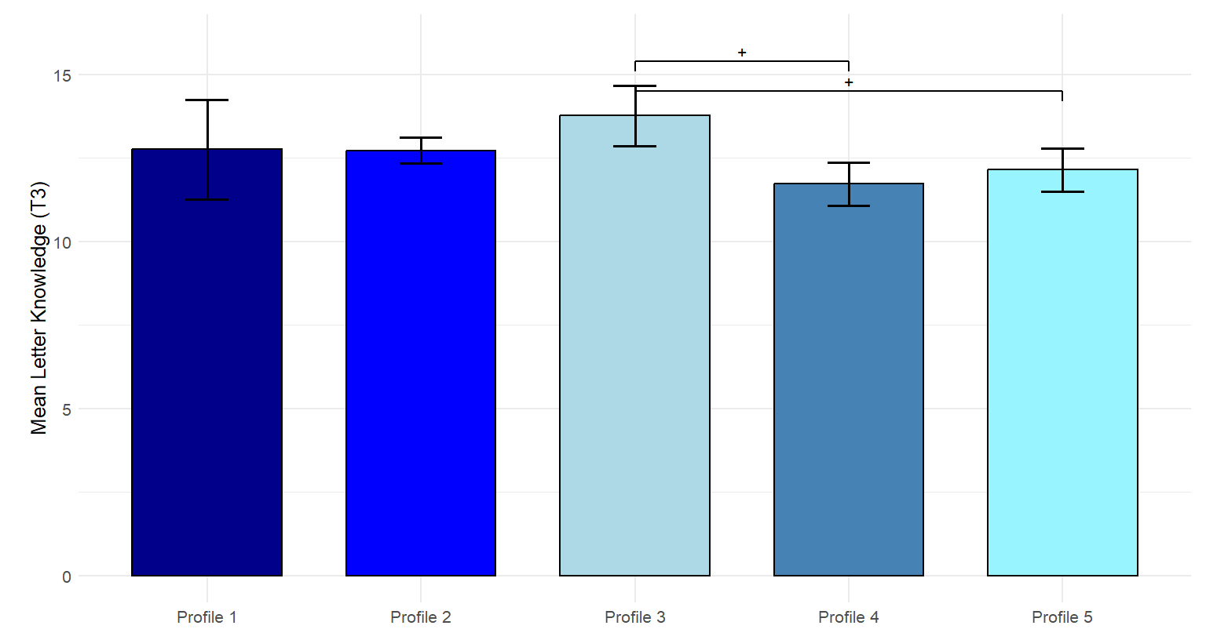
Note. Estimated letter knowledge ± SE at T3 controlled for cohort, family, and child characteristics. Profile 1 = “very low HLE” (n = 20, 4.1%); Profile 2 = “average HLE” (n = 230, 47.4%); Profile 3 = “few books–above average formal HLE” (n = 84, 17.3%); Profile 4 = “high HLE–average formal HLE” (n = 96, 19.8%); Profile 5 = “average HLE–very frequent parental reading” (n = 55, 11.3%).
⁺ p < .10.

Figure S17
Method Triangulation: Variable-Centered Path Model of Family and Child Characteristics, Home Literacy Environment, and Children’s Emergent Literacy Development
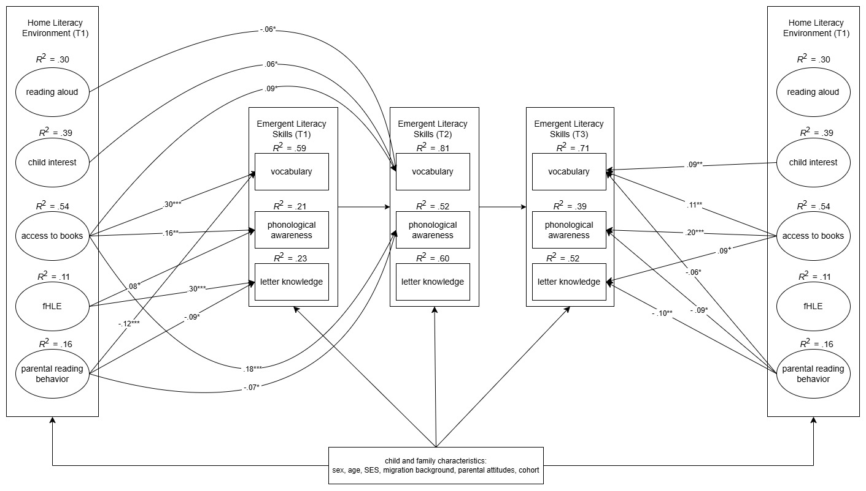
Note. fHLE = formal home literacy environment. Standardized regression coefficients are presented. The HLE is presented twice for clarity reasons. All paths are controlled for child (sex, age) and family characteristics (SES = socioeconomic status, migration background, and parental attitudes towards reading), and cohort, which are omitted from this figure for visual clarity. Emergent literacy skills are correlated within each measurement point (T1, T2, T3), and these within-time correlations are also omitted for visual parsimony. Autoregressive paths between measurement points for each literacy skill are included in the model but not shown in the figure. The complete model specification, including all control variables, correlations, and autoregressive paths, is available on OSF and in Tables S9-S13. χ²(9) = 53.301, p = .000; Comparative Fit Index (CFI) = .991; Root Mean Square Error of Approximation (RMSEA) = .099; Standardized Root Mean Square Residual (SRMR) = .057.
⁺p < .10. *p < .05. **p < .01. ***p < .001.

