Supplemental Materials
Figure S1
Confirmatory Factor Analysis on the Academic Self-Concept Measurement Model
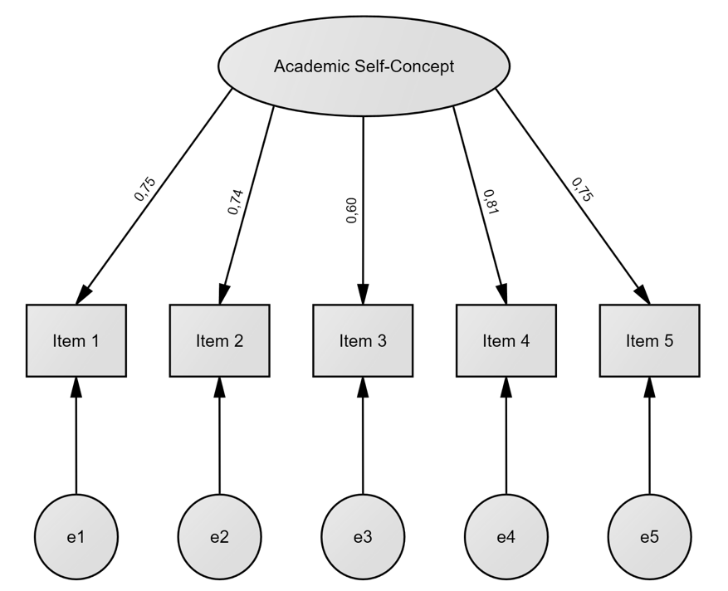
Note. Estimated parameters represent standardized factor loadings.

Figure S2
Confirmatory Factor Analysis on the Pretest Measurement Model
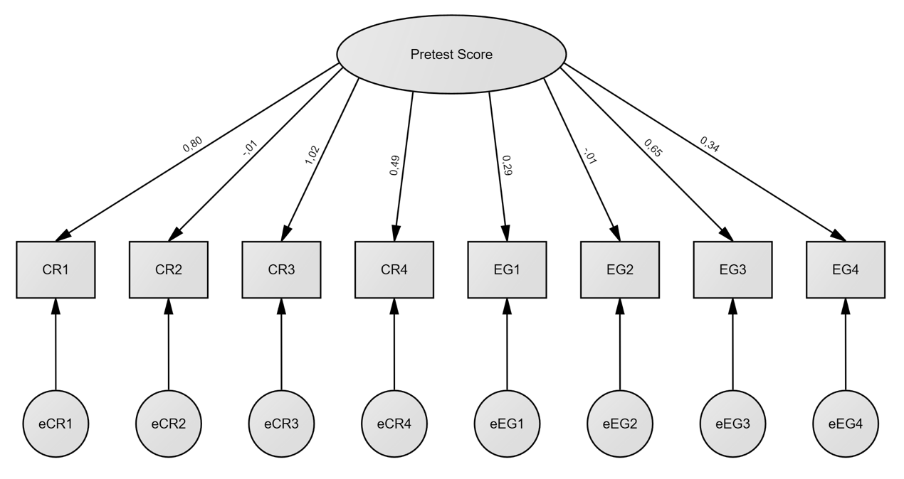
Note. Estimated parameters represent standardized factor loadings. Residual variables are represented by the circles at the bottom. CR = Cued recall question. EG = Example generation question.

Figure S3
Confirmatory Factor Analysis on the Respecified Pretest Measurement Model
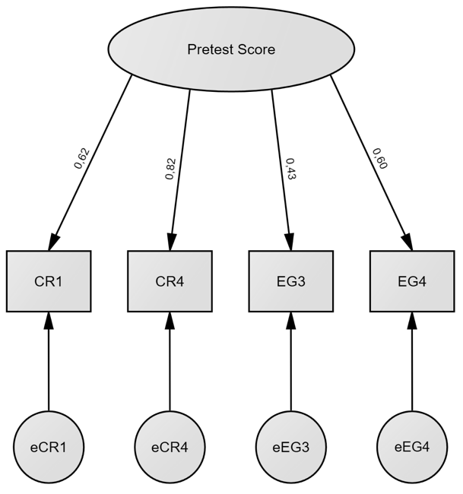
Note. Estimated parameters represent standardized factor loadings. Residual variables are represented by the circles at the bottom. CR = Cued recall question. EG = Example generation question.

Figure S4
Confirmatory Factor Analysis on the Retrieval Task Measurement Model
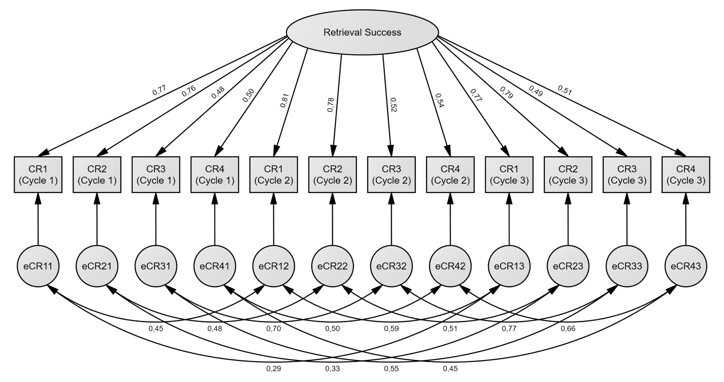
Note. Estimated parameters represent standardized factor loadings. Residual variables are represented by the circles at the bottom. CR = Cued recall task. Correlations between residual variables that relate to identical cued recall tasks (e.g., CR1 in cycle 1, 2, and 3) were allowed.

Figure S5
Confirmatory Factor Analysis on the Generative Task Measurement Model
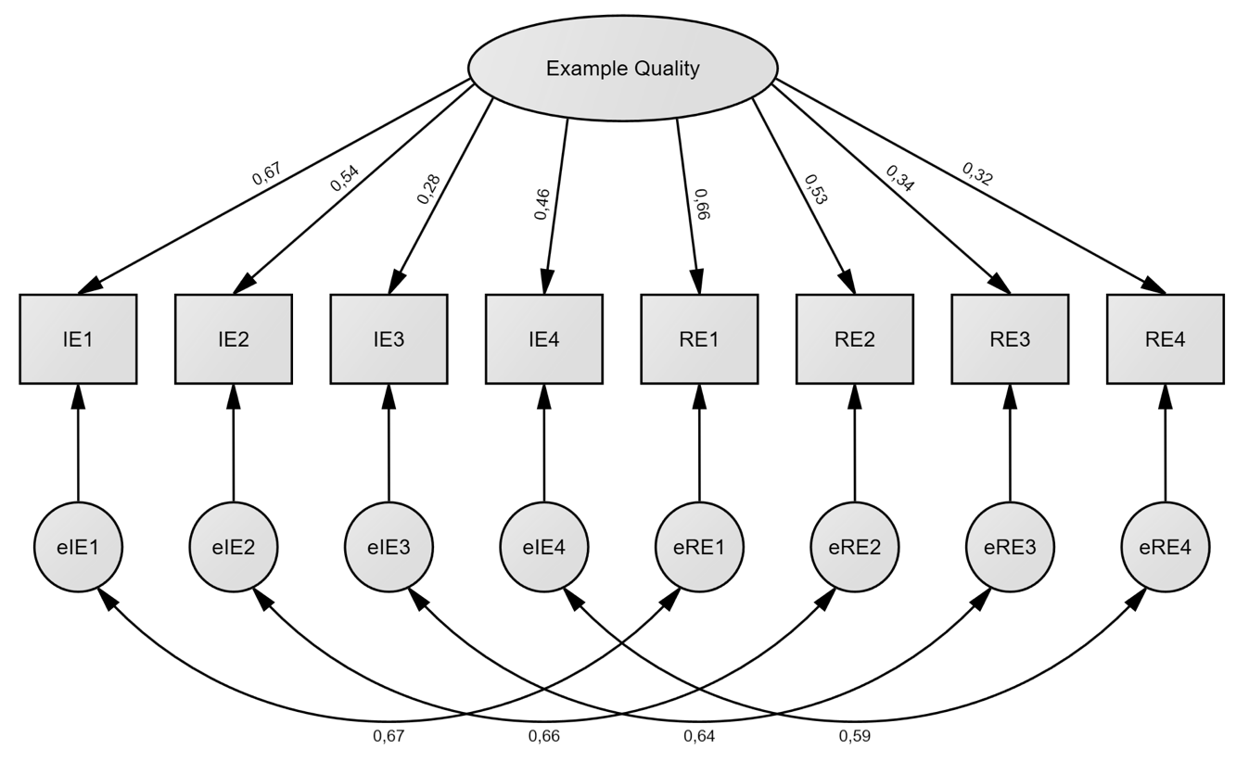
Note. Estimated parameters represent standardized factor loadings. Residual variables are represented by the circles at the bottom. IE = Initial example. RE = Revised example. Correlations between residual variables that relate to examples generated for the same concept (e.g., initial and revised example for concept 1) were allowed.

Figure S6
Confirmatory Factor Analysis on the Posttest Measurement Model
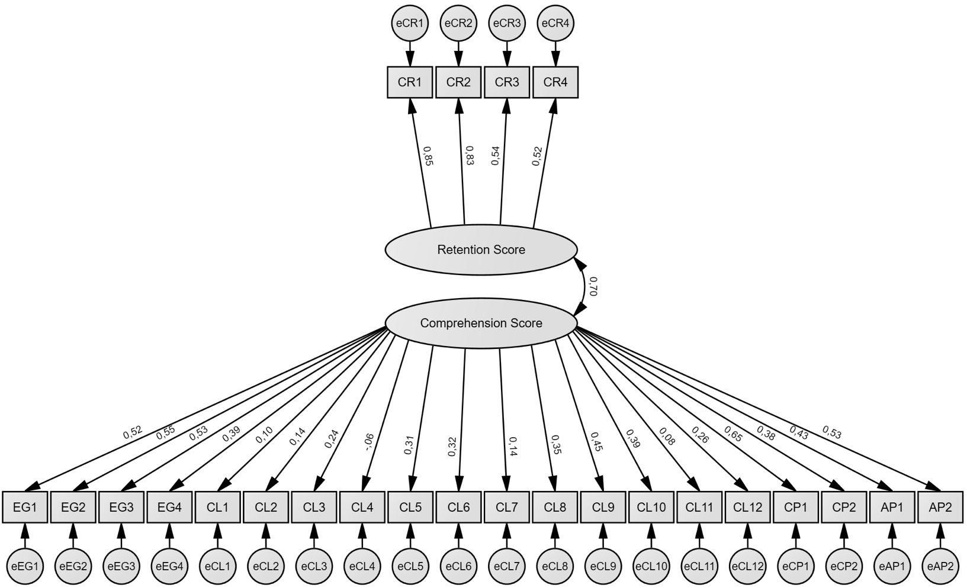
Note. Estimated parameters represent standardized factor loadings (single-headed arrows) or latent factor correlations (double-headed arrows). Residual variables are represented by the circles at the bottom. CR = Cued recall question. EG = Example generation question. CL = Classification question. CP = Comparison question. AP = Application question.
Figure S7
Confirmatory Factor Analysis on the Respecified Posttest Measurement Model
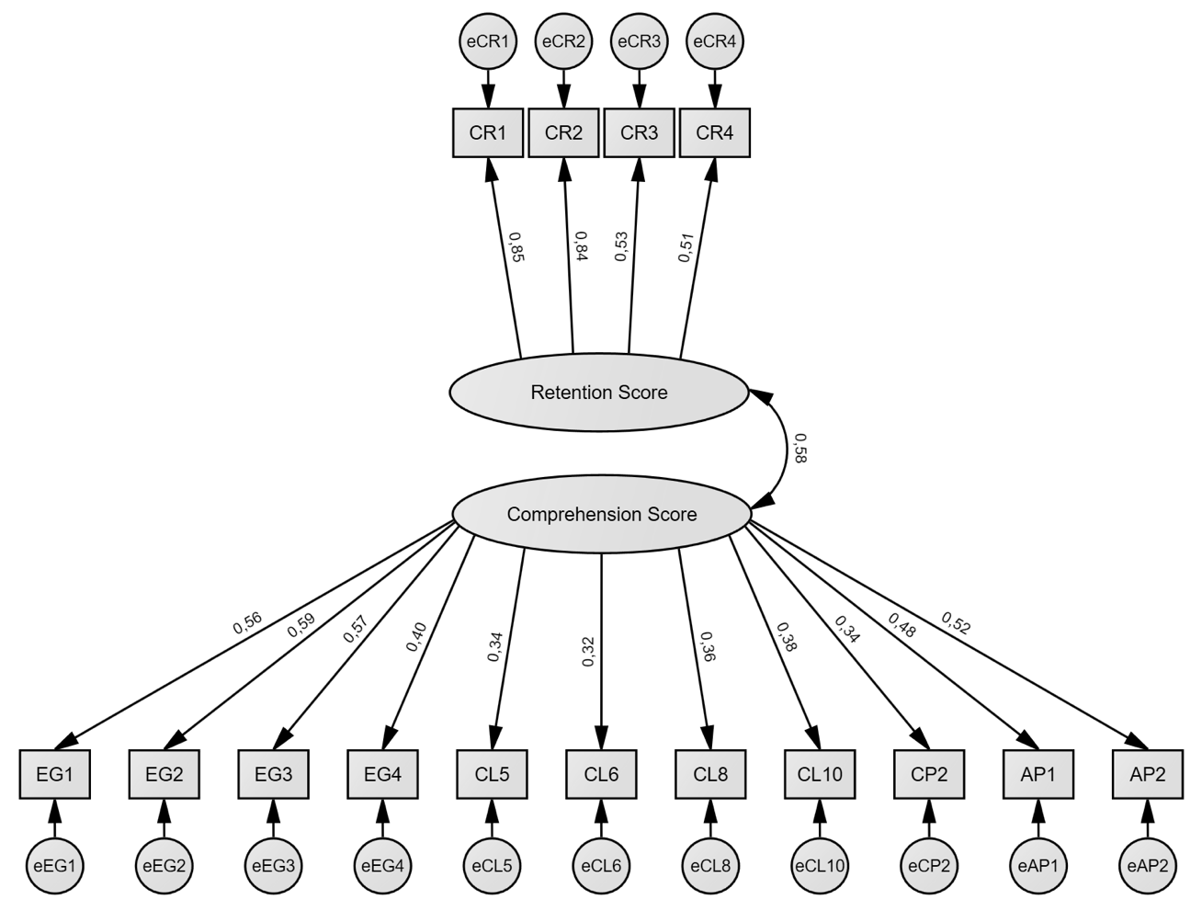
Note. Estimated parameters represent standardized factor loadings (single-headed arrows) or latent factor correlations (double-headed arrows). Residual variables are represented by the circles at the bottom. CR = Cued recall question. EG = Example generation question. CL = Classification question. CP = Comparison question. AP = Application question.

