Supplement to Using Theory-Informed Learning Analytics to Understand How Homework Behavior Predicts Achievement

Table of Contents
Supplement A: Approval of the study
Supplement B: Overview of performance tests
Supplement C: Overview of surveys (self-reported items and descriptive statistics)
Supplement D: Distributions of selected variables before and after winsorizing
Supplement E: CFA results for the scales
Supplement F: Overview of missing values for all survey and test variables
Supplement G: Comparison of different PCA solutions
Supplement H: Scatter plots for behavioral component values with English proficiency test scores

Supplement A
Approval of the Interact4School Study
The present information regarding approval and detailed information on the recruitment process of the Interact4School study can also be read in Parrisius, Wendebourg, Rieger, et al. (2024).
Approval
Data for the <name blinded for review> study were collected in three German federal states (i.e., Baden-Württemberg, Hamburg, and North Rhine-Westphalia). For Baden-Württemberg, the Ministry of Education and Cultural Affairs in Baden-Württemberg approved the study and the collection of the data (date of approval: July 19, 2021, file number: 31-6499.21/629/1). For Hamburg, the “Behörde für Schule und Berufsbildung” (Authority for School and Vocational Training) approved the study and the collection of the data (date of approval: July 13, 2021, file number e514.101.5000-002/221,025). In line with school law in North Rhine-Westphalia, according to which no superior ministry is responsible for approving school studies, the study and data collection in this federal state were approved by the individual head principals from the participating schools. The Ethics Committee for Psychological Research at the <institution blinded for review> confirmed that the study procedures aligned with ethical research standards with human subjects (date of approval: August 4, 2021, file number: A2.5.4-184_ns).

Supplement B
Overview of Performance Tests
English Proficiency – General Language Test (C-test; Pretest)

A typical C-test, a general English proficiency test, comprises five to six authentic text units with 25 blanks each. It is based on the concept of reduced redundancy. This text is the first of five texts that were presented to the seventh-grade English learners in this investigation:
My First Rabbit

My very first wonder of the world was a big, soft Angora rabbit. Her na_____ was Sarah. I lo_____ this rabbit more th_____ I loved m_____ baby sister. T_____ rabbit never ope_____ her mouth a_____ screamed and to_____ all the atten_____ away from m_____. The rabbit ne_____ woke everybody i_____ the mid_____ of the ni_____. No, Sarah ju_____ sat there un_____ a tree in our gar_____ and waited patie_____ for me t_____ come and gi_____ her more car_____ and more bread ea_____ day. And any_____ , to have a rabbit w_____ something special. Nob_____ else at school had a rabbit, but baby sisters were two a penny, and everyone had them.

English Proficiency – Specific Language Test (Post-test)

Proficiency Test | Time point | Grammatical structure | Sample item | Target answer(s) for sample item | Number of items
Posttest task cycle 1 | T2 | Simple Past | An hour ago, Susan (receive) an important phone call. | Received | 15
 |  | Modals | You ___ do something about the situation if you can. | Should | 5
 |  | Gerund | The jar doesn’t open. Let us try (use) a piece of cloth. | Using | 10
 |  |  |  |  | Total: 30
Note. After collecting the data, we systematically checked again all item wordings and observed ambiguity concerning one item from posttest task cycle 1 (i.e., “This winter we (spend) a lot of time at home.”) We decided to exclude it from the analyses.

All C-test and posttest items can be found in the corresponding PsychArchive repository: https://pasa.psycharchives.org/reviewonly/07606352ed4859ae419ca5b51ca71ce6d908ab1d0afe8f58ab91d0f31ebdb03e.

Supplement C
Overview of Self-Reported Items and Descriptive Statistics

Students’ Self-Reports

Scale/construct | Item (English/German) | Source
 | How true are these statements about you? / Wie sehr treffen diese Aussagen auf dich zu?
Personality – conscientiousness | I am efficient and work fast. / Ich bin tüchtig und arbeite flott. | BFI-K, Rammstedt & John (2005)
 | I plan things and carry them out. / Ich mache Pläne und führe sie auch durch. | BFI-K, Rammstedt & John (2005)
 | I do my work thoroughly. / Ich erledige meine Aufgaben gründlich. | BFI-K, Rammstedt & John (2005)
 | I tend to be lazy. / Ich bin bequem, neige zu Faulheit. | BFI-K, Rammstedt & John (2005)
Motivation – self-concept English | I just have no talent for English. / Für Englisch habe ich einfach keine Begabung. | Gaspard et al. (2017)
 | English just isn’t my thing. / Englisch liegt mir nicht besonders. | Gaspard et al. (2017)
 | I am good at English. / Ich bin gut in Englisch. | Gaspard et al. (2017)
 | English comes naturally to me. / Englisch fällt mir leicht. | Gaspard et al. (2017)
 | I am satisfied with my English performance. / Ich bin mit meiner Leistung in Englisch zufrieden. | Adapted from the Intrinsic Motivation Inventory (IMI), McAuley et al. (1989)
 | I usually feel confident in dealing with English. / Ich fühle mich im Umgang mit Englisch meist recht sicher. | Adapted from the Intrinsic Motivation Inventory (IMI), McAuley et al. (1989)
Motivation – intrinsic value English | English is fun for me. / Englisch macht mir Spaß. | Gaspard et al. (2017)
 | I like doing English. / Ich mache Englisch gerne. | Gaspard et al. (2017)
 | I simply like English. / Englisch mag ich einfach. | Gaspard et al. (2017)
Motivation – attainment value English | To be good at English means a lot to me. / Gut in Englisch zu sein, bedeutet mir viel. | Gaspard et al. (2017)
 | A good English grade is very important to me. / Mir ist eine gute Englischnote sehr wichtig. | Gaspard et al. (2017)
 | I care a lot about retaining the material in English. / Mir liegt viel daran den Stoff in Englisch zu behalten. | Gaspard et al. (2017)
 | English as a subject is important to me. / Das Fach Englisch hat für mich eine große Bedeutung. | Adapted from Gaspard et al. (2017)
Motivation – utility value English | Knowing about the subject of English brings me many advantages in my daily life. / Das Wissen aus dem Fach Englisch bringt mir im täglichen Leben viele Vorteile. | Gaspard et al. (2017)
 | Knowledge in English comes in handy during everyday life and leisure time. / Englischkenntnisse kann man im Alltag und in der Freizeit gut gebrauchen | Gaspard et al. (2017)
 | For my future working life it will pay off to be good in English. / Für meine berufliche Zukunft wird es sich auszahlen, gut in Englisch zu sein. | Gaspard et al. (2017)
 | Being good at English is worth it because you need it for school. / In Englisch gut zu sein lohnt sich, weil man es in der Schule einfach braucht. | Adapted from Gaspard et al. (2017)
Motivation – cost English | Doing English is exhausting to me. / Mich mit Englisch zu beschäftigen ist anstrengend. | Gaspard et al. (2017)
 | Dealing with English drains a lot of my energy. / Die Beschäftigung mit Englisch kostet mich eine Menge Energie. | Gaspard et al. (2017)
 | When dealing with English I ususally feel hopeless. / Wenn ich mich mit Englisch beschäftige, fühle ich mich oft hoffnungslos. | Self-developed
 | I am disappointed when I cannot solve a task in English. / Ich bin enttäuscht, wenn ich in Englisch eine Aufgabe nicht richtig lösen kann. | Self-developed
 | Dealing with English is boring to me. / Mich mit Englisch auseinanderzusetzen ist langweilig. | Self-developed
 | Dealing with English usually frustrates me. / Die Beschäftigung mit Englisch frustriert mich oftmals. | Self-developed
 | I’d have to sacrifice a lot of free time to be good at English. / Um in Englisch gut zu sein, müsste ich viel Freizeit opfern. | Gaspard et al. (2017)
 | How do you go about completing the tasks in FeedBook? / Wie verhälst du dich bei der Erledigung der Aufgaben im FeedBook?
Self-reported homework behavior | I am doing my best with the exercises in FeedBook. / Ich tue mein Bestes bei den Aufgaben im FeedBook. | Meurers et al. (2019)
 | Recently I have been working on the English exercises in FeedBook as well as I can. / Ich bearbeite in letzter Zeit meine Englischaufgaben im Feedbook so gut ich kann. | Meurers et al. (2019)
 | I try to fully complete my English exercises in FeedBook. / Ich versuche immer meine Englischaufgaben im Feedbook vollständig zu erledigen. | Meurers et al. (2019)

Descriptive Statistics

 | M | SD | Min | Max | Reliability
Prior English knowledge
 | 0.00 | 1.00 | -2.57 | 4.02 | 0.93
Homework behavior predictors
Sex (1 = male) | 0.44 | 0.50 | 0 | 1 | -
Conscientiousness | 0.00 | 0.49 | -1.60 | 1.38 | 0.71
Self-concept English | 0.00 | 0.61 | -1.87 | 1.17 | 0.87
Specific intrinsic value English | 0.00 | 0.25 | -0.87 | 0.78 | 0.90
Specific attainment value English | 0.00 | 0.40 | -1.55 | 0.98 | 0.78
Specific utility value English | 0.00 | 0.37 | -0.97 | 0.96 | 0.68
Specific cost value English | 0.00 | 0.42 | -0.97 | 0.96 | 0.82
General value factor | 0.00 | 0.60 | -1.70 | 1.25 | -
Self-reported homework effort | 0.00 | 0.49 | -1.95 | 0.58 | 0.83
Posttest English
 | 0.00 | 1.00 | -2.55 | 1.94 | 0.85
Note. Scale values are latent scores derived from CFA. The test scores were z-standardized.

Supplement D
Distributions of Selected Variables Before and After Winsorizing
 |  |  | Distribution
Description | Winsorized | Reason for winsorizing | Before | After | Percentage winsorized (of all students)
Proportion of task fields submitted correctly | no |  | 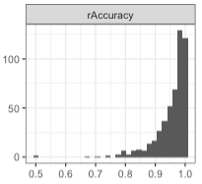 | --- | 0.0
Proportion of used opportunities to correct | no |  | 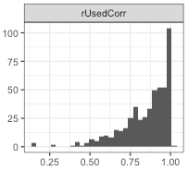 | --- | 0.0
Proportion of tasks only attempted | no |  | 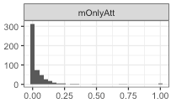 | --- | 0.0
Proportion of tasks submitted completely | no |  | 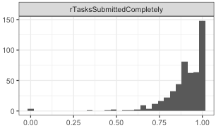 | --- | 0.0
Average sequence length | yes | Long sequence lengths appear together with low time on feedback and a lot of attempts. This hints trial and error and no concentrated working on the task. | 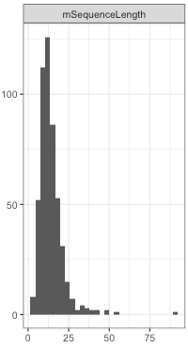 | 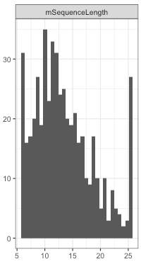 | 10.30
Average time per task field (in seconds) | yes | Longer durations result from working breaks within a task which reflect inactive time and no longer active working time on a task field | 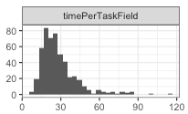 | 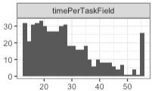 | 10.30
Average first attempt response time (in seconds) | yes | Students took breaks while working on a task resulting in long task field durations that do not reflect on-task but rather off-task behavior. | 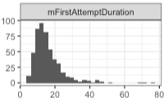 | 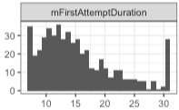 | 10.30
Average no. of attempts per task field | no |  | 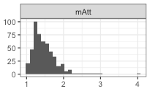 | --- | 0.0
Average time on feedback (in seconds) | yes | Particularly long feedback times (up to 30 sec) seem to be not plausible because of really short feedback messages (i.e., one sentence long messages) | 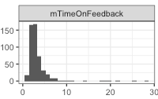 | 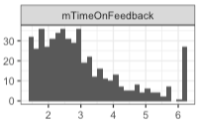 | 9.70
Average duration of last attempt (in seconds) | yes | Students took breaks while working on a task resulting in long task field durations that do not reflect on-task but rather off-task behavior. | 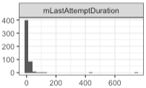 | 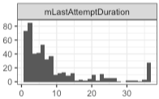 | 7.52
Proportion of task fields solved correct at first try | no |  | 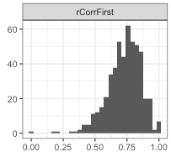 | --- | 0.0
Proportion of capstone tasks submitted | no |  | 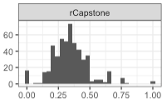 | --- | 0.0
If tasks were practiced again in practice mode | no |  | 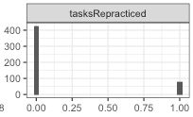 | --- | 0.0
Proportion of more practice tasks submitted | no |  | 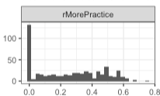 | --- | 0.0
SD of submission timestamps (in seconds) | yes | Some students worked on task cycle 1, after it was offically finished, we want to anlayze only task cycle 1 data | 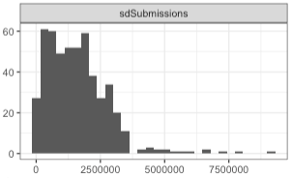 | 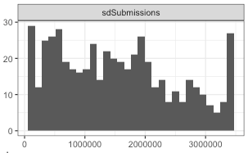 | 10.30
Proportion of active practicing days | no |  | 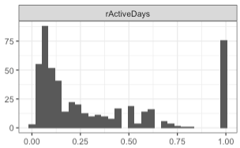 | --- | 0.0
Note. The x-axis displays the count, and the y-axis displays the value within each histogram.

Supplement E
CFA Results for the Scales
Factor | Item | Standardized loading
Specific intrinsic value | Intrinsic value 1 | 0.43*
 | Intrinsic value 2 | 0.41*
 | Intrinsic value 3 | 0.44*
Specific attainment value | Attainment value 1 | 0.70*
 | Attainment value 2 | 0.58*
 | Attainment value 3 | 0.27*
 | Attainment value 4 | 0.25*
Specific utility value | Utility value 1 | 0.57*
 | Utility value 2 | 0.66*
 | Utility value 3 | 0.37*
 | Utility value 4 | 0.08
Specific cost value | Cost 1 | 0.57*
 | Cost 2 | 0.66*
 | Cost 3 | 0.61*
 | Cost 4 | 0.36*
 | Cost 5 | 0.03
 | Cost 6 | 0.60*
 | Cost 7 | 0.58*
Expectancy | Expectancy 1 | 0.77*
 | Expectancy 2 | 0.73*
 | Expectancy 3 | 0.82*
 | Expectancy 4 | 0.81*
 | Expectancy 5 | 0.67*
General value factor | Intrinsic value 1 | 0.78*
 | Intrinsic value 2 | 0.78*
 | Intrinsic value 3 | 0.70*
 | Attainment value 1 | 0.53*
 | Attainment value 2 | 0.45*
 | Attainment value 3 | 0.54*
 | Attainment value 4 | 0.62*
 | Utility value 1 | 0.45*
 | Utility value 2 | 0.46*
 | Utility value 3 | 0.37*
 | Utility value 4 | 0.40*
 | Cost 1 | -0.52*
 | Cost 2 | -0.42*
 | Cost 3 | -0.51*
 | Cost 4 | 0.18*
 | Cost 5 | -0.72*
 | Cost 6 | -0.51*
 | Cost 7 | -0.39*
Conscientiousness | Conscientiousness 1 | 0.65*
 | Conscientiousness 2 | 0.49*
 | Conscientiousness 3 | 0.56*
 | Conscientiousness 4 | 0.57*
Self-reported homework behavior | Self-reported homework behavior 1 | 0.82*
Self-reported homework behavior | Self-reported homework behavior 2 | 0.74*
 | Self-reported homework behavior 3 | 0.77*
Note. * p < .05.

Supplement F
Overview of Missing Values for All Survey and Test Variables
Variable | N_{missing}
 | Absolute | In %
Self-reported homework behavior | 10 | 1.97
Self-concept English | 32 | 6.31
Intrinsic value English | 32 | 6.31
Attainment value English | 43 | 8.48
Utility value English | 40 | 7.89
Cost English | 51 | 10.06
Sex | 0 | 0
Conscientiousness | 70 | 13.81
English Pretest | 0 | 0
English Posttest | 0 | 0

Supplement G
Comparison of Different PCA Solutions

N components | RMSR | SRMR | Cumulative variance explained
2 | 0.12 | 0.11 | 0.37
3 | 0.09 | 0.07 | 0.49
4 | 0.08 | 0.05 | 0.58
5 | 0.07 | 0.03 | 0.66
6 | 0.07 | 0.02 | 0.72

Supplement H
Scatter Plots of All Study Variables with English Proficiency Test Scores

Homework behavior components with English proficiency
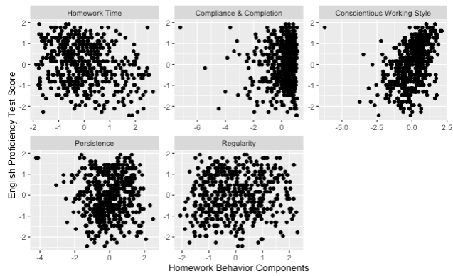

Students’ conscientiousness, motivation, and prior knowledge with English proficiency
