Supplementary materials for

What are the long-term prospects for children with comprehension weaknesses? A registered report investigating education and employment outcomes

Contents
Appendix S1: Sample descriptors 2
Figure S1 2
Table S1 3
Table S2 4
Appendix S2: UK SATs assessments 5
Appendix S3: Supplementary information for main analysis 7
Table S3 7
Table S4 8
Appendix S4: Question 1 (SATs) without school clustering 9
Table S5 10
Table S6 11
Appendix S5: Question 2 (GCSE) results without school clustering 13
Table S7 13
Table S8 14
Appendix S6: Exploratory analyses including reading ability as a covariate 15
Figure S2 15
Table S9 16
Table S10 17
Table S11 18
Table S12 19

Appendix S1: Sample descriptors

Figure S1
Sample-standardised scores for each reading profile on each selection measure
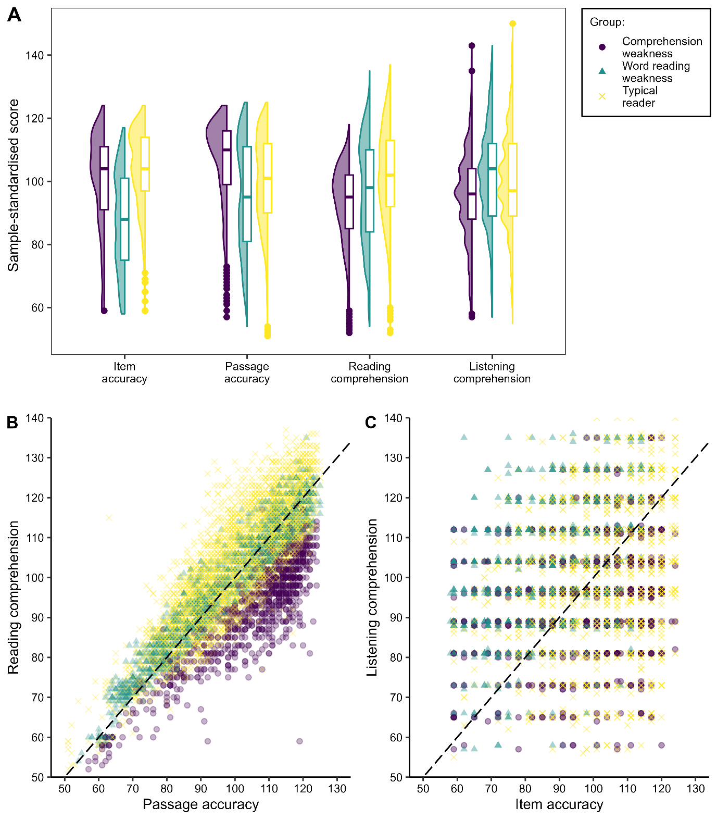
Note. (A) Distribution of scores on the two word reading and two comprehension measures included in the latent profile analysis; (B) Distribution of scores on the NARA measures of passage accuracy and comprehension; (C) Distribution of scores on the item accuracy (word and nonword reading) and WOLD listening comprehension measure. The dashed lines represent equivalent performance on the word reading and comprehension measures.

Table S1
Parent-reported needs for special arrangements at school at age 10

 | Comprehension weakness  (82.58%)ª | Word reading weakness  (81.49%)ª | No reading weakness  (82.06%)ª
Overall needs | 11.25 | 18.9 | 11.31
Emotional or behavioural problem | 1.53 | 1.86 | 1.73
Eyesight problem | 0.77 | 1.24 | 0.76
Hearing problem | 2.17 | 1.69 | 1.16
Learning difficulty | 5.63 | 9.58 | 4.21
Physical problem | 0.77 | 1.15 | 0.78
Reading difficulty | 3.71 | 10.56 | 3
Speech problem | 1.28 | 0.89 | 0.51
Other | 2.17 | 4.88 | 3.53
Note. a) Proportion of subgroup with data available

Table S2
School report of current special educational needs in Year 6 (age 10-11 years)

 | Comprehension weakness  (59.34%)ª | Word reading weakness  (58.50%)ª | No reading weakness  (55.47%)ª
Developmental delay | 1.43 | 1.11 | 0.48
Emotional and behavioural difficulties | 2.67 | 5.18 | 3.47
Learning difficulties | 9.79 | 18.29 | 7.7
Medical conditions | 3.03 | 2.09 | 1.12
Physical disabilities | 1.07 | 1.36 | 0.68
Specific learning difficulties | 3.92 | 8.92 | 4.15
Speech and language difficulties | 3.39 | 1.97 | 1.28
Sensory impairment (hearing) | 0.71 | 0.62 | 0.44
Sensory impairment (visual) | 0.36 | 0.25 | 0.52
Other | 8.39 | 14.57 | 8.87
Note. a) Proportion of subgroup with data available

Appendix S2: UK SATs assessments

Children in the ALSPAC cohort span three academic years. Year 6 SATs were completed by members of the cohort in the 2001/2002, 2002/2003, and 2003/2004 academic years. Year 9 SATs were completed by members of the cohort in the 2004/2005, 2005/2006, and 2006/2007 academic years.
Some relevant past SATs papers can be found on websites, such as https://www.testbase.co.uk/past-papers/ and https://www.sats-papers.co.uk/.
Of particular interest to readers may be the reading and language comprehension demands of the mathematics assessments. Sample first/last questions from Year 6 and Year 9 SATs papers are provided for reference below.

KS2 Mathematics (Year 6) – Paper 1 sample questions
From Qualifications and Curriculum Authority, 2003.
- Write in the missing numbers.
37 x ___ = 111
225 - ___ = 150
___ ÷ 4 = 21
(24) 30 children are going on a trip. It costs £5 including lunch. Some children take their own packed lunch. They pay only £3. The 30 children pay a total of £110. How many children are taking their own packed lunch?

KS2 Mathematics (Year 6) – Mental mathematics sample questions
From Qualifications and Curriculum Authority, 2003.
(1) “Write in figures the number one thousand and twenty.”
(20) “Look at your answer sheet. What is the angle between the hands of a clock at four o’clock?”

KS3 Mathematics (Year 9) – Paper 1 sample questions
From Qualifications and Curriculum Authority, 2003.
(1) On each spinner right five numbers to make the statements correct.
It is certain that you will get a number less than 6.
It is more likely that you will get an even number than an odd number.
It is impossible that you will get a multiple of three.
(21) The scatter graph shows 15 pupils’ coursework and test marks. To find a pupil’s total mark, you add the coursework mark to the test mark.
Which pupil had the highest mark?
Look at the statement below. Tick True or False. The range of coursework marks was greater than the range of test marks. Explain your answer.
Pupils with total marks in the shaded region on the graph win a prize. What is the smallest total mark needed to win a prize?

KS3 Mathematics (Year 9) – Mental mathematics sample questions
From Qualifications and Curriculum Authority, 2006.
(1) “A teacher divides a class of thirty pupils into six equal groups. How many pupils are in each group?”
(30) “m squared equals one hundred. Write down the two possible values of m plus fifteen.”

Appendix S3: Supplementary information for main analysis

Table S3
Data availability (n; %) in covariate and outcome variables for each reading group

 | Comprehension weakness  (n = 947) | Word reading weakness  (n = 1383) | No reading weakness  (n = 4516)
Covariates
Sex | 947 (100%) | 1382 (99.93%) | 4505 (99.76%)
Maternal education | 876 (92.50%) | 1271 (91.90%) | 4104 (90.88%)
Free school meal status | 800 (84.48%) | 1127 (81.49%) | 3780 (83.70%)
Outcome variables
SATs (Year 6)ª | 807 (85.22%) | 1171 (84.67%) | 3882 (85.96%)
SATs (Year 9)ª | 722 (76.24%) | 1007 (72.81%) | 3372 (74.67%)
GCSEsª | 794 (83.84%) | 1113 (80.48%) | 3738 (82.77%)
NEET status | 396 (41.82%) | 625 (45.19%) | 2001 (44.31%)
Note. (a) Data availability for educational outcomes is reported based on the availability of a school ID, as this was necessary for inclusion in the main analysis which included school clustering.

Table S4
Odds ratios for group comparisons of SATs performance in each subject
 | Base model |  |  |  |  | Adjusted model
 | B | SE | OR [95% CI] |  |  | B | SE | OR [95% CI]
CW vs. DW  English | 0.66 | 0.16 | 0.52 | [0.38, | 0.71] | 1.13 | 0.27 | 0.32 | [0.19, | 0.55]
Maths | 0.08 | 0.16 | 0.92 | [0.67, | 1.27] | 0.58 | 0.27 | 0.56 | [0.33, | 0.95]
Science | -0.51 | 0.16 | 1.66 | [1.22, | 2.27] | 0.04 | 0.26 | 0.96 | [0.57, | 1.61]
CW vs. TD  English | -0.43 | 0.13 | 1.53 | [1.18, | 2.00] | -0.16 | 0.22 | 1.17 | [0.76, | 1.80]
Maths | -0.91 | 0.14 | 2.49 | [1.90, | 3.26] | -0.52 | 0.22 | 1.68 | [1.08, | 2.59]
Science | -1.26 | 0.14 | 3.52 | [2.69, | 4.59] | -0.77 | 0.22 | 2.16 | [1.40, | 3.31]
DW vs. TD  English | -1.09 | 0.12 | 2.96 | [2.36, | 3.72] | -1.29 | 0.21 | 3.62 | [2.42, | 5.43]
Maths | -0.99 | 0.12 | 2.70 | [2.14, | 3.41] | -1.09 | 0.20 | 2.98 | [2.00, | 4.44]
Science | -0.75 | 0.12 | 2.11 | [1.68, | 2.67] | -0.81 | 0.20 | 2.24 | [1.51, | 3.32]

Appendix S4: Question 1 (SATs) without school clustering
Our primary analytical approach excluded the majority of children with missing data on the outcome variables, as they did not have an associated School ID to allow for clustering. To complement this analysis, our preregistered approach at Stage 1 was to conduct a supplementary analysis without school as random effect, thereby allowing all predictor and outcome variables to be imputed for all participants.
We preregistered the same mixed effects regression approach, including only participant ID as a random effect. However, when analysing the SATs data, the full model with covariates suffered convergence issues that could not be resolved, and no alternative was preregistered at Stage 1. For transparency, we present the base model using the initial mixed effects approach in Table S5 (as per Stage 1 plans). We then present both the base and covariate-adjusted models in Table S6, using a standard cumulative link regression model with cluster-robust standard errors to address for non-independence (not preregistered at Stage 1).

Table S5
Reading profile differences in meeting SATs target attainment levels according to subject and assessment point (supplementary analysis without school clustering, using a mixed effects model)
 | Base model
 | B | SE | t | p | OR [95% CI]
-1 | 0 | -4.05 | 0.06 | -63.8 | <.001 | 0.02 | [0.02, | 0.02]
0 | 1 | 0.26 | 0.05 | 5.11 | <.001 | 1.30 | [1.18, | 1.44]
CW-DW | 0.00 | 0.14 | 0.02 | .981 | 1.00 | [0.76, | 1.33]
CW-TD | 0.94 | 0.12 | 7.68 | <.001 | 2.55 | [2.01, | 3.25]
Year (6-9) | 0.57 | 0.03 | 17.35 | <.001 | 1.78 | [1.66, | 1.89]
Eng-Maths | 0.61 | 0.04 | 14.76 | <.001 | 1.84 | [1.70, | 2.00]
Eng-Sci | 0.77 | 0.04 | 18.35 | <.001 | 2.17 | [2.00, | 2.36]
CW-DW*Year | 0.05 | 0.09 | 0.51 | .607 | 1.05 | [0.87, | 1.26]
CW-TD*Year | 0.10 | 0.08 | 1.25 | .213 | 1.10 | [0.94, | 1.29]
CW-DW*Eng-Maths | 0.41 | 0.11 | 3.58 | <.001 | 1.50 | [1.20, | 1.88]
CW-TD*Eng-Maths | 0.35 | 0.09 | 3.70 | <.001 | 1.42 | [1.18, | 1.71]
CW-DW*Eng-Sci | 0.90 | 0.11 | 7.94 | <.001 | 2.46 | [1.97, | 3.07]
CW-TD*Eng-Sci | 0.66 | 0.09 | 6.94 | <.001 | 1.93 | [1.60, | 2.32]
Year*Eng-Maths | 1.19 | 0.08 | 14.22 | <.001 | 3.29 | [2.79, | 3.88]
Year*Eng-Sci | -0.99 | 0.08 | -12.47 | <.001 | 0.37 | [0.32, | 0.43]
CW-DW*Year*Eng-Maths | 0.10 | 0.23 | 0.43 | .664 | 1.11 | [0.70, | 1.75]
CW-TD*Year*Eng-Maths | 0.28 | 0.20 | 1.44 | .151 | 1.33 | [0.90, | 1.96]†
CW-DW*Year*Eng-Sci | -0.14 | 0.22 | -0.63 | .530 | 0.87 | [0.57, | 1.34]
CW-TD*Year*Eng-Sci | 0.08 | 0.19 | 0.41 | .682 | 1.08 | [0.75, | 1.57]
Note. CW = children with comprehension weaknesses; DW = children with decoding weaknesses; TD = typically developing children without reading weaknesses; Eng = English; Sci = Science; Maths = Mathematics. Parameters were estimated separately in m = 35 imputations (increased from initial 30 to ensure loss of precision <.01), and pooled using Rubin’s rules. The corresponding model adjusted for covariates did not converge. Bold font is used to denote significant predictors (p < .05) that correspond to hypotheses of interest. †marks predictors that differ in statistical significance relative to the primary analyses.

Table S6
Reading profile differences in meeting SATs target attainment levels according to subject and assessment point (supplementary analysis without school clustering, using cluster-corrected standard errors)
 | Base model |  |  |  |  |  |  | Adjusted model
 | B | SE | p | OR [95% CI] |  |  |  | B | SE | p | OR [95% CI]
-1 | 0 | -1.95 | 0.03 | <.001 | 0.14 | [0.13, | 0.15] |  | -1.56 | 0.05 | <.001 | 0.21 | [0.19, | 0.23]
0 | 1 | 0.08 | 0.02 | .001 | 1.08 | [1.04, | 1.14] |  | 0.66 | 0.05 | <.001 | 1.93 | [1.77, | 2.12]
CW-DW | 0.01 | 0.07 | .908 | 1.01 | [0.88, | 1.16] |  | -0.28 | 0.13 | .032 | 0.76 | [0.58, | 0.98]
CW-TD | 0.43 | 0.06 | <.001 | 1.54 | [1.38, | 1.73] |  | 0.25 | 0.11 | .019 | 1.28 | [1.04, | 1.58]
Year (6-9) | 0.34 | 0.02 | <.001 | 1.40 | [1.35, | 1.45] |  | 0.20 | 0.03 | <.001 | 1.22 | [1.15, | 1.30]
Eng-Maths | 0.35 | 0.02 | <.001 | 1.42 | [1.35, | 1.48] |  | 0.35 | 0.04 | <.001 | 1.42 | [1.30, | 1.54]
Eng-Sci | 0.37 | 0.02 | <.001 | 1.45 | [1.39, | 1.51] |  | 0.44 | 0.04 | <.001 | 1.55 | [1.45, | 1.68]
CW-DW*Year | 0.04 | 0.05 | .449 | 1.04 | [0.94, | 1.14] |  | -0.01 | 0.09 | .874 | 0.99 | [0.83, | 1.17]
CW-TD*Year | 0.06 | 0.04 | .168 | 1.06 | [0.98, | 1.15] |  | 0.05 | 0.07 | .445 | 1.05 | [0.92, | 1.21]
CW-DW*Eng-Maths | 0.20 | 0.06 | .002 | 1.22 | [1.07, | 1.38] |  | 0.23 | 0.12 | .056 | 1.26 | [0.99, | 1.60]†
CW-TD*Eng-Maths | 0.16 | 0.05 | .003 | 1.17 | [1.06, | 1.31] |  | 0.15 | 0.09 | .104 | 1.16 | [0.97, | 1.40]†
CW-DW*Eng-Sci | 0.43 | 0.06 | <.001 | 1.54 | [1.36, | 1.73] |  | 0.44 | 0.11 | <.001 | 1.55 | [1.26, | 1.92]
CW-TD*Eng-Sci | 0.32 | 0.05 | <.001 | 1.38 | [1.25, | 1.51] |  | 0.26 | 0.08 | .002 | 1.30 | [1.09, | 1.52]
Year*Eng-Maths | 0.63 | 0.04 | <.001 | 1.88 | [1.75, | 2.03] |  | 0.65 | 0.06 | <.001 | 1.92 | [1.70, | 2.14]
Year*Eng-Sci | -0.42 | 0.03 | <.001 | 0.66 | [0.61, | 0.70] |  | -0.52 | 0.05 | <.001 | 0.59 | [0.53, | 0.66]
CW-DW*Year*Eng-Maths | 0.10 | 0.11 | .350 | 1.11 | [0.90, | 1.36] |  | 0.10 | 0.12 | .391 | 1.11 | [0.88, | 1.39]
CW-TD*Year*Eng-Maths | 0.15 | 0.09 | .089 | 1.16 | [0.98, | 1.38]† |  | 0.17 | 0.10 | .083 | 1.19 | [0.98, | 1.42] †
CW-DW*Year*Eng-Sci | -0.02 | 0.10 | .835 | 0.98 | [0.80, | 1.20] |  | -0.06 | 0.11 | .597 | 0.94 | [0.76, | 1.17]
CW-TD*Year*Eng-Sci | 0.05 | 0.08 | .581 | 1.05 | [0.89, | 1.23] |  | 0.04 | 0.09 | .697 | 1.04 | [0.87, | 1.25]
Note. CW = children with comprehension weaknesses; DW = children with decoding weaknesses; TD = typically developing children without reading weaknesses; Eng = English; Sci = Science; Maths = Mathematics. The adjusted model controls for sex, maternal education, and free school meal status, including in interaction with all main effects and subordinate interactions. Parameters were estimated separately in m = 55 imputations (increased from initial 30 to ensure loss of precision <.01), and pooled using Rubin’s rules. Bold font is used to denote significant predictors (p < .05) that correspond to hypotheses of interest; †marks predictors that differ in statistical significance relative to the primary analyses.

Appendix S5: Question 2 (GCSE) results without school clustering
The GCSE outcomes were analysed as planned, using mixed effects models.

Table S7
Reading profile differences in meeting the national attainment target of 5 A*-C GCSE qualifications (supplementary analysis without school clustering)

 | Base model |  |  |  |  |  |  |  | Adjusted model
 | B | SE | t | p | OR [95% CI] |  |  |  | B | SE | t | p | OR [95% CI]
(Intercept) | 0.34 | 0.03 | 10.7 | <.001 | 1.40 | [1.32, | 1.49] |  | -0.34 | 0.06 | -5.89 | <.001 | 0.71 | [0.63, | 0.80]
CW vs. DW | -0.03 | 0.09 | -0.36 | .716 | 0.97 | [0.81, | 1.15] |  | -0.06 | 0.10 | -0.63 | .531 | 0.94 | [0.78, | 1.14]
CW vs. TD | 0.31 | 0.08 | 4.12 | <.001 | 1.37 | [1.18, | 1.58] |  | 0.24 | 0.08 | 2.95 | .003 | 1.27 | [1.08, | 1.49]
Sex |  |  |  |  |  |  |  |  | 0.50 | 0.06 | 8.62 | <.001 | 1.64 | [1.47, | 1.84]
Maternal ed. 1 |  |  |  |  |  |  |  |  | 0.70 | 0.09 | 8.17 | <.001 | 2.02 | [1.70, | 2.39]
Maternal ed. 2 |  |  |  |  |  |  |  |  | 1.50 | 0.09 | 16.68 | <.001 | 4.49 | [3.76, | 5.35]
FSM eligibility |  |  |  |  |  |  |  |  | -1.30 | 0.11 | -12.00 | <.001 | 0.27 | [0.22, | 0.34]
Note. CW = children with comprehension weaknesses; DW = children with decoding weaknesses; TD = typically developing children without reading weaknesses; Maternal ed. 1 = CSE/no qualification vs. O-level/vocational; Maternal ed. 2 = CSE/no qualification vs. A-level/degree; FSM = Free School Meal. Parameters were estimated separately in m = 80 imputations (increased from initial 30 to ensure loss of precision <.01 in the NEET analysis), and pooled using Rubin’s rules. Bold font is used to denote significant predictors (p < .05) that correspond to hypotheses of interest. All hypothesis tests aligned with the findings of the primary analysis.

Table S8
Reading profile differences in capped GCSE points scores (supplementary analysis without school clustering)

 | Base model |  |  |  |  |  |  | Adjusted model
 | B | SE | t | p | [95% CI] |  |  | B | SE | t | p | [95% CI]
(Intercept) | 335.47 | 1.32 | 254.01 | <.001 | [332.88, | 338.06] |  | 300.78 | 1.93 | 156.19 | <.001 | [297.00, | 304.56]
CW vs. DW | 1.73 | 3.61 | 0.48 | .633 | [-5.36, | 8.82] |  | 0.28 | 3.27 | 0.08 | .933 | [-6.14, | 6.69]
CW vs. TD | 19.6 | 3.06 | 6.41 | <.001 | [13.60, | 25.59] |  | 14.32 | 2.77 | 5.16 | <.001 | [8.88, | 19.76]
Sex |  |  |  |  |  |  |  | 19.9 | 1.88 | 10.56 | <.001 | [16.20, | 23.59]
Maternal ed. 1 |  |  |  |  |  |  |  | 32.01 | 3.14 | 10.21 | <.001 | [25.86, | 38.16]
Maternal ed. 2 |  |  |  |  |  |  |  | 71.38 | 3.15 | 22.68 | <.001 | [65.20, | 77.55]
FSM eligibility |  |  |  |  |  |  |  | -65.26 | 3.61 | -18.07 | <.001 | [-72.35, | -58.17]
Note. CW = children with comprehension weaknesses; DW = children with decoding weaknesses; TD = typically developing children without reading weaknesses; Maternal ed. 1 = CSE/no qualification vs. O-level/vocational; Maternal ed. 2 = CSE/no qualification vs. A-level/degree; FSM = Free School Meal. Parameters were estimated separately in m = 80 imputations (increased from initial 30 to ensure loss of precision <.01 in the NEET analysis), and pooled using Rubin’s rules. Bold font is used to denote significant predictors (p < .05) that correspond to hypotheses of interest. All hypothesis tests aligned with the findings of the primary analysis.

Appendix S6: Exploratory analyses including reading ability as a covariate

Figure S2
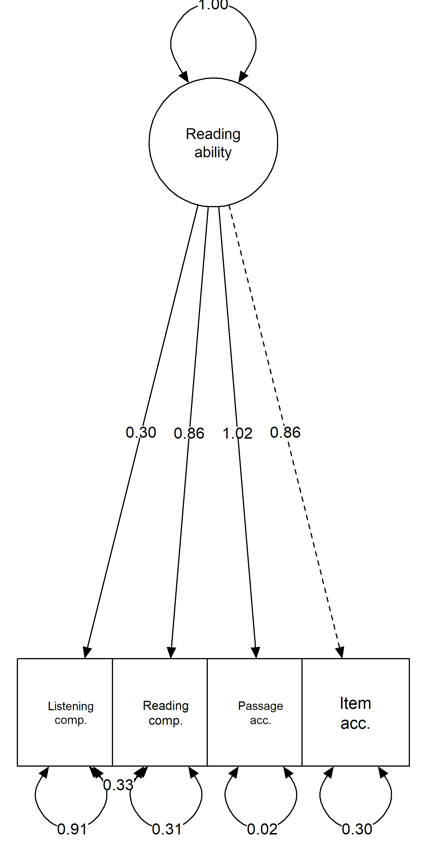
Task loadings on the overall reading ability factor

Note. The model also include covariates for age at test, not depicted.

Table S9
Reading profile differences in meeting SATs target attainment levels according to subject and assessment point, controlling for overall reading ability
 | Base model
 | B | SE | t | p | OR [95% CI]
-1 | 0 | -4.24 | 0.07 | -61.37 | <.001 | 0.01 | [0.01, | 0.02]
0 | 1 | 0.21 | 0.06 | 3.57 | <.001 | 1.23 | [1.10, | 1.37]
CW-DW | 1.59 | 0.12 | 13.60 | <.001 | 4.88 | [3.88, | 6.13] †
CW-TD | 1.68 | 0.10 | 17.37 | <.001 | 5.36 | [4.44, | 6.48]
Year (6-9) | 1.03 | 0.08 | 12.38 | <.001 | 2.80 | [2.38, | 3.30]
Eng-Maths | 0.90 | 0.05 | 18.40 | <.001 | 2.45 | [2.23, | 2.70]
Eng-Sci | 0.92 | 0.05 | 19.76 | <.001 | 2.51 | [2.29, | 2.75]
CW-DW*Year | 0.46 | 0.12 | 3.89 | <.001 | 1.58 | [1.25, | 1.98] †
CW-TD*Year | 0.27 | 0.09 | 2.85 | .004 | 1.30 | [1.09, | 1.57] †
CW-DW*Eng-Maths | 0.66 | 0.14 | 4.83 | <.001 | 1.93 | [1.48, | 2.51]
CW-TD*Eng-Maths | 0.44 | 0.11 | 4.00 | <.001 | 1.55 | [1.25, | 1.92]
CW-DW*Eng-Sci | 1.00 | 0.13 | 7.60 | <.001 | 2.72 | [2.10, | 3.52]
CW-TD*Eng-Sci | 0.71 | 0.11 | 6.66 | <.001 | 2.04 | [1.65, | 2.51]
Year*Eng-Maths | 1.79 | 0.09 | 19.50 | <.001 | 5.97 | [4.99, | 7.14]
Year*Eng-Sci | -1.04 | 0.09 | -12.08 | <.001 | 0.35 | [0.30, | 0.42]
CW-DW*Year*Eng-Maths | 0.81 | 0.26 | 3.07 | .002 | 2.24 | [1.34, | 3.75] †
CW-TD*Year*Eng-Maths | 0.67 | 0.21 | 3.14 | .002 | 1.96 | [1.29, | 2.99]
CW-DW*Year*Eng-Sci | 0.47 | 0.25 | 1.89 | .059 | 1.60 | [0.98, | 2.61]
CW-TD*Year*Eng-Sci | 0.52 | 0.21 | 2.52 | .012 | 1.68 | [1.12, | 2.51] †
Note. CW = children with comprehension weaknesses; DW = children with decoding weaknesses; TD = typically developing children without reading weaknesses; Eng = English; Sci = Science; Maths = Mathematics. This model controls for variation in overall reading ability (not included in table; full output available on the OSF). Parameters were estimated separately in m = 30 imputations (re-run from main analysis to include overall reading ability) and pooled using Rubin’s rules. The corresponding model adjusted for sociodemographic covariates did not converge. †marks predictors that differ in direction and/or statistical significance relative to the preregistered analyses without controlling for overall reading ability.

Table S10
Reading profile differences in meeting the national attainment target of 5 A*-C GCSE qualifications, controlling for overall reading ability

 | Base model |  |  |  |  |  |  |  | Adjusted model
 | B | SE | t | p | OR [95% CI] |  |  |  | B | SE | t | p | OR [95% CI]
(Intercept) | 0.57 | 0.11 | 5.10 | <.001 | 1.76 | [1.42, | 2.19] |  | -0.09 | 0.12 | -0.74 | 0.461 | 0.91 | [0.72, | 1.16]
Reading ability | 0.31 | 0.01 | 28.89 | <.001 | 1.36 | [1.34, | 1.39] |  | 0.29 | 0.01 | 26.53 | <.001 | 1.34 | [1.31, | 1.37]
CW vs. DW | 0.89 | 0.12 | 7.35 | <.001 | 2.44 | [1.93, | 3.10] † |  | 0.84 | 0.12 | 6.70 | <.001 | 2.31 | [1.81, | 2.95] †
CW vs. TD | 0.87 | 0.10 | 8.84 | <.001 | 2.40 | [1.97, | 2.91] |  | 0.81 | 0.10 | 8.00 | <.001 | 2.26 | [1.85, | 2.75]
Sex |  |  |  |  |  |  |  |  | 0.37 | 0.07 | 5.25 | <.001 | 1.44 | [1.26, | 1.66]
Maternal ed. 1 |  |  |  |  |  |  |  |  | 0.42 | 0.10 | 4.04 | <.001 | 1.52 | [1.24, | 1.87]
Maternal ed. 2 |  |  |  |  |  |  |  |  | 1.05 | 0.12 | 9.09 | <.001 | 2.84 | [2.27, | 3.56]
FSM eligibility |  |  |  |  |  |  |  |  | -1.12 | 0.13 | -8.86 | <.001 | 0.33 | [0.25, | 0.42]
Note. CW = children with comprehension weaknesses; DW = children with decoding weaknesses; TD = typically developing children without reading weaknesses; Maternal ed. 1 = CSE/no qualification vs. O-level/vocational; Maternal ed. 2 = CSE/no qualification vs. A-level/degree; FSM = Free School Meal. Parameters were estimated separately in m = 30 imputations (re-run from main analysis to include overall reading ability), and pooled using Rubin’s rules. †marks predictors that differ in direction and/or statistical significance relative to the preregistered analyses without controlling for overall reading ability.

Table S11
Reading profile differences in capped GCSE points scores, controlling for differences in reading ability

 | Base model |  |  |  |  |  |  | Adjusted model
 | B | SE | t | p | [95% CI] |  |  | B | SE | t | p | [95% CI]
(Intercept) | 340.22 | 3.15 | 107.92 | <.001 | 334.04 | 346.40 |  | 315.55 | 3.15 | 100.03 | <.001 | [309.37, | 321.74]
Reading ability | 10.16 | 0.22 | 45.37 | <.001 | 9.72 | 10.60 |  | 9.07 | 0.22 | 40.75 | <.001 | [8.64, | 9.51]
CW vs. DW | 24.99 | 2.96 | 8.45 | <.001 | 19.19 | 30.79† |  | 22.46 | 2.85 | 7.89 | <.001 | [16.88, | 28.04] †
CW vs. TD | 27.07 | 2.46 | 10.99 | <.001 | 22.25 | 31.90 |  | 24.41 | 2.37 | 10.31 | <.001 | [19.77, | 29.06]
Sex |  |  |  |  |  |  |  | 14.4 | 1.64 | 8.78 | <.001 | [11.19, | 17.62]
Maternal ed. 1 |  |  |  |  |  |  |  | 16 | 2.56 | 6.24 | <.001 | [10.97, | 21.03]
Maternal ed. 2 |  |  |  |  |  |  |  | 34.37 | 2.8 | 12.29 | <.001 | [28.88, | 39.86]
FSM eligibility |  |  |  |  |  |  |  | -41.9 | 2.94 | -14.23 | <.001 | [-47.68, | -36.13]
Note. CW = children with comprehension weaknesses; DW = children with decoding weaknesses; TD = typically developing children without reading weaknesses; Maternal ed. 1 = CSE/no qualification vs. O-level/vocational; Maternal ed. 2 = CSE/no qualification vs. A-level/degree; FSM = Free School Meal. Parameters were estimated separately in m = 30 (re-run from main analysis to include overall reading ability), and pooled using Rubin’s rules. †marks predictors that differ in direction and/or statistical significance relative to the preregistered analyses without controlling for overall reading ability.

Table S12
Reading profile differences in self-reporting as NEET at age 20, controlling for differences in reading ability
 | Base model |  |  |  |  |  |  |  | Adjusted model
 | B | SE | t | p | OR [95% CI] |  |  |  | B | SE | t | p | OR [95% CI]
(Intercept) | -2.02 | 0.08 | -25.92 | <.001 | 0.13 | [0.11, | 0.15] |  | -1.49 | 0.10 | -15.28 | <.001 | 0.22 | [0.19, | 0.27]
Reading ability | -0.12 | 0.02 | -6.65 | <.001 | 0.89 | [0.86, | 0.92] |  | -0.07 | 0.02 | -3.73 | <.001 | 0.93 | [0.90, | 0.97]
CW vs. DW | -0.55 | 0.21 | -2.56 | .011 | 0.58 | [0.38, | 0.88] † |  | -0.42 | 0.22 | -1.86 | .064 | 0.66 | [0.42, | 1.03]
CW vs. TD | -0.53 | 0.18 | -2.98 | .003 | 0.59 | [0.41, | 0.83] |  | -0.41 | 0.19 | -2.21 | .028 | 0.66 | [0.46, | 0.96] †
Sex |  |  |  |  |  |  |  |  | -0.42 | 0.13 | -3.21 | .002 | 0.66 | [0.51, | 0.85]
Maternal ed. 1 |  |  |  |  |  |  |  |  | -0.45 | 0.18 | -2.47 | .015 | 0.64 | [0.45, | 0.91]
Maternal ed. 2 |  |  |  |  |  |  |  |  | -0.80 | 0.21 | -3.84 | <.001 | 0.45 | [0.30, | 0.68]
FSM eligibility |  |  |  |  |  |  |  |  | 1.34 | 0.17 | 7.67 | <.001 | 3.82 | [2.70, | 5.39]
Note. CW = children with comprehension weaknesses; DW = children with decoding weaknesses; TD = typically developing children without reading weaknesses; Maternal ed. 1 = CSE/no qualification vs. O-level/vocational; Maternal ed. 2 = CSE/no qualification vs. A-level/degree; FSM = Free School Meal. Parameters were estimated separately in m = 80 (re-run from main analysis to include overall reading ability), and pooled using Rubin’s rules. †marks predictors that differ in direction and/or statistical significance relative to the preregistered analyses without controlling for overall reading ability.

