Supplemental Information
Validity Assessment of Daily Negative Affect Indices
Study 1
In line with Cranford et al. (2006), we assessed whether shortened versions of the Profile of Mood States (POMS) Questionnaire (McNair et al., 1971) were reliable. Indeed, when we aggregated the items across time, we found acceptable reliability scores for the two-item subscales for depressive (r=.95) and anxious moods (r=.93). After we modeled the items as time-variant, we found acceptable reliability of change scores for both subscales (depressive mood: R_{Change}=.98; anxious mood: R_{Change}=.97). In addition, we supplemented our reliability analysis with a validity assessment, as we predicted aggressive behaviors (i.e., a count score of two items; e.g., I broke or damaged something belonging to others on purpose. 0=no, 1=yes) would be associated with greater depressive and anxious moods as an assessment for concurrent validity. Indeed, depressive and anxious moods were associated with greater aggression (r=.28, p<.001; r=.29, p<.001, respectively), providing evidence of concurrent validity for our POMS subscales. To provide evidence of discriminant validity, we predicted that youth who perceived more support from parents and friends (mean score of two items; i.e., I felt supported by my parents or family.; I felt supported by a friend. 1=not at all, 5 = a lot; r=.80) would report fewer depressive and anxious moods. In line with our prediction, we found that adolescents’ perceived support was associated with fewer depressive (r=-.25, p<.001) and anxious moods (r=-.15, p<.001), suggesting that we found evidence of discriminant validity for our POMS subscales.
Study 2
Similar to our approach in Study 1, we assessed the validity of our POMS questionnaire’s subscales. We found positive and significant associations between depressive/anxious moods and adolescents’ aggressive behaviors (r=.10, p<.001; r=.11, p<.001, respectively), providing evidence of concurrent validity for our POMS subscales. In addition, we found significant and inverse relations between depressive/anxious moods and adolescents’ perceived support from parents and friends (r=-.23, p<.001; r=-.11, p<.001, respectively).
Validity Assessment of Daily School Cultural Socialization
Study 1
Due to our assessment of school cultural socialization that was adapted from an existing parental cultural socialization scale (Del Toro & Wang, 2022; Wang et al., 2015), we assessed the concurrent and discriminant validity for daily school cultural socialization. Considering that school cultural socialization assessed the student-teacher context, we expected that school cultural socialization would be related to more perceived support from teachers (i.e., evidence for convergence validity) relative to perceived support from family members and friends (i.e., evidence for discriminant validity). Indeed, school cultural socialization was related to more perceived support from teachers (B=.06, SE=.02, p<.01) and was unrelated to perceived support from family members and friends (B=.01, SE=.02, p=.60; B=.00, SE=.02, p=.93, respectively).
In addition, we examined the strength of the relationship between our daily measure of school cultural socialization with existing validated measures of student-reported school cultural socialization and teacher-reported cultural socialization. Recall our daily diary study was part of a larger ongoing longitudinal study, which administered bi-annual surveys among 348 adolescents and yearly surveys among their teachers (n=21). As part of these latter non-daily student- and teacher-reported surveys, students and teachers completed existing scales of school cultural socialization, including student perceived cultural socialization from school (4 items; i.e., This school provides opportunities for me that connect my racial/ethnic identity to being a good student. This school teaches me about my racial/ethnic group. I am satisfied with how much I learn about my racial/ethnic group in this school. In my school, students of all racial/ethnic backgrounds can be seen as high achievers. 1=strongly disagree, 5=strongly agree; Byrd, 2017; Del Toro & Wang, 2021) and teacher-reported engagement in cultural socialization (5 items; i.e., How often do you encourage students to celebrate any special days connected to their racial/ethnic or cultural background in their family? How often do you learn about the cultural knowledge (e.g. history, traditions, customs, values) of your students’ backgrounds? How often do you connect students’ community knowledge to the content? How often do you connect students’ culture (e.g. history, traditions, customs, values) to the content?; 0=never, 5=always; Hughes et al., 2017; Wang et al., 2022). These scales showed acceptable reliabilities (student-reported: α=.74; teacher reported: α=.82). With these data, we tested the relations between our daily school cultural socialization measure and existing non-daily student- and teacher-reported cultural socialization scales to strengthen the validity of our daily measure; ultimately, we found that they were significantly related with one another (r-range=.16-.25, p-range=.01-.05), further providing evidence of concurrent validity for our daily school cultural socialization measure.
Study 2
Like in Study 1, we found that only youth’s perceived support from teachers was related to positive levels of school cultural socialization (B=.01, SE=.00, p<.001) but their perceived support from family members and friends were unrelated to school cultural socialization (B=.00, SE=.00, p=.26; B=-.01, SE=.01, p=.09, respectively).
Cultural Socialization from School Adults versus Parents
Study 1
We imagined that parental cultural socialization would be associated with school cultural socialization; indeed, they were positively associated with one another (r=.72). However, this high correlation raised a question of whether they are distinguishable constructs. Thus, we performed a series of confirmatory factor analyses (CFAs), which revealed that a two-factor structure fit the data well, χ²(8)=69.31, p<.001, RMSEA=.07, CFI=.91, SRMR_{within}=.03, SRMR_{between}=.04, and better than a one-factor structure Δχ²(2)=151.98, p<.001, suggesting that cultural socialization from parents and schools were distinguishable constructs.
Study 2
Like in Study 1, parental and school cultural socialization were positively associated with one another (r=.56). Although this correlation was not as high as that in Study 1, we continued to assess whether parental and school cultural socialization were independent but related to one another. After a series of CFAs, a two-factor structure fit the data well, χ²(8)=13.35, p=.10, RMSEA=.01, CFI=.99, SRMR_{within}=.02, SRMR_{between}=.01, and better than a one-factor structure Δχ²(2)=169.97, p<.001, suggesting that cultural socialization from parents and schools were distinguishable constructs.
Missing Data
Study 1
Among the 134 participants, 51% of participants completed 13-14 diaries, 16% completed 11-12 diaries, 8% completed 9-10 diaries, and 25% completed at least two diaries. Participants on average completed 11 out of the 14 possible diaries, with a median count of 13 and in total summed up to 1,494 diaries across the 134 participants. Adolescents’ daily participation was unrelated to their sex (r=-.16, p=.06), age (r=.01, p=.91), free/reduced-priced lunch eligible (vs. ineligible) youth (r=-.15, p=.09), ethnic-racial discrimination (r=-.15, p=.11), school cultural socialization (r=-.16, p=.07), and negative affect (r=-.14, p=.09), suggesting that our data are characterized as missing at random (Enders, 2013). Nonetheless, to ensure that the amount of missing data did not present a concern, we re-estimated our results with listwise deletion and found that the pattern of our results replicated. Thus, we used the Full Information Maximum Likelihood (FIML) estimation to handle missing data and retain all 134 adolescents.
Study 2
Among the 159 participants, 136 adolescents participated in Wave 1, and 128 adolescents participated in Wave 2. Of the 136 adolescents who participated in Wave 1, 32 adolescents did not return to the study in Wave 2, but 23 new adolescents joined the study in Wave 2. Adolescents from these three groups (i.e., youth who stayed, left, or joined across waves) did not differ by ethnicity/race [χ(2)=6.00, p=.06], sex [χ²(2)=0.52, p=.77] and free/reduced-priced lunch eligible (vs. ineligible) youth [χ²(2)=2.74, p=.25], but older adolescents were more likely to leave than to stay in the study [F(2, 156)=5.56, p<.01]. These groups of youth also did not differ by negative affect [F(2, 156)=0.01, p=.99], ethnic-racial discrimination [F(2, 156)=0.65, p=.52], and school cultural socialization [F(2, 156)=0.43, p=.65].
Within each wave, rates of participation at the daily level were favorable. Of the 136 adolescents who participated in Wave 1, 80 (59%) adolescents completed 14-15 diaries, 41 (30%) adolescents completed 12-13 diaries, and the remainder 15 (11%) adolescents completed at least one diary. Of the 128 adolescents who participated in Wave 2, 79 (62%) adolescents completed 14-15 diaries, 25 (20%) adolescents completed 12-13 diaries, and the remainder 24 (18%) adolescents completed at least one diary. Adolescents on average completed 13 out of the 15 possible diaries at each wave (Study 1: M=13.16; Study 2: M=13.03). Adolescents’ daily participation was unrelated to their ethnicity-race (r=-.06, p=.46), sex (r=-.03, p=.72), age (r=-.12, p=.15), free/reduced-priced lunch eligible (vs. ineligible) youth (r=-.07, p=.41), ethnic-racial discrimination (r=-.09, p=.26), school cultural socialization (r=-.05, p=.53), and negative affect (r=-.08, p=.29), suggesting that our data are missing at random (Enders, 2013). Like in Study 1, the pattern of our results replicated when we re-estimated our models with listwise deletion, and we used the FIML estimator to retain all 159 adolescents.

Table S1
A List of Items Measuring Each Construct in Studies 1 and 2
Daily depressive mood
1 | Today, how often did you feel depressed or sad?
2 | Today, how often did you feel lonely?
Daily anxious mood
1 | Today, how often did you feel anxious?
2 | Today, how often did you feel nervous?
Daily angry mood
1 | Today, how often did you feel angry?
Daily ethnic/racial discrimination (Study 1 only)
 | Did any of the following happen to you today?
1 | People have said mean or rude things about me because of my race or ethnic group online.
2 | People have cracked jokes about people of my race or ethnic group online.
3 | People have said things that were untrue about people in my race or ethnic group online.
Daily ethnic/racial discrimination (Study 2 only)
 | Did any of the following happen to you today?
1 | People have said mean or rude things about me because of my race or ethnic group online or in person.
2 | People have cracked jokes about people of my race or ethnic group online or in person.
3 | People have said things that were untrue about people in my race or ethnic group online or in person.
Daily school cultural socialization
1 | Today, in school, did you recognize or celebrate holidays, traditions, and cultures of your racial/ethnic group?
2 | Today, in school, did you learn about your racial/ethnic group and cultural background?
Daily parental cultural socialization
1 | Today, did your parents or family talk to you about the values, traditions, and beliefs of your racial/ethnic/cultural background?
2 | Today, did your parents or family talk about how important it is to know about and be proud of your ethnic/cultural background?
3 | Today, did your parents or family participate in activities that are specific to your ethnic/cultural background?

Table S2
Intra-Class Correlation Coefficients for All Key Study Constructs in Studies 1 and 2
Study 1 Measures | Day | Person | School
Depressive mood | .47 | .50 | .03
Anxious mood | .50 | .50 | .00
Angry mood | .50 | .50 | .00
Ethnic/racial discrimination | .65 | .35 | .00
School cultural socialization | .58 | .41 | .01
Parental cultural socialization | .50 | .50 | .00
Study 2 Measures | Day | Wave | Person
Depressive mood | .37 | .00 | .63
Anxious mood | .43 | .01 | .56
Angry mood | .49 | .00 | .51
Ethnic/racial discrimination | .58 | .01 | .41
School cultural socialization | .54 | .00 | .46
Parental cultural socialization | .44 | .00 | .56

Table S3
Multilevel Models Regressing Daly Negative Affect on Study-1 Measures among 134 African American Adolescents in Study 1, After Including the Interactive Effects of School and Parental Cultural Socialization
 |  |  |  |  |  | Daily negative affect |  |  |  | Daily negative affect
Study-1 measures |  |  |  |  | B (SE) |  | β | 95% CI |  | B (SE) | β | 95% CI
Within-person fixed effects
 | Day |  |  |  |  | -0.02 (0.00)* | -0.11 | [-0.03, -0.01] |  | -0.02 (0.01)* | -0.11 | [-0.03, -0.01]
 | Parental cultural socialization |  |  |  |  | 0.05 (0.06) | 0.03 | [-0.07, 0.18] |  | 0.07 (0.07) | 0.04 | [-0.07, 0.20]
 | Ethnic/racial discrimination |  |  |  |  | 0.10 (0.05)* | 0.07 | [0.01, 0.20] |  | 0.11 (0.05)* | 0.08 | [0.01, 0.21]
 | School cultural socialization |  |  |  |  | 0.03 (0.05) | 0.02 | [-0.07, 0.14] |  | 0.08 (0.07) | 0.05 | [-0.06, 0.22]
 | Ethnic/racial discrimination x School cultural socialization |  |  |  |  | -- | -- | -- |  | -0.16 (0.06)* | -0.07 | [-0.29, -0.04]
 | Ethnic/racial discrimination x Parental cultural socialization |  |  |  |  | -- | -- | -- |  | 0.16 (0.12) | 0.05 | [-0.07, 0.39]
 | School cultural socialization x Parental cultural socialization |  |  |  |  | -- | -- | -- |  | -0.19 (0.07)** | -0.09 | [-0.32, -0.05]
Between-person fixed effects
 | Males (vs. females) |  |  |  |  | -0.19 (0.10) | -0.28 | [-0.38, 0.01] |  | -0.18 (0.10) | -0.28 | [-0.37, 0.01]
 | Age |  |  |  |  | 0.10 (0.02)*** | 0.20 | [0.06, 0.13] |  | 0.10 (0.01)*** | 0.20 | [0.06, 0.13]
 | Free/reduced-priced lunch eligible (vs. ineligible) youth |  |  |  |  | 0.37 (0.22) | 0.17 | [-0.06, 0.81] |  | 0.37 (0.21) | 0.17 | [-0.17, 0.79]
 | Parental cultural socialization |  |  |  |  | 0.01 (0.17) | 0.01 | [-0.32, 0.34] |  | 0.20 (0.17) | 0.11 | [-0.25, 0.53]
 | Ethnic/racial discrimination |  |  |  |  | 0.66 (0.44) | 0.11 | [-0.20, 1.51] |  | 0.18 (0.16) | 0.09 | [-0.23, 0.49]
 | School cultural socialization |  |  |  |  | 0.04 (0.14) | 0.02 | [-0.24, 0.32] |  | 0.17 (0.17) | 0.11 | [-0.27, 0.51]
 | Ethnic/racial discrimination x School cultural socialization |  |  |  |  | -- | -- | -- |  | 0.36 (0.68) | 0.09 | [-1.39, 1.69]
 | Ethnic/racial discrimination x Parental cultural socialization |  |  |  |  | -- | -- | -- |  | -0.58 (0.62) | -0.10 | [-2.18, 0.64]
 | School cultural socialization x Parental cultural socialization |  |  |  |  | -- | -- | -- |  | -0.53 (0.16)** | -0.21 | [-0.94, -0.22]
Intercept |  |  |  |  |  | 1.79 (0.06)*** | 2.74 | [1.67, 1.91] |  | 1.87 (0.08)*** | 2.86 | [1.72, 2.03]
Notes: * p < .05, ** p < .01, *** p < .001. CI = Confidence interval; SE = Standard error.

Table S4
Results from a Monte Carlo Power Simulation of Study 1’s Multilevel Model
 |  |  | Estimates
Model coefficients | Starting |  | Average | SD | SE Average | MSE | 95% Cover | % Sig Coeff
Within-person fixed effects
Daily negative affect ON
Day | -0.02 |  | -0.02 | 0.02 | 0.02 | 0.00 | 0.95 | 0.13
Parental cultural socialization | 0.04 |  | 0.04 | 0.02 | 0.02 | 0.00 | 0.93 | 0.52
Ethnic/racial discrimination | 0.11 |  | 0.11 | 0.02 | 0.02 | 0.00 | 0.94 | 1.00
School cultural socialization | 0.06 |  | 0.06 | 0.02 | 0.02 | 0.00 | 0.95 | 0.83
Ethnic/racial discrimination x  School cultural socialization | -0.15 |  | -0.15 | 0.02 | 0.02 | 0.00 | 0.93 | 1.00
Ethnic/racial discrimination x  Parental cultural socialization | 0.12 |  | 0.12 | 0.02 | 0.02 | 0.00 | 0.94 | 1.00
Between-person fixed effects
Daily negative affect ON
Males (vs. females) | -0.18 |  | -0.18 | 0.06 | 0.06 | 0.00 | 0.95 | 0.78
Age | 0.10 |  | 0.09 | 0.07 | 0.06 | 0.00 | 0.94 | 0.31
Free/reduced-priced lunch eligible (vs. ineligible) youth | 0.37 |  | 0.37 | 0.07 | 0.06 | 0.00 | 0.94 | 1.00
Parental cultural socialization | 0.20 |  | 0.19 | 0.07 | 0.06 | 0.00 | 0.94 | 0.84
Ethnic/racial discrimination | 0.53 |  | 0.53 | 0.07 | 0.06 | 0.00 | 0.92 | 1.00
School cultural socialization | 0.17 |  | 0.17 | 0.07 | 0.06 | 0.00 | 0.94 | 0.75
Ethnic/racial discrimination x  School cultural socialization | 1.09 |  | 1.09 | 0.07 | 0.06 | 0.00 | 0.93 | 1.00
Ethnic/racial discrimination x  Parental cultural socialization | -1.73 |  | -1.73 | 0.07 | 0.06 | 0.00 | 0.93 | 1.00

Table S5
Multilevel Models Regressing Daly Negative Affect on Study-1 and Study-2 Measures among 134 African American Adolescents in Study 1 (N-Diaries=1,494) and 159 Asian American and Latinx Adolescents in Study 2 (N-Diaries=3,458), After Removing Parental Cultural Socialization as a Covariate
 |  |  |  | Daily negative affect
Study-1 measures |  |  |  | B (SE)
Within-person fixed effects
 | Day |  |  | -0.01 (0.00)**
 | Ethnic/racial discrimination |  |  | 0.25 (0.06)***
 | School cultural socialization |  |  | 0.05 (0.03)
 | Ethnic/racial discrimination x School cultural socialization |  |  | -0.30 (0.05)***
Between-person fixed effects
 | Males (vs. females) |  |  | -0.11 (0.05)*
 | Age |  |  | 0.06 (0.01)***
 | Free/reduced-priced lunch eligible (vs. ineligible) youth |  |  | 0.17 (0.11)
 | Ethnic/racial discrimination |  |  | 0.47 (0.25)
 | School cultural socialization |  |  | 0.09 (0.08)
 | Ethnic/racial discrimination x School cultural socialization |  |  | -0.31 (0.76)
 |  |  |  | Daily negative affect
Study-2 measures |  |  |  | B (SE)
Within-person fixed effects
 | Day |  |  | 0.00 (0.00)
 | Ethnic/racial discrimination |  |  | 0.05 (0.03)
 | School cultural socialization |  |  | 0.03 (0.02)
 | Ethnic/racial discrimination x School cultural socialization |  |  | -0.14 (0.04)***
Between-person fixed effects
 | Asian (vs. Latinx) adolescents |  |  | 0.08 (0.06)
 | Males (vs. females) |  |  | -0.15 (0.05)**
 | Age |  |  | 0.01 (0.01)
 | Free/reduced-priced lunch eligible (vs. ineligible) youth |  |  | -0.05 (0.06)
 | Ethnic/racial discrimination |  |  | 0.54 (0.31)
 | School cultural socialization |  |  | -0.06 (0.06)
 | Ethnic/racial discrimination x School cultural socialization |  |  | 0.38 (0.36)
Notes: *p<.05, **p<.01, ***p<.001. CI=Confidence interval; SE=Standard error.

Table S6
Multilevel Models Regressing Daly Negative Affect on Study-1 and Study-2 Measures among 134 African American Adolescents in Study 1 (N-Diaries=1,494) and 159 Asian American and Latinx Adolescents in Study 2 (N-Diaries=3,458) with Lagged Dependent Variables as Covariates
 |  |  |  | Daily negative affect
Study-1 measures |  |  |  | B (SE)
Within-person fixed effects
 | Day |  |  | 0.00 (0.00)
 | Prior-day negative affect |  |  | 0.06 (0.02)**
 | Parental cultural socialization |  |  | 0.04 (0.03)
 | Ethnic/racial discrimination |  |  | 0.19 (0.02)**
 | School cultural socialization |  |  | 0.03 (0.02)
 | Ethnic/racial discrimination x School cultural socialization |  |  | -0.16 (0.05)**
Between-person fixed effects
 | Males (vs. females) |  |  | -0.12 (0.05)*
 | Age |  |  | 0.06 (0.01)***
 | Free/reduced-priced lunch eligible (vs. ineligible) youth |  |  | 0.17 (0.12)
 | Parental cultural socialization |  |  | 0.08 (0.10)
 | Ethnic/racial discrimination |  |  | 0.44 (0.23)
 | School cultural socialization |  |  | 0.02 (0.09)
 | Ethnic/racial discrimination x School cultural socialization |  |  | -0.34 (0.69)
 |  |  |  | Daily negative affect
Study-2 measures |  |  |  | B (SE)
Within-person fixed effects
 | Day |  |  | 0.00 (0.00)
 | Prior-day negative affect |  |  | 0.04 (0.01)***
 | Parental cultural socialization |  |  | 0.01 (0.02)
 | Ethnic/racial discrimination |  |  | 0.05 (0.03)
 | School cultural socialization |  |  | 0.02 (0.02)
 | Ethnic/racial discrimination x School cultural socialization |  |  | -0.12 (0.04)**
Between-person fixed effects
 | Asian (vs. Latinx) adolescents |  |  | 0.07 (0.06)
 | Males (vs. females) |  |  | -0.15 (0.05)**
 | Age |  |  | 0.01 (0.01)
 | Free/reduced-priced lunch eligible (vs. ineligible) youth |  |  | -0.05 (0.05)
 | Parental cultural socialization |  |  | 0.03 (0.11)
 | Ethnic/racial discrimination |  |  | 0.51 (0.32)
 | School cultural socialization |  |  | -0.07 (0.08)
 | Ethnic/racial discrimination x School cultural socialization |  |  | 0.39 (0.35)
Notes: *p<.05, **p<.01, ***p<.001. CI=Confidence interval; SE=Standard error.

Table S7
Multilevel Models Regressing Daily Negative Affect on Study-2 Measures among 159 Asian American and Latinx Adolescents in Study 2 (N-Diaries=3,458), Using the Original Likert Scale for Ethnic/Racial Discrimination
 |  |  |  |  | Daily negative affect |  |  |  | Daily negative affect
Study-2 measures |  |  |  |  | B (SE) | β | 95% CI |  | B (SE) | β | 95% CI
Within-person fixed effects
 | Day |  |  |  | 0.00 (0.00) | -0.07 | [-0.01, 0.00] |  | 0.00 (0.00) | -0.07 | [-0.01, 0.00]
 | Parental cultural socialization |  |  |  | 0.01 (0.05) | 0.00 | [-0.08, 0.10] |  | 0.00 (0.04) | 0.00 | [-0.08, 0.09]
 | Ethnic/racial discrimination |  |  |  | 0.11 (0.05)* | 0.05 | [0.01, 0.22] |  | 0.12 (0.06)* | 0.05 | [0.01, 0.25]
 | School cultural socialization |  |  |  | 0.02 (0.03) | 0.02 | [-0.04, 0.09] |  | 0.03 (0.03) | 0.03 | [-0.03, 0.09]
 | Ethnic/racial discrimination x School cultural socialization |  |  |  | -- | -- | -- |  | -0.29 (0.08)** | -0.08 | [-0.46, -0.13]
 | Ethnic/racial discrimination x Parental cultural socialization |  |  |  | -- | -- | -- |  | 0.23 (0.15) | 0.05 | [-0.06, 0.52]
R² |  |  |  |  | 0.01 |  |  |  | 0.02
Between-person fixed effects
 | Asian (vs. Latinx) adolescents |  |  |  | 0.12 (0.10) | 0.19 | [-0.07, 0.30] |  | 0.11 (0.10) | 0.18 | [-0.08, 0.30]
 | Males (vs. females) |  |  |  | -0.26 (0.10)** | -0.43 | [-0.44, -0.07] |  | -0.26 (0.09)** | -0.42 | [-0.45, -0.08]
 | Age |  |  |  | 0.02 (0.03) | 0.04 | [-0.04, 0.07] |  | 0.02 (0.03) | 0.05 | [-0.04, 0.07]
 | Free/reduced-priced lunch eligible (vs. ineligible) youth |  |  |  | -0.08 (0.10) | -0.13 | [-0.26, 0.10] |  | -0.08 (0.09) | -0.13 | [-0.27, 0.10]
 | Parental cultural socialization |  |  |  | 0.02 (0.21) | 0.01 | [-0.39, 0.44] |  | 0.04 (0.21) | 0.02 | [-0.37, 0.45]
 | Ethnic/racial discrimination |  |  |  | 1.50 (0.64)* | 0.39 | [0.25, 2.75] |  | 1.13 (0.67) | 0.29 | [-0.18, 2.45]
 | School cultural socialization |  |  |  | -0.08 (0.16) | -0.05 | [-0.38, 0.22] |  | -0.10 (0.15) | -0.07 | [-0.40, 0.20]
 | Ethnic/racial discrimination x School cultural socialization |  |  |  | -- | -- | -- |  | 1.73 (1.02) | 0.34 | [-0.28, 3.74]
 | Ethnic/racial discrimination x Parental cultural socialization |  |  |  | -- | -- | -- |  | -1.06 (1.12) | -0.21 | [-3.25, 1.14]
R² |  |  |  |  | 0.17 |  |  |  | 0.19
Intercept |  |  |  |  | 1.66 (0.05)*** | 2.68 | [1.57, 1.75] |  | 1.64 (0.05)*** | 2.66 | [1.54, 1.74]
Notes: * p < .05, ** p < .01, *** p < .001. CI = Confidence interval; SE = Standard error.

Table S8
Multilevel Models Regressing Daly Negative Affect on Study-2 Measures among 159 Asian American and Latinx Adolescents in Study 2, After Including the Interactive Effects of School and Parental Cultural Socialization
 |  |  | Daily negative affect |  |  |  | Daily negative affect
Study-2 measures |  |  | B (SE) | β | 95% CI |  | B (SE) | β | 95% CI
Within-person fixed effects
 | Day |  | 0.00 (0.00) | -0.07 | [-0.01, 0.00] |  | 0.00 (0.00) | -0.07 | [-0.01, 0.00]
 | Parental cultural socialization |  | 0.01 (0.05) | 0.00 | [-0.09, 0.10] |  | 0.00 (0.04) | 0.00 | [-0.08, 0.08]
 | Ethnic/racial discrimination |  | 0.04 (0.03) | 0.04 | [-0.01, 0.09] |  | 0.05 (0.02)* | 0.05 | [0.01, 0.10]
 | School cultural socialization |  | 0.02 (0.03) | 0.02 | [-0.04, 0.09] |  | 0.03 (0.03) | 0.03 | [-0.03, 0.09]
 | Ethnic/racial discrimination x School cultural socialization |  | -- | -- | -- |  | -0.14 (0.05)** | -0.08 | [-0.23, -0.05]
 | Ethnic/racial discrimination x Parental cultural socialization |  | -- | -- | -- |  | 0.11 (0.06) | 0.05 | [-0.02, 0.23]
 | School cultural socialization x Parental cultural socialization |  | -- | -- | -- |  | 0.01 (0.06) | 0.01 | [-0.10, 0.12]
Between-person fixed effects
 | Asian (vs. Latinx) adolescents |  | 0.12 (0.10) | 0.19 | [-0.07, 0.30] |  | 0.10 (0.09) | 0.17 | [-0.07, 0.29]
 | Males (vs. females) |  | -0.26 (0.10)** | -0.43 | [-0.44, -0.07] |  | -0.27 (0.10)** | -0.44 | [-0.46, -0.09]
 | Age |  | 0.02 (0.03) | 0.04 | [-0.04, 0.07] |  | 0.02 (0.03) | 0.04 | [-0.04, 0.07]
 | Free/reduced-priced lunch eligible (vs. ineligible) youth |  | -0.08 (0.10) | -0.13 | [-0.26, 0.10] |  | -0.11 (0.09) | -0.18 | [-0.29, 0.07]
 | Parental cultural socialization |  | 0.02 (0.21) | 0.01 | [-0.39, 0.44] |  | 0.36 (0.25) | 0.20 | [-0.13, 0.85]
 | Ethnic/racial discrimination |  | 1.50 (0.64)* | 0.39 | [0.25, 2.75] |  | 0.73 (0.52) | 0.19 | [-0.29, 1.75]
 | School cultural socialization |  | -0.08 (0.16) | -0.05 | [-0.38, 0.22] |  | -0.03 (0.16) | -0.02 | [-0.34, 0.28]
 | Ethnic/racial discrimination x School cultural socialization |  | -- | -- | -- |  | 2.23 (0.96)* | 0.44 | [0.35, 4.10]
 | Ethnic/racial discrimination x Parental cultural socialization |  | -- | -- | -- |  | -0.42 (1.05) | -0.08 | [-2.48, 1.64]
 | School cultural socialization x Parental cultural socialization |  | -- | -- | -- |  | -0.82 (0.31)** | -0.36 | [-1.43, -0.21]
Intercept |  |  | 1.66 (0.05)*** | 2.68 | [1.57, 1.75] |  | 1.69 (0.06)*** | 2.72 | [1.58, 1.80]
Notes: * p < .05, ** p < .01, *** p < .001. CI = Confidence interval; SE = Standard error.

Table S9
Results from a Monte Carlo Power Simulation of Study 2’s Multilevel Model
 |  |  | Estimates
Model coefficients | Starting |  | Average | SD | SE Average | MSE | 95% Cover | % Sig Coeff
Within-person fixed effects
Daily negative affect ON
Day | 0.00 |  | 0.00 | 0.01 | 0.01 | 0.00 | 0.94 | 0.06
Parental cultural socialization | 0.00 |  | 0.00 | 0.01 | 0.01 | 0.00 | 0.96 | 0.04
Ethnic/racial discrimination | 0.05 |  | 0.05 | 0.01 | 0.01 | 0.00 | 0.93 | 0.97
School cultural socialization | 0.03 |  | 0.03 | 0.01 | 0.01 | 0.00 | 0.94 | 0.71
Ethnic/racial discrimination x  School cultural socialization | -0.14 |  | -0.14 | 0.01 | 0.01 | 0.00 | 0.93 | 1.00
Ethnic/racial discrimination x  Parental cultural socialization | 0.11 |  | 0.10 | 0.01 | 0.01 | 0.00 | 0.95 | 1.00
Between-person fixed effects
Daily negative affect ON
Asian (vs. Latinx) adolescents | 0.10 |  | 0.10 | 0.05 | 0.05 | 0.00 | 0.93 | 0.60
Males (vs. females) | -0.24 |  | -0.24 | 0.05 | 0.05 | 0.00 | 0.95 | 1.00
Age | 0.02 |  | 0.01 | 0.05 | 0.05 | 0.00 | 0.96 | 0.06
Free/reduced-priced lunch eligible (vs. ineligible) youth | -0.08 |  | -0.08 | 0.05 | 0.05 | 0.00 | 0.94 | 0.41
Parental cultural socialization | 0.05 |  | 0.05 | 0.04 | 0.05 | 0.00 | 0.96 | 0.18
Ethnic/racial discrimination | 0.43 |  | 0.43 | 0.05 | 0.05 | 0.00 | 0.92 | 1.00
School cultural socialization | -0.07 |  | -0.07 | 0.05 | 0.05 | 0.00 | 0.94 | 0.36
Ethnic/racial discrimination x  School cultural socialization | 0.75 |  | 0.75 | 0.05 | 0.05 | 0.00 | 0.95 | 1.00
Ethnic/racial discrimination x  Parental cultural socialization | -0.43 |  | -0.43 | 0.05 | 0.05 | 0.00 | 0.93 | 1.00

Figure S1
The Interactive Effect of Daily Parental Cultural Socialization and Daily School Cultural Socialization on Daily Negative Affect in Study 1
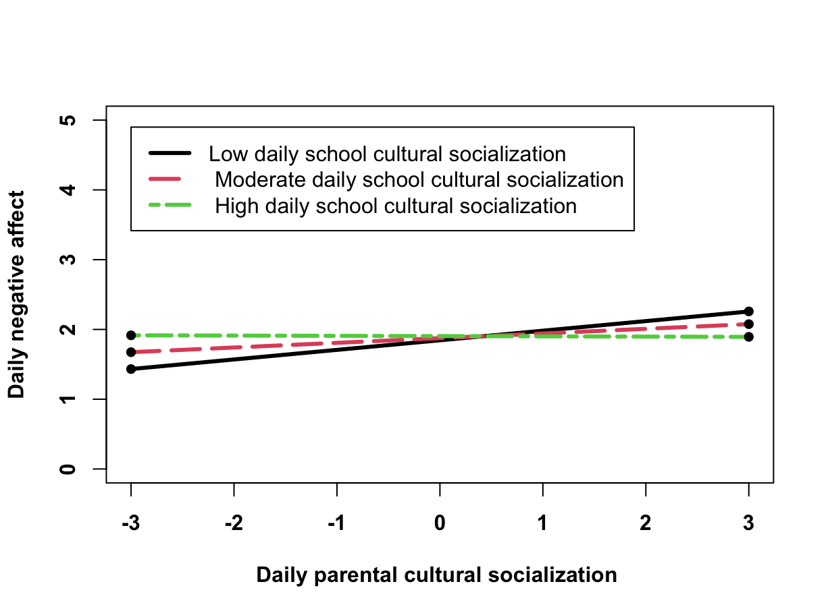

Figure S2
The Interactive Effect of Person-Level Parental Cultural Socialization and Person-Level School Cultural Socialization on Daily Negative Affect in Study 1
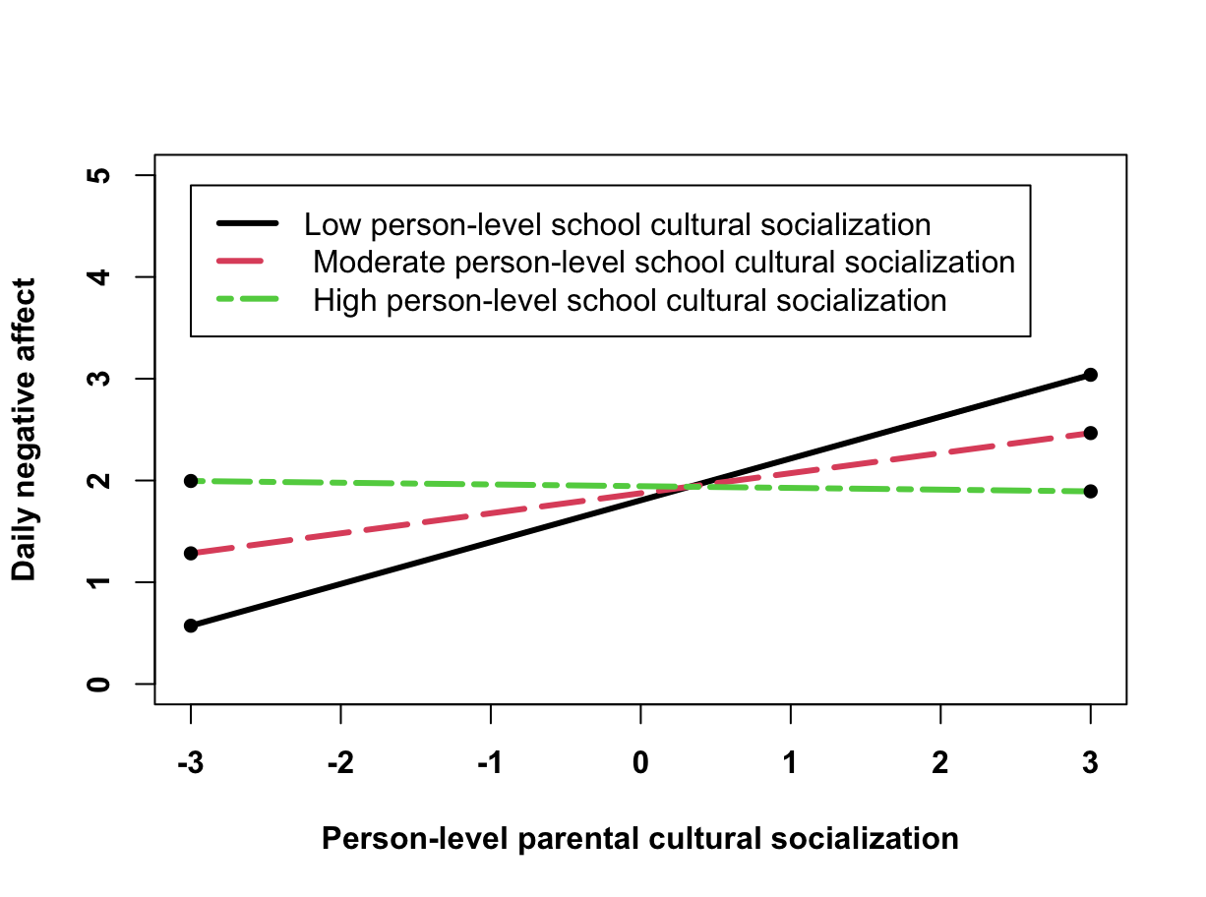

Figure S3
The Interactive Effect of Person-Level Parental Cultural Socialization and Person-Level School Cultural Socialization on Daily Negative Affect in Study 2
