Supplementary Materials
Appendix A. Biology Task
Readable Text
Contents
Textbook 2
13.9 Evolution occurs within populations 2
13.10 The Hardy-Weinberg equation can test whether a population is evolving 4
13.11 The Hardy-Weinberg equation is useful in public health science 7
Guided Reading Questions 8
Mastering Homework Quiz 9
Question 1 9
Question 2 9
Question 3 9
Question 4 10
Question 5 10
Learning Catalytics 11
Question 1 11
Question 2 11
Question 3 11
Mastering Post-Class Quiz 12
Question 1 12
Question 2 12
Question 3 12
Question 4 12
Question 5: Part A 13
Question 5: Part B 14
Question 6: 14

Textbook

13.9 Evolution occurs within populations
A common misconception about evolution is that individual organisms evolve during their lifetimes. It is true that natural selection acts on individuals: Each individual’s combination of traits affects its survival and reproductive success. But the evolutionary impact of natural selection is only apparent in the changes in a population of organisms over time.
A population is a group of individuals of the same species that live in the same area and can potentially interbreed. We can measure evolution as a change in the prevalence of certain heritable traits in a population over a span of generations. The increasing proportion of resistant insects in areas sprayed with pesticide is one example. Natural selection favored insects with alleles for pesticide resistance; these insects left more offspring than nonresistant individuals, changing the genetic makeup of the population.
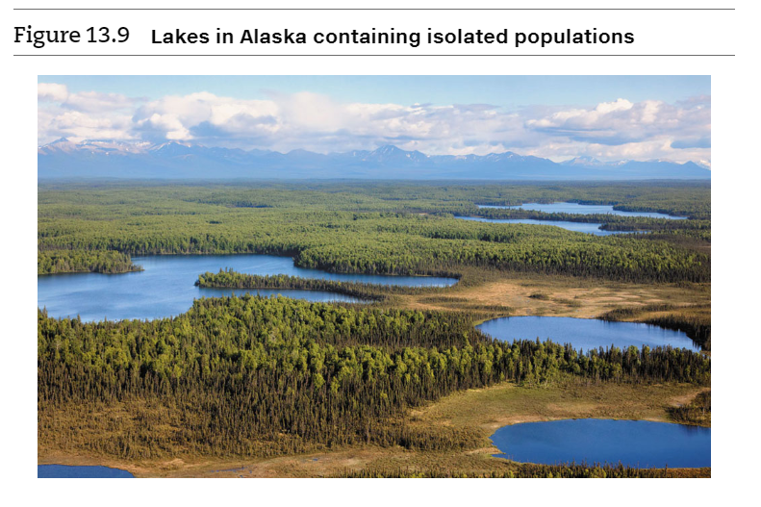
Different populations of the same species may be geographically isolated from each other to such an extent that an exchange of genetic material never or only rarely occurs. Such isolation is common in populations confined to different lakes, as shown in Figure 13.9, or islands. For example, each population of Galápagos tortoises is restricted to its own island. Not all populations have such sharp boundaries. However, members of a population typically breed with one another and are therefore more closely related to each other than they are to members of a different population.
In studying evolution at the population level, biologists focus on the gene pool, which consists of all copies of every type of allele at every locus in all members of the population. For many loci, there are two or more alleles in the gene pool. For example, in a mosquito population, there may be two alleles relating to DDT breakdown, one that codes for an enzyme that breaks down DDT and one for a version of the enzyme that does not. In populations living in fields sprayed with DDT, the allele for the enzyme conferring resistance will increase in frequency and the other allele will decrease in frequency. When the relative frequencies of alleles in a population change like this over a number of generations, evolution is occurring on its smallest scale. Such a change in a gene pool is often called microevolution.
In the next module, we’ll explore how to test whether evolution is occurring in a population.
Watch Topic Overview Video: How Populations Evolve (1 of 2) —Microevolution
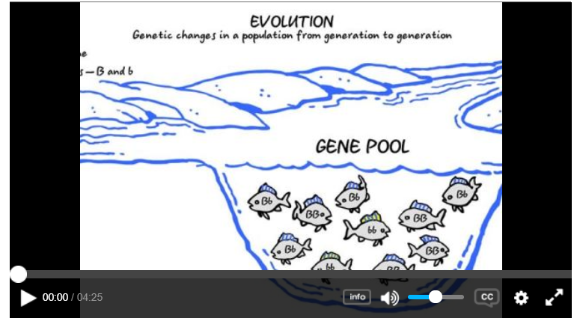

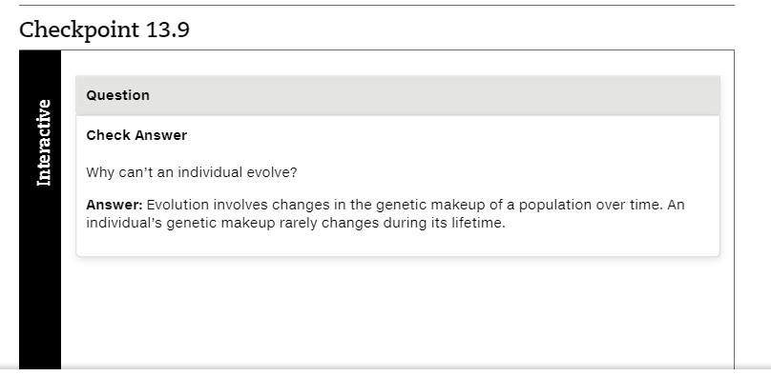

13.10 The Hardy-Weinberg equation can test whether a population is evolving
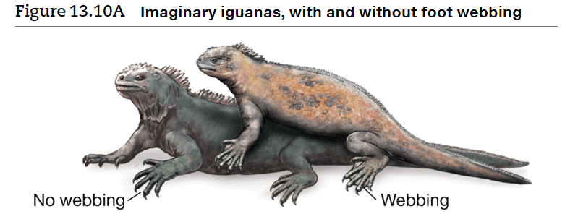
To understand how microevolution works, let’s first examine a simple population in which evolution is not occurring and thus the gene pool is not changing. Consider an imaginary population of iguanas with individuals that differ in foot webbing (Figure 13.10A). Let’s assume that foot webbing is controlled by a single gene and that the allele for nonwebbed feet (W) is completely dominant to the allele for webbed feet (w). The term dominant (see Module 9.3) may seem to suggest that over many generations, the W allele will somehow come to “dominate,” becoming more and more common at the expense of the recessive allele. In fact, this is not what happens. The shuffling of alleles that accompanies sexual reproduction does not alter the genetic makeup of the population. In other words, no matter how many times alleles are segregated into different gametes and united in different combinations by fertilization, the frequency of each allele in the gene pool will remain constant unless other factors are operating. This condition is known as the Hardy-Weinberg equilibrium named for the two scientists who derived it independently in 1908.

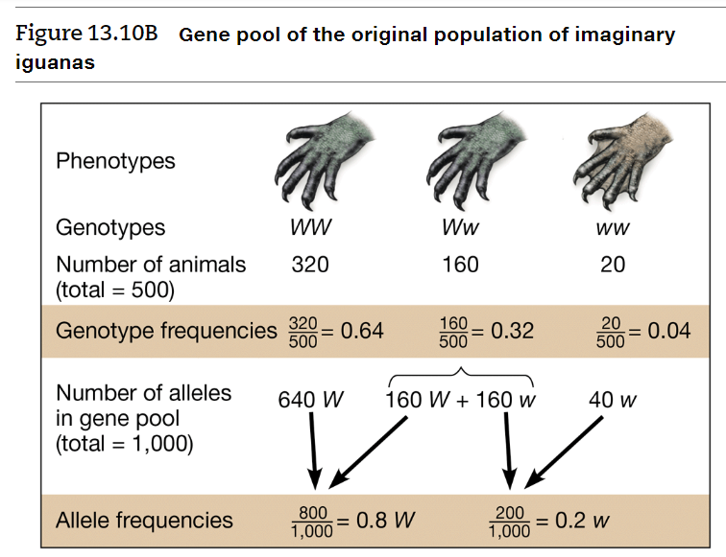
To test the Hardy-Weinberg equilibrium, let’s look at two generations of our imaginary iguana population. Figure 13.10B shows the frequencies of alleles in the gene pool of the original population. We have a total of 500 animals; of these, 320 have the genotype WW (nonwebbed feet), 160 have the heterozygous genotype, Ww (also nonwebbed feet, because the nonwebbed allele W is dominant), and 20 have the genotype ww (webbed feet). The proportions or frequencies of the three genotypes are shown in the middle of Figure 13.10B: 0.64 for WW(320500),(320500), 0.32 for Ww(160500),(160500), and 0.04 for ww(20500).(20500).

From these genotype frequencies, we can calculate the frequency of each allele in the population. Because these are diploid organisms, this population of 500 has a total of 1,000 alleles for foot type. To determine the number of W alleles, we add the number in the WW iguanas, 2×320=6402×320=640, to the number in the Ww iguanas, 160. The total number of W alleles is thus 800. The frequency of the W allele, which we will call p, is 8001,000,8001,000, or 0.8. We can calculate the frequency of the w allele in a similar way; this frequency, called q, is 0.2. The letters p and q are often used to represent allele frequencies. Notice that p+q=1p+q=1. The combined frequencies of all alleles for a gene in a population must equal 1. If there are only two alleles and you know the frequency of one allele, you can calculate the frequency of the other.
What happens when the iguanas of this parent population form gametes? At the end of meiosis, each gamete has one allele for foot type, either W or w. The frequencies of the two alleles in the gametes will be the same as their frequencies in the gene pool of the parental population, 0.8 for W and 0.2 for w.
Figure 13.10C shows a Punnett square that uses these gamete allele frequencies and the rule of multiplication (see Module 9.7) to calculate the frequencies of the three genotypes in the next generation. The probability of producing a WW individual (by combining two W alleles from the pool of gametes) is p×p=p2p×p=p2, or 0.8×0.8=0.640.8×0.8=0.64. Thus, the frequency of WW iguanas in the next generation would be 0.64. Likewise, the frequency of ww individuals would be q2=0.04q2=0.04. For heterozygous individuals, Ww, the genotype can form in two ways, depending on whether the sperm or egg supplies the dominant allele. In other words, the frequency of Ww would be 2pq=2×0.8×0.2=0.322pq=2×0.8×0.2=0.32. Do these frequencies look familiar? Notice that the three genotypes have the same frequencies in the next generation as they did in the parent generation.
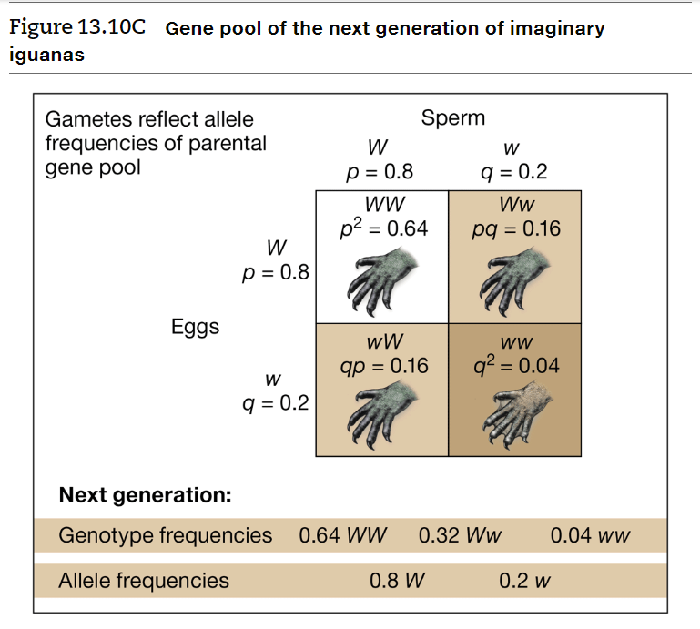

Finally, what about the frequencies of the alleles in this new generation? Because the genotype frequencies are the same as in the parent population, the allele frequencies p and q are also the same. In fact, we could follow the frequencies of alleles and genotypes through many generations, and the results would continue to be the same. Thus, the gene pool of this population is in a state of equilibrium—Hardy-Weinberg equilibrium.
Now let’s write a general formula for calculating the frequencies of genotypes in a population from the frequencies of alleles in the gene pool. In our imaginary iguana population, the frequency of the W allele ( p) is 0.8, and the frequency of the w allele (q) is 0.2. Again note that p+q=1p+q=1. Also notice in Figures 13.10B and 13.10C that the frequencies of the three possible genotypes in the populations also add up to 1 (that is, 0.64+0.32+0.04=10.64+0.32+0.04=1). We can represent these relationships symbolically with the Hardy-Weinberg equation
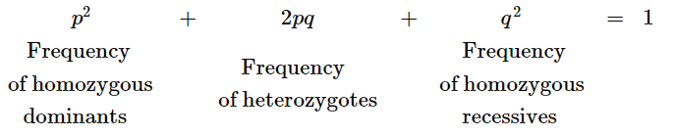
If a population is in Hardy-Weinberg equilibrium, allele and genotype frequencies will remain constant generation after generation. Something other than the reshuffling processes of sexual reproduction is required to change allele frequencies in a population. One way to find out what factors can change a gene pool is to identify the conditions that must be met if genetic equilibrium is to be maintained. For a population to be in Hardy-Weinberg equilibrium, it must satisfy five main conditions:
- Very large population. The smaller the population, the more likely that allele frequencies will fluctuate by chance from one generation to the next.
- No gene flow between populations. When individuals move into or out of populations, they add or remove alleles, altering the gene pool.
- No mutations. By changing alleles or deleting or duplicating genes, mutations modify the gene pool.
- Random mating. If individuals mate preferentially, such as with close relatives (inbreeding), random mixing of gametes does not occur, and genotype frequencies change.
- No natural selection. The unequal survival and reproductive success of individuals (natural selection) can alter allele frequencies.
Because all five conditions are rarely met in real populations, allele and genotype frequencies often do change. The Hardy-Weinberg equation can be used to test whether evolution is occurring in a population. The equation also has medical applications, as we see next.
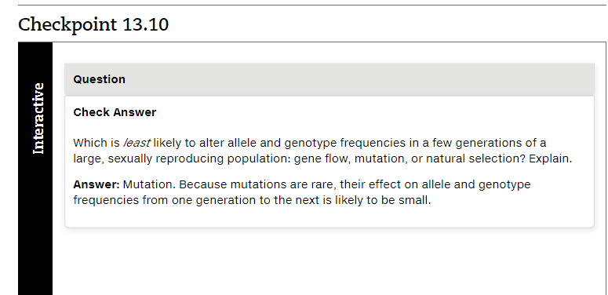

13.11 The Hardy-Weinberg equation is useful in public health science
CONNECTION Public health scientists use the Hardy-Weinberg equation to estimate how many people carry alleles for certain inherited diseases. Consider the case of phenylketonuria (PKU), an inherited inability to break down the amino acid phenylalanine that results in brain damage if untreated. Newborns are routinely screened for PKU, which occurs in about one out of 10,000 babies born in the United States. The health problems associated with PKU can be prevented by strict adherence to a diet that limits the intake of phenylalanine. Packaged foods with ingredients such as aspartame, a common artificial sweetener that contains phenylalanine, must be labeled clearly (Figure 13.11).
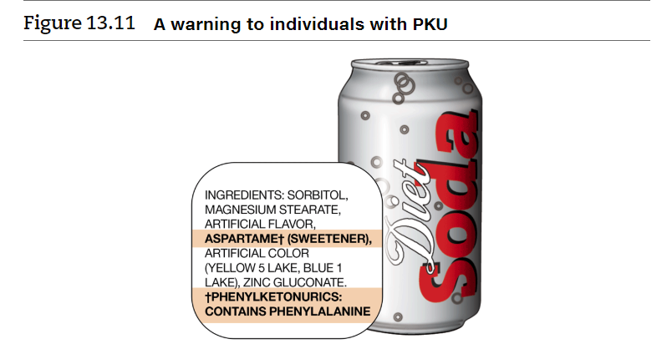
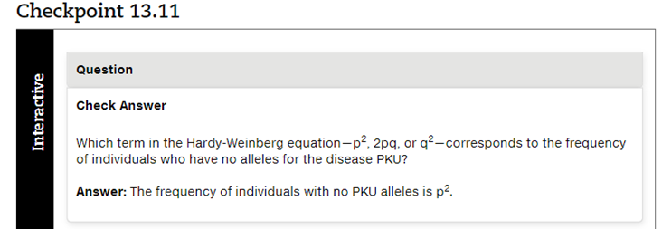
PKU is due to a recessive allele, so the frequency of individuals born with PKU corresponds to the q2q2 term in the Hardy-Weinberg equation. Given one PKU occurrence per 10,000 births, q2=0.0001q2=0.0001. Therefore, the frequency of the recessive allele for PKU in the population, q, equals the square root of 0.0001, or 0.01. And the frequency of the dominant allele, p, equals 1 – q, or 0.99. The frequency of carriers, heterozygous people who do not have PKU but may pass the PKU allele on to offspring, is 2pq, which quals 2×0.99×0.012×0.99×0.01, or 0.0198. Thus, the equation tells us that about 2% (actually 1.98%) of the U.S. population are carriers of the PKU allele. Estimating the frequency of a harmful allele is part of any public health program dealing with genetic diseases.

Guided Reading Questions
Pre-class Read Sections 13.9-13.11 in the textbook

1. What is a common misconception about individuals and evolution?

2. We know microevolution is occurring if we see what changing over many generations?

3. True or False? _____The shuffling of alleles through sexual reproduction leads to changes in the frequencies of alleles in the gene pool.

4. In class, we’ll work with the Hardy Weinberg equations a bit more, for now, let’s examine two equations:

p + q = 1

Which variable is the frequency of the dominant allele in the population? ____
Which variable is the frequency of the recessive allele in the population? _____

p² + 2pq +q²

Make sure for now, to know what type of individual/genotype each of these variables represent in the population?

p²

2pq

q²

5. If a population is NOT evolving it would satisfy five conditions of genetic equilibrium (Hardy Weinberg non-evolution):
a.
b.
c.
d.
e.

6. What can the Hardy-Weinberg equations tell us that is important to public health?

Mastering Homework Quiz

Question 1
- The smallest unit that can evolve is a _____.
  - gene
    - Feedback Text: Evolution occurs as different forms of genes become more or less common in a _____.
  - species
    - Feedback Text: A unit smaller than a species may undergo evolutionary change.
  - genotype
    - Feedback Text: Barring mutations, the genotype is a fixed feature of an individual organism, so it cannot evolve.
  - Population
    - Feedback Text: Populations evolve as individuals with different genotypes live and die, causing changes in the gene pool..
Hint: Consider the level of biological organization at which variation first appears.

Question 2
- What is the term for a change in the relative frequencies of alleles in a population over several generations?
  - Macroevolution
    - Feedback Text: Macroevolution takes longer than a few generations.
  - gene pool
    - Feedback Text: This is the term for the entire group of alleles in the population.
  - independent assortment
    - Feedback Text: This has to do with the combination of alleles present in an individual's gametes as a result of meiosis.
  - Microevolution
    - Feedback Text: Microevolution is a generation-to-generation change in allele frequencies within a population.
Hint: Consider both the type of change and the scale of this change.

Question 3
- Which condition would disturb the Hardy-Weinberg equilibrium and cause the gene pool to change?
  - No mutations occur.
    - Feedback Text:
  - Several homozygous recessive individuals leave the population.
    - Feedback Text: Gene flow can alter allele frequencies in the population.
  - All genotypes on average produce an equal number of fertile adult offspring.
    - Feedback Text:
  - Mating occurs at random.
    - Feedback Text:
Hint: Review the conditions that must be satisfied to maintain Hardy-Weinberg equilibrium.

Question 4
- Which of the following terms represents the frequency of heterozygotes in a population that is in Hardy-Weinberg equilibrium?
  - 2pq
  - q2
  - p
  - q
No hints, no feedback

Question 5
- Which of the following conditions would tend to make the Hardy-Weinberg equation more accurate for predicting the genotype frequencies of future generations in a population of a sexually reproducing species?
  - little gene flow with surrounding populations
  - mutations that alter the gene pool
  - a small population size
  - a tendency on the part of females to mate with the healthiest males
No hints, no feedback

Learning Catalytics

Question 1
An imaginary booby population is in Hardy-Weinberg equilibrium. The frequency of the recessive allele for webbed feet is 0.4. What is the frequency of individuals that have non-webbed feet?
“Students often incorrectly use only one equation here, did you use both? If not, reconsider your answer using both. If you did, justify why you needed both. (1 minute”

Question 2
In a population with two alleles (B and b), the allele frequency of B is 0.7. What would be the frequency of heterozygotes if the population is in Hardy-Weinberg equilibrium?

Question 3
In a fictional population, 4% of the individuals are affected with cystic fibrosis (genotype aa). Which is true?
- Approximately 1 in 2 people are heterozygotes
- Approximately 1 in 3 people are heterozygotes
- Approximately 1 in 4 people are heterozygotes
- Approximately 1 in 5 people are heterozygotes

Mastering Post-Class Quiz

Question 1
- Consider a hypothetical insect population of 100 individuals. Two equally represented alleles (A and a) exist for a particular gene. Which scenario is an example of microevolution in this population?
- The population is reduced in size due to loss of their food source. Fifty insects remain, and the two alleles are still present in their original proportions.
- The population is exposed to a toxin that kills individuals with the A allele. After exposure to the toxin the population has 25 surviving individuals, and 95% of them have the aa genotype.
- The population doubles in size, and the two alleles are maintained at their original proportions.
- Several insects migrate to a new location. The population is left with 80 insects, but the two alleles are still equally represented.

Question 2
- Microevolution, or evolution at its smallest scale, occurs when
- an individual's traits change in response to environmental factors.
- a population's allele frequencies change over a span of generations.
- a community of organisms changes due to the extinction of several dominant species.
- a new species arises from an existing species.

Question 3
- Imagine that you are studying a very large population of moths that is isolated from gene flow. A single gene controls wing color. Half of the moths have white-spotted wings (genotype WW or Ww), and half of the moths have plain brown wings (ww). There are no new mutations, individuals mate randomly, and there is no natural selection on wing color. How will p, the frequency of the dominant allele, change over time?
- p will fluctuate rapidly and randomly because of genetic drift.
- p will decrease because of genetic drift.
- p will increase; the dominant allele will eventually take over and become most common in the population.
- p will neither increase nor decrease; it will remain more or less constant under the conditions described.

Question 4
- The recessive allele of a gene causes cystic fibrosis. For this gene among Caucasians, p = 0.98. If a Caucasian population is in Hardy-Weinberg equilibrium with respect to this gene, what proportion of babies is born homozygous recessive and therefore suffers cystic fibrosis?
  - (0.02)2 = 0.0004
  - (0.98)2 = 0.9604
  - 0.02
  - 2(0.02 × 0.98) = 0.0392

Question 5: Part A
- Interpreting Data: Hardy-Weinberg Equation
A hypothetical population of 500 cats has two alleles, T and t, for a gene that codes for tail length. (T is completely dominant to t.) The table below presents the phenotype of cats with each possible genotype, as well as the number of individuals in the population with each genotype.
Assume that this population is in Hardy-Weinberg equilibrium. Recall that the Hardy-Weinberg equation is p 2 + 2pq + q 2 = 1
Phenotype | Genotype | Number of individuals
Long tail | TT | 180
Long tail | Tt | 240
Short tails | tt | 80

Part A - Can you use the Hardy-Weinberg equation to answer questions about the hypothetical cat population? Drag the numbers on the left to the appropriate blanks on the right to answer these questions. Answers can be used once, more than once, or not at all.
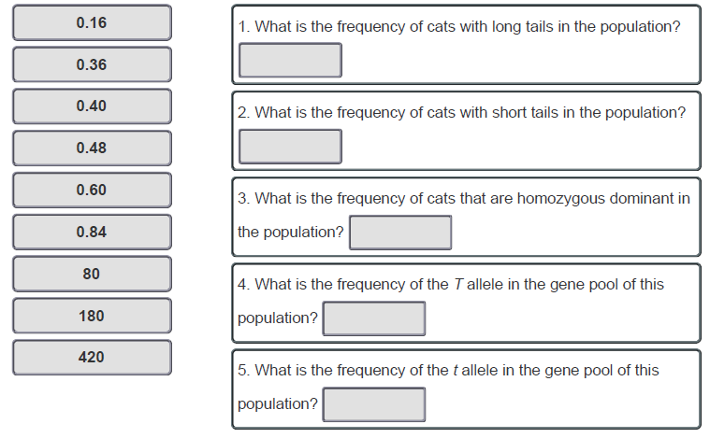

Question 5: Part B
Part B - Can you use the Hardy-Weinberg equation to answer questions about the next generation?
Recall that the frequencies of the two alleles in this population can be represented by p and q, and they can be used to predict the genotype frequencies of the next generation.
In this case, the frequency of the T allele (calculated in question 4 above) is equal to p, and the frequency of the t allele (calculated in question 5 above) is equal to q.
Drag the numbers on the left to the appropriate blanks on the right to answer these questions. Answers can be used once, more than once, or not at all.
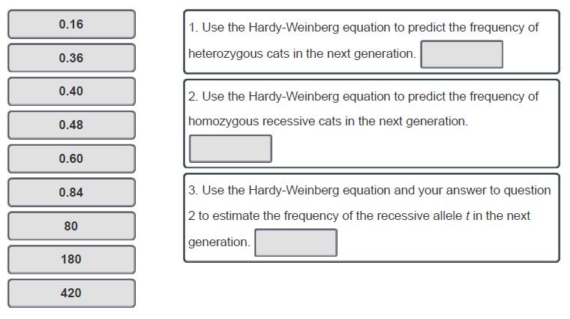

Question 6:
- In a certain group of African people, 4% are born with sickle-cell disease, an autosomal recessive disorder. Heterozygous individuals not only don't have sickle-cell disease, but also are resistant to malaria. If this group is in Hardy-Weinberg equilibrium, what percentage of the population is heterozygous and resistant to malaria?
  - 4%
  - 16%
  - 32%
  - 80%

Question 7:
- The frequency of a particular lethal recessive allele in a population is 0.02. Given this information, calculate the percentage of individuals who are carriers of the lethal recessive allele.
- approximately 0.04%
- 10%
- approximately 4%
- approximately 2%
Table S1
List and definitions of SRL Micro-level and Macro-level Processes
Macro-Level Process (and micro-level processes categorized within macro-)
Task Codes
Planning (PLAN)
Recycling:[target] (RECYCLE:target)
Sub-Goal:[target] (SG:target)
Task Definition (TDFN)
Monitoring Codes
Content Evaluation +/- (CE +/-)
Emotion Monitoring (EM)
Expectation of Adequacy of Content +/- (EAC +/-)
Feeling of Knowing +/- (FOK +/-)
Feeling of Recognition +/- (FOR +/-)
Judgement of Correctness +/- (JOC +/-)
Judgement of Learning +/- (JOL +/-)
Judgment of Understanding +/- (JOU +/-)
Monitor Information Coherence +/- (MIC +/-)
Monitoring Math Accuracy (MMA)
Monitoring Progress:[target] (MP:target)
Monitoring Use of Strategies +/- (MUS +/-)
Monitoring Understanding:[target] (MU:target)
Self-Knowledge Activation (SKA)
Task Difficulty (TD)
Time Monitoring (TM)
Domain-General Strategy Codes
Comparing and Contrasting (CC)
Coordinating Informational Sources (COIS)
Corroborating Sources (COS)
Draw (DRAW)
Emotion Regulation (ER)
Forming New Conclusion (FNC)
Help-Seeking (HSB)
Inferring Source Content (ISC)
Memorization (MEM) 52
Prior Knowledge Activation (PKA:Content or PKA:Course)
PKA:Content
Read Notes (RN)
Re-reading (RR)
Search (SEARCH)
Self-Questioning (SQ)
Self-Testing (ST)
Summarization (SUM)
Taking Notes (TN)
Table S1 (continued)
List and definitions of SRL Micro-level and Macro-level Processes
Domain-Specific Strategies
Mathematical Problem-Solving (MPS)
Assessment Strategies
Changing Answer
Match
Guessing
Ruling Out Answers
Reviewing Feedback
Skipping an Item
Testwiseness
Adaption Codes
Adapt (ADAPT)
Other Codes
Researcher Providing Instructions (RPI)
Table S2
Correlation Coefficients of Micro-TAP Counts with the in-task Quiz performance
TC | r | MON | r | DGS | r | DSS | r | ASSESS | r
TDFN | 0.08 | EAC+ | 0.2 | PKA: Content | 0.05 | MPS | -0.02 | Changing Answer | 0.28
PLAN | 0.03 | JOC- | 0.2 | COIS | 0.03 |  |  | Testwiseness | 0.04
SG:target | -0.1 | FOK+ | 0.13 | RN | 0.03 |  |  | Match | -0.14
RECYCLE: target | -0.27 | MIC+ | 0.13 | ST | 0.03 |  |  | Skipping an Item | -0.16
 |  | CE+ | 0.1 | TN | 0.02 |  |  | Receiving Feedback | -0.18
 |  | MMA | 0.09 | MEM | 0.01 |  |  | Ruling Out Answers | -0.19
 |  | MUS+ | 0.07 | SQ | -0.01 |  |  | Guessing | -.33*
 |  | EAC- | 0.03 | FNC | -0.03
 |  | JOC+ | 0.02 | HSB | -0.03
 |  | JOU+ | 0.02 | CC | -0.04
 |  | SKA | 0.01 | SUM | -0.04
 |  | FOK- | 0 | ISC | -0.1
 |  | MIC- | -0.04 | PKA:Course | -0.12
 |  | EM | -0.05 | DRAW | -0.16
 |  | MP:target | -0.07 | RR | -.32*
 |  | FOR+ | -0.08 | SEARCH | -.32*
 |  | MUS- | -0.08
 |  | TD | -0.09
 |  | TM | -0.1
 |  | FOR- | -0.12
 |  | JOL- | -0.12
 |  | MU:target | -0.12
 |  | CE- | -0.25
 |  | JOU- | -.29*

Table S3

Means, standard deviations, and correlations with confidence intervals for the Valanced Macros and Quiz_score

Variable | M | SD | 1 | 2 | 3 | 4 | 5 | 6 | 7 | 8 | 9
1. TD_POS | 2.66 | 1.43
2. TD_NEG | 11.89 | 6.26 | .04
 |  |  | [-.25, .32]
3. MON_POS | 12.60 | 9.28 | .28 | .38**
 |  |  | [-.01, .52] | [.10, .60]
4. MON_NEG | 14.15 | 10.68 | .21 | .47** | .55**
 |  |  | [-.09, .46] | [.21, .67] | [.31, .72]
5. DGS_POS | 5.11 | 4.86 | .23 | -.02 | .15 | .15
 |  |  | [-.06, .48] | [-.30, .27] | [-.14, .42] | [-.14, .42]
6. DGS_NEG | 11.11 | 7.86 | .37* | .44** | .54** | .63** | .25
 |  |  | [.09, .60] | [.18, .65] | [.29, .71] | [.42, .77] | [-.04, .50]
7. DSS | 7.68 | 3.40 | .02 | .38** | .24 | .15 | .03 | -.02
 |  |  | [-.27, .30] | [.11, .61] | [-.05, .49] | [-.15, .42] | [-.26, .31] | [-.31, .27]
8. ASSESS_POS | 0.38 | 0.64 | .14 | -.10 | .08 | -.09 | -.01 | -.06 | -.00
 |  |  | [-.15, .41] | [-.37, .20] | [-.21, .36] | [-.37, .20] | [-.29, .28] | [-.34, .23] | [-.29, .28]
9. ASSESS_NEG | 7.57 | 5.44 | .08 | .41** | -.08 | .21 | -.08 | .14 | -.09 | .03
 |  |  | [-.21, .36] | [.13, .62] | [-.36, .21] | [-.08, .47] | [-.36, .21] | [-.16, .41] | [-.37, .20] | [-.26, .31]
10. Quiz_score | 81.44 | 20.54 | -.06 | -.30* | .05 | -.32* | -.01 | -.38** | -.08 | .26 | -.36*
 |  |  | [-.34, .23] | [-.54, -.01] | [-.24, .33] | [-.55, -.03] | [-.30, .28] | [-.60, -.10] | [-.36, .21] | [-.02, .51] | [-.59, -.08]

Note. M and SD are used to represent mean and standard deviation, respectively. Values in square brackets indicate the 95% confidence interval for each correlation. The confidence interval is a plausible range of population correlations that could have caused the sample correlation (Cumming, 2014). * indicates p < .05. ** indicates p < .01.

Table S4

Means, Standard Deviations, and Correlations with Confidence Intervals for Ten Validated Traces and Quiz Score

Variable | M | SD | 1 | 2 | 3 | 4 | 5 | 6 | 7 | 8 | 9 | 10
1. Quiz Score | 79.75 | 23.47
2. Download GRQ | 0.94 | 0.24 | .16
 |  |  | [-.13, .43]
3. Syllabus Page Read | 0.06 | 0.24 | .09 | -.29*
 |  |  | [-.20, .36] | [-.53, -.01]
4. Resource Page Read | 0.33 | 0.78 | -.16 | .11 | .22
 |  |  | [-.42, .13] | [-.18, .38] | [-.07, .48]
5. Lesson Page Read | 0.35 | 0.70 | .19 | -.37* | .12 | .01
 |  |  | [-.10, .45] | [-.59, -.09] | [-.17, .39] | [-.27, .30]
6.GRQ Assignment Page Read | 0.79 | 0.46 | .08 | .07 | -.07 | -.22 | .17
 |  |  | [-.21, .36] | [-.22, .35] | [-.35, .22] | [-.47, .07] | [-.12, .43]
7. View Hint List | 0.58 | 0.94 | .03 | .07 | .12 | -.01 | -.13 | -.25
 |  |  | [-.25, .31] | [-.22, .35] | [-.17, .39] | [-.29, .28] | [-.40, .16] | [-.50, .03]
8. Access Hint | 0.56 | 0.94 | .02 | .06 | .12 | .00 | -.15 | -.26 | .99**
 |  |  | [-.27, .30] | [-.22, .34] | [-.17, .39] | [-.28, .28] | [-.41, .14] | [-.51, .02] | [.98, .99]
9. Formative Assessment Submission 1 | 2.79 | 0.54 | -.11 | .06 | -.06 | -.13 | .09 | .08 | -.01 | -.02
 |  |  | [-.38, .18] | [-.23, .34] | [-.34, .23] | [-.40, .16] | [-.20, .36] | [-.21, .35] | [-.29, .28] | [-.30, .27]
10. Formative Assessment Submission 2 | 0.04 | 0.20 | -.03 | -.38** | -.05 | .04 | .19 | -.13 | .09 | .10 | -.31*
 |  |  | [-.31, .25] | [-.60, -.10] | [-.33, .23] | [-.24, .32] | [-.09, .45] | [-.40, .16] | [-.20, .37] | [-.19, .37] | [-.54, -.02]
11. Request Quiz Answers | 0.02 | 0.14 | -.14 | .04 | -.04 | -.06 | -.07 | .07 | -.09 | -.09 | -.21 | -.03
 |  |  | [-.41, .15] | [-.25, .32] | [-.32, .25] | [-.34, .23] | [-.35, .21] | [-.22, .34] | [-.37, .20] | [-.36, .20] | [-.47, .07] | [-.31, .26]
Table S5

Means, standard deviations, and correlations with confidence intervals (Spring 2020, Raw Counts of Validated Traces)

Variable | M | SD | 1 | 2 | 3 | 4 | 5 | 6 | 7 | 8 | 9 | 10
1. Guided Reading Question Download | 27.60 | 6.60
2. Reading Assignment Page Read | 10.98 | 17.93 | -.03
 |  |  | [-.14, .09]
3. Access Hint | 28.80 | 41.71 | .10 | -.20**
 |  |  | [-.01, .21] | [-.30, -.09]
4. View Hint List | 27.34 | 42.46 | .10 | -.18** | 1.00**
 |  |  | [-.01, .21] | [-.29, -.07] | [1.00, 1.00]
5. Formative Assessment Submission 1 | 121.47 | 36.62 | .37** | -.23** | .25** | .24**
 |  |  | [.27, .46] | [-.33, -.12] | [.14, .35] | [.14, .35]
6. Formative Assessment Submission 2 | 5.94 | 4.18 | .21** | -.86** | .26** | .25** | .46**
 |  |  | [.10, .31] | [-.88, -.82] | [.15, .36] | [.14, .35] | [.36, .54]
7. Lesson Page Read | 27.61 | 27.66 | .30** | -.12* | .08 | .08 | .26** | .15**
 |  |  | [.20, .40] | [-.23, -.00] | [-.04, .19] | [-.04, .19] | [.15, .36] | [.04, .26]
8. Request Answer | 0.01 | 0.14 | -.01 | .07 | -.05 | -.04 | -.07 | -.08 | .09
 |  |  | [-.12, .10] | [-.04, .18] | [-.16, .06] | [-.16, .07] | [-.18, .04] | [-.19, .03] | [-.02, .20]
9. Syllabus Page Read | 26.16 | 19.66 | .26** | -.07 | .09 | .09 | .22** | .10 | .18** | -.01
 |  |  | [.15, .36] | [-.18, .05] | [-.02, .20] | [-.02, .20] | [.11, .32] | [-.01, .21] | [.06, .28] | [-.12, .10]
10. Final exam | 83.22 | 11.85 | .18** | -.09 | .09 | .08 | .34** | .18** | .07 | -.17** | .15*
 |  |  | [.07, .28] | [-.20, .02] | [-.03, .20] | [-.03, .19] | [.24, .43] | [.07, .29] | [-.04, .18] | [-.27, -.06] | [.03, .25]
11. Course Grade | 85.06 | 8.86 | .32** | -.11 | .19** | .19** | .59** | .28** | .18** | -.16** | .20** | .84**
 |  |  | [.22, .42] | [-.22, .00] | [.08, .30] | [.08, .29] | [.51, .65] | [.18, .38] | [.07, .29] | [-.27, -.05] | [.09, .31] | [.80, .87]
Table S6

Means, standard deviations, and correlations with confidence intervals (Fall 2020, Raw Counts of Validated Traces)

Variable | M | SD | 1 | 2 | 3 | 4 | 5 | 6 | 7 | 8 | 9 | 10
1. Guided Reading Question Download | 29.90 | 9.63
2.Reading Assignment Page Read | 28.61 | 5.61 | .36**
 |  |  | [.27, .44]
3. Access Hint | 11.54 | 19.09 | -.04 | .00
 |  |  | [-.14, .06] | [-.09, .10]
4. View Hint List | 10.52 | 19.75 | -.04 | .02 | 1.00**
 |  |  | [-.14, .06] | [-.08, .11] | [1.00, 1.00]
5. Formative Assessment Submission 1 | 117.76 | 34.30 | .25** | .35** | .04 | .04
 |  |  | [.15, .33] | [.27, .44] | [-.06, .14] | [-.06, .14]
6. rsrcPg.read | 42.13 | 49.71 | .34** | .22** | -.09 | -.09 | .21**
 |  |  | [.25, .42] | [.13, .31] | [-.19, .01] | [-.18, .01] | [.11, .30]
7. Lesson Page Read | 104.33 | 51.00 | .55** | .28** | .02 | .02 | .40** | .24**
 |  |  | [.48, .61] | [.19, .37] | [-.08, .11] | [-.08, .12] | [.31, .48] | [.15, .33]
8. Request Answer | 0.03 | 0.27 | -.02 | -.04 | .00 | .00 | -.08 | -.05 | -.07
 |  |  | [-.12, .08] | [-.14, .06] | [-.09, .10] | [-.09, .10] | [-.18, .02] | [-.14, .05] | [-.17, .02]
9. Syllabus Page Read | 24.62 | 22.92 | .37** | .15** | -.07 | -.07 | .27** | .48** | .43** | -.06
 |  |  | [.28, .45] | [.05, .24] | [-.17, .02] | [-.17, .03] | [.17, .35] | [.40, .55] | [.35, .51] | [-.16, .04]
10. Final Exam | 75.83 | 13.02 | .07 | .10* | .08 | .07 | .28** | .07 | .17** | -.13** | .14**
 |  |  | [-.03, .16] | [.00, .19] | [-.02, .17] | [-.02, .17] | [.19, .37] | [-.02, .17] | [.08, .27] | [-.23, -.04] | [.04, .23]
11. Course Grade | 84.54 | 9.46 | .22** | .27** | .09 | .08 | .49** | .14** | .27** | -.19** | .19** | .85**
 |  |  | [.12, .31] | [.18, .36] | [-.01, .18] | [-.02, .17] | [.41, .56] | [.04, .23] | [.17, .35] | [-.28, -.09] | [.10, .28] | [.82, .88]

