Effects of Tier 1 Content Literacy Intervention on Early-Grade English Learners’ Reading and Writing: Exploring the Mediating Roles of Domain-Specific Vocabulary and Oral Language Proficiency

Supplemental Online Materials (SOM)

Table S2
Table S1

Domain-Specific Vocabulary Knowledge Measures Scoring System
Score | Item selection and correct/incorrect case
4 | Student selected only two items that were all correct answers.
3 | Student selected three items: two correct answers and one incorrect answer.
2 | Student selected two items: one correct and one incorrect answer. Or, student selected four items: two correct and two incorrect answers.
1 | Student selected one item that was a correct answer. Or, student selected three items: one correct and two incorrect answers.
0 | Student selected one item that was an incorrect answer. Or, student selected two items that were all incorrect answers.
Note. We used item-response-theory to fit graded response models that account for the multiple response options. These analyses replicated the results reported in the original study (Authors, 2020). We used the 0-4 point scale in the paper because it allows us to report treatment-control differences in meaningful units (i.e., number of words learned).

Table S2

Correlation Matrix of Student-Level Measures for English Learners (Below the Diagonal) and English-Proficient Speakers (Above the Diagonal)

 | Correlation
Measures | 1 | 2 | 3 | 4 | 5 | 6 | 7 | 8 | 9 | 10 | 11 | 12 | 13
Reading pre-tests
- MAP reading | -- | .80 | .89 | .81 | 33 | .42 | .60 | .56 | .53 | .60 | .50 | .56 | --
- DIBELS | .78 | -- | .79 | .91 | .30 | .40 | .53 | .50 | .47 | .52 | .43 | .49 | --
Reading post-tests
- MAP reading | .89 | .79 | -- | .80 | .35 | .43 | .60 | .56 | .53 | .62 | .51 | .57 | --
- DIBELS | .78 | .92 | .80 | -- | .25 | .39 | .58 | .55 | .52 | .55 | .43 | .54 | --
Argumentative writing
- Science arg. writing | .35 | .36 | .38 | .34 | -- | .43 | .28 | .24 | .22 | .30 | .30 | .23 | --
- SS arg. writing | .48 | .42 | .48 | .43 | .41 | -- | .39 | .36 | .34 | .41 | .39 | .32 | --
Domain-specific vocabulary knowledge
- Science vocab. total | .54 | .51 | .56 | .53 | .30 | .39 | -- | .91 | .87 | .64 | .56 | .57 | --
- Science vocab. taught | .51 | .48 | .54 | .50 | .30 | .32 | .90 | -- | .72 | .60 | .51 | .54 | --
- Science vocab. untaught | .46 | .42 | .47 | .45 | .19 | .35 | .84 | .67 | -- | .56 | .48 | .50 | --
- SS vocab. total | .50 | .48 | .52 | .48 | .28 | .41 | .58 | .53 | .50 | -- | .90 | .84 | --
- SS vocab. taught | .41 | .40 | .44 | .40 | .29 | .38 | .50 | .45 | .43 | .88 | -- | .51 | --
- SS vocab. untaught | .43 | .41 | .44 | .42 | .16 | .30 | .48 | .44 | .40 | .80 | .42 | -- | --
English oral proficiency
- WIDA speaking | .37 | .33 | .38 | .32 | .20 | .16 | .24 | .23 | .18 | .20 | .18 | .15 | --
- WIDA listening | .57 | .45 | .58 | .45 | .34 | .34 | .38 | .37 | .30 | .40 | .37 | .30 | .45
Note. MAP = Measure of Academic Progress. DIBELS = Dynamic Indicators of Basic Early Literacy Skills. arg. = argumentative. vocab. = vocabulary. SS = social studies. WIDA = World-Class Instructional Design and Assessment.
Table S3Table
Table S3

Hierarchical Linear Modeling (HLM) Results of the Treatment Effects on Reading and Argumentative Writing Outcomes for the English Learners (EL) Subgroup

 | English learners
 | Reading |  | Argumentative writing
Sources | Reading proficiency (MAP reading) | Basic literacy skills (DIBELS) | Science | Social studies
Fixed effects
Intercept, ${\text{β}}_{\text{00}}$ | .55 (.08)*** | .62 (.08)*** | .56 (.29)) † | .39 (.28)
Treatment, ${\text{β}}_{\text{01}}$ | .02 (.03) | .02 (.03) | .26 (.10)* | .38 (.08)***
MAP pretest, ${\text{β}}_{\text{10}}$ | .69 (.02)*** | .09 (.02)*** | .34 (.06)*** | .40 (.06)***
DIBELS pretest, ${\text{β}}_{\text{20}}$ | .26 (.02)*** | .86 (.02)*** | .12 (.06)* | .14 (.06)*
Variance
Level 1, ${\text{ε}}_{\text{ij}}$ | .20 | .14 | .68 | .66
Level 2, ${\text{ζ}}_{\text{0}\text{j }}$ | .00 | .00 | .06 | .02
N | 1,230 | 1,226 | 599 | 548
Treatment effect size | .02 | .02 | .26 | .38
Note. Student-level demographic characteristics (i.e., gender, race/ethnicity, socioeconomic status, grade) and school randomization blocks were included in HLM analyses as covariates but suppressed in Table S3. MAP = Measure of Academic Progress. DIBELS = Dynamic Indicators of Basic Early Literacy Skills.
${\text{Y}}_{\text{ij}}\text{ = }{\text{β}}_{\text{00}}\text{ + }{\text{β}}_{\text{01}}{\text{(}\text{TREAT}\text{)}}_{\text{j}}\text{ + }\sum_{\text{m}\text{=1}}^{\text{2}}{{\text{β}}_{\text{m}\text{0}}{\text{(}\text{PRETEST}\text{)}}_{\text{ij}}}\text{ + }\sum_{\text{p}\text{=3}}^{\text{13}}{{\text{β}}_{\text{p}\text{0}}{\text{(}\text{COV}\text{)}}_{\text{ij}}\text{ + }\sum_{\text{q}\text{=2}}^{\text{7}}{{\text{β}}_{\text{0}\text{q}}}{\text{(}\text{BLOCK}\text{)}}_{\text{j}}\text{ +}} {\text{ε}}_{\text{ij}}\text{ + }{\text{ζ}}_{\text{0}\text{j }}$,
†p < .10, *p < .05, **p < .01, ***p < .001.

Table S4

Hierarchical Linear Modeling (HLM) Results of the Treatment Effects on Reading and Argumentative Writing Outcomes for the English-Proficient (EP) Subgroup

 | English-proficient learners
 | Reading |  | Argumentative writing
Sources | Reading proficiency (MAP reading) | Basic literacy skills (DIBELS) | Science | Social studies
Fixed effects
Intercept, ${\text{β}}_{\text{00}}$ | -.13 (.05)* | -.16 (.05)** | -.36 (.13)** | -.50 (.12)***
Treatment, ${\text{β}}_{\text{01}}$ | -.03 (.02) | -.01 (.02) | .24 (.06)*** | .45 (.06)***
MAP pretest, ${\text{β}}_{\text{10}}$ | .70 (.01)*** | .16 (.01)*** | .31 (.03)*** | .31 (.03)***
DIBELS pretest, ${\text{β}}_{\text{20}}$ | .22 (.01)*** | .80 (.01)*** | .14 (.03)*** | .20 (.03)***
Variance
Level 1, ${\text{ε}}_{\text{ij}}$ | .20 | .16 | .74 | .69
Level 2, ${\text{ζ}}_{\text{0}\text{j }}$ | .01 | .01 | .03 | .02
N | 4,147 | 4,128 | 2,119 | 1,974
Treatment effect size | -.03 | -.01 | .24 | .45
Note. Student-level demographic characteristics (i.e., gender, race/ethnicity, socioeconomic status, grade) and school randomization blocks were included in HLM analyses as covariates but suppressed in Table S4. MAP = Measure of Academic Progress. DIBELS = Dynamic Indicators of Basic Early Literacy Skills.
${\text{Y}}_{\text{ij}}\text{ = }{\text{β}}_{\text{00}}\text{ + }{\text{β}}_{\text{01}}{\text{(}\text{TREAT}\text{)}}_{\text{j}}\text{ + }\sum_{\text{m}\text{=1}}^{\text{2}}{{\text{β}}_{\text{m}\text{0}}{\text{(}\text{PRETEST}\text{)}}_{\text{ij}}}\text{ + }\sum_{\text{p}\text{=3}}^{\text{13}}{{\text{β}}_{\text{p}\text{0}}{\text{(}\text{COV}\text{)}}_{\text{ij}}\text{ + }\sum_{\text{q}\text{=2}}^{\text{7}}{{\text{β}}_{\text{0}\text{q}}}{\text{(}\text{BLOCK}\text{)}}_{\text{j}}\text{ +}} {\text{ε}}_{\text{ij}}\text{ + }{\text{ζ}}_{\text{0}\text{j }}$.

Table S5

Comparative Fit Index Measurement Models Factor Loadings and Goodness-of-Fit Statistics

Latent factors | Indicators | Standardized factor loadings | Goodness-of-fit statistics
Latent factors | Indicators | Standardized factor loadings | CFI | TLI | RMSEA [90% CI]
Domain-specific vocabulary knowledge | Science taught words | .68*** | .97 | .95 | .04 [.03 to .06]
 | Science untaught words | .61***
 | Social studies taught words | .62***
 | Social studies untaught words | .63***
English oral proficiency | WIDA speaking | .79*** | .99 | .97 | .04 [.01 to .06]
 | WIDA listening | .72***
Note. WIDA = World-Class Instructional Design and Assessment. CFI = Comparative Fit Index. TLI = Tucker–Lewis index. RMSEA = root mean square error of approximation. CI = confidence interval.
***p < .001
Table S6

Effect Sizes of the Observed Mediator Variables for English Learners (ELs) and English-Proficient (EP) Peers

Mediator variables | EL | EP
Domain-specific vocabulary knowledge
Science vocabulary knowledge
Total words | .49 | .51
Taught words | .42 | .49
Untaught words | .47 | .46
Social studies vocabulary knowledge
Total words | .52 | .59
Taught words | .54 | .69
Untaught words | .29 | .28
English oral proficiency
WIDA speaking | .002 | n/a
WIDA listening | .13 | n/a
Note. WIDA = World-Class Instructional Design and Assessment.

Figure S1
Figure S1

Results for the Structural Mediation Models of the Direct and Indirect Treatment Effects on Argumentative Writing via (a) Science Vocabulary Knowledge and (b) Social Studies Vocabulary Knowledge among English Learners

- Science model
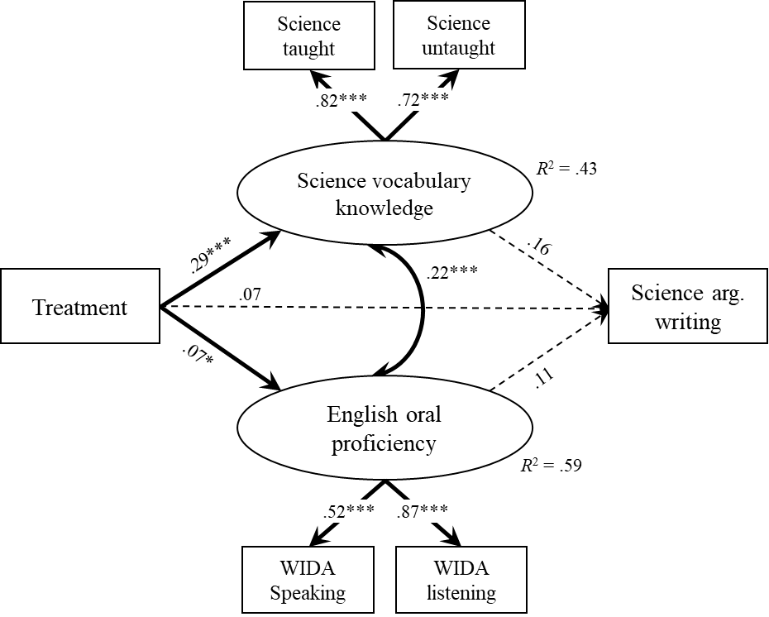

- Social studies model
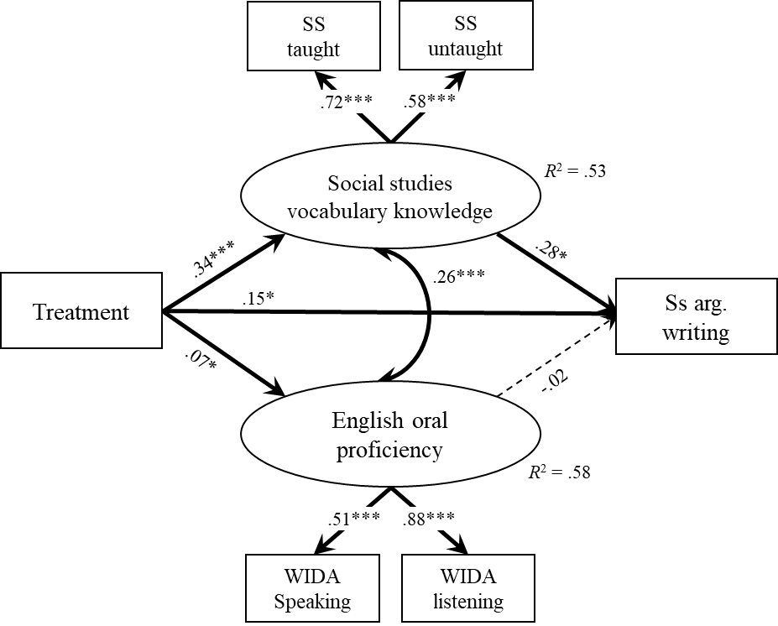

Note. Statistically significant (p < .05) path coefficients are shown in bold. Path estimates are standardized and standard errors are shown in parentheses. Student-level demographic characteristics (i.e., gender, race/ethnicity, socioeconomic status, grade) and school randomization blocks were included in the mediation analysis but not displayed in the path diagram. SS = social studies. arg. = argumentative.
*p < .05, **p < .01, ***p < .001.

Appendix S1
Fidelity of Implementation: Adherence Checklist
 | Checklist Items
 | Core Component 1: Concept Map | Y | N
1 | Teach students new concepts by explicitly connecting them to previously taught concepts
2 | Taught content vocabulary by helping children see how words are connected
 | Core Component 2: Interactive Read-Alouds Using Conceptually Related Text
3 | Use connected texts (i.e., texts about the same topic) across multiple days
4 | Preview the texts and make connections to what students are learning about.
5 | Lead elbow partners in an academic discussion.
6 | (After reading) Model strategies to address focal literacy standard(s)
 | Core Component 3: Argumentation
7 | Teach students how to support their opinions with reasons
8 | Teach students how to support their opinions with textual evidence, as opposed to feelings or belief
 | Core Component 4: Program Mission
9 | Help students understand today’s learning goals and how they support the Program Mission.
 | Core Component 5: Collaborative Research
10 | Provide students with opportunities to collaborate on in-class projects
11 | Organize students into mixed ability groups for at least part of the lesson

Appendix S2

Title of Books Used in the Treatment Group Lessons for Interactive Read-Aloud Activity

Domain | Title
 | Grade 1 | Grade 2
Science | - Ultimate Ocean Rumble  - Polar Bear vs Grizzly Bear  - Desert Animal Adaptations  - Rhino Rescue  - Killer Whale vs Great White Shark  - Penguins  - What was the Ice Age  - Desert Animal Adaptations | - Who Would Win? Tyrannosaurus Rex vs. Velociraptor  - Fossils (A True Book: Earth Science)  - No Bones About It: Discovering Dinosaurs  - T. Rex with Audio: Read, Listen, & Wonder  - Boy, Were We Wrong About Dinosaurs!  - T. Rex: Hunter or Scavenger  - Dinosaurs?!
Social Studies | - You Wouldn't Want To Be A Viking Explorer  - Keep On!: The Story of Matthew Henson Co-Discoverer of the North Pole  - You Wouldn't Want To Be Lewis and Clark  - National Geographic Readers: Sacagawea  - You Wouldn't Want to Be a Polar Explorer  - The Inuit Thought of It | - Marvelous Mattie  - Timeless Thomas  - You Wouldn't Want to Be on the First Flying Machine!  - Whoosh!: Lonnie Johnson's Super-Soaking Stream of Inventions  - If You Were A Kid During the Civil Rights Movement

Title of Books Used in the Control Group Lessons for Interactive Read-Aloud Activity

Domain | Title
 | Grade 1 | Grade 2
Science | - Velociraptor  - Tacky the Penguin  - What If You Had Animal Teeth?  - National Geographic Readers: Great Migrations Whales  - National Geographic Readers: Sharks!  - Emperor Penguins  - Penny the Rude Penguin  - Bee  - Owls- National Geographic Kids  - Lions - National Geographic Kids  - National Geographic Kids - Sharks  - Night and Day  - What Makes Day and Night  - Why Do We Need Soil?  - Earth's Landforms and Bodies of Water  - Is All Soil the Same?  - Hawaii Volcanoes National Parks (Reading A to Z)  - Hummingbirds (Reading A to Z)  - Blue Whales: Giant Mammals (Reading A to Z) | - Spinning Spiders (Let's-Read-and-Find-Out Science 2)  - What If You Had Animal Teeth?
Social Studies | - Meet My Neighbor, The Dentist  - Goods and Services Around Town  - All Kinds of Homes (RAZ Kids)  - George Washington and the General's Dog  - George Washington Carver  - Epic Books My Itty Bitty Bio on Rosa Parks  - Epic Books My Itty Bitty Bio on Benjamin Bannekar  - Epic Books My IttyBitty Bio on Howard Lewis Lattimer  - Epic Books My Itty Bitty Bio on Jackie Robinson  - President's Day  - A Day in the Life of a Garbage Collector | - (None)
Fiction | - Throw Your Tooth on the Roof  - Snow  - Frog and Toad are Friends  - Let's Read About Ruby Bridges  - The Hat  - Ron's Big Mission  - Duck for President  - Father Bear Comes Home  - Little Bear  - Days with Frog and Toad  - Caps for Sale  - Three Cheers for Tacky  - It's Mine.  - Down the Road  - Mathew & Tilley  - Chester's Way  - Julius: The Baby of the World  - Ruthie and the (Not So) Teeny Tiny Lie  - Last Stop on Market Street  - Jumanji  - Knuffle Bunny  - Peter's Chair  - Sheep on a Ship  - When I grow Up  - Cloudy With a Chance of Meatballs  - Amelia Bedelia  - Zelda and Ivy: The Runaways  - Miss Nelson is Missing  - Tumbleweed Stew  - George and Martha one more time  - Upstairs Mouse and Downstairs Mole by Wong Herbert Yee  - Quick as a cricket  - Lilly's Purple Plastic Purse  - The Drum  - Little Red Riding Hood,  - The Lion and the Mouse  - The Empty Pot  - The Three Little Pigs  - Recess Queen  - The Most Magnificent Thing  - It's Mine.  - Each Kindness  - Amazing Grace  - Bonk! Goes the Ball  - The Dot  - The Empty Pot  - An Extraordinary Egg  - The Snowy Day  - Arthur's Fire Drill  - Me on the Map  - Tree Homes  - What Pet Should I Get  - Red is Best.  - Henry and Mudge and the Starry Night  - Henry and Mudge and the Happy Cat  - Ruby the Copycat  - Wait and See  - Best Friends Sleep Over  - The Magic Fish  - Ira Sleeps Over  - Chair for my Mother  - Caps for Sale  - The Ant and the Grasshopper  - When Turtle Grew Feathers: A Tale from the Choctaw Nation  - Time Lines  - What Do You Do with an Idea?  - What Do You Do with a Problem?  - Captain Underpants  - Magic School Bus  - Junie B. Jones Has a Monster Under Her  - Little Red Hen Makes Pizza  - Brownilocks and the Three Bowls of Cornflakes  - Goldilocks  - A Picture Book of Abraham Lincoln  - How Much Can a Bare Bear Bear?  - The Great Kapok Tree  - Mighty Mississippi (Reading A to Z)  - Magic Tree House by Mary Pope Osborne (Dolphins at Daybreak)  - Magic Tree House by Mary Pope Osborne (Midnight on the Moon)  - The Yellow Yacht (A to Z Mysteries)  - The Mystery on the Mighty Mississippi | - One Fish Two Fish Red Fish Blue Fish  - Pete the Cat: I Love My White Shoes  - Quiet Place  - Is Your Mama a Llama  - Bend and Stretch: Learning about Your Bones and Muscles  - The Name Jar  - The Paper Crane  - Frankly Frannie  - Jame and the Giant Peach  - The Bad Seed  - The Lemonade War  - Anansi and the Moss Covered Rock  - Yeh-Shen: A Cinderella Story from China  - The Golden Sandal: A Middle Eastern Cinderella Story  - Anansi and the Magic Stick  - Stone Fox  - George's Marvelous Medicine  - I'm Trying To Love Spiders  - The Good Egg  - The Legend of Rock, Paper, Scissors  - Henry's Freedom Box: A True Story from the Underground Railroad

Appendix S3

Grade 1 and 2 Argumentative Writing Assessment in Science and Social Studies

- Grade 1 Argumentative Writing in Science

Rainforests
By Will Osborne and Mary Pope Osborne

People in the Rainforest
Rainforests are one of Earth’s most valuable resources. But the rainforests are being destroyed very quickly. New babies are born every day. There are more and more people living on Earth. Families are cutting down huge numbers of trees. They’re clearing land to build roads so that they can travel from place to place. They’re clearing land to build houses for shelter from the wet weather. They’re also clearing land to grow crops and raise cattle for their food. Half of the world’s rainforests are now gone.

Animals in the Rainforest
The rainforest is home to unique plants and animals that don’t live anywhere else. When a rainforest is destroyed, these plants and animals are destroyed with it. Some rainforest animals are becoming very rare. For example, there were once thousands of woolly spider monkeys. Now there are only a few hundred. This is bad news for many plants, flowers, and fruits that need spider monkeys to carry their seeds from place to place. Because of the interdependence between animals and plants in the rainforest, what hurts one organism could hurt many organisms.

Prompt: Should people be allowed to cut down trees in the rainforest?

Directions: Answer this question by making an argument. Before you start, take 3 minutes to think about what you want to write.
A good argument means:
- it has your opinion;
- it has your reasons;
- it explains your thinking using evidence; and
- it has a conclusion.

- Grade 1 Argumentative Writing in Social Studies

Women Explorers
Amelia Earhart
The airplane bounced among the clouds. The airplane carried Amelia Earhart. In 1928, Amelia Earhart became the first woman to ride across the Atlantic Ocean in an airplane. But she was only a passenger on that first trip. Today, she was flying the plane. If she made it, she would become the first woman to ever pilot a plane across the Atlantic Ocean. But first she had to succeed, and the trip was dangerous. Airplanes in the 1930s were small, and they didn’t have the special instruments that today’s planes do. Amelia struggled to get control. After 15 hours in the air, she did it! She crossed the Atlantic Ocean in an airplane she flew herself. Now, she would be a legend. However, while trying to fly around the world in 1937, she disappeared.

Sally Ride
Half a million people cheered when the space shuttle Challenger took off in Florida. It was 1983 and Sally Ride was on board and headed into space. Sally Ride was the first American woman in space. And she was the youngest American astronaut, male or female, at age 32. During their time in space, Sally and other scientists worked on 40 experiments. They tested many robots. Later, Sally wrote a book about her space exploration. She wrote about how the crew had to move around the ship by grabbing onto something on the wall to keep from floating away.

Prompt: Both Amelia Earhart and Sally Ride deserve to be celebrated. But, if you had to pick just one of these women explorers to celebrate, which one would you choose - Amelia Earhart or Sally Ride? Why?

Directions: Answer this question by making an argument. Before you start, take 3 minutes to think about what you want to write.
A good argument means:
- it has your opinion;
- it has your reasons;
- it explains your thinking using evidence; and
- it has a conclusion.

- Grade 2 Argumentative Writing in Science

The Death of Dinosaurs

The last dinosaurs died out about 65 million years ago. Scientists still do not agree about why this happened. There are many theories among scientists about how dinosaurs became extinct. Some scientists think that dinosaurs died out because the temperature on Earth got too hot or too cold for them. Others believe that a huge asteroid from space struck Earth.

An asteroid strike could have changed Earth’s climate. Dust clouds after the strike blocked the sun’s heat and light for months or even years. The air became colder and rainwater turned muddy and undrinkable. Plants would have stopped growing, so herbivores died from not having enough food. And then, carnivores could have not hunted them.

But, there is one problem with this theory: Scientists called paleontologists have not yet found dinosaur fossils or skeletons from the time of asteroid impact. Some evidence shows that all the dinosaurs had died even before the asteroid hit. Also, some animals lived through the time when the dinosaurs disappeared. The ancestors of today’s frogs, turtles, lizards, and snakes found a way to survive. Birds also survived. Scientists do not know why some animals lived but the dinosaurs did not.

Prompt: Some scientists think the dinosaurs died out after an asteroid struck Earth. But, not everyone agrees. Do you think that an asteroid killed the dinosaurs? Why or why not?

Directions: Answer this question by making an argument. Before you start, take 3 minutes to think about what you want to write.
A good argument means:
- it has your opinion;
- it has your reasons;
- it explains your thinking using evidence; and
- it has a conclusion.

- Grade 2 Argumentative Writing in Social Studies

Inventors

Leonardo da Vinci
Leonardo da Vinci was one of the greatest artists and thinkers the world has ever known. He was also an incredible scientist and inventor. Although Leonardo lived over 500 years ago, we still admire his genius today. Leonardo wrote that his first memory was when he was a baby lying in his cradle. He said that a bird called a kite swooped down on him, brushing its tail between his lips. Leonardo didn't seem sure whether this was a dream or whether it really happened. But he claimed that it was why he became interested in birds. All of his life, Leonardo drew pictures of birds, especially of their wings. He tried to figure out how the wings worked so he could build a flying machine. He thought that one day people might be able to fly, just like birds.

Henry Ford
As a young boy, Henry Ford had always been fascinated by mechanical devices, such as watches and wind-up toys. When he was young, he went to a one-room schoolhouse. There he showed an early interest in practical jokes. He was also good at solving math problems in his head. But Henry’s greatest love was studying mechanical objects. When Henry was seven, a worker on the family farm took apart his watch to show the boy how it ran. Henry immediately began to learn everything he could about watches. He made his own tools from bits of metal he found around the house and explored the inside of any watch he could find.

Prompt: Both young Leonardo da Vinci and Henry Ford deserve to be celebrated. But, if you had to pick just one of these young inventors to celebrate, which one would you choose - Leonardo da Vinci or Henry Ford? Why?

Directions: Answer this question by making an argument. Before you start, take 3 minutes to think about what you want to write.
A good argument means:
- it has your opinion;
- it has your reasons;
- it explains your thinking using evidence; and
- it has a conclusion.

Appendix S4

Grade 1 and 2 Domain-Specific Vocabulary Knowledge in Science and Social Studies

- Grade 1 Domain-Specific Vocabulary Knowledge in Science

- Circle two words that go with potential.
future | bones | ability | report
- Circle two words that go with unique.
characteristic | terrible | careful | different
- Circle two words that go with survive.
food | dirt | alive | music
- Circle two words that go with species.
type | family | furry | not real
- Circle two words that go with behavior.
fur | does | acts | grass
- Circle two words that go with camouflage.
protect | tell | hide | air
- Circle two words that go with advantage.
power | finds | follows | helps
- Circle two words that go with diversity.
large pieces | mix | variety | riches
- Circle two words that go with adaptation.
freeze | fit | scientist | change
- Circle two words that go with habitat.
wing | forest | place | weather
- Circle two words that go with physical feature.
claws | looks like | sleeps | acts like
- Circle two words that go with complex.
hard | quick | upset | problem

- Grade 1 Domain-Specific Vocabulary Knowledge in Social Studies

- Circle two words that go with ancestor.
visitor | family | cashier | grandparents
- Circle two words that go with expedition.
sailing | exercise | yard | Lewis and Clark
- Circle two words that go with navigation.
enemy | exploration | steer | novel
- Circle two words that go with discovery.
find | learn | pass | hide
- Circle two words that go with settle.
land | leave | wonder | stay
- Circle two words that go with obstacle.
order | difficulty | circle | problem
- Circle two words that go with indigenous.
native | late | delicious | Inuit
- Circle two words that go with celebrate.
sell | honor | cheer | blame
- Circle two words that go with explorer.
travel | adventure | exercise | explain
- Circle two words that go with route.
root | human | road | line
- Circle two words that go with community.
people | boat | neighbor | talk
- Circle two words that go with persistent.
continuous | recent | personal | never-ending

- Grade 2 Domain-Specific Vocabulary Knowledge in Science

- Circle two words that go with carnivore.
fruit | care | meat | prey
- Circle two words that go with extinct.
gone forever | living | existing | lost
- Circle two words that go with fossil.
utensil | bone | folks | footprint
- Circle two words that go with hypothesis.
thought | poem | guess | hippo
- Circle two words that go with brutal.
harsh | brave | cruel | friendly
- Circle two words that go with evidence.
choosing | proving | showing | feeling
- Circle two words that go with theory.
fairy | theme | argument | idea
- Circle two words that go with hunter.
handout | catcher | search | conclusion
- Circle two words that go with organism.
creature | animal | order | practice
- Circle two words that go with trait.
characteristic | truth | exam | feature
- Circle two words that go with paleontologist.
paint | history | dinosaur | pair
- Circle two words that go with reptile.
mobile | lizard | report | cold-blooded

- Grade 2 Domain-Specific Vocabulary Knowledge in Social Studies

- Circle two words that go with inventor.
creator | factor | maker | editor
- Circle two words that go with hire.
fire | bring in | remove | choose
- Circle two words that go with experiment.
test | element | scientist | reflection
- Circle two words that go with approve.
disagree | accept | like | apologize
- Circle two words that go with prototype.
crop | model | process | original
- Circle two words that go with establish.
set up | build | chop | laugh
- Circle two words that go with manufacture.
figure | divide | put together | create
- Circle two words that go with discrimination.
not equal | favorable | unfair | situational
- Circle two words that go with laboratory.
test | vote | Thomas Edison | story
- Circle two words that go with engineer.
designer | actor | further | builder
- Circle two words that go with foundation.
choice | basics | fiction | beginning
- Circle two words that go with ingenious.
creative | smart | clumsy | delicious

