Appendix 1 Power Analysis
Informed by the recent meta-analysis of the impacts of PD on classroom quality, this research anticipated an effective size of 0.5 at the teachers’ level (Egert et al., 2018). To adjust for the clustering intrinsic to our research design, this study incorporated a correction factor [1 + (m-1) × ICC] into our analyses, where 'm' represents the mean number of teachers in each school, and 'ICC' signifies the intra-class correlation coefficient (Gore et al., 2017). As shown in Figure 2, with an ICC value of 0.07 and a correction factor of 1.5, the power analysis prescribes the selection of eight teachers from each of the 24 kindergarten clusters. This configuration enables the RCT design to attain a statistical power of 80%, while maintaining an alpha level set at p < 0.05.
Figure 2.
The power of choosing different numbers of teachers per kindergarten cluster
The power levels
The number of subjects
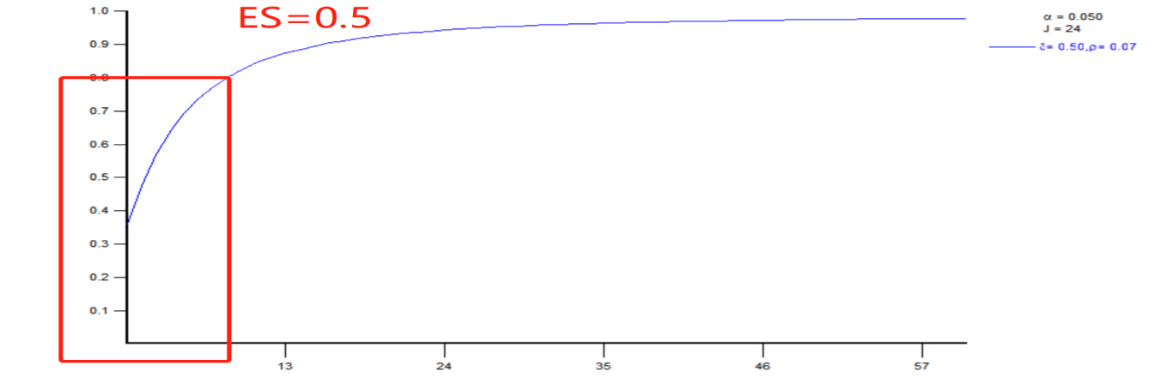

Appendix 2 Sensitivity Analysis
Table 7
The results of three-level models of the main effects of PD on child development
 | Emergent literacy |  |  | Emergent numeracy |  |  | Executive function |  |  | Social emotion
Coefficient | b | SE | 95%CI | b | SE | 95%CI | b | SE | 95%CI | b | SE | 95%CI
Fixed effect
Intercept | 61.88*** | 2.11 | [57.75, 66.01] | 68.40  *** | 2.42 | [63.66, 73.14] | 58.66  *** | 2.48 | [53.80, 63.52] | 58.33*** | 2.17 | [54.08, 62.58]
Level 1-Individual
Pre-test | 0.66  *** | 0.04 | [0.58, 0.74] | 0.64  ** | 0.04 | [0.55, 0.72] | 0.28  *** | 0.03 | [0.22, 0.35] | 0.38*** | 0.06 | [0.27, 0.49]
Age | 0.52  ** | 0.19 | [0.14, 0.89] | 0.64  ** | 0.21 | [0.24, 1.05] | 0.69  *** | 0.18 | [0.34, 1.03] | 0.19 | 0.20 | [-0.21, 0.59]
Gender | -0.03 | 1.43 | [-2.83, 2.76] | 2.70* | 1.35 | [0.06, 5.35] | -1.35 | 1.29 | [-3.87, 1.17] | -3.51  ** | 1.19 | [-5.84, -1.17]
Level 2-Classroom
Pre-ECERS-E | 8.92 | 8.28 | [-7.30, 25.15] | 6.62 | 4.83 | [-2.84, 16.08] | 10.38 | 7.40 | [-4.12, 24.89] | 0.14 | 0.21 | [-6.37, 12.08]
Pre-SSTEW | -2.22 | 1.29 | [-4.74, 0.31] | -1.10 | 1.27 | [-3.58, 1.39] | -3.42* | 1.67 | [-6.68, -0.15] | -0.08 | 0.22 | [-4.38, 3.67]
Classroom-average | 0.83  *** | 0.06 | [0.71, 0.95] | 0.78  *** | 0.05 | [0.69, 0.87] | 0.39  *** | 0.05 | [0.65, 1.01] | 0.43  *** | 0.07 | [0.29, 0.57]
Teacher qualification | 2.67 | 1.80 | [-0.86, 6.21] | -3.92  ** | 1.33 | [-6.52,  -1.32] | 0.31 | 1.40 | [-2.43, 3.04] | -0.82 | 2.86 | [-6.43. 4.80]
Teacher degree | -1.67 | 1.60 | [-4.80, 1.46] | -0.34 | 0.92 | [-2.14, 1.46] | -0.67 | 1.86 | [-4.30, 2.97] | -2.44 | 1.43 | [-5.24, 0.35]
Child-to-teacher ratio | 0.13 | 0.34 | [-0.52, 0.79] | -0.37 | 0.28 | [-0.92, 0.17] | -0.41 | 0.29 | [-0.98, 0.16] | 0.32 | 0.43 | [-0.52, 1.15]
Teacher Age | 0.31 | 0.54 | [-0.76, 1.37] | 0.40 | 0.71 | [-1.00, 1.80] | 0.41 | 0.55 | [-0.67, 1.49] | 0.97 | 0.55 | [-0.11, 2.04]
Level 3-Kindergarten
Intervention | 2.72  ** | 0.92 | [0.91, 4.53] | 0.94 | 1.15 | [-1.31, 3.19] | 4.53  *** | 1.14 | [2.31, 6.76] | 1.00 | 1.11 | [-1.17, 3.17]
City level | -1.55 | 1.15 | [-3.81, 0.71] | -3.08* | 1.49 | [-6.01,  -0.15] | -1.53 | 1.84 | [-5.14, 2.09] | 1.84 | 1.38 | [-0.86, 4.55]
District level | 0.38 | 1.67 | [-2.89, 3.65] | 0.24 | 1.79 | [-3.27, 3.75] | -0.26 | 1.72 | [-3.64, 3.11] | 1.73 | 1.85 | [-1.89, 5.35]
Location | -1.37 | 1.11 | [-3.54, 0.79] | 3.17* | 1.34 | [0.55, 5.79] | 1.00 | 1.30 | [-1.55, 3.55] | -0.41 | 1.21 | [-2.78, 1.97]
Type | -3.45  ** | 1.06 | [-5.54, -1.37] | -0.55 | 1.58 | [-3.65, 2.54] | 0.61 | 1.65 | [-2.62, 3.84] | 0.17 | 1.62 | [-3.01, 3.35]
Residual variances
Level 1-individual | 196.02  *** | 11.42 | [173.64, 218.40] | 185.37  *** | 12.04 | [161.78, 208.96] | 214.43  *** | 13.13 | [180.70, 240.16] | 206.64  *** | 13.26 | [180.65, 232.63]
Level 2- classroom | 0.01 | 7.12 | [-0.8, 0.10] | 0.01 | 7.18 | [-14.07, 14.07] | 0.23 | 7.85 | [-15.17, 15.62] | 0.79 | 6.15 | [-11.27, 12.85]
Level 3- kindergarten | 0.13 | 5.80 | [-11.24, 11.50] | 0.22 | 3.20 | [-6.05, 6.50] | 0.22 | 4.91 | [-9.41, 9.85] | 0.14 | 5.61 | [-10.87, 11.14]
Model summary
AIC | 6414.871 |  |  | 6384.93 |  |  | 6457.12 |  |  | 6443.83
Table 8
The results of regression models of the main effects of PD on child development
 | Emergent literacy |  |  | Emergent numeracy |  |  | Executive function |  |  | Social emotion
Coefficient | b | SE | 95%CI | b | SE | 95%CI | b | SE | 95%CI | b | SE | 95%CI
Fixed effect
Intercept | 24.85*** | 1.44 | [22.02, 27.67] | 33.09  *** | 2.16 | [28.86, 37.31] | 41.44  *** | 1.74 | [38.03, 44.84] | 37.41*** | 2.36 | [32.79, 42.04]
Variables
Intervention | 3.05  * | 1.21 | [0.69, 5.41] | 1.48 | 1.37 | [-1.22, 4.17] | 5.34  *** | 1.23 | [2.93, 7.74] | 1.29 | 1.29 | [-1.24, 3.82]
Pre-test | 0.77  *** | 0.03 | [0.71, 0.82] | 0.72  *** | 0.03 | [0.67, 0.78] | 0.35  *** | 0.03 | [0.29, 0.40] | 0.42  *** | 0.04 | [0.35, 0.49]
Residual variances | 209.37  *** | 12.50 | [184.87, 233.87] | 199.84  *** | 12.78 | [174.80, 224.87] | 225.96  *** | 14.48 | [197.58, 254.34] | 214.57  *** | 13.71 | [187.71, 241.43]
Model summary
AIC | 9651.707 |  |  | 9626.20 |  |  | 9693.41 |  |  | 9665.15

