**Supplementary materials**

1. **Example materials of the belief-bias syllogistic reasoning task**

|  |  |  |
| --- | --- | --- |
| **Table S1**  *Examples of the belief-bias syllogistic reasoning task including the incongruent trials (believable-invalid; unbelievable-valid) and congruent trials (believable-valid; unbelievable-invalid).* | | |
| Logical validity | Conclusion believability | |
|  | Believable | Unbelievable |
| Valid | Major premise: All birds have wings.  Minor premise: All crows are birds.  Conclusion: All crows have wings. | Major premise: All mammals can walk.  Minor premise: All whales are mammals.  Conclusion: All whales can walk. |
| Invalid | Major premise: All flowers need water.  Minor premise: All roses need water.  Conclusion: All roses are flowers. | Major premise: All meat products can be eaten.  Minor premise: All apples can be eaten.  Conclusion: All apples are meat products. |
| *Note.* The grey blanks include examples of the incongruent trials, and the white blanks the congruent trials. | | |

1. **Example Items of the Chinese critical thinking test (CCTT)**

We translated the example items measuring each sub-skill of critical thinking administered in the CCTT test from Chinese into English. Answers to the items were not provided due to copyright issues.

1. **Analysis**

“Not all the birds can fly,” expresses the same idea as:

A. None of the birds can fly.

B. Some birds cannot fly.

C. Someone who can fly is not a bird.

D. All birds cannot fly.

1. **Evaluation**

“Petrol prices have soared due to the combined effects of the 2008 global financial crisis and the chaotic situation in the Middle East. In that same time the costs of several petroleum derivatives have also gone up sharply. These two facts establish that petrol is a petroleum derivative.” The best evaluation of the speaker's reasoning is?

A. Good thinking, because petrol is a petroleum derivative.

B. Good thinking, but not all the facts are stated accurately.

C. Bad thinking. The cost of food has gone up in the same time, but that does not prove that petrol is food.

D. Bad thinking. One can draw no conclusions about petrol, given facts about petroleum derivatives.

1. **Deduction reasoning**

A college student club has members from seven cities: Beijing, Shanghai, Guangzhou, Wuhan, Chongqing, Shenzhen, and Xi’an. The tutor must pick five students, each from a different city, to perform a play at the New Year celebration performance. Any combination of five students will do, except that if someone from Beijing is selected, no one from Chongqing should be selected. Also, if someone from Guangzhou is picked, someone from Chongqing must be picked. And, if someone from Shanghai is selected, a member of Shenzhen must also be selected. Here are five possible combinations of students for the play. Which is the only combination that meets all the conditions?

A. Beijing, Shanghai, Guangzhou, Wuhan, Chongqing.

B. Shanghai, Guangzhou, Wuhan, Chongqing, Shenzhen.

C. Shanghai, Guangzhou, Wuhan, Shenzhen, Xi’an.

D. Beijing, Wuhan, Chongqing, Shenzhen, Xi’an.

E. Beijing, Shanghai, Guangzhou, Shenzhen, Xi’an.

1. **Inductive reasoning**

Consider this argument: “Elephant L is smaller than elephant X. Elephant Y is smaller than elephant L, but elephant M is smaller than elephant Y. Therefore, elephant Y is smaller than elephant J.” What information must be added to require that the conclusion be true, assuming all the premises are true?

A. Elephant L is bigger than J.

B. Elephant X is bigger than J.

C. Elephant J is bigger than L.

D. Elephant J is bigger than M.

1. **Inference reasoning**

Consider this group of statements: “Shang Tang was the first Monarch of the Shang dynasty. Each of the Shang Monarchs drank wine and used bronze drinking vessels exclusively. Anyone who has used a bronze drinking vessel, even once, will have lead poisoning. Lead poisoning always manifests itself through insanity.” Which of the following must be true if all of the above are true?

A. Those who suffer from insanity used the bronze drinking vessel at least once.

B. Whatever else, Monarch Shang Tang was certainly insane.

C. The exclusive use of bronze drinking vessels was the privilege of the Shang Monarchs.

D. Lead poisoning was common among people of the Shang dynasty.

1. **Example Items of the Critical thinking skills test with heuristics and biases (CTHB)**

We translated the example items for each task category administered in the CTHB tests (√. correct answer) from Chinese into English. Explanations of the items and answers are also provided.

1. **Causal base-rate task**

A trial tested 1,000 participants: 950 participants who buy their clothes at C&A and 50 participants who buy their clothes in exclusive clothes shops. Sacha was randomly selected out of those 1,000 participants. She is 36 years old, has a job as an asset manager at a bank, drives a Porsche, and lives in a Penthouse with her friend. How likely is it that Sacha buys her clothes in exclusive clothes shops?

A. more than 75%.

B. 50%.

C. 30%.

D. less than 10%. √

Explanation: This assignment requires participants not to confuse the logical validity of the conclusion with the believability of the conclusion, which probably seems unbelievable due to prior beliefs or real-world knowledge (Note that options A, B, and C demonstrate the tendency to base judgments on prior belief and to neglect the base-rate).

1. **Wason selection task**

Each of the four cards below has an image on one side and a digit on the other side. The following rule is applied to the cards: If there is a heart on one side, then there is a 7 on the other side. Question: Which two cards do you think need to be turned over to verify the authenticity of this rule?



A. Heart, 7. B. Heart, 4. √ C. Diamond, 7. D. Diamond, 4.

Explanation: This assignment requires people to not only seek to confirm the rule but also look for falsification of the rule. By turning over the card with a heart, you can test whether the rule is violated: If there is no 7 on the other side, the rule is violated. The same for turning over the card with a 4: If that card has a heart on the other side, the rule is violated. Because if there is a heart on one side, there should be a 7 on the other side. People who choose other options than the combination of the card with a heart and the card with a 4, verify rules rather than falsify them, or demonstrate matching bias by selecting options explicitly mentioned in the conditional statement.

1. **Conjunction task**

The Dutch national police has investigated crime in the major cities of the Netherlands. The city Rotterdam was part of the research and was selected by chance from the list of cities. Which of the following statements is most likely?

A. The Rotterdam police had to cut off staff and the number of street robberies in Rotterdam has increased.

B. The number of street robberies in Rotterdam has increased. √

Explanation: This assignment requires participants not to violate the conjunction rule which states that the probability of a conjunction cannot be more probable than one of its constituents.

1. **Covariation detection task**

You are an entrepreneur and your company is on the brink of bankruptcy. Your neighbor tells you about Corporate Fixer: a company that specializes in solving business problems. “They do fantastic work”, he says, “the company of a good friend of mine became extremely successful after their help!” You visit their website and find out that the services of Corporate Fixer are quite pricey. You are prepared to pay the price, provided that you have a better chance of solving your business problems with their help than without any help. On an independent comparison website, you see that (a) 188 companies received help from corporate fixer and solved their business problems, (b) 95 companies did not receive help and solved their problems, (c) 90 companies received help without solving their business problems, and (d) 25 companies did not receive help and did not solve their problems:

|  |  |  |
| --- | --- | --- |
|  | Help from Corporate fixer | No help from Corporate fixer |
| Business problems solved | 188 | 95 |
| Business problem unsolved | 90 | 25 |

Based on this information, would you commission from Corporate fixer or not?

1. Yes B. No √

Explanation: The important thing to notice here is that one should evaluate the information given in a 2 × 2 contingency table equally and suppress the tendency to focus on the large number in the cell.

1. **Cognitive reflection task**

If it takes 5 machines 5 minutes to make 5 widgets, how long would it take 100 machines to make 100 widgets?

A. 5 minutes. √ B. 100 minutes.

Explanation: This assignment requires people to override a prepotent response alternative that is incorrect and to engage in further reflection that leads to the correct response. “It takes 5 machines 5 minutes to make 5 widgets”, means every machine takes 5 minutes to produce 1 widget. So, it takes 5 minutes to make 100 widgets.

1. **Syllogistic reasoning task**

You will find two premises below that you must assume are true. Indicate whether the conclusion follows logically from the given premises.

Premise 1: No lawyers are straightforward,

Premise 2: Some crooks are straightforward,

Conclusion: Some lawyers are no crooks.

Given that both premises are true,

1. the conclusion follows logically from the premises.
2. the conclusion does not follow logically from the premises. √

Explanation: The important thing to notice here is that one does not confuse the believability of the conclusion with the logical validity of the conclusion.

|  |  |  |  |  |  |  |  |  |
| --- | --- | --- | --- | --- | --- | --- | --- | --- |
| **Table S2**  *Repeated-measures ANOVAs of the mean amplitudes of P200, N400, P600, LNC, and LPC.* | | | | | | | | |
|  |  | Condition | Location | Group | Condition × Group | Location × Group | Location × Condition | Location × Condition × Group |
|  | df | 1,70 | 2,140 | 1,70 | 1,70 | 2,140 | 2,140 | 2,140 |
| P200 | *F* | 6.95 | 4.48 | 1.06 | 4.35 | 1.72 | 0.92 | 0.82 |
| *p* | 0.01 | 0.03 | 0.31 | 0.04 | 0.19 | 0.37 | 0.40 |
| *η2* | 0.09 | 0.06 | 0.02 | 0.06 | 0.02 | 0.01 | 0.01 |
| N400 | *F* | 0.94 | 65.33 | 9.87 | 6.10 | 0.06 | 2.41 | 1.97 |
| *p* | 0.34 | < 0.01 | < 0.01 | 0.02 | 0.85 | 0.12 | 0.16 |
| *η2* | 0.01 | 0.48 | 0.12 | 0.08 | < 0.01 | 0.03 | 0.03 |
| P600 | *F* | 2.79 | 93.62 | 9.21 | 3.58 | 2.89 | 0.99 | 0.68 |
| *p* | 0.10 | < 0.01 | < 0.01 | 0.06 | 0.09 | 0.33 | 0.43 |
| *η2* | 0.04 | 0.57 | 0.12 | 0.05 | 0.04 | 0.01 | 0.01 |
| LNC | *F* | 11.95 | 3.33 | 2.82 | 2.04 | 1.47 | 5.14 | 6.34 |
| *p* | < 0.01 | 0.07 | 0.10 | 0.16 | 0.23 | 0.02 | < 0.01 |
| *η2* | 0.15 | 0.05 | 0.04 | 0.03 | 0.02 | 0.07 | 0.08 |
| LPC | *F* | 0.07 | 10.11 | 10.11 | 1.97 | 2.65 | 0.40 | 0.85 |
| *p* | 0.80 | < 0.01 | < 0.01 | 0.17 | 0.10 | 0.56 | 0.37 |
| *η2* | < 0.01 | 0.13 | 0.13 | 0.03 | 0.04 | < 0.01 | 0.01 |
| *Note.* LNC: late negative component; LPC: late positive component. | | | | | | | | |

**D. Repeated-measures ANOVAs of the mean amplitudes for each ERP component**

**E. Supplemental images of ERPs containing individual participant**

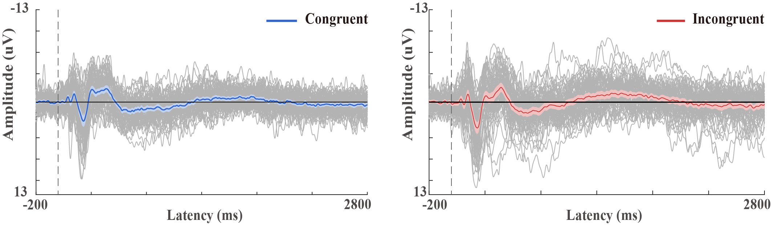

**Figure S1**

*Individual participant ERP waveforms for both the congruent and incongruent conditions of the belief-bias syllogistic reasoning task* *(N = 72, electrode site: Fz).*

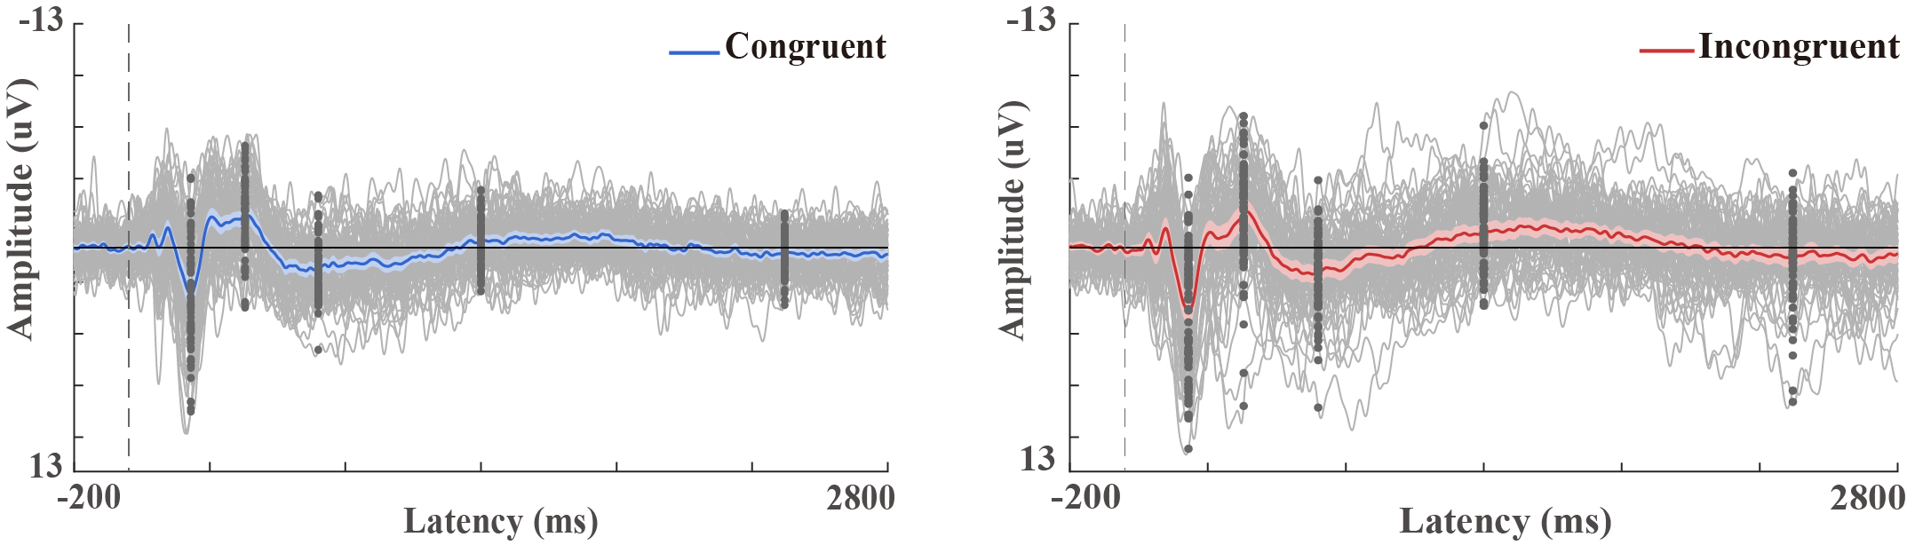

**Figure S2**

*Individual participant ERP waveforms with marked peak dots (P200: 230 ms, N400: 430 ms, P600: 700 ms, LNC: 1300 ms, and LPC: 2420 ms) for both the congruent and incongruent conditions of the belief-bias syllogistic reasoning task (N = 72, electrode site: Fz).*

*Note.* In Figure S1, the left side demonstrates that ERP waveforms for the congruent condition exhibited high consistency among participants. On the right side of Figure S1, while some participants exhibited occasional deviations from the mean ERP waveform in the incongruent condition, the majority closely followed the mean. Learned from the blog (https://www.mattcraddock.com/blog/2016/09/19/comparing-two-erps/), occasional deviations are common in research with larger sample sizes, as in our study. Figure S2 illustrates that peak points were relatively consistent among the majority of participants.

**F. Supplemental images of ERPs separately for sentence lengths**

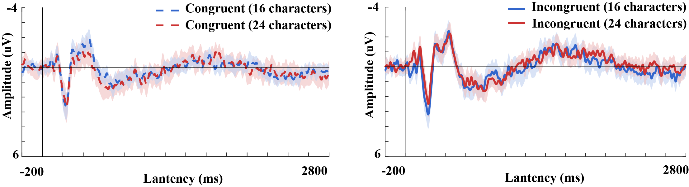

**Figure S3**

*Grand ERP waveforms for sentence lengths of 16-17 and 23-24 Chinese characters with 95% confidence intervals for both the congruent and incongruent syllogisms (N = 72, electrode site: Fz).*

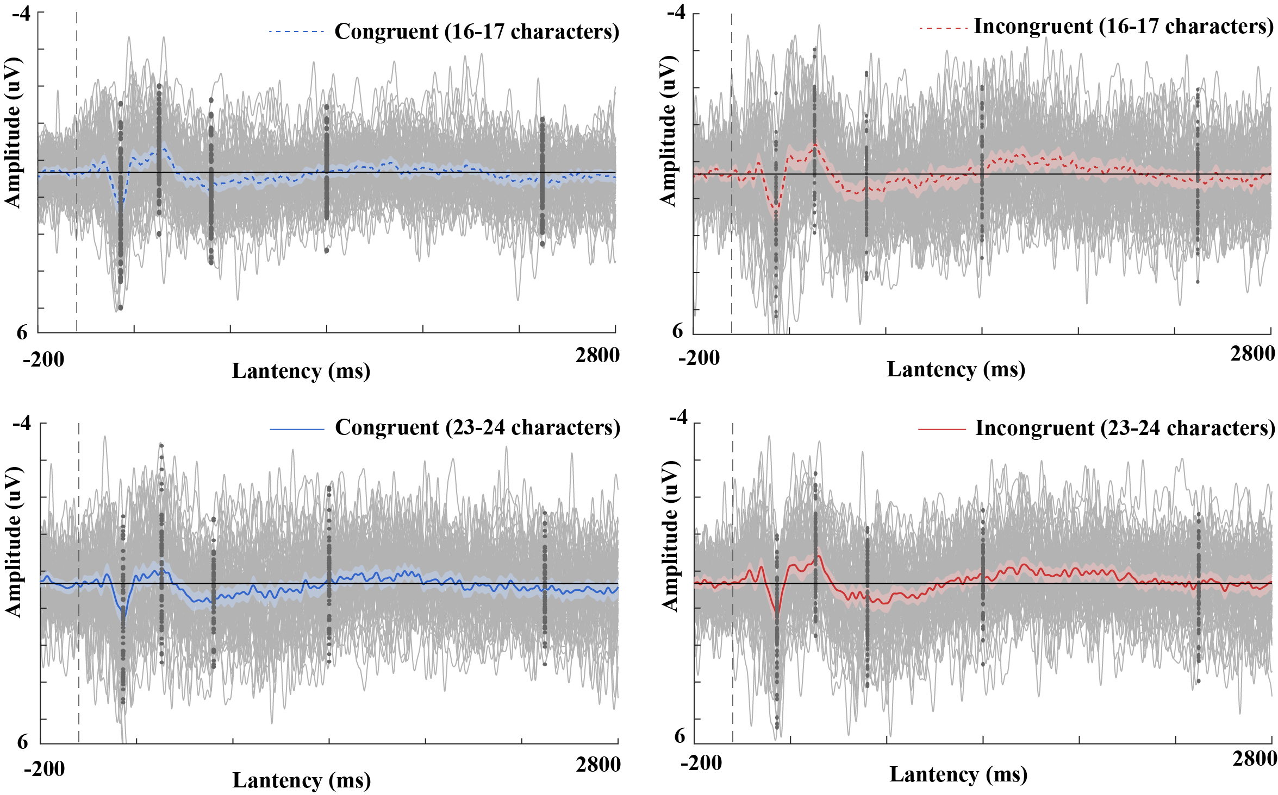

**Figure S4**

*Individual participant ERP waveforms for sentence lengths of 16-17 and 23-24 Chinese characters with marked peak dots for both the congruent and incongruent syllogisms (N = 72, electrode site: Fz).*

*Note*. To streamline the analysis, syllogisms of both 16-17 and 23-24 Chinese characters were chosen, each category including two-character length variations due to limited single-character syllogisms. Specifically, there were 37 syllogisms for the 16-17 length (22 congruent and 15 incongruent ones), and 36 syllogisms for the 23-24 length (17 congruent and 19 incongruent ones). Figure S3 reveals that the activation timing of ERP components remained consistent across the two types of sentence lengths, both in the congruent and incongruent conditions. Figure 4 further displays individual ERP waveforms, with the observed variability in individual waveforms likely stemming from the limited number of trials available for each type under each condition. Nevertheless, average ERP waveforms across all participants exhibit consistent patterns across different types of sentence lengths.