**Figure 1**

*Factor Loadings of the Items on the Latent Variables in the Confirmatory Factor Analyses (CFAs) Conducted per Wave.*

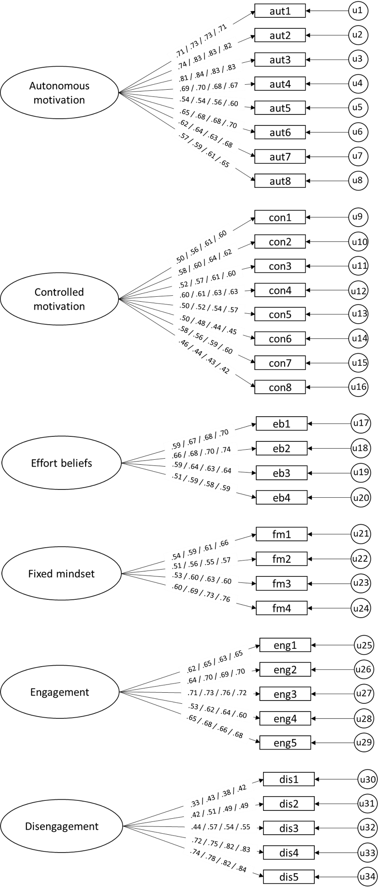

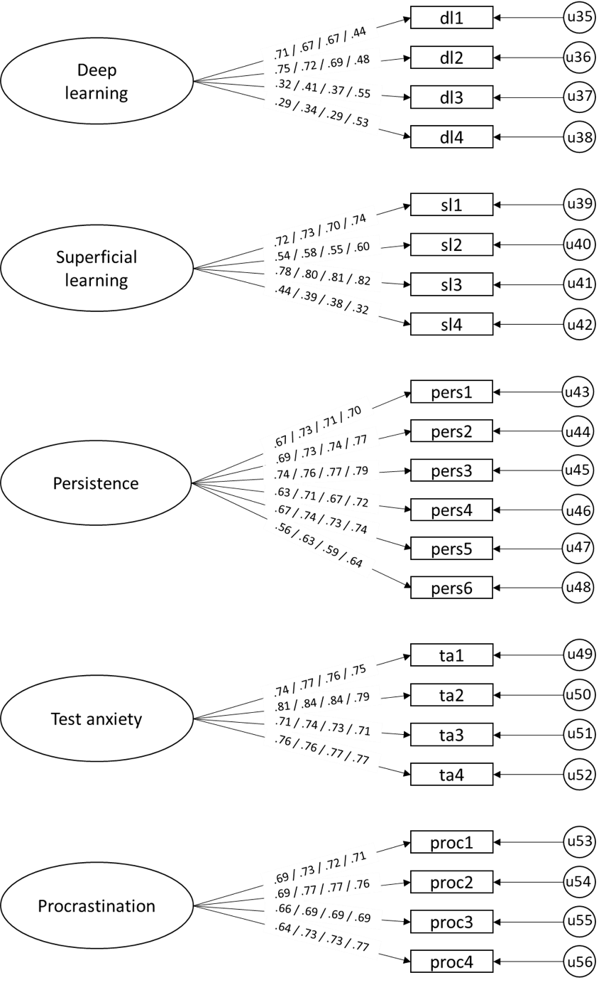

*Note.* The firstloading on each arrow is for Wave 1, the second loading is for Wave 2, the third loading is for Wave 3, and the fourth loading is for Wave 4. All factor loadings had a *p*-value < .001*.* Correlations between latent factors were included in the model, but, for readability, we decided not to include these correlations in the figure. These correlations can be found in Tables 1-4.

**Table 1**

|  |  |  |  |  |  |  |  |  |  |  |  |
| --- | --- | --- | --- | --- | --- | --- | --- | --- | --- | --- | --- |
|  | 1 | 2 | 3 | 4 | 5 | 6 | 7 | 8 | 9 | 10 | 11 |
| 1. Autonomous motivation | - |  |  |  |  |  |  |  |  |  |  |
| 2. Controlled motivation | .23*** | - |  |  |  |  |  |  |  |  |  |
| 3. Fixed mindset | -.05 | .20*** | - |  |  |  |  |  |  |  |  |
| 4. Effort Beliefs | .43*** | .21*** | -.07* | - |  |  |  |  |  |  |  |
| 5. Engagement | .55*** | .16*** | -.04 | .40*** | - |  |  |  |  |  |  |
| 6. Disengagement | -.39*** | .14*** | .19*** | -.28*** | -.62*** | - |  |  |  |  |  |
| 7. Superficial learning | .43*** | .16*** | -.06* | .47*** | .49*** | -.33*** | - |  |  |  |  |
| 8. Deep learning | .38*** | .06* | -.03 | .26*** | .31*** | -.19*** | .42*** | - |  |  |  |
| 9. Persistence | .53*** | .10** | -.11*** | .48*** | .64*** | -.53*** | .66*** | .36*** | - |  |  |
| 10. Test anxiety | .07** | .27*** | .17*** | .12*** | .02 | .28*** | .05* | .06* | -.06* | - |  |
| 11. Procrastination | -.37*** | .16*** | .24*** | -.25*** | -.50*** | .66*** | -.42*** | -.28*** | -.68*** | .39*** | - |

*Correlations among Latent Factors in the Confirmatory Factor Analysis (wave 1).*

*Note.* *** *p* < .001, ** *p* < .01, * *p* < .05

**Table 2**

|  |  |  |  |  |  |  |  |  |  |  |  |
| --- | --- | --- | --- | --- | --- | --- | --- | --- | --- | --- | --- |
|  | 1 | 2 | 3 | 4 | 5 | 6 | 7 | 8 | 9 | 10 | 11 |
| 1. Autonomous motivation | - |  |  |  |  |  |  |  |  |  |  |
| 2. Controlled motivation | .28*** | - |  |  |  |  |  |  |  |  |  |
| 3. Fixed mindset | -.12*** | .15*** | - |  |  |  |  |  |  |  |  |
| 4. Effort Beliefs | .41*** | .21*** | -.07* | - |  |  |  |  |  |  |  |
| 5. Engagement | .56*** | .19*** | -.12*** | .44*** | - |  |  |  |  |  |  |
| 6. Disengagement | -.44*** | .05 | .23*** | -.34*** | -.72*** | - |  |  |  |  |  |
| 7. Superficial learning | .44*** | .22*** | -.06* | .51*** | .56*** | -.44*** | - |  |  |  |  |
| 8. Deep learning | .41*** | .14*** | -.08** | .26*** | .36*** | -.24*** | .48*** | - |  |  |  |
| 9. Persistence | .52*** | .16*** | -.11*** | .48*** | .68*** | -.61*** | .73*** | .41*** | - |  |  |
| 10. Test anxiety | .04 | .30*** | .14*** | .10*** | .04 | .21*** | .06* | .15*** | -.07** | - |  |
| 11. Procrastination | -.36*** | .08** | .21*** | -.22*** | -.47*** | .66*** | -.43*** | -.23*** | -.64*** | .40*** | - |

*Correlations among Latent Factors in the Confirmatory Factor Analysis (wave 2).*

*Note.* *** *p* < .001, ** *p* < .01, * *p* < .05

**Table 3**

|  |  |  |  |  |  |  |  |  |  |  |  |
| --- | --- | --- | --- | --- | --- | --- | --- | --- | --- | --- | --- |
|  | 1 | 2 | 3 | 4 | 5 | 6 | 7 | 8 | 9 | 10 | 11 |
| 1. Autonomous motivation | - |  |  |  |  |  |  |  |  |  |  |
| 2. Controlled motivation | .34*** | - |  |  |  |  |  |  |  |  |  |
| 3. Fixed mindset | -.09*** | .06* | - |  |  |  |  |  |  |  |  |
| 4. Effort Beliefs | .40*** | .29*** | -.17*** | - |  |  |  |  |  |  |  |
| 5. Engagement | .56*** | 24*** | -.12*** | .43*** | - |  |  |  |  |  |  |
| 6. Disengagement | -.44*** | -.02 | .20*** | -.29*** | -.66*** | - |  |  |  |  |  |
| 7. Superficial learning | .44*** | .21*** | -.14*** | .51*** | .55*** | -.44*** | - |  |  |  |  |
| 8. Deep learning | .37*** | .16*** | -.12*** | .28*** | .34*** | -.22*** | .44*** | - |  |  |  |
| 9. Persistence | .51*** | .19*** | -.14*** | .47*** | .66*** | -.57*** | .74*** | .38 | - |  |  |
| 10. Test anxiety | .03 | .27*** | .10*** | .12*** | .04 | .21*** | .09*** | .21*** | -.03 | - |  |
| 11. Procrastination | -.37*** | .04 | .18*** | -.20*** | -.53*** | .66*** | -.45*** | -.24*** | -.68*** | .35*** | - |

*Correlations among Latent Factors in the Confirmatory Factor Analysis (wave 3).*

*Note.* *** *p* < .001, ** *p* < .01, * *p* < .05

**Table 4**

|  |  |  |  |  |  |  |  |  |  |  |  |
| --- | --- | --- | --- | --- | --- | --- | --- | --- | --- | --- | --- |
|  | 1 | 2 | 3 | 4 | 5 | 6 | 7 | 8 | 9 | 10 | 11 |
| 1. Autonomous motivation | - |  |  |  |  |  |  |  |  |  |  |
| 2. Controlled motivation | .37*** | - |  |  |  |  |  |  |  |  |  |
| 3. Fixed mindset | -.08** | .08** | - |  |  |  |  |  |  |  |  |
| 4. Effort Beliefs | .38*** | .23*** | -.11*** | - |  |  |  |  |  |  |  |
| 5. Engagement | .59*** | .30*** | -.14*** | .45*** | - |  |  |  |  |  |  |
| 6. Disengagement | -.45*** | -.03 | .19*** | -.26*** | -.67*** | - |  |  |  |  |  |
| 7. Superficial learning | .45*** | .24*** | -.10** | .48*** | .58*** | -.37*** | - |  |  |  |  |
| 8. Deep learning | .53*** | .27*** | -.06 | .36*** | .53*** | -.26*** | .60*** | - |  |  |  |
| 9. Persistence | .54*** | .20*** | -.13*** | .46*** | .71*** | -.56*** | .72*** | .56*** | - |  |  |
| 10. Test anxiety | .06* | .26*** | .06* | .08** | .06* | .18*** | .09** | .27*** | .000 | - |  |
| 11. Procrastination | -.36*** | .04 | .17*** | -.16*** | -.50*** | .63*** | -.38*** | -.20*** | -.62*** | .34*** | - |

*Correlations among Latent Factors in the Confirmatory Factor Analysis (wave 4).*

*Note.* *** *p* < .001, ** *p* < .01, * *p* < .05