**Supplemental Materials**

**Acquiring Science and Social Studies Knowledge in Kindergarten-4th Grade: Conceptualization, Design, Implementation, and Efficacy Testing of Content Area Literacy Instruction (CALI)**

**by C. M. Connor et al., 2016, *Journal of Educational Psychology***

**http://dx.doi.org/10.1037/edu0000128**



Copyright 2011 by Connor. Reprinted with permission.



Copyright 2011 by Connor. Reprinted with permission.



Copyright 2011 by Connor. Reprinted with permission.

# Example Question from the Reading-to-Understanding (formerly Garden Path Maze) Assessment

# Native Americans (item 4)

The __________ [*Miccosukee, Cherokee, Seminole, Tequesta*] tribe in Florida is actually made up of many different Native American tribes including the Creek tribe. Other tribes came from Georgia, Mississippi, and Alabama a long time ago. The tribe even included African American slaves who escaped from South Carolina and Georgia before the Civil War. During the 1800s, the United States government wanted them to move to Oklahoma. Some of them refused to leave Florida. Although soldiers came to fight them, they never surrendered to the United States. They hid from soldiers in the Everglades. That is why the Seminoles call themselves the “Unconquered People.”

Copyright 2011 by Connor. Reprinted with permission.

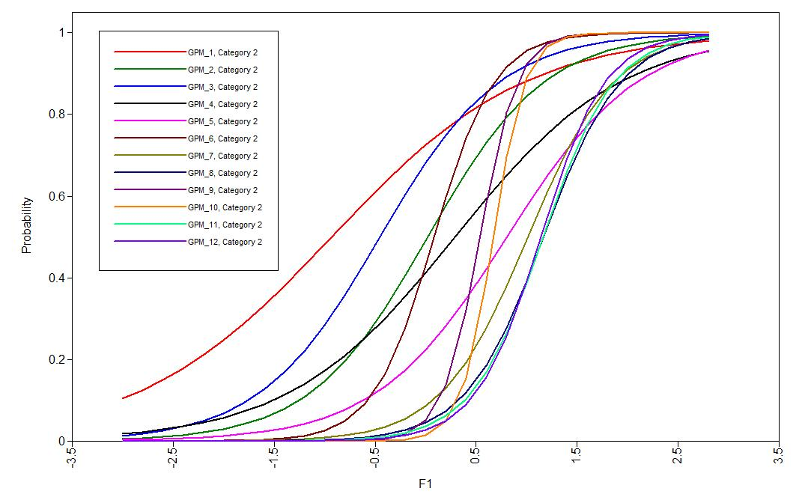

Figure S.1. Item Characteristic Curves for the Garden Path Maze from Item Response Theory (IRT) analysis. The x-axis shows the difficulty of the item and the y-axis the probability the child will answer the item correctly. Where the curve crosses .5 probability, the x-intercept indicates difficulty and the slope indicates discrimination (a). A steeper slope suggests greater discrimination.

#### Table S.2

*Piecewise Growth Curve Model Testing for Child X Instruction Interaction effects on Science*

*(SCI) and Social Studies (SS) Unit Tests over Time (WEEK)*

#### Final estimation of fixed effects:

|  |  |  |  |  |  |
| --- | --- | --- | --- | --- | --- |
| Fixed Effect | Coefficient | Standard error | *t*-ratio | Approx. *d.f.* | *p*-value |
| For INTRCPT1, *π0* | | | | | |
| For INTRCPT2, *β00* | | | | | |
| INTRCPT3, *γ000* | 4.582727 | 0.428550 | 10.694 | 39 | <0.001 |
| For CALI, *β01* | | | | | |
| INTRCPT3, *γ010* | -0.555701 | 0.274266 | -2.026 | 412 | 0.043 |
| For F_OC_W, *β02* | | | | | |
| INTRCPT3, *γ020* | 0.046230 | 0.018430 | 2.508 | 412 | 0.013 |
| For F_PC_W, *β03* | | | | | |
| INTRCPT3, *γ030* | 0.008941 | 0.008994 | 0.994 | 412 | 0.321 |
| For F_VOC_W, *β04* | | | | | |
| INTRCPT3, *γ040* | 0.006486 | 0.023107 | 0.281 | 412 | 0.779 |
| For CALIXPC, *β05* | | | | | |
| INTRCPT3, *γ050* | 0.001290 | 0.012055 | 0.107 | 412 | 0.915 |
| For CALIXOC, *β06* | | | | | |
| INTRCPT3, *γ060* | 0.000870 | 0.025352 | 0.034 | 412 | 0.973 |
| For CALIXPV, *β07* | | | | | |
| INTRCPT3, *γ070* | 0.006741 | 0.031833 | 0.212 | 412 | 0.832 |
| For SCI slope, *π1* | | | | | |
| For INTRCPT2, *β10* | | | | | |
| INTRCPT3, *γ100* | 1.889255 | 0.479814 | 3.937 | 2913 | <0.001 |
| For CALI, *β11* | | | | | |
| INTRCPT3, *γ110* | -4.247385 | 0.676203 | -6.281 | 2913 | <0.001 |
| For F_OC_W, *β12* | | | | | |
| INTRCPT3, *γ120* | -0.021347 | 0.045020 | -0.474 | 2913 | 0.635 |
| For F_PC_W, *β13* | | | | | |
| INTRCPT3, *γ130* | 0.032319 | 0.020180 | 1.602 | 2913 | 0.109 |
| For F_VOC_W, *β14* | | | | | |
| INTRCPT3, *γ140* | 0.002174 | 0.055945 | 0.039 | 2913 | 0.969 |
| For CALIXPC, *β15* | | | | | |
| INTRCPT3, *γ150* | 0.041623 | 0.030267 | 1.375 | 2913 | 0.169 |
| For CALIXOC, *β16* | | | | | |
| INTRCPT3, *γ160* | -0.124486 | 0.062034 | -2.007 | 2913 | 0.045 |
| For CALIXPV, *β17* | | | | | |
| INTRCPT3, *γ170* | 0.021017 | 0.078368 | 0.268 | 2913 | 0.789 |
| For WEEK slope, *π2* | | | | | |
| For INTRCPT2, *β20* | | | | | |
| INTRCPT3, *γ200* | 0.260049 | 0.027955 | 9.302 | 2913 | <0.001 |
| For CALI, *β21* | | | | | |
| INTRCPT3, *γ210* | 0.522975 | 0.039355 | 13.289 | 2913 | <0.001 |
| For F_OC_W, *β22* | | | | | |
| INTRCPT3, *γ220* | 0.000932 | 0.002604 | 0.358 | 2913 | 0.720 |
| For F_PC_W, *β23* | | | | | |
| INTRCPT3, *γ230* | -0.001143 | 0.001174 | -0.973 | 2913 | 0.331 |
| For F_VOC_W, *β24* | | | | | |
| INTRCPT3, *γ240* | 0.002111 | 0.003260 | 0.647 | 2913 | 0.517 |
| For CALIXPC, *β25* | | | | | |
| INTRCPT3, *γ250* | 0.004105 | 0.001744 | 2.354 | 2913 | 0.019 |
| For CALIXOC, *β26* | | | | | |
| INTRCPT3, *γ260* | 0.001281 | 0.003599 | 0.356 | 2913 | 0.722 |
| For CALIXPV, *β27* | | | | | |
| INTRCPT3, *γ270* | 0.001117 | 0.004545 | 0.246 | 2913 | 0.806 |
| For SCIXWK slope, *π3* | | | | | |
| For INTRCPT2, *β30* | | | | | |
| INTRCPT3, *γ300* | -0.181387 | 0.039734 | -4.565 | 2913 | <0.001 |
| For CALI, *β31* | | | | | |
| INTRCPT3, *γ310* | -0.074550 | 0.055970 | -1.332 | 2913 | 0.183 |
| For F_OC_W, *β32* | | | | | |
| INTRCPT3, *γ320* | 0.002191 | 0.003719 | 0.589 | 2913 | 0.556 |
| For F_PC_W, *β33* | | | | | |
| INTRCPT3, *γ330* | -0.000376 | 0.001669 | -0.225 | 2913 | 0.822 |
| For F_VOC_W, *β34* | | | | | |
| INTRCPT3, *γ340* | -0.001886 | 0.004632 | -0.407 | 2913 | 0.684 |
| For CALIXPC, *β35* | | | | | |
| INTRCPT3, *γ350* | -0.006229 | 0.002496 | -2.495 | 2913 | 0.013 |
| For CALIXOC, *β36* | | | | | |
| INTRCPT3, *γ360* | 0.005648 | 0.005131 | 1.101 | 2913 | 0.271 |
| For CALIXPV, *β37* | | | | | |
| INTRCPT3, *γ370* | -0.000988 | 0.006478 | -0.153 | 2913 | 0.879 |

#### Final estimation of level-1 and level-2 variance components

|  |  |  |  |  |  |
| --- | --- | --- | --- | --- | --- |
| Random Effect | Standard  Deviation | Variance  Component | *d.f.* | χ2 | *p*-value |
| INTRCPT1,*r0* | 1.19295 | 1.42312 | 402 | 1054.87411 | <0.001 |
| level-1, *e* | 2.62066 | 6.86783 |  |  |  |

## Final estimation of level-3 variance components

|  |  |  |  |  |  |
| --- | --- | --- | --- | --- | --- |
| Random Effect | Standard  Deviation | Variance  Component | *d.f.* | χ2 | *p*-value |
| INTRCPT1/INTRCPT2,*u00* | 2.41022 | 5.80918 | 39 | 1137.39757 | <0.001 |

*Note.* Deviance = 16926.72. Treatment condition CALI = 1, BAU = 0, SS is the Fixed Reference Group (SS=0, SCI = 1) Fall = F, Oral Comprehension W score = OC_W, Passage Comprehension W score = PC_W, treatment X PC interaction effect = CALXPC, treatment X OC interaction effect = CALIXOC, Science effect on time = SCIXWK.

**Table S.3**

*HLM Results when adding misspelling ratio to Piecewise Cross-classified Growth Model for 2nd through 4th graders*

**Final estimation of fixed effects:**

|  |  |  |  |  |  |
| --- | --- | --- | --- | --- | --- |
| Fixed Effect | Coefficient | Standard error | *t*-ratio | Approx. *d.f.* | *p*-value |
| For INTRCPT1, *π0* | | | | | |
| For INTRCPT2, *β00* | | | | | |
| INTRCPT3, *γ000* | 3.463159 | 0.317896 | 10.894 | 22 | <0.001 |
| For CALI, *β01* | | | | | |
| INTRCPT3, *γ010* | -0.083130 | 0.426471 | -0.195 | 201 | 0.846 |
| For POSCASP, *β02* | | | | | |
| INTRCPT3, *γ020* | -1.441906 | 1.063818 | -1.355 | 201 | 0.177 |
| For SCI slope, *π1* | | | | | |
| For INTRCPT2, *β10* | | | | | |
| INTRCPT3, *γ100* | 1.699174 | 0.700528 | 2.426 | 1533 | 0.015 |
| For CALI, *β11* | | | | | |
| INTRCPT3, *γ110* | -5.613039 | 0.997597 | -5.627 | 1533 | <0.001 |
| For POSCASP, *β12* | | | | | |
| INTRCPT3, *γ120* | -3.823665 | 2.464236 | -1.552 | 1533 | 0.121 |
| For WEEK slope, *π2* | | | | | |
| For INTRCPT2, *β20* | | | | | |
| INTRCPT3, *γ200* | 0.267434 | 0.041155 | 6.498 | 1533 | <0.001 |
| For CALI, *β21* | | | | | |
| INTRCPT3, *γ210* | 0.645135 | 0.058735 | 10.984 | 1533 | <0.001 |
| For POSCASP, *β22* | | | | | |
| INTRCPT3, *γ220* | -0.126137 | 0.145108 | -0.869 | 1533 | 0.385 |
| For SCIXWK slope, *π3* | | | | | |
| For INTRCPT2, *β30* | | | | | |
| INTRCPT3, *γ300* | -0.157512 | 0.058193 | -2.707 | 1533 | 0.007 |
| For CALI, *β31* | | | | | |
| INTRCPT3, *γ310* | -0.100423 | 0.082891 | -1.212 | 1533 | 0.226 |
| For POSCASP, *β32* | | | | | |
| INTRCPT3, *γ320* | 0.255561 | 0.204684 | 1.249 | 1533 | 0.212 |

**Final estimation of level-1 and level-2 variance components**

|  |  |  |  |  |  |
| --- | --- | --- | --- | --- | --- |
| Random Effect | Standard  Deviation | Variance  Component | *d.f.* | χ2 | *p*-value |
| INTRCPT1,*r0* | 1.51691 | 2.30101 | 201 | 677.62639 | <0.001 |
| level-1, *e* | 2.79568 | 7.81585 |  |  |  |

**Final estimation of level-3 variance components**

|  |  |  |  |  |  |
| --- | --- | --- | --- | --- | --- |
| Random Effect | Standard  Deviation | Variance  Component | *d.f.* | χ2 | *p*-value |
| INTRCPT1/INTRCPT2,*u00* | 0.50731 | 0.25736 | 22 | 41.24949 | 0.008 |

*Note.* Deviance = 9049.91951

# Quantile Regression Results

## Evaluation of Local Treatment Effects

To further explore the efficacy of treatment on proximal measures, quantile regression (Koenker & Bassett Jr, 1978; Petscher & Logan, 2014) was used to test the extent to which treatment effects varied conditional on posttest performance. Quantile regression is a form of conditional median model meaning that tests the relations at multiple points (quantiles) of the outcome distribution rather than viewing relations between outcomes and predictions in the vein of conditional averages (i.e., correlation, ordinary least squares regression, multilevel models, and structural equation models). Quantile regression relies on an asymmetric weighting system in which all data points are considered relative to their distance from each quantile. In this way, it possible to address efficacy questions beyond average relations to, “For whom was the treatment effective conditional on outcome performance?” Previous applications of quantile regression in the literature have used continuous variables regressed on a dichotomous variable of minority status (Petscher & Logan, 2014). As an extension of that model, it is possible to view the dichotomous variable as anything which may be dummy-coded, including treatment status. In order to evaluate the effect size in the quantile model, one allowable mechanism is to use Hedge’s *g* from an ANCOVA F-test with:

$$g= \sqrt{\frac{F(n_{1}+n_{2})(1-r^{2})}{n_{1}n_{2}}}$$

where *r* is the correlation between the pretest and posttest, $n_{1}$ is the sample size for the intervention group, and $n_{2}$ is the sample size for the control group. Because applications of quantile regression include a *t*-test for the model coefficients, it is possible to use the square of *t* in place of *F*.

The quantile analysis was used for the two proximal measures of Post-test Science (PO-SC) and Post-test Social Studies (PO-SS) as well as the distal measures of Picture Vocabulary, Oral Comprehension, and Passage Comprehension. Results for the proximal measures (Figure S.3) demonstrate that the impact of treatment varied across the distributions of PO-SC and PO-SS by grade level. For Kindergarten students, CALI demonstrated varying levels of effectiveness mostly for the PO-SS outcome whereby moderate effects were observed for students with low PO-SS compared with large effects for students with average to high PO-SS scores. Conversely, stronger effects were observed for CALI on the PO-SC for students with lower ability compared to higher. In grade 1, relatively strong effects were observed at high levels of PO-SC compared to lower while the reverse was found on the PO-SS outcome. Both grades 2 and 3 showed increasing effectiveness of CALI on PO-SS outcome as performance on the PO-SS posttest increased. A difference between these two grades is that effect sizes in grade 3 for PO-SC tracked PO-SS (i.e., increasing effectiveness) while in grade 2 the PO-SC maintained lower effects at higher levels of ability. Grade 4 demonstrated systematically large effects on both outcomes with stronger effects at the tails of the distribution for both outcome.

*Figure S.2.* Quantile regression results with Hedge’s *g* by grade for CALI Social Studies (PO-SS) and Science (PO-SC) Unit Post-tests.