Supplemental Material A: Image Ratings by Religiosity and Gender
Table SC1. Descriptive Statistics of IAPS Image Ratings by Religiosity and Gender
Rating | Religious |  | Non-Religious
Rating | Male | Female | Male | Female
Rating | M (SD) | M (SD) | M (SD) | M (SD)
Emotional intensity | 4.26 (1.56) | 4.48 (0.78) | 4.70 (0.68) | 3.55 (1.28)
Valence | 4.55 (0.43) | 4.47 (0.39) | 4.63 (0.47) | 4.52 (0.45)
Impropriety | 2.80 (0.96) | 2.98 (0.47) | 3.49 (0.99) | 2.88 (0.82)

Table SC2. Two-way ANOVA on Impropriety, Valence and Intensity Ratings
Rating | Source | MS | F(1,40) | p | η_{p}²
Impropriety | Gender | 0.49 | .70 | .41 | .02
Impropriety | Religiosity | 0.91 | 1.30 | .26 | .03
Impropriety | Gender x Religiosity | 1.65 | 2.37 | .13 | .06
Valence | Gender | 0.09 | 0.48 | .50 | .01
Valence | Religiosity | 0.05 | 0.26 | .62 | .01
Valence | Gender x Religiosity | 0.004 | 0.02 | .88 | .001
Intensity | Gender | 2.37 | 1.80 | .19 | .04
Intensity | Religiosity | 0.66 | 0.50 | .48 | .01
Intensity | Gender x Religiosity | 5.00 | 3.79 | .06 | .09

Supplemental Material B: Example Images
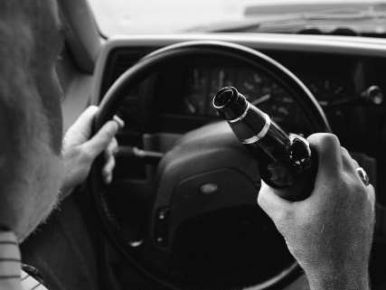
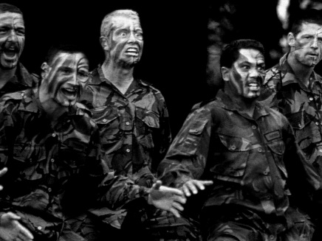
Supplemental Material C:
Table SE3: Pattern Image Rating Comparisons
Ratings | Neutral Images |  | Pattern Images |  | t(43) | p | d
Ratings | M | SD | M | SD | t(43) | p | d
Impropriety | 3.48 | 1.13 | 1.34 | 0.66 | -12.1 | < .001** | 2.31
Valence | 3.79 | 0.66 | 4.73 | 0.41 | 9.21 | < .001** | 1.71
Intensity | 4.66 | 1.26 | 1.60 | 0.98 | -14.7 | < .001** | 2.71
Table E1. Within Samples t-Tests for Ratings between Neutral and Pattern Images
** p < .001

Table SE4. Independent Samples t-Tests for Pattern Image Ratings by Group
Ratings | Religious  (n = 20) |  | Non-Religious  (n = 24) |  | t(42) | p | d
Ratings | M | SD | M | SD | t(42) | p | d
Impropriety | 1.13 | 0.38 | 1.52 | 0.80 | -2.01 | .051 | 0.62
Valence | 4.62 | 0.50 | 4.82 | 0.29 | -1.71 | .094 | 0.49
Intensity | 1.68 | 1.00 | 1.53 | 1.00 | 0.47 | .640 | 0.15

