Table S1
Summary of Cross-Sectional Studies Examining ADHD Associations with Temperament/Personality Traits
Study | Measure  (temperament) | Assessment  (temperament) | Language | Age | Sample size (% boys) | Temperament/personality correlates of ADHD
Foley et al. (2008) | SATI; CBQ | Parent-report | English | M = 8.7 | N = 55 (65% males) | Higher activity, negative reactivity, impulsivity; Lower task persistence, attentional focusing, inhibitory control
Drechsler et al. (2018) | JTCI | Parent-report | German | M = 8.8 | N = 111 (75% boys) | Higher novelty-seeking; Lower persistence and self-directedness; No association with harm avoidance, reward dependence, cooperativeness, or self-transcendence
Cho et al. (2009) | JTCI | Parent-report | Korean | M = 9.0 | N = 430 (70% boys) | Higher novelty-seeking; Lower persistence, self-directedness, and cooperativeness; No association with harm avoidance, reward dependence, or self-transcendence
Martel & Nigg (2006) | Q-Sort; EATQ | Parent-report | English | M = 9.5 | N = 179 (63% boys) | Higher negative emotionality; Lower reactive control, effortful control, resiliency
Bacchini et al. (2008) | QUIT | Parent-report | Italian | M = 9.5 | N = 195 (50% males) | Higher novelty-seeking; Lower persistence in attention; No association with negative emotionality
Cho et al. (2008) | JTCI | Self and parent-report | Korean | M = 10.2 | N = 102 (90% males) | Higher novelty-seeking and self-transcendence; Lower reward dependence, persistence, self-directedness, and cooperativeness
De Pauw & Mervielde (2011) | HiPIC; EAS; EATQ-R | Parent-report | Dutch | M = 10.5 | N = 519 (85% boys) | Higher emotionality, activity, negative affect; Lower effortful control, conscientiousness, benevolence, emotionality stability; No association with surgency, shyness, extraversion
Rettew et al. (2004) | JTCI | Parent-report | English | M = 11.0 | N = 300 (59% boys) | Higher fantasy; Lower persistence and self-directedness; No association with novelty-seeking, harm avoidance, reward dependence, cooperativeness or spirituality
Martel et al. (2010); Martel et al. (2011) | Q-Sort; EATQ; NEO-FFI | Parent-report | English | M = 11.7 | N = 548 (59% boys) | Higher neuroticism, negative emotionality, extraversion; Lower agreeableness, conscientiousness, effortful control, reactive control, and resiliency
Cukrowicz et al. (2006) | MPQ; MPR | Self- and parent-report | English | M = 11.7  M = 17.5 | 11: N = 1,624 (48% boys)  17: N = 1,252 (46% boys) | Higher negative emotionality; Lower constraint; No association with positive emotionality
Krieger et al. (2020) | BFQ-C | Self-report | Spanish | M = 13.5 | N = 118 (68% males) | Higher neuroticism; Lower conscientiousness and agreeableness; No association with extraversion
Alperin et al. (2017) | EATQ | Self- and parent-report | English | M = 13.8 | N = 109 (73% boys) | No association with surgency or fear (the only constructs they examined)
Martel et al. (2008)ª | Q-Sort; Little Five | Parent-report | English | M = 15.5 | N = 184 (59% boys) | Higher negative emotionality and neuroticism; Lower reactive control, resiliency, agreeableness, conscientiousness; No difference in extraversion
Skala et al. (2016) | TEMPS-M | Self-report | German | M = 18.0 | N = 3,280 (100% males) | Higher cyclothymic, irritable, and anxious temperament; No association with hyperthymic or depressive temperament
Note. BFQ-C = Big Five Questionnaire for Children. CBQ = Children’s Behavior Questionnaire. EAS = Emotionality, Activity, and Sociability Temperament Survey. EATQ = Early Adolescent Temperament Questionnaire (-Revised). HiPIC = Hierarchical Personality Inventory for Children. JTCI = Cloninger Junior Temperament and Character Inventory. MPQ = Multidimensional Personality Questionnaire. MPR = Multidimensional Personality Ratings. SATI = School-Age Temperament Inventory. TEMPS-M = Short version of the Temperament Evaluation of Memphis, Pisa, Paris, and San Diego - Autoquestionnaire. QUIT = Italian Questionnaire on Temperament. ª Only report on the adolescent sample as the child sample is identical to Martel & Nigg (2006). Martel et al. (2009) is excluded from this table because the samples overlap with Martel & Nigg (2006) and Martel et al. (2008). Samples in Martel et al. (2010) and Martel et al. (2011) overlapped, so these rows were combined.
Table S2
Descriptive Statistics of ADHD Symptoms
 | Combined ADHD |  | Hyperactive-Impulsive ADHD |  | Inattentive ADHD
 | Mean (SD) | Range | Mean (SD) | Range | Mean (SD) | Range
Age 10 | 2.23 (2.50) | 0 – 17 | 1.03 (1.39) | 0 – 9 | 1.21 (1.49) | 0 – 10
Age 11 | 1.72 (2.28) | 0 – 15 | 0.86 (1.36) | 0 – 8 | 0.87 (1.22) | 0 – 7
Age 12 | 2.02 (2.47) | 0 – 14 | 1.01 (1.49) | 0 – 10 | 1.01 (1.32) | 0 – 8
Age 13 | 2.18 (2.60) | 0 – 14 | 1.02 (1.49) | 0 – 10 | 1.16 (1.46) | 0 – 8
Age 14 | 2.03 (2.47) | 0 – 16 | 0.97 (1.41) | 0 – 8 | 1.07 (1.42) | 0 – 8
Age 15 | 1.92 (2.51) | 0 – 16 | 0.88 (1.47) | 0 – 8 | 1.06 (1.42) | 0 – 8
Age 16 | 1.63 (2.35) | 0 – 12 | 0.71 (1.35) | 0 – 8 | 0.93 (1.40) | 0 – 8
Age 17 | 1.29 (2.01) | 0 – 13 | 0.50 (1.07) | 0 – 8 | 0.79 (1.23) | 0 – 6

Table S3
Descriptive Statistics for EATQ-R Temperament Domains/Facets
 | Age 10 |  | Age 12 |  | Age 14 |  | Age 16
 | M (SD) | α / ω | M (SD) | α / ω | M (SD) | α / ω | M (SD) | α / ω
Effortful Control | 2.96 (.34) | .78 / .81 | 3.00 (.35) | .82 / .84 | 2.95 (.34) | .86 / .88 | 2.95 (.31) | .85 / .86
Activation Control | 2.96 (.47) | .63 / .69 | 2.88 (.49) | .69 / .75 | 2.79 (.46) | .71 / .76 | 2.77 (.41) | .68 / .73
Attention | 2.95 (.39) | .60 / .67 | 3.03 (.37) | .61 / .67 | 2.99 (.37) | .64 / .70 | 3.00 (.35) | .58 / .65
Inhibitory Control | 2.99 (.40) | .46 / .52 | 3.08 (.38) | .51 / .56 | 3.05 (.37) | .63 / .67 | 3.09 (.34) | .59 / .64
Negative Emotionality | 2.22 (.30) | .84 / .87 | 2.02 (.28) | .85 / .87 | 1.94 (.28) | .82/ .90 | 1.89 (.27) | .88 / .90
Fear | 2.83 (.47) | .67 / .72 | 2.47 (.49) | .70 / .75 | 2.21 (.40) | .62 / .68 | 2.17 (.39) | .68 / .72
Frustration | 2.41 (.46) | .73 / .79 | 2.25 (.44) | .74 / .81 | 2.20 (.41) | .76 / .82 | 2.14 (.41) | .79 / .84
Aggression | 1.42 (.41) | .78 / .83 | 1.40 (.38) | .79 / .84 | 1.40 (.38) | .82 / .87 | 1.34 (.31) | .80 / .84
Depressed Mood | 2.01 (.41) | .62 / .69 | 1.79 (.36) | .57 / .67 | 1.78 (.39) | .73 / .79 | 1.77 (.36) | .74 / .78
Shyness | 2.44 (.58) | .67 / .77 | 2.23 (.57) | .71 / .82 | 2.14 (.54) | .75 / .82 | 2.05 (.50) | .78 / .85
Positive Emotionality
Surgency | - | - | 2.59 (.39) | .76 / .79 | 2.65 (.36) | .79 / .82 | 2.62 (.35) | .82 / .84
Affiliation | 2.91 (.38) | .57 / .64 | 2.88 (.41) | .56 / .67 | 2.92 (.38) | .68 / .75 | 2.88 (.37) | .69 / .76
Note. M = mean, SD = standard deviation, α = alpha reliability, ω = omega reliability. Ages 10 and 12 include adolescent self-reports and mother-reports; ages 14 and 16 include adolescent self-reports, mother-reports, and father-reports.
Table S4
Descriptive Statistics for BFI Personality Domains
 | Age 14 |  | Age 16
 | M (SD) | α / ω | M (SD) | α / ω
Extraversion | 2.85 (.33) | .81 / .84 | 2.82 (.35) | .85 / .87
Agreeableness | 3.11 (.27) | .78 / .81 | 3.08 (.28) | .80 / .83
Conscientiousness | 2.89 (.32) | .85 / .87 | 2.88 (.31) | .84 / .87
Neuroticism | 2.20 (.31) | .78 / .82 | 2.23 (.32) | .81 / .84
Openness | 2.96 (.26) | .80 / .85 | 2.94 (.27) | .83 / .87
Note. M = mean, SD = standard deviation, α = alpha reliability, ω = omega reliability.
Both ages include adolescent self-reports, mother-reports, and father-reports.

Table S5
Descriptive Statistics for WAI Scale Scores
 | Age 14 |  | Age 16
 | M (SD) | α / ω | M (SD) | α / ω
Impulsivity | 2.26 (.71) | .79 / .84 | 2.20 (.67) | .78 / .84
Consideration for Others | 3.51 (.76) | .83 / .89 | 3.45 (.80) | .86 / .90
Note. M = mean, SD = standard deviation, α = alpha reliability, ω = omega reliability.

Table S6
Descriptive Statistics for Coded Observational Data
 | Age 10 |  |  |  | Age 12
 | M (SD) | Median | Range | ICC | M (SD) | Median | Range
Positive Mood | 4.34 (1.12) | 4.0 | 1.5 – 8 | .79 | 3.95 (1.00) | 4.0 | 1.5 – 8
Communication | 4.73 (1.01) | 5.0 | 2 – 8 | .66 | 4.71 (0.98) | 5.0 | 2 – 8
Dominance | 3.05 (1.14) | 3.0 | 1 – 7.5 | .67 | 3.49 (1.10) | 3.5 | 1 – 7
Warm/Supportive | 3.23 (1.12) | 3.0 | 1 – 8 | .72 | 3.31 (1.03) | 3.0 | 1 – 9
Prosociality | 4.00 (0.98) | 4.0 | 1 – 8 | .65 | 3.83 (0.91) | 4.0 | 1 – 8
Hostility | 1.33 (0.77) | 1.0 | 1 – 6 | .86 | 1.66 (1.17) | 1.0 | 1 – 7
Angry Coercion | 1.10 (0.42) | 1.0 | 1 – 6 | .82 | 1.18 (0.56) | 1.0 | 1 – 7
Externalized Negativity | 1.45 (0.76) | 1.0 | 1 – 6 | .73 | 1.61 (0.91) | 1.0 | 1 – 5.5
Antisocial | 2.50 (1.34) | 2.0 | 1 – 7.25 | .82 | 3.04 (1.56) | 3.0 | 1 – 8
Sad/Withdrawn | 1.88 (1.06) | 1.5 | 1 – 7.5 | .70 | 1.85 (1.12) | 1.5 | 1 – 7.25
Note. M = mean, SD = standard deviation. ICC = intraclass correlation coefficient.

Table S7
Correlations Between All Study Variables Averaged across All Available Assessments
 | 1 | 2 | 3 | 4 | 5 | 6 | 7 | 8 | 9 | 10 | 11 | 12 | 13 | 14 | 15 | 16 | 17 | 18 | 19 | 20 | 21 | 22 | 23
1. Combined ADHD
2. Hyper-Impulsive ADHD | .91
3. Inattentive ADHD | .90 | .64
4. Effortful Control | -.35 | -.26 | -.38
5. Negative Emotionality | .26 | .19 | .29 | -.45
6. Surgency | .18 | .23 | .09 | .01 | -.13
7. Affiliation | .01 | .07 | -.06 | .35 | .05 | .27
8. Extraversion | .06 | .17 | -.07 | .20 | -.28 | .38 | .43
9. Agreeableness | -.08 | -.04 | -.10 | .51 | -.29 | .10 | .48 | .38
10. Conscientiousness | -.26 | -.15 | -.34 | .69 | -.29 | .05 | .35 | .36 | .59
11. Neuroticism | .24 | .16 | .29 | -.46 | .58 | -.13 | -.23 | -.37 | -.59 | -.55
12. Openness | .03 | .06 | -.01 | .38 | -.11 | .24 | .41 | .42 | .50 | .47 | -.32
13. Impulsivity | .38 | .35 | .33 | -.29 | .21 | .27 | -.03 | .11 | -.22 | -.23 | .16 | .02
14. Consideration of Others | -.03 | -.01 | -.06 | .35 | -.04 | .08 | .42 | .14 | .45 | .30 | -.21 | .36 | -.18
15. Positive Mood | .06 | .10 | .01 | .26 | -.04 | .09 | .33 | .25 | .26 | .20 | -.12 | .28 | -.01 | .20
16. Communication | .03 | .09 | -.03 | .32 | -.08 | .12 | .37 | .23 | .28 | .25 | -.15 | .29 | -.04 | .24 | .62
17. Dominance | .06 | .06 | .05 | -.09 | -.02 | .06 | -.01 | .07 | -.12 | -.12 | .08 | -.00 | .08 | -.07 | .09 | .01
18. Warm/Supportive | .07 | .10 | .03 | .17 | -.02 | .03 | .28 | .26 | .20 | .16 | -.09 | .26 | -.02 | .18 | .64 | .58 | .07
19. Prosociality | .03 | .08 | -.04 | .24 | -.04 | .04 | .30 | .22 | .23 | .23 | -.13 | .21 | -.05 | .18 | .65 | .64 | -.01 | .71
20. Hostility | .11 | .08 | .13 | -.18 | .01 | -.02 | -.06 | .01 | -.14 | -.17 | .11 | -.09 | .08 | -.06 | -.06 | -.23 | .63 | -.08 | -.14
21. Angry Coercion | .05 | .03 | .06 | -.15 | -.01 | -.03 | -.08 | .02 | -.10 | -.11 | .09 | -.08 | .04 | -.10 | -.08 | -.16 | .47 | -.10 | -.11 | .73
22. Externalized Negativity | .13 | .11 | .12 | -.12 | .07 | .11 | -.03 | .03 | -.16 | -.18 | .13 | -.01 | .12 | -.01 | .20 | .06 | .34 | .12 | .04 | .41 | .20
23. Antisocial | .13 | .10 | .13 | -.21 | .03 | .09 | -.09 | -.01 | -.19 | -.21 | .13 | -.05 | .12 | -.11 | -.01 | -.18 | .75 | -.06 | -.21 | .76 | .50 | .46
24. Sad/Withdrawn | .07 | .07 | .05 | -.11 | .05 | .08 | -.02 | .02 | -.09 | -.08 | .13 | -.05 | .05 | -.04 | -.10 | -.13 | -.02 | -.03 | -.03 | .08 | .02 | .11 | .09
Note. Variables 1-3 are ADHD symptoms. Variables 4-7 are temperament domains. Variables 8-12 are Big Five domains. Variables 13-14 are Weinberger Adjustment Inventory scales. Variables 15-25 are coded observational variables. Hyper-Impulsive ADHD = Hyperactive-Impulsive ADHD. Correlations that are significant at p < .005 are bolded.
Table S8
Comparison of Rank-Order Stabilities by ADHD Symptom Cluster Type
 | Combined vs. Hyperactive |  | Combined vs. Inattentive |  | Hyperactive vs. Inattentive
 | z | p | z | p | z | p
Age 10 11 | 0.52 | .604 | 2.78 | .005 | 1.31 | .191
Age 11 12 | 1.98 | .047 | 0.67 | .500 | -0.88 | .378
Age 12 13 | 2.73 | .006 | 1.15 | .249 | -0.82 | .412
Age 13 14 | 3.37 | < .001 | 0.16 | .876 | -1.83 | .067
Age 14 15 | 0.68 | .494 | 0.81 | .420 | 0.08 | .939
Age 15 16 | 0.54 | .587 | 1.78 | .075 | 0.71 | .477
Age 16 17 | 2.12 | .034 | 3.10 | .002 | 0.45 | .651
Age 10 17 | 0.29 | .772 | 1.88 | .060 | 0.85 | .394
Note. z values are Pearson and Filon’s z (1898) calculated using the cocor.dep.groups.nonoverlap() function from the cocor package (Diedenhofen & Musch, 2015) in R. This function performs a significance test for the difference between two correlations based on the same group (i.e., dependent groups) with no overlapping variable. The null hypothesis is that the two correlations are equal to each other.

Table S9
Comparison of Concurrent Correlations by ADHD Symptom Cluster Type
 | Hyperactive-Impulsive r | Inattentive r | z | p
Effortful Control | -.26 | -.38 | 4.06 | <.001
Negative Emotionality | .19 | .29 | -3.22 | .001
Surgency | .23 | .09 | 4.30 | <.001
Extraversion | .17 | -.07 | 7.33 | <.001
Agreeableness | -.04 | -.10 | 1.76 | .078
Conscientiousness | -.15 | -.34 | 6.12 | <.001
Neuroticism | .16 | .29 | -3.90 | <.001
Openness | .06 | -.01 | 2.04 | .041
Impulsivity | .35 | .33 | 0.50 | .617
Consideration for Others | -.00 | -.06 | 1.52 | .127
Note. z values are Pearson and Filon’s z (1898) calculated using the cocor.dep.groups.overlap() function from the cocor package (Diedenhofen & Musch, 2015) in R. This function performs a significance test for the difference between two correlations based on the same group (i.e., dependent groups) an overlapping variable (i.e., the temperament/personality domain). The null hypothesis is that the two correlations are equal to each other.

Table S10
Comparison of Concurrent Correlations of Temperament/Personality Traits with Combined ADHD by Gender
 | Girls r | Boys r | z | p
Effortful Control | -.39 | -.34 | -0.77 | .438
Negative Emotionality | .33 | .19 | 1.96 | .050
Surgency | .25 | .13 | 1.61 | .107
Extraversion | .07 | .05 | 0.21 | .831
Agreeableness | -.14 | -.02 | -1.46 | .144
Conscientiousness | -.30 | -.25 | -0.63 | .528
Neuroticism | .30 | .17 | 1.62 | .106
Openness | .01 | .03 | -0.18 | .859
Impulsivity | .43 | .34 | 1.30 | .194
Consideration for Others | -.13 | .05 | -2.16 | .030
Note. z values are Pearson and Filon’s z (1898) calculated using the cocor.dep.groups.overlap() function from the cocor package (Diedenhofen & Musch, 2015) in R. This function performs a significance test for the difference between two correlations based on the same group (i.e., dependent groups) an overlapping variable (i.e., the temperament/personality domain). The null hypothesis is that the two correlations are equal to each other.

Table S11
Correlations between Observed Temperament Domains and ADHD Symptoms Separated by EATQ-R Informant
 | Combined ADHD |  |  | Hyperactive-Impulsive ADHD |  |  | Inattentive ADHD
 | Child | Mom | Dad | Child | Mom | Dad | Child | Mom | Dad
Effortful Control
Age 10 | -.37 | -.17 | - | -.26 | -.10 | - | -.38 | -.19 | -
Age 12 | -.42 | -.21 | - | -.31 | -.17 | - | -.42 | -.20 | -
Age 14 | -.37 | -.15 | -.03 | -.25 | -.13 | .03 | -.39 | -.13 | -.10
Age 16 | -.34 | -.16 | -.11 | -.22 | -.08 | -.06 | -.36 | -.19 | -.13
Negative Emotionality
Age 10 | .30 | .02 | - | .23 | -.04 | - | .28 | .06 | -
Age 12 | .27 | -.02 | - | .19 | -.07 | - | .28 | .04 | -
Age 14 | .36 | .05 | .05 | .30 | .04 | -.04 | .32 | .06 | .14
Age 16 | .29 | .05 | .11 | .22 | .00 | .05 | .26 | .08 | .13
Surgency
Age 12 | .16 | .09 | - | .17 | .13 | - | .10 | .02 | -
Age 14 | .15 | .11 | .15 | .17 | .08 | .17 | .08 | .11 | .10
Age 16 | .11 | .08 | .05 | .14 | .05 | .05 | .05 | .07 | .04
Note. Correlations significant at p < .005 are bolded.

Table S12
Correlations between Observed Big Five Personality Domains and ADHD Symptoms Separated by BFI Informant
 | Combined ADHD |  |  |  |  |  | Hyperactive-Impulsive ADHD |  |  |  |  |  | Inattentive ADHD
 | Age 14 |  |  | Age 16 |  |  | Age 14 |  |  | Age 16 |  |  | Age 14 |  |  | Age 16
 | Child | Mom | Dad | Child | Mom | Dad | Child | Mom | Dad | Child | Mom | Dad | Child | Mom | Dad | Child | Mom | Dad
E | .08 | .08 | .09 | .02 | -.04 | -.01 | .17 | .14 | .12 | .07 | .04 | .08 | -.03 | -.01 | .04 | -.04 | -.11 | -.10
A | -.09 | -.01 | -.04 | -.10 | -.00 | -.04 | -.04 | -.00 | -.03 | -.08 | .03 | -.01 | -.12 | -.02 | -.04 | -.09 | -.03 | -.05
C | -.35 | -.13 | -.06 | -.27 | -.10 | -.12 | -.21 | -.09 | -.00 | -.15 | -.01 | -.03 | -.40 | -.14 | -.10 | -.31 | -.16 | -.18
N | .25 | .04 | .10 | .26 | .09 | .10 | .21 | .03 | .05 | .20 | .03 | .07 | .24 | .05 | .12 | .24 | .12 | .11
O | .06 | .01 | -.01 | .10 | -.02 | -.00 | .12 | .01 | .05 | .07 | .00 | .01 | -.01 | .01 | -.06 | .10 | -.04 | -.02
Note. E = Extraversion. A = Agreeableness. C = Conscientiousness. N = Neuroticism. O = Openness to Experience. Correlations significant at p < .005 are bolded.

Table S13
Model Fit Indices for Bivariate Latent Growth Curve Models
 | Combined ADHD |  |  | Hyperactive-Impulsive ADHD |  |  | Inattentive ADHD
 | χ² (df) | CFI | RMSEA [90% CI] | χ² (df) | CFI | RMSEA [90% CI] | χ² (df) | CFI | RMSEA [90% CI]
Effortful Control | 1066.83 (249) | .87 | .070 [.066, .074] | 956.83 (249) | .89 | .065 [.061, .069] | 1003.92 (249) | .88 | .067 [.063, .071]
Activation Control | 867.66 (167) | .81 | .079 [.074, .084] | 757.14 (167) | .82 | .072 [.067, .078] | 797.36 (167) | .82 | .075 [.070, .080]
Attention | 930.51 (167) | .77 | .082 [.077, .088] | 813.33 (167) | .79 | .076 [.071, .081] | 852.06 (167) | .78 | .078 [.073, .083]
Inhibitory Control | 1038.26 (167) | .67 | .088 [.083, .093] | 913.34 (167) | .69 | .081 [.076, .087] | 990.29 (168) | .66 | .085 [.080, .090]
Negative Emotionality | 1123.45 (249) | .89 | .072 [.068, .077] | 1053.03 (249) | .90 | .069 [.065, .074] | 1115.39 (249) | .89 | .072 [.068, .076]
Fear | 1051.54 (170) | .72 | .088 [.083, .093] | 926.46 (170) | .75 | .081 [.076, .086] | 992.35 (170) | .72 | .085 [.080, .090]
Frustration | 856.08 (167) | .84 | .078 [.073, .083] | 742.09 (167) | .86 | .071 [.066, .077] | 791.83 (167) | .85 | .075 [.069, .080]
Aggression | 935.81 (167) | .85 | .083 [.078, .088] | 814.78 (167) | .86 | .076 [.071, .081] | 879.79 (167) | .85 | .080 [.074, .085]
Depressed Mood | 1125.22 (167) | .73 | .092 [.087, .097] | 976.45 (167) | .76 | .085 [.080, .090] | 1058.56 (167) | .74 | .089 [.084, .094]
Shyness | 861.91 (167) | .85 | .079 [.073, .084] | 738.39 (167) | .87 | .071 [.066, .077] | 797.97 (167) | .86 | .075 [.070, .080]
Positive Emotionality
Surgency | 685.61 (88) | .80 | .102 [.095, .110] | 685.62 (88) | .80 | .102 [.095, .110] | 685.62 (88) | .80 | .102 [.095, .110]
Affiliation | 1015.16 (167) | .70 | .087 [.082, .092] | 891.11 (167) | .73 | .080 [.075, .085] | 953.50 (167) | .70 | .084 [.078, .089]
Note. χ² = Chi-square test statistic; df = degrees of freedom; CFI = comparative fit index; RMSEA = root-mean-square error of approximation; 90%CI = 90% confidence interval.

Table S14
Model Fit Indices for Sex Multiple Group Models (Boys vs. Girls)
 | Combined ADHD |  |  | Hyperactive-Impulsive ADHD |  |  | Inattentive ADHD
 | χ² (df) | CFI | RMSEA [90% CI] | χ² (df) | CFI | RMSEA [90% CI] | χ² (df) | CFI | RMSEA [90% CI]
Effortful Control
Parameters free | 1372.26 (505) | .87 | .071 [.067, .076] | 1263.08(505) | .88 | .067 [.062, .071] | 1278.35(505) | .88 | .067 [.063, .072]
Parameters constrained | 1375.36 (509) | .87 | .071 [.067, .076] | 1264.52(509) | .88 | .066 [.062, .071] | 1283.92(509) | .88 | .067 [.063, .072]
Negative Emotionality
Parameters free | - | - | - | 1335.46 (505) | .89 | .070 [.065, .074] | 1401.98 (505) | .88 | .073 [.068, .077]
Parameters constrained | 1496.70(509) | .87 | .076 [.071, .080] | 1346.73 (509) | .89 | .070 [.065, .074] | 1418.55 (509) | .88 | .073 [.068, .077]
Surgency
Parameters free | 852.10 (181) | .78 | .107 [.100, .114] | 731.86 (181) | .81 | .097 [.090, .104]] | 795.38 (181) | .79 | .102 [.095, .110]
Parameters constrained | 857.40 (185) | .78 | .106 [.099, .113] | 736.37 (185) | .81 | .096 [.089, .103] | 800.12 (185) | .79 | .101 [.094, .109]
Note. χ² = Chi-square test statistic; df = degrees of freedom; CFI = comparative fit index; RMSEA = root-mean-square error of approximation; 90%CI = 90% confidence interval. Parameters that varied between models are level-level, slope-slope, and level-slope correlations. The Negative Emotionality – Combined ADHD parameters free model was not positive definite, so we did not interpret results.

Table S15
Bivariate Latent Growth Curve Models of Separated Self- and Mother-Reported Temperament Domains and Combined ADHD
 | Self-Reported Temperament |  |  |  |  | Mother-Reported Temperament
 | Model Fit Indices |  |  | Key Parameters |  | Model Fit Indices |  |  | Key Parameters
 | χ² (df) | CFI | RMSEA [90% CI] | Level-Level | Slope-Slope | χ² (df) | CFI | RMSEA [90% CI] | Level-Level | Slope-Slope
Effortful Control | 1058.34 (249) | .80 | .069  [.065, .074] | -.77 | -.42 | 1003.21 (249) | .87 | .067  [.063, .071] | -.35 | -.19
Negative Emotionality | 1217.39 (249) | .86 | .076  [.072, .080] | .66 | .36 | 1010.56 (249) | .90 | .067  [.063, .072] | .07 | .02
Surgency | 671.50  (89) | .78 | .101  [.094, .108] | .33 | .07 | 645.43 (88) | .78 | .099  [.092, .106] | .13 | -.35
Note. Results are from LGC models where latent and observed variables are standardized (std.all in lavaan). Correlations significant at p < .05 are bolded.

Table S16
Model Fit Indices for Random-Intercept Cross Lagged Panel Models
 | Combined ADHD |  |  |  | Hyperactive-Impulsive ADHD |  |  |  | Inattentive ADHD
 | χ² (df) | CFI | RMSEA [90% CI] | SRMR | χ² (df) | CFI | RMSEA [90% CI] | SRMR | χ² (df) | CFI | RMSEA [90% CI] | SRMR
Effortful Control | 644.33 (173) | .92 | .064 [.058, .069] | .049 | 662.38 (173) | .91 | .065 [.060, .070] | .050 | 637.44 (173) | .92 | .063 [.058, .068] | .049
Negative Emotionality | 735.44 (173) | .92 | .069 [.064, .075] | .044 | 739.89 (173) | .92 | .070 [.065, .075] | .044 | 737.34 (173) | .92 | .070 [.064, .075] | .045
Surgency | 343.93 (51) | .88 | .095 [.086, .105] | .055 | 339.51 (51) | .88 | .094 [.085, .104] | .054 | 340.63 (51) | .87 | .094 [.085, .104] | .055
Note. χ² = Chi-square test statistic; df = degrees of freedom; CFI = comparative fit index; RMSEA = root-mean-square error of approximation; 90%CI = 90% confidence interval.

Figure S1
Histograms of Total ADHD Symptom Counts by Age
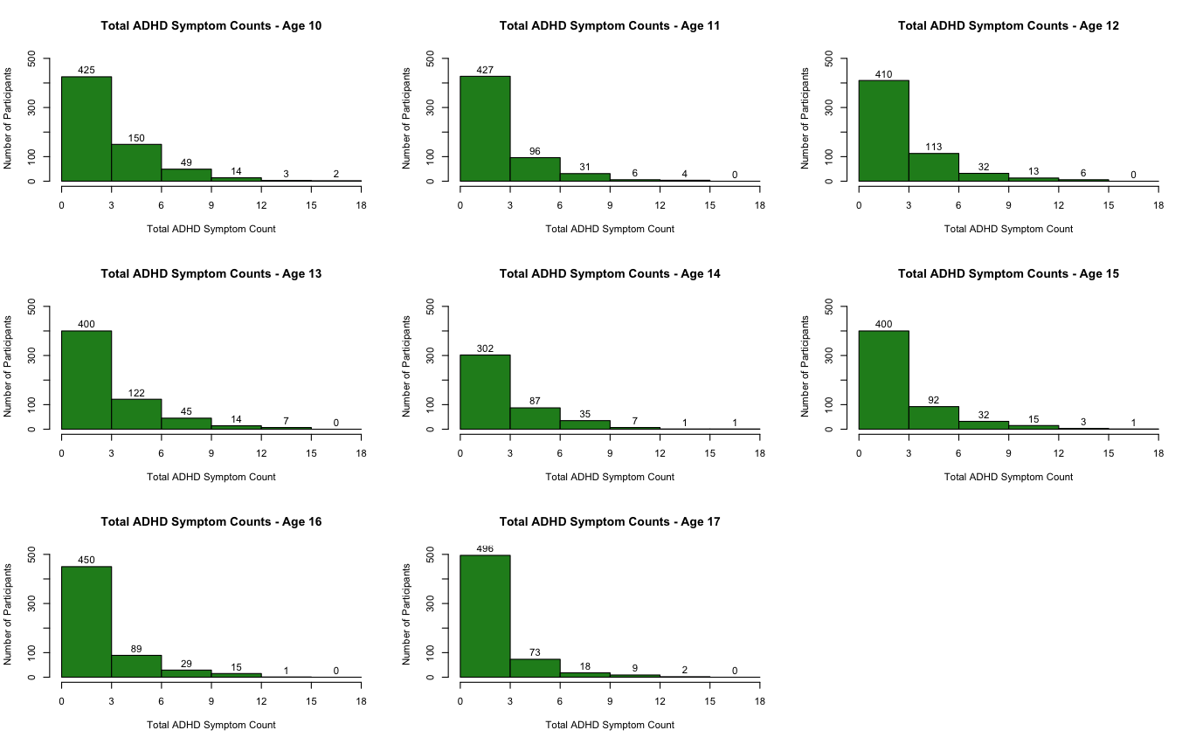
Note. Histogram bins are left-closed and right-open, such that values on a boundary go on the right. Participants in bins starting at 6 symptoms meet DSM-IV criteria for an ADHD-Combined diagnosis.
Figure S2
Histograms of Hyperactive-Impulsive ADHD Symptom Counts by Age
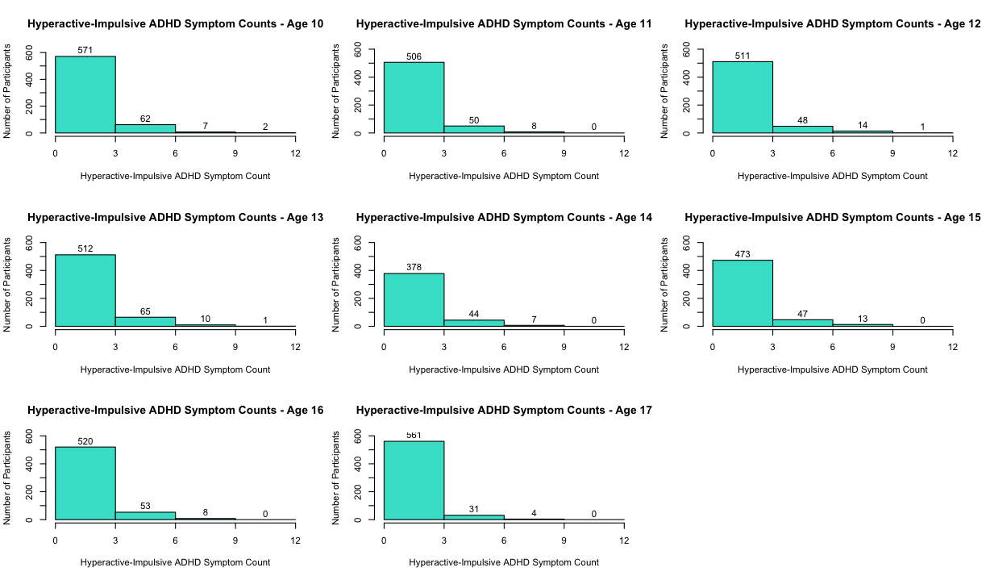
Note. Histogram bins are left-closed and right-open, such that values on a boundary go on the right. Participants in bins starting at 6 symptoms meet DSM-IV criteria for an ADHD-Hyperactive-Impulsive diagnosis.
Figure S3
Histograms of Inattentive ADHD Symptom Counts by Age
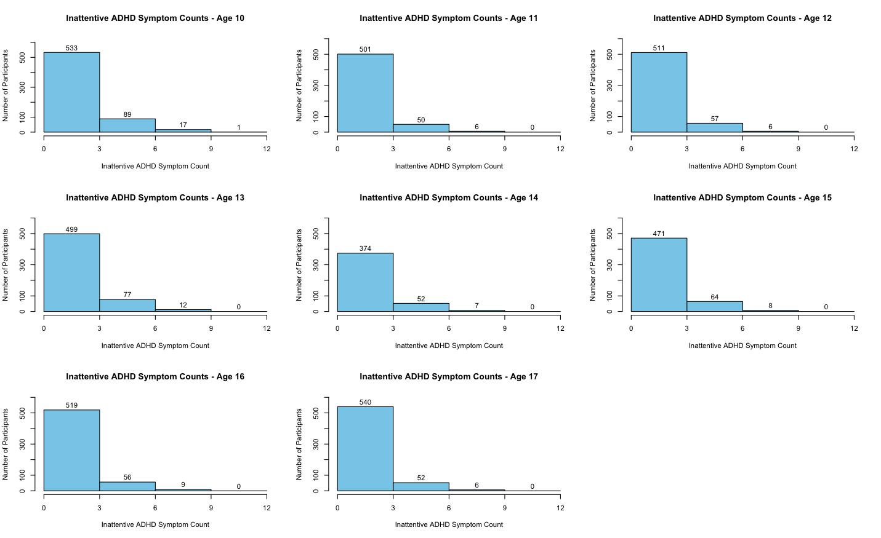
Note. Histogram bins are left-closed and right-open, such that values on a boundary go on the right. Participants in bins starting at 6 symptoms meet DSM-IV criteria for an ADHD-Inattentive diagnosis.

