Supplementary Material

S1. Additional Materials
Figure S1
Additional Materials
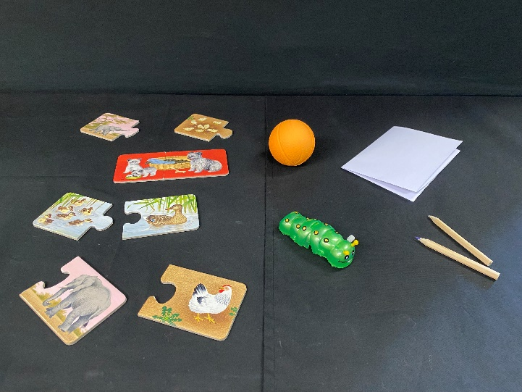  Warm-up materials |   Puppet
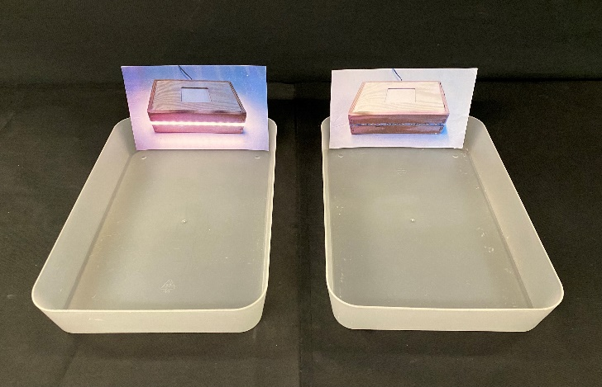
Plastic containers

S2. Learning Phase: Detailed Coding, Analyses, and Discussion

Coding
The measures employed in the learning phase serve as indicators of children's proficiency in learning the cause-effect relationship.
Hypothesis Formulation. Children’s responses to what causes the box to light up were classified into three categories. Those who correctly identified the black dot as the cause of light were categorized as having the correct hypothesis. Those who said that the black dot lights up the box after the experimenter’s prompting question (i.e., “What do the ones that light up the box have in common?”) were categorized as providing the correct hypothesis after prompting. The remaining children, who did not offer a hypothesis, were categorized as providing no correct hypothesis.

Detailed Analyses and Discussion
Hypothesis Formulation. We assessed children’s ability to generate a correct hypothesis based on evidence in the first hypothesis formulation phase. In T1, 41% (78/191) of children generated the correct hypothesis spontaneously, 36% (68/191) did so after the prompt, and 24% (45/191) of the children did not generate the correct hypothesis. In T2, 87% (156/179) generated the correct hypothesis, 12% (21/179) did so after the prompt, and 1% (2/179) of children did not generate the correct hypothesis. To investigate the differences in children’s hypothesis formulation between T1 and T2, we conducted a Friedman test, revealing a significant improvement in hypothesis formulation in T2 compared to T1 (N = 185, χ²(1) = 80.327, p < .001).
While not the primary focus of this study, our findings also indicate a developmental progression in hypothesis formulation ability from 4 to 5.5 years. Approximately one-third of 4-year-olds formulated the correct hypothesis, with another one-third formulated it after a prompt. At 5.5 years, the large majority formulated the correct hypothesis without a prompt. This highlights the capacity of young children to formulate hypotheses based on evidence showcasing perfect covariation. Notably, our results differ from those of Piekny and Maehler (2013)—the only study examining hypothesis generation in young children to our knowledge—which reported floor effects before the elementary school years. Our hypothesis formulation task, comparatively, was less challenging in several aspects. Considering the task disparities, we hypothesize that factors influencing young children's hypothesis formulation performance may include data ambiguity, task complexity (number of variables), and information presentation (step-by-step versus all-in-one).

S3. Justifications in the EVGEN Phase
One of our objectives was to analyze children's justifications for their object choice during the EVGEN phase. The social context's pragmatics resulted in a high number of ambiguous justifications, making it challenging to distinguish between disconfirming justifications and pure descriptions. For instance, when asked why they chose the small disconfirming object in Trial 1 of T1 at 4 years, many children responded with "Because this is small." This statement could be intended for disconfirmation, as children might have assumed it was based on prior discussions during the verbal argumentation phase that the small one activated the light. However, it's also possible that children used this sentence solely to describe the features without intending to disconfirm. Due to this ambiguity, we excluded this measure from our primary analyses. Rather, we present the coding and descriptives of justifications in the Supplemental Material.

Coding of Justifications
We examined the EVGEN justifications of the children who chose the correct object. The coding of justifications was extensive. Originally, eight categories emerged during coding. Later, we further categorized these eight categories into three broad ordinal response categories based on the quality of justifications. These categories and descriptives results are listed in Table S1. The best response category was disconfirming justifications. This was followed by partial justifications which were relevant but not sufficiently elaborate to indicate a disconfirmation. The lowest category was irrelevant justifications or providing no justification at all.
Table S1
Justification Categories, Their Definitions, and Example Justifications
Broad Categories |  | Detailed Categories | Definition | Example
 | Disconfirming justifications | Disconfirming | Justifications that refute the false claim | That’s a small one but it lights up the box.
 | Partial justifications  (Relevant but not sufficiently elaborate  to indicate a disconfirmation) | Alternative cause | Justifications mentioning the actual cause of the light | This one lights up the box because it has a black dot on it.
 |  | Effect | Statements mentioning that the chosen object causes or does not cause an effect | Because this one lights up the box.
 |  | Features | Statements about a feature of the chosen object | Because this one is small.  Because this one has a black dot.
 |  | Teaching | Statements that indicate an intention to teach the puppet | Because I want to show Max.
 | Irrelevant/  No justification | Prediction | Predictions regarding the effect of the chosen object | Maybe this one lights up the box.
 | Irrelevant/  No justification | Unclear | Statements that cannot be categorized | Because it is correct.
 |  | No justification | No response or stating one does not know | I don’t know.
Note. All example justifications were given in T1 Trial 1 after choosing the small object with the black dot.

EVGEN Justifications: Descriptives and Discussion
We examined the justifications of children who chose the correct object. Table S2 shows the proportion and the frequency of the three justification categories. Notably, a significant proportion of children provided partial justifications. Despite not articulating a full disconfirming justification, it was evident within the context of argumentation that children were indeed referring to the disconfirming object. The high prevalence of partial justifications is likely attributed to children perceiving the articulation of a fully elaborate disconfirming justification as redundant, given the apparent clarity of their reference to the disconfirming object. This, however, is inherent to the protest paradigm and stems from the pragmatics of the social context.
Table S2
The Proportion and the Frequency of the Justifications in the EVGEN Phase
Category | T1 |  | T2
Category | Trial 1 | Trial 2 | Trial 1 | Trial 2
Disconfirming justifications | 4% (6) | 4.5% (3) | 16.1% (24) | 16.5 (18)
Partial justifications | 65% (101) | 56.7% (38) | 70.5% (105) | 64.2 (70)
Irrelevant/No justification | 31% (48) | 38.8% (26) | 13.4% (20) | 19.3 (21)
Total N | 155 | 67 | 149 | 109

S4. Detailed Task Descriptions

General Cognitive Skills and Knowledge
Nonverbal Ability (Block Design, HAWIVA-III by Ricken et al. 2007). In this subtest, children were presented with a collection of red and white blocks and tasked with recreating specific designs and patterns using these blocks. The test measured their spatial perception, visual-motor integration, and problem-solving abilities. The test consisted of 23 items, each progressively increasing in complexity. For the initial 6 items, children were given two attempts (scoring 2 for the first try correct, 1 for the second try correct, and 0 for incorrect). Items 7 to 23 were scored with 2 for a correct design and 0 for an incorrect one (maximum score = 46). If a child made three consecutive errors, the task was terminated, and the child received a score of 0 for the remaining items.
Verbal Ability (SETK 3-5 by Grimm et al., 2015). Children’s language memory, sentence comprehension, and morphological rule formation were assessed with three subtests of SETK 3-5. Raw values from each subtest were transformed into standardized T-values according to the age-specific norms and the average of the three subtests was used as an index for children’s verbal ability.
General Knowledge Test (HAWIVA-III by Ricken et al. 2007). This test assesses children’s general cultural knowledge, long-term memory, and acquired facts through questions like "How many eyes do you have?" or "What do you use to cut something?" The task comprises 28 trials, each worth 1 point. The task ends when the child responds incorrectly in five consecutive trials.

Executive Functions
Working Memory (Backward digit span by Ricken et al. 2007). Children were presented with a series of digits and asked to repeat the digits in reverse order. Starting with a two-digit sequence, the length of the digit sequence progressively increases until eight digits. Children received a score based on the total number of sequences they could accurately recall in reverse.
Inhibition. In the Day/Night Stroop task, children should respond “night” to a drawing of the sun and “day” to a drawing of the moon (Gerstadt et al., 1994). The dependent variable is the number of correct responses out of 16 test trials. ICC for Day/Night Stroop was .98 indicating excellent reliability. In the Simon Says task (Strommen, 1973, see also Kloo & Sodian, 2017 for the details of the version we used), where children should do an action (e.g., touch your nose) only when the instructions were preceded by “Simon says.”, while they should inhibit a response when the instructions were not preceded by “Simon says” (non-Simon trials). We used the sum of 10 non-Simon trials for analyses. ICC for Simon says was .90 indicating excellent interrater reliability.
Planning (Truck loading by Fagot & Gauvain, 1997). In this task, children were presented with a toy mail truck and colored party invitations to deliver to similarly colored houses on a paper playboard. Children had to load the invitations on the truck in reverse order to distribute them in an efficient way. (For details on task description, see Kloo & Sodian, 2017). There were four difficulty levels, each level consisted of two trials. The lowest difficulty level required children to sort the mail of two houses and one new house was added for each successive difficulty level with the maximum difficulty level including five houses. Children received a score ranging from 0 to 4 based on the highest difficulty level they reached. ICC was .96 indicating excellent interrater reliability.
Cognitive Flexibility (Border Version of DCCS by Zelazo, 2006). In this task, children were presented with cards featuring drawings differing in two dimensions: color and shape. In the initial pre-switch phase, they were asked to sort the cards based on the color dimension, and later, in the post-switch phase, the sorting rule was changed to the shape dimension. For the more challenging border phase, a new dimension was introduced, where children were instructed to sort the cards based on the presence or absence of a border: sorting by color when there was a border on the cards and by shape when there was none. Given that children exhibited ceiling performance in the pre-and post-switch phases, we used their scores from the 12 border version trials. ICC was .99 indicating excellent interrater reliability.

Theory of Mind and Advanced Theory of Mind
Theory of Mind (Wellman & Liu, 2004). The Knowledge Access task assesses children’s ability to understand that others may have access to different information than they do. Children were shown a toy dog figure inside a box and were subsequently questioned about whether a person who lacked visual access to the box knew what was inside the box. The Content False Belief task assesses children’s understanding that others can hold false beliefs about the contents of an object. Children were shown a candy box (Smarties) containing an unexpected toy pig and asked to evaluate the belief of another individual who was unaware of the box's true contents. The Explicit False Belief task assesses children’s ability to understand that others can hold false beliefs about the world. Children were presented with a story about a character who holds a belief that his gloves are in a wardrobe, despite them actually being in his backpack, and subsequently, the children were asked to predict where the character would search for his gloves. In all three tasks, children were asked control questions to ensure that they comprehend the questions and the task format. For each task, children received a score of 1 if they correctly answered the control questions and the test question, leading to a theory of mind (ToM) score ranging from 0 to 3.
Advanced Theory of Mind (Birthday Puppy Story, Sullivan et al., 1994). In this task, children were told a story in which a mother misinforms her son about his birthday gift to surprise him, and the child discovers the real present unbeknownst to his mother. During a later conversation, the grandmother asks the mother what the child is getting as his birthday present and what he thinks he is getting. Children were asked about the mother’s false belief about the child’s belief (second-order false belief). Children received 1 point for correctly answering both the control questions and the test question while receiving a score of 0 for any incorrect responses to these questions.
Metacognition (Partial Exposure Task, Rohwer et al., 2012). This task utilized a visual barrier, an opaque shoebox for concealing objects, and eight toys arranged in a specific order. The comprehensive task included three distinct metacognitive tasks: Complete Knowledge (K), Total Ignorance (I), and Partial Knowledge (P), each featuring two trials. Children underwent the trials in a fixed order (K-I-P-P-I-K). Participants were asked about their knowledge of the contents of a box, with the Complete Knowledge task involving full knowledge, the Total Ignorance task indicating no information, and the Partial Knowledge Task in which children knew that one of two objects in the box without knowledge of which one. In this study, only scores from the Partial Exposure task were utilized, given that children demonstrated ceiling performance in the other two tasks. For each Partial Exposure trial, children earned a score of 1 for successfully indicating their incomplete knowledge, resulting in a score ranging from 0 to 2.

S5. Correlations Between Cognitive Abilities and Argument Types
Table S3
Nonparametric Correlations (and Partial Correlations) Between Cognitive Abilities and Argument Types
 | T1 |  |  |  |  | T2
 | Verbal argumentation | AC | ND | CD |  | Verbal argumentation | AC | ND | CD
T1 4 years
Nonverbal | .16* (.12*) | .15* (.11*) | -.06 | .09 |  | .03 | .08 | -.09 | .00
Verbal | .23*** | .13* | -.00 | .16** |  | .19*** | .17** | .07 | -.01
Knowledge | .24***(.14**) | .13* (.05) | .03 | .16** (.10*) |  | .05 | .10# | .04 | -.10#
WM | .23** (.17**) | .18* (.14**) | .02 | .15* (.11*) |  | .14* (.07) | .05 | .01 | -.02
Planning | .17* (.08#) | .07 | .10# | -.00 |  | .27*** (.21***) | .27*** (.21***) | .00 | .05
Inhibition | .18** (.16***) | .22***(.22***) | .03 | .05 |  | .08# | .08 | .06 | .06
Theory of mind | .27*** (.18***) | .17* (.10*) | .02 | .17** (.12*) |  | .21** (.13*) | .23*** (.17**) | .26*** | -.10#
T2 5.5 years
Flexibility | .07 | .12* (.08) | -.04 | -.03 |  | .21*** (.20***) | .21*** (.19***) | -.01 | .11#
WM | .04 | .16** (.12*) | .01 | -.09# |  | .06 | .03 | -.08 | -.06
Inhibition | .14* (.12*) | .13* (.13**) | .03 | .07 |  | .17** (.14**) | .09# | .01 | .06
Theory of mind | .18** (.15**) | .16# (.15**) | .03 | .02 |  | .02 | .07 | .10# | -.09
Advanced ToM | .10# | .11* (.07#) | .08 | .04 |  | .04 | .09 | -.08 | .01
Metacognition | .18** (.12*) | .13* (.08#) | .04 | .09 |  | .14* (.08#) | .12# | -.01 | .01
# p < .10. * p < .05. ** p < .01 *** p < .001.
For arguments that correlated with verbal ability, partial correlations controlling for verbal ability were reported in parentheses.
For T1 arguments, Ns ranged between 153-186, except for T1 WM (Ns = 132-133) and Nonverbal (Ns = 136-143). For T2 arguments, Ns ranged between 145-177, except for T1 WM (N =126) and Nonverbal (N = 136).

S6. Correlations between the Cognitive Abilities and the EVGEN Performance
Table S4
Nonparametric Correlations (and Partial Correlations) between the Cognitive Abilities and the EVGEN Performance
 | T1 EVGEN |  | T2 EVGEN
 | τ | N | τ | N
T1 4 years
Nonverbal | .16* (.12*) | 132 | .21**(.17**) | 136
Verbal | .08# | 166 | .18** | 168
Knowledge | .01 | 172 | .11# | 170
Working Memory | .05 | 127 | .12# | 127
Planning | -.03 | 154 | .19** (.15**) | 158
Inhibition | .02 | 163 | .07 | 167
Theory of mind | .11# | 156 | .09 | 153
T2 5.5 years
Flexibility | .04 | 159 | .27*** (.26***) | 175
Working memory | .09 | 155 | .06 | 171
Inhibition | .09# | 160 | .06 | 176
Theory of mind | .03 | 162 | .11# | 178
Advanced ToM | .01 | 154 | -.01 | 165
Metacognition | .12# | 161 | .16* (.09*) | 177
# p < .10. * p < .05. ** p < .01, ***p < .001. EVGEN = EVGEN sum score. For argument types that correlated with verbal ability, partial correlations controlling for verbal ability were reported in parentheses. Ns ranged between 152-178, except for T1 WM (N = 127) and Nonverbal (Ns = 132-136). The Ns for partial correlations ranged between 125-145 for T1 EVGEN and between 129-167 for T2 EVGEN.

S7. Correlations Between Cognitive Abilities
Table S5
Nonparametric Correlations Between Cognitive Abilities
 | 1 | 2 | 3 | 4 | 5 | 6 | 7 | 8 | 9 | 10 | 11 | 12 | 13
T1 4 years
1 Nonverbal | -
2 Verbal | .15** | -
3 Knowledge | .20*** | .38*** | -
4 WM | .23** | .28*** | .29*** | -
5 Planning | .19** | .18*** | .16** | .25*** | -
6 Inhibition | .11* | .09* | .06 | .08 | .09# | -
7 ToM | .16* | .35*** | .33*** | .27*** | .28*** | .15* | -
T2 5.5 years
8 Flexibility | .24*** | .16** | .11* | .33*** | .24*** | .04 | .07 | -
9 WM | .29*** | .20*** | .16** | .35*** | .20*** | .02 | .21*** | .16** | -
10 Inhibition | .11* | .06 | .12* | .15* | .10# | .09# | .17** | .11* | .03 | -
11 ToM | .01 | .14** | .16** | .14* | .10# | .01 | .22*** | .08 | .03 | .07 | -
12 AToM | .05 | -.07 | .04 | .10 | .12# | -.02 | .06 | .11# | .18** | .05 | .07 | -
13 Metacognition | .24*** | .25*** | .24*** | .11# | .09 | .09# | .15* | .02 | .20** | .08 | .10# | -.02 | -
Notes. Nonverbal = Nonverbal intelligence; Verbal = Verbal ability; Knowledge = General knowledge; WM = Working memory; ToM = Theory of mind; AToM = Advanced theory of mind (Second-order false belief). Nonparametric correlations [Kendall’s tau (τ), one-sided] were reported as some variables were not normally distributed. # p < .10. * p < .05. ** p < .01, ***p < .001

S8. Additional Exploratory Analyses

S8.1 Longitudinal Correlations Between Argumentation Measures
Table 5 presents longitudinal bivariate correlations among different argumentation measures. Concerning cross-sectional relationships, verbal argumentation consistently correlated with EVGEN Trial 1 at both time points. Regarding EVGEN, there was a small negative correlation between the two trials at T1, with no correlation at T2. Concerning longitudinal associations, small correlations were observed between verbal argumentation across two time points and between EVGEN Trial 1. Moreover, verbal argumentation at T1 correlated with EVGEN Trial 2 at T2.

Table S6
Longitudinal Correlations Among Argumentation Measures
Variable | T2 Verbal argumentation | T2 AC | T2 CD | T2 ND | T2 EVGEN sum score | T2 EVGEN Trial 1 | T2 EVGEN Trial 2
T1 Verbal argumentation | .18* | .21** | -.08 | .11# | .15* | .04 | .13*
T1 AC | .24** | .02 | .16* | .01 | .09 | .00 | .08
T1 CD | .08 | .17* | -.03 | .05 | .06 | .03 | .02
T1 ND | .09 | .07 | -.04 | .12# | .08 | .03 | .08
T1 EVGEN sum score | .08 | .01 | .05 | .03 | -.03 | .03 | -.05
T1 EVGEN Trial 1 | .13# | .12# | .10# | .01 | .00 | .09 | -.04
T1 EVGEN Trial 2 | .02 | -.05 | .00 | .03 | -.02 | -.02 | -.02
Note. Verbal argumentation = Valid verbal argumentation; AC = Alternative-cause argument; CD = Causal-disconfirming argument; ND = Noncausal-disconfirming argument; EVGEN = Evidence generation.
# p < .10, *p < .05, **p < .01.

S8.2 Frequencies and Proportions of Verbal Argumentation Patterns
Table S7
Verbal Argumentation Patterns in T1 and T2
 | T1 |  | T2
Categories | % | n | % | n
Valid verbal argumentation
AC only | 12.4 | 23 | 28.8 | 51
CD only | 29.0 | 54 | 15.3 | 27
ND only | 2.7 | 5 | 4.0 | 7
AC & CD | 8.6 | 16 | 12.4 | 22
AC & ND | - | - | 9.6 | 17
CD & ND | 1.1 | 2 | 0.6 | 1
AC, CD, & ND | 1.1 | 2 | 0.6 | 1
No valid verbal argumentation | 45.2 | 84 | 29 | 51
Total | 100 | 186 | 100 | 177
Note. AC = Alternative cause; CD = Causal disconfirming; ND = Noncausal disconfirming

S8.3 Verbal Argumentation’s Impact on the Subsequent EVGEN Performance
To assess the potential impact of children's verbal argumentation on their performance in subsequent EVGEN trials, we investigated whether the type of verbal arguments provided could predict their outcomes in the EVGEN phase. Descriptive statistics for T1 and T2 are presented in Table S4.
Table S8
Frequencies of Success in EVGEN Trials Based on Verbal Argumentation Patterns
 | T1 |  | T2
Categories | Trial 1 | Trial 2 | Trial 1 | Trial 2
Valid verbal argumentation
AC only | 21/21 | 11/21 | 47/51 | 32/51
CD only | 52/53 | 16/50 | 27/27 | 18/27
ND only | 2/4 | 3/4 | 5/7 | 6/7
AC & CD | 16/16 | 5/16 | 21/22 | 11/22
AC & ND | - | - | 11/17 | 14/17
CD & ND | 2/2 | 0/2 | 1/1 | 0/1
AC, CD, & ND | 2/2 | 0/2 | 1/1 | 1/1
No explicit argumentation | 65/80 | 35/80 | 37/51 | 27/51
Total | 178 | 175 | 177 | 177
Note. AC = Alternative cause; CD = Causal disconfirming; ND = Noncausal disconfirming
We conducted four logistic regression analyses, each predicting one of the EVGEN trials at the two time points. The independent variables comprised the three argument types, with two exceptions. Firstly, at T1, noncausal arguments were excluded due to their infrequent occurrence, hindering statistical analyses. Secondly, when predicting T1 Trial 1, alternative-cause was omitted as an independent variable due to the complete separation in the data. Specifically, all children who provided alternative-cause arguments chose the correct object in EVGEN Trial 1, resulting in zero observations for the category of children who provided an alternative-cause argument but were wrong in EVGEN Trial 1. Figures S2 and S3 illustrate the estimated probabilities of choosing the correct object in the EVGEN trials based on the type of argument produced in the verbal argumentation phase in T1 and T2, respectively.
Figure S2
Probability of Success in the EVGEN Trials Depending on Verbal Argumentation Types at T1
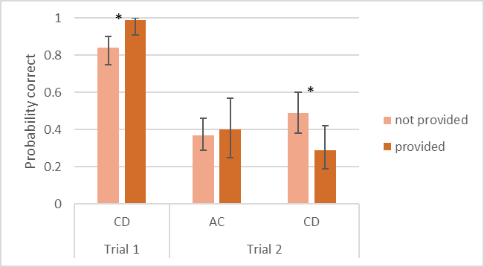
Note. * indicates a significant difference at the .05 level.
Figure S3
Probability of Success in the EVGEN Trials Depending on Verbal Argumentation Types at T2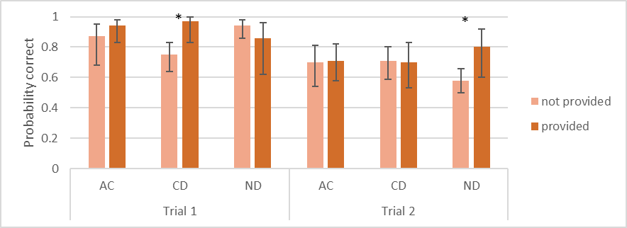
Note. * indicates a significant difference at the .05 level.
In models with multiple independent variables, we assessed multicollinearity using VIF and Tolerance statistics, and no multicollinearity was identified. The logistic regression results are presented in Table S5. Across both time points, children presenting causal arguments were more likely to succeed in the causal EVGEN trial (Trial 1) compared to those who did not provide these arguments. At T1, the children providing causal arguments were also less likely to succeed in the noncausal EVGEN trial (Trial 2). Furthermore, at T2, children producing noncausal arguments were more likely to succeed in the noncausal EVGEN trial. Regarding alternative-cause arguments, at T1, complete separation suggests a strong association between providing alternative-cause arguments and success in the causal EVGEN trial. However, this was not observed in the other trials.
Table S9
Logistic Regression Results for Object Choice Based on Verbal Argumentation Types
 | Parameter Estimates |  |  |  |  |  | Model Summary
 | B (SE) | p | Odds ratio | Lower bound | Upper bound | χ² (df) |  | R² | p
T1
EVGEN Trial 1 (causal) |  |  |  |  |  | 10.41 (1) |  | .14 | .001
Constant | 1.74 (0.29) | <.001 | 5.71 | - | -
Causal disconfirming | 2.46 (1.05) | .019* | 11.73 | 1.50 | 91.50
EVGEN Trial 2 (noncausal) |  |  |  |  |  | 5.03 (2) |  | .04 | .081
Constant | -0.16 (0.21) | .456 | 0.86 | - | -
Causal disconfirming | -0.72 (0.33) | .028* | 0.49 | .26 | .92
Alternative cause | 0.11 (0.39) | .762 | 1.12 | .54 | 2.34
T2
EVGEN Trial 1 (causal) |  |  |  |  |  | 18.98 (3) |  | .18 | <.001
Constant | 1.18 (0.32) | <.001 | 3.24 | - | -
Causal disconfirming | 2.51 (1.04) | .016* | 12.24 | 1.59 | 94.37
Noncausal disconfirming | -1.03(0.53) | .050# | 0.36 | 0.13 | 1.00
Alternative cause | 0.83 (0.46) | .072# | 2.29 | 0.93 | 5.63
EVGEN Trial 2 (noncausal) |  |  |  |  |  | 5.25 (3) |  | .04 | .155
Constant | 0.30 (0.25) | .245 | 1.34 | - | -
Causal disconfirming | -0.02 (0.35) | .964 | 0.99 | 0.50 | 1.94
Noncausal disconfirming | 1.08 (0.54) | .044* | 2.94 | 1.04 | 8.38
Alternative cause | 0.09 (0.32) | .774 | 1.10 | 0.59 | 2.04
Notes. The lower and upper bounds are those for the 95% confidence interval. R² is Nagelkerke statistic.

S8.4 Theory of Mind as the Common Correlate of AC and ND Arguments
The analyses revealed differences in the correlates of the three argument types, except theory-of-mind ability emerging as a common longitudinal correlate for both alternative-cause and noncausal arguments. The infrequent occurrence of noncausal arguments and their high co-occurrence with alternative-cause arguments brought up the possibility that the strong correlation in noncausal arguments might be confounded by the presence of alternative-cause arguments. To explore this, we compared the theory-of-mind scores of children showcasing different verbal argumentation patterns, as illustrated in Figure S4 with a boxplot representing six groups of children. Due to the low sample size of children producing only noncausal arguments, we could not run significance testing including this group. Qualitative comparison of the means demonstrated that theory-of-mind scores of the Alternative Cause Only Group (n = 42, M = 1.76, SD = 0.93) and Noncausal Only Group (n = 5, M = 2.00, SD = 0.71) were both relatively high.
Additionally, we performed a univariate ANOVA analysis involving five verbal argumentation patterns (excluding “ND only”, “CD & ND,” and “AC, CD, & ND” combinations due to the small sample size (n < 5), see Table S5 for the frequencies all argument types). This analysis was significant, indicating an expected main effect of verbal argumentation pattern, F(4, 140) = 5.26, p < .001, partial eta squared = .13. Post hoc comparisons demonstrated that children providing alternative-cause and noncausal arguments had significantly higher theory-of-mind scores than three subgroups of children, namely, No valid verbal argumentation, CD Only, and AC & CD (ps < .05). Taken together, a combination of significance testing and qualitative comparisons suggest that the association between noncausal arguments and theory of mind was not merely a by-product of the co-occurrence with alternative-cause arguments. While the post hoc results did not reach significance, the descriptives hint at a potential additive effect of providing both alternative-cause and noncausal disconfirming arguments, as this group received the highest theory-of-mind scores.
Figure S4
Distribution of Theory-of-Mind Scores Across Different Verbal Argumentation Patterns
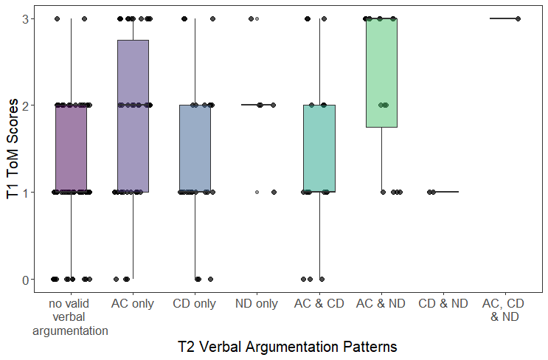

References
Fagot, B. I., & Gauvain, M. (1997). Mother-child problem solving: Continuity through the early childhood years. Developmental Psychology, 33(3), 480–488. https://doi.org/10.1037//0012-1649.33.3.480
Gopnik, A., & Sobel, D. M. (2000). Detecting blickets: How young children use information about novel causal powers in categorization and induction. Child Development, 71(5), 1205–1222. https://doi.org/10.1111/1467-8624.00224
Legare, C. H. (2012). Exploring explanation: Explaining inconsistent evidence informs exploratory, hypothesis-testing behavior in young children. Child Development, 83(1), 173–185. https://doi.org/10.1111/j.1467-8624.2011.01691.x
Legare, C. H., & Lombrozo, T. (2014). Selective effects of explanation on learning during early childhood. Journal of Experimental Child Psychology, 126, 198–212. https://doi.org/10.1016/j.jecp.2014.03.001
Rohwer, M., Kloo, D., & Perner, J. (2012). Escape from metaignorance: How children develop an understanding of their own lack of knowledge. Child Development, 83(6), 1869–1883. https://doi.org/10.1111/j.1467-8624.2012.01830.x
Sobel, D. M., Erb, C. D., Tassin, T., & Weisberg, D. S. (2017). The development of diagnostic inference about uncertain causes. Journal of Cognition and Development, 18(5), 556–576. https://doi.org/10.1080/15248372.2017.1387117
Sullivan, K., Zaitchik, D., & Tager-Flusberg, H. (1994). Preschoolers can attribute second-order beliefs. Developmental Psychology, 30(3), 395–402. https://doi.org/10.1037/0012-1649.30.3.395
Wellman, H. M., & Liu, D. (2004). Scaling of theory-of-mind tasks. Child Development, 75(2), 523–541. https://doi.org/10.1111/j.1467-8624.2004.00691.x
Zelazo, P. D. (2006). The Dimensional Change Card Sort (DCCS): A method of assessing executive function in children. Nature Protocols, 1(1), 297–301. https://doi.org/10.1038/nprot.2006.46

Since the two EVGEN trials at T1 were negatively associated, and Trial 2 followed Trial 1, we ran an additional logistic regression model, including the EVGEN Trial 1 success as an additional independent variable. This model did not lead to a better model compared to the reported model with two independent variables, χ²(3)= 9.26, p = .075, R² = .08. Moreover, the individual contribution of EVGEN Trial 1 was not significant, β = -1.03, SE = 0.69, p = .084, Odds ratio = 0.36, 95% CI [.11-1.15]. For this reason, we report logistic regression analyses without the EVGEN Trial 1.

