Social Connectedness Without Eye Contact: 18- But Not 9-Month-Olds Use Proximal Touch to Infer Third-Party Joint Attention During Observational Learning

Supplementary Information
Table of contents
S1 – Supplementary Information Statistical Models
S2 – Supplementary Analyses Encoding Phase
S3 – Supplementary Analyses Recognition Test Phase
S4 – Supplementary Information Fixation Filter
References
Supplementary Figures
Figure S1. Areas of interest (AOIs) during the encoding phase
Figure S2. Areas of interest (AOIs) during the recognition test phase
Figure S3. Time-course of the novelty preference score during the 10-second recognition test phase
Supplementary Tables
Table S1. Valid trial statistics for the four conditions (9-month-olds)
Table S2. Means (standard deviations) for looking times during the encoding phase in (9-month-olds)
Table S3. Results from post-hoc one-sample t-tests testing the novelty preference score until video end within the four conditions against chance (9-month-olds)
Table S4. Valid trial statistics for the four conditions (18-month-olds)
Table S5. Means (standard deviations) for looking times during the encoding phase in (18-month-olds)
Table S6. Results from post-hoc one-sample t-tests testing the novelty preference score until video end within the four conditions against chance (18-month-olds)

Supplementary Online Repository
Video examples, eye-tracking raw data and scripts for pre-processing and analyzing the data are openly assessable on the Open Science Framework (link: https://osf.io/g7nsq/).

S1 – Supplementary Information Statistical Models
We used the R software environment (R version 4.4.1, RStudio version 2024.4.2.764) for pre-processing and analyzing the data and for setting AOIs. The following analytical steps were conducted separately for the two age groups. The reason for pre-registering separate models instead of relying on a more complex, combined model was twofold. First, we aimed to maximize the interpretability of our results in relation to our pre-registered within-age group hypotheses concerning proximity, eye contact, and their interaction (with distinct age group assumptions, see section “The Current Study” in the paper). A combined model including a three-way interaction between age, proximity, and eye-contact would have made it considerably more difficult to draw clear conclusions about these within-sample effects. Second, the novelty-preference based object encoding paradigm has not been used with 18-month-old toddlers, meaning that we did not know how the preference score would unfold in this age group when using an identical timing for both age groups in the recognition test, considering that infants’ visual skills and capacities like memory and processing speed improve with age (Colombo, 2001; Pelphrey et al., 2004; Reznick et al., 2004). Given this uncertainty, we decided to characterize developmental signatures by comparing condition differences within each age group instead of comparing the scores directly between age groups. The importance of such careful considerations when applying the paradigm in developmental studies is discussed in more detail in a comprehensive review by Michel & Thiele (2025).

Model Descriptions
We fitted three Generalized Linear Mixed Models (GLMMs) with beta distributed error structure to model the novelty preference score as a function of “eye contact” and “touch”: A full model, a reduced model and a null model. Originally, we preregistered to conduct Linear Mixed Models (LMMs) with gaussian error distribution. However, following consult with a statistician we decided to use a beta distribution since this distribution is a more appropriate fit for proportion scores where the variable of interest is continuous and bounded between zero and one (Ferrari & Cribari-Neto, 2004). The general structure of the three models was as follows:

Full Model
As main fixed effects, the full model included all possible main effects and interactions between eye contact and touch. Specifically, we included the interaction between “eye contact” and “touch” and the main effects of “eye contact” (1,0) and “touch” (1,0). As control variables, we included fixed effects for “running trial number” (1-16) and “trial number within condition” (1-2). As random effects, we included “subject” as intercept as well as random slopes on “subject” for “running trial”, “eye contact” and “touch”.

Full glmmTMB (Novelty Preference Score (transformed) ~
Eye Contact Condition : Touch Condition + Eye Contact Condition + Touch Condition + Running Trial (transformed) + Trial within Condition (transformed) +
(1 | ID) + (0 + Running Trial (transformed) | ID) + (0 + Eye Contact Condition | ID) +
(0 + Touch Condition | ID)
, data=overall.data, family = beta_family(link="logit"))

Reduced Model
As main fixed effects we included “eye contact” and “touch” in the reduced model. We included the same control variables and random effects as in the full model.

Reduced glmmTMB (Novelty Preference Score (transformed) ~
Eye Contact Condition + Touch Condition +
Running Trial (transformed) + Trial within Condition (transformed) +
(1 | ID) + (0 + Running Trial (transformed) | ID) + (0 + Eye Contact Condition | ID) +
(0 + Touch Condition | ID)
, data=overall.data, family = beta_family(link="logit"))

Null Model
The null model was lacking all predictors of interest.

Null glmmTMB (Novelty Preference Score (transformed) ~
Running Trial (transformed) + Trial within Condition (transformed) +
(1 | ID) + (0 + Running Trial (transformed) | ID) + (0 + Eye Contact Condition | ID) +
(0 + Touch Condition | ID)
, data=overall.data, family = beta_family(link="logit"))

Fitting the Models
We fitted the models using the R-package glmmTMB version 1.1.9 (Brooks et al., 2017). The glmmTMB package can treat zero-inflated, but does not support one-inflated models. To account for this, the novelty preference score (dependent variable) was transformed following a recommendation of Smithson and Verkuilen (2006):
y * (n − 1) + 0.5) / n
In this formular, y represents all values of the dependent variable and n is the overall sample size. As planned in the preregistration, we first included a full random effect structure in the models (i.e., random slopes on subject for eye contact condition, touch, the interaction between eye contact and touch, running trial, trial within condition). However, our models including this random effect structure did not converge. To address the convergence issue in our models, we (a) reduced the complexity of the random effect structure by excluding the interaction term and one of the two trial covariates (trial within condition) and (b) z-transformed the covariates running trial and trial within condition.

Model Comparisons
After successfully fitting the models, we ran likelihood ratio tests comparing the full model with the null model lacking the predictors of interest using anova (full, null). If the full-null model comparison indicated statistically significant effects of the predictors on the outcome, we conducted further likelihood ratio tests comparing the full model with the reduced model in which the respective predictors were excluded one by one. The significance of the individual fixed effects was based on likelihood ratio tests comparing the full model with the reduced model excluding the individual fixed effects using the drop1-function in R with an alpha-level of .05. The estimates and standard deviations were retrieved using the summary function.

Follow-Up Analyses
First, we tested all possible pair-wise contrasts between the four conditions using the R-package emmeans version 1.10.4 (Lenth, 2020). We adjusted the alpha level via Bonferroni correction to control for multiple testing issues. Second, we used one-sample t-tests to test the proportion score against chance level within each condition.

S2 – Supplementary Analyses Encoding Phase
We conducted the following analyses in addition to the preregistered analysis plan to explore the data further.

Looking Times to the Screen, the Actors, and the Object Held by one Actor
We compared whether infants’ overall attention to the videos in the encoding phase differed across conditions. For this purpose, we fitted three generalized linear mixed model with gamma distribution for infants’ looking times during the action phase: one for their looking times at the overall screen, one for their looking time to the actors’ faces, and one for their looking time to the object including the hand of the actor holding it (dependent variables). We used GLMMs with a non-normal gamma distribution to account for the right-skewed distribution of the looking time data (Lo & Andrews, 2015). To fit the models, we used the lme4 R-package version 1.1-35.5 (Bates et al., 2020). We included the same fixed and random effects in all three models. As main fixed effects, we included “condition”, as well as “running trial” and “trial per condition” (control fixed effects). As random effects we included “subject” as intercept as well as random slopes on “subject” for “running trial”, “touch”, and “eye contact”. We included looking times of the entire encoding phase. The AOIs used for the analyses of the data in the object encoding phase are illustrated in Figure S1. The significance of the individual fixed effects was based on likelihood ratio tests comparing the full model with the reduced model excluding the individual fixed effects using the drop1-function in R with an alpha-level of .05.

9-Month-Olds
We did not find condition differences in 9-month-olds’ looking times at the overall screen (χ²(1) = 0.19, p = .66, estimate = −.006, SE = .01), infants’ looking times at the object held by the actor (χ²(1) = 3.78, p = .052, estimate = −.09, SE = .052), and infants’ looking time at the actors’ faces (χ²(1) = 1.12, p = .29, estimate = −.03, SE = .02). The means and standard deviations of the looking times in the action phase are depicted in Table S2.

18-Month-Olds
We did not find condition differences in 18-month-olds’ looking times at the overall screen (χ²(1) = 0.92, p = .34, estimate = −.02, SE = .02), infants’ looking times at the object held by the actor (χ²(1) = 0.47, p = .49, estimate = .02, SE = .03), and infants’ looking time at the actors’ faces (χ²(1) = 3.54, p = .06, estimate = −.05, SE = .03). The means and standard deviations of the looking times in the action phase are depicted in Table S5.

S3 – Supplementary Analyses Recognition Test Phase
Results from our main analysis reported in the main manuscript revealed that 9-month-olds showed no significant deviation from chance level in conditions with lower proportion scores (both “eye contact” conditions). Conversely, 18-month-olds displayed a significant below-chance preference in the condition with lowest proportion score (“no eye contact – no touch”), indicating increased looking times to the familiarized object. As discussed in the paper, one potential explanation for the observed familiarity preference in 18-month-olds could be attributed to partial object encoding, indicative of a “less complete internal representation of the stimulus” (Pascalis & de Haan, 2003). This would align with studies demonstrating a shift from familiar to novel information (Kosie et al., 2023; Rose et al., 1982). To explore this in our data and understand why only 18-month-olds, but not 9-month-olds, exhibited a familiarity preference, we examined how the novelty preference score unfolded over time during the recognition test.

Time-Course of the Novelty Preference Score
To explore the time-course of the novelty preference score across conditions and age groups, we used visualizations of the descriptive data. To prepare the data for plotting, we divided the 10-second recognition phase into 500 ms time bins for each trial (see also Lindskog et al., 2019). Within each time bin, we determined the fixation duration on the novel and familiar objects and then calculated the proportion score using the same formula as our main measure (i.e., fixation duration on the novel object divided by the total fixation duration on both objects). As illustrated in Figure S3, the period during which the condition effect was visible, seemed to (a) emerge later in 9-month-olds than in 18-month-olds, and (b) last longer in 18-month-olds compared to 9-month-olds. Visualizations suggested that both 9- and 18-month-olds showed below-chance (familiarity) preferences in the “lowest-scoring” conditions during the time period when the condition effect was visible.

9-Month-Olds
In the beginning of the recognition test, 9-month-olds’ proportion scores were at chance level in all conditions, suggesting the absence of an initial systematic group level preference (some individuals might have looked at the novel, some at the familiar object during the first approx. 3 seconds). Then, the group-level mean went above chance level (novelty preference) in the “eye contact” conditions and below chance level (familiarity preference) in the “no eye contact” conditions. Then, the means of all conditions approached chance level again.

18-Month-Olds
Eighteen-month-olds tended to need less orienting time compared to 9-month-olds. The group-level mean rapidly went above chance level (novelty preference) in all three conditions that scored above chance level in the main analysis relying on the collapsed score. In the fourth condition (“no eye contact – no touch”), the score seemed to remain below chance level (familiarity preference) throughout the period when the condition effect was visible.
Taken together, the visualization of the descriptive time-course data aligns with the idea that, when having fully encoded an object during the previous familiarization phase, infants and toddlers tended to disengage from this object when re-encountering it during the recognition test phase, and focus primarily on novel information. Conversely, incomplete encoding during the encoding phase might have led to longer exploration of the familiarized object when seeing it in the recognition test, potentially for finalizing its processing. Our finding that, in the main analysis based on the collapsed score, 9-month-old infants’ score was at chance level (not below chance) in the “no eye contact” conditions, might be explained by the slower emergence and shorter duration of the condition effect compared to 18-month-olds. While visual inspections of the time-course data suggest that 9-month-old infants may also show a familiarity preference when the condition effect becomes apparent, this preference might have been generally weaker and shorter, leading to a non-significant below-chance preference in the combined score. In 18-month-olds, in contrast, the effect seemed to emerge faster and last longer, giving the familiarity preference more “weight” when merging the data.
In summary, the time-course visualization depicted in Figure S3 supports the assumption that age-related differences in attentional orienting and processing speed may have contributed to overall faster or slower visual orienting during the recognition test, influencing the presence or absence of a familiarity preference in the pooled data.

S4 – Supplementary Information Fixation Filter
To define fixations, we used the Tobii Velocity-Threshold Identification (I-VT) fixation filter with the following default parameter values: a velocity and distance threshold of 30° per second, no noise reduction, a maximum time between fixations of 75 ms, a maximum angle between fixations of 0.5°, a minimum fixation duration of 60 ms, and an interpolated of missing data for data segments below 75 ms. More details are provided by Tobii Pro here: https://www.tobiipro.com/siteassets/tobii-pro/learn-and-support/analyze/how-do-we-classify-eye-movements/determining-the-tobii-pro-i-vt-fixation-filters-default-values.pdf

References
Bates, D., Maechler, M., Bolker, B., & Walker, S. (2020). Lme4: Linear mixed-effects models using “Eigen” and S4 classes. R package version 1.1.15.
Brooks, M., E., Kristensen, K., Benthem, K., J. ,van, Magnusson, A., Berg, C., W., Nielsen, A., Skaug, H., J., Mächler, M., & Bolker, B., M. (2017). glmmTMB Balances Speed and Flexibility Among Packages for Zero-inflated Generalized Linear Mixed Modeling. The R Journal, 9(2), 378. https://doi.org/10.32614/RJ-2017-066
Colombo, J. (2001). The Development of Visual Attention in Infancy. Annual Review of Psychology, 52(1), 337–367. https://doi.org/10.1146/annurev.psych.52.1.337
Ferrari, S., & Cribari-Neto, F. (2004). Beta Regression for Modelling Rates and Proportions. Journal of Applied Statistics, 31(7), 799–815. https://doi.org/10.1080/0266476042000214501
Kosie, J. E., Zettersten, M., Abu-Zhaya, R., Amso, D., Babineau, M., Baumgartner, H. A., Bazhydai, M., Belia, M., Benavides-Varela, S., Bergmann, C., Berteletti, I., Black, A. K., Borges, P., Borovsky, A., Byers-Heinlein, K., Cabrera, L., Calignano, G., Cao, A., Chijiiwa, H., … Lew-Williams, C. (2023). ManyBabies 5: A large-scale investigation of the proposed shift from familiarity preference to novelty preference in infant looking time. https://doi.org/10.31234/osf.io/ck3vd
Lenth R (2020) emmeans: estimated marginal means, aka least-squares means. R package
version 1.10.4
Lindskog, M., Rogell, M., Kenward, B., & Gredebäck, G. (2019). Discrimination of Small Forms in a Deviant-Detection Paradigm by 10-month-old Infants. Frontiers in Psychology, 10, 1032. https://doi.org/10.3389/fpsyg.2019.01032
Lo, S., & Andrews, S. (2015). To transform or not to transform: Using generalized linear mixed models to analyse reaction time data. Frontiers in Psychology, 6. https://doi.org/10.3389/fpsyg.2015.01171
Michel, C., & Thiele, M. (2025). Revisiting the Object‐Processing Paradigm in the Study of Gaze Cues: What Two Decades of Research Have Taught Us About Infant Social Learning. Infancy, 30(2), e70007. https://doi.org/10.1111/infa.70007
Pascalis, O., & de Haan, M. (2003). Recognition Memory and Novelty Preference: What Model. In Progress in infancy research (pp. 95–119). Psychology Press.
Pelphrey, K. A., Reznick, J. S., Davis Goldman, B., Sasson, N., Morrow, J., Donahoe, A., & Hodgson, K. (2004). Development of Visuospatial Short-Term Memory in the Second Half of the 1st Year. Developmental Psychology, 40(5), 836–851. https://doi.org/10.1037/0012-1649.40.5.836
Reznick, J. S., Morrow, J. D., Goldman, B. D., & Snyder, J. (2004). The Onset of Working Memory in Infants. Infancy, 6(1), 145–154. https://doi.org/10.1207/s15327078in0601_7
Rose, S. A., Melloy-Carminar, P., & Bridget, W. H. (1982). Familiarity and Novelty Preferences in Infant Recognition Memory: Implications for Information Processing. Developmental Psychology, 18(5), 704.
Smithson, M., & Verkuilen, J. (2006). A better lemon squeezer? Maximum-likelihood regression with beta-distributed dependent variables. Psychological Methods, 11(1), 54–71. https://doi.org/10.1037/1082-989X.11.1.54
Thiele, M., Gredebäck, G., & Haun, D. (2024, November 1). Disentangling the influence of visual and physical cues of interpersonal sharedness on infants’ object encoding in an observed triadic interaction context. Retrieved from osf.io/g7nsq
Wickham H (2016). ggplot2: Elegant Graphics for Data Analysis. Springer-Verlag New York.
ISBN 978-3-319-24277-4, https://ggplot2.tidyverse.org.

Figure S1
Areas of interest (AOIs) during the object encoding phase
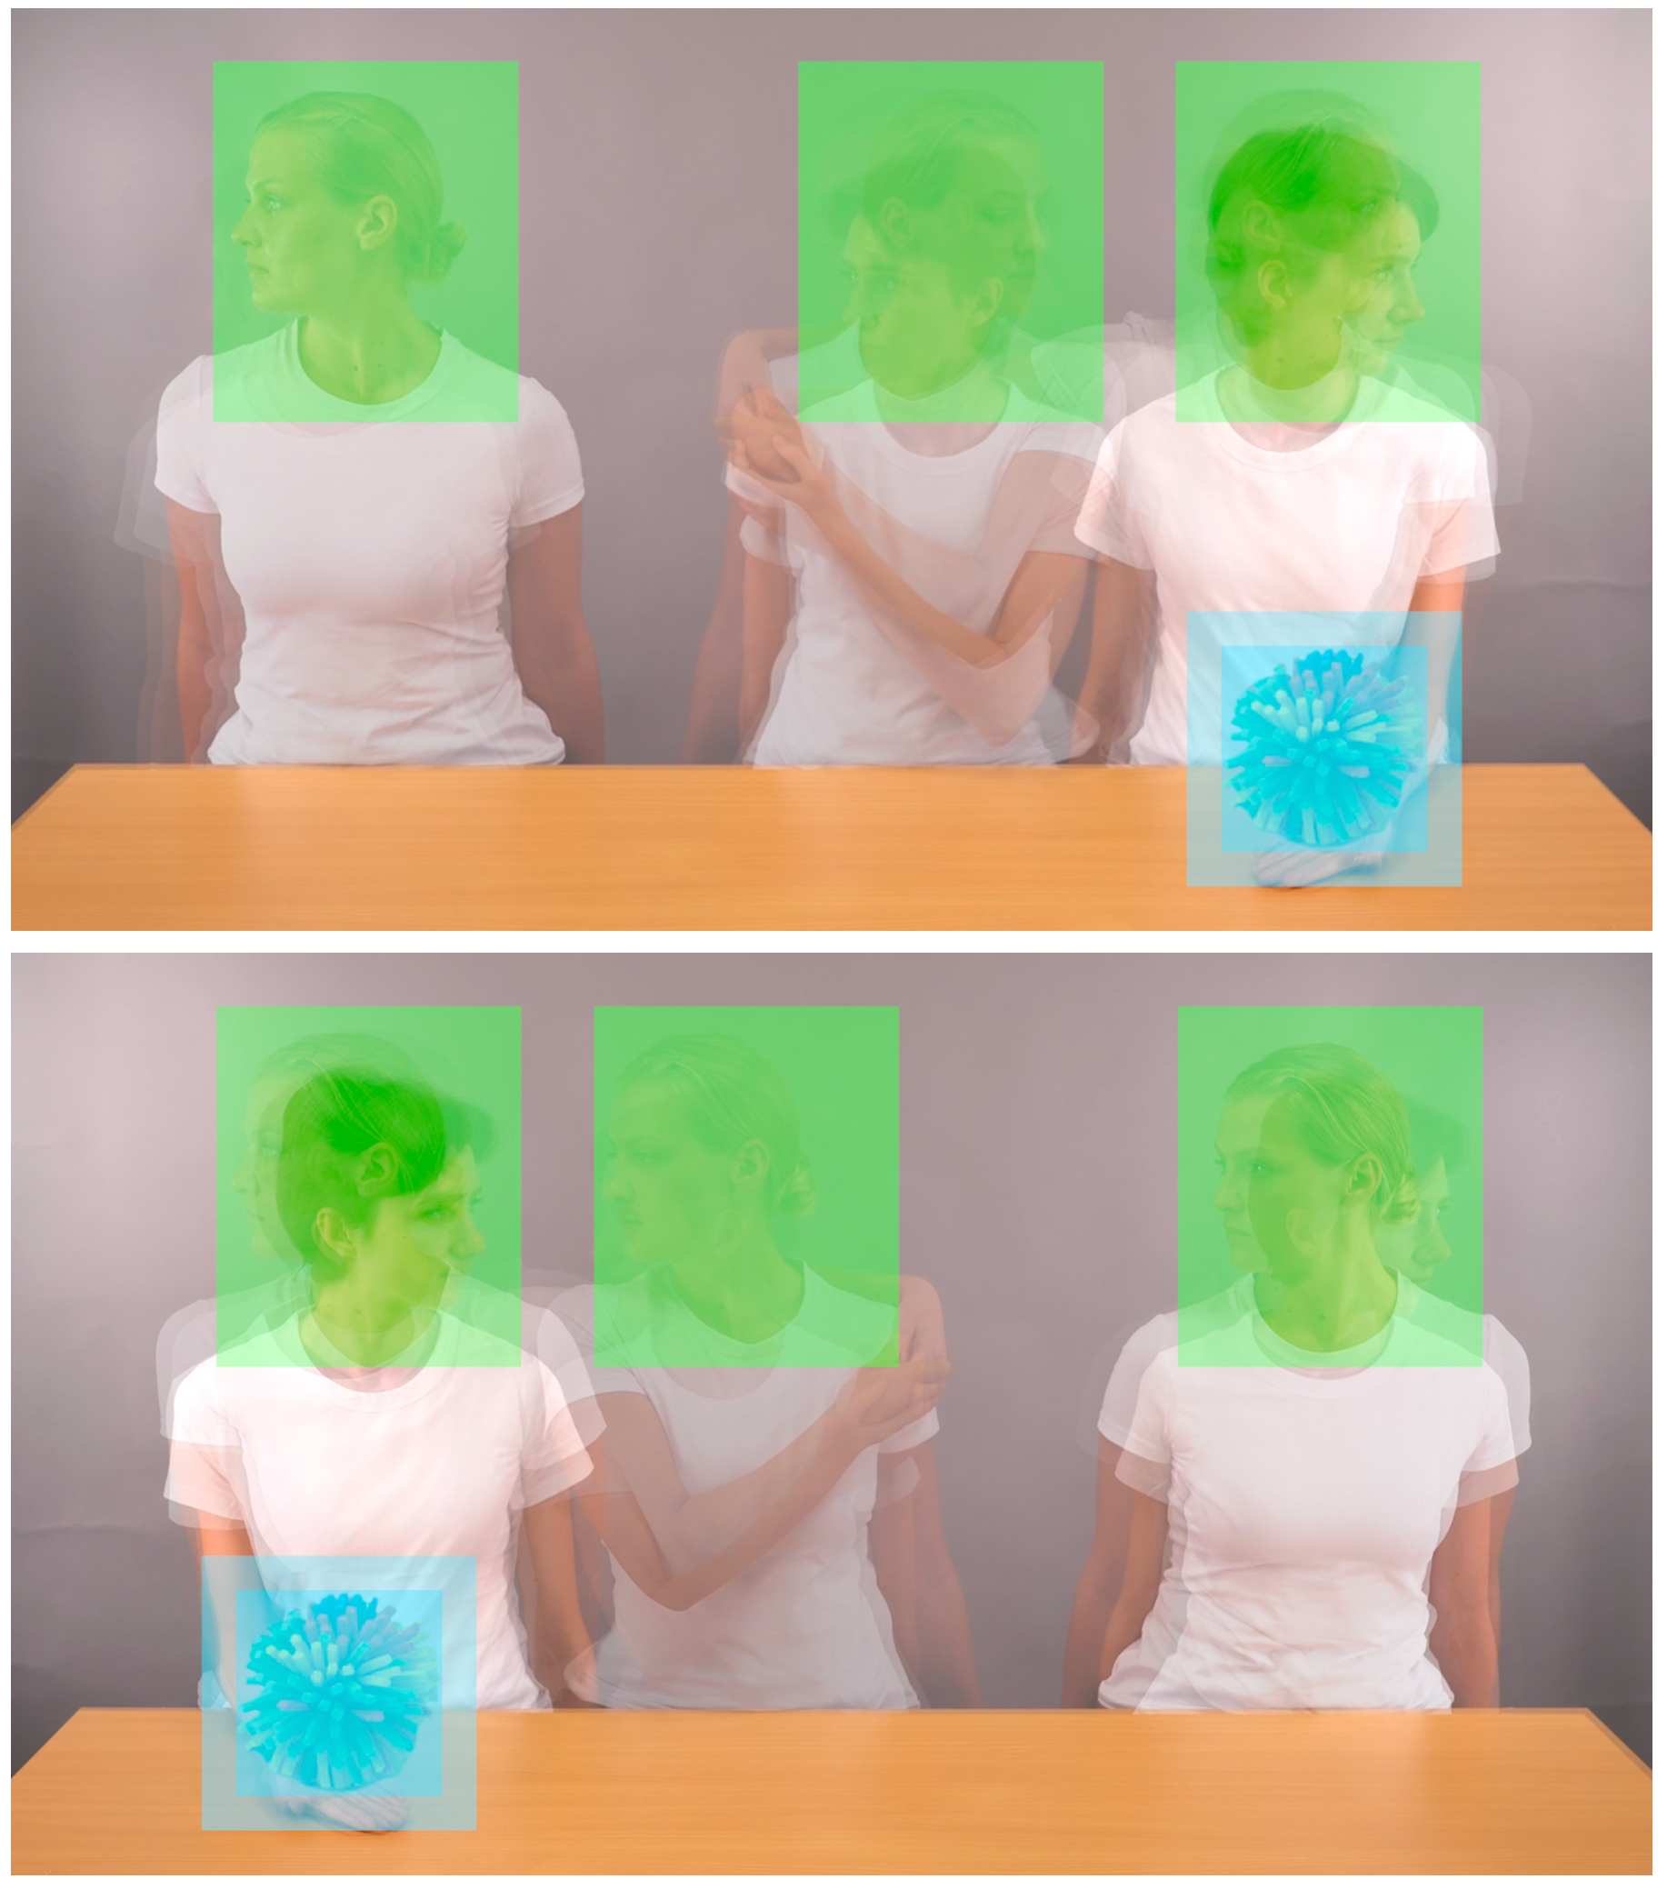
Note. The top image illustrates AOIs during trials showing the object-holding actor the right side of the screen, the bottom image AOIs during trials showing the object-holding actor on the left side of the screen. All videos were presented in full-screen view (1920×1080 pixels). Blue areas = Object AOIs in the videos of the encoding (320×320 pixels), defined 1° visual angle larger than the maximum dimensions of the object. Green areas = Face AOIs covering all possible head movements in all conditions (356×420 pixels).

Figure S2
Areas of interest (AOIs) during the recognition test phase

Note. Inner blue areas = actual object size (240×240 pixels). Outer blue area = Object AOIs (320×320 pixels), defined 1° visual angle larger than the maximum dimensions of the objects.

Figure S3
Time-course of the novelty preference score during the 10-second recognition test phase
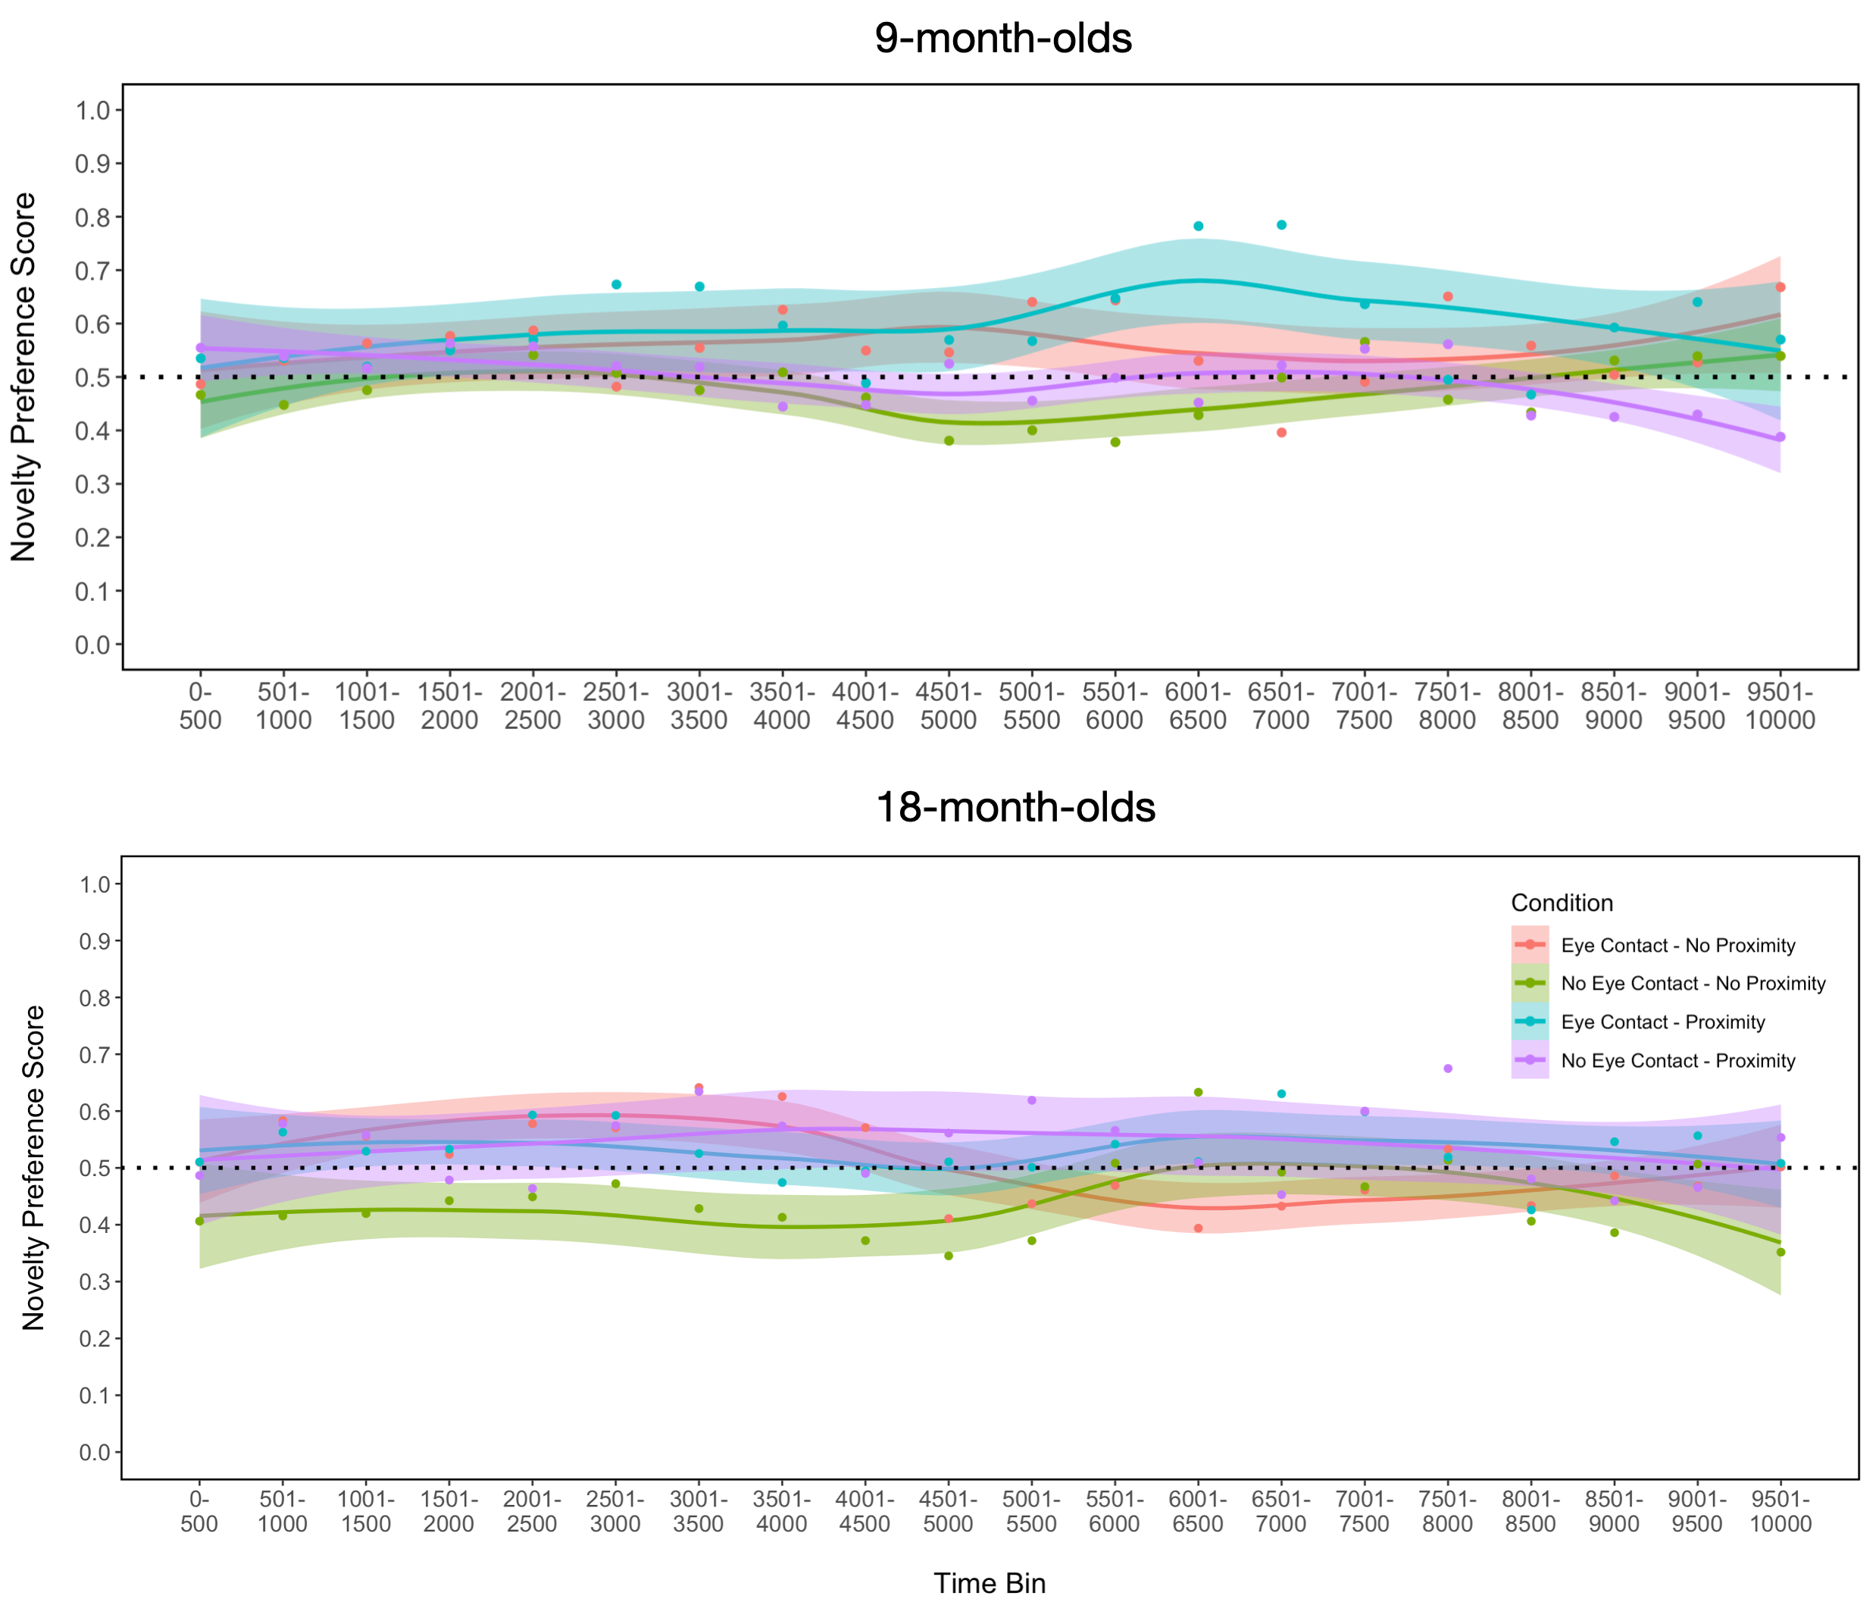

Note. The dots represent for each time bin the means across all individuals for each condition (i.e., one data point per condition within each time bin). The smooth curves loess fit to the data of the plot using the “geom_smooth” function from the “ggplot” R package. The shaded areas around the lines represent the standard error bounds.

Table S1
Valid trial statistics for the four conditions (9-month-olds)
 | Number of valid trials
Condition | Total | Min | Max | M(SD) | Infant  looking at object  (fam.) | Infant  not looking at object  (fam.)
Eye Contact Touch | 117 | 2 | 4 | 3.66(.55) | 69 | 48
Eye Contact  No Touch | 122 | 2 | 4 | 3.81(.54) | 77 | 45
No Eye Contact Touch | 117 | 2 | 4 | 3.66(.55) | 73 | 44
No Eye Contact  No Touch | 118 | 3 | 4 | 3.69(.47) | 76 | 42
Total | 474 | 2 | 4 | 3.70(.52) | 295 | 179
Note. Each individual could provide between 1 (min.) and 4 (max.) trials per condition. The maximum number of total trials across all infants was 128 per condition. The “infant looking at object (fam.)” column represents the number of valid trials during which infants had looked at the object at all over the total duration of the encoding phase (i.e., fixation duration > 0 ms within the object AOI). The “infant not looking at object (fam.)” column represents the number of valid trials during which infants had not looked at the object at all over the total duration of the encoding phase (i.e., fixation duration = 0 within the object AOI).
Table S2
Means (standard deviations) for looking times during the encoding phase (9-month-olds)
 | Condition
 | Eye Contact  no Touch | Eye Contact Touch | No Eye Contact Touch | No Eye Contact  no Touch
LT Screen (n.s.) | 7468.73 (2363.29) | 7542.87 (2652.62) | 7258.91  (2523.26) | 7340.71  (2269.62)
LT Object AOI (n.s.) | 1352.19 (1538.11) | 1496.93 (1976.49) | 1199.51 (1635.09) | 1218.45  (1546.16)
LT Faces AOIs (n.s.) | 4821.34 (2720.35) | 4360.47 (2669.80) | 4808.93 (2704.75) | 4946.49  (2819.14)
Notes. The looking times represent the sum of fixation durations within the corresponding area of interest (AOI) in milliseconds (ms). The total video duration was 11000 ms.

Table S3
Results from post-hoc one-sample t-tests testing the novelty preference score until video end within the four conditions against chance (9-month-olds)
Condition | M(SD) | t | df | p | d
Eye Contact – Touch | 0.56 (.08) | 4.49 | 31 | <.001*** | .79
Eye Contact – No Touch | 0.58 (.07) | 6.65 | 31 | <.001*** | 1.18
No Eye Contact – Touch | 0.49 (.08) | –1.02 | 31 | .31 | –.18
No Eye Contact – No Touch | 0.49 (.07) | –0.54 | 31 | .60 | –.10

Table S4
Valid trial statistics for the four conditions (18-month-olds)
 | Number of valid trials
Condition | Total | Min | Max | M(SD) | Infant  looking at object  (fam.) | Infant  not looking at object  (fam.)
Eye Contact Touch | 97 | 1 | 4 | 3.03(.90) | 86 | 11
Eye Contact  No Touch | 103 | 2 | 4 | 3.22(.87) | 99 | 4
No Eye Contact Touch | 98 | 1 | 4 | 3.06(1.01) | 90 | 8
No Eye Contact No Touch | 98 | 1 | 4 | 3.06(1.01) | 87 | 11
Total | 396 | 1 | 4 | 3.09(.94) | 367 | 34
Note. Each individual could provide between 1 (min.) and 4 (max.) trials per condition. The maximum number of total trials across all infants was 128 per condition. The “infant looking at object (fam.)” column represents the number of valid trials during which infants had looked at the object at all over the total duration of the encoding phase (i.e., fixation duration > 0 ms within the object AOI). The “infant not looking at object (fam.)” column represents the number of valid trials during which infants had not looked at the object at all over the total duration of the encoding phase (i.e., fixation duration = 0 within the object AOI).
Table S5
Means (standard deviations) for looking times during the encoding phase (18-month-olds)
 | Condition
 | Eye Contact  no Touch | Eye Contact Touch | No Eye Contact Touch | No Eye Contact  no Touch
LT Screen (n.s.) | 8453.42 (2369.16) | 8098.20 (2673.51) | 7951.53  (2803.57) | 7647.89  (2845.51)
LT Object AOI (n.s.) | 2000.98 (1286.76) | 1894.94 (1486.44) | 2006.69  (1469.78) | 1726.89  (1599.44)
LT Faces AOIs (n.s.) | 4769.89 (2687.60) | 4126.89 (2507.87) | 4061.82  (2554.03) | 4022.19  (2918.01)
Notes. The looking times represent the sum of fixation durations within the corresponding area of interest (AOI) in milliseconds (ms). The total video duration was 11000 ms.
Table S6
Results from post-hoc one-sample t-tests testing the novelty preference score until video end within the four conditions against chance (18-month-olds)
Condition | M(SD) | t | df | p | d
Eye Contact – Touch | 0.55 (.12) | 2.42 | 31 | .02* | .43
Eye Contact – No Touch | 0.54 (.12) | 2.13 | 31 | .04* | .38
No Eye Contact – Touch | 0.54 (.11) | 2.07 | 31 | .046* | .37
No Eye Contact – No Touch | 0.42 (.12) | –3.76 | 31 | .0007*** | –.67

