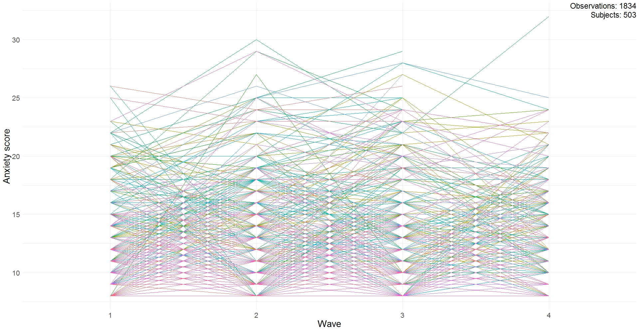
Supporting Information

Figure S1. Visualization of all individual trajectories for anxiety symptoms
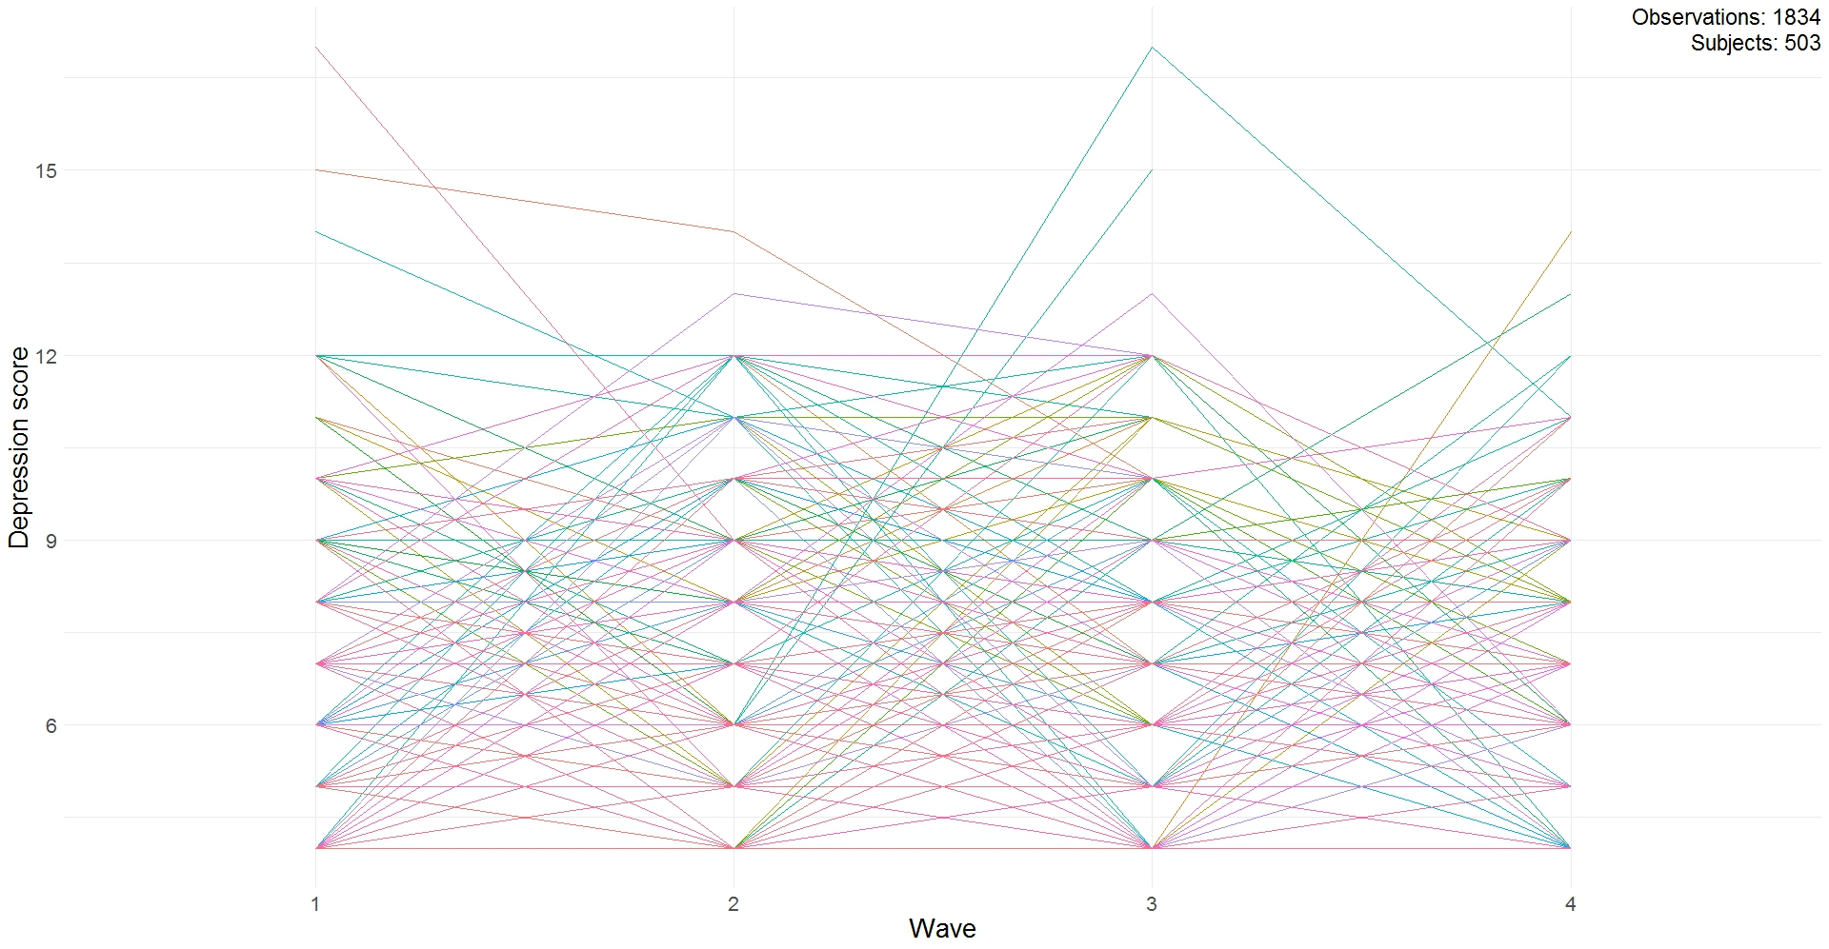

Figure S2. Visualization of all individual trajectories for depressive symptoms
 | n = 503 |  |  |  |  |  |  |  |  | Proportion of individuals in each class
 | Loglikelihood | Parameters | AIC | BIC | SABIC | Entropy | Posterior probability range | LMR-LRT (p value) | Convergence | 1 | 2 | 3 | 4 | 5
1 | -4984.08 | 6 | 9980.15 | 10005.47 | 9986.43 | 1.00 | - | - | True | 100% | - | - | - | -
2 | -4919.11 | 10 | 9858.22 | 9900.43 | 9868.69 | 0.85 | 0.88-0.97 | <.001 | True | 12.33% | 87.67% | - | - | -
3 | -4892.33 | 14 | 9812.66 | 9871.75 | 9827.31 | 0.85 | 0.88-0.95 | <.001 | True | 74.75% | 21.07% | 4.17% | - | -
4ª | -4891.68 | 18 | 9819.36 | 9895.33 | 9838.20 | 0.59 | 0.63-0.92 | .87 | True | 3.98% | 22.86% | 48.11% | 25.05% | -
5ª | -4889.71 | 22 | 9823.42 | 9916.27 | 9846.44 | 0.77 | 0.46-0.91 | .44 | True | 21.87% | 70.78% | 3.98% | 2.19% | 1.19%
Table S1. Model statistics for the 1- to 5-class models for anxiety symptoms.
Note: AIC = Akaike Information Criterion; BIC = Bayesian Information Criterion; SABIC = Sample size Adjusted Bayesian Information Criterion; LMR -RT = Lo-Mendell-Rubin Likelihood Ratio Test.
ªThe 4- and 5-class model had convergence issues and produced unstable results.

Table S2. Information regarding the intercept and slope of each trajectory regarding anxiety and depressive symptoms.
 | Anxiety symptoms |  | Depressive symptoms
 | Class 1 – High – Stable (n = 63, 12.33%)) | Class 2 – Low – Increasing (n = 441, 87.67%) | Class 1 – Low – Increasing (n = 397, 78.93%) | Class 2 – High – Decreasing (n = 69, 13.72%) | Class 3 – Strong Increasing (n = 37, 7.36%)
Intercept (SE) | 18.70 (0.78)*** | 9.91 (0.22)*** | 4.82 (0.11)*** | 9.69 (0.37)*** | 5.12 (0.54)***
Slope (SE) | -0.13 (0.32) | 0.62 (0.09)*** | 0.21 (0.04)*** | -0.48 (0.14)*** | 1.27 (0.24)***
Note. *p <.05; **p < .01; ***p<.001.

Table S3. Model statistics for the 1- to 5-class models for depressive symptoms.
 | n = 503 |  |  |  |  |  |  |  |  | Proportion of individuals in each class
 | Loglikelihood | Parameters | AIC | BIC | SABIC | Entropy | Posterior probability range | LMR-LRT (p value) | Convergence | 1 | 2 | 3 | 4 | 5
1 | -3727.20 | 6 | 7466.40 | 7491.72 | 7472.68 | 1.00 | - | - | True | 100% | - | - | - | -
2 | -3673.40 | 10 | 7366.80 | 7409.01 | 7377.26 | 0.84 | 0.86-0.97 | <.001 | True | 14.12% | 85.88% | - | - | -
3 | -3651.00 | 14 | 7330.00 | 7389.09 | 7344.65 | 0.83 | 0.80-0.96 | <.001 | True | 78.93% | 13.72% | 7.36% | - | -
4 | -3651.00 | 18 | 7338.00 | 7413.97 | 7356.84 | 0.59 | n.a. | 1.00 | True | 13.92% | 77.33% | 0.00% | 7.75% | -
5 | -3651.00 | 22 | 7346.00 | 7438.85 | 7369.02 | 0.39 | n.a. | 1.00 | True | 76.54% | 14.71% | 0.00% | 0.00% | 8.75%

Note: AIC = Akaike Information Criterion; BIC = Bayesian Information Criterion; SABIC = Sample size Adjusted Bayesian Information Criterion; LMR-LRT = Lo-Mendell-Rubin Likelihood Ratio Test; n.a. = not applicable, as one or more of the classes contained 0.00% of the participants.

Table S4. Correlation table of all study variables.
 | Child age | Child gender | COVID-19 Infection | Death of loved one | Days since start data collection | Information focused parent-child emotion regulation | Active parent-child emotion regulation | Avoidant parent-child emotion regulation | Negative COVID-19 impact | Positive COVID-19 impact | Parental mental health problems | Feelings of rejection | Anxiety symptoms | Depressive symptoms
Child’s age in months | --
Child’s gender (0 = female) | -.06 | --
COVID infection parent (0 = no) | .03 | -.05 | --
Death of loved one (0 = no) | .05 | -.05 | -.05 | --
Days into the pandemic since start data collection | .02 | -.01 | .13** | .09* | --
Information focused parent-child emotion regulation | .38** | -.01 | .05 | .07 | -.03 | --
Active parent-child emotion regulation | .27** | .08 | .03 | .03 | -.05 | .27** | --
Avoidant parent-child emotion regulation | .19** | .02 | .01 | <.01 | .03 | .06 | .24** | --
Negative COVID-19 impact | .12** | .04 | .05 | .13** | .15** | .03 | .06 | .19** | --
Positive COVID-19 impact | -.05 | -.03 | -.03 | .06 | -.06 | .10* | .04 | <.01 | -.20** | --
Parental mental health problems | .13** | .03 | .04 | .10* | .10* | <-.01 | .04 | .14** | .57** | -.26** | --
Feelings of rejection | .13** | .04 | .01 | .02 | .05 | .02 | .04 | .19** | .36** | -.17** | .42** | --
Anxiety symptoms | .23** | .04 | -.05 | .16** | <.01 | .21** | .17** | .22** | .30** | -.06 | .28** | .24** | --
Depressive symptoms | .19** | .04 | .03 | .12** | .10* | .10* | .11* | .16** | .39** | -.13** | .34** | .31** | .55** | --
Note. Pearson correlation coefficients are shown.
*p <.05; **p < .01; ***p<.001.

Table S5. Mean and standard deviation of the predicting variables per class.
 | Anxiety symptomsª |  | Depressive symptoms^{b}
 | Class 1: High  (n = 62) | Class 2: Low  (n = 441) | Class 1: Low (n = 397) | Class 2: High – Decreasing  (n = 69) | Class 3: Strong Increasing  (n = 37)
 | Mean (SD) | Mean (SD) | Mean (SD) | Mean (SD) | Mean (SD)
Child’s age in months | 51.71 (14.43)*** | 41.86 (15.36) | 41.57 (15.36)² | 51.08 (14.84)¹ | 44.30 (14.91)
Child’s gender  female, n, (%)  male, n (%) | 25 (40.30%)  37 (59.70%) | 215 (48.80%)  226 (51.20%) | 195 (49.10%)²  202 (50.90%)² | 29 (42.00%)¹  40 (58.00%)² | 16 (43.20%)  21 (56.80%)
Days into the pandemic since start data collection | 58.41 (46.20) | 52.94 (46.49) | 52.20 (45.85) | 60.88 (48.08) | 55.24 (49.56)
COVID infection parent  Yes , n(%) | 3 (4.80%) | 47 (10.70%) | 38 (9.6%) | 10 (14.50%) | 2 (5.4%)
Death of loved one  Yes , n (%) | 15 (24.20%) | 65 (14.70%) | 53 (13.40%)² | 23 (33.30%)^{1,3} | 4 (10.80%)²
Information focused parent-child emotion regulation | 2.32 (1.05)*** | 1.83 (1.07) | 1.82 (1.05) | 2.16 (1.13) | 2.11 (1.15)
Active parent-child emotion regulation | 21.10 (1.79)*** | 20.10 (3.02) | 20.04 (3.10) | 20.97 (2.01) | 20.73 (1.74)
Avoidant parent-child emotion regulation | 6.92 (2.54)** | 5.81 (2.05) | 5.84 (2.12) | 6.55 (2.32) | 6.01 (1.99)
Negative COVID-19 impact | 35.33 (10.37)*** | 28.84 (7.07) | 28.21 (6.90)^{1,2} | 36.13 (9.69)¹ | 32.97 (6.47)¹
Positive COVID-19 impact | 16.78 (4.44) | 17.83 (4.96) | 17.87 (5.09) | 16.87 (3.97) | 17.49 (4.45)
Parental mental health problems | 29.29 (20.24)*** | 16.98 (15.62) | 16.02 (15.75)^{2,3} | 30.32 (18.31)¹ | 22.97 (13.68)¹
Feelings of rejection | 8.32 (268)*** | 6.89 (2.20) | 6.78 (2.20)^{2,3} | 8.38 (2.71)¹ | 7.68 (1.73)¹
ªDifferences between the anxiety symptoms classes were tested using an independent samples t-test (continuous variables) and Chi Squared test (categorical variables). Significant differences between class 1 and class 2 are denoted with an asterisks. *p <.05, **p < .01, ***p < .001
^{b}Differences between the depressive symptoms classes were tested using a MANOVA (continuous variables) and Chi Squared test (categorical variables). Significant differences between class 1, class 2 and class 3 are denoted by a superscript of the class number with which the significant difference was found.
Note. Participants of the current longitudinal sample (n = 503) were compared to the participants that did not complete 3 or more waves, but did complete T1 (n = 2617). The T1 sample completed the questionnaire significantly later (M days: T1 = 75; longitudinal = 53, p < .001), experienced more deaths of loved ones (20.5% vs. 14.6%, p = .002), and scored higher on parental mental health problems (M = 20.26, SD = 18.48 vs. M = 18.49, SD = 6.73, p = .049), parental negative perception of the pandemic (M = 30.89, SD = 8.73 vs. M = 29.64, SD = 7.84, p = .002), and information-focused parent-child emotion regulation (M = 2.02, SD = 1.89 vs. M = 1.89, SD = 1.08, p = .03).

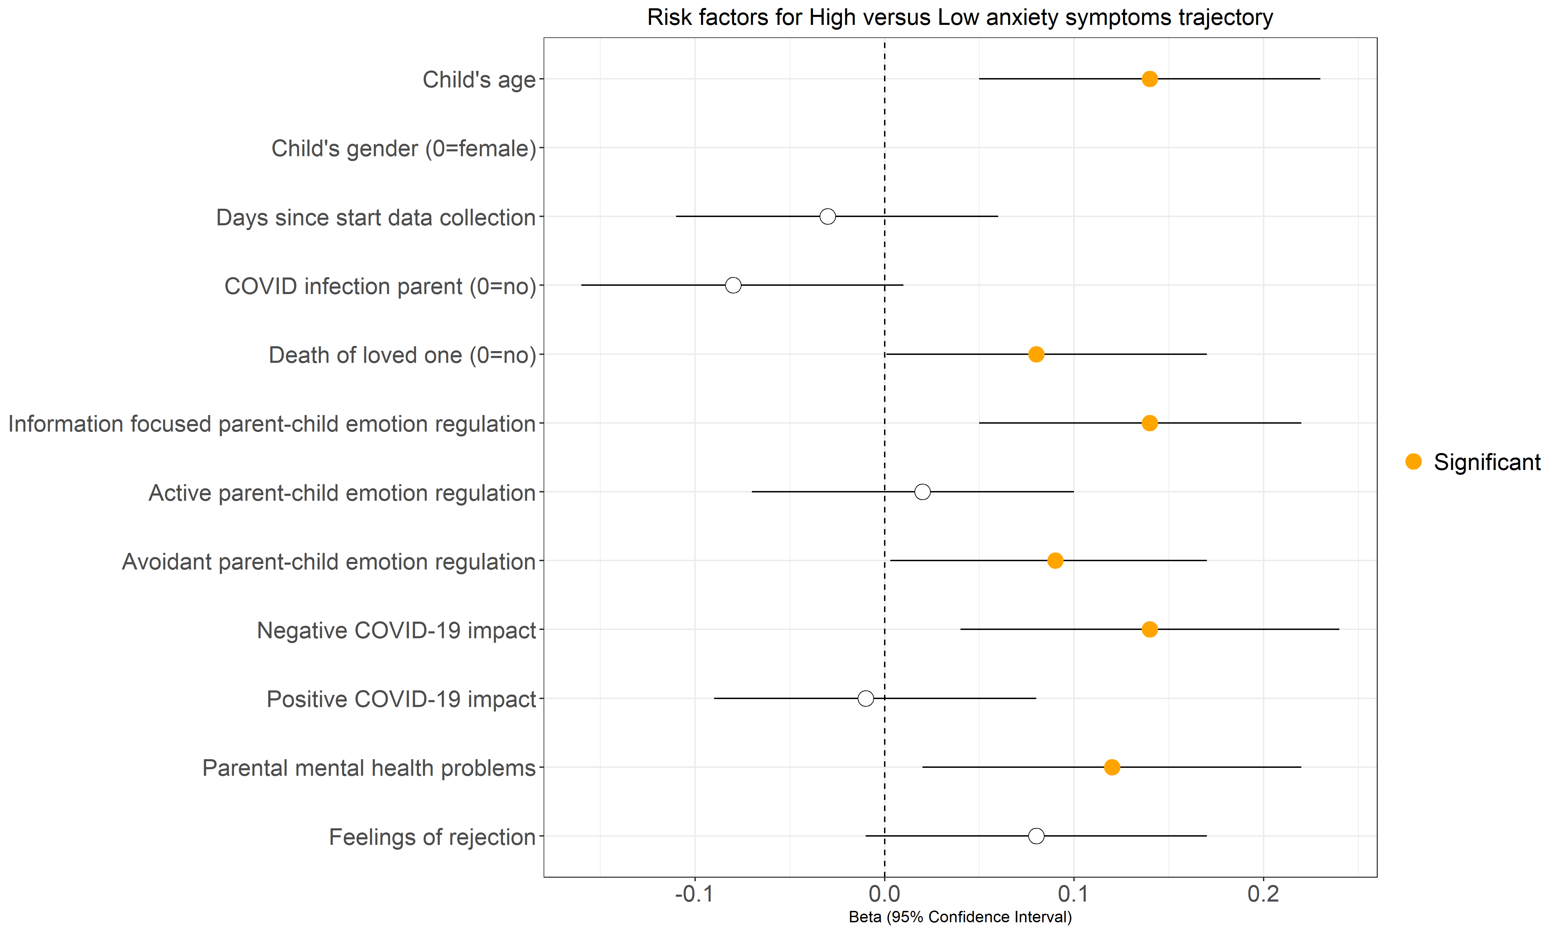

Figure S3. Risk factors for the High versus Low anxiety symptoms trajectory
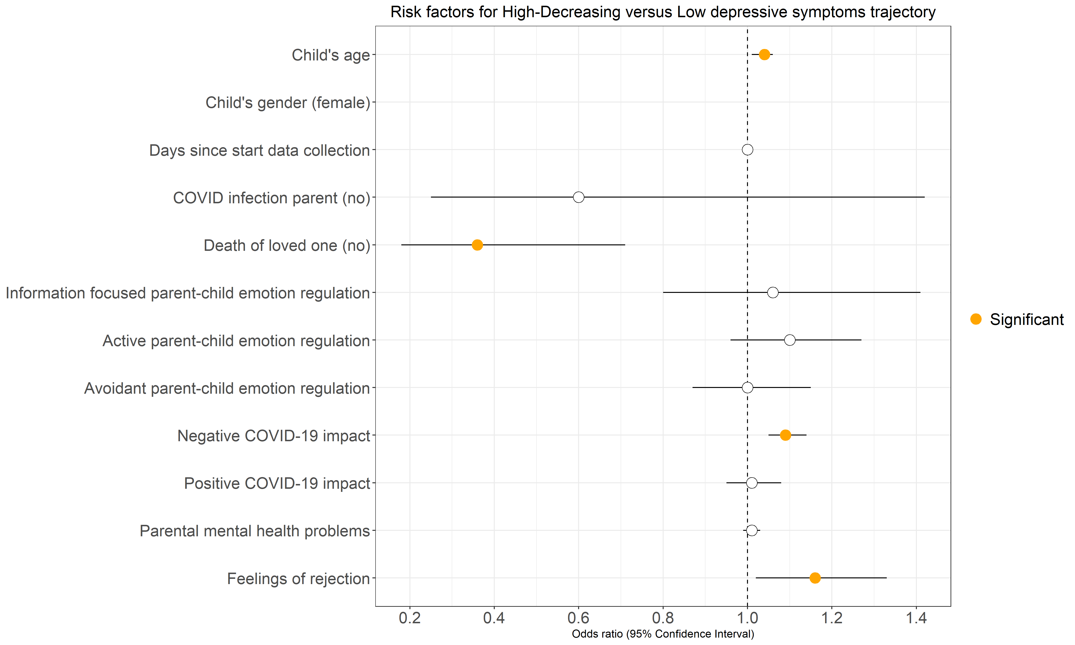

Figure S4. Risk factors for the High-Decreasing versus Low depressive symptoms trajectory
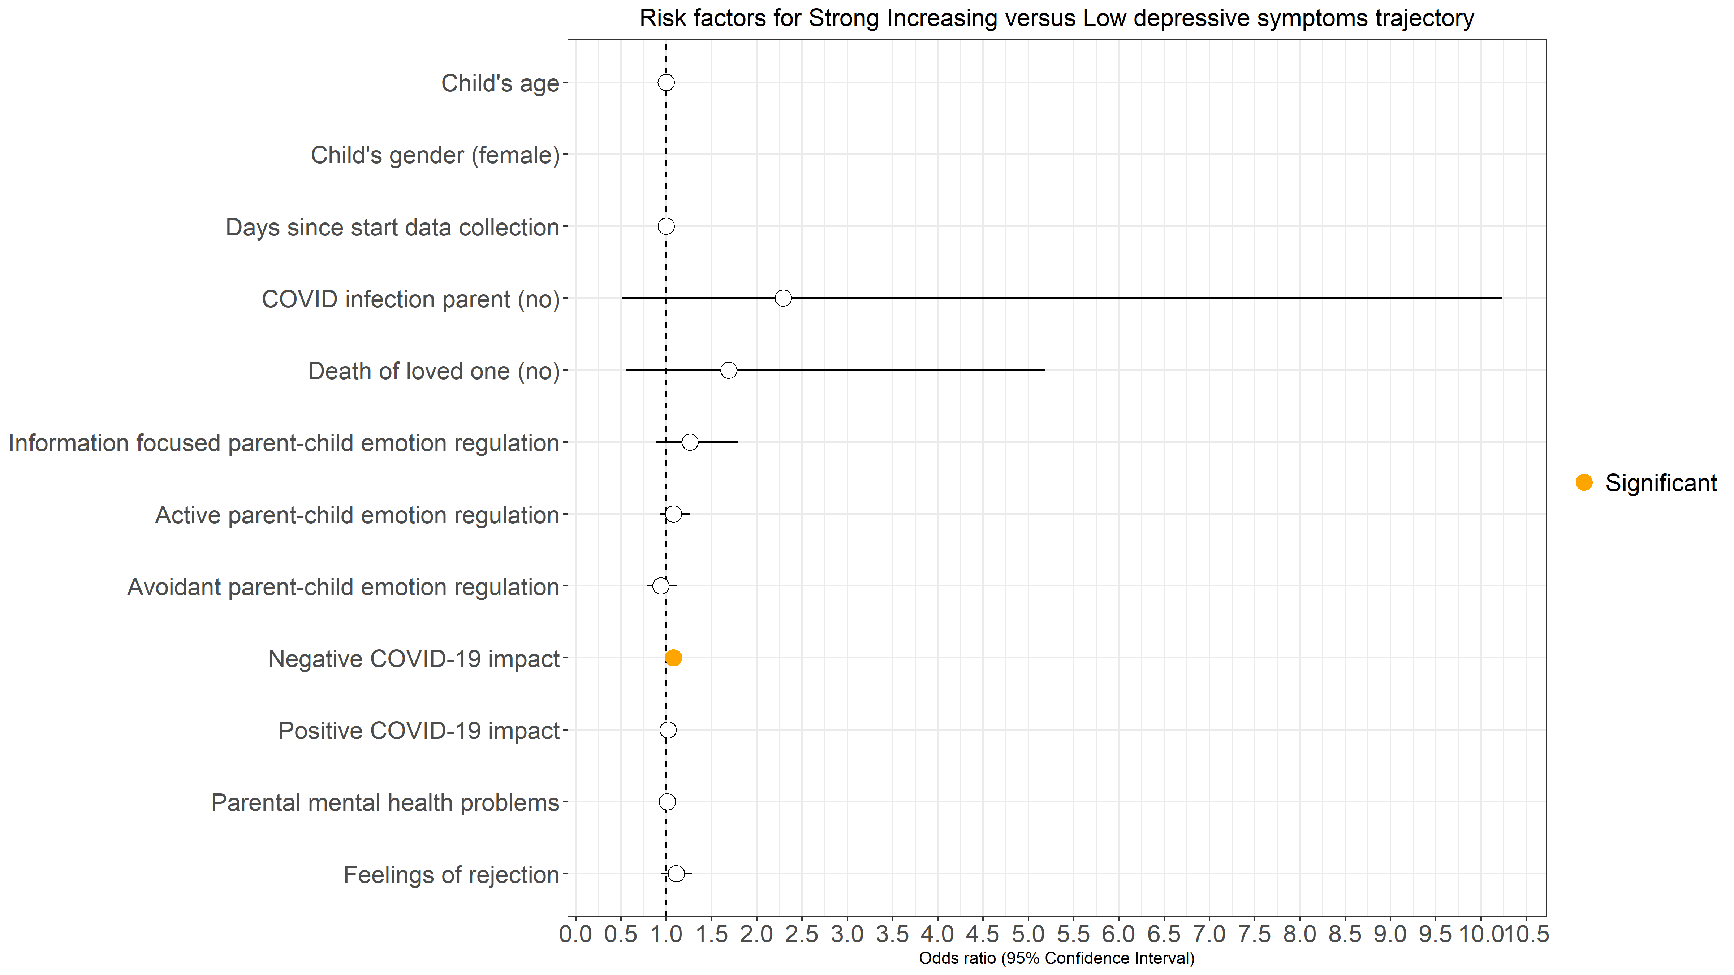
Figure S5. Risk factors for the Strong Increasing versus Low depressive symptoms trajectory
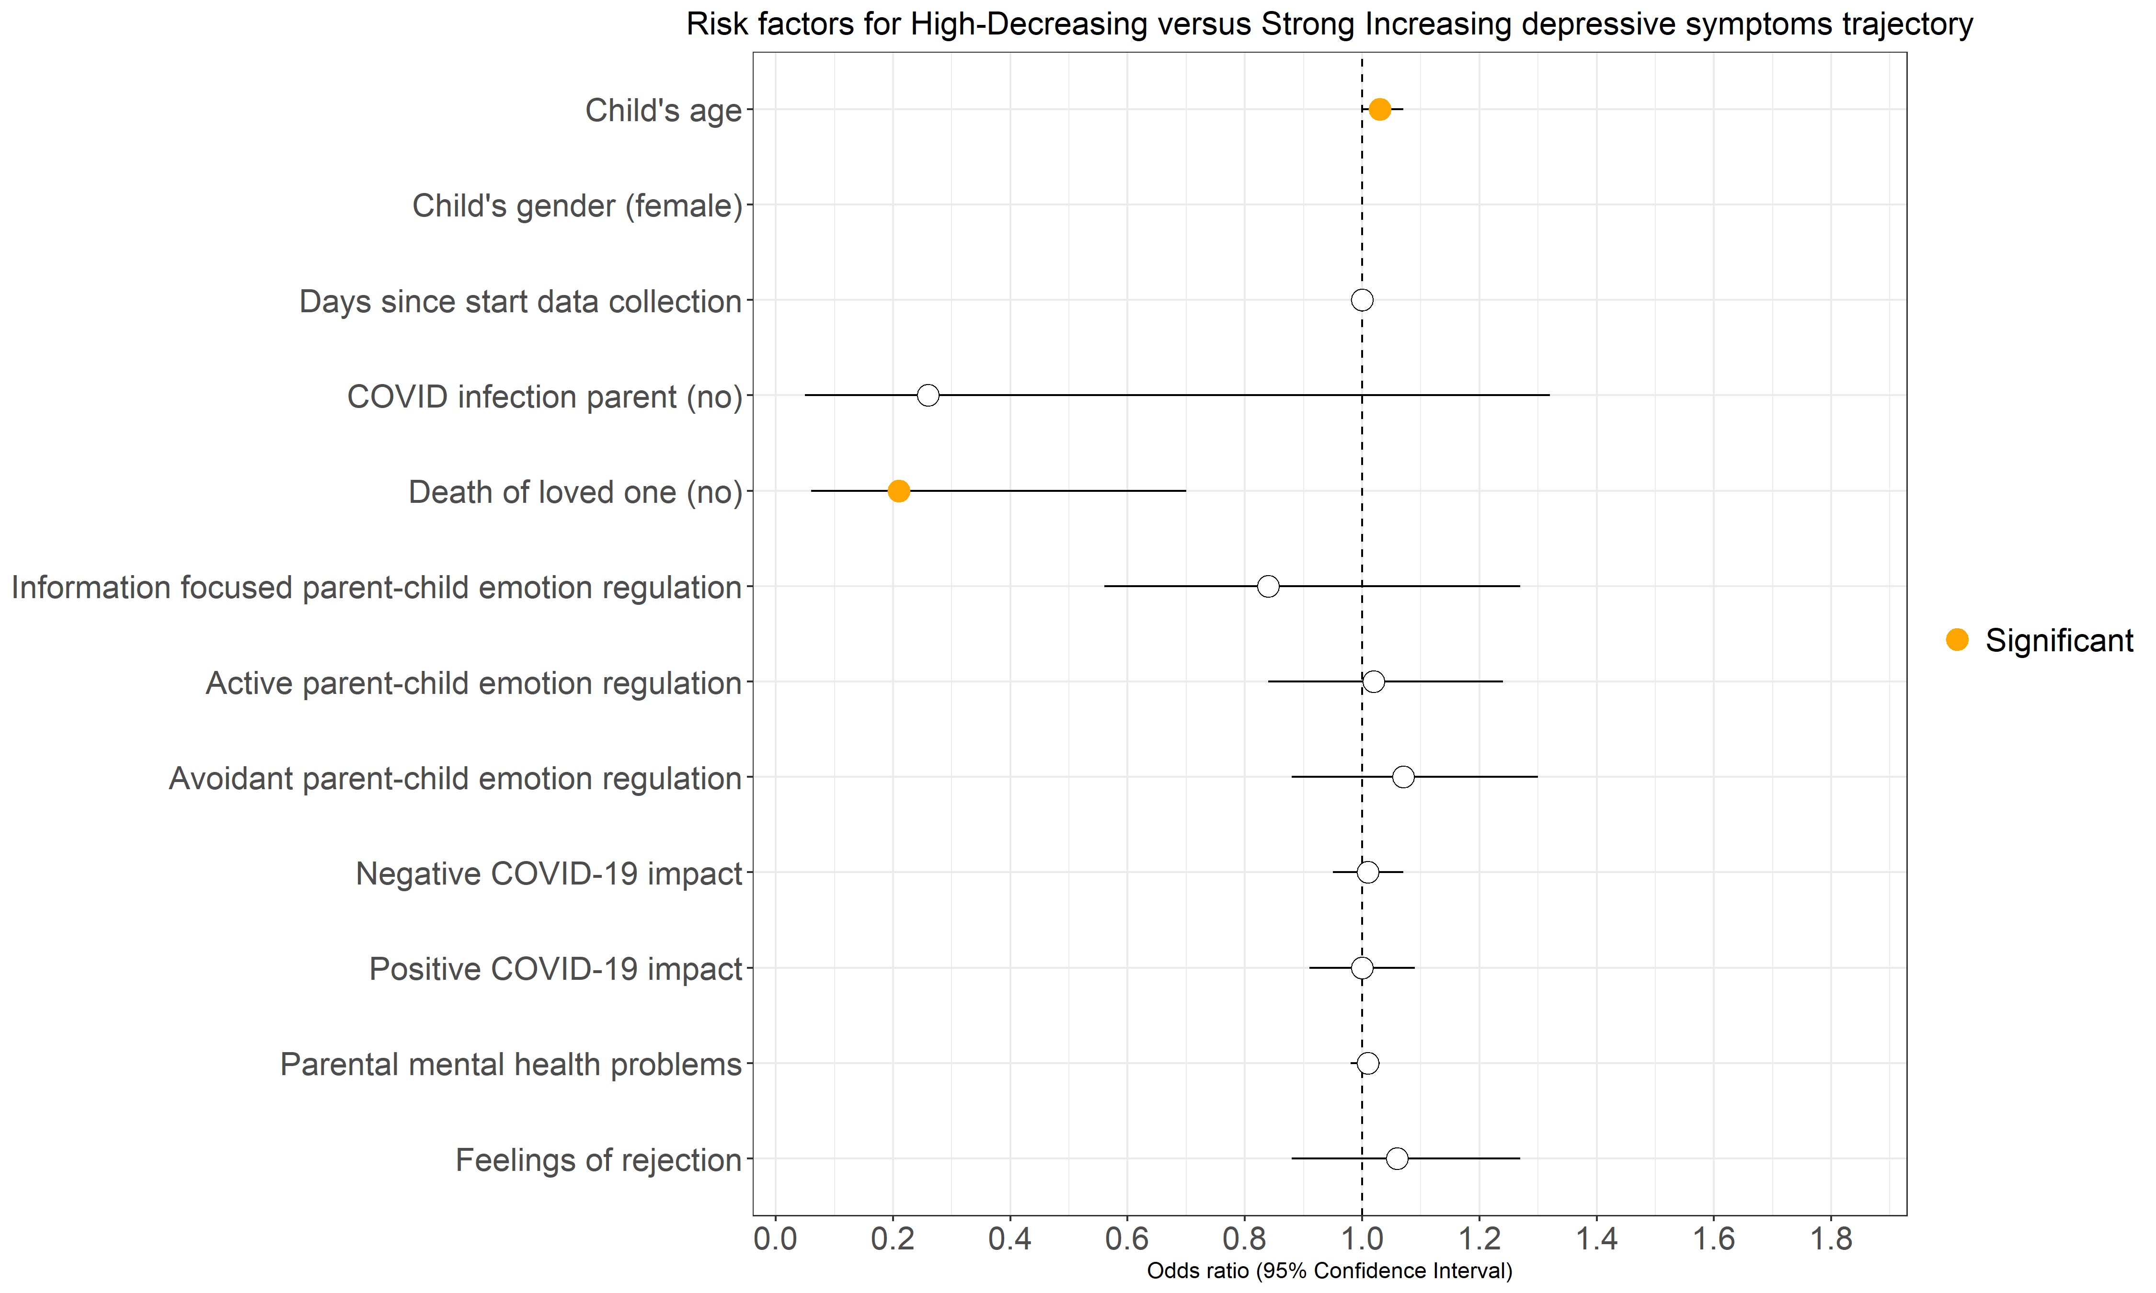
Figure S6. Risk factors for the High-Decreasing versus Strong Increasing depressive symptoms trajectory

