Supplemental Materials for
Not So Bad for Whom? Family-Specific Associations between Daily Helicopter Parenting and Emerging Adults’ Affective Well-Being
Table of Contents
1. Demographic Information 2
2. Data Completion 4
3. Measures 6
Momentary Overparenting Scale (Daily) 6
Positive and Negative Affect (Daily) 7
Mother-Oriented Interdependent Self-Construal (Baseline) 8
Family Obligation (Baseline) 9
Emotional Interdependence (Baseline) 10
4. Confirmatory Factor Analysis 11
4.1. Mother-Oriented Interdependent Self-Construal 11
4.2. Family Obligation 12
4.3. Emotional Interdependence 13
5. Model Specification 14
6. Sensitive analysis 15
6.1.H1 & H2 15
6.1.1. Demonstration of Effect Heterogeneity for Double Iterations 16
6.1.2. Demonstration of Effect Heterogeneity with more than 10 Reports in Helicopter Parenting 17
6.1.3. Demonstration of Effect Heterogeneity for cut-off at .10 18
6.2. H3 & H4 19
6.2.1. Effect Heterogeneity for Double Iterations 19
6.2.2. More than 10 Reports in Helicopter Parenting 20
6.2.3. Cut-off at .10 21

- Demographic Information
Table S1
Sample Demographics
Participants | N
Gender, % Male (n) | 146 | 44.5 (65)
Age (years), M (SD)ª | 146 | 18.7 (0.58)
Major, % (n) | 146
Engineering |  | 46.6 (68)
Management |  | 17.1 (25)
Arts, Literature, Science |  | 9.6 (14)
Agriculture |  | 4.8 (7)
Education |  | 2.7 (4)
Ethic, % (n) | 146
Han |  | 91.1 (133)
Hui, Yao |  | 2.1 (3)
Zhuang |  | 1.4 (2)
Bai, Li, Man, Miao, Tujia |  | 0.7 (1)
Religion, % (n) | 146
No religious |  | 81.5 (119)
Buddhist |  | 2.7 (4)
Christian |  | 2.1 (3)
Islamic, Taoism |  | 0.7 (1)
Others or Not sure |  | 18 (12.4)
Family Monthly Income | 146
~< 5,000 RMB (691 USD) |  | 13.0 (19)
~5,001 to 10,000 RMB (691 to 1,383 USD) |  | 41.8 (61)
~10,001 to 15,000 RMB (1,383 to 2,074 USD) |  | 15.1 (22)
~15,001 to 20,000 RMB (2,074 to 2,765 USD) |  | 5.5 (8)
~> 20,001 RMB (2,765 USD) |  | 6.2 (9)
Not sure |  | 18.5 (27)
Living Area, % (n) | 146
Urban |  | 54.1 (79)
Rural |  | 45.9 (67)
Province, % (n) | 146
Hunan |  | 37.0 (54)
Guangdong |  | 5.5 (8)
Hebei, Hubei, Xinjiang |  | 4.8 (7)
Zhejiang |  | 4.1 (6)
Shanxi |  | 3.4 (5)
Hainan, Henan, Shaanxi, Sichuan |  | 2.7 (4)
Gansu, Guangxi, Jiangsu, Jiangxi, Neimeng, Ningxia |  | 2.1 (3)
Anhui, Fujian, Guizhou, Heilongjiang, Liaoning,  Qinghai, Shandong, |  | 1.4 (2)
Beijing, Chongqing, Jilin, Yunnan |  | 0.7 (1)

- Data Completion
Figure S1
Overview of Completion across 30 days (N = 146)
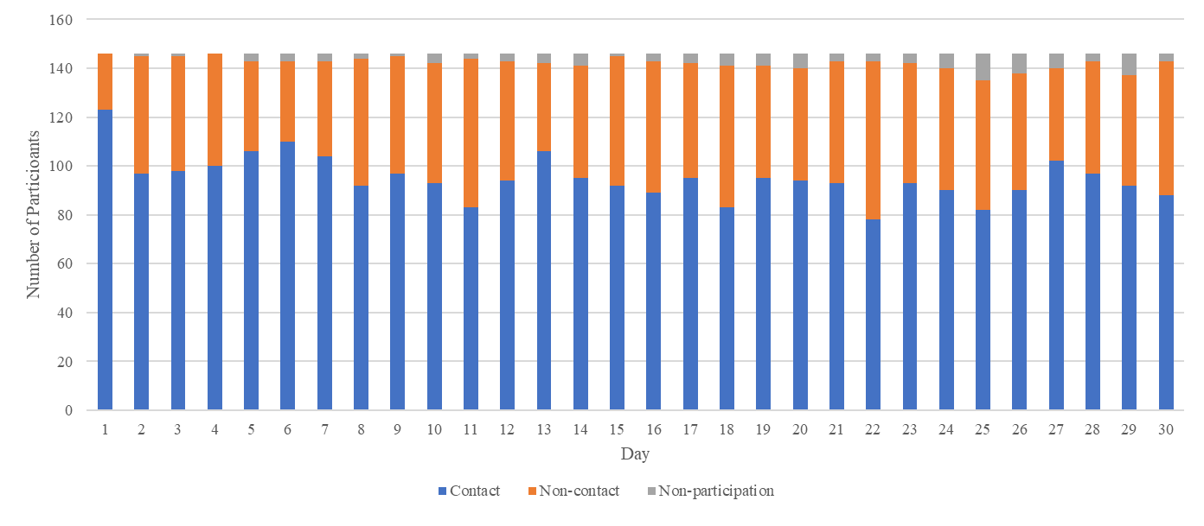
Note. The blue bars represent participants who completed the questionnaire and interacted with their mothers on a particular day. The orange bars represent participants who completed the questionnaire but did not report any interaction with their mothers. The gray bars represent participants who did not complete the daily survey.

Table S2
Overview of compliance across participants on daily perceived helicopter parenting (N = 146)
Completed daily questionnaire | Number of participants
0 (0%) | 2 (1.3%)
1 to 5 (3.3-16.7%) | 5 (3.4%)
6 to 10 (2-33.3%) | 15 (10.3%)
11 to 15 (36.7-50%) | 26 (17.8%)
16 to 20 (53.3-66.7%) | 31 (21.2%)
21 to 25 (70-83.3%) | 22 (15.1%)
26 to 29 (86.7-96.7%) | 26 (17.8%)
30 (100%) | 19 (13.0%)
Note. The average completion rate for daily positive and negative affect exceeded 97%.

- Measures

Momentary Overparenting Scale (Daily)
Today, I felt that…
hp1: My mother got very involved with my life.
hp2: My mother unnecessarily worried about me.
hp3: My mother tried to help me even though it wasn’t necessary.

0 = Not at all
100 = Very much

Positive and Negative Affect (Daily)
Today, I felt that…
pana1: Happy.
pana2: Relaxed.
pana3: Sad.
pana4: Afraid.
pana5: Hostile.
pana6: Anxious.
pana7: Energetic.
pana8: Short-tempered.
pana9: Cheerful.
pana10: Motivated.
pana11: Depressed.
0 = Not at all
100 = Very much

Subscales:
Positive Affect (sa4, sa5, sa11, sa15, and sa21);
Negative Affect (sa7, sa8, sa9, sa10, sa14, and sa22).

Note: The full scale and validation of this shorten scale can be found in https://osf.io/9a7gf/.

Mother-Oriented Interdependent Self-Construal (Baseline)
Below are a number of statements about how you feel when you are around your MOTHER. In each case, please choose the answer that most closely matches your actual situation.
isc1: My relationship with my mother is an important part of who I am.
isc2: When I think of myself, I often think of my mother also.
isc3: If a person hurts my mother, I feel hurt as well.
isc4: To know the real me, it helps to know about my relationship with my mother.
isc5: When I think about who I am, I think about my relationship with my mother.
isc6: If my mother succeeds at something, I feel proud.
isc7: Who I am depends on the things my mother does.
isc8: If my mother was to do something bad, I would feel ashamed.
isc9: I often see my mother as a part of me.
isc10: I would feel bad about myself, if I did not have a good relationship with my mother.
1 = Very untrue of me
2 = Untrue of me
3 = Mildly untrue of me
4 = Mildly true of me
5 = Ture of me
6 = Very true of me

Family Obligation (Baseline)
For each item below, please select the response option that best reflects the level of importance to you:
fo1: Spend time at home with your family.
fo2: Spend holidays with your family.
fo3: Spend time with your family on weekends.
fo4: Eat meals with your family.
fo5: Follow your parents’ advice about choosing friends.
fo6: Do well for the sake of your family.
fo7: Follow your parents’ advice about choosing a job or major in college.
fo8: Help your parents financially in the future.
fo9: Live at home with your parents until you are married.
fo10: Spend time with your parents even after you no longer live with them.
fo11: Have your parents live with you when they get older.
1 = not important at all,
2 = slightly important,
3 = moderately important,
4 = quite important,
5 = very important,
6 = extremely important

Emotional Interdependence (Baseline)
Below are a number of statements about daily behaviors. In each case, please choose the answer that most closely matches your actual situation.
enter1_m: I like to show my friends pictures of my mother.
enter2_m: I feel longing if I am away from my mother for too long.
enter3_m: My mother is the most important people in the world to me.
enter4_m: Being away from my mother makes me feel lonely.
enter5_m: I sometimes call home just to hear my mother’s voice.
enter6_m: While I am home on a vacation I like to spend most of my time with my mother
enter7_m: After being with my mother for a vacation I find it difficult to leave her/him.
enter8_m: I like to hug my mother
enter9_m: My mother is my best friend.
enter10_m: I seem to be closer to my mother than most people my age.
1 = very untrue of me
2 = untrue of me
3 = mildly untrue of me
4 = mildly true of me
5 = true of me
6 = very true of me

- Confirmatory Factor Analysis
  - Mother-Oriented Interdependent Self-Construal
Table S3
Standardized Factor Loading
Item | 10 items | 9 items
isc1: My relationship with my mother is an important part of who I am. | .598 | .646
isc2: When I think of myself, I often think of my mother also. | .743 | .728
isc3: If a person hurts my mother, I feel hurt as well. | .484 | .448
isc4: To know the real me, it helps to know about my relationship with my mother. | .649 | .695
isc5: When I think about who I am, I think about my relationship with my mother. | .691 | .695
isc6: If my mother succeeds at something, I feel proud. | .502 | .461
isc7: Who I am depends on the things my mother does. | .468 | .373
isc8: If my mother was to do something bad, I would feel ashamed. | .036 | -
isc9: I often see my mother as a part of me. | .531 | .467
isc10: I would feel bad about myself, if I did not have a good relationship with my mother. | .409 | .311
Note: Bold values indicate factor loadings less than .30.

Model fit for 10-item version: (CFI = 0.685, TLI = 0.595, SRMR = 0.089, RMESA = 0.135 [0.110, .0.160]).

  - Family Obligation

Table S4
Standardized Factor Loading
Item | Three-factor | Second  Order
Current assistance |  | .743
fo1: Spend time at home with your family. | .898 | .898
fo2: Spend holidays with your family. | .856 | .856
fo3: Spend time with your family on weekends. | .962 | .962
fo4: Eat meals with your family. | .826 | .826
Respect for family |  | .933
fo5: Follow your parents’ advice about choosing friends. | .550 | .550
fo6: Do well for the sake of your family. | .507 | .507
fo7: Follow your parents’ advice about choosing a job or major in college. | .514 | .514
Future support |  | .857
fo8: Help your parents financially in the future. | .547 | .547
fo9: Live at home with your parents until you are married. | .519 | .519
fo10: Spend time with your parents even after you no longer live with them. | .753 | .753
fo11: Have your parents live with you when they get older. | .627 | .627

  - Emotional Interdependence
Table S5
Standardized Factor Loading
Item | 10 items
enter1_m: I like to show my friends pictures of my mother. | .405
enter2_m: I feel longing if I am away from my mother for too long. | .628
enter3_m: My mother is the most important people in the world to me. | .510
enter4_m: Being away from my mother makes me feel lonely. | .714
enter5_m: I sometimes call home just to hear my mother’s voice. | .720
enter6_m: While I am home on a vacation I like to spend most of my time with my mother | .732
enter7_m: After being with my mother for a vacation I find it difficult to leave her/him. | .782
enter8_m: I like to hug my mother | .633
enter9_m: My mother is my best friend. | .571
enter10_m: I seem to be closer to my mother than most people my age. | .658

- Model Specification
Figure S2
Specification of Dynamic Structural Equation Model
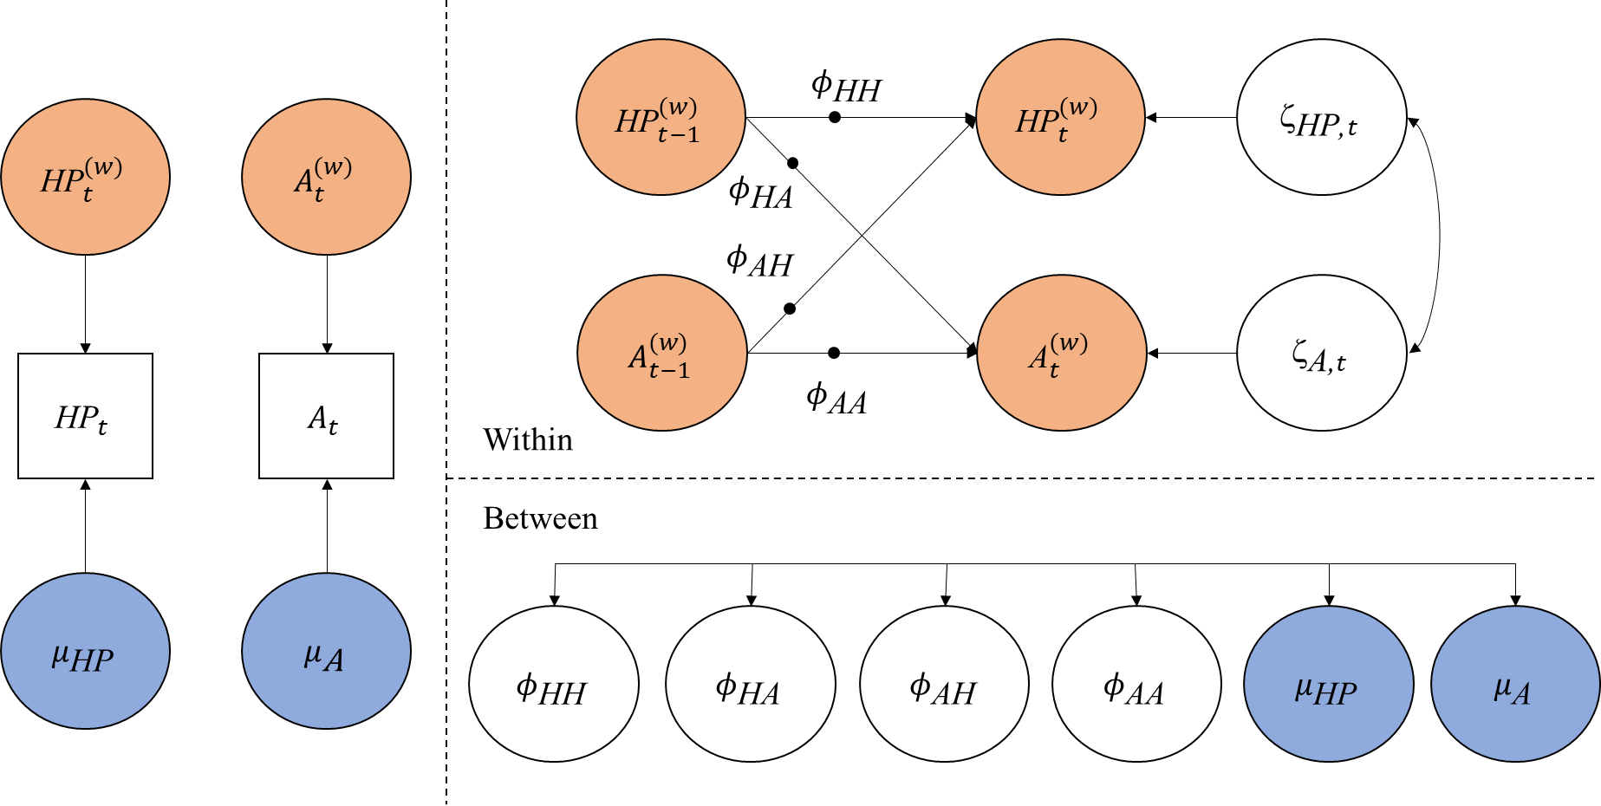
Note: A = affect, HP = helicopter parenting. Left panel: Variables are decomposed in between-family part (μ = individuals mean, in blue), and within-family part (A^{(w)} = within-person centered score of affect, HP^{(w)} = within-person centered score of helicopter parenting, in orange). Top panel: On the within-family level, helicopter parenting and affect predict themselves and each other over time (ϕ = regression parameter, ζ = innovation). Bullets on lines indicate the estimation of random effects (i.e., all person-specific effects). Bottom panel: On the between-family level, these random effects and individual means are correlated. The figure is adapted from (Bülow et al., 2022)

- Sensitive analysis

6.1.H1 & H2
Table S6
Summary of Sensitive Analyses (H1 & H2)
 | Main analysis |  | Double iterations |  | 10 reports |  | Cut-off at .10
 | Est. St. | SD/Est | Est. St. | SD/Est | Est. St. | SD/Est | Est. St. | SD/Est
HP (t - 1) PA (t) | -.01 | 22.36 | -.01 | 22.36 | -.02 | 11.18 | -.01 | 22.36
PA (t - 1) HP (t) | -.01 | 10.00 | -.01 | 10.00 | -.01 | 18.97 | -.01 | 10.00
HP (t - 1) NA (t) | .07 | 3.19 | .07 | 3.19 | .06 | 3.33 | .07 | 3.19
NA (t - 1) HP (t) | .09 | 2.22 | .08 | 2.50 | .09 | 2.14 | .09 | 2.22
Note. Bold values indicate significant/meaningful estimates. HP = helicopter parenting. PA = positive affect. NA = negative affect Est = unstandardized estimate. Est. St. = standardized estimate (i.e., STDYX standardization in Mplus). SD/Est. = standard deviation fixed effect ration by this formula √Var/b, a value ≥ 0.25 is the criterium for a significant variance (Bolger et al., 2019). Cut-off at 1.0 used the output of main analyses. For full output see https://osf.io/m4uqz/.

6.1.1. Demonstration of Effect Heterogeneity for Double Iterations
Figure S3
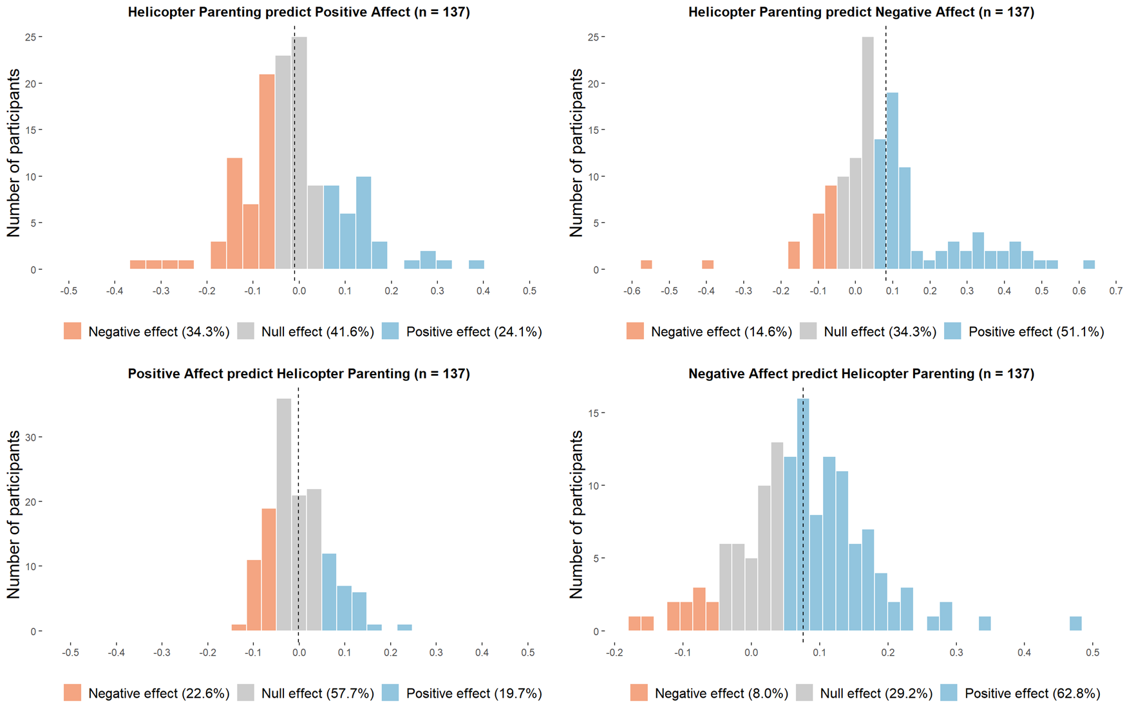

6.1.2. Demonstration of Effect Heterogeneity with more than 10 Reports in Helicopter Parenting
Figure S4
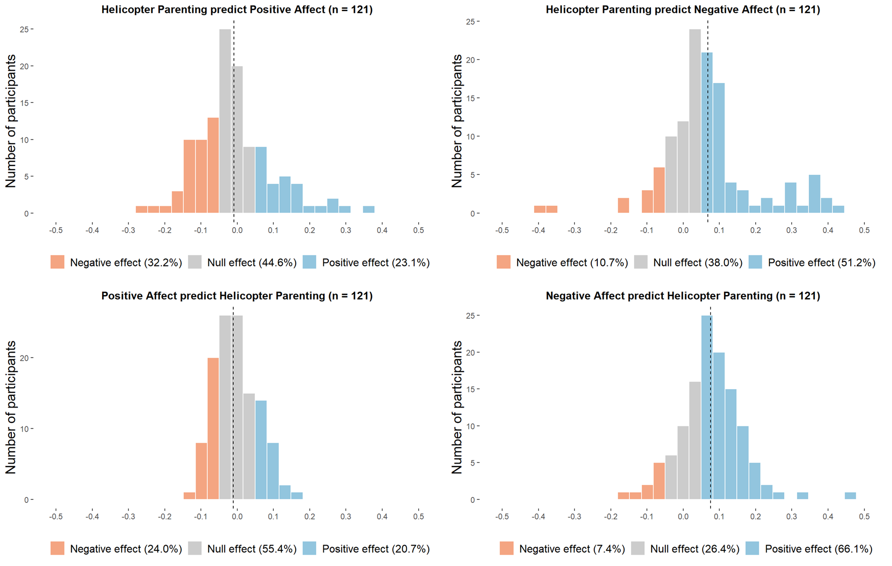

6.1.3. Demonstration of Effect Heterogeneity for cut-off at .10
Figure S5
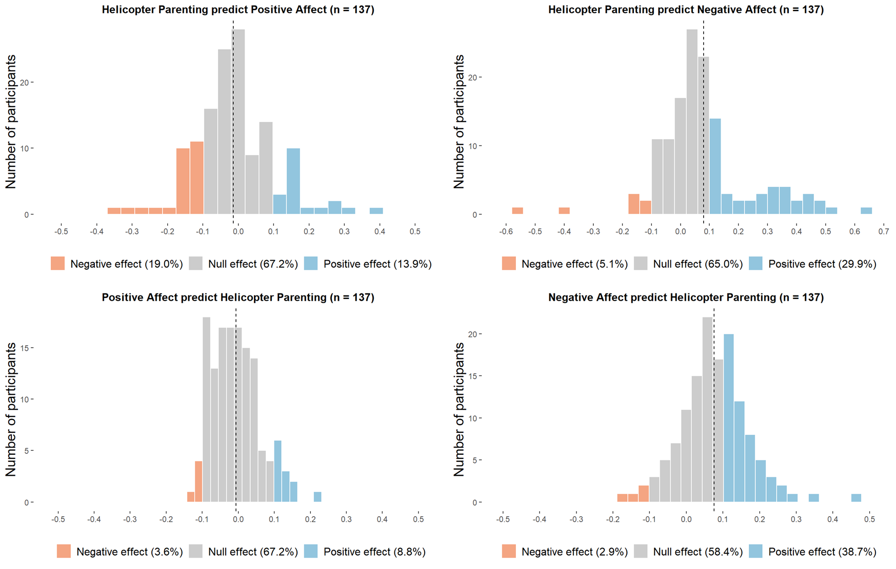
Note. The range of each bar has been adjusted for clear demonstration.

6.2. H3 & H4

6.2.1. Effect Heterogeneity for Double Iterations
Table S7
Overview of subgroups (N = 146)
Subgroups | n | % | MOISC  M (SD) | EI  M (SD) | FO  M (SD) | FO_C  M (SD) | FO_R  M (SD) | FO_F  M (SD) | HP  M (SD) | PA  M (SD) | NA  M (SD)
- Detrimental | 76 | 52.1 | 4.60 (0.63) | 3.88 (0.90) | 4.40 (0.76) | 4.69 (1.03) | 3.89 (0.93) | 4.38 (0.83) | 17.34^{ab} (13.53) | 58.45 (18.75) | 19.68ª (14.78)
- Beneficial | 32 | 21.9 | 4.90 (0.65) | 4.15 (0.91) | 4.58 (0.86) | 4.78 (1.06) | 3.97 (1.12) | 4.47 (0.83) | 34.38^{ac} (15.50) | 56.64ª (16.38) | 16.71 (11.76)
- Mixed | 9 | 6.2 | 4.46 (0.97) | 3.44 (1.19) | 3.92 (0.72) | 3.86 (1.29) | 3.44 (0.65) | 4.39 (0.77) | 27.35 (12.86) | 53.14 (9.01) | 27.87ª (12.46)
- Non-effectual | 19 | 13.0 | 4.77 (0.80) | 3.67 (0.91) | 4.62 (0.80) | 4.93 (1.05) | 3.95 (0.89) | 4.34 (0.71) | 24.83^{bc} (11.66) | 66.66ª (13.35) | 10.55 (8.59)
- Unexpected  (opposing effect of Mixed) | 1 | 0.7 | 5 (-) | 3.9 (-)- | 5.27 (-) | 6 (-) | 4 (-) | 4.5 (-) | 5.68 (-) | 33.21 (-) | 14.32 (-)
- No variance | 9 | 6.2 | 4.53 (0.69) | 3.67 (1.17) | 4.97 (0.61) | 5.47 (0.87) | 4.04 (0.90) | 4.14 (0.60) | .051 (1.21) | 51.64 (22.71) | 18.79 (16.65)
Note. MOISC = Mother-Oriented Interdependent Self-Construal; EI = Emotional Interdependence; FO = Family Obligation; C = Current assistance; R = Respect for family; F = Future assistance. HP = helicopter parenting; PA = positive affect; NA = negative affect. M = mean. SD = standard deviation. Person-average levels of HP, PA, NA were derived by averaging scores across all daily reports. Means with difference superscripts with the same column indicate significant differences between subgroups in post-hoc analyses.

6.2.2. More than 10 Reports in Helicopter Parenting
Table S8
Overview of subgroups (N = 146)
Subgroups | n | % | MOISC  M (SD) | EI  M (SD) | FO  M (SD) | FO_C  M (SD) | FO_R  M (SD) | FO_F  M (SD) | HP  M (SD) | PA  M (SD) | NA  M (SD)
- Detrimental | 69 | 47.3 | 4.67 (0.62) | 3.97 (0.86) | 4.42 (0.78) | 4.74 (1.03) | 3.84 (0.87) | 4.36 (0.86) | 17.51ª (13.17) | 58.92 (19.00) | 20.05ª (14.79)
- Beneficial | 25 | 17.1 | 4.73 (0.78) | 3.91 (1.10) | 4.46 (0.90) | 4.58 (1.10) | 3.89 (1.15) | 4.40 (0.87) | 31.50ª (16.37) | 56.30 (16.56) | 16.31 (12.39)
- Mixed | 9 | 6.2 | 4.74 (0.97) | 3.69 (0.92) | 4.19 (0.97) | 4.03 (1.48) | 4.04 (1.03) | 4.47 (0.82) | 37.06 (16.79) | 54.88 (13.67) | 21.34 (10.83)
- Non-effectual | 18 | 12.3 | 4.56 (0.72) | 3.56 (0.83) | 4.49 (0.76) | 4.83 (1.01) | 3.82 (1.00) | 4.31 (0.66) | 23.41 (13.24) | 60.60 (17.85) | 10.19ª (7.26)
- No variance & exclude | 25 | 17.1 | 4.72 (0.69) | 3.81 (1.10) | 4.78 (0.67) | 5.14 (0.98) | 4.05 (0.90) | 4.47 (0.63) | 17.89 (16.05) | 57.57 (17.08) | 19.93 (15.30)
Note. MOISC = Mother-Oriented Interdependent Self-Construal; EI = Emotional Interdependence; FO = Family Obligation; C = Current assistance; R = Respect for family; F = Future assistance. HP = helicopter parenting; PA = positive affect; NA = negative affect. M = mean. SD = standard deviation. Person-average levels of HP, PA, NA were derived by averaging scores across all daily reports. Means with different superscripts within the same column indicate significant differences between subgroups in post-hoc analyses.

6.2.3. Cut-off at .10
Table S9
Overview of subgroups (N = 146)
Subgroups | n | % | MOISC  M (SD) | EI  M (SD) | FO  M (SD) | FO_C  M (SD) | FO_R  M (SD) | FO_F  M (SD) | HP  M (SD) | PA  M (SD) | NA  M (SD)
- Detrimental | 53 | 36.3 | 4.65 (0.65) | 4.00 (0.87) | 4.42 (0.72) | 4.79 (0.97) | 3.79 (0.85) | 4.31 (0.84) | 19.20ª (13.49) | 61.78 (16.26) | 24.12ª (16.18)
- Beneficial | 19 | 13.0 | 4.68 (0.81) | 3.73 (1.15) | 4.30 (0.93) | 4.39 (1.18) | 3.70 (1.15) | 4.51 (0.77) | 35.08^{ab} (17.06) | 53.76 (11.97) | 18.62 (13.27)
- Mixed | 2 | 1.4 | 4.89 (1.10) | 3.90 (0.14) | 3.77 (0.19) | 3.25 (1.06) | 3.67 (0.94) | 3.88 (0.18) | 35.36 (19.54) | 48.85 (6.84) | 31.13 (17.93)
- Non-effectual | 63 | 43.2 | 4.72 (0.69) | 3.82 (0.94) | 4.54 (0.83) | 4.77 (1.10) | 4.03 (0.97) | 4.46 (0.80) | 22.00^{b} (14.53) | 57.76 (19.36) | 12.72ª (8.27)
- No variance | 9 | 6.2 | 4.53 (0.69) | 3.67 (1.17) | 4.97 (0.61) | 5.47 (0.87) | 4.04 (0.90) | 4.14 (0.60) | .051 (1.21) | 51.64 (22.71) | 18.79 (16.65)
Note. MOISC = Mother-Oriented Interdependent Self-Construal; EI = Emotional Interdependence; FO = Family Obligation; C = Current assistance; R = Respect for family; F = Future assistance. HP = helicopter parenting; PA = positive affect; NA = negative affect. M = mean. SD = standard deviation. Person-average levels of HP, PA, NA were derived by averaging scores across all daily reports. Means with difference superscripts with the same column indicate significant differences between subgroups in post-hoc analyses.

Reference
Bülow, A., Van Roekel, E., Boele, S., Denissen, J. J. A., & Keijsers, L. (2022). Parent–adolescent interaction quality and adolescent affect—An experience sampling study on effect heterogeneity. Child Development, 93(3), e315-e331. https://doi.org/10.1111/cdev.13733

