This material is connected to the article “Anticipating disagreement enhances source memory in English- and Turkish-speaking preschool children”, published in Developmental Psychology. Doi: 10.1037/dev0001996

Supplementary Material

A: Additional Preregistered Dependent Variables
We preregistered logistic linear mixed-effects models for two additional dependent variables: whether children mentioned any source (Source Mentioned), and whether children provided the correct source if asked in a forced choice format (Source Memory Recognition).

Source Mentioned
We coded whether children provided any relevant answer (a reference to seeing or telling), even if incorrect, as an indication of children’s general willingness to answer the open-ended source memory question.
No interactions emerged in the 4-way model (with Language, Condition, Source, and Age, plus random participant intercepts). The model revealed main effects of Age, Source, Language, and Trial. Mentioning a source was more likely for older children, when the child saw the object themselves, for English-speaking children, and for later trials. See Table S1 and Figure S1.
We preregistered conducting this model separately for each Language.
English-Speaking. There were no 3-way interactions or 2-way interactions in the model. The model revealed a main effect of Age and Trial: older children were more likely to provide a source than younger children, and children were more likely to provide a source on later trials (see Table S1 and Figure S1A).
Turkish-Speaking. There were no 3-way interactions or 2-way interactions in the model. The model revealed a main effect of Age and Source: older children were more likely to provide a source than younger children, and children were more likely to provide a source when they saw the object themselves (see Table S1 and Figure S1B).
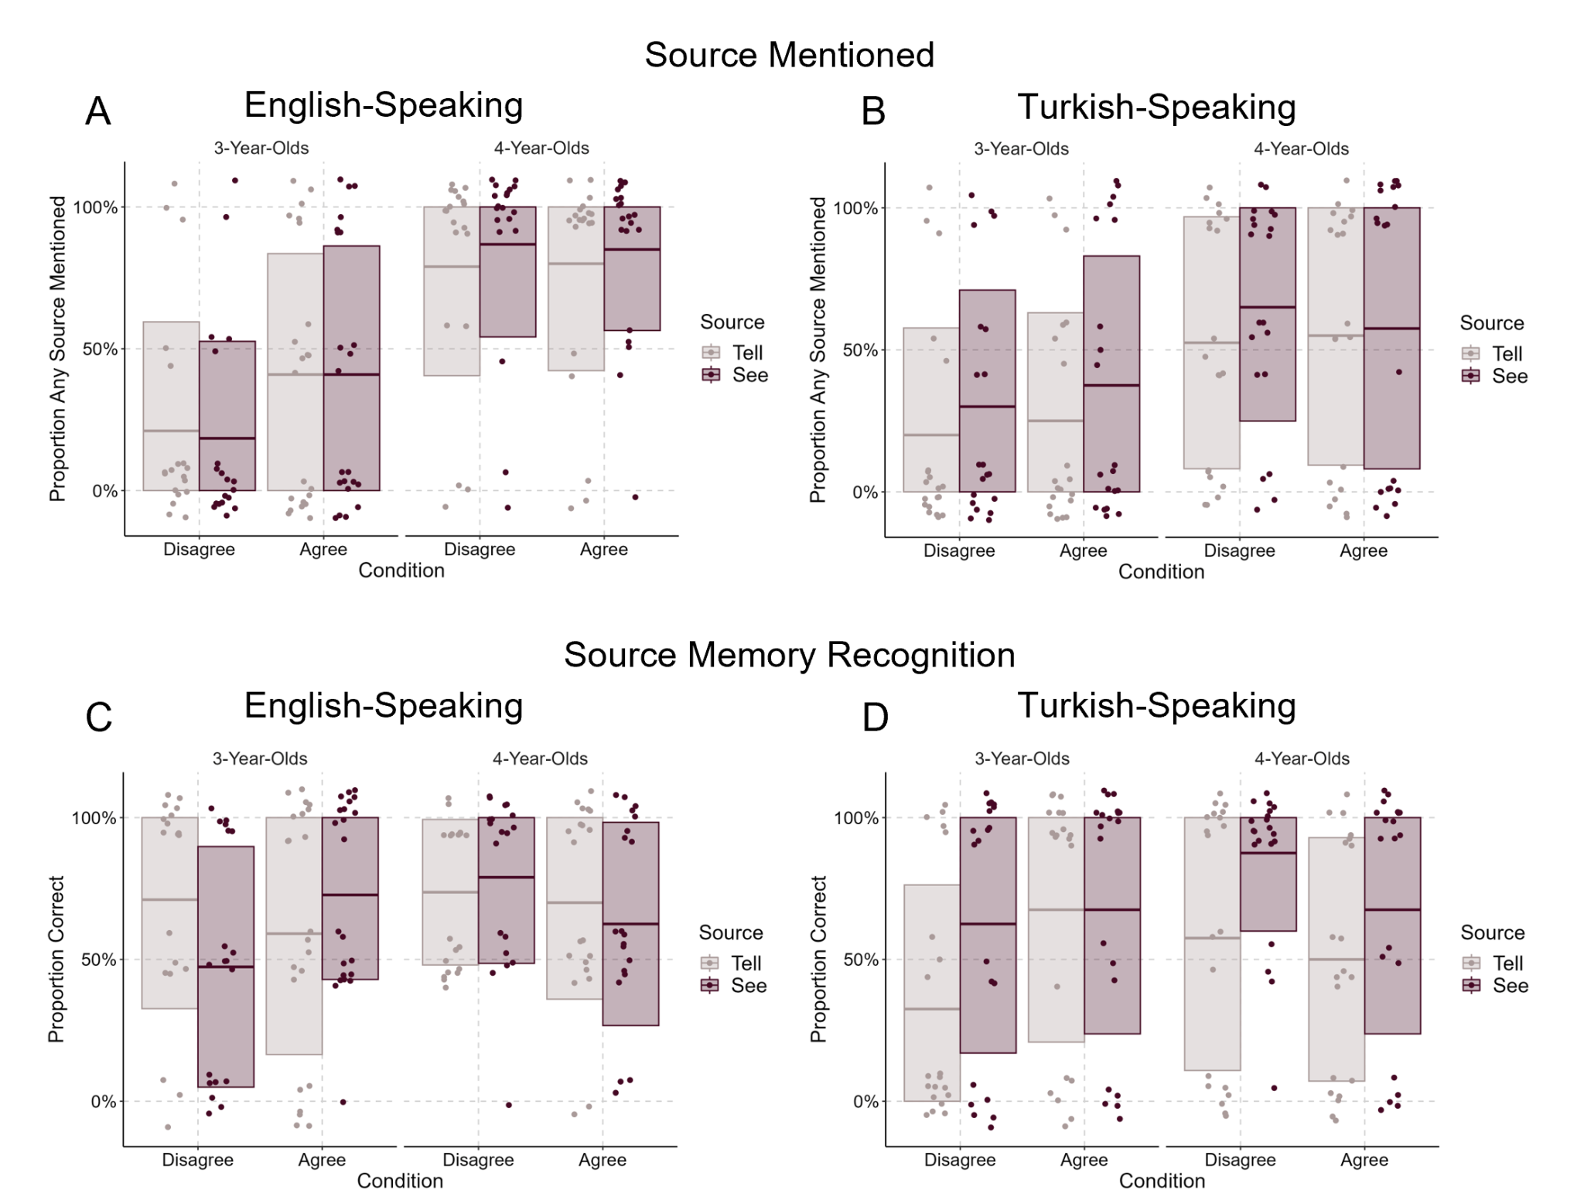
Figure S1. (A,B) Proportions of trials where children mentioned a source, split by Condition (Agree/Disagree) and Source (See/Tell) for English-speaking children (A) and Turkish-speaking children (B). (C,D) Proportions of trials where children recognized the correct source in a forced-choice question, split by Condition (Agree/Disagree) and Source (See/Tell) for English-speaking children (C) and Turkish-speaking children (D). Boxplots represent means and standard deviations, dots are individual data points (randomly jittered for visibility).

Source Memory Recognition
We also examined recognition memory for sources, which can provide additional context about whether children correctly encoded the source, even if not done so explicitly.
There was no 4-way interaction, but there were 3-way interactions between Condition, Source and Age, and between Condition, Source, and Language. To follow up on these
Source Mentioned | Term | Est. | SE | z | p
4-Way Model | Intercept | -0.85 | 0.56 | -1.53 | .126
 | Source | 0.92 | 0.33 | 2.77 | .006
 | Condition | 0.17 | 0.87 | 0.20 | .846
 | Age | 3.31 | 0.63 | 5.21 | < .001
 | Language | -2.25 | 0.92 | -2.43 | .015
 | Trial | 0.33 | 0.14 | 2.40 | .016
 | Language:Age | -1.53 | 0.86 | -1.78 | .075
 | Condition:Language | -0.32 | 1.74 | -0.18 | .855
 | Source:Language | 0.64 | 0.65 | 0.98 | .328
 | Source:Age | 0.16 | 0.35 | 0.45 | .655
 | Condition:Age | -0.21 | 0.86 | -0.25 | .805
 | Condition:Source | -0.52 | 0.65 | -0.79 | .429
 | Condition:Source:Age | -0.40 | 0.70 | -0.58 | .563
 | Condition:Language:Age | 0.73 | 1.71 | 0.43 | .671
 | Condition:Source:Language | -0.04 | 1.30 | -0.03 | .973
 | Source:Language:Age | -0.85 | 0.70 | -1.21 | .227
 | Condition:Source:Language:Age | 0.88 | 1.40 | 0.63 | .530
English-Speaking | Term | Est. | SE | z | p
 | Intercept | 0.13 | 0.85 | 0.16 | .875
 | Source | 0.65 | 0.52 | 1.25 | .211
 | Condition | 0.31 | 1.35 | 0.23 | .819
 | Age | 4.38 | 1.07 | 4.11 | < .001
 | Trial | 0.42 | 0.21 | 1.95 | .052
 | Age:Source | 0.62 | 0.56 | 1.11 | .267
 | Age:Condition | -0.59 | 1.32 | -0.45 | .654
 | Source:Condition | -0.55 | 1.02 | -0.54 | .592
 | Age:Source:Condition | -0.91 | 1.11 | -0.81 | .416
Turkish-Speaking | Term | Est. | SE | z | p
 | Intercept | -1.74 | 0.78 | -2.22 | .026
 | Source | 1.20 | 0.43 | 2.76 | .006
 | Condition | 0.01 | 1.14 | 0.01 | .990
 | Age | 2.36 | 0.77 | 3.08 | .002
 | Trial | 0.27 | 0.18 | 1.48 | .139
 | Age:Source | -0.25 | 0.44 | -0.58 | .562
 | Age:Condition | 0.13 | 1.13 | 0.11 | .912
 | Source:Condition | -0.51 | 0.83 | -0.62 | .539
 | Age:Source:Condition | 0.03 | 0.88 | 0.03 | .976

Table S1. Results of GLMMs for whether a source was mentioned.

interactions, we ran the model separately in each Condition. There were no significant effects in the Agreement condition, but the Disagreement condition included a significant main effect of Age and a Source by Language interaction (see Table S1). Older children in both language samples were more likely to correctly recognize the source in a forced-choice question.
English-Speaking. There was a three-way interaction between Age, Source, and Condition (see Table S1 and Figure S1C). We therefore conducted the model separately within each age group. In 4-year-olds, there were no differences by Source, Condition, or their interaction. In 3-year-olds, there was a significant interaction between Source and Condition. Three-year-olds in the Disagreement condition had higher accuracy on Tell trials compared to See trials, though this did not reach conventional levels of significance, Z = 1.76, p = .078, r = 0.40. See and Tell trials were not significantly different for 3-year-olds in the Agreement condition, Z = -0.72, p = .472, r = 0.15.
Both age groups had above-chance recognition, 3-year-olds: M = 62%, SD = 25%, Z = 2.90, p = .004, r = .58, 4-year-olds: M = 71%, SD = 22%, Z = 4.30, p < .001, r = .78. English-speaking children at all ages therefore appear to have encoded the correct source.
Turkish-Speaking. There was no 3-way interaction or interactions with Age. There was a Source by Condition interaction: Three and 4-year-olds were more accurate for See over Tell trials in the Disagreement condition, Z = -2.73, p = .006, r = 0.43, but not in the Agreement condition, Z = -0.84, p = .400, r = 0.13 (see Table S2 and Figure S1D).
Four-year-olds recognized sources above chance, M = 66%, SD = 29%, Z = 2.80, p = .005, r = 0.56, but 3-year-olds did not, M = 58%, SD = 30%, Z = 1.51, p = .136, r = 0.35. Turkish-speaking children by 4 years old appear to have encoded the correct source.

Source Memory Recognition | Term | Est. | SE | z | p
4-Way Model | Intercept | 0.59 | 0.22 | 2.68 | .007
 | Source | 0.47 | 0.18 | 2.57 | .010
 | Condition | -0.10 | 0.20 | -0.48 | .635
 | Age | 0.37 | 0.10 | 3.56 | < .001
 | Language | -0.20 | 0.20 | -0.98 | .325
 | Trial | 0.04 | 0.08 | 0.51 | .613
 | Language:Age | 0.20 | 0.20 | 1.00 | .317
 | Condition:Language | 0.10 | 0.40 | 0.24 | .812
 | Source:Language | 1.06 | 0.37 | 2.88 | .004
 | Source:Age | 0.01 | 0.19 | 0.07 | .941
 | Condition:Age | -0.47 | 0.20 | -2.28 | .023
 | Condition:Source | -0.31 | 0.37 | -0.85 | .395
 | Condition:Source:Age | -0.75 | 0.38 | -2.00 | .046
 | Condition:Language:Age | -0.29 | 0.41 | -0.72 | .472
 | Condition:Source:Language | -1.81 | 0.74 | -2.47 | .014
 | Source:Language:Age | 0.52 | 0.38 | 1.39 | .164
 | Condition:Source:Language:Age | 1.41 | 0.76 | 1.86 | .063
Agreement | Term | Est. | SE | z | p
 | Intercept | 0.60 | 0.30 | 2.03 | .043
 | Source | 0.30 | 0.24 | 1.27 | .204
 | Age | 0.12 | 0.14 | 0.88 | .380
 | Language | -0.12 | 0.26 | -0.48 | .634
 | Trial | 0.01 | 0.11 | 0.09 | .929
 | Age:Language | 0.04 | 0.28 | 0.16 | .873
 | Language:Source | 0.22 | 0.48 | 0.45 | .651
 | Age:Source | -0.33 | 0.26 | -1.28 | .200
Disagreement | Term | Est. | SE | z | p
 | Intercept | 0.56 | 0.33 | 1.73 | .083
 | Source | 0.64 | 0.28 | 2.30 | .021
 | Age | 0.61 | 0.15 | 4.18 | < .001
 | Language | -0.23 | 0.30 | -0.77 | .442
 | Trial | 0.07 | 0.12 | 0.64 | .522
 | Age:Language | 0.37 | 0.29 | 1.29 | .198
 | Language:Source | 2.03 | 0.55 | 3.72 | < .001
 | Age:Source | 0.40 | 0.26 | 1.53 | .125

English-Speaking | Term | Est. | SE | z | p
 | Intercept | 0.55 | 0.30 | 1.84 | .066
 | Source | -0.05 | 0.25 | -0.21 | .836
 | Condition | -0.13 | 0.25 | -0.54 | .591
 | Age | 0.25 | 0.13 | 1.97 | .049
 | Trial | 0.08 | 0.11 | 0.76 | .450
 | Age:Source | -0.24 | 0.25 | -0.93 | .352
 | Age:Condition | -0.31 | 0.25 | -1.21 | .226
 | Source:Condition | 0.57 | 0.50 | 1.14 | .254
 | Age:Source:Condition | -1.38 | 0.51 | -2.72 | .007
 | Term | Est. | SE | z | p
3-year-olds | Intercept | 0.63 | 0.42 | 1.52 | .129
 | Source | -0.22 | 0.34 | -0.65 | .516
 | Condition | 0.27 | 0.35 | 0.76 | .450
 | Trial | -0.04 | 0.15 | -0.25 | .805
 | Source:Condition | 1.63 | 0.68 | 2.38 | .017
 | Term | Est. | SE | z | p
4-Year-olds | Intercept | 0.39 | 0.43 | 0.93 | .354
 | Source | 0.01 | 0.36 | 0.04 | .969
 | Condition | -0.50 | 0.36 | -1.38 | .167
 | Trial | 0.22 | 0.16 | 1.35 | .176
 | Source:Condition | -0.57 | 0.73 | -0.78 | .436
Turkish-Speaking | Term | Est. | SE | z | p
 | Intercept | 0.65 | 0.33 | 1.96 | .050
 | Source | 1.07 | 0.28 | 3.85 | < .001
 | Condition | -0.03 | 0.32 | -0.10 | .917
 | Age | 0.50 | 0.17 | 2.96 | .003
 | Trial | -0.01 | 0.11 | -0.06 | .954
 | Age:Source | 0.28 | 0.28 | 0.99 | .320
 | Age:Condition | -0.65 | 0.33 | -1.94 | .053
 | Source:Condition | -1.28 | 0.54 | -2.35 | .019
 | Age:Source:Condition | -0.01 | 0.56 | -0.02 | .984
Table S2. Results of GLMMs for whether a source was correctly recognized.

B: Exploratory Comparison of Language Samples
Here we report simple effects models for the 4-way interaction presented in the main text, split by Condition (for Source Memory) and Age (for Perceptual Memory) rather than Language to allow for comparison of the two language samples.

Source Memory
For 3-year-olds, there was a significant 3-way interaction between Language, Condition, and Source. We followed up on this by further grouping by Condition, finding no Language or Source differences in the Agreement condition, but a Location by Source interaction in the Disagreement condition. This is also reported in the main text: Turkish-speaking 3-year-olds gave more correct sources on See trials than Tell trials in the Disagreement condition, but English-speaking 3-year-olds showed no difference. There was only a Source by Condition interaction and a main effect of Language in 4-year-olds. English-speaking 4-year-olds gave more correct sources than Turkish-speaking 4-year-olds. The interaction matches what is reported in the main text: 4-year-olds generally recalled first-hand sources better than second-hand sources in the Disagreement condition, Z = -2.98, p = .003, r = .48, but there was no difference in accuracy between sources in the Agreement condition, Z = 1.23, p = .217, r = .20. See Table S3.

Perceptual Memory
For 3-year-olds, the only significant interaction was between Condition and Language: English-speaking 3-year-olds correctly remembered the color better than Turkish-speaking 3-year-olds in the Disagreement condition, Z = 2.28, p = .023, r = .36, but there was no difference between samples in the Agreement condition, Z = -0.81, p = .420 , r = .13. There were no main effects or interactions for 4-year-olds. See Table S4.

Source Memory | Term | Est. | SE | z | p
3-Year-Olds | Intercept | -3.80 | 0.96 | -3.97 | < .001
 | Source | 1.37 | 0.53 | 2.61 | .009
 | Condition | 1.92 | 0.96 | 1.99 | .047
 | Language | -0.51 | 0.92 | -0.55 | .580
 | Trial | 0.22 | 0.18 | 1.22 | .224
 | Condition:Source | -2.04 | 1.03 | -1.98 | .048
 | Source:Language | 1.83 | 1.02 | 1.79 | .073
 | Condition:Language | -0.82 | 1.82 | -0.45 | .652
 | Condition:Source:Language | -4.02 | 2.04 | -1.97 | .049
 | Term | Est. | SE | z | p
Agreement | Intercept | -2.46 | 0.79 | -3.14 | .002
 | Source | 0.31 | 0.46 | 0.68 | .495
 | Language | -0.72 | 0.89 | -0.81 | .417
 | Trial | 0.27 | 0.21 | 1.30 | .193
 | Language:Source | -0.16 | 0.91 | -0.18 | .860
 | Term | Est. | SE | z | p
Disagreement | Intercept | -10.70 | 2.58 | -4.15 | < .001
 | Source | 5.01 | 1.79 | 2.79 | .005
 | Language | -2.87 | 2.68 | -1.07 | .283
 | Trial | 0.09 | 0.42 | 0.21 | .832
 | Language:Source | 8.21 | 3.47 | 2.36 | .018
 | Term | Est. | SE | z | p
4-Year-Olds | Intercept | 0.25 | 0.44 | 0.57 | .567
 | Source | 0.52 | 0.32 | 1.63 | .104
 | Condition | -0.38 | 0.54 | -0.71 | .480
 | Language | -1.74 | 0.57 | -3.07 | .002
 | Trial | 0.06 | 0.14 | 0.42 | .675
 | Condition:Source | -2.53 | 0.66 | -3.83 | < .001
 | Source:Language | 0.78 | 0.63 | 1.23 | .219
 | Condition:Language | 0.09 | 1.08 | 0.08 | .935
 | Condition:Source:Language | 2.14 | 1.27 | 1.68 | .094

Table S3. Results of GLMMs for Source Memory, split by Age.
Perceptual Memory | Term | Est. | SE | z | p
3-Year-Olds | Intercept | 0.49 | 0.34 | 1.44 | .150
 | Source | 0.16 | 0.26 | 0.60 | .547
 | Condition | 0.19 | 0.36 | 0.53 | .598
 | Language | -0.44 | 0.36 | -1.22 | .223
 | Trial | 0.06 | 0.12 | 0.55 | .586
 | Condition:Source | 0.11 | 0.52 | 0.21 | .836
 | Source:Language | 0.03 | 0.52 | 0.06 | .955
 | Condition:Language | 1.57 | 0.72 | 2.18 | .029
 | Condition:Source:Language | 0.96 | 1.05 | 0.92 | .359
 | Term | Est. | SE | z | p
4-Year-Olds | Intercept | 2.04 | 0.45 | 4.56 | < .001
 | Source | 0.34 | 0.30 | 1.11 | .266
 | Condition | 0.11 | 0.44 | 0.26 | .797
 | Language | 0.28 | 0.44 | 0.62 | .533
 | Trial | -0.20 | 0.14 | -1.44 | .151
 | Condition:Source | -0.24 | 0.61 | -0.40 | .691
 | Source:Language | -0.24 | 0.61 | -0.39 | .697
 | Condition:Language | -1.01 | 0.89 | -1.13 | .258
 | Condition:Source:Language | -0.40 | 1.21 | -0.33 | .743

Table S4. Results of GLMMs for Perceptual Memory, split by Age.

C: Robustness Checks

Perceptual Accuracy (English-Speaking Children Only)
Our preregistered analysis plan was to exclude trials in which children did not know the correct colour word, assessed in the colour naming test at the end of the study. This was only conducted in the English-speaking sample, so we report the model with all participants in the main text for added power and comparability between the samples. The preregistered model here (Table S5 and Figure S2) shows the same pattern of results: no significant main effects or interactions.

Perceptual Memory (Only when colour known) | Term | Est. | SE | z | p
 | Intercept | 1.49 | 0.41 | 3.64 | < .001
 | Source | 0.30 | 0.29 | 1.03 | .301
 | Condition | -0.07 | 0.42 | -0.17 | .866
 | Age | 0.18 | 0.21 | 0.87 | .385
 | Trial | -0.11 | 0.13 | -0.84 | .402
 | Age:Source | -0.08 | 0.29 | -0.27 | .791
 | Age:Condition | 0.45 | 0.43 | 1.06 | .289
 | Source:Condition | -0.22 | 0.58 | -0.38 | .707
 | Age:Source:Condition | 0.22 | 0.58 | 0.37 | .710

Table S5. Results of GLMM for Perceptual Memory, only including trials where the colour was known. Only English-speaking children were asked this question.
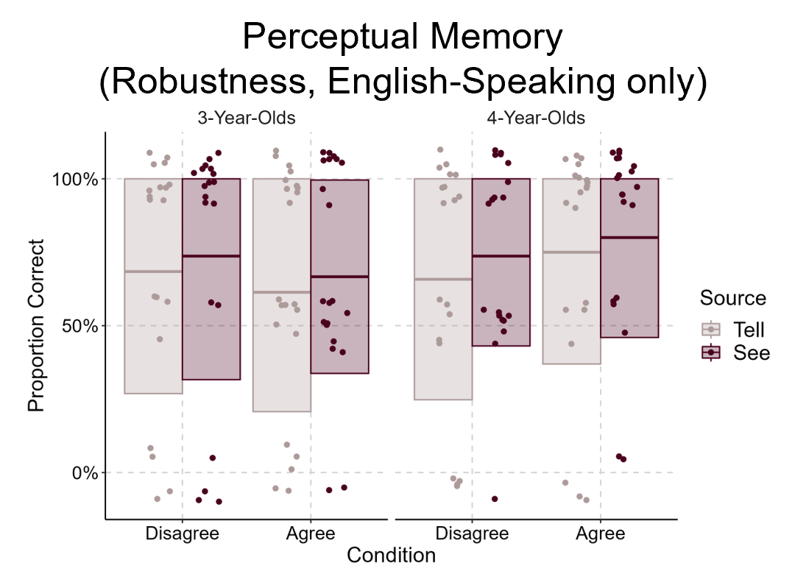
Figure S2. Proportion of Perceptual Questions answered correctly, given that children knew the correct colour name for that trial. This data is for the English-speaking sample only. Boxplots represent means and standard deviations, dots are individual data points (randomly jittered for visibility).

Open Source Accuracy Only When a Source was Mentioned
Many children, especially 3-year-olds, failed to mention a source on many trials. As our Source Memory coding treats all non-answers as incorrect, some of our effects might be due to lack of responding rather than lack of source memory. Table S6 and Figure S3 present the models with these trials removed from the analysis completely. The models do not differ from those reported in the main text.

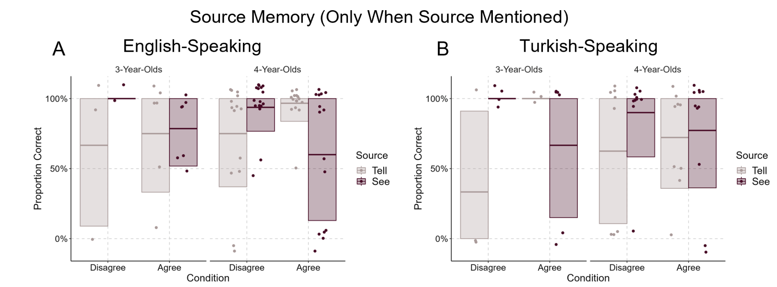
Figure S3. Proportion of Source Memory questions answered correctly in (A) the English-speaking sample and (B) the Turkish-speaking sample, given that the child provided a valid answer on that trial. Boxplots represent means and standard deviations, dots are individual data points (randomly jittered for visibility).

Source Memory (Only When Source Mentioned) | Term | Est. | SE | z | p
English-Speaking Sample | Intercept | 1.54 | 0.39 | 4.00 | < .001
 | Source | 0.23 | 0.35 | 0.64 | .520
 | Condition | -0.20 | 0.39 | -0.52 | .603
 | Age | 0.45 | 0.20 | 2.28 | .023
 | Trial | 0.06 | 0.16 | 0.35 | .725
 | Age:Source | -0.09 | 0.35 | -0.25 | .803
 | Age:Condition | 0.00 | 0.39 | 0.01 | .994
 | Source:Condition | -0.59 | 0.69 | -0.85 | .393
 | Age:Source:Condition | -3.24 | 0.73 | -4.44 | < .001
 | Term | Est. | SE | z | p
3-year-olds | Intercept | 0.89 | 0.54 | 1.63 | .103
 | Source | 0.08 | 0.49 | 0.17 | .868
 | Condition | 0.07 | 0.53 | 0.14 | .893
 | Trial | 0.19 | 0.25 | 0.73 | .466
 | Source:Condition | 1.57 | 0.95 | 1.65 | .099
 | Term | Est. | SE | z | p
4-year-olds | Intercept | 1.86 | 0.50 | 3.70 | < .001
 | Source | 0.02 | 0.43 | 0.06 | .955
 | Condition | -0.16 | 0.48 | -0.34 | .735
 | Trial | -0.01 | 0.19 | -0.07 | .942
 | Source:Condition | -2.47 | 0.88 | -2.82 | .005
 | Term | Est. | SE | z | p
Turkish-Speaking Sample | Intercept | 1.93 | 0.66 | 2.94 | .003
 | Source | 0.96 | 0.51 | 1.88 | .060
 | Condition | -0.08 | 0.55 | -0.14 | .886
 | Age | 0.25 | 0.27 | 0.93 | .355
 | Trial | -0.28 | 0.21 | -1.33 | .182
 | Age:Source | 0.23 | 0.51 | 0.45 | .654
 | Age:Condition | -0.20 | 0.55 | -0.36 | .721
 | Source:Condition | -3.52 | 1.11 | -3.17 | .002
 | Age:Source:Condition | 1.38 | 1.03 | 1.34 | .182

Table S6. Results of the GLMMs for the English-speaking and Turkish-speaking samples on Source Memory accuracy given that a valid answer was provided on that trial.

We do not encourage strong interpretations of this because we did not include the use of evidentials as a correct answer in the Turkish-speaking sample, to be consistent and conservative in our coding scheme across samples. When we include evidentials as a correct answer, the Turkish-speaking children give more correct sources overall with the same Condition by Source interaction. Our data and analyses are available on OSF for anyone interested in exploring this further.

