Supplemental Materials:
Latent Transition Analysis of Parent Emotion Socialization Profiles
Latent Profile Analysis with 2019 Data
The LPA was conducted with Mplus (V8.6), with 1-10 models tested in total. Thirteen indicators were included: the standardized mean scores of five subscales for parents’ beliefs about children’s emotions, one total score of parent emotion dysregulation, and seven subscales of emotion-related parenting practices. We excluded participants who did not provide response data for all three measures included in the latent profile analysis (n=87). We handled variable-level missing data with Full Information Maximum Likelihood (FIML) estimation. A robust maximum likelihood estimator (MLR) was used in all models to control for clustering by household (i.e., where two-parent dyads provided response data, n=111). While we did not conduct a power analysis to ascertain the minimum sample size for the current study, the 2019 and 2020 samples (N=869 and 567) meet Nylund-Gibson and Choi (2018) recommendation of a sample with ≥ 300 participants for a latent profile analysis.
We utilized a variety of methods to select the best-fitting solution. We assessed whether there were changes to the Akaike, Bayesian, and sample-size adjusted Bayesian values. The model with the lowest values is typically selected as the final model, or when model fit does not improve with an added profile. Often, the Akaike, Bayesian, and sample-size adjusted Bayesian values will decrease with the addition of a profile (Morin et al., 2016). Researchers recommend to plot these values on an elbow plot and select the model with the most prominent bend or the point where the lines plateau (Morin et al., 2016). We examined results of the Vuong-Lo-Mendell-Rubin Likelihood Ratio Test/Lo-Mendell-Rubin Adjusted Likelihood Ratio Tests. A statistically significant p value (p<.05) indicates there is an improvement in model fit compared to a model with one less profile (Morin et al., 2016). To examine profile delineation, we examined the 95% confidence intervals of the within-profile means. If the confidence intervals for a within-profile mean score overlap for two profiles, this suggests the mean scores do not significantly differ between the two profiles (Sinha et al., 2021; Weller et al., 2020). It should be noted that there is no known rule for how many within-profile scores need to significantly differ. In addition to fit statistics, deciding on the best-fitting model was guided by qualitative interpretation of the profiles, parsimony, and a sound theoretical rationale. See Table S3 for the confidence intervals and standardized mean scores of within-profile indicators, for the three-profile model (2019 profiles).
Three emotion socialization profiles were identified: 1) emotion coaching parents with low levels of emotion dismissing beliefs, emotion dysregulation, and emotion dismissing behaviors, and high levels of emotion coaching behaviors (57%, n = 492); 2) emotion dismissing parents with high levels of emotion dismissing beliefs, emotion dysregulation, and emotion dismissing behaviors, and low levels of emotion coaching behaviors (10%, n = 86) and; 3) emotion disengaged parents with moderate levels of emotion dismissing beliefs, emotion dysregulation, and emotion dismissing behaviors, and low levels of emotion coaching behaviors (33%, n = 291). Proceeding the LPA, Author conducted measurement invariance testing of the profiles across mothers and fathers, and parents of children in early (i.e., 4-6 years) versus middle childhood (i.e., 7-10 years). Findings suggested that the same profiles emerged across each group. Further, we tested associations between the profiles and similar theoretical constructs, parent/child characteristics, and contextual factors. Associations were within expected directions. For instance, relative to the emotion coaching profile, the emotion dismissing profile was associated with higher levels of negative emotion expression in the family, and fathers were more likely to be a member of this profile.
Table S1
Bivariate Correlations of Study Variables
 | ER | AN | AU | CO | ST | MA | EM | EE | P-S | EMO | DR | PR | MR | CA | CG | PG | PA | PS | ST | ED | MG | ER | AN | AU | CO | ST | MA | EM | EE | P-S | EMO | DR | PR | MR
2019 Response Data
ER | 1
AN | -.02 | 1
AU | .04 | -.19*** | 1
CO | .01 | -.01 | .43*** | 1
ST | .11*** | -.12** | .02 | .17*** | 1
MA | .13*** | -.06 | .44*** | .30*** | .11*** | 1
EM | -.04 | -.16*** | -.26*** | -.21*** | .06 | -.22*** | 1
EE | -.11** | -.20*** | -.24*** | -.15*** | .11* | -.20*** | .61*** | 1
PS | -.08* | -.09** | -.15*** | -.15*** | .03 | -.09* | .59*** | .54*** | 1
EMO | .03 | -.03 | .00 | -.07* | .01 | .10* | .35*** | .30*** | .61*** | 1
DR | .26*** | .04 | .08* | .09** | .08* | .15*** | -.14*** | -.24*** | -.23*** | -.09** | 1
PR | .16*** | .05 | .28*** | .29*** | .12*** | .32*** | -.40*** | .54*** | -.36*** | -.21*** | .38*** | 1
MR | .15*** | .10* | .34*** | .27*** | .06 | .40*** | -.41*** | -.38*** | -.32*** | -.13** | .31*** | .64*** | 1
CA | -.04 | .01 | .11*** | .10** | .01 | .13** | -.09* | -.04 | -.09* | -.10** | .03 | .05 | .09** | 1
CG | -.04 | -.03 | -.05 | -.08* | -.06 | -.09* | .04 | .02 | -.04 | -.04 | -.04 | -.00 | .00 | -.04 | 1
PG | -.01 | .08* | .21*** | .21*** | -.05 | .24*** | -.25*** | -.21*** | -.25*** | -.11* | .02 | .21*** | .27*** | .05 | .04 | 1
PA | -.14*** | -.04 | -.02 | -.07* | -.04 | .04 | .01 | .01 | -.03 | -.10** | .05 | -.05 | -.04 | .33*** | -.04 | .15*** | 1
PD | .67*** | -.05 | .01 | .01 | .13*** | .10* | -.01 | -.07* | -.04 | .01 | .18*** | .10** | .06 | .00 | -.05 | -.02 | -.11** | 1
PS | .62*** | -.06 | -.02 | -.07 | .20* | .16 | -.22* | -.16 | -.12 | -.09 | .06 | .13 | .16 | -.04 | -.07 | -.02 | -.21* | .69*** | 1
ED | -.08* | -.01 | -.09** | -.10* | -.05 | -.18*** | .00 | -.02 | -.03 | -.08* | .10** | -.04 | -.06 | -.08 | -.01 | .01 | .13** | -.14*** | -.10* | 1
MG | .02 | .02 | -.01 | -.08* | -.03 | .02 | -.00 | .05 | .03 | -.01 | -.01 | .09** | .07* | -.01 | .03 | -.01 | .06 | -.03 | -.01 | .14*** | 1
2020 Response Data
ER | .63* | .04 | .01 | .03 | .11* | .12** | -.13** | -.16*** | -.12** | -.02 | .17*** | .14** | .09 | -.06 | -.08 | .05 | -.15** | .51*** | .47*** | -.05 | -.05 | 1
AN | -.02 | .16** | .04 | -.07 | -.03 | .11* | .13* | .09 | .02 | -.01 | -.04 | -.01 | .02 | .01 | .01 | .03 | .00 | -.03 | .07 | -.08 | .06 | -.00 | 1
AU | .04 | .17*** | .72*** | .33*** | .07 | .43*** | -.30*** | -.22*** | -.20*** | -.01 | .11* | .35*** | .39*** | .13* | -.03 | .30*** | -.02 | .01 | .14 | -.04 | -.01 | -.00 | .14** | 1
CO | .01 | .14** | .39*** | .62*** | .13* | .28*** | -.17*** | -.04 | -.16** | -.09 | .06 | .23*** | .22*** | .13** | -.01 | .22*** | -.05 | -.01 | -.02 | -.01 | -.01 | -.02 | .04 | .50*** | 1
ST | .11*** | .15** | .10* | .19** | .55*** | .13** | -.01 | .02 | .10 | .09 | .06 | .08 | .03 | .08 | -.04 | -.05 | -.05 | .18*** | .34** | -.07 | -.07 | .19*** | .04 | .09 | .23*** | 1
MA | .13*** | .09 | .35*** | .25*** | .08 | .74*** | -.20*** | -.12* | -.10 | .05 | .16** | .35*** | .36*** | .12* | -.02 | .27*** | -.02 | .15** | .23* | -.20*** | .06 | .14** | .09 | .46*** | .41*** | .16** | 1
EM | -.04 | -.12** | -.32*** | -.25*** | .07 | -.28*** | .59*** | .50*** | .44*** | .21*** | -.19*** | -.38*** | -.44*** | -.03 | -.02 | -.31** | .01 | -.01 | -.22* | -.00 | .03 | -.15** | .12* | -.35*** | -.20*** | .00 | -.26*** | 1
EE | -.11** | -.16** | -.21*** | -.08 | .15* | .18*** | .47*** | .67*** | .40*** | .21*** | -.29*** | -.28*** | -.35*** | -.06 | .01 | -.19*** | .02 | -.07* | -.16 | -.03 | .02 | -.21** | .02 | -.20** | -.02 | .07 | -.15* | .66*** | 1
PS | -.08* | -.10* | -.20*** | -.20*** | .02 | -.14*** | .43*** | .43*** | .57*** | .40*** | -.28*** | -.36*** | -.36*** | -.06 | -.07 | -.28*** | -.03 | -.04 | -.19 | -.07 | .03 | -.17*** | .07 | -.25*** | -.17*** | .00 | -.11* | .59*** | .54*** | 1
ED | -.08 | .01 | -.06 | -.11* | .08 | .10* | .21*** | .23*** | .40*** | .52*** | -.11** | -.19*** | -.14** | -.07 | -.02 | -.20*** | -.10** | .01 | -.16 | -.07 | .02 | -.08 | .02 | -.06 | -.06 | .10* | .05 | .39 | .42*** | .64*** | 1
DR | .25*** | .01 | .03 | .05 | .03 | .15** | -.13* | -.21*** | -.20*** | -.06 | .56*** | .33*** | .27*** | .04 | -.04 | .03 | .05 | .18*** | .33 | .06 | .00 | .25*** | .05 | .13 | .03 | .03 | .19** | -.20*** | -.26*** | -.29*** | -.20*** | 1
PR | .16 | -.06 | .28*** | .19** | .08 | .26*** | -.30*** | -.24*** | -.28*** | -.17*** | .38*** | .61*** | .52*** | .03 | -.00 | .19*** | -.05 | .10** | .05 | -.03 | .12* | .22** | .02 | .31*** | .16* | -.00 | .28*** | -.39*** | -.30*** | -.45*** | -.36*** | .44*** | 1
MR | .15*** | .05 | .32*** | .25*** | .05 | .40*** | -.40*** | -.37*** | -.29*** | -.09* | .29*** | .52*** | .63*** | .10 | -.00 | .25*** | -.04 | .06 | .27* | -.06 | .09* | .12 | .01 | .40*** | .27*** | .06 | .41*** | -.49*** | -.41**** | -.42*** | -.19*** | .37*** | .65*** | 1
Note. Variables are unstandardized. ER=parents’ emotion regulation (DERS measure); AN=parents’ anger belief (PBACE measure) (subscale was reverse scored); AU=parents’ autonomy belief (PBACE measure); CO=parents’ control belief (PBACE measure); STA=parents’ stability belief (PBACE measure); MA=parents’ manipulation belief (PBACE measure); EM=empathy subscale (CCNES short-form measure); EE=expressive encouragement subscale (CCNES short-form measure); P-S=problem-solving subscale (CCNES short-form measure); EMO=emotion-focused responses subscale (CCNES measure); DR=distress reactions subscale (CCNES short-form measure); PR=punitive reactions subscale (CCNES short-form measure); MR=minimization reactions subscale (CCNES short-form measure); CA=child age; CG=child gender; PG=parent gender; PA=parent age; PD=parents’ psychological distress (KESSLER measure); PS=parents’ stress (DASS measure); ED=education; MG=migrant. Child gender and parent gender coded as: 0=female, 1=male. Education coded as: 0=did not complete tertiary education, 1=completed tertiary education. Migrant coded as: 0=parent born in country of residence, 1=parent born outside of country of residence.
Table S2
Binomial Logistic Regression Comparing 2019 Data
to Missing Data in 2020
Variable | OR [UL, LL] | p | SE
Parent gender | 1.22 [.90, 1.7] | .19 | .19
Child gender | 1.34 [.98, 1.8] | .06 | .21
Parent age | .987 [.96, 1.0] | .31 | .01
Child age | 1.14 [1.0, 1.3] | .00 | .05
Parent education | .658 [.47, .91] | .01 | .11
Employment status | .830 [.56, 1.2] | .35 | .17
Household income | 1.2 [.85, 1.7] | .31 | .20
Note. OR = odds ratio; UL = upper limit 95% confidence interval;
LL = lower limit 95% confidence interval; SE = standard error.
Child gender and parent gender coded as: 0 = female, 1 = male.
Employment status coded as: 0 = unemployed, 1 = employed.
Household income coded as 0= low income, 1 = middle-upper income.

Figure S1
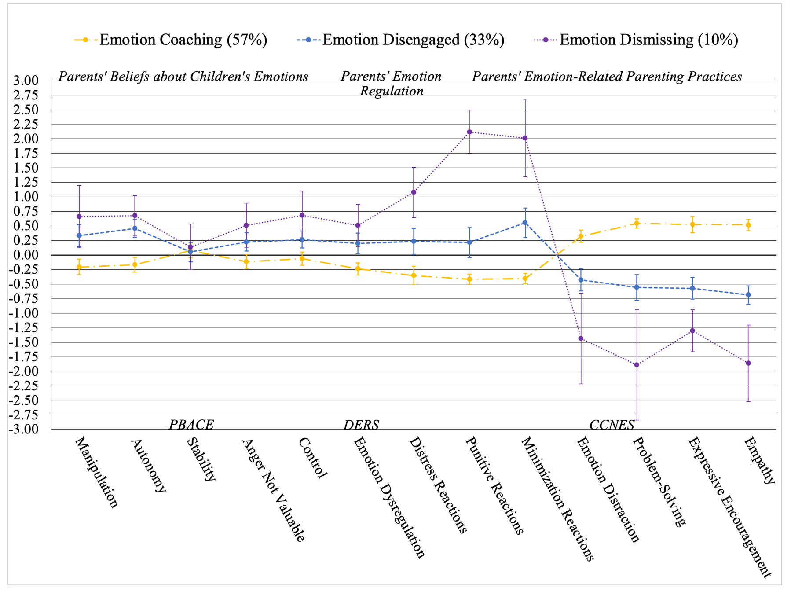
Standardized Mean Scores of the Three-Profile Model Indicators (2020 data) and their 95% Confidence Intervals for Parents of Children Aged 4-10 Years

Note. PBACE=Parents’ Beliefs About Children’s Emotions Questionnaire. DERS=Difficulties in Emotion Regulation Scale. CCNES = Coping with Children’s Negative Emotions Scale.

Table S3
Confidence Intervals and Standardized Mean Scores of Within-Profile Indicators with 2019 Data
 | Emotion Coaching  UL  95% CI | Z-Score | Emotion Coaching  LL  95% CI | Emotion Disengaged  UL  95% CI | Z-Score | Emotion Disengaged  LL  95% CI | Emotion Dismissing  UL  95% CI | Z-Score | Emotion Dismissing  UL  95% CI
Manipulation | -0.37 | -0.23 | -0.09 | 0.01 | 0.21 | 0.41 | 0.49 | 0.67 | 0.85
Autonomy | -0.30 | -0.18 | -0.07 | 0.21 | 0.38 | 0.56 | 0.58 | 0.78 | 0.98
Stability | -0.03 | 0.08 | 0.19 | -0.33 | -0.18 | -0.03 | 0.11 | 0.40 | 0.68
Anger Not Valuable | -0.23 | -0.12 | -0.02 | -0.11 | 0.02 | 0.15 | -0.09 | 0.12 | 0.33
Control | -0.24 | -0.13 | -0.02 | 0.02 | 0.18 | 0.34 | 0.58 | 0.92 | 1.2
Emotion Dysregulation | -0.24 | -0.13 | -0.02 | -0.07 | 0.10 | 0.26 | 0.10 | 0.36 | 0.61
Distress Reactions | -0.39 | -0.28 | -0.17 | 0.03 | 0.18 | 0.34 | 0.68 | 0.93 | 1.2
Punitive Reactions | -0.50 | -0.45 | -0.39 | -0.20 | 0.00 | 0.21 | 1.9 | 2.4 | 2.8
Minimization Reactions | -0.60 | -0.48 | -0.37 | 0.07 | 0.29 | 0.51 | 1.3 | 1.6 | 1.9
Emotion Distraction | 0.15 | 0.29 | 0.43 | -0.48 | -0.25 | -0.02 | -1.1 | -0.77 | -0.45
Problem-Solving | 0.39 | 0.52 | 0.64 | -0.77 | -0.51 | -0.24 | -1.4 | -1.1 | -0.77
Expressive Encouragement | 0.45 | 0.58 | 0.71 | -0.91 | -0.72 | -0.52 | -1.1 | -0.81 | -0.54
Note. UL=upper limit, LL=upper limit, CI=confidence interval.

Table A4
Posterior Classification Probabilities for Latent Profile Analysis with 2020 Data (N=567)
 | Emotion Coaching | Emotion Disengaged | Emotion Dismissing
Emotion Coaching | 95% | 5% | <1%
Emotion Disengaged | 7% | 92% | 2%
Emotion Dismissing | <1% | 7% | 93%
Note. Posterior

