Supplementary Materials

Procedure with Original Stimuli in German
Experimental trials
(1) Object presentation: First Narrator (N1): ‘Ich werde diesen Aufkleber verstecken!’ (English: ‘I will hide this sticker!’; 3s), Intro trial (only presented in the first trial): ‘Schau, die Äffchen! Sie helfen dir den Aufkleber zu finden.‘ (English: ‘Look at the monkeys! They will help you to find the sticker.’; 7s); (2) Presentation of agents and locations: N1: ‘Hey Äffchen, wo ist der Aufkleber?’ (English: ‘Hey monkeys, where is the sticker?’; 3s); (3) Naming Phase: Monkey 1: ‘Hier!’ (English: ‘Here!’), Second Narrator 2 (N2): ‘Er glaubt, dass er da drin ist.’ (English: ‘He thinks it is in there.’; 9s); (4) second prompt: N1: ‘Hey Äffchen, wo ist der Aufkleber?’ (English: ‘Hey monkeys, where is the sticker?’; 3s); (5) Naming Phase: Monkey 2: ‘Hier!’ (English: ‘Here!’), N2: ‘Er weiß, dass er da drin ist.’ (English: ‘He knows it is in there.’; 9s); (6) still frame (2s); (7) fixation screen; (8) Response Phase - pre-questioning phase: both boxes visible (2.5s); (9) Response Phase - post-questioning phase: boxes light up, N1: ‘Wo ist der Aufkleber?’ (English: ‘Where is the sticker?’; 2.5s).

Filler trials
(1) Object presentation: First Narrator (N1): ‘Ich werde diesen Aufkleber verstecken!’ (English: ‘I will hide this sticker!’; 3s); (2) Presentation of agents and locations: N1: ‘Hey Äffchen, wo ist der Aufkleber?’ (English: ‘Hey monkeys, where is the sticker?’; 3s); (3) Naming Phase: Monkey 1: ‘Hier!’ (English: ‘Here!’), Second Narrator 2 (N2): ‘Da ist er wirklich drin.’ (English: ‘It is really there!’; 9s); (4) second prompt: N1: ‘Hey Äffchen, wo ist der Aufkleber?’ (English: ‘Hey monkeys, where is the sticker?’; 3s); (5) Part 1 (comparable to Naming Phase): Monkey 2: ‘Hier!’ (English: ‘Here!’), N2: ‘Er tut so als ob er da drin ist.’ (English: ‘He just pretends that it is inside’; 9s); (6) still frame (2s); (7) fixation screen; (8) Part 2 comparable to Response Phase - pre-questioning phase: both boxes visible (2.5s); (9) Part 2 comparable to Response Phase - post-questioning phase: boxes light up, N1: ‘Wo ist der Aufkleber?’ (English: ‘Where is the sticker?’; 2.5s).

Supplementary Figure 1.
Graph depicting the proportion of target looking time (fixations on target AOI/fixations on target + distractor AOI) in the naming phase (y Axis) per age group (x Axis) including error bars (upper: mean+se, lower: mean-se).

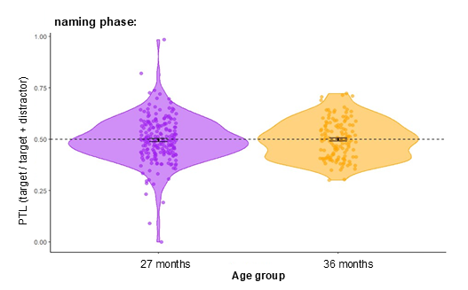

Supplementary Figure 2.
Graph depicting the preference for the AOIs (AOIs were dummycoded: -1 = distractor, 1 = target, y Axis) during the response phase in ms (< 2500ms: pre-questioning phase, >2500ms post-questioning phase, x Axis) per age group for each trial separately.

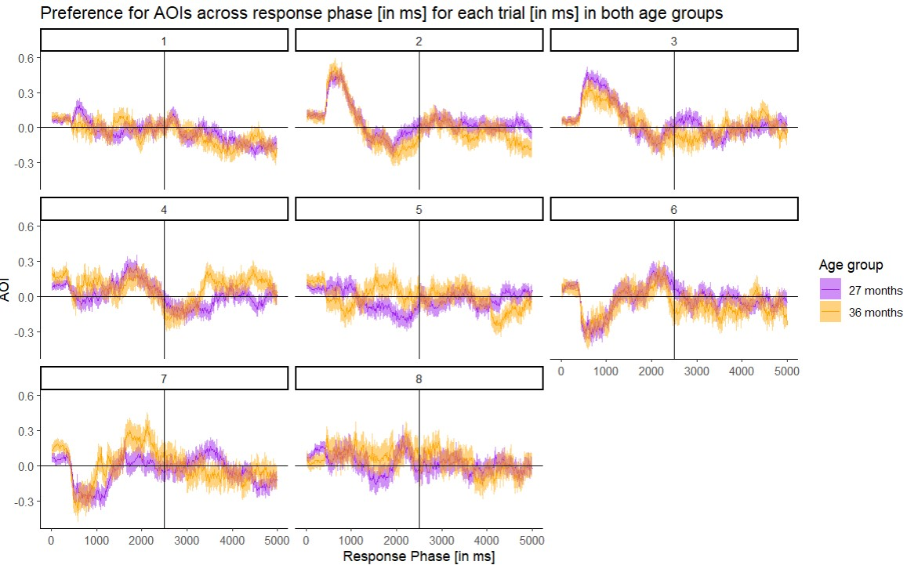

Supplementary Table 1.
Results for model 3: LMEM adding trial number as fixed effect to the no-interaction model
term | Estimate | se | t-value | p-value
(Intercept) | 0.540 | 0.044 | 12.347 | 0.008
phasepost | -0.052 | 0.011 | -4.871 | <0.001
age36Months | -0.015 | 0.022 | -0.663 | 0.626
trial.no | -0.001 | 0.005 | -0.207 | 0.842
The model specification was as follows:
ptl ~ phase + age + trial.no (1+phase + trial.no ||id)+(1 + age||trial.no)+(1+trial.no + age||target)

Supplementary Table 2.
Results for model 4: LMEM considering longitudinal nature of data in the interaction model
term | Estimate | se | t-value | p-value
(Intercept) | 0.532 | 0.038 | 13.809 | 0.030
phasepost | -0.043 | 0.014 | -3.185 | 0.002
age36Months | -0.003 | 0.025 | -0.128 | 0.913
phasepost:  age36Months | -0.023 | 0.022 | -1.053 | 0.293
The model specification was as follows:
ptl ~ phase * age + (1+phase + trial.no ||id)+(1 + age||trial.no)+(1+trial.no + age||target)+(1+phase*age + trial.no ||id.no)

Supplementary Table 3.
Results for model 5: LMEM considering longitudinal nature of data in the no-interaction model
term | Estimate | se | t-value | p-value
(Intercept) | 0.536 | 0.038 | 13.972 | 0.032
phasepost | -0.052 | 0.011 | -4.864 | <0.001
age36Months | -0.015 | 0.022 | -0.661 | 0.629
The model specification was as follows:
ptl ~ phase + age + (1+phase + trial.no ||id)+(1 + age||trial.no)+(1+trial.no + age||target)+(1+phase+age + trial.no ||id.no)

Supplementary Table 4.
Results for testing the longitudinal stability of the response pattern in the pre-questioning phase: testing whether performance at 27 months predict performance at 36 months
term | Estimate | se | t-value | p-value
(Intercept) | 0.463 | 0.061 | 7.628 | <0.001
ptl.27Months | 0.135 | 0.113 | 1.196 | 0.234
The model specification was as follows: ptl.27M ~ ptl.36M

Supplementary Table 5.
Results for testing the longitudinal stability of the response pattern in the post-questioning phase: testing whether performance at 27 months predict performance at 36 months
term | Estimate | se | t-value | p-value
(Intercept) | 0.471 | 0.054 | 8.675 | <0.001
ptl.27Months | -0.032 | 0.106 | -0.304 | 0.762
The model specification was as follows: ptl.27M ~ ptl.36M

Supplementary Table 6.
Results for the attrition analysis: testing performance difference in 27 months performance between those who dropped out and those who attended again at 36 months of age
term | Estimate | se | t-value | p-value
(Intercept) | 0.525 | 0.011 | 48.524 | <0.001
phasepost | -0.043 | 0.013 | -3.199 | 0.001
dropoutyes | 0.016 | 0.014 | 1.128 | 0.259
The model specification was as follows: ptl.27M ~ phase + dropout

Supplementary Table 7.
Results for model 6: LMEM examining only the subset of the pre-questioning phase in the 27-month-olds
term | Estimate | se | t-value | p-value
(Intercept) | 0.529 | 0.025 | 21.281 | 0.008
age36Months | -0.002 | 0.020 | -0.116 | 0.928
The model specification was as follows:
ptl ~ age + (1+trial.no ||id)+(1 + age||trial.no)+(1+trial.no + age||target)

Supplementary Table 8.
Results for model 7: LMEM examining the subset of the post-questioning phase in the 27-month-olds
term | Estimate | se | t-value | p-value
(Intercept) | 0.487 | 0.043 | 11.242 | 0.080
age36Months | -0.026 | 0.020 | -1.300 | 0.424
The model specification was as follows:
ptl ~ age + (1+trial.no ||id)+(1 + age||trial.no)+(1+trial.no + age||target)

Supplementary Table 9.
Results for model 8: LMEM examining only the subset of the pre-questioning phase in the 36-month-olds
term | Estimate | se | t-value | p-value
(Intercept) | 0.527 | 0.029 | 17.960 | 0.022
age27Months | 0.002 | 0.020 | 0.116 | 0.928
We releveled age to make the 36-month-olds the baseline and examine effects at 36-months of age. The model specification was as follows:
ptl ~ age + (1+trial.no ||id)+(1 + age||trial.no)+(1+trial.no + age||target)
Supplementary Table 10.
Results for model 9: LMEM examining only the subset of the post-questioning phase in the 36-month-olds
term | Estimate | se | t-value | p-value
(Intercept) | 0.462 | 0.045 | 10.163 | 0.077
age27Months | 0.026 | 0.020 | 1.299 | 0.425
We releveled age to make the 36-month-olds the baseline and examine effects at 36-months of age. The model specification was as follows:
ptl ~ age + (1+trial.no ||id)+(1 + age||trial.no)+(1+trial.no + age||target)

Supplementary Table 11.
Results for model 11: LMEM examining mental utterances of know and think in the subset of the 36-month-olds
term | Estimate | se | t-value | p-value
(Intercept) | 0.532 | 0.058 | 9.209 | <0.001
phasepost | -0.064 | 0.018 | -3.495 | <0.001
know.36Months | -0.012 | 0.059 | -0.202 | 0.840
think.36Months | 0.006 | 0.021 | 0.313 | 0.755
The model specification was as follows: ptl ~ phase + know + think + (1 + trial.no ||id)+(1+trial.no ||target)

